The ideas and suggestions in this tip sheet connect with the practice principles of the Victorian Early Years Learning and Development Framework.
- Partnerships with families
- Partnerships with professionals
- High expectations for every child
- Equity and diversity
- Respectful relationships and responsive engagement
- Integrated teaching and learning approaches
- Assessment for learning and development
- Reflective practice
It is recommended that educators refer to the VEYLDF and the practice guides for further suggestions and ideas about continuous improvement.
Fundamental to effective early childhood education and care is the expectation that every child will have the opportunity to grow and learn. This means that educators work collaboratively with families to create meaningful and differentiated programs that respond to children’s interests, enabling children to reach their full potential.
“Responsive learning relationships are strengthened as educators and children learn together and share decisions, respect and trust. Responsiveness enables educators to respectfully enter children’s play and ongoing projects, stimulate their thinking and enrich their learning.”
– The Early Years Learning Framework for Australia p15
With the change to the educator to child ratio, educators may be working with larger numbers of children with very diverse circumstances. This will most likely include children who may require additional support.
Educators who work in partnership with families and other professionals to better understand how all children can be supported to fully participate in the program, achieve the best outcomes for individual children that may require additional support, as well as the group as a whole.
Differentiated responses take into consideration the various ways children learn through offering diverse learning experiences and can be further enhanced by utilising expert advice to enrich and enable every child’s learning and development.
This approach relies on a commitment to high expectations for every child and a belief in their right to access high quality early childhood education.
Suggested strategies to
support responding effectively
to every child:
Responding to the abilities, strengths and interest of all children starts with the enrolment and orientation process. It is important to get to know every family member and recognise that some families may require additional support. It may be helpful to start enrolment processes earlier and make time to discuss individual requirements, expectations and appropriate responses with families. This may be best supported by including other relevant professionals. »

Consider using the time at the beginning of the year (or before you start working together) to meet as a team to discuss how the program can best suit individual children. At this meeting it would be helpful to talk about logistics (organising the space and resources for example), also discuss your views on how to ensure all concerned maintain high expectations when working with diverse groups of children and families. Discuss how the team can plan for differentiated approaches that support learning and development for every child. This could also be an opportunity to understand the perspectives of others and talk through any discrepancies or differences and come to an agreement about how to proceed.
Use your regular team meetings to talk about how all children and their families are engaging in the program. It is helpful to spend time as a team reflecting on how individual children are participating in the program. Consider how they are advantaged or disadvantaged by the program you are providing and how this could be modified to create stronger outcomes with particular reference to equity and diversity and the inclusion of all children.


Questions for
reflective discussion
The VEYLDF practice principles invites educators to think about and challenge their current practices. Use the following questions to support discussion with your colleagues.
- Share your understanding of inclusion in early childhood education. Use the joint statement on inclusion of children with a disability in early childhood education and care to guide your discussion.
- Consider this quote from the EYLF – ‘Educators think critically about opportunities and dilemmas that can arise from diversity and take action to redress unfairness.’ (EYLF pg13) – what do you think this means in practice?
- What are the benefits of inclusion for all children?
- What might be the challenges?
- What could you do to address these challenges? What strategies might you develop?
- How can you maximise the benefits?
- What might you need to reconsider or change in your practice to realise high expectations for each child?
- How could you include other professionals to create authentic and collaborative partnerships to support children and their families?

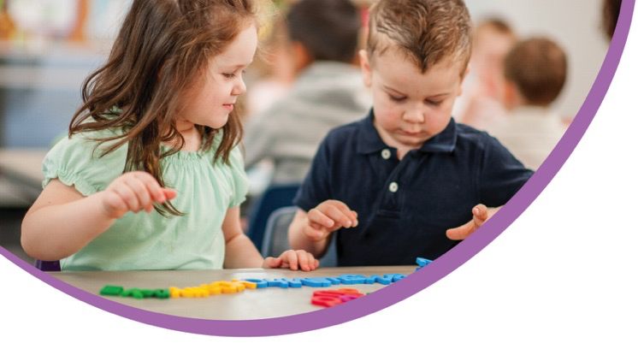
Utilise a communication diary or journal. Use a team diary or journal to make notes about concerns or questions that you have about how individual children are participating in the program. You may invite other professionals to offer their feedback as well. Use this in reflective discussions and to develop individual learning plans that maximise learning and development outcomes.
References and further reading
http://www.education.vic.gov.au/childhood/providers/funding/Pages/improvedchildratioinkindergarten.aspx

