The ideas and suggestions in this tip sheet connect with the practice principles of the Victorian Early Years Learning and Development Framework.
- Partnerships with professionals
- High expectations for every child
- Equity and diversity
- Respectful relationships and responsive engagement
- Integrated teaching and learning approaches
- Assessment for learning and development
- Reflective practice
- Partnerships with families
It is recommended that educators refer to the VEYLDF and the practice guides for further suggestions and ideas about continuous improvement.
The role of the learning space in early childhood education and care programs as powerful learning mechanism is well established. When educators take time to work with their colleagues to create dynamic and holistic learning spaces, both inside and outside, they invite children to explore and discover, interact and engage and support their interests, growth and development in the five learning outcomes.
“An environment is a living, changing system. More than a physical space, it includes the way time is structured and the role we are expected to play. It conditions how we feel, think and behave; and it dramatically affects the quality of our lives. The environment either works for us or against us as we conduct our lives.”
– Greenman 1988 p5
With the change to the educator to child ratio, educators may be able to interact with smaller groups of children more often. Larger numbers of children may mean there will be more demands on the space and a need to consider this is designing environments that support learning. This might mean that spaces are used differently than in the past or that the planning for spaces becomes more intentional with clear expectations for children and adults.
Creating effective learning spaces for larger groups starts with having high expectations of children and a belief that, with strong teaching strategies, children will be able to work in their environments in purposeful and respectful ways. Utilising a collaborative approach, where each educator is part of the teaching and learning decisions, environments become mechanisms to support the varying interests of the group and an effective way to create diverse learning experiences for each child.
Suggested strategies to support strong physical and social environments:
Use small group opportunities with children to talk through how the environments are working. Children will have clear opinions about how spaces are working, what they will need as well as ideas about how to look after the resources. If a particular area is not working in the way you planned, include children in determining the solutions. »

Work as a team to undertake an environmental audit. After you have set up the environment (both inside and outside) step back and examine closely the learning spaces that you have created. Using reflective practice to identify the ways these spaces make it easier or more challenging for children to settle into and learn within the environment. Remember spaces send powerful messages to children about how to behave – ensure these messages are about their productive participation in the program.
Another way to analyse the environment is to use the vision for children in the Early Years Learning Framework. Make a list of the spaces that connect with the concepts of belonging, being and becoming. Discuss the result with your team. Make plans to address any imbalances – are there enough places to just ‘be’ for example?

An audit might also need to examine the number of resources available to children. Larger groups will need more of the basic equipment and resources utilised in early childhood programs such as scissors, crayons, markers or sticky tape holders. Consider providing ‘banks’ of these basic resources that children can access readily throughout the program.
Questions for
reflective discussion
The VEYLDF practice principles invites educators to think about and challenge their current practices. Use the following questions to support discussion with your colleagues.
- What is your understanding of how the way environments support children’s learning?
- If environments send ‘powerful messages’ to children, what messages do you want children to receive from the spaces that are created?
- What challenges to children’s learning and participation does your environment present?
- What could you do to address these challenges? What strategies might you develop?
- How will diverse learning styles be catered for?
- What challenges might children have as they participate in the program – how will these be catered for?
- Where will smaller groups meet? What resources do these spaces need?
- What assets do your environments have?
- How can you maximise these benefits?
Support these approaches with intentional teaching strategies that help child learn about how to access, use, maintain and store the equipment.
Use the regular staff meeting times as an opportunity to reflect on the learning environment. Considering how the learning environment is supporting learning requires ongoing reflection and decisions about how to change/modify approaches. Make this a standard agenda item in these meetings to ensure it doesn’t get forgotten. Use the reflective question below to guide the conversation or make up your own.
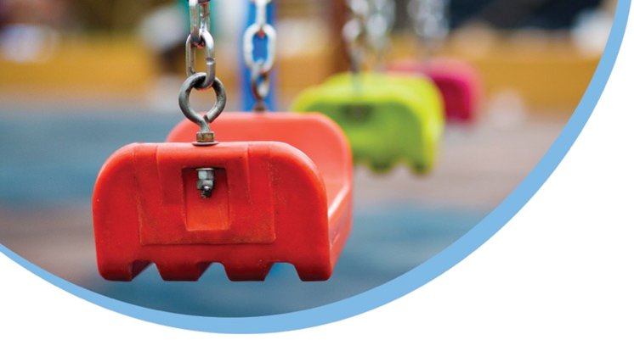
Use an indoor/outdoor program as much as possible. Utilising two spaces for larger groups of children will promote a more settled atmosphere and enriched participation. The presence of more educators will make this approach more possible but require educators to plan together for both spaces and consider ways to provide learning in the five outcomes, both indoors and outdoors.
References and further reading
http://www.education.vic.gov.au/childhood/providers/funding/Pages/improvedchildratioinkindergarten.aspx

