Kindergarten Quality Improvement Program
Program overview and summary of early findings
March 2021
CONTENTS

Executive Summary 3
Kindergarten Quality Improvement Program 4
Quality Matters 4
Overview of KQIP 4
KQIP Phase 1 5
KQIP Phase 2 5
KQIP Participants 5
KQIP Program Evaluation 7
Interim Report 1 – October 2019 7
Interim Report 2 – January 2020 7
Interim Report 3 – July 2020 7
Interim Report 4 – February 2021 10
Next Steps 10
Appendix A – National Quality Standard 11
Appendix B – NQS Ratings 12

Executive Summary
The Kindergarten Quality Improvement Program (KQIP) is a professional development initiative that provides intensive and targeted support to Victorian early childhood education and care (ECEC) services in need of quality improvement support. The program aims to lift the quality of these services to improve outcomes for children, to help ensure every child starts school developmentally on track.
KQIP is delivered over two distinct phases. KQIP Phase 1 is a six-month program focusing on Governance and Leadership – Quality Area 7 of the National Quality Standard (NQS), and KQIP Phase 2: an 18-month program focuses on Educational Programming and Practice – Quality Area 1 of the NQS. KQIP prioritises these areas because studies have found that creating and sustaining an organisational culture that fosters and delivers high-quality teaching, programming and practice is critical to advancing children’s learning and development.
The evidence emerging from an ongoing independent program evaluation indicates that KQIP is having highly favourable impacts on the quality of participating services, as measured by changes in NQS ratings. An analysis of a sample of services indicates that participants of the program with a Working Towards rating were approximately four times more likely to improve their NQS Overall ratings than non-participating Victorian ECEC services, and almost three times more likely than other Australian ECEC services.
Building on the strong evidence base for KQIP, the program will be expanded to continue to support ECEC services identified as requiring additional support. All participating services will have access to comprehensive diagnostic threshold tools, intensive mentoring support, multiple online and in-person professional development days, networking opportunities and expert-facilitated communities of practice. These supports will be provided at various levels within the service (i.e. to educators, Approved Providers and the leadership group) to create an environment for embedding long-term change and improvements.

Kindergarten Quality Improvement Program
This report provides an overview of the Kindergarten Quality Improvement Program and a summary of early findings from the independent program evaluator.

The Victorian Government is committed to ensuring that every child has a successful start to life – regardless of where they are located and which early childhood education and care (ECEC) service they attend. While over 86 per cent of Victoria’s ECEC services are either Meeting or Exceeding the National Quality Standard (NQS), 13 per cent of services are Working Towards the NQS.
The NQS sets a transparent national benchmark for the quality of ECEC services and includes seven quality areas that are important to children’s learning and development outcomes (see Appendix A). The NQS Assessment and Rating process is conducted by regulatory authorities to provide an independent and robust assessment of service quality. Services are assessed and rated against each of the seven NQS quality areas and receive an overall rating based on these results (see Appendix B).

Quality Matters
Studies show that leadership is one of the most important drivers of quality improvement in early childhood settings. Educational leaders are influential in fostering a culture of learning, innovation, program improvement and staff development. When staff in leadership positions foster positive and collaborative working environments, educators are supported and encouraged to excel in their practice, which can enhance children’s learning and development outcomes.
There is a general expert consensus that ‘process quality’ – child-staff interaction and children’s activities – is the central way in which early childhood education benefits children’s development and learning. Local and international evidence shows that preschool programs must be high quality to achieve significant, lasting impact, because it is the quality of educational programs and early childhood educators’ practice that are the most critical factors for affecting positive child outcomes.,

Overview of KQIP
Established in 2018, the Kindergarten Quality Improvement Program (KQIP) aims to lift the quality of participating services to improve outcomes in service governance and leadership, and educational program and practice. The program provides intensive and targeted professional development opportunities for Victorian education and care services delivering a funded kindergarten program that need additional support.
Based on the research, KQIP is designed to contain two phases. Phase 1 focuses on Governance and Leadership (NQS Quality Area 7 - QA7) and Phase 2 focuses on Educational Program and Practice focuses (NQS Quality Area 1 - QA1). These are the quality areas that most services in Victoria tend to have the lowest rating against. An overview of each Phase is provided below.

KQIP Phase 1
KQIP Phase 1 – Improving Quality Through Leadership and Governance is a six-month program for staff in management and leadership roles, such as Approved Providers, Service Directors, Nominated Supervisors and Educational Leaders.
The aim of KQIP Phase 1 is to build participants understanding of the role and responsibility of service leaders and their understanding of the importance of leadership as an essential platform for delivering high quality educational program and practice, which will ultimately enhance outcomes for children.
Program components include the delivery of three professional development workshops, individualised support from mentors, online collaboration spaces and digital learning resources, and networking opportunities.
Mentors work with ECEC services to assess their current needs through the use of diagnostic tools and develop strategies to build capacity across the service. Professional development workshop include topics on leadership theories, understanding and embedding service philosophies, understanding leadership roles, managing performance-based feedback, professional identity and collaborative relationships.

KQIP Phase 2
KQIP Phase 2 – Improving Quality Through Educational Program and Practice is an 18-month program for early childhood teachers, leaders and educators.
The goal for services participating in Phase 2 is that they will be able to create and sustain an organisational culture which fosters and delivers high quality teaching, programming and practice that advances children’s learning and development.
Program components include delivery of six professional development workshops, a pre-assessment, individualised support from mentors, practice observation using the Reflect, Respect, Relate observational scales, an online collaboration space, digital learning resources, and networking opportunities.
Similar to Phase 1, mentors work with ECEC services to assess their current needs through the use of diagnostic tools and develop strategies to build capacity across the service. Workshop topics include planning for learning, critical reflection, understanding the planning cycle, assessing learning, techniques for teaching and learning, and engaging with the Victorian Early Years Learning and Development Framework.

KQIP Participants
Since 2018, 269 unique services have been or are being supported through KQIP. Some services have participated in both Phase 1 and Phase 2 of the program. Of these:
- 232 have completed the six-month Phase 1 program across three cohorts
- 60 have completed the 18-month Phase 2 program in the first cohort
- 80 commenced the Phase 2 program’s second cohort in late-2020, scheduled to complete by April 2022.

A breakdown of KQIP participants to date by key characteristics is provided in Table 1:
Table 1: Participation in KQIP Phases and Cohorts by characteristics
 | Characteristic | Phase 1: Service Governance and Leadership |  |  | Phase 2: Educational Program and Practice |  | Total
 |  | Cohort 1 | Cohort 2 | Cohort 3 | Cohort 1 | Cohort 2
 |  | 2018 | 2019 | 2020 | 2019 - 2020 | 2020 - 2021
All Participants |  | 120 | 35 | 77 | 60 | 80 | 269 unique*
Service type | Long Day Care program | 83 | 25 | 57 | 45 | 64 | 192
 | Stand-alone kindergarten | 37 | 10 | 20 | 15 | 16 | 77
Management type | For-profit | 61 | 14 | 45 | 35 | 41 | 140
 | Not-for-profit / community-managed / school-based | 59 | 21 | 32 | 25 | 39 | 129
Early Years Management (EYM) | EYM | 93 | 6 | 14 | 12 | 13 | 54
 | No EYM | 27 | 29 | 61 | 48 | 67 | 215
Size by no. approved places (small <50; medium 51-100; large >101) | Small | 47 | 12 | 27 | 18 | 20 | 98
 | Medium | 46 | 12 | 26 | 28 | 32 | 97
 | Large | 27 | 11 | 24 | 14 | 28 | 74
*Services that have completed both Phase 1 and Phase 2 have only been counted once.

KQIP Program Evaluation
The Department of Education and Training has engaged an independent organisation to conduct an evaluation of KQIP. The evaluation will assess program processes and implementation, gauge the impacts and the sustainability of KQIP outcomes, and provide recommendations on how future iterations of the program could be adapted in response to the findings. Formative and summative evaluation methodologies will be used to generate program insights. The evaluation commenced in 2019 and will be completed in 2023.
The evaluation methodology uses qualitative and quantitative approaches to deliver twelve reports containing interim findings over the course of the evaluation and two final reports. Each interim report will focus on post-program evaluation points at certain timestamps of each KQIP Phase, including 6-months, 12-months and 24-months. The summary below presents an overview of findings to date.

Interim Report 1 – October 2019
The report contained insights about service’s program participation and experiences through a survey conducted following completion of the Phase 1 program. The survey found that, of the Phase 1 program activities, services were most engaged with the professional learning days and mentoring (particularly when mentoring was conducted in-person).

Participants also raised opportunities to enhance program delivery. Responses included:
- increased mentor support – more time with mentor during program, and a possible follow-up post-program
- increased scope for attendance of professional development workshops – extend invitations to additional key staff at each level
- greater number of professional development workshops
- greater flexibility in scheduling of program activities.

Interim Report 2 – January 2020
This report includes case studies of the experiences of twelve services that participated in the Phase 1 program. Change activities related to NQS Quality Area 7 were underway in each service and services reported that the program had increased service leader knowledge and confidence in initiating quality improvement activities. Relationships with mentors continued (through Phase 2 participation) assisting in implementing change.

These case studies highlighted that participants had a generally positive experience with the program and noted the benefits of a renewed culture of professionalism. Some barriers to realising this program’s full potential included the impact of high staff turnover at some services, which made sustained quality improvements difficult.

Interim Report 3 – July 2020
This report examined changes in the NQS ratings of services that had been re-assessed following participation in KQIP Phase 1. The report found that services that completed KQIP were more likely to have improved their NQS Overall rating (see Figure 1) and their NQS ratings across Quality Area 7 (see Figure 2) relative to other services in Victoria and Australia that did not participate in KQIP. The report found that services that completed KQIP were more likely to have improved their NQS Overall rating (see Figure 1) and their NQS ratings across Quality Area 7 (see Figure 2) relative to other services in Victoria and Australia that did not participate in KQIP.
The Department acknowledges that process and cultural changes take time. Further data collection and analysis is warranted to test any deterministic factors amongst services that did not improve their NQS QA 7 rating following program participation. This will assist in better understanding trends in quality improvement, factors that influence changes in quality ratings, and how these can be strengthened.
Figure 1: NQS Overall rating changes for services who participated in KQIP Phase 1 and other services in Victoria and Australia
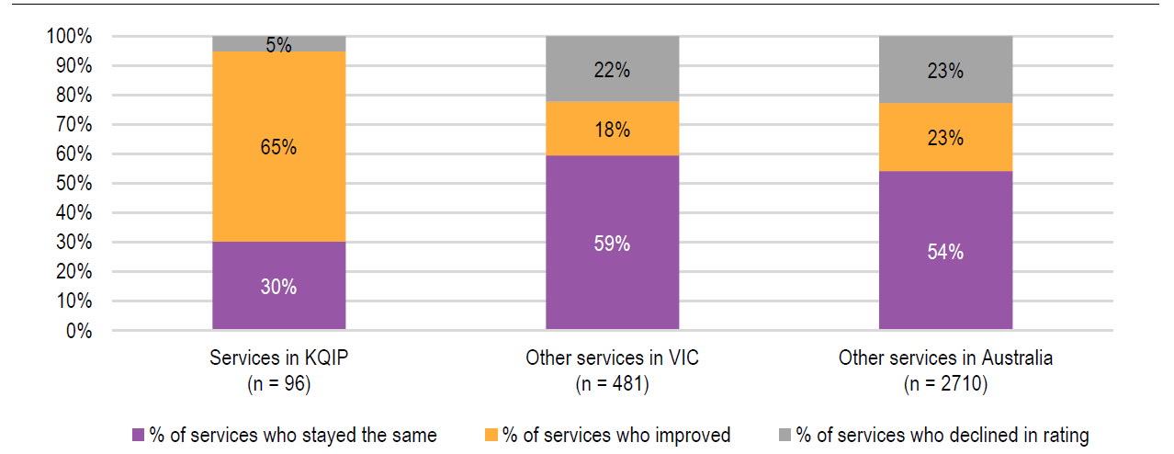
Notes:
- Other services in Victoria and Australia who did not participate in KQIP were either LDC services, part of a pre-school/kindergarten or a stand-alone kindergarten.
- Only includes Phase 1 participants that were re-rated
- Percentages may not add up to 100 per cent due to rounding.
- The analysis used results of NQS assessments prior to 2019 that also had a subsequent NQS re-assessment in 2019 or 2020 which was after the service participated in the program.

Figure 2: NQS QA 7 rating changes for services who participated in KQIP Phase 1 and other services in Victoria and Australia
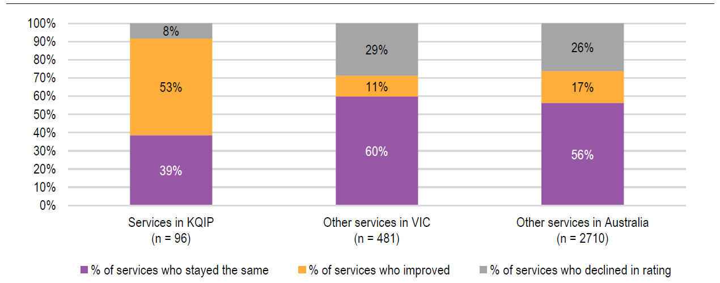
Notes:
- Other services in Victoria and Australia who did not participate in KQIP were either LDC services, part of a pre-school/kindergarten or a stand-alone kindergarten.
- Only includes Phase 1 participants that were re-rated
- Percentages may not add up to 100 per cent due to rounding.
- The analysis used results of NQS assessments prior to 2019 that also had a subsequent NQS re-assessment in 2019 or 2020 which was after the service participated in the program.

Interim Report 4 – February 2021
This report examined the progress of change activities and emerging outcomes of Cohort 1 services 24 months after completing the Phase 1 program. Participating services typically planned or progressed changes for each of the six NQS QA 7 elements. Most commonly, this included change to the Quality Improvement Plan, Educational Leader role or supports, and Service philosophy. Most services (between 67–86 per cent of services across NQS QA 7 elements) indicated that changes involved both policy / documentation change and cultural change, relative to either area individually. This is an important distinction for improving the likelihood of sustaining change over time.

Next Steps
While a complete picture of long-term benefits and impacts is still emerging as KQIP continues to be delivered, early indications from the independent evaluation suggest that the program is having positive impacts on quality improvement in participating services.
To support the rollout of three-year-old kindergarten and the broader quality agenda in early childhood, KQIP will be expanded to continue to provide support for additional eligible ECEC services. Findings from the interim evaluation reports will be used to inform the design and delivery of an expanded KQIP to ensure it builds on the strengths and successes of previous program iterations.
All participating services will be provided with access to comprehensive diagnostic threshold tools, intensive mentoring support (for varying hours based on their need and NQS rating), multiple online and in-person professional development days, networking opportunities and expert-facilitated communities of practice. Supports will be provided to various levels within the service, including educators, Approved Providers, and the leadership group to help create a more supportive environment for embedding long-term change and improvements. There will also be flexible program entry and exit processes to calibrate dosage to maximise this program’s effectiveness. This expanded KQIP is scheduled to be begin delivery in 2021.

Appendix A – National Quality Standard
The National Quality Standard (NQS) sets a high national benchmark for early childhood education and care and outside school ours care services in Australia.
The NQS includes seven quality areas that are important to outcomes for children.
Services are assessed and rated by their regulatory authority against the NQS and given a rating for each of the seven quality areas. Services also receive an overall rating based on these results.
The seven quality areas are:
- Quality Area 1 – Educational Program and Practice – Educational program and practice of educators are child-centred, stimulating and maximise opportunities for enhancing and extending each child’s learning and development.
- Quality Area 2 – Children’s Health and Safety – Children have the right to experience quality education and care in an environment that safeguards and promotes their health, safety and wellbeing.
- Quality Area 3 – Physical Environment – Physical environment is safe, suitable and provides a rich and diverse range of experiences that promote children’s learning and development.
- Quality Area 4 – Staffing Arrangements – Quality and experienced educators, who develop warm, respectful relationships with children, create predictable environments and encourage children’s active engagement in the learning program.
- Quality Area 5 – Relationships with Children – Relationships with children are responsive, respectful and promote children’s sense of security and belonging.
- Quality Area 6 – Collaborative Partnerships with Families and Communities – Collaborative relationships with families are fundamental to achieving quality outcomes for children, and community partnerships based on active communication, consultation and collaboration are essential.
- Quality Area 7 – Governance and Leadership – Effective leadership and governance of the service contributes to quality environments for children’s learning and development. Effective leaders establish shared values for the service and set clear direction for the service’s continuous improvement.

Appendix B – NQS Ratings
NQS Rating | Criteria
Exceeding NQS | - Service goes beyond the requirements of the NQS in at least 4 of the 7 quality areas, with at least two of these being quality areas 1, 5 6 or 7
Meeting NQS | - Service meets the NQS  - Service provides quality education and care in all 7 quality areas.
Working Towards NQS | - Service provides a safe education and care program  - There are 1 or more quality areas identified for improvement

As at February 2021.
Douglass, A. L. (2019), Leadership for Quality Early Childhood Education and Care, OECD. https://bit.ly/3jagAuu
E4Kids Research Program (2016). Overview of Findings
OECD (2018), Engaging Young Children: Lessons from Research about Quality in ECEC.
Australian Children’s Education and Care Authority (2018), National Quality Standards, retrieved 20 October 2020 from https://www.acecqa.gov.au/nqf/national-quality-standard

