What are learning programs responsive to children?

Learning programs that are responsive to children’s learning:

• encourages children to explore, solve problems, communicate, think, create and construct
• has minimal rules (with some exceptions,
such as those that keep children safe)

• is a rich sensory experience (involving sound, sight, touch, taste, smell and movement)
• involves concepts that will be used
in more formal learning situations (such as language, literacy and numeracy)
• extends children’s social skills and emotional regulation, while being fun and holistic.
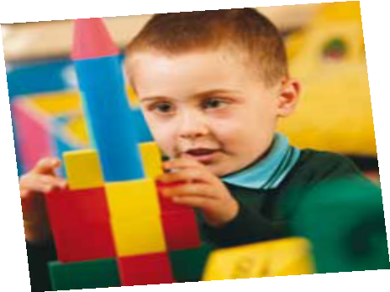
Child-directed play is a teaching and learning approach familiar to all children. They use it at home, with siblings or friends, on their own, at early childhood settings, for example. During transition to school, opportunities to continue with this style of learning can help children adjust to
other guided-play or adult-led teaching and learning approaches.
Early childhood professionals recognise that learning is an active process that must involve children’s engagement. Play is essential for its ability to stimulate
and integrate a wide range of children’s intellectual, physical, social and creative abilities. Play builds on children’s capabilities, strengths, interests, and knowledge.
How can these be put into practice?

Educators use a variety of approaches to deepen their understanding of what works best for individual children. Professional learning, discussions with other educators and reflection can all assist them understand these approaches to learning. These approaches can include co-teaching with other educators to deepen their knowledge of how children learn and how to scaffold learning and development using a range of approaches
When development responsive learning program educators may:

• gather and analyse information about each child’s progress from a wide range of sources

• reflect and respond to children’s similarities and differences and build on children’s
capabilities, strengths, interests and knowledge

• provide activities for children to explore, solve problems, communicate, think, create and
construct

• support child-directed, adult-led and guided play and learning teaching and learning
approaches

• promote and use practices that have been shown to be successful in supporting children’s learning and development, and challenge and change those practices that have not achieved success
• gather information that supports, informs, assesses and enriches decision-making
about appropriate professional practices
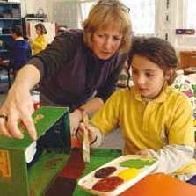
These strategies should be supported by sustained and shared interactions with children through play to more focused learning with lifelong benefits.

