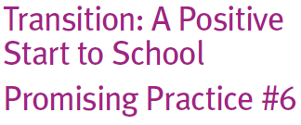
Transition: A Positive
Start to School
Promising Practice #6

What are buddy programs?

Buddy programs refer to programs which involve older children being paired with younger children, between children starting school and children in older grades. Older children are sometimes in Years 5 or 6, Other programs are designed with children in Years 1 or 2.
The purpose of a buddy program is to support a smooth transition for children starting school. Schools report that the programs promote social and support networks for children beginning Prep and promote a sense of community and belonging in the school.
A Buddy program can also be helpful for families new to a school.
How can these be put into practice?

The goal is to develop relationships between the younger and older children, enhancing the sense of a friendly and supportive school community.
There are benefits for the older buddy in acknowledging their leadership, responsibility and pride in their ability to be helpful.
Programs have included the following elements:

• adults are involved to oversee how the relationships develop and are maintained

• the older buddy is provided with advice and some ‘training’ on how to be a buddy

• making sure each buddy plainly understand each other’s role

• there are clear processes for determining what to do if the relationship is not working for
either party

• children participate in structured activities together as well as being provided with
opportunities to identify other activities they might do with and for each other

• considering temperaments, styles, gender and other elements when matching
buddies.

Buddy programs for families may be known by other names, such as family support groups or parent buddies or mentors.
Many schools provide opportunities such as informal and social occasions for families new to the school to get to know one another, develop new relationships and clarify any aspect of school life that is unclear. Others may offer more structured programs where new families can elect to be matched with a family that already has a child in the school to ease transitions and assist in developing a supports for families and a welcoming school community.
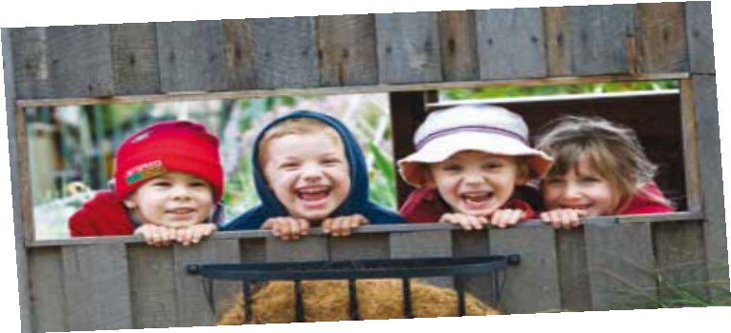
Please see Promising Practice #7 for more information on family engagement activities.

