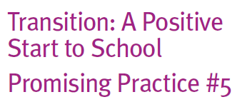
Start to School
Promising Practice #5

What is a transition network?

Transition and birth to eight networks already exist in many parts of Victoria. They comprise members with an interest in the early years of children’s lives and
in improving early learning and transition experiences for children, families, educators and communities more broadly.
In connecting with one another through networks:

• relationships can be built and
strengthened

• insight into the bigger picture for children and families is gained (including the important contribution each service makes to children and their families’ long term outcomes)
• ideas can be shared and solutions to
problems jointly explored

• staff can feel supported and less
isolated.
How can these be put into practice?

Networks seem to work best when they are well-led, and when the sustainability of the network is considered in the early phases of setting up the network, developing goals and designing the transition program. Networks with several ‘champions’ are more likely to maintain momentum and encourage active involvement in the group’s planned activities. The wider the network’s membership base, potentially, the easier it is to allocate roles, responsibilities and workload.
When establishing and operating a network, the following strategies may be worth considering:

• hold regular meetings and/or facilitate regular contact to help establish a common vision for transition, identify roles in the transition process/program and to develop partnerships and trust between members
• Depending on network priorities, schedule regular catch ups on days where most members are available (in some areas this happens each term or more regularly). Alternating times and days can allow those who work part time to access the networks on some occasions.
• acknowledge different views and needs and develop common understandings

• respect children and families in the transition process by acknowledging, valuing
and consulting them about their experiences, understandings and feelings

• develop an understanding and familiarity with each other’s services, programs, curriculum, philosophical frameworks and methods for planning and implementing these, and develop an agreed best practice transition program
• be mindful of making the networking process a part of rather than additional work

• review the role and function of the network on a regular (annual) basis to ensure
that it is meeting the needs of members

