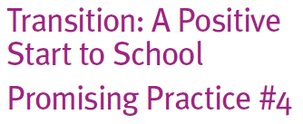
Start to School
Promising Practice #4

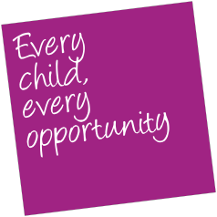

Joint professional learning

What is joint professional learning?

Professional learning or development is a term commonly used to describe additional training provided to further develop
the skills and knowledge to improve practice. In early childhood services, outside school hours care services and schools it is recognised as an important strategy in improving children’s learning and development and building common understanding about good practice.
Work with Best Start sites, transition pilots and local networks has shown that bringing together relevant professionals from early childhood services (including child care and kindergarten, early childhood intervention services, Maternal and Child Health), schools, Primary School Nursing, student support services and other organisations with expertise and knowledge in working with children and families to participate
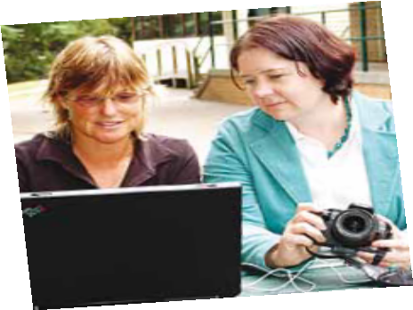
in professional development can be rewarding, build relationships and improve practice.
How can this be put into practice?

Topics should be selected to meet the goals identified by local areas.

Joint professional development opportunities enable all educators to hear the same information at the same time, and to engage in discussion and professional reflection about how new knowledge can be applied to support the continuity of learning for children from birth to eight, respecting and valuing the contribution that everyone makes.
There is great value in having professional diversity within these forums, where professionals from health, education, local government and other agencies can share experiences, build stronger relationships and reflect on how systems function and can be improved.
Professional learning is an ongoing process and is most effective when supported by effective networks, peer-mentoring, consultation and opportunities to learn from one another.
Some possible issues to consider when designing joint professional development programs may include:

• Family centred practice - working in partnership with families

• Supporting children with additional needs

• Assessing and documenting children’s learning and development

• Literacy, numeracy and oral language in the early years

• Child centred practice

• Seeking children’s views – engagement and consultation

• Intentional teaching in play based programs

• Continuity of learning across the birth to eight years

