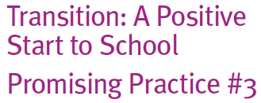
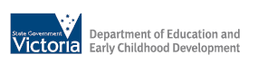
Start to School
Promising Practice #3

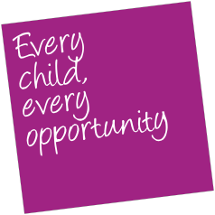

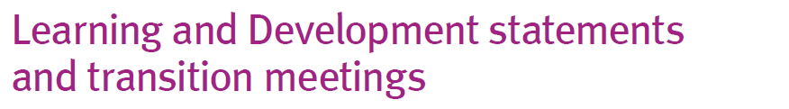
Learning and Development statements and transition meetings

What are learning and development statements and transition meetings?

Learning and development (Transition) statements refer to documented information, shared between early childhood services and schools, which aims to provide important information about individual children and their families when children start school. Transition meetings are often held between families and educators to support the transfer of these documents and provide opportunities to further discuss the information in detail.
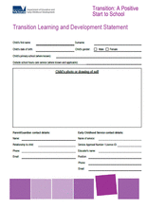
How can these be put into practice?

Victoria now has a consistent format for collecting information to support transition to school, through the Transition Learning and Development Statement. When information is provided in a consistent format this helps schools identify and plan curriculum which builds on a child’s previous learning and development.
The Transition Learning and Development Statement provides a tool for the consistent transfer of information between early childhood services, outside school hours care services and schools. It draws upon the learning outcomes identified for children in the Victorian Framework.
The Transition Learning and Development Statement has two parts, one for the family (Part 1) and one for the early childhood educator (Part 2). For families of children with a severe disability, there is an additional page (Part 1A) to record information on the
additional services involved or any other important information the school should know, if this has not already been recorded.
The Transition Learning and Development Statement complies with privacy legislation and therefore cannot be adapted locally.
Preparing the statement provides opportunities for discussions between children, families and educators.
If early childhood educators share their impressions of children’s learning and development throughout the year before school starts, there should be no surprises to families in the information collated for the statement.
Meetings or further discussions with families to support the transfer of this information provide an opportunity to explore this information about each child and the perspectives and professional knowledge of early childhood educators.
For more detail about completing the Statement please see the Transition: A Positive
Start to School Resource Kit.

To access the Resource Kit, Transition Statement and other supporting resources, please visit:

www.education.vic.gov.au/earlylearning

