Tip – How do I rotate images?

1. Rotate images within Online TLDS platform:

Once you have attached the child’s image or drawing, click on the rotate buttons to rotate the image left or right in Section 1 and the Section 2 & 3 parent link.
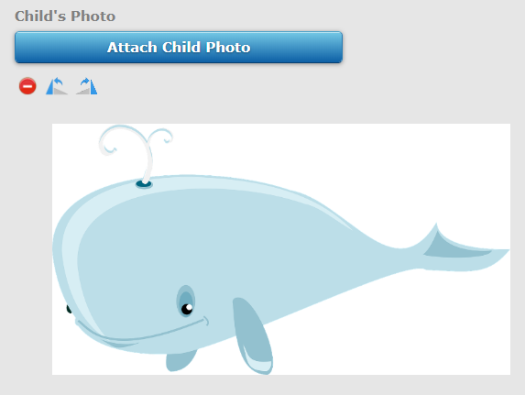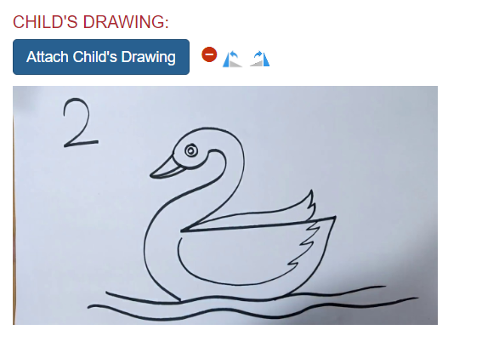

2. Rotate images on your computer:

- Open Paint from Windows Start menu.
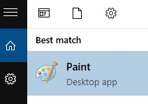

- From within Paint, open the image you want to rotate.
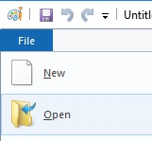

- Go to the Home tab.
Click Rotate.
Click OK. And Save the image.
Please note: Even if the image shows up the right way in Paint, please make sure you still click on the Save button.
