Tip – How do I reopen/recall a statement?

Please note: You can reopen a statement for editing if it has not yet been submitted to the child’s future school.

To re-open a statement:

- Under the first column, press the Reopen button which looks like the image below.
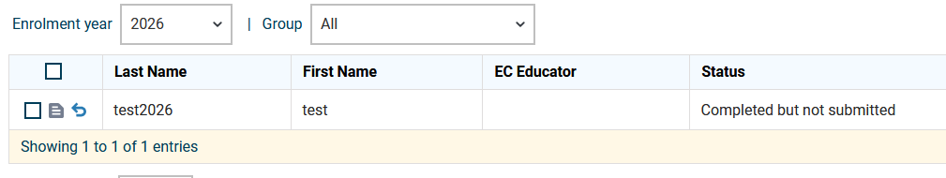

- Click Yes.

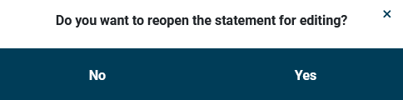

- Click the Edit button to edit the statement again.
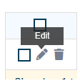

If you have submitted a statement to a school, but realise you need to make further edits, or have sent it to the wrong school, you can recall the statement.

To recall a statement:

- Under the first column, press the Recall button which looks like the image below.

- Enter the reason you are recalling the statement in the box and click Recall.
Please note: The school will be able to see the recall reason entered.

