Tip – Password-protected TLDS

When sending electronic document via email, you need to take the following basic security steps:

1. Password-protect the Word document. To do this, open the word document.
2. Go to “File” tab.
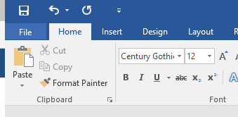

3. Under “Info”, click on “Protect Document” and select “Encrypt with Password”.
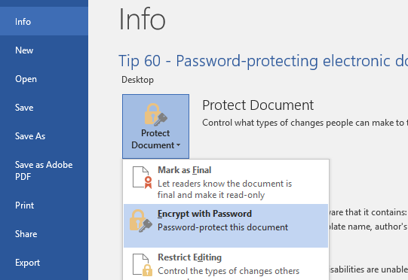

4. Enter the password (use the child’s DOB, DDMMYYYY), then press ‘OK’.
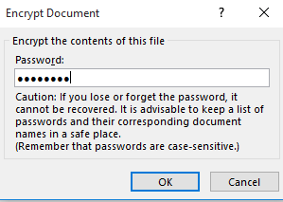

5. Attach the password-protected document to email.
6. Send the password-protected document to the recipient(s) - do not include the password itself in this email. Provide “hint” (in the body of the email, NOT in the Subject field) to remind the parents/school about the password, such as, “Hint: password is Date of Birth of the Child, DDMMYYYY”

Note: Please print out and save your password safely into a folder and make sure it’s kept safely for your future reference. If you forgot or lost your password, there's is NO way of recovering your documents and may have to recreate those documents again.

