Tip – How to navigate to the Online TLDS platform?

- Copy and paste the following URL into your address bar at top left-hand corner of your web browser, and then press Enter:
https://www.vcaa.vic.edu.au/assessment/foundation-10/insight-assessment-platform/vcaa-insight-assessment-platform

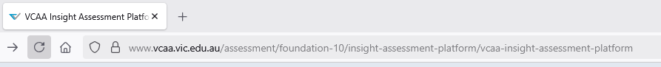

- Make sure you arrive at the VCAA Insight Assessment Platform webpage as below.
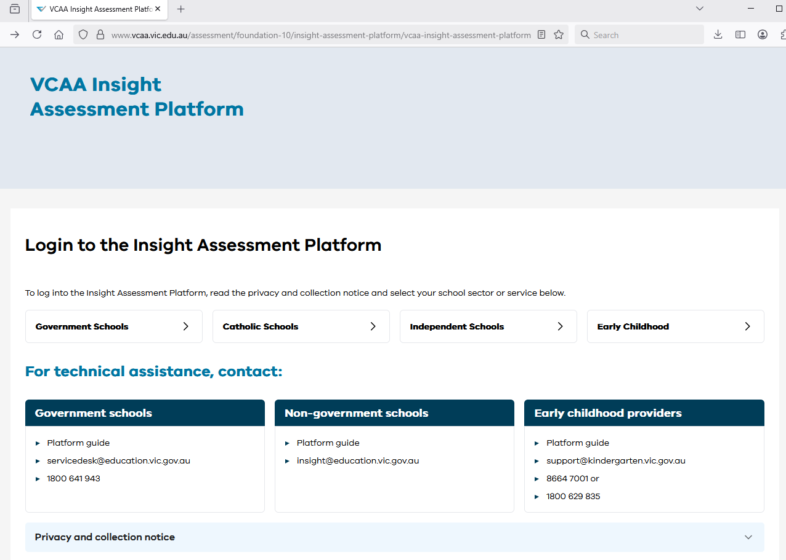

- Scroll down and click on “Early Childhood” at the right-hand side.
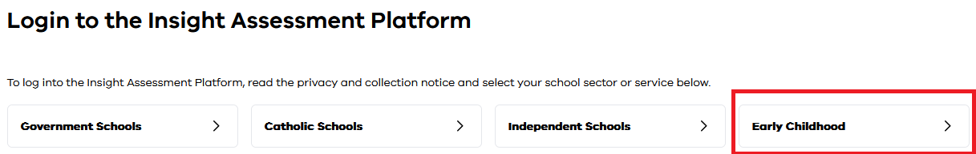

- The link will take you to the login screen for the Online TLDS as shown below.
