Tip – How to navigate to and download the electronic transition statement?

- Copy and paste the following URL into your address bar at top left hand corner of your web browser, and then press Enter:
http://www.education.vic.gov.au/childhood/professionals/learning/Pages/transitionstat.aspx

- Make sure you arrive at “Transition Learning and Development Statement” webpage.
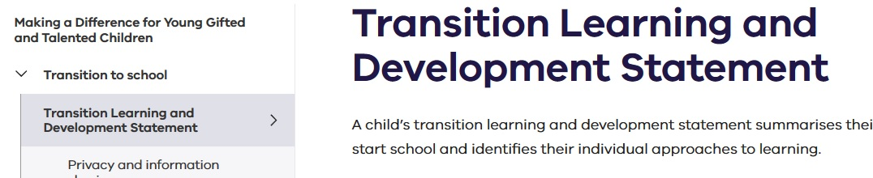

- Scroll down until you find the Electronic Transition Statement. There are two versions:
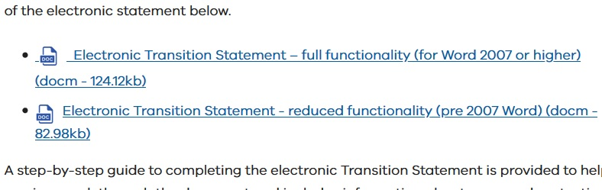

- Click on either Full functionality or Reduced functionality statement according to the software you use. Then, click “Save File” and then OK.
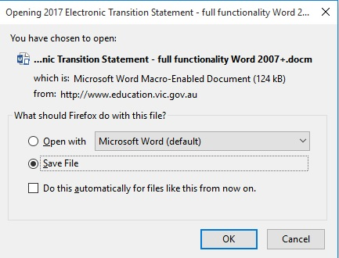

- Browse to your “Downloads” folder and locate the electronic transition statement you just downloaded. Double click to open it.
