Tip – How to reset Online TLDS password?

- If you don’t remember the password to login to Online TLDS, or the password you have does not allow you to login, please check with other staff members first as they might have changed the password.

- If no one knows the correct password. You can reset the password by clicking “Forgot password” on the Online TLDS login page.
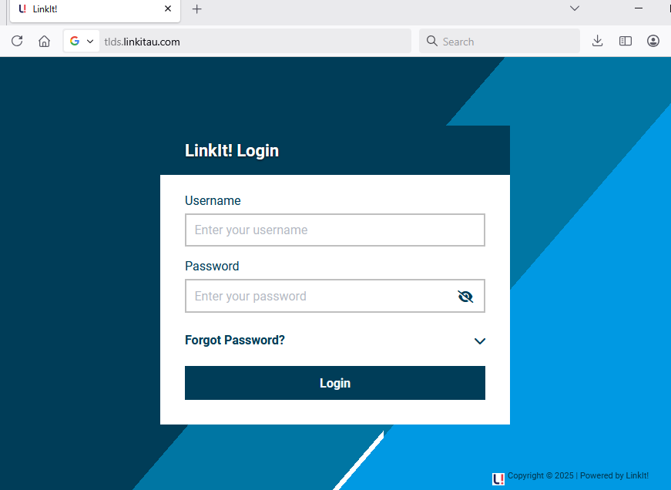

- Enter your username in the following box and click Submit.
Please note: the username is your centre’s SE number. E.g. SE-xxxxxxxx
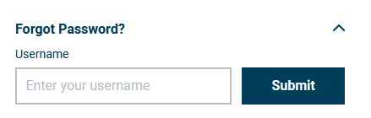

- An email will be sent to your registered service address, as per NQAITS.

Note 1: If you are not sure about what your registered service email address is, you can find the information on Australian Children’s Education & Care Quality Authority’s website. The website address is listed below:
https://www.acecqa.gov.au/resources/national-registers/services?s=&f%5B0%5D=service_state%3AVIC

Note 2: If you want to change/update the service email address, you can go to National Quality Agenda IT System’s (NQAITS) website. The website address is listed below: https://portal.nqaits.gov.au/SignIn?ReturnUrl=%2F
If you are not able to log into the NQAITS portal, we suggest you speak to your service manager or contact NQAITS directly via 1300 307 415 or licensed.childrens.services@edumail.vic.gov.au
The timeframe for updating a service email address will likely be 24-48hrs.

