Guide for educators writing Electronic Transition Statements

Full functionality version - Suitable for Microsoft Word (2007 or later)
This guide is for educators in early childhood education and care (ECEC) services completing Electronic Transition Learning and Development Statements (Electronic Transition Statements).
Further guidance about how to complete Transition Statements, including supporting children and families to complete their sections of the Statement, is provided in the Transition: A Positive Start to School Resource Kit available at www.education.vic.gov.au/transitiontoschool.
Important note on privacy: Educators completing Transition Statements, regardless of the format they are using, are required to adhere with all privacy laws regarding the collection and disclosure of personal and health information, which includes the Transition Statement. Refer to Privacy and information sharing for further information.
Contents
Before you begin using the Electronic Transition Statement 3
Overview of the Electronic Transition Statement 4
USING THE ELECTRONIC TRANSITION STATEMENT 5
How to download the Electronic Transition Statement 5
How to create a file for the individual child’s Transition Statement 5
How to input the Child’s name into the header field 6
Completing Section 1: Child and Service Details 9
Checklist of Transition Statement components 9
Completing Section 1.1 Outcomes and Teaching Strategies 10
About 10
Actions required 11
How to use the pick lists for learning and development outcomes 11
How to undo your selection from the pick lists 12
How to delete pick lists you are not using 13
How to input intentional teaching strategies 13
Completing Section 1.2: Enhanced transitions 14
Completing Section 2: The child and Section 3: The family 15
How to print the Transition Statement 15
How to send the Electronic Transition Statement to the parent/guardian via email 15
When Sections 2 and/or 3 are completed 16
Completing Section 4 17
Sharing the Transition Statement 17
How to print the Transition Statement 18
How to create a PDF version of the Electronic Transition Statement 18
How to send the Electronic Transition Statement via email 19
Troubleshooting 20
Can I exit the Electronic Transition Statement without finishing it? 20
How do I go back into a Transition Statement that I have already started or completed? 20
Why can’t I see the ‘pick lists’ on my Transition Statement? 20
Why can’t I edit the whole Electronic Transition Statement? 20
Where else can I get help? 20
Handy How-to Instructions for functionality 21
How to select a date using the date function 21
How to insert an image or photo to the Transition Statement 21
How to check a checkbox 25
Tips 27
Tip 1 – Save often 27
Tip 2 – Remember you can Undo 27
Tip 3 – You can copy/paste content into text fields 27
Tip 4 - You can password protect a Word file in Microsoft Word 2007 28

Before you begin using the Electronic Transition Statement
Before you begin to use the Electronic Transition Statement, please note and/or check the following:
- Accessing the Electronic Transition Statement: The Electronic Transition Statement can be found at www.education.vic.gov.au/transitionstatement. In order to edit the Electronic Transition Statement, you will need to download/save a copy to your computer. Do this by opening the file you want to download, then go to the File menu and select ‘Save As’, and select where you want to save it and what you want to name the file.

- IT System Requirements: The Electronic Transition Statement has been designed to enable completion on a computer. There are two Electronic Transition Statements to choose from:
  - Electronic Transition Statement - Full functionality for Word 2007 (or later)
  - Electronic Transition Statement - Reduced functionality (for pre 2007 Microsoft Word)
Microsoft Word is required to complete the Electronic Transition Statement. Check your Start/Windows menu on your PC, or via the Apple icon on your Apple Macintosh to see whether Word is installed and which version/year it is to determine which Electronic Transition Statement to use.
- Follow the prompts/instructional text: The Electronic Transition Statement has prompts and instructional text to guide you through completing each section. The document has been protected to restrict editing to the required fields, to make it easier for users to know where they need to provide a response.

- Printing/Scanning documents: You may need to print, scan and upload documents to your computer. If you are unsure how to do this, or do not have the facilities, please make arrangements for someone to support you with this task.

- Attaching photos: You have the option to insert a photo of a child to their Electronic Transition Statement. It will save you time if these photos are already saved onto your computer and easily accessible.

- File naming conventions: It is important to ensure you have a consistent file naming convention for your Electronic Transition Statements. This is to ensure that personal information related to a particular child is protected, meets privacy obligations, and assists document retention. When first downloading the Electronic Transition Statement, it is recommended to rename the file ‘Electronic Transition Statement – Template’. Each individual Transition Statement can then be saved as ‘Transition Statement – Child’s name’.

- Troubleshooting: This User Guide contains instructions on common processes like downloading, completing, and saving your Electronic Transition Statement, plus detail on the functionality of the Electronic Transition Statement. Please read this Guide and follow the steps before requesting further assistance.
For account administration or technical support, please contact the Insight Assessment Platform helpdesk Monday to Friday between 9AM to 5PM by email at: insight@education.vic.gov.au.

Overview of the Electronic Transition Statement
The table below describes each section of the Electronic Transition Statement and who should complete it.
Section | Information collected | To be completed by
Section 1: Child and Service Details | - The child’s details (name, date of birth etc.), parent/guardian details and ECEC service details.  - Contextual information about the ECEC service and specific information related to the child that may be useful for prep teachers to know or may impact on the child’s continuity of learning. | ECEC educator*
Section 1.1 – Outcomes and Teaching Strategies | Descriptions of the child’s learning progress against the VEYLDF Learning and Development Outcomes and the Victorian Curriculum F-2, and specific intentional teaching strategies to support the child’s continuity of learning when they start school. | ECEC educator*
Section 1.2 –  Enhanced Transitions for children with a disability or developmental delay | This section should be completed for children with a disability or developmental delay. It collects additional specific information to support the child’s inclusion and learning at school. | ECEC educator* (in collaboration with other professional/s supporting the child, where applicable, and with parent/guardian permission)
Section 2 – The child | The child’s feelings and perspectives on starting school, including a drawing. This section is optional. | Completed with the child by an adult they know and feel comfortable with (educator or family member)**
Section 3 – The family | The perspective of the parent/guardian(s) on their child’s transition to school, and other information they would like to share. | Parent/guardian(s)**
Section 4 – Sharing the Transition Statement | - A declaration from the educator that the child’s parent/guardian is aware that the Transition Statement will be shared with their child’s school and OSHC service (where applicable)  - A declaration from the educator that the child’s parent/guardian has received the completed Transition Statement  - A record of whether the parent/guardian has chosen to opt out of sharing the Transition Statement with the school and OSHC service (if applicable). | ECEC educator*
*ECEC educators should write Transition Statements in discussion and with input from families, and from other professionals who may be supporting the child during the transition to school (with permission from the parent/guardian).
** Families for whom English is an additional language may require assistance from the educator and/or an interpreter/translator to complete the Child and Family sections, and to understand their choice to opt out of sharing the Transition Statement information.

USING THE ELECTRONIC TRANSITION STATEMENT

How to download the Electronic Transition Statement
Before you start writing Transition Statements, you will need to download the Electronic Transition Statement document to your computer from www.education.vic.gov.au/transitionstatement.
- Click on the Electronic Transition Statement file you want to download.

Result: A pop-up will appear asking if you want to Open the file from www.education.vic.gov.au
Select ‘Yes’ to open the file.

- When the file opens, it will open as a ‘Read Only’ file. To save the file (or download a copy), go to File, then ‘Save As’ and select the destination on your computer where you would like to save your Transition Statements. This is the template you will use to complete all Transition Statements for children at your service, so it is recommended to use the file name ‘Electronic Transition Statement – Template’ when saving.

- Once you’ve named the file, select ‘Save’. The document will now be saved to your computer.

How to create a file for the individual child’s Transition Statement
- Open your saved Electronic Transition Statement template.

- Go to the File menu, select ‘Save As’ and save the file as ‘Transition Statement – Child’s name’. Use the name of the child for whom you are going to start/complete the Electronic Transition Statement. Each child requires their own Transition Statement.

- When you see the file name has updated to reflect ‘Transition Statement – Child’s name’, you can begin completing the Transition Statement for that child.

How to input the Child’s name into the header field
The Electronic Transition Statement has a header that captures the Child’s name. A header appears at the top of each page of the document, and usually contains text or a logo (like letterhead for example). You only need to enter information into the header field once for it to carry through to each page of the document. By adding the child’s name to the header field, every page of the Electronic Transition Statement will display the child’s name. This means there will be no mistaking whose Transition Statement it is, or who the information relates to. The header field is circled below.
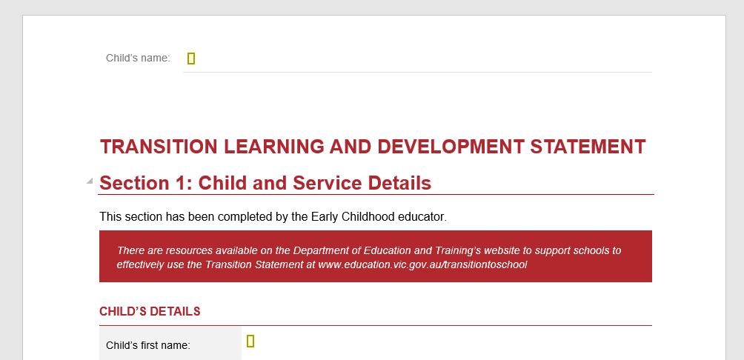
To input the child’s name into the header:
- Double click over the header text (i.e. Child’s name) and you will see the header appear (a grey box appears ‘Header – Section 1’ with a dotted line across the page). The light grey header text will become darker to show the header field is now ready for editing.

Result:
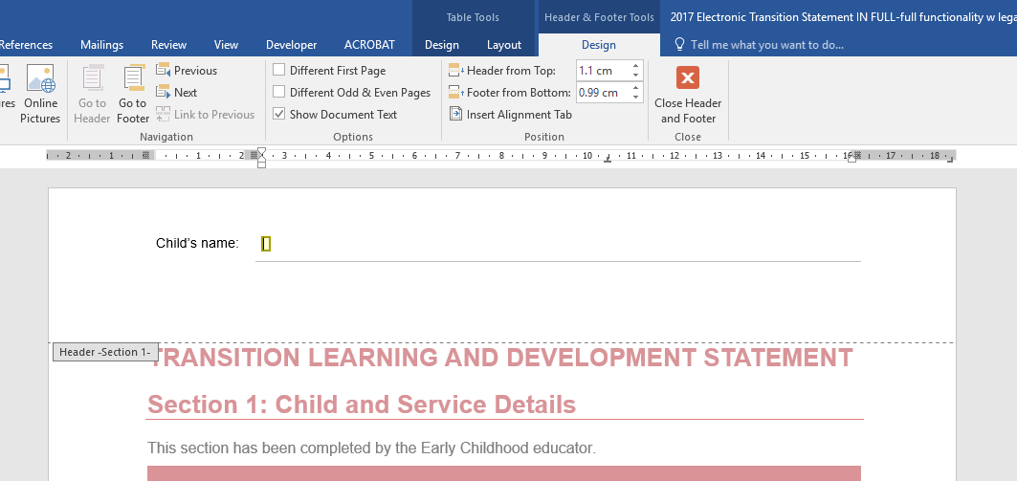

- The Electronic Transition Statement is protected so that only certain fields can be edited (these are highlighted in yellow). Move the cursor or mouse to the field (yellow box) next to ‘Child’s name:’ and enter the child’s name for whom you are completing the Transition Statement.

Result:
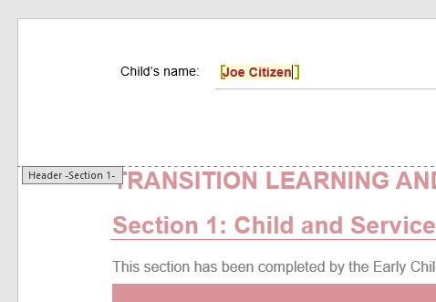

- Once you have entered the child’s name, double click somewhere underneath the great dotted line marked ‘Header – Section 1-‘ and the main body of the Transition Statement will become brighter and ready for you to complete.

Note: The header will become dull in colour as you are no longer editing that part of the page.

Result:

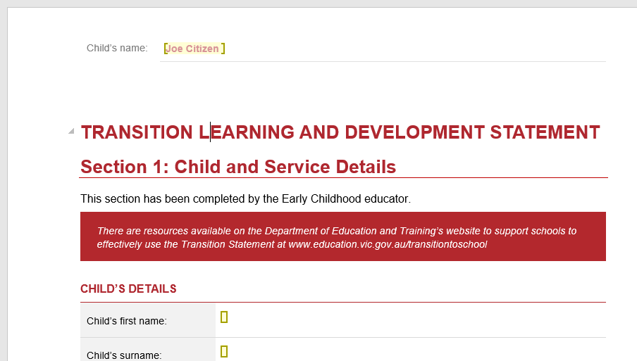

Completing Section 1: Child and Service Details
Section 1 captures details on the child, parent/guardian, and the early childhood service. It also allows educators to record information on the context of the early years setting and specific information about the child.
Throughout the Electronic Transition Statement, enter required information into the marked yellow boxes. Use the mouse or tab key to move the cursor to each yellow box to enter a response.

- Complete all fields in Child’s Details
Ensure Child’s date of birth is correct. The date functionality automatically defaults to today’s date and year, so you need to ensure the correct year is selected in the ‘Child’s date of birth’ field. Refer to How to select a date for instruction.

- Insert the Child’s Photo. Refer to How to insert an image for instruction.

- Complete the contact details for parent/guardian and the early childhood service.

- Follow prompts (light grey instructional text) under the headings ‘Context of early years setting’ and ‘Specific Information’ to complete these fields:

Context of early years setting: enter a description of the ECEC service and learning environment.
Specific Information: include information about the child and their family that may impact on this child’s continuity of learning (i.e. any significant health concerns, allergies, history; language/s spoken at home (including if appropriate Auslan, Aboriginal language); any significant family circumstances; specific positive learning relationships; any disclosed/diagnosed disability or developmental delay (more information can be provided in Section 1.2)).

Note: The ‘specific information’ field is not intended to collect information about the child’s learning and development progress or strategies to support their learning, as this is collected in Section 1.1.

Checklist of Transition Statement components
The final part of Section 1 is a checklist to identify which sections of this child’s Transition Statement are complete. The checklist outlines which sections are mandatory, and requires you to check/mark each checkbox as each section is completed. This not only shows you which sections of the Transition Statement are outstanding, but also allows the receiving teacher to know which sections of the Transition Statement they will be receiving for this child (i.e. if Section 1.2 has been completed indicating that the child requires an enhanced transition, or if Section 3: The family has been completed and returned).
- Check/mark the relevant checkboxes to indicate which sections have been completed. Refer to How to Check a Checkbox for instruction.
Note: you should only check the checkbox once you have completed each section. The first checkbox sits against Section 1 and Section 1.1, therefore should only be checked after both of these sections have been completed.

Completing Section 1.1 Outcomes and Teaching Strategies

About
Section 1.1 is the main body of the Transition Statement. This section provides both a short summary of the child’s learning and development, along with helpful strategies that can support the receiving teacher to plan curriculum, the environment and get to know what works best for this child’s learning style.
For each Outcome (Identity, Community, Wellbeing, Learning, and Communication), you will need to provide a description of the child’s learning progress, as well a suggested intentional teaching strategy to support the child’s continuity of learning when they start school. Try to make these as specific and concise as you can, to ensure that they are easy for the receiving teacher to use to inform their planning.
To make this easier, ‘pick lists’ of learning and development descriptors drawn from the VEYLDF and the first three levels of the Victorian Curriculum have been provided.
Under each outcome you will see a number of ‘pick lists’ (that act as drop down menus) relating to different aspects of that Outcome. For example, under the ‘IDENTITY’ Outcome there are seven pick lists relating to seven different aspects of Identity. The pick lists Attachment – engagement and Attachment – communication have been circled below to demonstrate what the pick list looks like.
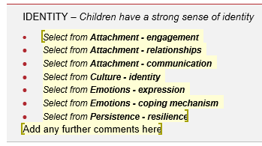
Each pick list contains three or more learning and development descriptors that you can select from to describe the child’s learning progress.
For example, the Attachment – engagement pick list has three descriptors to choose from:
- Is able to confidently explore and engage with familiar and new social and physical environments.
- Is able to confidently explore and engage with familiar environments, however requires some support to explore and engage with new social and physical environments.
- Requires adult support to explore and engage and develop confidence with familiar and new social and physical environments

Actions required

- You must select at least one descriptor for each Outcome (for example, at least one descriptor from one of the picklists under ‘Identity’).
- You can only select one descriptor per pick list (for example, one descriptor under ‘Attachment - engagement’).
- You do not need to select a descriptor under every pick list.
- It is recommended that you select between 2 and 5 descriptors in total for each Outcome. Only select those that you think are most important to communicate to the receiving teacher in order for them to ensure continuity of learning and development for the child.

How to use the pick lists for learning and development outcomes
- To view the ‘pick list’ of descriptors, click onto the title of the pick list (i.e. Select from Attachment - engagement). A grey box will appear around the title of the ‘pick list’ and an arrow will appear to the right of the title.
Result:
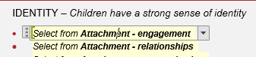

- Click the arrow to the right of the ‘pick list’ title to view the descriptors you can select from for this aspect of the Outcome.

- Click the descriptor that best applies to this child.

- Once you have made your selection, the descriptor you selected will replace the ‘pick list’ for that Outcome.
Result:
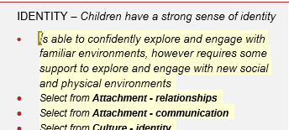

- Click on the text to edit the descriptors or add additional information. For example, input the child’s name or other information to personalise that statement.
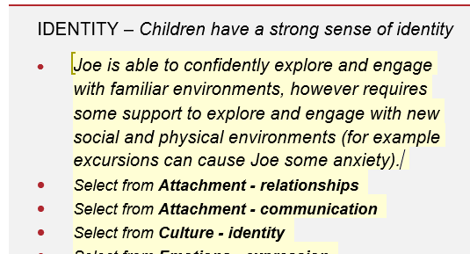

How to undo your selection from the pick lists
If you want to undo your selection from the pick list, you can select the undo arrow from the top menu, or press the ‘Ctrl’ and the ‘Z’ key simultaneously.
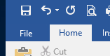 OR 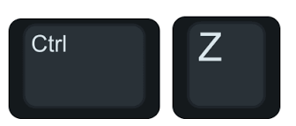

Note: These Undo commands will work to undo any changes you have made to the document, however not after selecting ‘Save’ or ‘Save As’ – as the save function creates the latest version of the document from which you can’t undo (and you can’t undo the ‘Save’ action).

How to delete pick lists you are not using
It is recommended that you select between 2 and 5 descriptors in total for each Outcome. Only select those that you think are most important to communicate to the receiving teacher in order for them to ensure continuity of learning and development for the child.
As you do not need to select a descriptor under every pick list, you can delete those pick lists you don’t want. To delete unnecessary pick lists:
- Select the text with your mouse so that it becomes highlighted (dark grey):
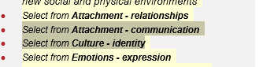
- Once text is highlighted, right click on the mouse to select 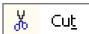, or use the keyboard by pressing 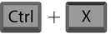

Result: The pick lists you are not using will then be removed.
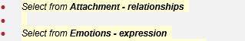

How to input intentional teaching strategies
- For each outcome, click in the right-hand column where indicated by the yellow box to enter one or more intentional teaching strategies that have worked well with the child and are likely to support their continued learning progress when they start school. Try to keep these concise and specific where possible. A minimum of one intentional teaching strategy is required per outcome.
Repeat making a selection from the pick list of learning and development outcomes and entering free text intentional teaching strategies for each of the five Outcomes (Identity, Community, Wellbeing, Learning and Communication).

Completing Section 1.2: Enhanced transitions
Section 1.2 captures information to support enhanced transitions for a child with a disability or developmental delay. It includes details of early childhood professionals supporting the child and family, and lists reports or assessments that have been undertaken and are available to support early inclusion planning.
- It is recommended that Section 1.2 be completed for a child with a disability or developmental delay.
- A child does not have to have a diagnosis for Section 1.2 to be completed by the educator, but you should discuss with the parents/guardians how this section will help their child settle into school.
- Section 1.2 should be completed by the ECEC educator but specialist early childhood professionals can contribute information (with parent/guardian permission).
- You can skip section 1.2 (leave blank) if the child does not require an enhanced transition.
- Enter the details of any specialist early childhood professional supporting this child and family through the transition to school. This may be an early childhood intervention professional, key worker, or transition support coordinator.

- Enter the details of any additional specialised professionals supporting the child. Check the ‘Report available’ check box to indicate if there are any reports from this professional that may support the child’s transition and inclusion at school. See How to check a checkbox for instruction.
Note: If there is insufficient room to capture the details of multiple specialist early childhood professionals engaged to support the child, these should be recorded in a separate document and attached to the Transition Statement when it is shared with the school or OSHC service (if applicable).
- Under ‘Additional information to support the child’s inclusion at school’, you can include more specific areas of note and strategies for inclusion support that relate to the child’s disability or developmental delay.

- Under ‘Other reports/plans available’ you can list any reports that haven’t been previously mentioned, the date of the report (see How to select a date for instruction), and note whether they will be provided to the school.

- Under ‘Early ABLES reports’ you can indicate if an Early ABLES assessment has been completed for the child, when it was completed, and if it is available on request. If an Early ABLES report has been completed for the child, indicate whether the report is the first report or the second report by completing the relevant date field.

- Click ‘Save’ and proceed to the next section.

Completing Section 2: The child and Section 3: The family
Section 2 is to be completed by/with the child (supported by an adult with whom the child feels comfortable)
Section 3 is to be completed by the parent/guardian(s) of the child, with support from the ECEC educator if required. These sections can be:
- printed out and provided to the parent/guardian(s) to complete in hard copy, along with a copy of Sections 1, 1.1 and 1.2 (if applicable)
- sent via email to the parent/guardian for them to complete on computer

How to print the Transition Statement
- Ensure the details you have already entered into the Transition Statement are saved.

- Go to File and select ‘Print’. Depending on your printer you may be able to select certain printing options, such as double sided printing, or select the pages for printing (i.e. if you did not complete section 1.2, you don’t need to print those pages for the parents).

- Give a hard copy to the parent/guardian(s) and explain the significance of the Transition Statement and the valuable contribution they can make to sections 2 (with their child) and section 3.

How to send the Electronic Transition Statement to the parent/guardian via email
- Save the Transition Statement you have been editing and then close the file.

- Open your email account and start a new email to the parents.

- Within your email, go to the ‘Attach document’ button (usually a paper clip icon).

- An attach document directory window will pop up. Navigate to where the Transition Statement for that child is saved and select the file to attach to the email. Click ‘Attach’ or ‘Insert’ to attach the file to your email.

Note: This will attach an editable version of the document, meaning that parents can view (but also edit) any information you have put into the file. This will not override your file, as you will still have the original saved on your computer. It will require you to direct parents specifically to edit Section 2 (if you want them to complete it with the child) and Section 3, and request that they do not edit any other fields.
If parents/guardians have any issues viewing or completing the document electronically, this may be due to compatibility issues (using different computer systems). In these cases, it is best to print out the statement and provide the family with a hard copy to complete.

When Sections 2 and/or 3 are completed
Remember to update the relevant checkboxes in Section 1 of the child’s Transition Statement to indicate which sections have been completed and will make up the Transition Statement. This will advise the receiving teacher of which sections of the Transition Statement they should have for that child.
If Sections 2 and/or 3 have been completed in hard copy:
- Scan these sections and save the PDF file to your computer. Ensure that you name the PDF file appropriately to ensure that you can accurately identify which child the PDF relates to.

If Sections 2 and/or 3 have been completed electronically:
- Compare your original file with the returned document the family has provided to ensure your inputs in Sections 1 and 1.1 have not been edited. If your inputs haven’t been changed by the family, you can override your copy of this child’s transition statement with theirs, or alternatively you can copy and paste their answers from Sections 2 and/or 3 across to your original file.

- Click ‘Save’.
If Sections 2 and/or 3 have not completed:
- Work with the child to complete Section 2: The child as part of their program in the early years setting.

- Follow up with the family to see if you are able to assist them complete this section, or obtain responses that are representative of the family perspective.

- Update the checkboxes in Section 1 to reflect which Sections are now complete and will be components of the completed Transition Statement to be passed onto the school.

Remember: Section 2 and Section 3 of the Transition Statement are optional for the child and family to complete. Encourage completion, and if required, work together with the child and family to complete these sections. If they are not completed or returned, even with assistance offered, they will just not form part of the completed Transition Statement.

Completing Section 4
- Complete Section 4 of the Transition Statement to acknowledge that you informed the parent/guardian of the Transition Statement being shared, and provided them with a hard copy of the completed Transition Statement. See How to check a checkbox for instruction.

- If the parent/guardian has opted out of sharing the Transition Statement, check the relevant checkbox in the For Service Use Only line:

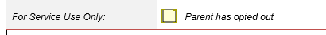
If the parent/guardian opts out of sharing the Transition Statement, this means that you:
- are not able to provide it the Transition Statement to the school or OSHC service
- must provide a copy of the Transition Statement to the parent/guardian only.
It is then the parent/guardian responsibility to share it with the school if they choose to.

Sharing the Transition Statement
The Transition Statement can be shared either in hard copy or electronically. It is important to remember that it is only shared with the family, who receive a completed copy of the statement in their preferred format (hard copy or electronic), and with the receiving school or OSHC service (if applicable) if the parent/guardian has NOT opted out of the Transition Statement being shared.
Important note on privacy: Educators completing Transition Statements, regardless of the format they are using, are required to adhere with all privacy laws regarding the collection and disclosure of personal and health information, which includes the Transition Statement. Refer to Privacy and information sharing for further information.

How to print the Transition Statement
- Ensure the details you have already entered into the Transition Statement are saved.
- Go to File menu and select Print. Depending on your printer you may be able to select certain printing options, such as double sided printing, or select the pages for printing (i.e. if you did not complete section 1.2, you don’t need to print those pages).

- Provide a hard copy to the parent/guardian(s).

- Assuming the parent/guardian has not opted out of sharing the statement with the receiving school, provide a hard copy to the receiving school and to the OSHC service (if applicable).

How to create a PDF version of the Electronic Transition Statement
Once the Electronic Transition Statement is complete, it is recommended to save the file as a PDF prior to sending via email. This will ensure no further changes can be made to the finalised Transition Statement, and makes it easier for those receiving it to navigate the document.
To create a PDF:
- Go to File menu and select Save As, and select a location to save your PDF Transition Statement. It would make sense to save it in the same location as the Word version for this child.

- When the Save As window pops up, select the location for saving, check that the file name is the same as your Word version. In the ‘Save As Type’ field (below the file name) use the right hand arrow to dropdown the list.

- Select PDF from the ‘Save As Type’ drop down list:
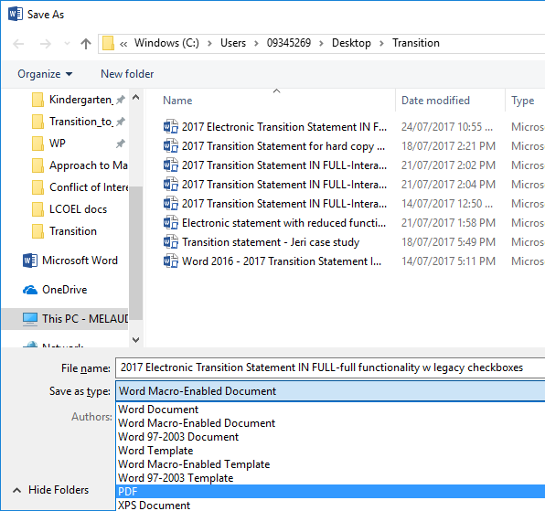

- Select Save.
Note: When you hit ‘Save’, your computer will create the PDF of the Transition Statement. Depending on your computer settings, the PDF will usually open automatically, so you can see that all of the information is there and displaying correctly. If you notice that something is wrong, you will still have your Word version open, or saved, that you can amend before creating the PDF again.

How to send the Electronic Transition Statement via email
- Password protect the Transition Statement you have been editing and then close the file.

- Open your email account and start a new email to the parents or school.

- Within your email, go to the ‘Attach document’ button (usually a paper clip icon).

- An attach document directory window will pop up. Navigate to where the Transition Statement for that child is saved and select the file to attach to the email. Click ‘Attach’ or ‘Insert’ to attach the file to your email.

Troubleshooting

Can I exit the Electronic Transition Statement without finishing it?
Yes, you can exit the Electronic Transition Statement without finishing it at any time, and if you have made any changes then Microsoft Word should remind you to save the file prior to exiting/closing the file. Select the ‘Save’ button if you do not want to lose any changes you have made.

How do I go back into a Transition Statement that I have already started or completed?
Open the file from where you saved it on your computer.

Why can’t I see the ‘pick lists’ on my Transition Statement?
The pick list functionality only works on more recent versions of Microsoft Word. If you cannot see the pick lists, you should use the ‘Reduced Functionality’ version of the Electronic Transition Statement, which allows you to copy and paste outcome descriptors from a separate pick list, rather than select them from a drop down menu.

Why can’t I edit the whole Electronic Transition Statement?
The Electronic Transition Statement has restricted editing permissions on it, so that users don’t accidentally change the key information (titles and instructions) in the form. Anything that is marked in a yellow box can be edited either by directly typing into the box, by copying and pasting text into the box, or by selecting an option from the icon already there (i.e. check box, date or the drop-down picklist).

Where else can I get help?
Refer to the Handy How-to Instructions for guidance on the functionality of this document. Refer to the Tips for assistance on how to save, undo, copy and paste into your document. Microsoft Word itself has a Help function that might be useful to you, otherwise further IT support is available through State Library Victoria (details below).
For account administration or technical support, please contact the Insight Assessment Platform helpdesk Monday to Friday between 9AM to 5PM by email at: insight@education.vic.gov.au.

Handy How-to Instructions for functionality
The Electronic Transition Statement includes some new functionality to streamline the form and make it easier for users. The following ‘How to’ guides will assist you in familiarising yourself with common functions of the Electronic Transition Statement:
- How to select a date using the date function
- How to insert an image or photo
- How to check a checkbox

How to select a date using the date function
Throughout the Electronic Transition Statement there are a number of date fields that are required where you will see the field displaying:
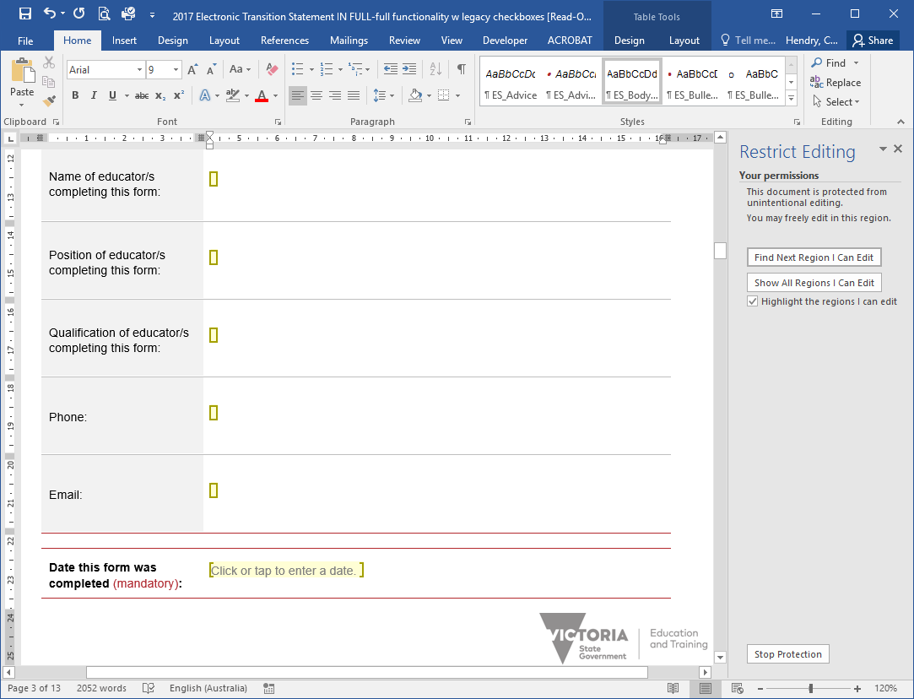
To select a date:
- As per the prompt, click on the yellow box so that it becomes selected (goes light grey):
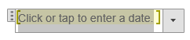

- Select the arrow to drop down the mini calendar and select the relevant date. This function will default to today’s date, so be sure to scroll through to the correct month and year for the date required.
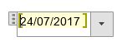
Note: Once a date is selected, you can edit it by typing the numbers directly into the field, or by using the dropdown calendar again.

How to insert an image or photo to the Transition Statement
Note: In order to insert an image to the Transition Statement, it will need to be saved as an electronic file in your system.
- To insert an image, click into the yellow box in the centre of the field where you want the image to be so the cursor appears there:
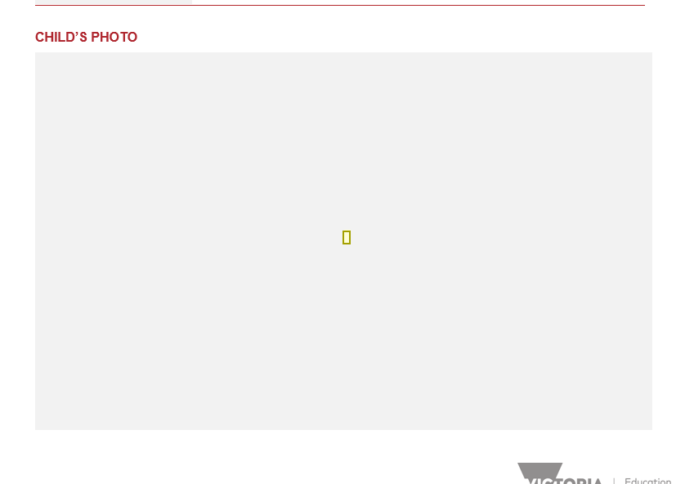

- Go to the menu bar at the top of the page and select ‘Insert’ then ‘Pictures’:

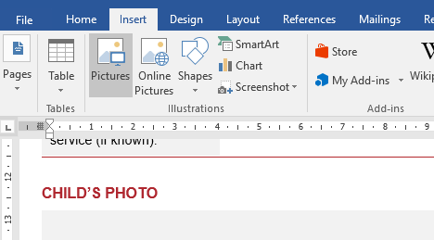

Result: The ‘Insert Picture’ window will appear so you can select the image/photo from where it is saved on your computer:

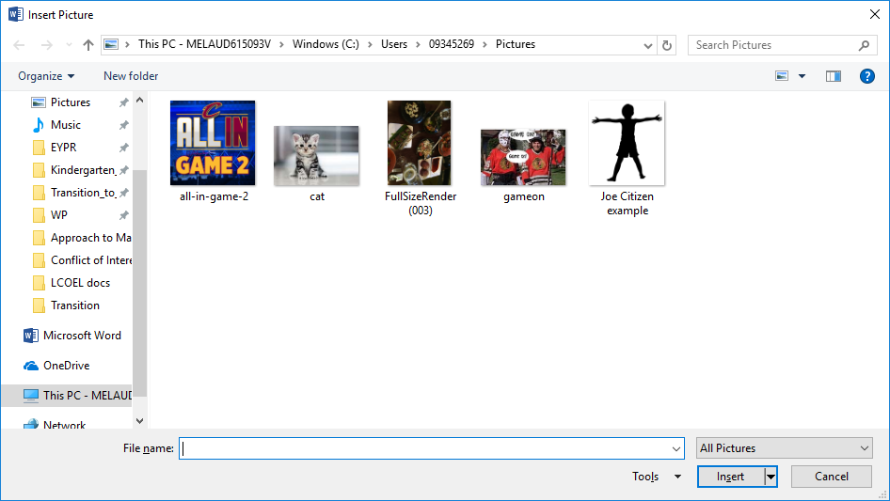

- Locate the image/photo on your computer, select it by clicking on it once and then click on the ‘Insert’ button (as marked below). Note: when you select the image, the file name will automatically populate into the File name field at the bottom of the window.
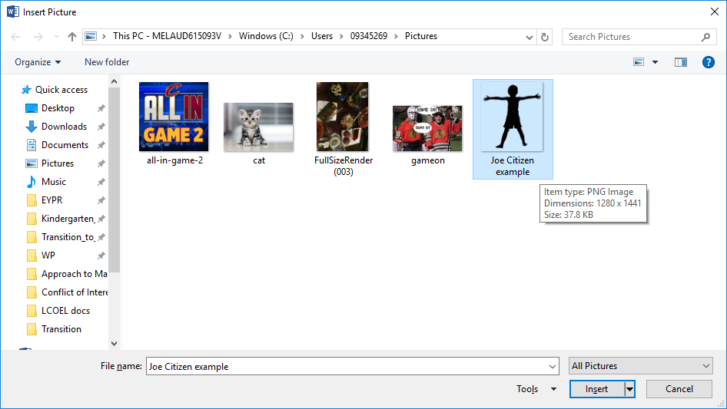

Result: Your image/photo will be inserted into the Transition Statement form.

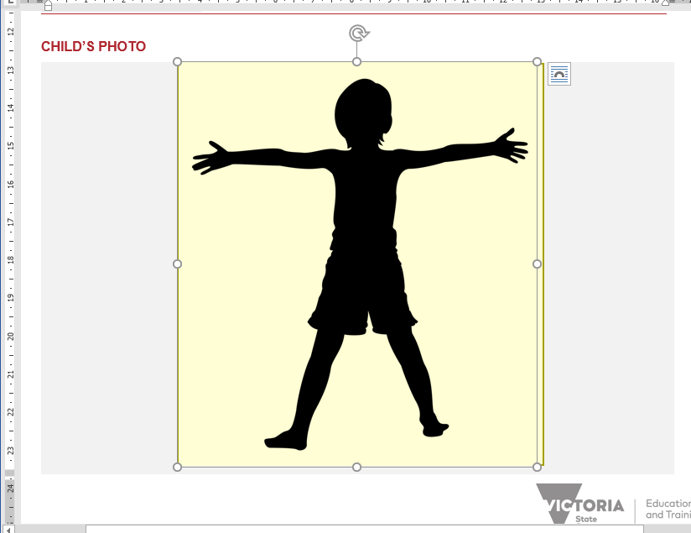
Note: An alternate method of inserting an image is to ‘cut’ of ‘copy’ the image from somewhere else and ‘paste’ it into the box.
- To reduce, enlarge or rotate your image, click once on it (to select) and use the corner dot (circled below) to adjust the size, or the circled arrow at the top of the image to rotate it. Small arrows will appear when you use the dots to adjust the size.
Result:
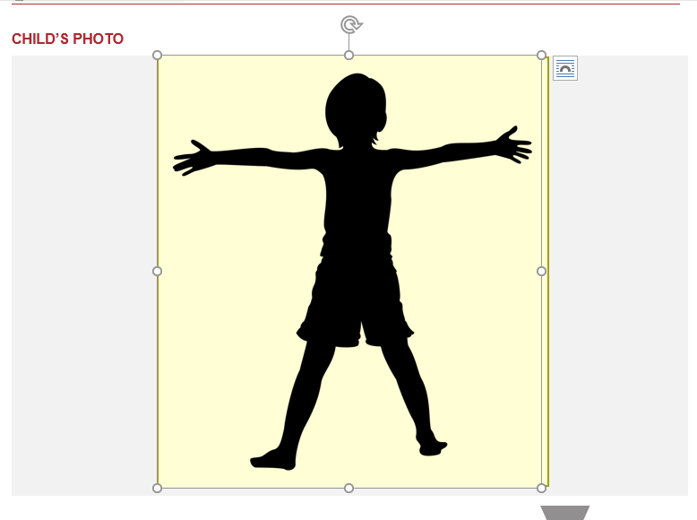
Note: Depending on the size of the image selected, it may be pushed onto a new page. Resize the image using the corner dots (circled above) to reduce its size so that it fits into the designated space.

How to check a checkbox
Throughout the Electronic Transition Statement there are a number of checkboxes that require your response. These are indicators to yes/no questions, or to acknowledge that certain actions have been taken (such as Sections completed, or parents informed).
To check a checkbox:
- Double click in the centre of the checkbox square:
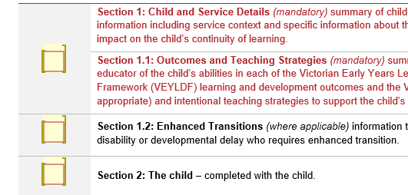
Result: This will bring up a ‘Check Box Form Field Options’ window. You will see that the default value of the checkbox is ‘Not checked’.
- Select the button next to ‘Checked’ to mark the checkbox.
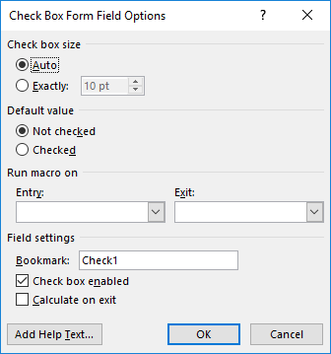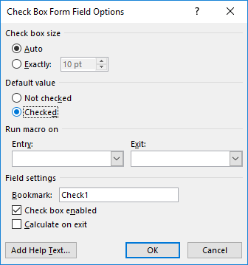

Result: Your checkbox will now be ‘Checked’, showing a cross mark in the checkbox.
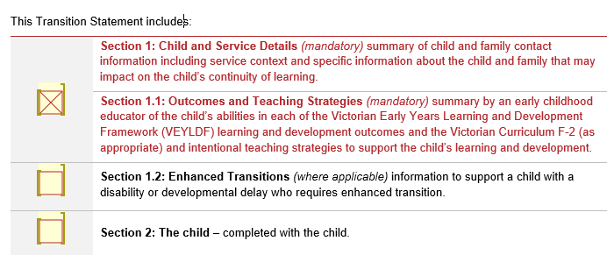

Note: To ‘uncheck’ the checkbox, follow the same process as above, but change the Default value from ‘Checked’ to ‘Not checked’

Tips

Tip 1 – Save often
It’s a good idea to save often as you are writing your Transition Statements. This is particularly helpful when you are completing Section 1.1 where you are selecting and editing learning and development descriptors, and writing intentional teaching strategies.

The ‘Save’ button is located under the File menu, but there are also two shortcuts you can use:

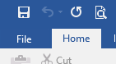 OR 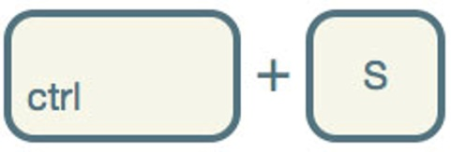

Tip 2 – Remember you can undo
If you want to undo something that you’ve just done in your document (before you hit save) you can select the undo arrow from the top menu, or press the ‘Ctrl’ and the ‘Z’ key simultaneously.
OR

Tip 3 – You can copy/paste content into text fields
If you want to copy some existing text into your Transition Document, you can do so into the yellow boxes that outline where you have permission to enter text.
To copy text:
- Select the text you want to copy with your mouse or cursor, so that it is highlighted light grey:
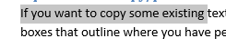
- Once selected, right click and select ‘Copy’, or hit Ctrl C on your keyboard.
To paste text:
- Move the cursor to where you want to paste the text. In the Electronic Transition Statement this will be a yellow box.
- Click inside the yellow box and then right click and select ‘Paste’, or hit Ctrl V on your keyboard.

Tip 4 - You can password protect a Word file in Microsoft Word 2007
- Click the ‘Office’ button in the top left hand corner of the screen.
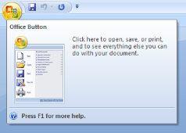
- Select ‘Prepare’
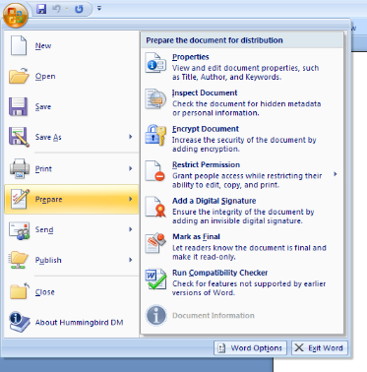
- Select ‘Encrypt Document’
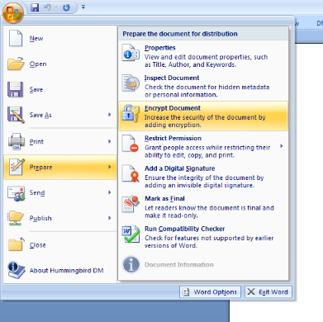
- Enter your chosen Password. It is recommended to use a password that you and the recipient will know or understand.

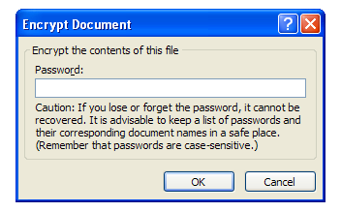
Document is now password protected.

To complete the process:
- Send the password you have set to the recipient in an email for the purpose of opening the document
- Attach the Electronic Transition Statement to a separate email
- Send the Electronic Transition Statement to the recipient - do not include the password in this email.

