Tip – Section 2 and 3 (For teachers)

The Online TLDS platform has a function in Section 2 and 3 which allows you to create a link for the parents to complete Section 2 and 3 of the statement online too.

- You will find this “Create Links for Section 2 & 3” area AFTER you complete Section 1. Click Create New Link.
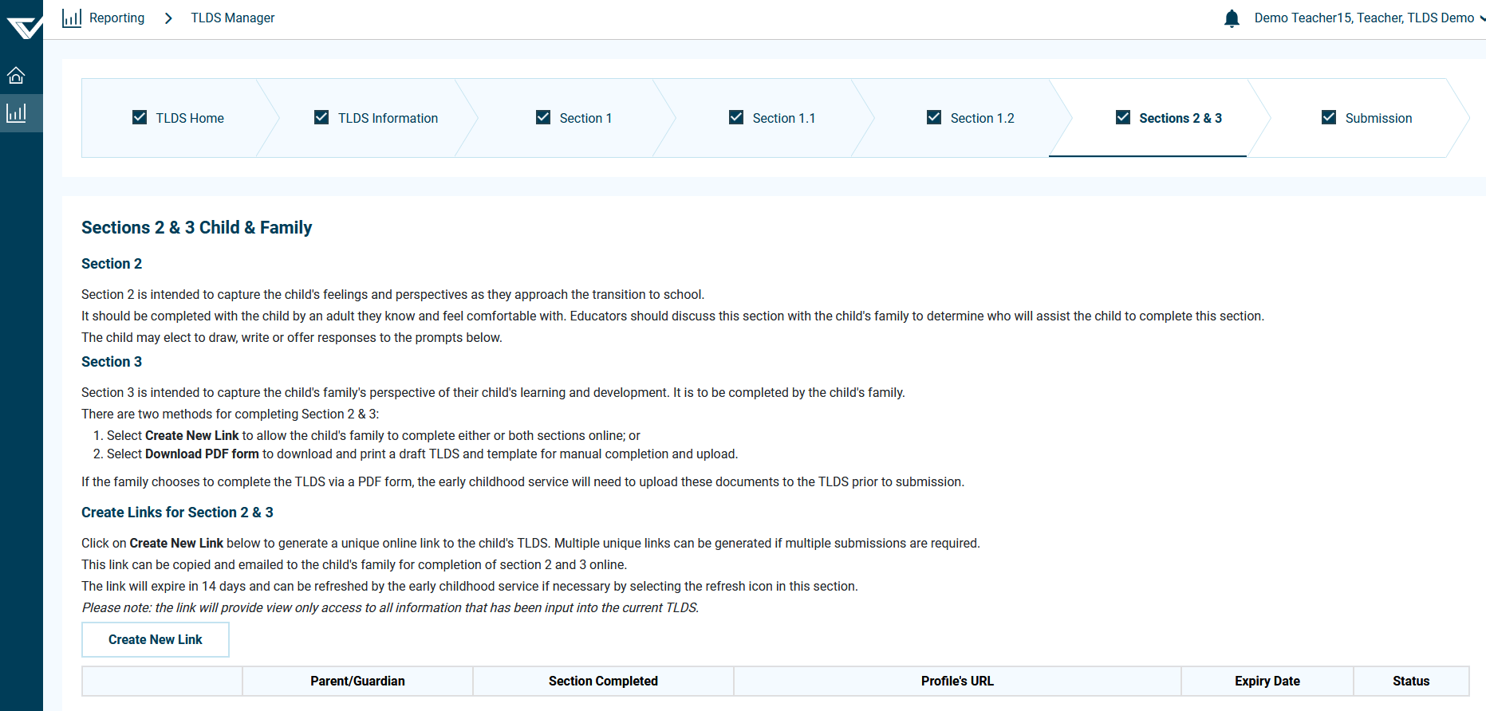

- A hyperlink will be created which looks like the image below.

- You can click on the LINK icon in front of the hyperlink to copy the link to clipboard. Or click the link in Step 2 and a new tab should open up in your web browser. Copy and paste the link/URL in an email and send it to the child’s parents.
Note 1: Each link is specific to the child whose TLDS you are writing, and parents will need to enter their child’s date of birth in order to view their child’s TLDS and complete sections 2 and 3.
Note 2: Multiple links can be created for the one child, if it needs to go to multiple parents, noting that this will mean duplication of some sections (i.e. there will be two copies of section 3 if Mum and Dad complete one each).

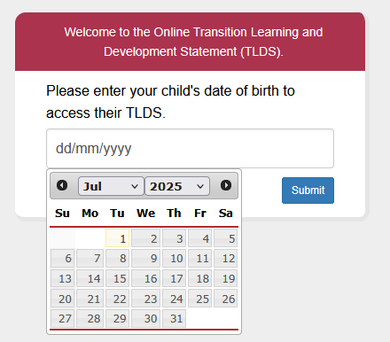

- If the parents do not complete Section 2 and 3 before the expiry date or they have entered their child’s DOB incorrectly 3 times, the status of the link in Step 2 will be expired or deactivated like the images below. You can click the Activate icon to re-activate the link.

The icons under this section are:
Activate: activate Section 2 and 3 hyperlink
Deactivate: deactivate Section 2 and 3 hyperlink
Refresh: extend the “Expiry Date” for another 14 days
View: view Section 2 and 3
Delete: delete the Section 2 and 3 hyperlink and all the content

- Click Yes to re-activate the link in Step 2.
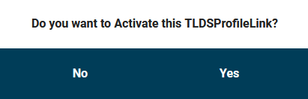

- Once the parents complete the statement. The status will be changed to Completed like the images below.

