
Time to say goodbye – helping your child manage separations
Issue No. 025

From birth, your child’s life is full of transitions. The key to successful transitions is that children need to feel safe, confident and supported and informed.
If your child uses an early childhood education and care service, they go through a transition each time they say goodbye to you in the morning and goodbye to their educator in the afternoon.
The younger your child, the more important it is to handle separations with care and sensitivity so that your child feels secure.

Each child will experience separation in different ways
A child who attends a service once a week may take longer to become comfortable in a new environment than the child who attends five days a week. A child’s temperament or age may affect how they manage your leaving and returning.
Each child deals with separations in their own way and in their own time – there is no universal pattern. On Monday your child might be happy to be left at family day care. On Friday they might be in tears. Be prepared for surprises. There is probably a sound reason for the change in behaviour, but you won’t always be able to work it out!

Time to say goodbye . . . what can you do?
- If your child attends a setting with more than one educator, try to leave your child with the same person each time. This is especially important for babies so they can form a new attachment to a key educator.
- Discuss in advance with the educator what they can do to comfort your child as you leave. If you are leaving your child, wherever possible an educator should be with your child as you leave. This is especially important for children under 3. Most services have procedures and orientation programs for you and your child, so that everyone can begin to get to know each other.
- Help your child to be comfortable in their new environment by checking what the service induction policy is so that you and your child are prepared. At first, your child may wish you to spend time with them and the educator. Gradually, you can move from playing to watching. This gives the educator time to begin forming a relationship with your child with the security of you being there.
- If you can, start with short separations. This is especially important for babies. As your child develops a stronger relationship with the educator and learns that you always come back when you say you will, you can extend the time.
- Work out a parting routine. This might include a small ritual like giving three kisses and three hugs. Or you might read one story, give a hug and wave through the window.
- A favourite toy can be a useful ‘bridge’ between your child’s two worlds. So can a photo of a family pet, or a photo of you.
- Don’t sneak away! Always say goodbye to your child. Tell your child when you’ll be back and then leave. It’s tempting to check that your child is okay by going back. But each time you return and then leave, your child has to deal with another separation.
- Remember children are not “putting it on” to make you feel guilty, their experience of separation is genuine and unique to them. Educators can provide you with an update via phone or email about how your child has settled after a particularly difficult separation.
- Ask if you can have photos of your child’s educator at home. Speak warmly about them between visits.
- Ask your child’s educator for support and advice if your child is struggling with separation anxiety.


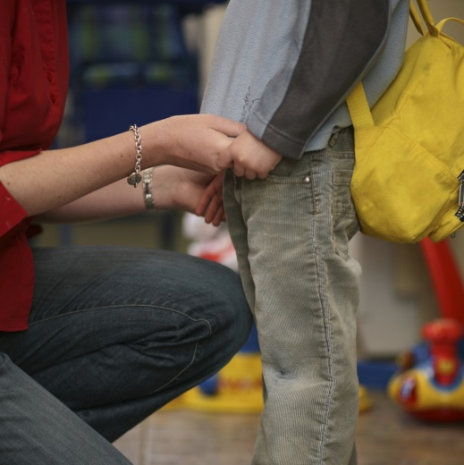
Related links
- Enrolling and starting child care
- Kids Matter’s Being apart
- Raising Children’s Child care: planning, preparing, settling in
- Raising Children’s Handling transitions

- Secure Transitions: Supporting children to feel secure, confident and included. (ECA publication)

You may also like to read
You may also like to read other titles in this series:
- Partnerships: working together
- Courageous conversations: talking to your child’s educator
Other related newsletters can be found at www.education.vic.gov.au

