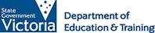
What does high-quality early childhood education and care look like?
Issue No. 022
The following information can be used by families choosing an early childhood education and care service for the first time, or by families who are already using a service.
Early childhood education and care settings include family day care, long day care, kindergarten and occasional care.

High quality early childhood education and care has many features, but three are critical:
- It is based on a genuine partnership between you and your child’s educator. Both you and the educator must be able to work with each other to support your child’s learning.
- It allows children time to learn through play – to explore and take part in a variety of learning experiences.
- It supports all aspects of your child’s learning and development – identity, community, wellbeing, learning and communication.

Always visit in person
- Visit more than one service if you can. Don’t just rely on what other families say. Your child is unique and all families are different.
- Make sure the service is an approved service and there is a service approval displayed.
- Do you feel welcome? Are the educators asking questions about your child and your family? Do they talk to your child? Are they interested in your questions and concerns?
- Are the educators warm and responsive when interacting with the children in their care? Do they ask the children open-ended questions? Do they listen to the children?
- Look at the children playing. Do they have a choice of fun and challenging learning opportunities? Is there space for the children to play with others or alone? Are there spaces where children can go to be quiet?
- What does the physical environment tell you? Does the environment appear to reflect the lives and cultures of the children who use the service? Is there a diversity of artwork where children have clearly been encouraged to make their own decisions about what to draw or paint?
- Are the outdoor and indoor spaces welcoming and suitable for children? Are the buildings, furniture, equipment and resources safe and well maintained?

Ask lots of questions!
- What is their rating against the National Quality Standard? Is the rating displayed?
- How long have staff been at the service? A quality program will offer a consistent, caring relationship between staff and your child. If there is a high turnover of staff or high numbers of relief staff, ask why.
- How will the educators work with you as partners in your child’s learning?
- How will they include your child’s interests in the broader educational program? How will they tell you about your child’s progress? Ask them to describe the educational program.
- What behaviour do they expect from the children? What expectations do they have of the children? How do they encourage positive behaviour?
- What qualifications do the staff have? How many staff to children are there? Is this higher than the minimum requirements? Services will have early childhood teachers and educators who either have an approved diploma level early childhood education and care qualification (or are working towards one) and all other educators must have a Certificate III level Early Childhood education and Care qualification.
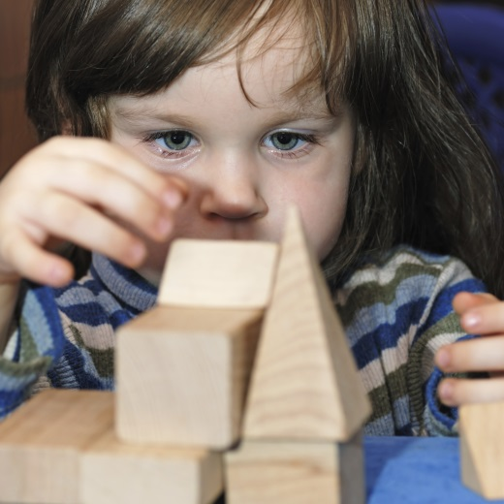
- How will the service support orientation and inclusion for you and your child?

How important is this rating under the National Quality Standard?
Services are assessed for quality under the National Quality Standard. Each service is rated as significant improvement required, working toward, meeting or exceeding the National Quality Standard. All services are encouraged to keep improving.
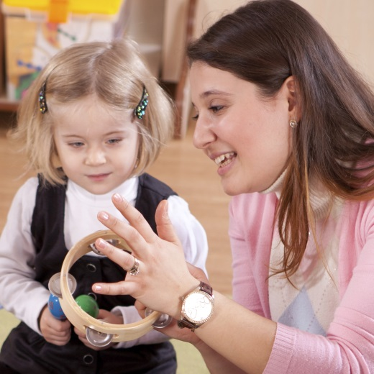
The quality areas are: Educational Program and Practice, Health and Safety, Facilities, Staffing, Relationships, Collaboration, Leadership and Management. The ratings will give you useful information about your child’s service: what they do well and what they are trying to improve. But remember a service can be ‘working toward’ or ‘meeting’ the Standard and still offer a quality program. Please see the rating as one part of a bigger picture.

Related links
- The National Quality Standard
- National Quality Framework
- My Child
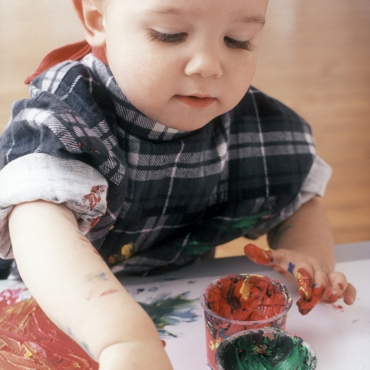

You may also like to read
You may also like to read other titles in this series:
- Partnerships: working together
Other related newsletters can be found at www.education.vic.gov.au

