
Having conversations with your child
Issue No. 018

We talk to our children every day. We give them instructions, ask them questions – even tell them stories.
But a conversation is a special way of talking. It’s a two-way exchange. Your child says something and you listen. You respond and they listen. You pause to give them time to respond. And so it goes on in a serve and return pattern.
Conversations can be serious (about problems or big ideas like friendship). But they can also be playful and funny.
The important thing is that you are talking with your child – not at your child! This is an important way for your child to learn how to be an effective communicator.

Why are conversations important?
Meaningful conversations build trust and develop your child’s confidence. Your child learns that you care about them, you know them, and you are interested in what they think, feel and do. They learn how to talk respectfully to others and to listen. These are important life skills. Conversations also build your child’s sense of identity as children see themselves as contributing to conversations.
They are certainly a great way to build your child’s vocabulary and language skills. And they are an opportunity to share enjoyment and encourage a sense of wonder – in both you and your child.
Meaningful conversations that demand explanations, opinions and connections all assist your child’s thinking and language skills.

Ideas for meaningful conversations
- Conversations don’t need words. Listen to a baby coo and babble. Look them in the eye and encourage them with smiles and talk. They’ll respond in turn – and before you know it, you’re having a conversation.
- Babies and young toddlers can understand a lot more than they can say. If they make a sound in response to something you say, stop and talk some more – even if you have no idea what they just said!
- Sing songs and rhymes to your baby and pause to let them take part before starting again.
- Meaningful conversations only happen when you’re paying attention. Find time to talk with your child when you are free of distractions (including your mobile phone!). This might be when you go for a walk, before your child goes to bed or while enjoying meals together.
- In some cases, you’ll need to stop what you’re doing to listen – for example, when your child is eager to tell you something or is upset. Sometimes you will see an opportunity to start a conversation – for example, when your child shows interest in something new.
- Sometimes waiting for a response with a quiet pause can give a child time to collect their thoughts and respond.
- Have conversations in your first language – this will strengthen your child’s connection to family and culture and help build literacy skills in both their home languages and English.
- During a conversation:
- Watch your child’s body language and expressions. Listening is about more than hearing words. A child who says ‘I’m okay’, but is trembling and teary, is not okay.
- Respect what your child is saying. If they are upset, acknowledge their feelings regardless of whether you think they are warranted, rather than jumping to solutions or telling them ‘everything’s okay’.
- Ask open ended questions to avoid simple ‘yes/no’ responses: What happened next? How did that make you feel? What’s happening in this drawing?
- Where appropriate, respond to questions with more than a ‘yes/no’. This keeps the conversation alive.


Related links
- Conversations with babies Centre for Child and Community Health, Royal Children’s Hospital’s Conversations with babies
Raising Children’s:
- Talking to your baby
- Talking: babies
- How to communicate with babies and toddlers
- Why talking is important


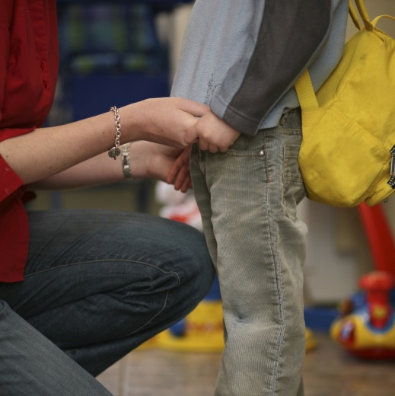
You may also like to read
You may also like to read other titles in this series:
- Encouraging children to manage their own behaviour
- Sharing books with your child
- Time to say goodbye – helping your child manage separations
Other related newsletters can be found at www.education.vic.gov.au

