Building your child’s resilience
Issue No. 016

All young children will face challenges and setbacks. Your child might be upset when their ball rolls off the mat and under the TV. Your child might be disappointed that a friend can’t come and play. Or they might be frustrated at not being able to ride their new scooter.
Sometimes those challenges are on a bigger scale – becoming ill, moving to a new city or starting at a new education and care program.
Resilience is the ability to handle tough times – to keep trying (persevering), to adapt to change, and to meet challenges. Resilient children take considered risks and cope with the unexpected. They persist when faced with challenges or when their first attempt isn’t successful.
Being resilient is an important part of your child’s sense of identity and wellbeing.

Myths and misunderstandings
Resilience is about strength of character, not about being tough. Telling a four-year old not to cry won’t make your child strong – it will only teach them to hide their feelings when they feel angry or sad.
Telling your child always to be happy and positive does not build resilience. Nor does excessive praise – in fact, if you praise everything that your child does, they may be less likely to deal with setbacks. Praise can result in children only trying to please adults. Encouragement gives information, feedback and supports independence. A child needs to feel valued and accepted to be resilient. They need to know that you are there and they can get help and support. This encourages them to take risks and try new things. The more things your child tries, the more experience they have of problem solving, learning from their mistakes and persevering.

What does this mean for me?
As your child’s first and most important teacher, you play an important role in supporting your child to be resilient.
- Be prepared to let your child struggle for a bit. If your child’s ball rolls away and they cry, wait and see if they will crawl and get it without your help.
- Notice and acknowledge your child’s efforts: say things like: I liked the way you kept trying until you were able to finish that puzzle.
- Treat mistakes as learning. Avoid fault finding or criticism as this will stop your child from trying new things. Talk about the things your child has learnt (as well as what you have learnt) through their mistakes.
- Model resilient behaviour. How do you react when things go wrong? How do you respond to loss and disappointment? Your child learns from what you do.
- If your child is old enough, explain that now and then everyone has a difficult or unhappy time. It’s a normal part of life and most problems can be worked out.
- Give your child time to do the things they are good at. They’ll develop a sense of achievement and learn that we get good at things by practising and persevering.
- Help your child to have realistic expectations. If your child is learning to ride a bike without training wheels, let them know that this will take time. Unrealistic expectations will cause disappointment.
- If success is achievable, encourage your child to keep trying (but don’t pressure them). Acknowledge their frustrations: It will get easier the more you do it.
- If your child is struggling, break the task into smaller steps, or make it easier so your child can experience some success.
- You don’t need to look for chances to build your child’s resilience – they’ll occur naturally.

Related links
See Kids Matter’s:
- Ups and downs: learning to keep a balance

You may also like to read
You may also like to read other titles in this series:
- Your child’s most important teacher
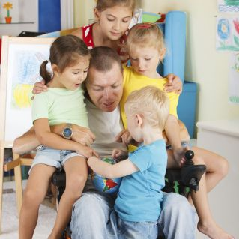
- ‘I can do it!’ Encouraging your child’s independence
- Supporting your child to make decisions
- Having conversations with your child
Other related newsletters can be found at www.education.vic.gov.au

