‘I can do it myself!’ Encouraging your child’s independence
Issue No. 014

Doing things without your help is an important way for children to build a strong sense of identity and wellbeing. It’s a way for your child to see themselves as capable.
A baby learns to crawl and no longer needs to be carried all the time. A child starts family day care and learns to relate to a new adult without you being there. Your child learns how to take considered risks (jumping off the slide or approaching an unfamiliar group of children), with you present.
All are signs of a growing independence.
Children also learn how to be responsible for their own health and wellbeing by dressing, eating and toileting without your help. As they do, they practise large and fine motor skills, gain confidence and build self-esteem.
Over time, your child will become more and more able to do things for themselves – but for many years there will be a balance between doing things without your help and doing things with your support and guidance.
Time for children to follow their own ideas, to make their own choices, and develop as self-regulating learners, is important. Everything children do must have a purpose that makes sense to them. It is important to help children learn to be more independent.

What can you do to encourage your child’s independence?
- Encourage babies to be independent by giving them lots of space to move (indoors and outdoors). Look at what life is like from floor level: what can you add to make the world interesting for your baby? What needs to be moved for safety?
- Step back and let your child take reasonable risks. Your child may be wet, dirty and scraped as they climb down from the tree but they will be full of pride in what they’ve achieved.
- At times, step back and let your child try to fix their own problems. Can your child resolve a conflict without your help? If not, can you support your child to find their own solution through suggesting options that might resolve problems or issues?

- Encourage your child to feed themselves from an early age. Give older babies’ finger food; introduce forks and spoons with toddlers. Older children might use tongs to serve themselves. Use small jugs or measuring cups so your child can pour their own drinks.
- Find household tasks that your child can do independently or help you with – setting or clearing the table or putting their clothes in the laundry basket.
- Arrange your home to encourage independence – have a stool near the basin so your child can wash their own hands; have tissue boxes in more than one room so children are encouraged to blow their noses; give your child a small towel to dry themselves with.
- Make it easy for your child to dress and undress without your help. Pants with an elasticised waistband are easier to take off and pull on when toileting. Use shoes with Velcro straps rather than laces.
- Look for signs of readiness: Children who are asking questions or trying things themselves may be ready for more independence. But don’t withdraw all help and support at the first sign that they can do something alone, they need to practice doing things over and over again.
- Encouraging your child to do things for themselves helps to avoid them learning that the “work of the household” is not their business. Recognising and encouraging them to make contributions to the household and shared experiences will lead to greater feelings of achievement.
- If your child has a disability, encouraging them to be independent might take more time. Don’t give up! Your early intervention service will have ideas and resources to support you.

Related links
- Teaching your child to get dressed – (includes a rough guide to dressing skills at different ages)
- Daily personal hygiene and care for babies – (covers teaching your child to wash and dry themselves, clean their teeth and blow their nose)

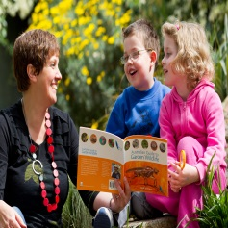
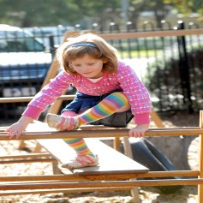
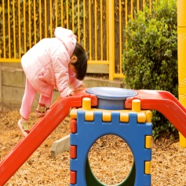
You may also like to read
You may also like to read other titles in this series:
- Supporting your child to make decisions
- Building your child’s resilience
- Helping your child to have a strong sense of identity
- Helping your child have a strong sense of wellbeing
- Helping your child to connect with and contribute to the world
Other related newsletters can be found at www.education.vic.gov.au

