Everyday learning
Issue No. 012

Your child’s most important learning happens in everyday situations. It doesn’t wait until your child starts kindergarten or school.
As your child plays at home, they learn to relate to you, to any brothers, sisters or family members and to their friends. They learn what it means to be comforted when they are upset, how to take turns, how to be kind. They learn what it means to keep going when things get tough, what it’s like to feel sad and then to feel happy again.
As your child goes through daily routines, such as meal times, they learn to share by not taking all the salad from the bowl. They learn to problem solve when everyone wants the last piece of pie. They learn to make choices and to use and manipulate utensils like tongs and forks. With our guidance, they learn about safety (hot things and sharp things).
Think of shopping – an opportunity for your child to learn about colour, size and number: What colour apples will we buy? Can we choose the big bananas? Put some more grapes in the bag. Your child can use the scales and learn about things that are heavy and light.
When you plant seedlings in the garden your child learns about science (what do plants need to grow?) They learn to solve problems (how will all those seedlings fit in the space we have?) and build numeracy skills (how many rows will we need; how many will be put in each row?) As the plants grow, they can care for the plants (building responsibility) and enjoy a sense of wonder at seeing them grow.

What can I do to encourage everyday learning?
- Remember children will copy what you do. They are learning every time they see you speak to others, manage your emotions or deal with frustration or conflict.
- Look for opportunities to support your child’s everyday social and emotional learning. For example, you might talk about feelings after a child has hurt their sibling, or introduce the idea of fairness when children are fighting over a toy. You might encourage your child to try two more times before giving up, or break a task into smaller parts to help your child achieve success.
- Share your interests with your children – riding bikes, bush walking, gardening, going to the football or playing a musical instrument. What opportunities do they present for everyday learning?
- Share the household chores with the children – look at recipe books, make a shopping list, make a salad, set the table, recycle the papers, wash the dishes; post a letter. What opportunities do they present for everyday learning?
- There’s no need to buy a lot of expensive toys to help your child learn. (In fact, some elaborate toys can only be used in one way and children quickly tire of them).
- Provide play experiences that your child really gets involved in and support your child with both questions and information. Your children will then interact and learn about a whole host of things in their world (like maths, science, reading and writing) through play.
- Everyday learning is about making the most of the here and now. Taking advantage of everyday learning opportunities that present themselves as your child explores the world may mean slowing down and taking more time to do things along with your child. Taking time to engage and wonder about the world around us is one of the most precious things that we can share with our children.

Related links
- Everyday Learning Series – Early Childhood Australia has a Series that covers a vast array of topics from everyday learning about confidence and coping skills to everyday learning about being “green”. These publications are for sale through Early Childhood Australia via the above hyperlink.

You may also like to read
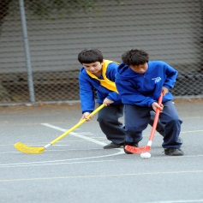
You may also like to read other titles in this series:
- Your child’s most important teacher
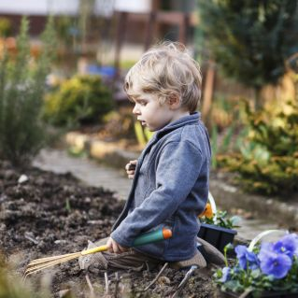
- Encouraging your child’s strengths and interests
- Having conversations with your child
- Helping your child to be an active and involved learner.
Other related newsletters can be found at www.education.vic.gov.au
