Helping your child be a confident and involved learner
Issue No.006
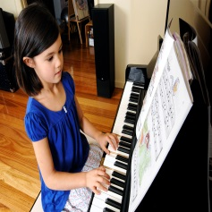
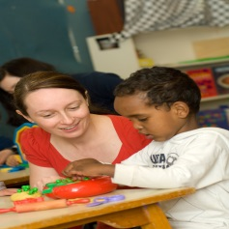
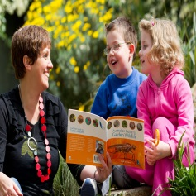
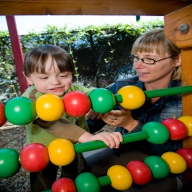
One of the five learning outcomes in the Victorian Early Years Learning and Development Framework and the Early Years Learning Framework for Australia is that children are confident and involved learners.

Children learn from birth
Babies learn that they can make things happen (banging on a saucepan makes a noise, smiling at you makes you smile back). They try to solve problems (how can I get this slippery mango into my mouth) and actively explore their world (what’s around this corner?).
When you encourage and support your child to be a curious and active learner, your child experiences learning as fun and rewarding. They learn to love learning! And that’s the key to becoming a confident and involved learner.
Confident and involved learners enjoy exploring and experimenting. They meet challenges and take risks. They learn that it’s okay to fail and that they can get help when they need it. As they get older they realise that working with others sometimes gets better results than doing things alone!
A confident and involved learner persists. The child who can’t do a somersault at first, but tries again and again until they succeed has learned the importance of not giving up. They are more likely to face their next challenge with confidence. And if they can’t do a somersault, they learn that it’s okay to not be able to do it. They can always try again later.
Confident and involved learners continue to ask questions and explore their world: Why is the rain wet? Why is Julio crying? Can a frog swim and jump? And they learn where to go to find answers. These basic questions can foster curiosities’ that form early maths and science concepts.

How can I support my child to be an active and involved learner?
- You are your child’s first and most important teacher. Your child learns first through relationships with you and others in the family. The opportunities and experiences that you give your child are therefore critical.
- Make sure your baby has the chance to move around, touch things, taste things, pull things apart and talk to them/converse about things in a way where you both listen to each other, ask a question and pause for a response.
- Give your child many and varied opportunities for play – time for your child to play alone, with friends and with you. Give your child periods of uninterrupted play that allow them to create, build, discover and imagine. Sensory play–i.e. touching and feeling lots of different surfaces and materials, is especially important.
- Older children will begin to take initiative as learners by asking questions when needed and attempting small projects and as they grow they will experiment with ways of expressing and communicating ideas and feelings to particular audiences or for particular purposes.
- The most important learning for young children happens through everyday experiences. It doesn’t require specialised classes or expensive toys, water and sand can offer hours of opportunities to learn and play for children.
- If you set out to teach a new skill like drinking from a cup or learning to use scissors, repeat the experience so that your child has the chance to practice.
- Encourage and support your child to be curious and to ask questions. Encourage them to use their imagination and to solve problems. Together, use books and the internet to help them find answers.
- With older children, encourage them to extend their thinking: Why do you think that happened? How can we fix that? Predict what would happen if . . .?
- Encourage older children to use informal measurement units like hand-spans and pencil lengths to make, describe and compare measurements of length, area etc.
- Encourage and support your child’s interests. Children learn at different rates, in different ways and at different times.

Other related newsletters can be found at www.education.vic.gov.au

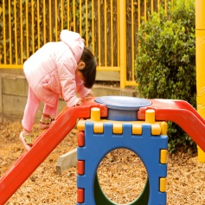
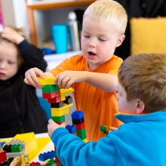
Related links
- Belonging, Being and Becoming: The Early Years Learning Framework for Australia
- Victorian Early Years Learning and Development Framework for all Children from Birth to Eight Years (2009)
- Curiosity and Confidence – a Kids Matter information sheet

You may also like to read
- Early childhood learning
- Helping your child to have a strong sense of identity
- Helping your child to connect and contribute to the world
- Helping your child to have a strong sense of wellbeing
- Helping your child to be an effective communicator
