Helping your child to connect and contribute to the world
Issue No.003
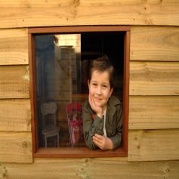
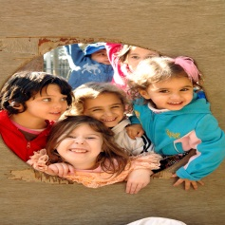
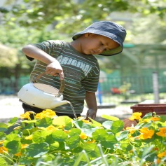
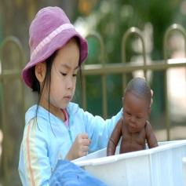
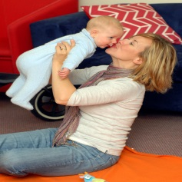
One of the five learning outcomes in the Victorian Early Years Learning and Development Framework and the Early Years Learning Framework for Australia is that children are connected with and contribute to their world.

From birth, children live and learn with others
At first, most of that living and learning takes place within a family.
But from birth, your child is also part of a community with friends and neighbours. They go to shops and libraries and playgrounds. They might also attend an early childhood education and care setting. They gradually become aware that they live in a country called Australia and that they are part of a bigger world.
With support, your child will connect with and contribute to their world in more varied and complex ways.
Over time, your child will learn respect and compassion for others – people they know as well as those less familiar. They will become aware of others’ rights and their own rights, and what other people do in the world around them.
They will learn to care for and respect their environment (homes, buildings, streets, parks). They’ll learn how to comfort others and learn that what they say and do can affect how others feel. They’ll learn how to be a good friend!

How can I help my child to connect with and contribute to their world?
- Find ways for your child to contribute to family life – and show that you value that contribution! Involve babies in conversations and family activities. Let your toddler carry dishes to or from the table or feed the pets. Let your child put away their toys or help with the recycling.
- Babies and toddlers use play to investigate and explore new ideas, and as they grow they will explore how and why natural factors like weather patterns and human activities affect their lives. In time they will be able to investigate and describe elements of the natural and built environments in their local area.
- Encourage your child to be part of day to day decision making and problem solving: There is no more room on your shelf for more books. Can you choose three books to give to your sister?
- Introduce the importance of ‘being fair’ with toddlers and older children to help them understand and work through challenging behaviours.
- Give your child lots of opportunities to mix with other children. This is how they learn to cooperate with others and to negotiate roles and relationships.
- Encourage children to use language, including English and any other language/s used in your family.
- Find ways for your child to explore and appreciate diversity. Visits to the zoo, museum or gallery are great for this. Read books or find internet sites that help your child discover other countries and people. Learn about and take part in cultural celebrations in your local community – for example, Holi, Ramadan, Christmas or Chinese New Year.
- Talk to your child about any volunteering you do, or any charities you support or use. Your child may want to be involved in helping others – a great way for them to learn empathy, care and compassion.
- Take your child to every day places like supermarkets, the post office, and the market and explain what happens there and what people do.

Other related newsletters can be found at www.education.vic.gov.au

Related links
- Belonging, Being and Becoming: The Early Years Learning Framework for Australia
- Victorian Early Years Learning and Development Framework for all Children from Birth to Eight Years (2009)
(N.B: The full frameworks and standards are accessible online as PDFs.)
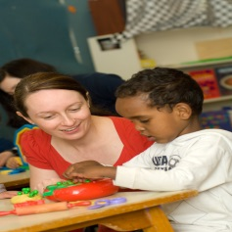
You may also like to read:
- Early childhood learning
- Helping your child to have a strong sense of identity
- Helping your child to have a strong sense of wellbeing
- Helping your child to be an effective communicator
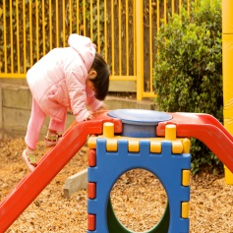
- Helping your child be a confident and involved learner

