Tips for filming with your smartphone:

* Film horizontally! The videos we create are intended for wide screen viewing, so make sure you turn your phone around.

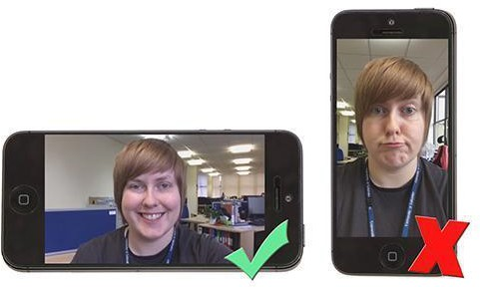

* When filming people speaking, film from the elbows up and don’t leave too much space above the head - get close so the microphone can pick up sound
* Speakers should look directly at the lens of the camera.
* Allow some time at the end of the clip before you stop recording, hold the eyeline with the camera for 2 seconds before moving/stopping recording to allow for editing.
* Use the best lighting you can find. Outside is ideal, but not in full sunlight. If inside, try to stand facing a window, or have your interviewee facing the window, so that they have nice, even, natural light. Never have your subject with their back to the light (Backlit).

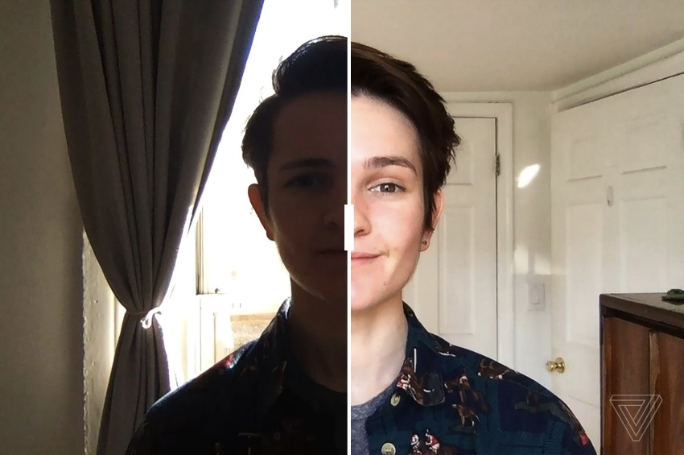

# Backlit, versus facing a light source (such as a window)

* Make sure you select the best camera settings available. Ideally HD or 4K 25FPS
* Wait a second after pressing record before you start speaking and leave a 2 second pause at the end before you stop recording.
* Don’t zoom on your phone (especially) or camera. Move closer.
* Find the quietest room or area you can and don’t stand too far from the camera. If you’re talking from the other side of the room, the in-built microphone on your camera or phone won’t pick up your voice.
* If you’re filming outside, pay attention to external noise, such as traffic, construction work and wind.
* When holding the camera, it’s important to maintain a steady hold. Hold it close to your body, with your elbows tucked in, to stay steady. Using a tripod or a stand will help.
* Get lots of different shots when filming an activity - shoot more that you think you’ll need

# File delivery

* For any files under 15MB please email to [videoproduction@education.vic.gov.au](mailto:videoproduction@education.vic.gov.au)
* For files bigger than 15MB please use [WeTransfer](https://wetransfer.com/) (or Google Drive) to send the files to [videoproduction@education.vic.gov.au](mailto:videoproduction@education.vic.gov.au)