Victorian Students: Psychological Resilience
Psychological resilience refers to an adaptive and healthy state of social and emotional functioning. Young people who are psychologically resilient are more likely to respond constructively to challenges and difficulties they face in their lives. Ryan and Deci (2001) developed a scale which assesses autonomy (sense of personal agency), relatedness (positive connections with others) and competence (feeling capable or masterful), and About You uses a shortened version of this, known as the Basic Psychological needs scale.
Most Victorian students (70 per cent) showed a high level of psychological resilience on this scale, and this varied little by gender or age.
Students with a high level of psychological resilience were more likely to report enjoying school (72 per cent, compared to 41 per cent of students with a low level of resilience).
Proportion of students showing high levels of psychological resilience, by selected risk and protective factors, 2014
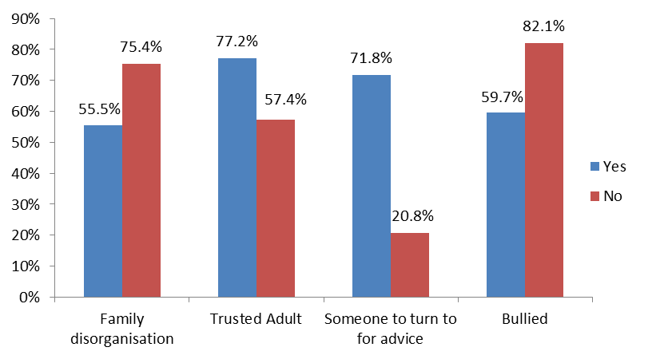
Resilient students were also less likely to have skipped or wagged school in the last month (25 per cent) compared to students with a low level of resilience (36 per cent).
Students were more likely to be highly resilient if they:
Had a trusted adult in their lives (77 per cent were resilient compared with 57 per cent of students who did not have a trusted adult).
Had someone to turn to for advice when having problems (72 per cent compared to 21 per cent).
Were in the healthy weight range (73 per cent compared to 64 per cent of overweight or obese students).

Students at higher risk included:
- Those living in one parent families (only 65 per cent were resilient, compared to 74 per cent of students living in couple families)
- Students from language backgrounds other than English (60 per cent were resilient compared with 72 per cent of other students).
- Students from families with poor family management (or disorganisation) (56 per cent compared with 75 per cent of other students).
- Students who were recently bullied (60 per cent resilient, compared with 82 per cent of their peers who were not bullied).
For more information see Resilience Framework

