Follow-up Evaluation Findings
Transition: A Positive Start to School

2011 Follow-up Evaluation
Transition: A Positive Start to School

Starting school is an important milestone for children and their families.
The Transition: A Positive Start to School initiative aims to improve children’s experience of starting school and was developed on the basis of national and international research about the importance of a positive start to school for children, families and educators.
The Transition Learning and Development Statement is an important part of the initiative. It summarises a child’s strengths as they start school, identifies their interests and helps the prep teacher to get to know the children entering their class.
A comprehensive evaluation of the initiative was undertaken in 2010. The final report, Evaluation of Transition: A Positive Start to School Initiative (2010) is available for download.
In 2011, a targeted follow-up evaluation was conducted. Early Childhood Professionals, Prep Teachers, and those working in Outside School Hours Care (OSHC) services were surveyed. The aim and response rate of each survey is outlined below:

Audience | Aim of survey | Responses
Early Childhood Professionals | How are early childhood professionals engaging with Transition Statements? | - 630 responses  kindergarten teachers (89%)
Prep Teachers | How valuable is the information in each section of the Statement?  How have Statements been used since the first evaluation? | - 914 responses  Government (73%)  Catholic (14%)  Independent (11%)
Outside School Hours Care | What is the level of awareness of the Transition Initiative and Statements?  Are OSHC services using Statements? If so, how? | - 151 responses

Findings

Early Childhood Professionals

- The vast majority of respondents (between 90.5% and 92.2%) considered all sections of the Statement as valuable (those who responded ‘agree’ and ‘strongly agree’).
- Early childhood professionals typically spent around 45-60 minutes preparing each Statement.
Figure 1: Response by early childhood professionals when asked whether the time taken to write the Statements was an improvement on the previous year  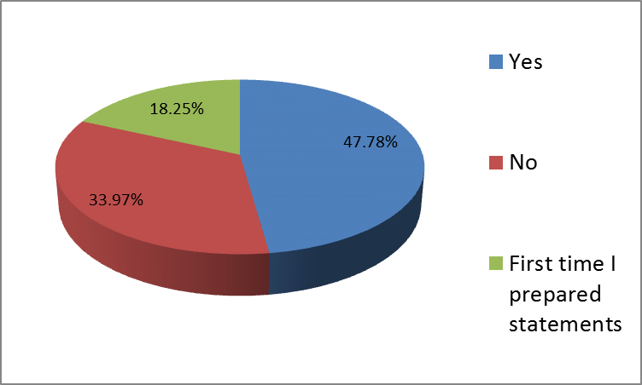 |  | - Almost half of the early childhood professionals (48%) reported that the time taken to write Statements this year was an improvement on the previous year.
- Early childhood professionals appreciate contact and feedback from prep teachers as a way of improving the quality of information they provide.
- Of the feedback provided, around 11% of early childhood professionals reported that prep teachers gave general feedback on the content of Statements and 15% reported that prep teachers contacted them to discuss individual children if the early childhood educator ticked the box on the consent page of the Statement.

Prep Teachers

Figure 2: Degree to which prep teachers read the Statements  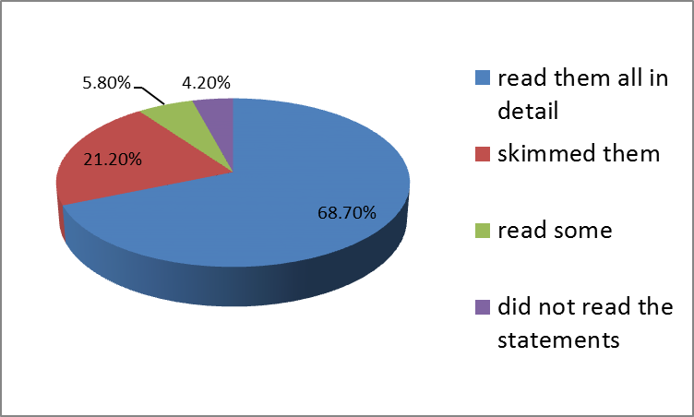 |  | - Almost all prep teachers (96%) read the Statements.

Prep Teachers cont.

Figure 3: Percentage of early childhood professionals and prep teachers who considered each section of the Statement to contain valuable information  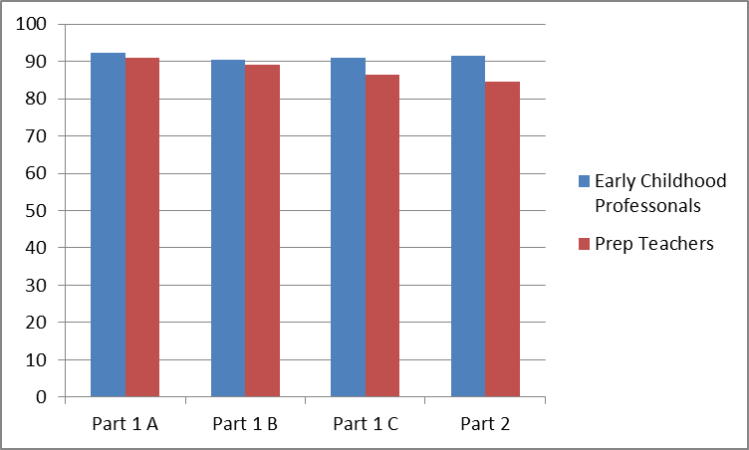  Part 1A - parents/guardians, Part 1B - the child, Part 2 - the early childhood educator. Part 1C - optional for families to complete if their child has additional learning and developmental needs, a disability or developmental delay. | - The majority of prep teachers (up to 91%) considered all sections of the Statement as valuable and that they help support a positive start to school for children (those who responded ‘agree’ and ‘strongly agree’).

- Prep teachers were most likely to use the information in the Statements for background information on the child and family (94%), and to support children with additional needs (87%).  - Prep teachers are less likely to use them for curriculum design and delivery (48%). | Figure 4: How Prep Teachers used the Statements (%)  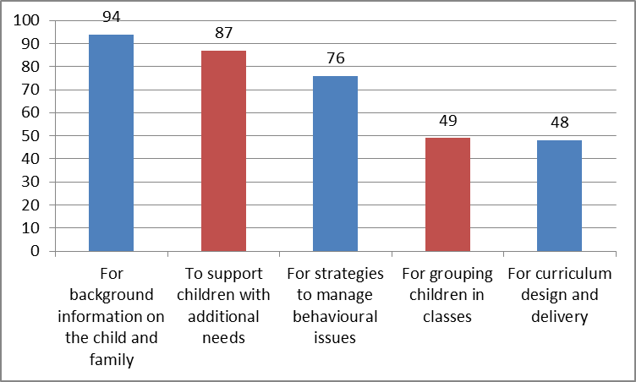

- 72% of prep teachers reported having a good relationship with local early childhood services and almost half (44%) stated that the Statements had strengthened their existing relationships or networks with early childhood services.
- 71% of prep teachers reported that primary school principals are supportive of the Transition Initiative.

Outside School Hours Care Services

- Respondents from OSHC services reported a higher level of awareness of the Initiative (80%) compared to their awareness of Transition Statements (65%).
- Around 75% of OSHC services (112 respondents) did not receive Statements.
- Of the OSHC services that received Statements, the vast majority (around 90%) considered the information they contained as valuable.
- Many OSHC services are involved in transition to school programs and activities.
- Statements received by OSHC services were mainly used for strategies to settle children into the service (91%) and for background information on the child and family (94%).

Opportunities for Improvement

All three surveys asked how transition to school could be improved at their local level. The following themes emerged as opportunities:
- Understanding each other’s environment – Opportunities for both prep teachers and early childhood professionals to gain a better understanding of each other’s environment (in terms of practice and curriculum) would assist a smooth transition.
- Professional development for primary schools – Engaging primary schools with the five learning and development outcome areas of the Victorian Framework and the Transition Initiative was considered important. It is particularly important given the Victorian Framework is for all children from birth to eight and therefore relevant to a range of settings in which children participate (including early years and school up to grade 2).
- Complementary transition activities – Buddy systems, orientation (e.g. visits, engagement with school environment), streamlined enrolment processes, and communication/networks are considered important activities that support a smooth transition to school and are a complement to Statements.
- Support for parents – Suggestions related to the most effective ways to communicate with families who are concerned about how to write Statements and the development of resources for parents to aid them with understanding the content of Statements (five learning and development outcome areas of the Victorian Framework).
- Timing – When schools receive Statements tends to correlate with the way prep teachers use them. This suggests a need for better communication to ensure schools receive Statements at a time that suits their needs, wherever possible.
- Provision of Statements to OSHC – It is important that OSHC services receive copies of the Statements (if the parent/guardian has given permission for this to occur) as these services play a significant role in assisting children to have a positive transition to school.

