On Track

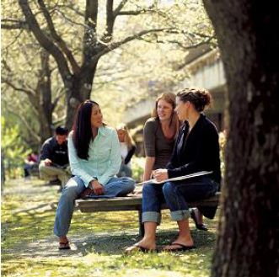
The On Track Survey 2013

Highlands LLEN

LLEN Report



This report provides information about the destinations of 2012 students exiting schools in this LLEN.

On Track follows up young people in the six months after they leave school to obtain data about their post school education, training and employment destinations.

Data obtained through the On Track survey are used to publish post Year 12 education, training and employment destinations, celebrating the broad range of outcomes schools create for young people – not just university but studying at TAFE, undertaking apprenticeships and other forms of training or employment. Those not studying or in part-time work who request additional pathway advice and support are referred to Youth Connections for help with their career plans.

Since 2003, more than 415,000 Year 10, 11 and 12 school‐leavers have participated in On Track Surveys.

The first On Track Longitudinal Surveys followed groups of 2003 and 2004 school leavers to gain a more detailed picture of their transitions over the four years after they leave school.

The second longitudinal study began in 2008 and followed a cohort of 2007 school leavers until 2011.

Annual On Track reports and the On Track longitudinal reports are available on the On Track website:
www.education.vic.gov.au/ontrack.

Tables

1. | Destinations of 2012 Year 12 or equivalent completers by LLEN
2. | Destinations of 2012 early school leavers LLEN
3. | Destinations of 2012 school leavers by leaver status and year level, Highlands LLEN and Victoria
4. | Reasons for 2012 school leavers not studying in 2013, Highlands LLEN and Victoria

Figures

1. | Destinations of 2012 Year 12 or equivalent completers, Highlands LLEN and Victoria
2. | Destinations of 2012 Year 12 or equivalent completers, showing deferrals, Highlands LLEN and Victoria
3. | Destinations of 2012 early school leavers, Highlands LLEN and Victoria

  Table 1
  Destinations of 2012 Year 12 or equivalent completers by LLEN
LLEN |  |  |  |  |  |  |  |  | Total Interviewed | Year 12 completers / response rate
  University
  TAFE/VET
  Apprentice/ Trainee
  Employed
  Looking For Work
  NILFET*
  Unknown
 | n | 965 | 279 | 85 | 236 | 70 | 15 |  | 1,650 | 2,122
  Banyule Nillumbik
 | % | 58.5 | 16.9 | 5.2 | 14.3 | 4.2 | 0.9 |  | 100 | 77.8
 | n | 264 | 109 | 88 | 188 | 52 | 6 |  | 707 | 858
  Baw Baw Latrobe
 | % | 37.3 | 15.4 | 12.4 | 26.6 | 7.4 | 0.8 |  | 100 | 82.4
 | n | 1506 | 289 | 82 | 311 | 94 | 42 |  | 2,324 | 3,083
  Bayside Glen Eira Kingston
 | % | 64.8 | 12.4 | 3.5 | 13.4 | 4.0 | 1.8 |  | 100 | 75.4
 | n | 669 | 356 | 116 | 158 | 91 | 16 | 1 | 1,407 | 1,888
  Brimbank Melton
 | % | 47.5 | 25.3 | 8.2 | 11.2 | 6.5 | 1.1 | 0.1 | 100 | 74.5
 | n | 96 | 26 | 34 | 56 | 8 | 1 |  | 221 | 282
  Campaspe Cohuna
 | % | 43.4 | 11.8 | 15.4 | 25.3 | 3.6 | 0.5 |  | 100 | 78.4
 | n | 537 | 89 | 18 | 100 | 19 | 16 |  | 779 | 1,153
  Capital City
 | % | 68.9 | 11.4 | 2.3 | 12.8 | 2.4 | 2.1 |  | 100 | 67.6
 | n | 24 | 11 | 12 | 40 | 10 | 1 |  | 98 | 124
  Central Grampians
 | % | 24.5 | 11.2 | 12.2 | 40.8 | 10.2 | 1.0 |  | 100 | 79.0
 | n | 260 | 84 | 61 | 159 | 30 | 6 |  | 600 | 867
  Central Ranges
 | % | 43.3 | 14.0 | 10.2 | 26.5 | 5.0 | 1.0 |  | 100 | 69.2
 | n | 661 | 289 | 131 | 382 | 101 | 16 |  | 1,580 | 2,214
  Frankston Mornington Peninsula
 | % | 41.8 | 18.3 | 8.3 | 24.2 | 6.4 | 1.0 |  | 100 | 71.4
 | n | 2144 | 453 | 134 | 309 | 101 | 43 | 3 | 3,187 | 4,234
  Gateway
 | % | 67.3 | 14.2 | 4.2 | 9.7 | 3.2 | 1.3 | 0.1 | 100 | 75.3
 | n | 157 | 51 | 75 | 136 | 24 | 4 |  | 447 | 613
  Gippsland East
 | % | 35.1 | 11.4 | 16.8 | 30.4 | 5.4 | 0.9 |  | 100 | 72.9
 | n | 78 | 33 | 44 | 112 | 11 | 1 |  | 279 | 356
  Glenelg Southern Grampians
 | % | 28.0 | 11.8 | 15.8 | 40.1 | 3.9 | 0.4 |  | 100 | 78.4
 | n | 294 | 79 | 89 | 279 | 47 | 10 |  | 798 | 1,022
  Goldfields
 | % | 36.8 | 9.9 | 11.2 | 35.0 | 5.9 | 1.3 |  | 100 | 78.1
 | n | 212 | 81 | 86 | 174 | 37 | 5 |  | 595 | 815
  Goulburn Murray
 | % | 35.6 | 13.6 | 14.5 | 29.2 | 6.2 | 0.8 |  | 100 | 73.0
 | n | 447 | 105 | 74 | 277 | 57 | 10 |  | 970 | 1,335
  Highlands
 | % | 46.1 | 10.8 | 7.6 | 28.6 | 5.9 | 1.0 |  | 100 | 72.7
 | n | 872 | 454 | 133 | 254 | 105 | 13 |  | 1,831 | 2,430
  Hume Whittlesea
 | % | 47.6 | 24.8 | 7.3 | 13.9 | 5.7 | 0.7 |  | 100 | 75.3
 | n | 2452 | 203 | 38 | 316 | 53 | 37 | 2 | 3,101 | 4,081
  Inner Eastern
 | % | 79.1 | 6.5 | 1.2 | 10.2 | 1.7 | 1.2 | 0.1 | 100 | 76.0
 | n | 752 | 287 | 69 | 208 | 83 | 13 |  | 1,412 | 1,932
  Inner Northern
 | % | 53.3 | 20.3 | 4.9 | 14.7 | 5.9 | 0.9 |  | 100 | 73.1
 | n | 950 | 271 | 71 | 176 | 65 | 7 |  | 1,540 | 2,096
  Maribyrnong Moonee Valley
 | % | 61.7 | 17.6 | 4.6 | 11.4 | 4.2 | 0.5 |  | 100 | 73.5
 | n | 68 | 24 | 26 | 26 | 6 | 1 |  | 151 | 208
  Murray Mallee
 | % | 45.0 | 15.9 | 17.2 | 17.2 | 4.0 | 0.7 |  | 100 | 72.6
 | n | 86 | 56 | 35 | 138 | 25 | 3 |  | 343 | 442
  NE Tracks
 | % | 25.1 | 16.3 | 10.2 | 40.2 | 7.3 | 0.9 |  | 100 | 77.6
 | n | 51 | 10 | 12 | 19 | 3 | 2 |  | 97 | 124
  North Central
 | % | 52.6 | 10.3 | 12.4 | 19.6 | 3.1 | 2.1 |  | 100 | 78.2
 | n | 120 | 58 | 69 | 133 | 19 | 1 | 1 | 401 | 541
  North East
 | % | 29.9 | 14.5 | 17.2 | 33.2 | 4.7 | 0.2 | 0.2 | 100 | 74.1
 | n | 117 | 42 | 50 | 134 | 18 | 1 |  | 362 | 499
  Northern Mallee
 | % | 32.3 | 11.6 | 13.8 | 37.0 | 5.0 | 0.3 |  | 100 | 72.5
 | n | 1220 | 409 | 181 | 438 | 123 | 24 | 1 | 2,396 | 3,155
  Outer Eastern
 | % | 50.9 | 17.1 | 7.6 | 18.3 | 5.1 | 1.0 | 0.0 | 100 | 75.9
 | n | 838 | 245 | 157 | 383 | 86 | 24 | 1 | 1,734 | 2,385
  Smart Geelong Region
 | % | 48.3 | 14.1 | 9.1 | 22.1 | 5.0 | 1.4 | 0.1 | 100 | 72.7
 | n | 1200 | 535 | 168 | 376 | 145 | 27 | 2 | 2,453 | 3,339
  South East
 | % | 48.9 | 21.8 | 6.8 | 15.3 | 5.9 | 1.1 | 0.1 | 100 | 73.5
 | n | 83 | 29 | 36 | 95 | 19 | 5 |  | 267 | 353
  South Gippsland Bass Coast
 | % | 31.1 | 10.9 | 13.5 | 35.6 | 7.1 | 1.9 |  | 100 | 75.6
 | n | 174 | 97 | 110 | 188 | 34 | 4 | 1 | 608 | 790
  South West
 | % | 28.6 | 16.0 | 18.1 | 30.9 | 5.6 | 0.7 | 0.2 | 100 | 77.0
 | n | 80 | 21 | 35 | 68 | 12 | 5 |  | 221 | 294
  Wimmera Southern Mallee
 | % | 36.2 | 9.5 | 15.8 | 30.8 | 5.4 | 2.3 |  | 100 | 75.2
 | n | 604 | 257 | 81 | 190 | 74 | 5 | 1 | 1,212 | 1,606
  WynBay
 | % | 49.8 | 21.2 | 6.7 | 15.7 | 6.1 | 0.4 | 0.1 | 100 | 75.5
 | n |  |  |  |  |  |  |  | 33,771 | 45,247
  Victoria
  17,981
  5,332
  2,400
  6,059
  1,622
  364
  13
 | % | 53.2 | 15.8 | 7.1 | 17.9 | 4.8 | 1.1 | 0.0 | 100 | 74.6

  Notes:
  Completers who deferred a place at university or TAFE have been allocated to their labour market destinations.
  NILFET*: Not in labour force, education or training

Table 2
  Destinations of 2012 early school leavers by LLEN
LLEN |  | University | TAFE/VET | Apprentice/ Trainee | Employed | Looking For Work | NILFET | Unknown | Total Interviewed | Est. Early Leavers / response rate
 | n | 1 | 14 | 23 | 15 | 14 | 5 | 0 | 72 | 251
  Banyule Nillumbik
 | % | 1.4 | 19.4 | 31.9 | 20.8 | 19.4 | 6.9 | 0.0 | 100 | 28.7
 | n | 0 | 34 | 49 | 36 | 27 | 4 | 0 | 150 | 364
  Baw Baw Latrobe
 | % | 0.0 | 22.7 | 32.7 | 24.0 | 18.0 | 2.7 | 0.0 | 100 | 41.2
 | n | 1 | 20 | 23 | 17 | 12 | 5 | 0 | 78 | 354
  Bayside Glen Eira Kingston
 | % | 1.3 | 25.6 | 29.5 | 21.8 | 15.4 | 6.4 | 0.0 | 100 | 22.0
 | n | 1 | 32 | 31 | 30 | 26 | 5 | 0 | 125 | 432
  Brimbank Melton
 | % | 0.8 | 25.6 | 24.8 | 24.0 | 20.8 | 4.0 | 0.0 | 100 | 28.9
 | n | 0 | 5 | 34 | 11 | 5 | 1 | 0 | 56 | 125
  Campaspe Cohuna
 | % | 0.0 | 8.9 | 60.7 | 19.6 | 8.9 | 1.8 | 0.0 | 100 | 44.8
 | n | 4 | 19 | 8 | 29 | 22 | 3 | 0 | 85 | 389
  Capital City
 | % | 4.7 | 22.4 | 9.4 | 34.1 | 25.9 | 3.5 | 0.0 | 100 | 21.9
 | n | 0 | 6 | 5 | 2 | 1 | 1 | 0 | 15 | 63
  Central Grampians
 | % | 0.0 | 40.0 | 33.3 | 13.3 | 6.7 | 6.7 | 0.0 | 100 | 23.8
 | n | 1 | 14 | 19 | 15 | 7 | 3 | 0 | 59 | 182
  Central Ranges
 | % | 1.7 | 23.7 | 32.2 | 25.4 | 11.9 | 5.1 | 0.0 | 100 | 32.4
 | n | 0 | 57 | 52 | 43 | 26 | 10 | 0 | 188 | 564
  Frankston Mornington Peninsula
 | % | 0.0 | 30.3 | 27.7 | 22.9 | 13.8 | 5.3 | 0.0 | 100 | 33.3
 | n | 4 | 49 | 36 | 41 | 25 | 11 | 0 | 166 | 533
  Gateway
 | % | 2.4 | 29.5 | 21.7 | 24.7 | 15.1 | 6.6 | 0.0 | 100 | 31.1
 | n | 0 | 16 | 38 | 30 | 15 | 4 | 0 | 103 | 282
  Gippsland East
 | % | 0.0 | 15.5 | 36.9 | 29.1 | 14.6 | 3.9 | 0.0 | 100 | 36.5
 | n | 0 | 9 | 11 | 17 | 4 | 0 | 0 | 41 | 92
  Glenelg Southern Grampians
 | % | 0.0 | 22.0 | 26.8 | 41.5 | 9.8 | 0.0 | 0.0 | 100 | 44.6
 | n | 0 | 30 | 49 | 48 | 28 | 10 | 0 | 165 | 450
  Goldfields
 | % | 0.0 | 18.2 | 29.7 | 29.1 | 17.0 | 6.1 | 0.0 | 100 | 36.7
 | n | 0 | 13 | 19 | 32 | 12 | 12 | 0 | 88 | 334
  Goulburn Murray
 | % | 0.0 | 14.8 | 21.6 | 36.4 | 13.6 | 13.6 | 0.0 | 100 | 26.3
 | n | 0 | 18 | 43 | 38 | 31 | 9 | 0 | 139 | 503
  Highlands
 | % | 0.0 | 12.9 | 30.9 | 27.3 | 22.3 | 6.5 | 0.0 | 100 | 27.6
 | n | 2 | 56 | 56 | 39 | 33 | 9 | 0 | 195 | 760
  Hume Whittlesea
 | % | 1.0 | 28.7 | 28.7 | 20.0 | 16.9 | 4.6 | 0.0 | 100 | 25.7
 | n | 3 | 16 | 6 | 11 | 11 | 7 | 0 | 54 | 199
  Inner Eastern
 | % | 5.6 | 29.6 | 11.1 | 20.4 | 20.4 | 13.0 | 0.0 | 100 | 27.1
 | n | 7 | 43 | 20 | 41 | 50 | 25 | 0 | 186 | 612
  Inner Northern
 | % | 3.8 | 23.1 | 10.8 | 22.0 | 26.9 | 13.4 | 0.0 | 100 | 30.4
 | n | 0 | 33 | 19 | 28 | 15 | 3 | 0 | 98 | 413
  Maribyrnong Moonee Valley
 | % | 0.0 | 33.7 | 19.4 | 28.6 | 15.3 | 3.1 | 0.0 | 100 | 23.7
 | n | 0 | 8 | 9 | 7 | 7 | 1 | 0 | 32 | 73
  Murray Mallee
 | % | 0.0 | 25.0 | 28.1 | 21.9 | 21.9 | 3.1 | 0.0 | 100 | 43.8
 | n | 1 | 14 | 19 | 9 | 8 | 2 | 0 | 53 | 180
  NE Tracks
 | % | 1.9 | 26.4 | 35.8 | 17.0 | 15.1 | 3.8 | 0.0 | 100 | 29.4
 | n | 0 | 3 | 6 | 7 | 2 | 1 | 0 | 19 | 48
  North Central
 | % | 0.0 | 15.8 | 31.6 | 36.8 | 10.5 | 5.3 | 0.0 | 100 | 39.6
 | n | 0 | 8 | 14 | 7 | 1 | 0 | 0 | 30 | 123
  North East
 | % | 0.0 | 26.7 | 46.7 | 23.3 | 3.3 | 0.0 | 0.0 | 100 | 24.4
 | n | 0 | 11 | 15 | 6 | 5 | 2 | 0 | 39 | 135
  Northern Mallee
 | % | 0.0 | 28.2 | 38.5 | 15.4 | 12.8 | 5.1 | 0.0 | 100 | 28.9
 | n | 2 | 39 | 77 | 60 | 40 | 19 | 0 | 237 | 776
  Outer Eastern
 | % | 0.8 | 16.5 | 32.5 | 25.3 | 16.9 | 8.0 | 0.0 | 100 | 30.5
 | n | 0 | 38 | 60 | 27 | 24 | 9 | 0 | 158 | 548
  Smart Geelong Region
 | % | 0.0 | 24.1 | 38.0 | 17.1 | 15.2 | 5.7 | 0.0 | 100 | 28.8
 | n | 3 | 60 | 56 | 63 | 57 | 11 | 0 | 250 | 744
  South East
 | % | 1.2 | 24.0 | 22.4 | 25.2 | 22.8 | 4.4 | 0.0 | 100 | 33.6
 | n | 0 | 11 | 16 | 18 | 9 | 5 | 0 | 59 | 152
  South Gippsland Bass Coast
 | % | 0.0 | 18.6 | 27.1 | 30.5 | 15.3 | 8.5 | 0.0 | 100 | 38.8
 | n | 0 | 15 | 29 | 26 | 8 | 6 | 0 | 84 | 314
  South West
 | % | 0.0 | 17.9 | 34.5 | 31.0 | 9.5 | 7.1 | 0.0 | 100 | 26.8
 | n | 0 | 5 | 9 | 9 | 7 | 2 | 0 | 32 | 123
  Wimmera Southern Mallee
 | % | 0.0 | 15.6 | 28.1 | 28.1 | 21.9 | 6.3 | 0.0 | 100 | 26.0
 | n | 0 | 40 | 25 | 27 | 26 | 7 | 0 | 125 | 376
  WynBay
 | % | 0.0 | 32.0 | 20.0 | 21.6 | 20.8 | 5.6 | 0.0 | 100 | 33.2
 | n |  |  |  |  |  |  |  | 3,181 | 10,534
  Victoria
  30
  736
  876
  789
  558
  192
 | % | 0.9 | 23.1 | 27.5 | 24.8 | 17.5 | 6.0 | 0.0 | 100 | 30.2

  Figure 1
  Destinations of 2012 Year 12 or equivalent completers: Highlands LLEN and Victoria
 | 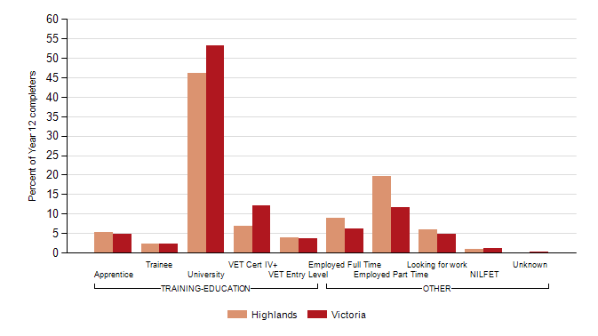
  Note:
  Completers who deferred a place at university or TAFE/VET have been allocated to their labour market destinations.
  Figure 2
  Destinations of 2012 Year 12 or equivalent completers, showing deferrals: Highlands LLEN and Victoria
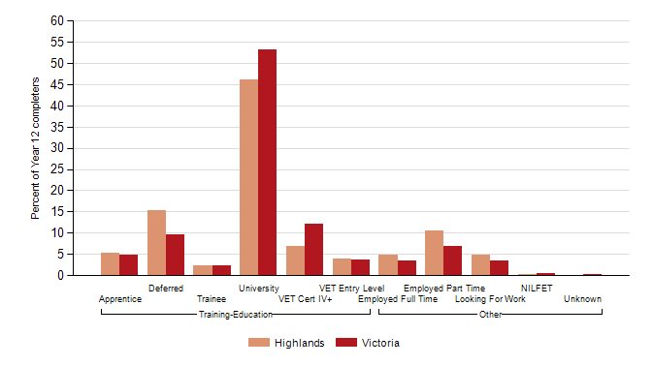

  Figure 3
  Destinations of 2012 early school leavers: Highlands LLEN and Victoria
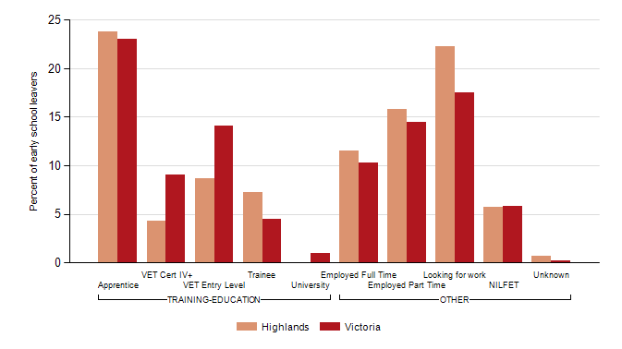

Table 3
  Destinations of all 2012 school leavers by leaver status and year level: Highlands LLEN and Victoria
 |  |  | Highlands |  |  | Victoria
Year level | Destination |  | n | % | n | %
Year 12 or equivalent completers | TRAINING-EDUCATION | Apprentice | 51 | 5.3 | 1609 | 4.8
Year 12 or equivalent completers | TRAINING-EDUCATION | Trainee | 23 | 2.4 | 791 | 2.3
Year 12 or equivalent completers | TRAINING-EDUCATION | University | 447 | 46.1 | 17981 | 53.2
Year 12 or equivalent completers | TRAINING-EDUCATION | VET Cert IV+ | 66 | 6.8 | 4095 | 12.1
Year 12 or equivalent completers | TRAINING-EDUCATION | VET Entry Level | 39 | 4.0 | 1237 | 3.7
Year 12 or equivalent completers | OTHER | Employed Full Time | 86 | 8.9 | 2088 | 6.2
Year 12 or equivalent completers | OTHER | Employed Part Time | 191 | 19.7 | 3971 | 11.8
Year 12 or equivalent completers | OTHER | Looking for work | 57 | 5.9 | 1622 | 4.8
Year 12 or equivalent completers | OTHER | NILFET | 10 | 1.0 | 364 | 1.1
Year 12 or equivalent completers | OTHER | Unknown |  | 0.0 | 13 | 0.0
All Year 12 or equivalent completers |  |  |  |  | 970 | 100.0 | 33771 | 100.0

Year 10 or below early leavers | TRAINING-EDUCATION | Apprentice | 4 | 18.2 | 141 | 30.1
Year 10 or below early leavers | TRAINING-EDUCATION | Trainee | 2 | 9.1 | 29 | 6.2
Year 10 or below early leavers | TRAINING-EDUCATION | VET Cert IV+ |  | 0.0 | 25 | 5.3
Year 10 or below early leavers | TRAINING-EDUCATION | VET Entry Level | 2 | 9.1 | 93 | 19.8
Year 10 or below early leavers | OTHER | Employed Full Time | 4 | 18.2 | 38 | 8.1
Year 10 or below early leavers | OTHER | Employed Part Time | 4 | 18.2 | 51 | 10.9
Year 10 or below early leavers | OTHER | Looking for work | 4 | 18.2 | 71 | 15.1
Year 10 or below early leavers | OTHER | NILFET | 2 | 9.1 | 20 | 4.3
Year 10 or below early leavers | OTHER | Unknown |  | 0.0 | 1 | 0.2
All Year 10 or below early leavers |  |  |  |  | 22 | 100.0 | 469 | 100.0

Year 11/12 early leavers | TRAINING-EDUCATION | Apprentice | 29 | 24.8 | 592 | 21.8
Year 11/12 early leavers | TRAINING-EDUCATION | Trainee | 8 | 6.8 | 114 | 4.2
Year 11/12 early leavers | TRAINING-EDUCATION | University |  | 0.0 | 30 | 1.1
Year 11/12 early leavers | TRAINING-EDUCATION | VET Cert IV+ | 6 | 5.1 | 263 | 9.7
Year 11/12 early leavers | TRAINING-EDUCATION | VET Entry Level | 10 | 8.5 | 355 | 13.1
Year 11/12 early leavers | OTHER | Employed Full Time | 12 | 10.3 | 290 | 10.7
Year 11/12 early leavers | OTHER | Employed Part Time | 18 | 15.4 | 410 | 15.1
Year 11/12 early leavers | OTHER | Looking for work | 27 | 23.1 | 487 | 18.0
Year 11/12 early leavers | OTHER | NILFET | 6 | 5.1 | 165 | 6.1
Year 11/12 early leavers | OTHER | Unknown | 1 | 0.9 | 6 | 0.2
All Year 11/12 early leavers |  |  |  |  | 117 | 100.0 | 2712 | 100.0

Table 4
  Reasons for not studying in 2012: Highlands LLEN and Victoria
 |  |  | Highlands | Victoria
Reasons for not studying |  |  | % | %
Year 12 or equivalent completers
Not in education or training and did not defer
 | You just needed a break from study | 78.1 | 67.2
 | You wanted some other experiences, like travel, before continuing your education | 31.1 | 26.1
 | You wanted to start earning your own money | 92.3 | 80.2
 | You would have had to move away from home | 17.5 | 20.5

Early school leavers
 | The courses you were interested in were not available locally | 27.1 | 26.3
 | You just needed a break from study | 57.1 | 56.9
 | You never planned or intended to study | 24.3 | 22.0
 | You wanted to start working | 85.7 | 80.7

  Notes:
  1. The data in this table are for all school leavers who are not in education or training, including those who
  deferred a place at university or TAFE, as well as those who did not apply for study.
  2. Respondents may have selected more than one reason.

