On Track


The On Track Survey 2012

Gippsland East LLEN

LLEN Report



This report provides information about the destinations of 2011 students exiting schools in this LLEN.

On Track follows up young people in the six months after they leave school to obtain data about their post school education, training and employment destinations.

Data obtained through the On Track survey are used to publish post Year 12 education, training and employment destinations, celebrating the broad range of outcomes schools create for young people – not just university but studying at TAFE, undertaking apprenticeships and other forms of training or employment. Those not studying or in part-time work who request additional pathway advice and support are referred to Youth Connections for help with their career plans.

Since 2003, more than 415,000 Year 10, 11 and 12 school‐leavers have participated in On Track Surveys.

The first On Track Longitudinal Surveys followed groups of 2003 and 2004 school leavers to gain a more detailed picture of their transitions over the four years after they leave school.

The second longitudinal study began in 2008 and followed a cohort of 2007 school leavers until 2011.

Annual On Track reports and the On Track longitudinal reports are available on the On Track website:
www.education.vic.gov.au/ontrack.

Tables

1. | Destinations of 2011 Year 12 or equivalent completers by LLEN
2. | Destinations of 2011 early school leavers LLEN
3. | Destinations of 2011 school leavers by leaver status and year level, Gippsland East LLEN and Victoria
4. | Reasons for 2011 school leavers not studying in 2012, Gippsland East LLEN and Victoria

Figures

1. | Destinations of 2011 Year 12 or equivalent completers, Gippsland East LLEN and Victoria
2. | Destinations of 2011 Year 12 or equivalent completers, showing deferrals, Gippsland East LLEN and Victoria
3. | Destinations of 2011 early school leavers, Gippsland East LLEN and Victoria

  Table 1
  Destinations of 2011 Year 12 or equivalent completers by LLEN
LLEN |  |  |  |  |  |  |  | Total Interviewed | Year 12 completers / response rate
  University
  TAFE/VET
  Apprentice/ Trainee
  Employed
  Looking For Work
  NILFET*
 | n | 911 | 265 | 126 | 224 | 68 | 8 | 1,602 | 2,088
  Banyule Nillumbik
 | % | 56.9 | 16.5 | 7.9 | 14.0 | 4.2 | 0.5 | 100 | 76.7
 | n | 269 | 150 | 104 | 201 | 48 | 11 | 783 | 1,016
  Baw Baw Latrobe
 | % | 34.4 | 19.2 | 13.3 | 25.7 | 6.1 | 1.4 | 100 | 77.1
 | n | 1357 | 349 | 109 | 341 | 80 | 18 | 2,254 | 3,129
  Bayside Glen Eira Kingston
 | % | 60.2 | 15.5 | 4.8 | 15.1 | 3.5 | 0.8 | 100 | 72.0
 | n | 693 | 330 | 79 | 138 | 70 | 7 | 1,317 | 1,785
  Brimbank Melton
 | % | 52.6 | 25.1 | 6.0 | 10.5 | 5.3 | 0.5 | 100 | 73.8
 | n | 105 | 37 | 36 | 68 | 11 | 1 | 258 | 349
  Campaspe Cohuna
 | % | 40.7 | 14.3 | 14.0 | 26.4 | 4.3 | 0.4 | 100 | 73.9
 | n | 495 | 111 | 28 | 92 | 21 | 5 | 752 | 1,193
  Capital City
 | % | 65.8 | 14.8 | 3.7 | 12.2 | 2.8 | 0.7 | 100 | 63.0
 | n | 39 | 16 | 8 | 55 | 10 | 1 | 129 | 167
  Central Grampians
 | % | 30.2 | 12.4 | 6.2 | 42.6 | 7.8 | 0.8 | 100 | 77.2
 | n | 235 | 89 | 48 | 130 | 30 | 4 | 536 | 751
  Central Ranges
 | % | 43.8 | 16.6 | 9.0 | 24.3 | 5.6 | 0.7 | 100 | 71.4
 | n | 662 | 340 | 169 | 433 | 76 | 12 | 1,692 | 2,400
  Frankston Mornington Peninsula
 | % | 39.1 | 20.1 | 10.0 | 25.6 | 4.5 | 0.7 | 100 | 70.5
 | n | 2117 | 466 | 156 | 308 | 68 | 24 | 3,139 | 4,257
  Gateway
 | % | 67.4 | 14.8 | 5.0 | 9.8 | 2.2 | 0.8 | 100 | 73.7
 | n | 180 | 74 | 82 | 146 | 22 | 1 | 505 | 688
  Gippsland East
 | % | 35.6 | 14.7 | 16.2 | 28.9 | 4.4 | 0.2 | 100 | 73.4
 | n | 78 | 26 | 44 | 96 | 13 | 3 | 260 | 329
  Glenelg Southern Grampians
 | % | 30.0 | 10.0 | 16.9 | 36.9 | 5.0 | 1.2 | 100 | 79.0
 | n | 297 | 98 | 111 | 205 | 39 | 10 | 760 | 962
  Goldfields
 | % | 39.1 | 12.9 | 14.6 | 27.0 | 5.1 | 1.3 | 100 | 79.0
 | n | 151 | 85 | 85 | 153 | 23 | 3 | 500 | 777
  Goulburn Murray
 | % | 30.2 | 17.0 | 17.0 | 30.6 | 4.6 | 0.6 | 100 | 64.4
 | n | 425 | 128 | 74 | 213 | 46 | 8 | 894 | 1,217
  Highlands
 | % | 47.5 | 14.3 | 8.3 | 23.8 | 5.1 | 0.9 | 100 | 73.5
 | n | 841 | 509 | 150 | 236 | 88 | 13 | 1,837 | 2,448
  Hume Whittlesea
 | % | 45.8 | 27.7 | 8.2 | 12.8 | 4.8 | 0.7 | 100 | 75.0
 | n | 2495 | 270 | 66 | 294 | 69 | 37 | 3,231 | 4,365
  Inner Eastern
 | % | 77.2 | 8.4 | 2.0 | 9.1 | 2.1 | 1.1 | 100 | 74.0
 | n | 763 | 272 | 80 | 197 | 67 | 16 | 1,395 | 2,028
  Inner Northern
 | % | 54.7 | 19.5 | 5.7 | 14.1 | 4.8 | 1.1 | 100 | 68.8
 | n | 874 | 276 | 87 | 164 | 50 | 12 | 1,463 | 1,972
  Maribyrnong Moonee Valley
 | % | 59.7 | 18.9 | 5.9 | 11.2 | 3.4 | 0.8 | 100 | 74.2
 | n | 64 | 36 | 27 | 31 | 4 | 2 | 164 | 223
  Murray Mallee
 | % | 39.0 | 22.0 | 16.5 | 18.9 | 2.4 | 1.2 | 100 | 73.5
 | n | 73 | 26 | 34 | 119 | 14 | 4 | 270 | 336
  NE Tracks
 | % | 27.0 | 9.6 | 12.6 | 44.1 | 5.2 | 1.5 | 100 | 80.4
 | n | 40 | 10 | 11 | 16 | 3 |  | 80 | 106
  North Central
 | % | 50.0 | 12.5 | 13.8 | 20.0 | 3.8 |  | 100 | 75.5
 | n | 113 | 74 | 59 | 143 | 11 | 3 | 403 | 569
  North East
 | % | 28.0 | 18.4 | 14.6 | 35.5 | 2.7 | 0.7 | 100 | 70.8
 | n | 118 | 45 | 37 | 102 | 15 | 3 | 320 | 448
  Northern Mallee
 | % | 36.9 | 14.1 | 11.6 | 31.9 | 4.7 | 0.9 | 100 | 71.4
 | n | 1175 | 513 | 254 | 455 | 122 | 19 | 2,538 | 3,406
  Outer Eastern
 | % | 46.3 | 20.2 | 10.0 | 17.9 | 4.8 | 0.7 | 100 | 74.5
 | n | 784 | 242 | 142 | 438 | 75 | 10 | 1,691 | 2,316
  Smart Geelong Region
 | % | 46.4 | 14.3 | 8.4 | 25.9 | 4.4 | 0.6 | 100 | 73.0
 | n | 1231 | 609 | 221 | 403 | 133 | 28 | 2,625 | 3,632
  South East
 | % | 46.9 | 23.2 | 8.4 | 15.4 | 5.1 | 1.1 | 100 | 72.3
 | n | 101 | 45 | 39 | 78 | 17 | 7 | 287 | 389
  South Gippsland Bass Coast
 | % | 35.2 | 15.7 | 13.6 | 27.2 | 5.9 | 2.4 | 100 | 73.8
 | n | 212 | 85 | 118 | 160 | 20 | 3 | 598 | 778
  South West
 | % | 35.5 | 14.2 | 19.7 | 26.8 | 3.3 | 0.5 | 100 | 76.9
 | n | 72 | 19 | 26 | 77 | 9 | 5 | 208 | 271
  Wimmera Southern Mallee
 | % | 34.6 | 9.1 | 12.5 | 37.0 | 4.3 | 2.4 | 100 | 76.8
 | n | 640 | 317 | 103 | 201 | 66 | 14 | 1,341 | 1,855
  WynBay
 | % | 47.7 | 23.6 | 7.7 | 15.0 | 4.9 | 1.0 | 100 | 72.3
 | n | 9 | 13 | 14 | 26 | 6 | 1 | 69 | 92
  Unknown LLEN
 | % | 13.0 | 18.8 | 20.3 | 37.7 | 8.7 | 1.4 | 100 | 75.0
 | n |  |  |  |  |  |  | 33,901 | 46,342
  Victoria
  17,619
  5,925
  2,727
  5,943
  1,394
  293
 | % | 52.0 | 17.5 | 8.0 | 17.5 | 4.1 | 0.9 | 100 | 73.2

  Notes:
  Completers who deferred a place at university or TAFE have been allocated to their labour market destinations.
  NILFET*: Not in labour force, education or training

Table 2
  Destinations of 2011 early school leavers by LLEN
LLEN |  | University | TAFE/VET | Apprentice/ Trainee | Employed | Looking For Work | NILFET | Total Interviewed | Est. Early Leavers / response rate
 | n | 0 | 13 | 31 | 16 | 13 | 4 | 77 | 300
  Banyule Nillumbik
 | % | 0.0 | 16.9 | 40.3 | 20.8 | 16.9 | 5.2 | 100 | 25.7
 | n | 0 | 43 | 56 | 28 | 17 | 7 | 151 | 385
  Baw Baw Latrobe
 | % | 0.0 | 28.5 | 37.1 | 18.5 | 11.3 | 4.6 | 100 | 39.2
 | n | 0 | 12 | 24 | 28 | 15 | 6 | 85 | 373
  Bayside Glen Eira Kingston
 | % | 0.0 | 14.1 | 28.2 | 32.9 | 17.6 | 7.1 | 100 | 22.8
 | n | 0 | 39 | 64 | 37 | 25 | 6 | 171 | 565
  Brimbank Melton
 | % | 0.0 | 22.8 | 37.4 | 21.6 | 14.6 | 3.5 | 100 | 30.3
 | n | 0 | 4 | 19 | 5 | 6 | 0 | 34 | 100
  Campaspe Cohuna
 | % | 0.0 | 11.8 | 55.9 | 14.7 | 17.6 | 0.0 | 100 | 34.0
 | n | 2 | 17 | 12 | 27 | 25 | 13 | 96 | 444
  Capital City
 | % | 2.1 | 17.7 | 12.5 | 28.1 | 26.0 | 13.5 | 100 | 21.6
 | n | 0 | 0 | 6 | 3 | 3 | 1 | 13 | 74
  Central Grampians
 | % | 0.0 | 0.0 | 46.2 | 23.1 | 23.1 | 7.7 | 100 | 17.6
 | n | 0 | 9 | 33 | 16 | 9 | 5 | 72 | 247
  Central Ranges
 | % | 0.0 | 12.5 | 45.8 | 22.2 | 12.5 | 6.9 | 100 | 29.1
 | n | 0 | 33 | 71 | 58 | 30 | 13 | 205 | 676
  Frankston Mornington Peninsula
 | % | 0.0 | 16.1 | 34.6 | 28.3 | 14.6 | 6.3 | 100 | 30.3
 | n | 2 | 33 | 44 | 34 | 19 | 4 | 136 | 512
  Gateway
 | % | 1.5 | 24.3 | 32.4 | 25.0 | 14.0 | 2.9 | 100 | 26.6
 | n | 0 | 24 | 63 | 35 | 16 | 7 | 145 | 430
  Gippsland East
 | % | 0.0 | 16.6 | 43.4 | 24.1 | 11.0 | 4.8 | 100 | 33.7
 | n | 0 | 6 | 25 | 14 | 2 | 0 | 47 | 112
  Glenelg Southern Grampians
 | % | 0.0 | 12.8 | 53.2 | 29.8 | 4.3 | 0.0 | 100 | 42.0
 | n | 2 | 49 | 102 | 50 | 24 | 13 | 240 | 570
  Goldfields
 | % | 0.8 | 20.4 | 42.5 | 20.8 | 10.0 | 5.4 | 100 | 42.1
 | n | 1 | 24 | 23 | 21 | 8 | 2 | 79 | 308
  Goulburn Murray
 | % | 1.3 | 30.4 | 29.1 | 26.6 | 10.1 | 2.5 | 100 | 25.6
 | n | 0 | 31 | 61 | 22 | 10 | 6 | 130 | 468
  Highlands
 | % | 0.0 | 23.8 | 46.9 | 16.9 | 7.7 | 4.6 | 100 | 27.8
 | n | 0 | 47 | 67 | 46 | 41 | 8 | 209 | 847
  Hume Whittlesea
 | % | 0.0 | 22.5 | 32.1 | 22.0 | 19.6 | 3.8 | 100 | 24.7
 | n | 3 | 14 | 14 | 12 | 14 | 2 | 59 | 238
  Inner Eastern
 | % | 5.1 | 23.7 | 23.7 | 20.3 | 23.7 | 3.4 | 100 | 24.8
 | n | 2 | 46 | 41 | 31 | 45 | 26 | 191 | 707
  Inner Northern
 | % | 1.0 | 24.1 | 21.5 | 16.2 | 23.6 | 13.6 | 100 | 27.0
 | n | 1 | 29 | 34 | 19 | 18 | 10 | 111 | 435
  Maribyrnong Moonee Valley
 | % | 0.9 | 26.1 | 30.6 | 17.1 | 16.2 | 9.0 | 100 | 25.5
 | n | 0 | 10 | 20 | 8 | 2 | 3 | 43 | 98
  Murray Mallee
 | % | 0.0 | 23.3 | 46.5 | 18.6 | 4.7 | 7.0 | 100 | 43.9
 | n | 0 | 12 | 15 | 7 | 3 | 0 | 37 | 109
  NE Tracks
 | % | 0.0 | 32.4 | 40.5 | 18.9 | 8.1 | 0.0 | 100 | 33.9
 | n | 0 | 1 | 8 | 3 | 2 | 3 | 17 | 39
  North Central
 | % | 0.0 | 5.9 | 47.1 | 17.6 | 11.8 | 17.6 | 100 | 43.6
 | n | 0 | 11 | 14 | 11 | 8 | 1 | 45 | 173
  North East
 | % | 0.0 | 24.4 | 31.1 | 24.4 | 17.8 | 2.2 | 100 | 26.0
 | n | 0 | 4 | 15 | 12 | 3 | 1 | 35 | 134
  Northern Mallee
 | % | 0.0 | 11.4 | 42.9 | 34.3 | 8.6 | 2.9 | 100 | 26.1
 | n | 1 | 48 | 94 | 65 | 40 | 5 | 253 | 824
  Outer Eastern
 | % | 0.4 | 19.0 | 37.2 | 25.7 | 15.8 | 2.0 | 100 | 30.7
 | n | 0 | 62 | 83 | 42 | 31 | 9 | 227 | 656
  Smart Geelong Region
 | % | 0.0 | 27.3 | 36.6 | 18.5 | 13.7 | 4.0 | 100 | 34.6
 | n | 1 | 60 | 62 | 69 | 46 | 16 | 254 | 812
  South East
 | % | 0.4 | 23.6 | 24.4 | 27.2 | 18.1 | 6.3 | 100 | 31.3
 | n | 0 | 11 | 17 | 11 | 6 | 3 | 48 | 142
  South Gippsland Bass Coast
 | % | 0.0 | 22.9 | 35.4 | 22.9 | 12.5 | 6.3 | 100 | 33.8
 | n | 0 | 15 | 43 | 32 | 6 | 2 | 98 | 335
  South West
 | % | 0.0 | 15.3 | 43.9 | 32.7 | 6.1 | 2.0 | 100 | 29.3
 | n | 0 | 8 | 25 | 17 | 8 | 1 | 59 | 187
  Wimmera Southern Mallee
 | % | 0.0 | 13.6 | 42.4 | 28.8 | 13.6 | 1.7 | 100 | 31.6
 | n | 0 | 44 | 36 | 39 | 31 | 6 | 156 | 462
  WynBay
 | % | 0.0 | 28.2 | 23.1 | 25.0 | 19.9 | 3.8 | 100 | 33.8
 | n | 0 | 2 | 7 | 8 | 7 | 2 | 26 | 123
  Unknown LLEN
 | % | 0.0 | 7.7 | 26.9 | 30.8 | 26.9 | 7.7 | 100 | 21.1
 | n |  |  |  |  |  |  | 3,549 | 11,885
  Victoria
  15
  761
  1,229
  826
  533
  185
 | % | 0.4 | 21.4 | 34.6 | 23.3 | 15.0 | 5.2 | 100 | 29.9

  Figure 1
  Destinations of 2011 Year 12 or equivalent completers: Gippsland East LLEN and Victoria
 | 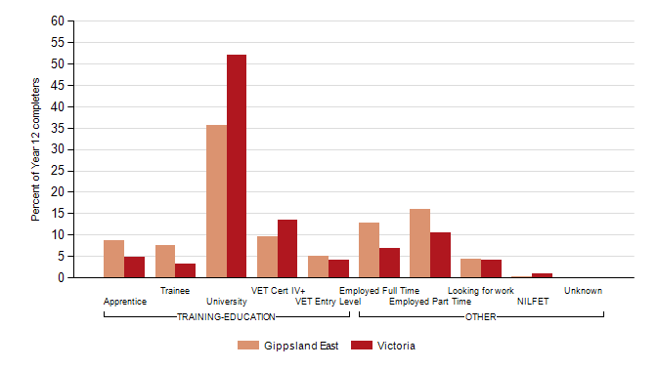
  Note:
  Completers who deferred a place at university or TAFE/VET have been allocated to their labour market destinations.
  Figure 2
  Destinations of 2011 Year 12 or equivalent completers, showing deferrals: Gippsland East LLEN and Victoria
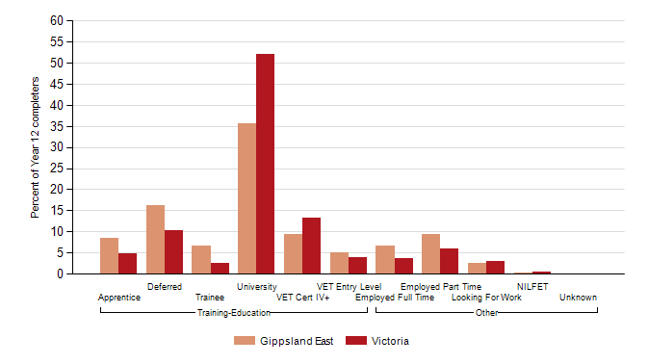

  Figure 3
  Destinations of 2011 early school leavers: Gippsland East LLEN and Victoria
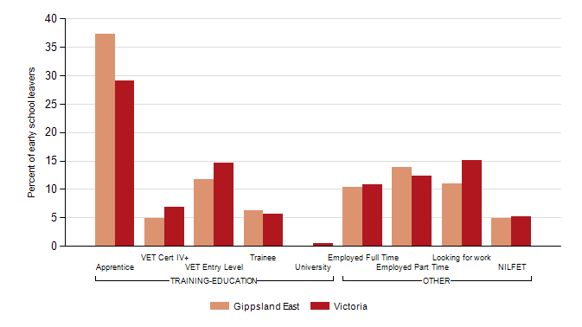

Table 3
  Destinations of all 2011 school leavers by leaver status and year level: Gippsland East LLEN and Victoria
 |  |  | Gippsland East |  |  | Victoria
Year level | Destination |  | n | % | n | %
Year 12 or equivalent completers | TRAINING-EDUCATION | Apprentice | 44 | 8.7 | 1660 | 4.9
Year 12 or equivalent completers | TRAINING-EDUCATION | Trainee | 38 | 7.5 | 1067 | 3.1
Year 12 or equivalent completers | TRAINING-EDUCATION | University | 180 | 35.6 | 17619 | 52.0
Year 12 or equivalent completers | TRAINING-EDUCATION | VET Cert IV+ | 48 | 9.5 | 4547 | 13.4
Year 12 or equivalent completers | TRAINING-EDUCATION | VET Entry Level | 26 | 5.1 | 1378 | 4.1
Year 12 or equivalent completers | OTHER | Employed Full Time | 65 | 12.9 | 2343 | 6.9
Year 12 or equivalent completers | OTHER | Employed Part Time | 81 | 16.0 | 3600 | 10.6
Year 12 or equivalent completers | OTHER | Looking for work | 22 | 4.4 | 1394 | 4.1
Year 12 or equivalent completers | OTHER | NILFET | 1 | 0.2 | 293 | 0.9
All Year 12 or equivalent completers |  |  |  |  | 505 | 100.0 | 33901 | 100.0

Year 10 or below early leavers | TRAINING-EDUCATION | Apprentice | 5 | 38.5 | 219 | 37.4
Year 10 or below early leavers | TRAINING-EDUCATION | Trainee | 2 | 15.4 | 32 | 5.5
Year 10 or below early leavers | TRAINING-EDUCATION | University |  | 0.0 | 1 | 0.2
Year 10 or below early leavers | TRAINING-EDUCATION | VET Cert IV+ | 1 | 7.7 | 26 | 4.4
Year 10 or below early leavers | TRAINING-EDUCATION | VET Entry Level | 2 | 15.4 | 125 | 21.4
Year 10 or below early leavers | OTHER | Employed Full Time |  | 0.0 | 29 | 5.0
Year 10 or below early leavers | OTHER | Employed Part Time | 1 | 7.7 | 48 | 8.2
Year 10 or below early leavers | OTHER | Looking for work | 2 | 15.4 | 70 | 12.0
Year 10 or below early leavers | OTHER | NILFET |  | 0.0 | 35 | 6.0
All Year 10 or below early leavers |  |  |  |  | 13 | 100.0 | 585 | 100.0

Year 11/12 early leavers | TRAINING-EDUCATION | Apprentice | 49 | 37.1 | 811 | 27.4
Year 11/12 early leavers | TRAINING-EDUCATION | Trainee | 7 | 5.3 | 167 | 5.6
Year 11/12 early leavers | TRAINING-EDUCATION | University |  | 0.0 | 14 | 0.5
Year 11/12 early leavers | TRAINING-EDUCATION | VET Cert IV+ | 6 | 4.5 | 218 | 7.4
Year 11/12 early leavers | TRAINING-EDUCATION | VET Entry Level | 15 | 11.4 | 392 | 13.2
Year 11/12 early leavers | OTHER | Employed Full Time | 15 | 11.4 | 357 | 12.0
Year 11/12 early leavers | OTHER | Employed Part Time | 19 | 14.4 | 392 | 13.2
Year 11/12 early leavers | OTHER | Looking for work | 14 | 10.6 | 463 | 15.6
Year 11/12 early leavers | OTHER | NILFET | 7 | 5.3 | 150 | 5.1
All Year 11/12 early leavers |  |  |  |  | 132 | 100.0 | 2964 | 100.0

Table 4
  Reasons for not studying in 2011: Gippsland East LLEN and Victoria
 |  |  | Gippsland East | Victoria
Reasons for not studying |  |  | % | %
Year 12 or equivalent completers
Not in education or training and did not defer
 | The courses you were interested in were not available locally | 26.4 | 20.1
 | You just needed a break from study | 62.1 | 66.7
 | You never planned or intended to study | 29.9 | 26.9
 | You wanted to start earning your own money | 87.4 | 82.8

Early school leavers
 | The courses you were interested in were not available locally | 31.5 | 24.6
 | You just needed a break from study | 48.1 | 56.1
 | You never planned or intended to study | 27.8 | 24.1
 | You wanted to start earning your own money | 85.2 | 80.4

  Notes:
  1. The data in this table are for all school leavers who are not in education or training, including those who
  deferred a place at university or TAFE, as well as those who did not apply for study.
  2. Respondents may have selected more than one reason.

