TRANSITION: A POSITIVE START TO SCHOOL INITIATIVE – CONSULTATION 2015

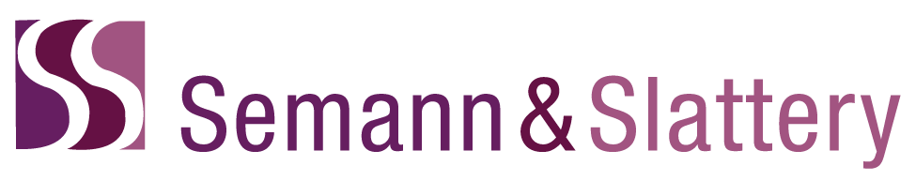

DISCLAIMER
Semann & Slattery will bear no responsibility for any loss or inconvenience arising to the client organisation and/or any third party, which may arise through use of the data and/or recommendations from this project and the final report. If you have any question regarding this report, please contact the Directors at info@semannslattery.com

Table of Contents
THE RESEARCH TEAM 4
EXECUTIVE SUMMARY 6
INTRODUCTION 16
METHODOLOGY 20
Research design 20
Ethics approval 20
Recruitment strategies 20
Data gathering processes 21
Participants 23
Data Analysis 24
Limitations to this consultation 25
FINDINGS 26
Findings from prior to school, school and OSHC professionals 26
1. What successful strategies are being implemented, by schools and by ECEC services, to facilitate positive transitions for children and families? 27
Family specific meetings 27
Individual activities 29
Networks 30
School-based programs 31
Variations in practice according to diverse needs and backgrounds 36
Have participants observed changes in children’s transition to school from using these strategies? What are these? 53
2. How are the Transition Statements and supporting resources used and how helpful are they to key stakeholders? 57
Perceptions of use of Transition Statements 57
Helpfulness of DET transition resources 59
Do participants use the supporting resources? Why/why not? How are they used? 66
What information in the Transition Statements and supporting resources is most helpful? What isn’t helpful, if any? What could be improved? 68
3. How are transition strategies currently being evaluated by ECEC services and schools, to determine the level of interest for the further development of the Outcomes and Indicators evaluation tool? 77
Existence of evaluation practices 77
Perception of importance 79
Frequency 79
Tools or resources used to evaluate 79
Stakeholder perspectives included 84
Manner in which the information was used 84
How do participants know if the strategies implemented are impacting on children’s transition to school? Are strategies evaluated and/or reviewed? 87
Findings from families 90
Children’s positive experiences in starting school: 91
Resources for transition 93
Preparation for school strategies 94
Additional information 95
Findings from discussions with children 97
DISCUSSION 100
Recommendations 105
APPENDICES 109
APPENDIX 1: questions asked in face-to-face consultations and/or telephone conversations 109
APPENDIX 2: online survey questions 111
APPENDIX 3: external transition resources listed by prior to school focus group participants 123
APPENDIX 4: children’s data 124

THE RESEARCH TEAM

Anthony Semann - Director Semann & Slattery
- PhD Candidate (Macquarie University)
- Master of Arts with Merit (Sociology & Social Policy)
- Bachelor of Education (Early Childhood)
- Certificate IV (Workplace Assessment and Training)
- Accredited Hogan Assessor

Lorraine Madden – Associate Semann & Slattery
- Masters of Applied Science (Coaching Psychology)
- Bachelor of Education (Early Childhood)
- Diploma of Teaching (Early Childhood)
- Diploma Counselling and Groupwork
- Certificate IV (Workplace Assessment and Training)
- Accredited Hogan Assessor

Dr Hanan Sukkar – Senior Associate Semann& Slattery
- D.Ed. Special Education
- M.Ed. Special Education
- Grad. Dip Leadership in Policy
- PG Dip Special Education
- B.SC. Child & Family Development

Christa Sue Walker – Associate Semann & Slattery
- Graduate Certificate Science (Statistics) Current
- Masters of Education
- Bachelor of Arts (International Relations & Political Science)
- CERT IV & CELTA

Suallyn MItchelmore – Associate Semann & Slattery
- PhD Candidate (Macquarie University)
- Master Education Leadership (Early Childhood Education)
- Bachelor of Teaching (Early Childhood)
- Bachelor of Arts (Fine Arts)
- Certificate IV (Workplace Assessment and Training)

Associate Professor Alma Fleet – Adjunct Associate Semann & Slattery and Honorary Associate Macquarie University
- PhD
- Master of Education
- Bachelor of Arts (with Honours)
- Bachelor of Teaching

Dr Katey De Gioia - Senior Lecturer Macquarie University
- PhD
- Master of Education (Early Childhood)
- Bachelor of Education (Early Childhood)
- Diploma of Education (Early Childhood Education)

EXECUTIVE SUMMARY

It is widely accepted in both national and international literature that children’s experience of educational transitions has an impact on their learning and development, wellbeing and their engagement with the school. Additionally the role and relationships of educators across the prior to school and school sector is critical to ensuring the successful transitioning of children. To this end the Victorian Department of Education and Training has demonstrated leadership in developing a range of resources and processes with the explicit aim of ensuring the educational success of Victorian students.

In 2009, Victoria released the Transition: A Positive Start to School initiative. The aim of this initiative was to improve the experiences of starting school for children and families by enhancing the development and delivery of transition programs. The initiative was accompanied by a transition kit that included:
- A transition to school resource kit;
- Transition learning and development statements;
- A professional development package for early childhood and primary school educators on transition with strong links to professional development related to the Victorian Early Years Learning and Development Framework; and
- A research report from Victoria University on the outcomes and indicators of a positive start to school.

The individualised Transition Learning and Development Statement (Statement) supports the consistent transfer of information, irrespective of the school a child will attend. The Statement provides an opportunity for children, their families and the professionals working with them to share valuable information. It summarises a child’s strengths and abilities, identifies their individual approach to learning, provides insights into their family background and indicates how the child can be supported to continue their learning and development.

In 2010 further support for transition to school included:
- A report on the evaluation of the transition initiative which provided feedback and recommendations on the development of the initiative, roll out and support, and resource materials;
- A professional development program to support the transition initiative in term 3, including a specialised module to support early childhood educators to engage families from Culturally and Linguistically Diverse backgrounds; and
- A guide to assist prep teachers to use the statement for designing and delivering curriculum.

In 2014, 74,826 Victorian children moved from early childhood education and care or home-based settings into primary school, with 51,222 of those (68 per cent) starting Prep in a government school. For the vast majority of these children, the transition to school is a positive and exciting time in their lives. Recently, the Victorian Government has made further progress in ensuring that transitions for all children support their academic success.

The Education Transitions report by the Victorian Auditor General Office (2015) examined ‘how well early childhood education and care providers and schools support children to make successful transitions’. It also looked at how effective the Department of Education and Training (DET) has been in supporting, guiding and monitoring early childhood education and care providers and schools.’ (pg vii). A number of recommendations were contained in the report including a recommendation that a review of the use of early years transitions statements be undertaken with a particular focus on the adequacy of the information captured; the relationships between early childhood and school based educators and the training and development of educators in early childhood and school based settings to develop a shared understanding of the role of both sectors.

Noted in the Auditor General Office report is the increase levels of participation in kindergarten programs across Victoria. In 2014, approximately 96 per cent of four-year-old children in Victoria were enrolled in a funded kindergarten program. Research has indicated that children in high quality early childhood programs show better outcomes across a range of areas including: better cognitive and language development, and better achievement in maths and reading when they go to school (Sylva, Melhuish, Sammons, Siraj-Blatchford, Taggart, 2004; Harrison, Ungerer, Smith, Zubrick, Wise, et al., 2009). Some of the classic studies of early intervention indicate that these benefits can last a life-time (Semann & Sims, 2010), as well as having a positive impact on a child's later school-based outcomes.

It is timely given emerging evidence relating to transition to school, the Victorian Auditor General’s report and the time passed since the release of Transition: A Positive Start to School initiative (Transition Initiative) that an investigation be undertaken exploring how to improve a range of transition to school initiatives and processes. To this end, the Transition: A Positive Start to School initiative - Consultation 2015 was an initiative funded by the Victorian Department of Education and Training. The consultation sought to obtain qualitative feedback from key stakeholders to strengthen the Department’s understanding of current transition approaches, including the use of Transition Statements and supporting resources, to consider what is working well and where improvements can be made.

Specifically, the consultation aimed to address:
- What successful strategies are being implemented by schools and prior to school services to facilitate positive transitions for children and families;
- How transition statements and supporting resources are used and how helpful they are to key stakeholders; and
- How transition strategies are being evaluated by prior to school services and schools, to determine the level of interest for the further development of the Outcomes and Indicators evaluation tool.

A mixed methods approach was employed to reflect the views of stakeholders in regional and metropolitan Victoria between the May and June 2015. Focus groups, teleconferences, online surveys and informal consultations were used to document stakeholders’ feedback. A total of 626 people participated in the project. This included 409 prior to school professionals, 136 school professionals, 8 Outside School Hours Care (OSHC) professionals, 42 family members and 31 prep children. It should also be noted that every effort was made to include a large number and diverse range of participants in the project. This project captured a snapshot of the overall transition community and the data and recommendations should be read alongside other research and statistics about the transition to school conducted in Victoria in order to provide a more multi-dimensional and more detailed analysis of the Victorian education sector. It is suggested that further work be considered to capture the voices particularly of families and children from a variety of demographics.

This consultation highlighted a number of key themes evident across settings and stakeholders. These key themes included approaches that prioritise ongoing communication and collaboration, the valuing of personal relationships, and how flexibility and responsiveness enhance the experience of starting school for children and families. Such principles were also supported through previous research which identified a range of promising practices including but not limited to those which support family involvement activities, joint opportunities for learning and learning programs responsive to the needs of children. The effectiveness of the Transition: A Positive Start to School initiative can also be seen in the number of respondents who referred to (although not always by name) materials and practices identified in the transition kit.

Overall, there was a support for Transition Statements as a means of ensuring that information was transferred from a prior to school to a school setting with the explicit aim of supporting a child’s success during this period of change. Of particular note was the apparent need for further resourcing and support to assist educators in both prior to school and school settings understanding the ways in which strength based approaches can be applied to the writing of Transition Statements. A misinterpretation of this approach was evidenced throughout the consultation phase with educators assuming that a strengths based approach meant that only positive attributes about a child could be noted within the Transition Statement.

Furthermore, there were numerous examples cited where educators in both prior to school and school settings ensured that the needs of specific cohorts of children, including children from culturally and linguistically diverse backgrounds, children with additional needs, children from Aboriginal backgrounds and children known to child protection, were accommodated through the transition process. In accommodating the specific needs of these children, educators noted a commitment to individualised support and approaches during the transition phase for both children and their families. Extending on supporting both the needs of these specific cohorts as well as other children, relationship building between educators and families was noted as central to a child’s successful transition. This relationship building as well as the broader success of transitions was identified as requiring an investment of time and resourcing for educators. For some educators, the transition statements were an enabler and mechanism for facilitating relationships with families and an entrée into conversations with families about their child’s learning and development.

Throughout the study a number of participants in prior to school settings shared concerns about the perception that Transition Statements were not being used to the best of their ability by school based educators, stating that teachers in schools did not take the time to read these statements. However this was disputed by a number of teachers who clearly stated the usefulness of Transition Statements in supporting a child’s success at school.

Specific findings which resulted from this study related to each of the determined key questions were as follows:

What successful strategies are being implemented by schools and prior to school services to facilitate positive transitions for children and families?

While allowing for local context and individual variation, a number of consistent transition strategies were evident across settings and stakeholders to facilitate positive transitions for children and families. Generally, successful approaches were perceived as ones that prioritise ongoing communication and relationships with children and families. Many of these strategies are consistent with commonly used transition to school practices identified in the evaluation of 30 transition pilots funded through the Transition: A Positive Start to School initiative, which ran from October 2008 to May 2009 (Astbury, 2009). These “promising practices” are included in the Transition: A Positive Start to School Resource Kit (DEECD, 2009).

Variations in transition approaches were also noted when supporting children and families from diverse backgrounds and with diverse needs. This included children with a disability or additional need; children and families from English as an Additional Language (EAL) backgrounds; children and families from Koorie backgrounds; and children known to Child Protection/ChildFIRST. Such variations in approaches are consistent with information included in Part 2 of the Transition: A Positive Start to School Resource Kit.

Participants noted that additional support is required for children with additional needs. The diverse approaches developed at a local level could be considered by the Department for implementation on a more consistent basis, and could be provided to educators across the State with this information.

It is noted that the Transition: A Positive Start to School Resource Kit was considered the most helpful DET resource by both prior to school and school online survey respondents. However, the extent to which participants gained the ideas for their transition strategies from the Resource Kit is unclear, although it is affirming for the Department that the positive strategies that were reported as being used were consonant with those recommended in the Kit.

Teachers
Teachers/educators across schools and prior to school settings are committed to making transition to school a positive experience for children and families. Opportunities to develop stronger connections and shared understandings through face to face meetings, professional conversations, and reciprocal visits were seen as beneficial to enhancing current transition practices. The sentiments expressed by teachers/educators reflect their appreciation of transition practices that are underpinned by strong, genuine and collaborative relationships. Such an approach which values relationships as being core to successful transitional processes is supported by the understanding of the importance of creating and maintaining strong relationships across a range of settings including those between home and educational settings. This ecological understanding situates the relationships across a range of systems as central to ensuring contextual understandings and the successful transition of children across a range of settings, and builds on the Victorian Early Years Learning and Development Frameworks adaption of Bronfenbrenner’s (1979) Ecological model of child development.

Families
There was wide variation in families’ experience of and expectations about starting school. Families who were comfortable with their children’s transition to school, valued conversations with trusted teachers, both in prior-to-school settings and schools, as well as school transition programs and activities. Families also identified a range of opportunities for strengthening their child’s transition experience and these improvements included increased communication between families and educators as well as a greater understanding about the child and families specific circumstances which might impact on their child’s transition. Families noted the value of Transition Statements in the context of round table discussions.

Children
A child’s transition to school impacts greatly on their future school experiences including their settling into a formal school setting. Children who participated in the focus groups shared a range of positive aspects associated with starting school including making friends, and doing things they enjoyed, including learning and playing. Additionally children recalled initial feelings of uncertainty, shyness and nervousness. Children with siblings or friends in the school were more confident than those without, although with supportive school environments, initial reticence was quickly overcome. Key elements that emerged from analysis of children’s data, which was supported by previous research, included the importance of family support, siblings’ prior experiences, transition programs, and making friends. Children also appreciated being able to name and clarify expectations, particularly by becoming familiar with their teacher, the school environment and school routines.

How are supporting resources used including Transition Statements and how helpful are they to key stakeholders?

Resources
Prior to school sites were creative in sourcing resource material from a range of sites as well as developing their own information systems to assist with transition to school. Nevertheless, whilst physical materials were useful to support transition to school, human resources were deemed more effective, and as such the valuing of relationships was prioritised throughout the data collected. Opportunities to meet and share information, including reciprocal visits between schools and prior to school settings, were associated with enhancing current transition practices.

Transition Statements
Whilst transition statements were noted as being a valuable tool for sharing information to support a child’s transition to school, a number of participants raised opportunities for improvements to strengthen the existing Statements and to address a number of existing challenges. This included the diverse audience the document is intended for, the need for additional professional development and the challenges faced by new graduating teachers in completing the Statements who may not have previously attended professional development. Transition Statements were noted to be time-consuming for prior to school teachers/educators and under-utilised by prep teachers (by 31 from 97 respondents in an open ended online survey and in seven prior to school or combined focus groups and teleconferences). There was also concern from families that the Transition Statement may not always be used efficiently by school teachers.

In order to overcome these challenges participants suggested revising the content, length and format of the statements as well as employer bodies providing the necessary time to complete the Statements. Areas for improvement included further opportunities created to share additional information across educational settings while ensuring privacy and confidentiality is maintained, addressing concerns about the appropriate use of strengths-based reporting, and the need for information about strengths based reporting to be accessed by prep teachers and support personnel.

How are transition strategies being evaluated by prior to school services and schools, in relation to the level of interest for further development of the Outcomes and Indicators evaluation tool?

Evaluation
Formalised evaluation processes serve a critical role in improving systems and processes whilst also enabling reflection as a tool for system reform. While some respondents indicated that they conducted reflection or evaluation sessions after the Transition Statement process, across the sector, evaluation processes were generally informal. A notable proportion of participants (approximately 20% as identified in online surveys) reported that they were not evaluating transition approaches and strategies at all. A number of participants cited that they were unaware of any formal tools available to evaluate their transition processes.

There was also concern about the lack of critical reflection on Transition Statements. This is closely linked to the relationship between schools and prior to school settings. Three focus groups and one teleconference consultation with the prior to school sector raised the issue that they do not receive any indication from schools about the quality and effectiveness of Transition Statements. For early childhood educators, to complete Transition Statements and not receive feedback from schools about whether this was helpful or not was a particular point of concern.

Considerations and Enablers

Resulting from the research a number considerations and enablers have been identified. These include:
- Developing professional learning opportunities to support teachers in working with a diverse range of families to enhance transition;
- Recognising the importance of adjusting transition approaches as required when supporting vulnerable families. This includes building relationships as early as possible, accessing key information from families, and facilitating meetings with families, teachers and other stakeholders;
- Extending transition to school programs, projects and information sessions to include long day care and OSHC settings, and promote greater involvement and collaboration across a broader range of prior to school, school and OSHC settings;
- Ensuring that voices of all stakeholders (including families and children) are included in initiatives led by education professionals in reviewing and revising transition processes;
- Investigating strategies to support networking across sectors to strengthen respectful and professional relationships;
- Providing clear messages to both sectors about ongoing professional dialogues with regards to children and families during transition;
- Increasing understanding of the purpose and need for transition to school statements to be available to key stakeholders in schools, prior to orientation days;
- Supporting schools and prior-to-school settings in coming together to develop a shared understanding of strength-based approaches to transition including the use of both positive descriptions and identification of areas needing further attention;
- Including transition to school principles and strategies in initial and ongoing teacher education;
- Ensuring any revision of transition resources take into consideration the specific needs of children with a disability;
- Prioritising ways to allocate time for transition approaches, including meeting with families, sharing of information and completion of related paperwork;
- Ensuring that any proposed revision to Transition Statements includes feedback from a range of stakeholders including addressing concerns about ways in which families can make a useful contribution;
- Continuing to review transition processes with all stakeholders, including young children and their families; and
- Developing an evaluation tool that is light on documentation, easy to use, time efficient and involves discussion and critical reflection with key stakeholders.

It is also recommended that the Victorian Department of Education and Training undertake further work in identifying the most appropriate mechanisms that will support the implementation of the above listed enablers.

INTRODUCTION

The Education and Training Reform Act 2006 sets the overarching legislative framework for education and training in Victoria. The Act encourages access to high quality education but does not necessarily discuss transition to school (VAGO, 2015). Yet, starting school is a major transition for children and their families. It is a period of change that can be both challenging and exciting. It can be described as a major milestone and a new phase of life for both children and their families (DET, 2015). From a professional viewpoint, for early childhood education and care providers and schools, transition is a process that prepares students for the move; it also ensures that children’s information is transferred as efficiently and effectively as possible to the new school environment (VAGO, 2015).

The experience of transition to school has increased in significance in recent years, while nationally, the Council of Australian Governments has committed to all children being enrolled in early childhood programs prior to starting school. The focus for this transition for children and families has been the movement between the two settings, although historically there has been an ad hoc approach to the partnerships between prior to school and school settings during this transition time. Internationally, research has shown that stronger cohesion between prior to school settings and schools can reduce potential challenges for children during transition (OECD, 2006). The notion of ‘readiness’ has been applied to both the child and the school; ‘ready schools’ take into account individual children and families within the context of the transition (Graue, 2006; Petriwskyj, Thorpe & Tayler, 2005).

In 2009, Victoria released the Transition: A Positive Start to School initiative. The aim of this initiative was to improve the experiences of starting school for children and families by enhancing the development and delivery of transition programs. The initiative was accompanied by a transition kit that included:
- A transition to school resource kit;
- Transition learning and development statements;
- A professional development package for early childhood and primary school educators on transition with strong links to professional development related to the Victorian Early Years Learning and Development Framework; and
- A research report from Victoria University on the outcomes and indicators of a positive start to school.

The individualised Transition Learning and Development Statement (Statement) supports the consistent transfer of information, irrespective of the school a child will attend. The Statement provides an opportunity for children, their families and the professionals working with them to share valuable information. It summarises a child’s strengths and abilities, identifies their individual approach to learning, provides insights into their family background and indicates how the child can be supported to continue their learning and development.

In 2010 further support for transition to school included:
- A report on the evaluation of the transition initiative which provided feedback and recommendations on the development of the initiative, roll out and support, and resource materials;
- A professional development program to support the transition initiative in term 3, including a specialised module to support early childhood educators to engage families from CALD backgrounds; and
- A guide to assist prep teachers to use the Statement for designing and delivering curriculum.

In 2014, 74,826 Victorian children moved from early childhood education and care or home-based settings into primary school, with 51,222 of those (68 per cent) starting Prep in a government school. For the vast majority of these children, the transition to school is a positive and exciting time in their lives. Recently, the Victorian Government has made further progress in ensuring that transitions for all children support their academic success.

In 2015, the Victorian Auditor General’s Office (VAGO) conducted an audit of Victoria’s education transitions, this included transition from early childhood to school, and from primary school to secondary college. The report found that The Department of Education and Training (DET) has implemented a robust and comprehensive approach to supporting early-years transitions.

The VAGO audit also found that ‘most Victorian children are well prepared for their transition to primary school. Prep teachers’ assessments of children's developmental vulnerability and academic preparedness have both improved. However, one in five children still begin school with a developmental vulnerability, and particular cohorts of children—including those from Aboriginal backgrounds, areas with lower socio-economic status, and boys—fare much worse.
The improvements have occurred concurrently with DET’s development and implementation of a comprehensive framework for early-years transitions that includes:
- High-quality guidance and resources for schools, early childhood education and care services and families;
- The requirement for funded kindergarten services to complete and issue transition statements for each child; and
- Specifically-funded programs.

The VAGO report also stated that:

‘more could be done to better monitor the quality and effectiveness of kindergarten programs as well as the initiatives DET has in place to encourage a positive transition to school. DET needs to increase its focus on transitions into school for boys, Aboriginal children, students learning English as an additional language, and students from low socio-economic backgrounds’ (pg. 10).

As a response to this VAGO audit, and a timely six years after the release of the Transition Initiative, the Victorian Department of Education and Training (DET) will review the Transition Statement and supporting resources. In this context, The Transition: A Positive Start to School initiative - Consultation 2015 was an initiative funded by DET. The project sought to obtain qualitative feedback from key stakeholders to strengthen the Department’s understanding of current transition approaches, including the use of Transition Statements and supporting resources, to consider what is working well and where improvements can be made.

Specifically, the consultation aimed to address:
- What successful strategies are being implemented by schools and prior to school services to facilitate positive transitions for children and families;
- How Transition Statements and supporting resources are used and how helpful they are to key stakeholders; and
- How transition strategies are being evaluated by prior to school services and schools, to determine the level of interest for the further development of the Outcomes and Indicators evaluation tool.

This report highlights the findings of consultations undertaken with professionals from a range of prior to school services, schools, outside school hours care (OSHC) services, and with families and children in regional and metropolitan Victoria. The report identifies key themes and issues arising from these findings. It also identifies summary findings for policy-makers to pursue to ensure all children and families experience a positive transition experience. This information, in conjunction with other projects and data sources, will contribute towards a richer knowledge base on transition to school in Victoria, and enable the Department, schools and prior to school settings to better support children and families.

METHODOLOGY

Research design
In order to gain insight into current transition-to-school practices and resource usage across Victoria, a mixed methods approach was employed for the research design. This approach to methodology enabled the process of data gathering to be complementary and allow for triangulation. Both qualitative and quantitative methods of gathering data were equally important in addressing the questions that were posed (Cresswell & Plano Clark, 2010). Qualitative data obtained from focus groups were analysed using NVivo, a computer software program to assist with data analysis. Quantitative data obtained from the online survey were analysed using online survey software and descriptive statistics. Qualitative data obtained from consultations with children and family members was analysed thematically using principles of grounded theory to identify key patterns in both visual and textual data.

This consultation represents a small part of the Victorian community. The information and insights offered by this report are valuable as a snapshot. However these findings need to be triangulated against other data sources by the Department in order to ascertain a more holistic picture on what is happening in transition to school in Victoria.

Ethics approval
Ethics was sought through the Victorian Department of Education and Training, Strategy and Review Group only. Approval was granted 14th April 2015.

Recruitment strategies

Social media
A website was created to provide information about the Transition Consultations (www.victransition.com). It identified the aims of the consultation, how potential participants could become involved, dates and locations of consultations (focus groups) and contact details for further information. The online survey hyperlink was also included on this webpage.

A number of social media platforms were used to promote the project, these included:
- The Semann & Slattery Facebook page (“Liked” by over 4000 people);
- Team members’ personal Facebook pages which have links to people in the education sector;
- Appropriate Facebook groups accessed by school and early childhood professionals throughout Australia: for example, Victorian Early Childhood Teachers Group, EYLF/NQF Ideas and Discussion;
- DET Twitter;
- Email ‘tags’ placed on team members’ response emails; and
- Departmental circulars.

Contacts made in each community
The Victorian Department of Education and Training (DET) emailed communication through their channels targeting key stakeholders and peak organisations, schools, prior to school services, DET schools and appropriate representatives in the Independent and Catholic school sectors.

Research team members from Semann & Slattery and Macquarie University, working in pairs were assigned to communities to gather data. Within each community the following recruitment measures were taken to encourage participation:
- Initial identification and conversations with known contacts. From here, networks were used to further identify participants and recommendations were made;
- Contact with Local Government representatives. This enabled discussion of the consultation and information to be passed through to target audiences. This was also used as a point of contact for access to families; and
- Contact with local schools and prior to school settings; either via email or telephone.

Data gathering processes
Data were gathered using the following means:
- Focus groups. Participants included:
- Early childhood education and care educators and leadership teams, including child care centres, kindergartens, and family day care. In addition, inclusion support facilitators, Maternal and Child Health Nurse and DET representatives were in attendance.
- Prep teachers and leadership teams from government, Catholic, independent schools and OSHC workers and early intervention workers.
- Families of children who started school in 2014 and 2015 in government, Catholic and independent schools, and families of children who are about to start school in 2016.
- Children who had started their first year of school. Two schools were targeted for this purpose, one in North-West Victoria and a school situated in the South-West Victorian region. School principals were contacted, the consultation explained and children currently in Prep and associated buddies were invited to be involved. In both sites, only Prep children participated with parental permission in the consultation.

Focus groups for prior to school and school and OSHC participants were organized and the questions used in these focus groups are included in Appendix 1.

- Teleconferences: These were conducted via phone and participants included early childhood teachers/educators and teachers/ principals from the school sector. In addition a Koorie Engagement Officer, Project Officer and Health Care Worker participated in the teleconference. These were offered to participants in regional areas where there were not enough participants available to hold a sector specific focus group. Similar questions were used in the teleconference to those used during focus groups. In some instances, individual phone interviews were held.

- Online survey: The use of an online survey was not a part of the original methodology. However, it was determined that this option would provide teachers and educators across the prior to school and school/OSHC sectors with additional opportunities to share their experiences and perspectives as part of the consultation process. This included the opportunity for people not able to attend the face-to-face consultations to contribute. Accordingly, two online surveys were developed: one for prior to school and one for school/OSHC.

The questionnaire comprised 30 questions to align with questions used in focus groups. The online survey questions included a mix of open ended and closed ended questions, to provide both qualitative data and quantitative data. Online survey questions are included in this report as Appendix 2. A total of 383 people completed the online survey. This included 283 prior to school respondents and 94 school and 6 OSHC respondents.

- Informal consultations: In some regions families and children were invited to participate in a less formal environment. Researchers were situated on the school or prior to school grounds and spoke with parents or children who had shown an interest in being involved. Questions asked of families and children are included as Appendix 1.

Participants
The following tables represent participants involved in each of the data gathering processes:

Table 1: Number of participants involved in focus group consultations from prior to school, school and OSHC settings
Location | Prior to school | School | OSHC
Dandenong | 30 | 5 | 0
Bendigo | 0 | 0 | 0
Lilydale | 12 | 0 | 0
Geelong | 16 | 7 | 2
Latrobe | 14 | 10 | 0
Moonee Valley | 30 | 16 | 0
Wangaratta | 10 | 2 | 0
TOTAL | 112 | 40 | 2

Table 2: Number of participants involved in teleconference consultations from prior to school, school settings
Location | Prior to school | School*
Warrnambool | 6 | 1
Mildura | 5 | 1
Horsham | 2 | 0
Other | 1 | 0
TOTAL | 14 | 2
* There were no participants from OSHC programs involved in the teleconference.

Table 3: Number of participants involved in child and family consultations from prior to school and school settings
Location | Families | Children
Dandenong | 5 | NA
Bendigo | 5 | 15
Lilydale | 9 | NA
Geelong (FG) | 9 | NA
Latrobe (FG) | 5 | NA
Moonee Valley (FG) | 9 | 16
Wangaratta | 0 | N/A
TOTAL | 42 | 31
* Focus groups. Those not labelled, involved informal consultations.

Table 4: Number of online survey respondents from prior to school, school and OSHC settings
Prior to school | 283
School | 94
OSHC | 6
Total | 383

Data Analysis
Qualitative data were analysed using NVivo, a computer software program to assist with data analysis (QSR International Pty Ltd, 2011). All data were transcribed and imported into NVivo. Initially data was divided into the three discreet groups associated with the questions posed:
- Transition approaches;
- Transition resources; and
- Evaluation of transition practices.

Data within each group were coded accordingly with themes and patterns consequently identified. The project team reviewed codes within each group and across the data to ensure consistency in analysis. Coded data were subject to further scrutiny. Each set were examined to identify any differences based on location and sector (prior to school and school) with findings reported showing these attributes.

Quantitative data were analysed using online survey software and descriptive statistics. Data from the two online surveys were represented using Survey Monkey’s data representation tools in a Word document, resulting in a tabulation and pie chart per question. Simple summaries of each sample were then described highlighting the mode and/or interesting emergent features.

Qualitative data obtained from consultations with children and family members was analysed thematically using principles of grounded theory to identify key patterns in both visual and textual data.

Limitations to this consultation

As noted previously this study captures a snapshot of the transition processes across Victoria and the use of associated resources. In undertaken this study the following limitations were identified:
- OSHC participants: There was very limited participant involvement from OSHC participants despite all efforts being made to involve them in the consultation. Further consultation in this area specifically targeting OSHC is needed to provide true representation of their experiences of transition to school approaches and resources.
- Contextual factors: including conflicting consultations; for example DET regional restructures and industrial protected action regarding Transition Statements may have impacted on participant involvement.
- Family involvement: research involving families and more specifically families from CALD backgrounds takes time. Building rapport and ensuring families feel comfortable to trust researchers is not automatic. This was not possible as family individual consultations or focus groups were held at a particular time and potential participants attended. Further, in some communities the research team approached schools to invite parents to participate in the focus groups and therefore they circulated print material which may have excluded involvement of families from CALD backgrounds or those who experience illiteracy.
- Survey completion rate: Whilst the online survey was developed as an alternative to attendance at the focus groups, there was a low completion rate across all cohorts. There were a large number of open-ended questions to elicit information similar to focus groups, which may have created survey fatigue.
- Children’s involvement: Further research from a larger number of children might enable more perspectives to be gained.

FINDINGS

Findings from prior to school, school and OSHC professionals

Findings for prior to school, school and OSHC participants are presented below under the three key questions that address:
- What successful strategies are being implemented, by schools and by ECEC services, to facilitate positive transitions for children and families?
- How are the Transition Statements and supporting resources used and how helpful are they to key stakeholders?
- How are transition strategies currently being evaluated by ECEC services and schools, to determine the level of interest for the further development of the Outcomes and Indicators evaluation tool?

Within each question set, findings incorporate data from the focus groups, teleconferences and the online survey. Participant quotes are represented. These are taken directly from the following means:
- Facilitator sheets at the focus groups;
- Transcription of teleconferences; and
- Qualitative data collected from the online survey.

Family and children’s responses are represented separately following the responses to the questions identified above.

1. What successful strategies are being implemented, by schools and by ECEC services, to facilitate positive transitions for children and families?

The Transition Resource Kit (2009) contains within it a range of promising practices which support effective transitions. These promising practices which emerge from research conducted in Victoria aim to support transitional practices that enable young learners to succeed as they move across educational settings. A number of these promising practices were identified in the course of this research project and in part led to successful transitional processes across a range of diverse settings. The Victorian Auditor General’s Office report also identifies that Victorian early childhood and school settings are generally undertaking a range of successful initiatives that support a child’s transition from an early childhood program to a school setting.

Findings from focus groups, teleconferences and online surveys identified that there were many strategies being implemented in prior to school and school settings to support successful transitions. These strategies are analysed and described below coded to the following:
- Family specific meetings;
- Networks; and
- School-based programs

It is envisaged this information will assist the Department of Education and Training to strengthen its understanding of current transition approaches and inform the development and provision of future resources and support to school and prior to school services.

Family specific meetings
Participants in school focus groups identified a number of specific meetings and events that they undertook to support families. Such a practice supports parental engagement and involvement and is critical in enhancing partnerships across service systems. This approach is also aligned to the promising practice of family involvement as highlighted in the Transition: A Positive Start to School Kit (2009).

For example, the school focus group held in Dandenong identified the following:
- One-on-one interviews with parents/child on enrolment;
- Parent information nights, with prep teachers in attendance;
- Parent information sessions while children attended transition sessions in fourth term;
- School tours, which included weekend options for working parents; and
- Prep bbq was held in first term for prep children, their families and their school buddies.

The school focus group held in Geelong also noted parent information sessions as a strategy to support transition. These were organised through the network meetings and covered a range of topic areas including speech development, nutrition and behaviour.

Prior to school focus groups also reported holding family specific meetings. The most commonly reported meetings were:
- Parent/teacher discussions or interviews (Dandenong, Geelong, Latrobe, Warrnambool);
- Parent information nights (Geelong, Lilydale, Warrnambool); and
- School open days (Latrobe).

Participants in a combined focus group, including mostly prior to school teachers in Wangaratta reported that meetings were held with the family and all professionals involved with children, in order to set goals and “move forward together”.

Participants in the Warrnambool prior to school teleconference commented that their information night was facilitated through the early years network and “attended by kindergartens and by schools”.

A range of topic areas were covered in information nights including:
- Expectations for kindergarten and for school; School readiness; and Transition Statements (Warrnambool); and
- Transitions (Lilydale, Latrobe).

The Lilydale prior to school focus group noted that their information session covered “transition from three-year-old kindergarten to four-year-old kindergarten and four year old kindergarten to prep”. They also noted that they provided information about “practices promoted in the formal program and what parents can do at home”.

Participants in some prior to school focus groups highlighted the importance of ongoing conversations that started early with individual families and continued throughout the year. In the Warrnambool teleconference it was noted “We encourage parents to start thinking about school early. We talk to families regularly about school and what it might be like, expectations, etc.”. In the Lilydale prior to school focus group, participants noted the importance of keeping families informed about meetings held between kindergartens and local prep teachers “to show transparency between early childhood and primary perspectives”. Participants in the Moonee Valley prior to school focus group highlighted the importance of supporting families by helping them “become informed about choices available”.

Participants across the various prior to school focus groups endeavoured to keep families informed about transition activities, including:
- When to enrol; schools’ orientation dates; and the process of preparing transition statements (Lilydale); and
- Information about open days (Moonee Valley).

Information to families was also provided through the use of resources including:
- A CD on school readiness; and articles from prep teachers about smooth transitions (Dandenong);
- A lunch box recipe book to practice packing a lunch box for school (Lilydale);
- Notes to parents about expectations; notes in newsletters (Warrnambool); and
- A specific noticeboard in the early childhood centre ’all about school’ (Moonee Valley).

Individual activities
The provision of individual activities to support children’s transition was noted in five prior to school focus groups and one combined focus group, consisting mostly of prior to school teachers. Activities included:
- Dramatic play, e.g. School uniforms, school set up (Dandenong, Geelong, Wangaratta);
- Reading stories; developing local social storybooks (Dandenong, Geelong, and Wangaratta). In the Geelong focus group, it was noted that social stories were read to kindergarten children by visiting prep teachers;
- Lunch box program/week (Geelong, Lilydale, Moonee Valley);
- School uniform day/week (Geelong, Lilydale, Moonee Valley, Wangaratta); and
- Playing games (Wangaratta).

Participants in the Lilydale prior to school focus group and the Warrnambool prior to school teleconference commented that they talk to children throughout the year about starting school. In the Lilydale prior to school focus group, this was described as “informal and incidental conversations with children about going to school, asking for their thoughts, feelings and perspectives i.e. asking, have you visited school? What did it look like? How is it different to kinder?” In the Warrnambool prior to school teleconference one participant commented, “We do activities with children throughout the year that are designed to help them get ready for school, e.g. resilience, managing behaviour [and] social skills”.

Networks
Localised transition networks are an effective way of ensuring collaboration, the sharing of practices and relevant information and ultimately the bridging of differences across the education system with the explicit aim to support a child’s transition. Localised transition networks have been identified as a promising practice in making transition to school a positive experience for children (DET, 2009). Cross sector networking meetings were highlighted in the school focus groups and most particularly in prior to school focus groups and teleconferences as a feature of their transition strategies.

Participants in school focus groups identified cluster or transition meetings (Latrobe) and “speed dating” (Dandenong and Moonee Valley) between prior to school and school teachers as examples of cross sector networking meetings. “Speed dating” is a term commonly used to describe meetings between prior to school and school teachers or representatives to hand over Transition Statements.

Participants in prior to schools focus groups also noted network meetings (Dandenong, Geelong, Moonee Valley, Warrnambool) and “speed dating” (Dandenong, Latrobe, Moonee Valley) as examples of cross sector networking. Networking meetings were typically held regularly throughout the year to provide opportunities for kindergarten and prep teachers to come together, share ideas and discuss issues. Participants in the Warrnambool prior to school teleconference also emphasised the importance of providing a verbal handover in addition to the written statements, saying this had “a greater impact”.

Participants in the combined Horsham and Mildura teleconference, consisting primarily of prior to school teachers, spoke about meeting with a number of schools to introduce them to Transition Statements “so that they are familiar with the terminology”. Participants from the Warrnambool prior to school teleconference also spoke about collaborative projects, such as a parent information night on school readiness attended by teachers from kindergartens and schools. Another Warrnambool participant noted, “We have an early childhood networking group, for anyone who works with children in the 0-8 year age group. We meet four times per year to discuss a range of issues – not only transition. This is currently organised through the Council.”

Participants in a number of prior to school focus groups also identified more informal visits and meetings as a component of their current transition practices. In the Geelong prior to school focus group, one participant gave the example of a new teacher introducing herself to the school “to develop [the] relationship”. Participants in the Geelong prior to school focus group and the Wangaratta combined focus group also noted that maternal child health nurses were included in transition meetings and conversations about starting school.

School-based programs
Participants across four school focus groups, three prior to school focus groups and/or teleconferences, and one combined focus group noted several school-based programs that were included in current transition approaches. They included:
- Transition/orientation sessions (Dandenong, Latrobe, Moonee Valley, Warrnambool, Latrobe, Geelong);
- Buddy Programs (Dandenong, Moonee Valley, Latrobe);
- School open days (Latrobe); and
- Assessments, e.g. online numeracy and literacy (Moonee Valley, Wangaratta).

In addition to the above, other examples of school based activities and programs were noted as follows:
- A “pre-prep playgroup” where children attended school for one hour to play in the classroom and allow prep teachers to observe children’s play, interactions, separation, etc. (Dandenong).
- Orientation visits [to school] planned by the preschool and school together and including the provision of play-based activities. (Dandenong).
- As part of orientation visits, [children] are walked to OSHC to see where to go, [then] Prep students in term one are picked up and dropped off by OSHC. (Moonee Valley)
- “We have a day in first term where we invite the three DET Kinders* (children and teachers) to come on a designated days to spend some time in the classroom”. (Wangaratta).
* This quote is as recorded by participants in the Wangaratta focus group. It is assumed this reference is to Department funded kindergarten programs.

Visits to settings
The promising practice of reciprocal visits for both children and educators have been noted in this research as one way in which educators have supported a child’s transitional experiences. These visits allow for greater familiarity for both children and adults as they become more accustomed and comfortable in a new learning environment. Participants in focus groups and teleconferences identified visits to settings as a component of their approach to school transition. This included visits from prep teachers and school children to kindergartens, and visits from kindergarten teachers and children to schools and prep classes. Visits to settings were described more frequently in prior to school focus groups and/or teleconference participants than in school focus groups. Visits to settings are described below in relation to (a) visits to schools by kindergarten children and teachers; and (b) visits to kindergartens by school children and teachers.

Participants valued a range of visits to school by kindergarten children and teachers, for example:
- Kindergarten children visit schools to use school facilities, e.g. school grounds, library, gym, prep class (Dandenong, Geelong, Wangaratta, Warrnambool).
- Prior to school teachers attending school with child and family to support transition (Dandenong).
- Kindergarten teachers visiting schools (Wangaratta, Latrobe). In the Latrobe prior to school focus group it was noted that some kindergarten teachers “visit school after a term to follow up on how children are” (Latrobe).
- A school provided a ‘fun’ day of activities for the kindergarten visit (Geelong).
- Children are a part of school events, e.g. sports days (Latrobe, Warrnambool).
- Meetings with prep coordinator to “hand deliver” transition statements (Moonee Valley).
- Some schools “provide buses to get the children [to the school]” (Warrnambool).

Participants in prior to school focus groups and/or teleconferences noted the following visits to kindergartens by school children and teachers:
- Prep teachers visiting kindergartens (Geelong, Latrobe, and Dandenong). It was noted in the Latrobe school focus group that visits allow teachers to see children in their own setting, and served to “build […] relationships with kindergarten students and teachers”. In the Geelong school focus group, prep teachers also spend time “chatting to parents” on these visits.
- School children visiting kindergartens (Dandenong, Geelong, Moonee Valley). This included older children visiting kindergartens, e.g. to read to kindergarten children, as part of buddy program, or to meet for lunch.
- One to one contact with school staff dropping off information (Moonee Valley and Wangaratta).
- Past pupils to visit children at Kindergarten to talk about their experiences at school (Geelong).
- Prep teachers visiting Kindergartens (Latrobe, Warrnambool, Moonee Valley).

It was noted that visits to schools might vary depending on the kindergarten, where they are located, and their relationship with the school. It was also proposed in the Warrnambool prior to school teleconference that visits “happen more with the rural kindergartens”.

Participants in the Wangaratta combined focus group, which included mostly prior to school teachers, highlighted similar visits to those described above, including reciprocal visits from children and teachers. Interestingly, it was also noted in this focus group that current visits are “less than what was happening years ago, [due to] less resources, time and funding”.

School, OSHC and prior to school respondents who completed the online survey were also asked about their transition to school strategies. Respondents in both surveys were asked to select from 12 pre-determined options, ticking as many as apply. The top five responses of school teachers and prior to school teachers and educators, and the top two responses of OSHC educators, all of which received more than a 50% response rate are shown in Table 5 below.

Table 5: Responses from school, OSHC and prior to school respondents regarding current approaches to transition to school with children and families
School (n=47) | OSHC (n=3) | Prior to school (n=169)
Formal reciprocal visits for children and families, e.g. orientation programs (92%) | Informal reciprocal visits for children and families (67%) | Supporting families to contribute to transition statements (82%)
Attending local transition network meetings (68 %) | Attending local transition network meetings (67%) | Informal reciprocal visits for children and families (65%)
Family involvement programs e.g. information sessions (72%) | Buddy programs between children starting school and older children (67%) | Attending local transition network meetings (60%)
Buddy programs between children starting school and older children (68%) |  | Accessing appropriate support for children with additional needs e.g. funding (56%)
Accessing appropriate support for children with additional needs (62%) |  | Discussing the content of transition statements with school/OSHC settings (56%)

It can be seen that approaches involving Transition Statements appear twice in the top five responses for prior to school settings.

Online survey responses are consistent with comments in focus groups and teleconferences described previously, in relation to strategies being implemented to support transitions. The only approach that rated in the top five responses for school and prior to school settings was accessing appropriate support for children with additional needs.

Respondents to the online survey were also asked about their transition to school approaches and to comment on which approaches had the greatest impact on children and families. Respondents were presented with the same range of options and asked to select up to three approaches in relation to those that they believed had the greatest impact. The top three approaches of school, OSHC and prior to school respondents are shown below in Table 6.

Table 6: Top three responses from school, OSHC and prior to school respondents regarding transition approaches that have the greatest impact on children and families
School (n=47) | OSHC (n=3) | Prior to school (n=164)
Formal reciprocal visits for children and families (81%) | Informal reciprocal visits for children and families (67%) | Informal reciprocal visits for children and families (50%)
Buddy programs between children starting school and older children (40%) | Attending local transition network meetings (33%) | Supporting families to contribute to transition statements (38%)
Family involvement programs e.g. information sessions (39%) | Buddy programs between children starting school and older children (33%) | Discussing the content of transition statements with school/OSHC settings (26%)

It is noted that the top three transition approaches rated by school and prior to schools as having the greatest impact also featured in their top five responses regarding current approaches to transition to school. All of these approaches that practitioners believe have the greatest impact are identified in the Transition Kit (2009) as promising practices. Interestingly, there are no commonalities amongst school and prior to school respondents within the top three ranked transition approaches perceived as having the greatest impact on children and families.

Respondents to the online survey were also given the opportunity to share other ideas and thoughts about transition to school in a final open-ended question. A common theme of developing relationships across the sector emerged in responses from both prior to school respondents and school respondents as to how to improve on current transition approaches.

An analysis of the comments in the school survey revealed that respondents were eager for opportunities to connect with prior to school settings through visits and face-to-face discussions. This was also identified as being valuable and supportive to meaningful transition practices. This was highlighted in 43% of responses to this question (n=9) and is reflected in the words of one respondent who said:

“In addition to all processes involved with transition to school, it is most valuable to visit a centre, talk to the teacher, do observation visits if necessary, build up rapport with prior to school agencies in your area, even if you can't attend network meetings”.

Similarly, a key theme in the prior to school survey, reflected by 27% of respondents (n=78) was the belief that building relationships and networks with school settings was an effective way to support transition to school. Examples provided by respondents included opportunities to develop shared understandings through face to face meetings and professional conversations, along with cross-context site visits were seen as beneficial to strengthening transition practices. This sentiment is summed up in the words of one prior to school respondent who said:

“It would be nice if the evaluation and reporting systems for early childhood and primary school were more aligned - bridging the gap of understanding between early years teachers and primary school teachers seems to be the largest barrier that once a common understanding is reached, respectful professional relationships and positive transitions for children tend to follow”.

Variations in practice according to diverse needs and backgrounds

Transition to school is a significant moment for children and their families. While many children make this transition successfully, some children and families need additional support. In exploring strategies being implemented to support transition in focus groups, teleconferences and surveys, it became apparent that transition approaches varied across prior to schools settings and schools, according to the needs and backgrounds of children and families, and that in some instances additional resources and support was required.

Participants across both school and prior to school settings noted they tailored their transition approach according to the individual needs of children and families. This was highlighted by participants in the Moonee Valley school focus group; participants in prior to school focus groups in Latrobe, Lilydale, Moonee Valley; and participants in the combined Mildura/Horsham teleconferences, which included mostly prior to school teachers.

Specific examples provided by school participants in Latrobe included:
- Providing individual assistance to families, i.e. assistance filling out forms, reminders, breaking down information; and
- Introducing buddy systems between current and future students.

Specific examples provided by prior to school participants in Latrobe included:
- Beginning conversations [with families] early in the year;
- Being mindful of the range of factors impacting families, “which impacts upon how we approach families about school” e.g. work, age, finance, can impact upon families going to school; and
- Change in language; adopting a personal approach; helping families to complete Transition Statements.

Specific examples provided in the combined Mildura/Horsham teleconference included:
- Starting transition earlier;
- Link in with the local school officer;
- Strategies to build relationships with the school; and
- Organising an extended orientation for children that we believe would benefit from greater familiarity with the school.

Participants in focus groups, teleconferences and surveys also commented on variations in approaches in relation to the specific needs and backgrounds of children and families. Findings were identified and analysed according to the diverse needs and backgrounds of children and families including:
- Children with a disability or additional need;
- Children and families from culturally and linguistically diverse backgrounds;
- Children and families from Koorie backgrounds;
- Children known to Child Protection/ChildFIRST; and
- Parents with specific needs.

Children with a disability or additional need
Participants in five school focus groups and one individual teleconference identified a number of strategies to support transition to school for children with disabilities. Strategies included:
- Meetings/extra meetings with parents (Geelong, Latrobe, Warrnambool);
- Transition tailored to meet individual child’s needs, e.g. more visits prior to starting (Dandenong, Geelong, Moonee Valley);
- Exploring opportunities for additional assessments to support funding applications required before children begin school (Latrobe); and
- Collaborative approaches, involving schools, prior to schools, families and other professionals (Warrnambool).

A Warrnambool school participant provided an example of a collaborative approach regarding a child with a diagnosed condition. She said, “With parent consent, we start dialogue with the parents about what can we do to support their transition. We have a parent support group meeting next week for a family with a child with high and ongoing support needs. This includes the school, kinder, family and other relevant support people. This helps us understand the level of need and what the school needs to do to be ready”.

Participants in five prior to school focus groups, two individual teleconferences and two combined focus groups and teleconferences consisting mostly of prior to school teachers, described a range of additional measures undertaken to support transition to school for children with disabilities. This included:

- An individualised and tailored approach for children with additional needs and their parents (Moonee Valley);
- Support meetings held throughout the year (Warrnambool);
- More time spent talking with teachers about how best to support children’s learning (Dandenong);
- Transition/discussions starting earlier (Geelong, Latrobe, Moonee Valley, Dandenong, Mildura/Horsham);
- Extra transition time (Wangaratta);
- More detailed and specific information provided about children (Dandenong);
- Collaborative approaches, involving prior to schools, schools, early intervention and health professionals and families (Latrobe, Moonee Valley, Dandenong, Geelong, (Wangaratta); and
- Visiting schools with parents (Mildura/Horsham, Geelong).

Early intervention
Participants in five prior to school focus groups and one individual teleconference noted the value of early intervention in aiding transition to school for children with disabilities, and supporting parents to make informed choices about starting school and school options. Specific comments made included:
- ECIS helps to assist with funding process at schools via consultation (Geelong);
- ECIS produce individual reports for children with additional needs (Geelong);
- The Preschool Field Officer comes out and helps transition (Latrobe);
- Having conversations with families regarding their thoughts about when to send their child to school (Lilydale);
- Early intervention key workers giving families of additional needs children information about options for school (Moonee Valley); and
- Early intervention often add reports with parent consent (Moonee Valley).

Prior to school participants in the Warrnambool teleconference made reference to the sections of the Transition Statements for families to acknowledge when they have sought outside services. It was noted “Prep teachers find it valuable to know what early intervention services children have accessed in their early years, and how they could learn from that”. However, participants in the Latrobe prior to school focus group believed there was some contention about the ‘strengths based’ style in which transition statements were written, suggesting this might limit a full understanding of the child’s needs when they commence school. This suggests that professionals may require additional understanding of ‘strength’ based writing. The face to face consultations indicated little knowledge of the DET resource on this approach.

In some instances teachers provided additional information to that required in the transition statements. In the Warrnambool teleconference one participant noted that they had developed a document for children receiving early intervention to provide an overview of children’s presenting behaviours and how they can be best addressed. They noted, “This is done in collaboration with families. It is passed on with the Transition Statements. This has been fairly successful in getting the information where it is needed. Sometimes it might go directly to the school from Early Childhood Intervention Services (ECIS)”. Such a finding supports the need for additional resources and information specific about a positive transition for students with additional needs

Funding
In the Moonee Valley prior to school focus group, gaining access to funding to support children who were transiting from prior to school settings into schools was described as complex. In the same focus group it was noted that there is often a misunderstanding about funding timelines and the process associated with accessing funding. Funding was also an issue raised in the Warrnambool teleconference, with one participant noting, “We get funding for some children and when they go to school they don’t get funding”.

Second year of kindergarten
A prior to school teacher Mildura/Horsham teleconference noted that families of children with disabilities may be given the option of a second year of kindergarten rather than starting school. She said, “In Term 2 options are given to parents to consider either a school transition or second year of kindergarten”. This option was also noted in the Moonee Valley prior to school focus group, with the following comment recorded as part of a small group discussion: “Kindergarten staff thinking children with additional needs to have a second year of kindergarten rather than thinking about school”.

A remark made by a Mildura participant in an individual teleconference, highlighted the challenges of transition to school for children with disabilities. She said, “To navigate around what services and support are available for children with disabilities is a nightmare”. She also commented on the complexities of getting assessments for funding support, which is required earlier in special needs schools than in schools. She added, “We have developed a guide for children with disabilities, from diagnosis to early intervention support, childcare, Kindergarten and into prep. This is a draft and sitting with disabilities services at the moment and will be added to existing resources”. This issue was raised by a number of participants and highlights the need any future review of transition resources take into consideration the specific needs of children with a disability.

Respondents in the online survey were asked if they varied their approach to transition to school when supporting children and families with diverse needs and backgrounds. 76% of prior to school respondents who answered this question (n=173) and 91% of school respondents who answered this question (n=46) in the online surveys reported changing their approach when supporting children with a disability or additional need.

When respondents indicated they did vary their approach, they were also asked to describe how they varied it. 116 prior to school respondents and 34 school respondents answered this question. Strategies listed in the online survey are consistent with findings from the focus groups and are described under the following categories from both prior to school and school respondents:
- Support for families;
- More information and/or time;
- Working with other services; and
- Funding.

Support for families
21% of respondents in the prior to school survey who answered this question reported providing additional support for families with children with a disability or additional need. Specific comments included:
- Providing additional meetings;
- Collaborative planning;
- Intensive discussions;
- Attending school transition days with children;
- Providing information, e.g. regarding funding models;
- Visiting schools and special schools with families;
- Funding applications;
- Support with enrolment;
- Questions to ask the school about supporting their child’s needs;
- Empowering parents with knowledge about their responsibilities as well as the school responsibilities;
- Involving relevant specialists and professionals; and
- Being mindful of language used with parents.

Meetings with families were a key strategy of prior to school respondents in supporting families. In some instances respondents reported having additional meetings. Meetings held served several purposes including:
- To talk about any concerns that parents may have;
- For collaborative planning with the family and early intervention service;
- To provide information regarding funding models;
- To apply for additional funding;
- To offering more support around questions to ask the school about supporting their child’s needs;
- To explore school options;
- To complete the additional "journey' kit with parents and school staff”; and
- Information sharing for all parties.

One respondent noted, “I have very intensive discussions with parents and specialists involved with the child, and discussions over many months with the school principal and prep teachers. Supporting the parents in any way that is beneficial to them in understanding the transition process”.

29% of school respondents who answered this question also reported providing additional support for families with children with disabilities. Examples included:
- Meetings with families. Meetings sometimes include relevant stakeholders, e.g. prior to school teachers, DET support services staff, etc. In some instances extra meetings were required. Some respondents commented on the need to meet early in the transition process; and
- Additional visits (and meetings) “to ensure we have everything ready”.

More information and/or time
30% of prior to school respondents who answered this reported providing additional support for families of children with disabilities, including more detailed documentation and more time to support the child and families’ transition to school. For one respondent this included letters from support agencies. One respondent noted that for children with disabilities they “would provide as much info regarding child's needs as well as link schools with support services”. Another respondent noted they “collaborate with other services to complete the statement and might add social stories or photos of school etc.”. Yet another respondent said they share “information early in the year so specific planning and support around child’s needs can be met”.

In commenting on the need for more time, specific comments from prior to school respondents included:
- “Completing additional information and liaising with the school”;
- “Extra meetings throughout the year”;
- Writing reports for children with complex needs, which “take much longer to write”; and
- “Talking through the process”.

Some prior to school respondents also noted the importance of starting the process earlier, and having more meetings than they might usually. Two respondents commented on the greater urgency of making contact with schools to support transition for children with disabilities and additional needs, with one stating there was “more impetus to the meet primary teacher” and another remarking they make “more deliberate contact with schools”.

21% of school respondents who answered this question commented on the need to spend more time with families to support transition to school. Examples included time for visits and meetings. In addition, 9% of school respondents commented on the need to seek additional information through meetings with parents and professionals and relevant reports from past services. Information was sought for different purposes including knowledge of specific strategies to support the child, and to access funding.

Working with other services
31% of prior to school respondents who answered this question commented on the assistance provided from external services and/or personnel to support transition to school for children with disabilities and additional needs. Examples included Preschool Field Officers (PSFO), early childhood intervention professionals, allied health professionals, key workers and specialist schools. Some respondents said they held transition meetings involving all key stakeholders, including the child’s family, teachers and other specialists and/or support services.

38% of school respondents who answered this question commented on the need to work alongside and/or consult with a range of support personnel and services to support transition for children with disabilities. Examples provided included DET support services staff, early intervention professionals, paediatricians, and other relevant consultants. Consultations with other services assisted with:
- Gaining an understanding of children’s needs;
- Assessment process;
- Funding applications;
- Setting up Individual Learning Plans (ILPs); and
- Developing a transition plan.

Funding
12% of prior to school respondents who answered this question mentioned funding as an additional strategy used to support transition to school for children with disabilities. For example, one respondent reported working with schools to “help organise testing etc. for additional support funding”, and another mentioned “discussion[s] with other specialists, including discussions around applications for funding for additional assistance”.

27% of school respondents who answered this question also made reference to funding in supporting transition to school for children with disabilities. Two respondents commented on the need to commence applications for funding as early as possible. Meetings with the parent, prior to school teachers and relevant support services were noted as assisting with this process.

Children from Culturally and Linguistically Diverse backgrounds
Participants in four school focus groups identified a number of strategies to support transition to school for children and families from Culturally and Linguistically Diverse (CALD) backgrounds. Strategies included:
- Providing CALD parents with extra time and support when explaining and completing forms, etc. (Geelong);
- Building relationships with families from CALD backgrounds (Latrobe);
- Employing staff from the same CALD backgrounds to support children and families (Moonee Valley, Latrobe, Dandenong);
- Finding ways to engage with families/children that do not use early education and care centres, e.g. “engage with other settings like playgroups” (Moonee Valley);
- Providing visual information (Dandenong); and
- Using migrant liaison officers (Dandenong).

One participant in the Dandenong school focus group added that having a high number of families from CALD backgrounds meant their approach “does not vary greatly as we try to ensure all parents can access information”.

Four prior to school focus groups from the total cohort, also identified a number of strategies to support transition to school for children and families from CALD background. This was not mentioned by the remaining cohorts. Strategies included:
- Using interpreters to communicate with families, e.g. Transition Statements, including the family section. In some instances this might be a member of staff (Dandenong, Moonee Valley);
- “Translations of [Transition] Statements” (Dandenong);
- Face to face meetings involving families, prior to school and school teachers (Geelong); and
- Taking a slower approach, with more discussion needed (Latrobe).

In the online survey, 56% of prior to school respondents (from n=173) stated they changed their approach when supporting children a CALD background, while 31% reported having no experience working with children from a CALD background. 65% of school respondents (from n=46) stated they changed their approach when supporting children from a CALD background, while 30% said they had no experience working with children from a CALD background.

When respondents indicated they did vary their approach, they were also asked to describe how they varied it. 79 prior to school respondents and 21 school respondents answered this question. Strategies listed in the online survey are consistent with findings from the focus groups and are described under the following categories from both prior to school and school respondents:
- Support for families;
- More information and/or time; and
- Working with other services.

Support for families
30% of prior to school respondents who answered this question commented that they provided additional support for families from a CALD backgrounds. Examples included:
- Providing families with choice, e.g. “[I] ask if they would like an interpreter or if they would like to do it together with me”;
- “Support for parent with understanding transition statement and dates of school transition program”;
- “I helped the mum who were not confident in writing English statement”;
- “Offer to assist them with writing the family of the [transition] statement”;
- “Using multi language information sheets”;
- “[Using] bi-lingual resources”;
- “Involving specialist services in process”;
- “Support services sought to help”;
- “Utilise bilingual educators where possible”;
- “Increased discussion and face to face hand over of transition statement”;
- “Assisting understanding of enrolment procedures”; and
- “Make [transition statements] simpler to read with more dot points and less paragraphs”.

One respondent commented that while they provided support to help families understand the [transition] document and what to include, “often it is so overwhelming for parents I end up completing most of the document myself”. Another respondent endorsed this sentiment when they said “I sit with families and an interpreter to support families to communicate their thoughts and feelings in Part A. Some families don't want to fill in the sections at all and ask me (teacher) to complete it for them”.

48% of school respondents who answered this question made reference to strategies to provide additional support for families from a CALD backgrounds. Examples included:
- Using an interpreter, as necessary;
- Additional materials in language spoken at home;
- Offering multiple parent information sessions;
- Organised meetings with parents and prior to school teachers;
- Informal verbal communications;
- Discussing opportunities for extra support;
- Additional/ extended meetings with families; and
- Providing additional resources for families to build English skills.

More information and time
18% of prior to school respondents who answered this question noted the importance of providing more guidance, information and/or time for CALD families with children starting school. This involved the use of interpreters, translation of relevant documentation, and in some instances the use of extra resources. They also reported needing more time to explain transition processes and activities to families to help them understand. This included time to access the appropriate resources to support transition, e.g. interpreters, translated material, as well as time spent with families. One respondent commented, “I explained the process individually to some families to ensure that they understood the process, as well as explaining to them about the importance of the statements for schools”.

17% of prior to school respondents who answered this question also noted that they provided teachers/schools with additional information to support transition. One respondent said "I give more information to teachers around areas of concern, strengths and interests or individual strategies I've found to be helpful/necessary”. Another said they shared “obs (sic] and [the] portfolio kept throughout kindergarten year with the teacher to explain more about child's capabilities”.

Working with other services
18% of prior to school respondents who answered this question noted the involvement of support and/or specialist services to assist with transition to school. This included the use of interpreters and translated materials. One respondent commented that they used additional support “as required to ensure parents are aware of supports available”.

43% of school respondents who answered this question noted the involvement of support and/or specialist services to assist with transition to school. This included the use of interpreters, translated materials and CALD professionals.

Children from Koorie backgrounds
Participants in a school focus group and a prior to school teleconference reported using different strategies to support transition to school for children and families from Koorie backgrounds. In the Latrobe school focus group, this included building relationships with Koorie families and seeking additional funding for Koorie children. In the Warrnambool prior to school teleconferences, participants reported using a Koorie Engagement Support Officer (KESO) and Koorie Pre-School Assistants (KPSA) to help families better understand their role in getting their children school ready, and to assist them in their transition to school experience. One participant also commented on the potential role of the KPSAs to “mentor them to assist families to complete Transition Statements”.

In another prior to school teleconference in a different regional area, one participant who had a role in supporting Koorie families, noted that her approach “can differ from family to family and child to child depending on the supports that they need”. Her individualised approach included supporting families with all aspects of transition, such as orientation visits and enrolment. It also involved building relationships with prior to school and school settings, and where required, passing on relevant information to the KESO at each school.

In the online survey, 31% of prior to school respondents (from n=173) reported they changed their approach when supporting children from Koorie backgrounds, while 48% reported having no experience working with children from Koorie backgrounds. 41% of school respondents (from n=46) reported they changed their approach when supporting children from Koorie backgrounds, while 39% reported having no prior experience.

When respondents indicated they did vary their approach, they were also asked to describe how they varied it. 43 prior to school respondents and 14 school respondents answered this question. Strategies listed in the online survey are consistent with findings from the focus groups and are described under the following categories:
- Support for families;
- More information and time; and
- Working with other services.

Support for families
14% of prior to school respondents who answered this question reported providing additional support for Koorie families to support transition. This included: support with enrolment, spending more time with families to prepare children for transition, and supporting families to complete [transition] statements. One respondent noted that importance of “developing trust, effective communication and relationship building between family, teachers and child, with support from the Koorie Engagement Support Officers”. Another commented on the importance of “being sensitive to needs and culture”.

21% of school respondents who answered this question noted the need for more consultation with families and services to support transition to school for children from a Koorie background.

More information or time
9% of prior to school respondents who answered this question highlighted the need for more time in relation to the transition process described above.

Working with other services
21% of prior to school respondents who answered this question made reference to the involvement of support and/or specialist people or services, according to need. Four respondents made specific reference to the Koorie Engagement Support Officer (KESO). Another respondent mentioned Koorie liaison officers and Koorie elders. One respondent noted the importance of “linking families in to the KESO” where they were not already. Another said they “would like the KPSAs and associated people to take a more positive role in the transition and to provide support at kindergarten, getting to know the children so they can offer support at school”.

43% of school respondents who answered this question commented on the need to link with relevant personnel and/or agencies to support transition to school for Koorie children and families. This included Koori Support Staff and Koorie Education Officers. One respondent noted that this collaboration with relevant personnel helped to “establish mutually respectful relationships”.

Children known to Child Protection/ChildFIRST
Respondents in the online survey were asked to comment on if and how their approach varied when supporting children known to Child Protection/ChildFIRST. This question was not asked of participants in focus groups and teleconferences.

Table 7: Responses from prior to school, schools and OSHC regarding varying their approach known to Child Protection/ChildFIRST
 | Prior to school | Schools | OSHC
Stated they changed their approach supporting children known to Child Protection/ChildFIRST | 51% (n=89) | 61% (n=28) | 25%  (n=1)
Had no experience working with children known to Child Protection/ChildFIRST | 32% (n=55) | 28% (n=13) | 0%  (n=0)

As can be seen from Table 7, more than half of the respondents from prior to school and school settings stated they changed their approach supporting children known to Child Protection/ChildFIRST.

When respondents indicated they did vary their approach, they were also asked to describe how they varied it. 73 prior to school respondents and 19 school respondents answered this question. Strategies listed by respondents are described below under the following categories:
- Support for families
- More information and/or time
- Working with other services.

Support for families
10% of prior to school respondents who answered this question commented that they provided additional support to families with children known to Child Protection/ChildFIRST. Examples included:
- Taking the child and family to the school;
- The provision of social stories;
- Discussions with school around support for the family;
- Case planning meetings to ensure school enrolment goes ahead;
- Extra communication with school before and after transition;
- Reminding families of transition timeframes; and
- Empowering parents with knowledge.

One prior to school respondent noted, “These families also may need extra support as sometimes they disengage from the transition process altogether”. Another commented on the skills required of educators, noting that “[these children] can present greater challenge already, if the child has been abused, or are at high risk, or being neglected by parent/s, the educators' trauma management skills would mean make or break for this child's health and wellbeing”.

21% of school respondents who answered this question also commented on the need to provide children known to Child Protection/ChildFIRST and their families, with additional support. Specific comments provided emphasised:
- The importance of building relationships as soon as possible;
- The need for background knowledge from families about their situation; and
- Organising meetings with parents and prior to school teachers.

More information and/or time
26% of prior to school respondents who answered this question noted the need to provide more information and more time and effort to support transition to school for families with children known to Child Protection/ChildFIRST. Examples included: building relationships, completing documentation such as transition statements, meeting with families and schools, and liaising with specialist and support staff. Four respondents commented on the importance of ensuring all stakeholders, including families, participated in transition meetings.

Some respondents were cautious about how much information they could share with schools. One respondent said, “Waded through it, unsure how much information legally able to impart, so kept info sharing to a minimum and focused on child's EYLF qualities”. Another commented, “Within the confines of confidentiality, I work with the school so they are aware of any support the child and family may need”. Yet another said, “I needed to clarify with DHS exactly what I could legally discuss/disclose with the school”. Another said, “[I] try to give extra information in a roundabout way so the teacher knows that this child may need extra support when transitioning to school”.

One school respondent commented on the need to “allow more time to get all relevant background information to understand the child/ren better”.

Working with other services
30% of prior to school respondents who answered this question said they accessed support through a range of support personnel and services to assist in transition to school for families with children known to Child Protection/ChildFIRST. Examples provided included school counsellors, welfare coordinators, child first/child protection caseworkers, early intervention professionals and KPSOs. One respondent noted, “We liaise with child protection and welfare services when working with children known to child protection. This may mean additional meetings and processes to provide a coordinated approach”.

42% of school respondents who answered this question also commented that they made contact with relevant support personnel and services to support transition for children known to Child Protection/ChildFIRST. Examples included child protection caseworkers, and staff from Department of Human Services and ChildFIRST.

Meeting parents’ individual needs
Participants in two prior to school focus groups also highlighted the importance of supporting parents with diverse needs, for example, parents with limited literacy skills or those with mental health issues. Individualised approaches to supporting these parents were similar to those identified previously. They included:
- Working with individual families with documentation (Dandenong);
- Face to face meetings (Geelong); and
- Providing extra transition visits for anyone who might be anxious about starting school in smaller groups (Geelong).

Comments from a participant not directly working in a school or prior to school setting in a regional teleconference endorsed the need for an individualised approach to supporting parents with a mental health issue. She noted the importance of being mindful of the parent’s perspective noting, “it takes persistence and perseverance”.

Have participants observed changes in children’s transition to school from using these strategies? What are these?

Participants were able to identify observed changes in their practices that they felt resulted in changes to children’s transition to school, using the various strategies they described above. This included what they might be doing differently now compared with five years ago. It is envisaged that changes over time may have been influenced by the 2009 Transition initiative, and potentially, improved the experiences of starting school for children and families. Changes noted by participants were coded in the following categories: (1) communication, (2) information sharing (3) changing demographics and (4) supporting children with additional needs.

- Communication
School focus group participants particularly noted that relationships and communication had increased as a result of the implementation of the strategies:

- Increased communication from school to kindergarten with teachers - “meeting one on one personal interactions - need support i.e. funding to cover teachers absence from school to meet kindergarten teachers” (Dandenong).
- Relationships with kindergarten teachers - “if working with them over a few years you can have more candid conversations” (Geelong).
- Using data to improve connections/dialogue and the importance of connecting with families. “Recognise importance of building connections Preschool field officer driven changes in Cardinia Shire” (Dandenong).

This was supported by responses from the focus groups with prior to school teachers:
- “Having network meetings to share information teachers say what they want to know, advocates for children families within schools” (Latrobe).
- “Something that is different is the networks that have been created. Since the Transition Statements we are more able to talk to families and schools. Prior to the Transition Statements we didn't have permission to talk to schools. They have allowed us to talk to families, in relation to passing on more information. We have more three-way discussions between kinder, families and Prep teachers. There is a more coordinated approach. There is greater communication and stronger relationships. The gap between prior to school and school is closing. We feel more comfortable to meet, talk and share on a more professional level. We are now using the same language” (Warrnambool).

There was also a change in understanding of each sectors’ spaces as a result of the information sharing. School focus group participants identified the following:
- “Visiting kindergartens, as a teacher has allowed me to be more accepting of children’s different learning styles and the importance of play based learning. Not all kids need to be sitting on a mat to be listening or learning” (Moonee Valley).
- “The kindergartens visit in term one - this is the third year we have done this. This came out of thinking how we could better build other structures to support transition – we have had positive feedback from kindergarten and parents” (Warrnambool).
- “The previous three years we have held a parent forum about school readiness - what it means to be ready for 3 year old and 4 year old kinder, and to be ready for school. We didn’t have big numbers last year, but it has helped us to build better professional dialogue between schools and kinders, and for kindergarten teachers, it has brought to the fore the level of expectations we have for children starting school. Kindergarten teacher didn’t realise that kids are expected to come to school to learn to read and write. It built their professional knowledge. As a result some kindergarten colleagues have said ‘I need to speak to that parent about their child’s readiness for school’. It’s opened up dialogue between Kindergarten and Prep teachers” (Warrnambool).

One prior to school focus group also identified that the school had developed a sound orientation program so the prior to school setting chose not to conduct visits with the school: “Not doing school visits by kindergarten in Sale as school orientation so thorough” (Latrobe).

- Information sharing
With the changes to communication processes and networking, there was also an increase in the type of information being shared and the usefulness of this information. School participants in the Geelong focus group were able to acknowledge that there had been a change in types of information being shared:

- “Form developed to get extra information to know children better and applications for funding can occur earlier, if needed. Better prepared” (Geelong).
- “The quality of the information is better than five years ago. More of a focus on the children’s learning. More children are coming from a broader range of kindergartens - we have had to adjust our transition to meet lots of different kindergartens. More prep children coming in - more behavioural issues – the earlier we know that the better” (Geelong).
- However, in one combined teleconference, there was an identified concern that changes in information sharing had resulted in a negative impact for relationship building. One participant stated that, “Time dedicated to writing Transition Statements has meant that we have lost direct links with schools through liaising and visits because of the pressures of the paperwork, this takes away from building relationships with schools” (Mildura & Horsham).

- Changing demographics
Some regions commented on significant changes that they had made as a result of their changing demographics. School participants shared the following:

- “Parent expectations are increasing. Parents asking more and different questions” (Geelong).
- “Employed part time translators due to increase of refugees” (Latrobe).
- “So much change! Home visits - has been a massive positive experience; Cluster meetings rotate through settings so professionals can see how the settings work / expectations; Closer ties with ECEC” (Moonee Valley).

Participants in one combined teleconference (school Mildura) discussed the introduction of home visits to assist families with the transition to school documents and processes as a new initiative. While noted in several school focus group, the strategy of home visits is an example of innovative practice not currently identified as a promising practice. Its potential as such may warrant further investigation.

- Supporting children with additional needs
Participants from one school focus group and two combined teleconferences noted changes that had implications for the their local communities and supports that they could offer to families:

- “Prep teachers visit less [than in previous years] for children with additional needs Schools – transition important (perception) for enrolments. Changes due to: lack of professional time; lack of funding; pressure of professional expectations; lack of full understanding from schools re “the preschool child” (Combined Wangaratta).
- EC early intervention: Transition identified as a priority but we are not able to offer support because once Term 1 (of the child’s school year) comes we have to close the file on that child - “File closed”. We used to send transition reports and integration information to the principal, now we send directly to prep teacher and it is up to the Prep teacher to follow any concerns up with us. The phone only rings if there is trouble. We are now spending more time in Term 3 & Term 4 focused on transition because unable to do follow-up visits in Term 1 of following year (once the child starts school). There is no longer any overlap or continuity. This is isolating and distressing for children and families who feel that there is no one to fall back on. (Combined Mildura & Horsham).

2. How are the Transition Statements and supporting resources used and how helpful are they to key stakeholders?

A number of resources, including the Transition Statements, were developed as part of the 2009 Transition initiative to provide information and guidance to improve the development of local transition-to-school processes. Participants held a range of views relating to the use of Transition Statement and supporting resources. This included how helpful they are to key stakeholders and where improvements can be made. These views are described below and coded to the following:
- Perceptions of use of Transition Statements
- Helpfulness of DET transition resources

Perceptions of use of Transition Statements
Transitions Statements have been a critical process in ensuring the transfer of information between prior to school and school settings (VAGO, 2015). Whilst previous research has also found some challenges in the perceptions associated with the usefulness of the transition statements, it should be noted that this is ‘not necessarily a reflection about the usefulness of the statements to transfer information, but is more about the communication and respect that exists between early childhood teachers and primary school teachers’ (VAGO, 2015).

Prior to school participants in focus groups or teleconferences in Geelong, Wangaratta, Dandenong, Moonee Valley and Horsham/Mildura questioned the value of the Transition Statement as a tool to support current transition practice. Participants in Dandenong noted that the Transition Statement was a non-negotiable requirement. While the researchers understand that Transition Statements are a funding and policy requirement for funded kindergartens, one participant believed the Statements were “a legislative requirement but it is not necessarily the best tool.” Other key issues relating to perceptions of the use of Transition Statements in schools included:

- Lack of feedback from school teachers about the statements (Horsham/Mildura, Moonee Ponds) This was frustrating and disappointing for some, given the time and effort they spent on them. One person stated: “It’s hard to gauge the usefulness of the Statements because we don’t get feedback from teachers”, while another stated: “When you don’t get response from the schools, you feel reluctant to write the statement and be enthused”. These views were echoed by participants from Moonee Ponds, who noted, “Most schools don’t acknowledge they actually received Transition Statements”.
- A belief school teachers were not reading them (Moonee Ponds, Warrnambool).
- Teachers not understanding the strengths based writing style in which the statements are written (Warrnambool). Some prior to school participants commented on the need to “read between the lines” (Geelong, Wangaratta). Participants in Wangaratta also noted: “Schools not knowing that you only tick the box of children [you] really need to follow up”. Similarly, a prior to school participant in Geelong said she “put sticky note on statement asking school to ring. The school didn’t ring until day three”.
- Questions about who the reports [Statements] are for (Warrnambool, Wangaratta). One participant in the Warrnambool teleconference commented, “It feels like we should be writing two different reports – one for families and one for the schools”.

Participants in the Moonee Valley prior to school focus group noted that it is “difficult to include (information) about children with additional needs” in the Transition Statement. Interestingly, 57% of this group (n=30) indicated they were familiar with the Sharing Our Journey resource when they were shown it. In contrast, participants in the Geelong focus group noted the same resource was “good for helping parents of children with additional needs”. In this focus group 63% of participants (n=16) indicated they were familiar with the Sharing Our Journey resource when they were shown it. It is not possible to determine the extent to which this resource may inform their practice.

School participants had less to say in focus groups regarding the use of Transition Statements. Participants from Wangaratta and Geelong sought clarification about who the Transition Statement was being written for. Expanding on this concern, one person stated, “If the Transition Statement is a handover of information to facilitate a seamless transition, we need to include the good and the bad.”

Two OSHC participants in the Geelong school focus group had contrasting experiences in receiving information about children commencing school, including the Transition Statements. While one commented that information was not always passed on, another reported that transition statements did come through to OSHC. One prep teacher, in response to this comment, acknowledged that sharing information with OSHC was not something she had previously considered. It was apparent however, that she saw this as being a useful thing to do.

One participant in the Moonee Valley school focus group relayed a story of a parent with a child with a number of health and learning issues, who did not believe the Transition Statement was a true reflection of her child’s abilities. After reading her child’s Transition Statement she said, “That’s not my child”. Similarly, the child’s prep teacher, who had a number of concerns regarding the child, commented that the Statement did not alert her to any issues.

Helpfulness of DET transition resources
Respondents in the online survey were also asked to comment on how helpful Department of Education and Training (DET) resources were in supporting transition to school. This was assessed using a 4 point Likert scale where 1 = ‘not helpful’ and 4 = ‘very helpful’. Answer choices of ‘unsure’ or ‘never used this resource’ were assigned a weighting of 0 and thus not included in the weighting calculations. The findings, shown below in Table 8, indicate that the Transition: A Positive Start to School resource is the most helpful resource for prior to school and school professionals.

Table 8: Helpfulness of DET resources in supporting transition to school, perceptions of prior to school, school and OSHC professionals
Top 5 DET Resources | Ranking (out of 4)
Prior to school professionals (n=198)
Transition: A Positive Start to School Resource Kit | 2.68
Transition Learning and Development Statement sample | 2.57
Strength-based approach: A guide to writing Transition Learning and Development Statements | 2.46
Sharing Our Journey: The transition from kindergarten to school for children with additional needs | 2.40
Using the Transition Learning and Development Statement to inform curriculum design and delivery: A Practical Guide | 2.00
School Professionals (n=64)
Transition: A Positive Start to School Resource Kit | 2.20
Sharing Our Journey: The transition from kindergarten to school for children with additional needs | 1.36
How to write and interpret the Transition Learning and Development Statement | 1.25
Transition Learning and Development Statement sample | 1.19
Using the Transition Learning and Development Statement to inform curriculum design and delivery: A Practical Guide | 1.19
Outside School Hours Care Professionals (n=4) *
Transition: A Positive Start to School Resource Kit | 2.25
* All other resources were given a 0.50 weighted average by OSHC professionals

Respondents in the online survey were also asked to comment on how they used DET resources they found ‘helpful’ or ‘very helpful’, ticking as many options provided as applicable. The top five responses for prior to school respondents are listed below in Table 9. Resources were used in various ways, most notably for ‘information and reference’ (73%). Other uses cited by the majority of respondents included ‘to prepare Transition Statements’ and ‘to discuss with colleagues’, at 65% and 52% respectively.

Table 9: Utilisation of ‘helpful’ or ‘very helpful’ DET resources for prior to school respondents
Answer Options | Response Percentage | Response  Count
For your information and reference | 73% | 138
To prepare Transition Statements | 65% | 124
To discuss with colleagues | 52% | 99
To inform transition approaches and practices | 47% | 90
To understand and interpret Transition Statements | 35% | 66

The top five responses for school respondents are listed below in Table 10. Resources were used in various ways, most notably for ‘information and reference’ (62%). Also receiving a notable response rate were: ‘to discuss with colleagues’ and ‘to inform transition approaches and practices’, at 42% and 41% respectively. Lower down the ranking, at 20%, was the response ‘to understand and interpret Transition Statements’.

Table 10: Utilisation of ‘helpful’ or ‘very helpful’ DET resources for school respondents
Answer Options | Response Percentage | Response  Count
For your information and reference | 60% | 36
To discuss with colleagues | 40% | 24
To inform transition approaches and practices | 40% | 24
To develop transition to school policies and procedures | 30% | 18
To inform curriculum design | 25% | 15

The top three responses for OSHC respondents are listed below in Table 11 and mirror the top three responses of school respondents.

Table 11: Utilisation of ‘helpful’ or ‘very helpful’ DET resources for OSHC respondents
Answer Options | Response Percentage | Response  Count
For your information and reference | 100% | 4
To discuss with colleagues | 75% | 3
To inform transition approaches and practices | 50% | 2

Respondents in the online survey were asked to comment on where they accessed DET transition resources and how easy it was for them to access these resources. DET resources were accessed by the majority of both prior to school respondents (83%) and school respondents (52%) via the ‘website’. In addition, 64% of both prior to school respondents and 30% of school respondents said that their ‘setting has copies’. These were the top two responses in both surveys. Responses from OSHC representatives are consistent with those of both prior to school and school respondents, with 100% accessing resources from the website and 75% from their setting.

The majority of prior to school respondents found accessing DET Transition Statements and supporting resources to be either ‘easy’ or ‘very easy’ (a combined response of 64%), while less than 10% found it to be ‘difficult’ or ‘very difficult’. Less than half of all school respondents reported finding accessing DET Transition Statements and supporting resources either ‘easy’ and/or ‘very easy’ (a combined response of 43%), while less than 10% found this ‘difficult’ or ‘very difficult’. Interestingly, 25% of school respondents compared with only 1% of prior to school respondents said ‘never accessed’ the DET Transition Statements and supporting resources. In addition, 75% of OSHC respondents said they found accessing DET resources ‘easy’ and 25% found it ‘difficult’.

Where respondents indicated they have never used any of the DET resources, they were asked to indicate why. For the prior to school respondents who answered this question (n=53), two reasons were listed as follows:

‘Unaware’: 34 of 53 respondents said they were unaware that the DET resources listed in the previous question existed.

‘Time & content prohibitive’: 8 of 53 respondents commented on the number of available resources and lack of time to read them. One respondent noted: “Too many resources to choose from lack of time to read them”.

For the school respondents who answered this question (n=18), two reasons were listed as follows:

7 of 18 school respondents said they were unaware that these resources existed or they were ‘Not seen as relevant’ to the school context, as teachers within these settings do not have to write Transition Statements, and therefore do not see the resources as being relevant to their work. Responses included: “I don't know what they are”; “I don't write transition statements” and “Generally didn't know they existed, we are a primary school so we don't write transition statements”.

‘Unaware’: 7 of 18 respondents of school respondents said they were unaware that the DET resources listed previously existed.

None of the four OSHC respondents reported not using the DET resources, however, three responded to the question asking why they didn’t use them. One respondent commented they were unknown to them, and another said they were not given to them. A third respondent made the following comment: “The OSHC is never included in transition by the schools, childcare services or minders. We have asked but are told it is not our area of concern. So why go into it if principals and early learning educators will not involve you?”

Respondents in the online survey were also asked to comment on how helpful they believe DET Transition Statements are for families. In the prior to school survey (n=178) Transition Statements were seen to be ‘helpful’ and/or ‘very helpful’ for families by one third of respondents (a combined response of 33%). A similar percentage (32%) considered the Statements to be ‘somewhat helpful’. In the school survey (n=49), Transition Statements were not found to be highly helpful for families, with only a quarter of respondents indicating they were ‘helpful’ and/or ‘very helpful’. A higher percentage of respondents (29%) suggested that the Transition Statements were ‘somewhat helpful’. Interestingly, an even higher percentage was ‘unsure’ whether or not the Statements were helpful for families (31%). This finding reinforces the importance of school teachers liaising more closely with families about the information being shared.

OSHC respondents expressed varying views, although it is acknowledged they were considerably smaller in numbers (n=4). One respondent believed the statements to be ‘very helpful’, another ‘somewhat helpful’, while a third was ‘unsure’. A fourth respondent, in response to this question said, “No idea, they are secret documents for families and schools, not for OSHC”.

Respondents were also given the opportunity to provide a comment in response to this question. In the prior to school survey (n=36) there was a clear level of conflict within the responses to this question. 39% of respondents described the Statements as being valued by families, as reflected in the following comment: “The families are usually absolutely amazed at how well we have pinpointed their child...by using the VEYLDF wordings. They are very impressed with the professionalism”.

In contrast, 31% of respondents believed that families did not understand them, which for some was due to the terminology used. One respondent noted, “Families tend to view this as a "report" on their child, but as it is written in jargon (even when I attempt to leave jargon out) and is worded positively, I don't think they understand it completely. Any child sounds good in a strength-based approach”. This reflects an opinion by one teacher.

Other comments suggested that some respondents saw the Statements being not relevant to families. One respondent commented, “Families appreciate the hard work undertaken but as the reports are written for schools they are a waste of time”.

Additional comments from school respondents (n=4) also suggest that some question the value of the Statements for families and for schools. One respondent wrote, “I'm unsure. Sometimes I think families write what they think they should write”, while another stated, “They are not honest or realistic. They are all the same and give no indications of clear differences in developmental progress”.

Do schools/OSHC services use the Transition Statements? Why/why not? How are they used e.g. for planning?

Related findings from focus groups and teleconferences from schools and OSHC are described below coded to the following:
- Usability;
- Slippage in schools; and
- Clarity of information.

Usability
The perception of prior to school participants is that many schools are not reading the statements. Such perceptions are however disputed in other forums where school teachers spoke of the usefulness of transitions statements as a means of preparing for new children entering their classrooms. This is supported by comments from school participants attending the focus groups, who identified the following issues:
- Information provided by parents was useful (Geelong, Wangaratta);
- Don’t provide a complete picture of the child (Geelong, Dandenong, Latrobe, and Moonee Valley). One participant noted: “Sometimes you need to say there are deficits. Sometimes you need to be honest”; and
- Not all children come to school with a transition statement (Dandenong, Moonee Valley).

One OSHC participant in the Geelong school/OSHC focus group stated that the Transition Statement “isn’t relevant or hasn’t been explained to staff” adequately. They argued that OSHC programs don't see them, stating, “I don’t think they think to pass that information on.” There was some discussion amongst the group about whether this was a privacy issue, although it was later acknowledged by one participant that there is a section on the Statement that parents can sign consenting that information can be shared with OSHC.

Slippage in schools
Prior to school focus group participants from Dandenong noticed that: “schools may not use the Transition Statement to the full extent… Primary teachers advised that they only look at Part 2, which includes settling strategies and interests.” Some participants would like to see schools more accountable to reading and using the Statements.

Participants in the Moonee Valley school focus group and the Horsham/Mildura teleconference expressed concern around the alignment of the Transition Statement to schools protocols. At the Moonee Valley focus group it was noted that Statements are not always passed on to prep teacher. Similarly, a prep teacher in the Horsham/Mildura teleconference stated: “At our school, Transition Statements go to the coordinator of prep unit who reads them. Once prep teachers are allocated we get the Transition Statements. I read them all but they are not always useful. It is more valuable to have a 10-minute conversation with the kindergarten teacher.”

Building on this idea, a prior to school participant in the same teleconference emphasised the importance of “building relationships” [and having] stronger connections” between children, families and school staff. She noted that they “used to have more school visits but in the last 5 years there has been less and less time for this”.

Clarity of information
A strengths based approach to Transition Statements aims to highlight a child’s strengths and abilities, identifies their individual approach to learning, provides insights into their family background and indicates how the child can be supported to continue their learning and development. Throughout this study there were a range of interpretations related to a strengths based approach to writing transition statements. A prep teacher from the Horsham/Mildura teleconference commented on the strength-based approach used in writing the Transition Statement and noted that “Kindergarten teachers are writing positive comments and are asking the prep teacher to read between the lines to interpret (skills and abilities)”. This misinterpretation of ‘strength’ based approach was echoed by participants in the Dandenong school focus group and both the Moonee Valley prior to school and school focus groups. Participants stated that a strengths-based Statement:
- “Is not a true indicator of a child’s skills”;
- Is “warm and fuzzy”;
- “Lack key information about child development”; and
- May not include “sensitive information”.

Prior to school focus group participants in Dandenong also commented on the capacity of the Statement to address the “individual needs of vulnerable families”, and the “subjectivity of the Statement, which depends on personal skills”.

One prior to school participant in the Horsham/Mildura teleconference stated that they attach “a skills sheet to the Transition Statement” to provide further clarity regarding a child’s developmental skills. An early childhood intervention practitioner from the Lilydale prior to school focus group noted that in support of children with developmental delays or disability, “it is easier to use a two page snapshot which contains specific and individualised strategies to support children in the classroom.” It is not known if this practice is widely supported by families.

This notion was supported by school participants in Geelong who stated that, “Sometimes information about children’s needs and abilities does not come out in the Transition Statement…often quite generic…All positive statements…You need to read between the lines”. Participants from the Wangaratta combined focus group suggested aligning the language between the VEYLDF and the AusVELS for future consistency in transition practices. They also recommended the use of dot points so that the document is less wordy. Lastly, they suggested to “get rid of jargon and tokenistic language.”

Do participants use the supporting resources? Why/why not? How are they used?
Findings from focus groups and teleconferences identified that the use of supporting resources varied across regions. However, participants from prior to school and schools were resourceful in identifying complementary resources and strategies that they use to support effective transition to school. Resources are described in relation to the following:
- Locally developed resources
- External sourced resources

Locally developed resources
Prior to school and school focus groups and teleconference participants reported that they create their own independent resources. For instance, one prior to school program in Dandenong has developed a mail merge with standard comments and phrases to assist in writing the Transition Statement. Prior to school focus group participants from Dandenong and Geelong also collated previous statements to create a bank of statements and phrases.

A participant from the Horsham/ Mildura teleconference stated that they “write a personal letter to introduce the child,” as the Transition Statement misses the “personal factor”. Teachers from prior to school programs in Latrobe noted the importance of developing social experiences at school settings, and therefore took photos to develop personal social stories for each child. In addition, Moonee Ponds prior to school focus group participants commented that, “Prep students visit kindergarten programs, as a strategy, and write a book about what (kindergarten children) might need to know about school” to assist with transition. While only noted in one focus group, the strategy of prep children writing transition books for kindergarten children is another example of innovative practice. This initiative is similar to, but builds on, the promising practice of social story-boards. It’s potential as a promising practice may warrant further investigation.

Participants from the Lilydale prior to school focus group use self-developed checklists and a self-developed dot point document to communicate children’s strengths and abilities. Similarly participants from the Latrobe school focus group specified that that they used an assessment sheet as part of the transition process. Lastly, a participant in the Geelong school focus group stated they have an “all about me form” which assists prep teachers in acquiring more information about the child with additional needs during the transition process. Whilst these examples shared highlight the ways in which localised tools were developed across the state to support a child’s transition, these tools require further investigation on their validity and reliability in the context of transition statements.

External sourced resources
Prior to school focus groups and teleconference participants identified a diverse range of applications, organisations, websites, presentations, books and documents. A listing of these resources is included as Appendix 3.

One specific resource worth mentioning here is the Transition Statement Maker from Teacher Learning Network. This resource was used by participants in all prior to school focus groups and teleconferences, with the exception of participants in the Warrnambool teleconference, where participants noted they were aware of it but had not used it. Prior to school respondents in the online survey also made reference to this resource. In fact, of the respondents who drew upon resources developed by other organisations (n=78), 36% cited the Transition Statement Maker as a tool they used when writing Transition Statements. One respondent noted that using this resource “has made the recording much easier. I modified the wording to suit the individual where necessary. [It’s] easy to use and time efficient”. Another responded said, “Disagree in principle, but after 5 years of 52 individual statements, could not keep going”.

What information in the Transition Statements and supporting resources is most helpful? What isn’t helpful, if any? What could be improved?

Findings from focus groups and teleconferences identified that the use of the Transition Statement and supporting resources varied across regions.
These views are described below and coded to the following:
- DET resources used;
- Barriers to use of DET resources; and
- Strategies to improve Transition Statements.

DET resources used
Prior to school focus groups from Dandenong, Geelong and Lilydale identified the Transition Resource Kit as most helpful. Participants from Dandenong, Geelong, Latrobe and Lilydale prior to school focus groups as well as teleconference participants from Horsham and Mildura also identified Sharing the Journey as an equally helpful resource. Other DET resources used included DET parent resources, a DVD for theoretical information and CALD information on the DET website.

Participants from the Dandenong school focus group referred to the Early Years Learning Framework (EYLF) and the Victorian Early Years Learning and Development Framework (VEYLDF). Participants from the Geelong school focus group noted that they mostly use the Transition Resource Kit and the Transition Statement, followed by the Strength-Based Approach guide, the VEYLDF, and lastly, Sharing Our Journey.

Participants from the Moonee Ponds school focus group noted that they have not used the DVD. However, they noted that the VEYLDF is occasionally used for planning. In addition, participants stated, “The Transition Resources Kit is kept in the library and is not actively used.” Lastly, participants revealed that not all prep teachers use the Transition Statement, stating “Some prep teachers use it and some don’t.”

Participants from Latrobe school focus group listed the resources as those that they used: Transition Resource Kit, Information sheet for families, Guidelines to help families complete the transition statement, Strengths-based guide and Sharing Our Journey.

Barriers to use of DET resources
Participants from the Dandenong prior to school focus group stated that they “are all using the transition resources.” However, resources are often used less “because of the feedback received from schools.” Dandenong participants also stated that “DET website is difficult to navigate. Many people are not aware of the resources available.”

Participants from the Geelong prior to school focus group indicated that they “would use more of the resources if paid time was allocated for writing Transition Statements.” They also stated that using “strengths based languages isn’t always ideal in conveying the message.” Horsham/Mildura prior to school teleconference participants highlighted that they “don’t use most of the DET resources because of the repetitive and generic language. Once people see this language they are put off and distanced.”

Participants from Latrobe prior to school focus group noted that they use “the Transition Statement to inform curriculum design.” However, resources are not consistently used due to “time factors and accessibility.” One participant also stated, that there are “lots of different resources” available, and wondered “which one to use?” Participants from the Moonee Ponds prior to school focus group articulated that they rarely use the Transition Statement Resource Kit, as it “hasn’t been updated since 2009… There are things obsolete… There is no time to look at it.”

Participants from the Dandenong school focus group identified that “language between early years and schools is different (therefore) different interpretations often occur”, whereas participants in the Geelong school focus group suggested “having a guided approach” to support prep teacher in reading the Transition Statements. A prep teacher from this focus group stated that she “didn’t find a need to open the [resource] folder”.

Participants in some prior to school and school focus groups noted they were unaware of the existence of some resources. Prior to school focus group participants from Dandenong and Latrobe were not aware of the VEYLDF DVD, despite it being available online on the DET website. Some prior to school focus groups participants in Moonee Ponds suggested that new graduates do not know where to find DET resources.

Furthermore, school focus groups participants in Dandenong affirmed that they had not previously seen the resource Using Transition Learning and Development Statement to inform curriculum design and delivery. In the same group, only one school out of three was familiar with the Transition: A positive start to school resource kit. The school participants highlighted that new graduates need support with how to access resources, as they are often unaware of available resources.

Strategies to improve Transition Statements
Respondents in the online survey were asked to comment specifically about the DET Transition Statements. Comments from focus groups are also included where relevant. Responses are described in relation to:
- Structure, e.g. the layout and format of the document and the content of the transition statement (prior to school n=121; school n=29);
- Process, e.g. how the statements are completed (prior to school n=134; school n=25); and
- Content (prior to school n=98; school n=26).

Structure
The greatest response from prior to school respondents to the question of the structure of the Transition Statements related to the usability of the document, which can be characterised as the ‘length and format’ of the Transition Statement, along with the ‘clarity of information’ presented in the Statement.

‘Length and format’: 32% of prior to school respondents called for a more simplified format to the document, along with the suggestion of a checklist format there was a strong belief that a more simplified structure, such as a one page overview of the child, would be more personalised, be more likely to be read by the prep teacher and be more relevant to the school setting.

Issues pertinent to length and format were also noted in the focus groups. Participants from the combined Wangaratta focus group stated “the Transition Statement is too wordy” and needs “stream lining”, a view supported by participants from Lilydale prior to school focus group. A participant from the Geelong schools focus group recommended the use of “dot points to engage people.” Similarly, a participant in the Lilydale prior to school focus group urged the Department to make the format of the Transition Statement easier to read in order to “make the process quicker as (they) are bound by time restrictions away from the floor.”

‘Clarity of information’: 25% of prior to school respondents believed that the Statements did not always give a clear or accurate representation of the child because of the strength based approach to writing about each child and that they did not align with information that is relevant to the school setting, which called upon the prep teacher to “read between the lines”. Writing the statements, it was felt, was also attached to jargon filled language, taking away from the personalisation of the document and a clear picture of the child.

Specific comments from prior to school respondents about how to improve the layout and format of the Statements are included below:

“The physical layout leaves gaps and when photocopied uses lots of paper. The content requires a lot of thought so is very time consuming. It would be good if something could be developed that had a more user friendly format e.g. tick a box with an attached explanation or some other format that cut out so much writing”.

“The statements feel quite restrictive in terms of what you can and cannot write about- often the information most useful to prep teachers cannot be added. While writing things (sic) as "strength based" is important, where students genuinely struggle or have concerning behaviours, Prep teachers need to be aware of the journey the child has been on. The statements are very long to write (longer than primary school reports) and therefore feedback I have received is that Prep teachers don't have time to read them”.

“It should be simplified to a summary of the child's strengths and interests, strategies that have been successful to support the child's learning and development and areas requiring further support. A one page summary from the educator that is clear and concise so that primary school educators actually use them”.

“They could be a lot more concise. The section ‘Things that might help the child settle into school’ is sufficient to list the child's outcomes info in. ‘The child's interests’ area simply repeats what is listed in the first part. There is not enough time for teachers to complete these Statements for approximately 50 children each year, when they are so lengthy - nor the time for school teachers to read them if they are too lengthy”.

The greatest response from school respondents to the question of the structure of the Transition Statements related to ‘unclear content’ and ‘not aligned with school context’.

‘Content unclear’: 34% of school respondents, focused on the content of the Transition Statements. Specifically, respondents commented on the strength-based approach to writing the statement, and a belief that the content within the statements was heavily reliant upon cut and paste, therefore lacking any depth of real/personalised information. There was also a belief that because the Transition Statements were written collaboratively with families that the information could not be as frank.

“So much cutting and pasting of comments. Not personal enough about the child. As parents read first before coming to the prep teacher not a true indication of the child. Scale dots including effort, behaviour etc.”.

“For the Transition Statements to be private, for teacher’s reference only and a separate one for parents; For Statements to state true behaviours of students, and not just all of the positive ones”.

‘Not aligned with school context’: 24% of school respondents believed that Transition Statements did not align with the context and language of the school setting and curriculum: “The language and evaluations used in pre-school are not correlated to primary school settings”.

Process
‘Dissemination’ was key for 36% of prior to school respondents. This related to the process of sharing the information in the Transition Statements with schools and with families, and looking at ways to streamline the current back and forth nature of completing the document. “Better system needed for getting them back from parents and passing on to schools”. Dissemination also related to the capacity to share accurate information with schools, such as the effectiveness of face-to-face meetings.

‘Time’: The amount of time that Transition Statements take to complete was noted as an area of improvement by 29% of prior to school respondents. Two main issues were identified in relation to time: one being the fact that writing Transition Statements was often undertaken in unpaid time; and the other being the time taken to complete the Statements, including the process of getting families to complete the document.

One prior to school respondent, in response to how the Transition Statements might be improved, commented on the value of relationships in supporting transition to school for children and families. They wrote:

“Writing the Transition Statement is a waste of time. I spend hours of my own time writing them, helping my families who have ESL or issues with literacy, explaining what they are about, helping them fill them in, then spending hours trying to get them back from families, collating them, copying them, sending them to schools. Only to find the prep teacher rarely reads them and on the ones I tick asking them to call me, this rarely happens. I would be better off using this time to build better and stronger relationships with schools through developing personal relationships rather than written reports that no one reads.”

Another respondent said:
“It would be good to have funded days to allow them to be completed in paid time not personal time. My experience has been that primary teachers don't make it a priority to read them so how do we develop a document that they want and need. Families also find it difficult to make the time to read and consent to the document. How can we make the process more accessible to them”?

Time was also an issue raised in the focus groups. Participants from Lilydale, Moonee Ponds, Latrobe and Dandenong prior to school focus groups as well as teleconference participants from Horsham/Mildura highlighted the time it takes to complete the Transition Statements. Participants asked for “time release”, “time allocation” or “admin time” to successfully complete the desired statements, as currently educators are writing them in their own time.

‘Not an accurate picture’: 40% of school respondents believed that Transition Statements did not provide an accurate picture of the child. There was a belief that because parental approval is required that information was not as frank and honest about areas of support or need for the child. Some respondents noted that because the Statements were written in a strength-based/positive frame, they do not always provide information that is supportive to transition and to the school. Specific comments included:

“Eliminate the 'strengths based' approach. It is too difficult to read between the lines and does not communicate the child's needs effectively”.

“Because the Transition Statements require parental approval it is often necessary as prep coordinator to visit childhood settings to speak personally to coordinators for greater insight into specific children’s needs and clarify certain details written about a child's social and emotional capabilities”.

“More definite learning statements and needs and not always written from the positive and ignoring negative comments particularly in regard to behavioural and learning issues Statements need to be more honest. Several times we have had students arriving with no prior information and the students have needed PSD applications”.

‘Handover process/timing’: 28% of school respondents commented on the handover process of the Statements, including the timing they were handed over to schools. Respondent sought to receive the statements in a timely manner, giving them adequate time to group children, meet with families and to apply for funding (if necessary). Face-to-face handover and sharing of information was seen as a valuable avenue to support transition to school.

“Receiving all Statements in a timely manner. Not having these provided weeks after students have started prep. Transition statements that are written do not provide clear information about students’ capabilities. Statements written are too broad, seem to be copied and pasted for each student”.

“Face to face transfer of the statements so specific information can be shared”.

“It is disappointing that we don't always receive the Statements. Also that parents don't always assist”.

Two OSHC respondents responded to this question, although their issue was more related to receiving the Statements in the first place. One commented, “For an OSHC service not connected to a school we have great issues accessing these documents”. Similarly, the other said, “[It would] be great if OSHC was included in the statement run”.

Content
‘Streamline/ clarify’: The greatest response to this question, by 35% of prior to school respondents, related to the length of the Transition Statements. Responses ranged from opting for a streamlined approach, which would see Statements being shorter and simpler, more concise and user friendly, with fewer words and less jargon. One respondent suggested that the Department, “Consult with early years professionals to update the look and usability of the documents”.

‘Specific accurate information’: 46% of school respondents commented on the type of information contained in Transition Statements. Respondents conveyed that this information was often unclear to them, which may have been because of their misconception about the strength based approach in which they are written. Specific comments provided by respondents included:

“No, except that it would be more helpful for prep teachers to have a more balanced response from kindergarten teachers, all children have positives and negatives not just positives, the challenges that children present need to be planned for so that transition is smooth”.

“Perhaps encouraging schools to think about information that might be relevant to their cohort, for example, it is useful for us to know things that are specifically relevant to refugee and migrant communities”.

One additional issue offered by participants relating to strategies for improvement is the provision of targeted and timely support. Prior to school focus group participants from Dandenong stated that they initially used the resource kit, but they rarely use it now. They highlighted what is currently needed is up-skilling the workforce. A participant stated, “In the first three years there was a lot of training (offered to educators)…. (But now), resources need to be reintroduced for people returning to the field (and for) new teachers etc.” In addition, “a refresher training session (should be considered) for regional Victoria.” A participant from Latrobe prior to school focus group suggested the development of Transition Statement samples for quick reference, a view supported by participants from the Wangaratta combined focus group.

3. How are transition strategies currently being evaluated by ECEC services and schools, to determine the level of interest for the further development of the Outcomes and Indicators evaluation tool?

Evaluating transition to school practices leads to better processes and practices at a local level. The process of evaluation is a learning apparatus that can empower stakeholders by expanding on what they know, through experience, works well and enhancing those processes.

For the Department of Education and Training, evaluation can provide decision-makers with an evidence base about good practices and the performance of already existing resources. This knowledge can then inform high-level decisions around the development of new high quality resources for use by educators in the field.

Participants from focus groups, teleconferences and online surveys identified whether or not they evaluated their transition to school approaches and also described, where applicable, how they are evaluated. Findings were identified and coded to the following categories:
- Existence of evaluation practices;
- Perception of importance;
- Frequency;
- Resources or tools used;
- Stakeholder perspectives included; and
- Manner in which information was used.

Existence of evaluation practices
From conversations with focus group and telephone interview participants, evaluation practices appeared to be in place in most settings, albeit inconsistency in the methods carried out was recorded across both school and prior to school sectors. Where evaluation processes existed, it was evident that many participants are relying on informal methods to evaluate the success of an approach. Remarks from a Warrnambool school professional highlight the lack of formality involved in her setting’s evaluation practices, “This is done based on gut instinct. We don't have a formal methodology. We have encountered circumstances that needed us to reflect on what we do”. Informal methods are discussed in more detail further in the section.
Where there were no evaluation practices in place, several focus group and teleconference participants cited not having formal tools as a reason for not evaluating. Comments included:

“There’s no formal process. It’s very brief and fleeting” (prior to school Latrobe)

“I don’t know that we do explicitly. I might look at last year and think that seemed to go okay. We don't have the opportunity to go back into the classroom and see how it has worked for the kids” (prior to school Warrnambool)

“I wouldn’t know how to evaluate it and I don’t have an evaluation process” (prior to school Lilydale)

“No actual tools apart from informal discussions” (prior to school Dandenong)
“No formal tools” (school Moonee Ponds)

Participants from schools, OSHC and prior to school settings who completed the online survey were asked a ‘yes’ or ‘no’ question in relation to whether or not they evaluated transition approaches/activities. The online surveys established that the vast majority of respondents from prior to school and schools settings evaluated their transition to school approaches (see Table 12). Even so, this identified a significant proportion from those two groups (approximately 20%) who did not engage in any evaluation process. Evaluation of processes and effectiveness related to transition statements at a localised level provides scope for improvements. Such improvement would allow both prior to school and school settings ensure the maximum impact of transition statements is achieved.

In comment boxes elsewhere, several survey respondents, similar to focus group and teleconference participants, indicated not having any knowledge of the availability of formal tools for evaluation. One prior to school respondent commented: “I reflect/evaluate the process via critical reflection/professional critique. I was unaware of formal resources that facilitate the process”.

Table 12: Responses from prior to school, schools and OSHC regarding existence of current evaluation practices
 | Prior to school | Schools | OSHC
YES | 80% (n=139) | 83% (n=38) | 25% (n=1)
NO | 20% (n=34) | 17% (n=8) | 75% (n=3)

Perception of importance
Only participants who completed the online survey were asked about how important they felt it was to evaluate their transition approaches. Interestingly, while it has been made clear in other findings that formal evaluation processes have not been established across either sector, the vast majority of participants responded with either ‘high priority’ or ‘essential’ when asked about how important they felt the processes were.

Frequency
Of the focus group and telephone interview participants who indicated that they did evaluate their transition to school approach, evaluating on an annual basis was the most commonly cited response. Similarly, the vast majority of respondents from prior to school settings, schools and OSHC who completed the online survey indicated evaluating their transition approaches/activities on an annual basis. For prior to school settings, this represented 86% of respondents (from n=139); for schools, this represented 89% of respondents (from n=38), and for OSHC, this represented 100% (from n=1).

A minority of approximately 10% for both prior to school settings and schools evaluated every two years or less often. In response to this question, one prior to school respondent noted,
“It should be evaluated every year but we just have not had the time and have used positive feedback from families and services to guide practice. However, this is not best practice”.

Tools or resources used to evaluate
When queried about resources or tools employed to evaluate success, participants in focus groups and the combined telephone interviews identified parent and child surveys, network meetings and relationships with and feedback from schools and families as highly useful resources. For example, responses indicating more than one resource or tool were common. This is exemplified in notes taken during two prior to school focus groups:

- Feedback from network groups/consultations/informal car park parents chat (Dandenong); and
- Communication with schools, parents early childhood educators, ECIS etc. (Moonee Valley).

Generally, individual participants from the same focus group consultation cited a different resource or tool indicating that services might use a combination of these. When asked specifically about resources or tools used to evaluate success, professionals at the Lilydale prior to school focus group reflected this variety in their statements, “[We use] parents’ conversations about how their child is going particularly if they have a younger child attending” and “Informal follow up meeting with prep teachers both at the school in the classroom and when they visit the kindergarten.” Another participant said, “We ask the children themselves”. While a fourth participant discussed using kindergarten visits to evaluate success, “Some schools visit the kindergarten and this is highly valued by the kindergarten staff and it is useful to have feedback and give feedback.”

During focus groups consultations participants from school and prior to school settings commonly referenced the use of surveys for evaluating transition practices and data gathering. This included parent surveys and child surveys. One Latrobe focus group participant mentioned a prep teacher survey, “(name withheld) has a survey this year on the Transition Statement (survey monkey) for prep teachers’ informal feedback at network meetings”. A prior to school Lilydale professional described when the surveys were used, “…ECIS evaluation: parent evaluation forms are sent out once the families are discharged from the service”.

While surveys were cited by multiple settings and across sectors, only one consultation expanded on the effectiveness of the tool. In this case, the respondent identified that the tool was used at the wrong time of year and perhaps not gathering the desired data. They said, “we have an annual parent survey that we use. It is done early in the year before we do a lot of transition to school activities, so we don’t really capture this”.

The relationship between prior to school settings and schools was seen as a valuable resource in evaluating success. Participants from both schools and prior to school settings commented on how they rely on feedback from one another as a resource in their evaluation of a child’s transition, as highlighted in the comments below:

“We get informal feedback from schools”. (prior to school Latrobe)

“We talk to kindergarten teachers about how they felt the process was for them.” (school Geelong)

“Some schools visit the kindergarten and this is highly valued by the kindergarten staff and it is useful to have feedback and give feedback.” (prior to school Lilydale)

“Informal follow up meeting with prep teachers both at the school in the classroom and when they visit the kinder.” (prior to school Lilydale)

“Proactive about relationship with other ECEC settings.” (school Moonee Ponds)

“Discussions between prep and kindergarten teachers – especially co-located.” (prior to school Moonee Valley)

The nature of this feedback was both formal, such as a discussions taking place during a scheduled visit, and informal, for example, conversations at a network meeting. Prior to school participants attending the Moonee Valley focus group also commented on how co-located environments better facilitate communication and strong relationships between sectors.

Importantly, however, the use of professionals’ feedback as a tool for evaluating transition to school practices appeared to vary widely across consultations. Relationships with schools were relied on as a resource and indicator of success only where collaborative and respectful relationships existed. Participants at two focus groups in particular identified this concern. A Moonee Valley prior to school professional commented, “[There is] no way to measure unless relationships continue”. This sentiment was echoed by a participant in the Horsham and Mildura teleconference, “We can’t genuinely evaluate without a connection with the school.” This emphasises the importance of relationships in all aspects of transition practices, including evaluation.

The most useful indicator of success was seen to be feedback from families and children. A number of prior to school services actively sought this by ringing families in the first term of the following year or by having kindergarten staff visit or ring the school for an update on how individual children were coping. This was described by a Warrnambool prior to school professional, “We check in on families – we ring them in term one to see how they are”.

More commonly, feedback to prior to school services was received from families informally. The most opportune time for this being when the family of a transitioned child had a younger sibling still attending the prior to school service as highlighted by a Dandenong prior to school professional, “Feedback about how children have transitioned to school is mostly through younger siblings following through at kindergarten or if the child returns to kindergarten”.

Also cited were informal conversations happening within the community, for example, catching up with a family in a supermarket, or at a community event. These conversations were highly valued and seen as the most reliable account of a child’s transition experience. Responses around this finding included:

“Most evaluation happens informally: meeting in supermarket, having younger siblings that attend the kindergarten, etc.” (teleconference combined Horsham & Mildura)

“Parents evaluate transition by re-visiting the centre” (focus group prior to school Dandenong)

“Informal/verbal feedback from families” (focus group prior to school Geelong).

Respondents in the online survey were also asked about the tools or resources they used to evaluate transition to school practices. Respondents were presented with a multiple-choice question where they were able to select more than one answer option from a list. Interestingly, the resources and tools given in the answer options were not things that came up during the focus groups. The top 5 answers from both sectors are shown below in Table 13.

Table 13: Top five responses from schools, OSHC and prior to school regarding tools or resources used to evaluate successful transition to school approaches/activities
Prior to School (n=139) | Schools (n=41) | OSHC (n=1)
Other (please specify)* (37%)  *examples are provided below | Resources developed by you/your prior to school/school/OSHC setting (54%) | Other (please specify) (100%)  - informal discussions with children and families
Resources developed by you/your prior to school/school/OSHC setting (25%) | I don't use any resources or tools to evaluate success (22%)
I don't use any resources or tools to evaluate success (25%) | Resources developed by the Victorian Department of Education and Training (20%)
Resources developed by the Victorian Department of Education and Training (22%) | Information from books and book chapters about transition to school (17%)
Information from journals and journal articles about transition to schools (21%) | Other (please specify) (15%)

There were four commonalities amongst schools and prior to school respondents within the top five responses, the only difference being the option around accessing information from ‘journals’ for schools, and ‘books’ for prior to school settings.

* Respondents who selected ‘other’ were able to provide comments in a text box. Given the findings from the focus group, it is not surprising that the majority of these responses highlighted feedback from schools and families (both formal and informal) as the main resource they rely upon during evaluation. Examples of responses typed into the ‘other’ text box are here:

- Discussion with teachers and families (online respondent – ECEC leader/kindergarten teacher, North West Victoria, regional);
- Informal feedback from schools and families (online respondent – Cluster Manager, North West Victoria, regional);
- Parent and student surveys. Informal, ongoing discussion with early years teacher team. Plan to also use DET resources to evaluate (online survey respondent, School Principal North West Victoria, regional);
- Comments from families, teachers and kindergarten parents (online respondent – School principal, South East Victoria, regional); and
- Parent feedback, staff feedback and conversations with children (online survey respondent – School principal, South East Victoria, metropolitan).

Stakeholder perspectives included
In discussing whose perspectives are included in the evaluation process, participants from focus groups and teleconference consultations indicated the main stakeholders as - children, families, educators/teachers and management. Children with additional needs were noted during the Dandenong prior to school focus group.

Respondents in the online survey were also asked about whose perspectives were included in the evaluation process. Similarly, respondents identified the main stakeholders – children, families, educators/teachers and management (see Table 14).

Table 14: Persons whose perspectives are considered in evaluation of transition processes by prior to school, school and OSHC settings
 | Prior to School (n=138) | Schools (n=38) | OSHC (n=1)
Families | 90% | 89% | 100%
Staff in your setting | 86% | 84% | 100%
Children | 67% | 66% | 100%
Management/leaders in your setting | 51% | 42% | 0%

Manner in which the information was used
Focus group and telephone interview participants from school and prior to school settings indicated they used data collected during the evaluation process to inform and adapt practices, underline what is already working well and, ultimately, create more effective transition to school approaches/activities. Exemplifying this are statements from two professionals. A Dandenong prior to school setting educator said her service uses the information to, ‘adapt and plan for next year”. While a professional from a school in Geelong stated, “We [use the information] to tweak around the edges what is currently working”.

Respondents in the online survey were also asked to explain the uses of the information collected relating to evaluation processes. The top two valid responses were to inform and adapt practices and to support discussions. These concepts are reflected in the words of two respondents who said they use the information related to their evaluation practices:

“To make our service respond and support all involved better each year” (online respondent, ECEC educational leader/kindergarten teacher, North East Victoria, metropolitan)

“To have conversations which are then evaluated by the team and used to inform practice for the following year” (online respondent, ECEC educational leader/kindergarten teacher, South East Victoria, metropolitan).

Falling under ‘to inform and adapt practices’ was the concept of using the information in critical reflection with colleagues. The process of critical reflection was commonly cited across both sectors:
“I reflect/evaluate the process via critical reflection/professional critique” (online respondent - ECEC educational leader/kindergarten teacher, North West Victoria)

“As a team we critically reflect on what we implemented and how it went. [We ask ourselves,] Did it cover the learning outcomes that we intended?” (online respondent, ECEC leader/kindergarten teacher – North West Victoria, regional)

“[We use the information for] critical reflection with co-workers”. (respondent - ECEC leader/kindergarten teacher, North West Victoria).

There was a third significant group that fell under the heading ‘uncategorised’. These responses did not relate well to the question indicating that perhaps respondents misunderstood the question. For example, many respondents simply wrote ‘surveys’.

How do participants know if the strategies implemented are impacting on children’s transition to school? Are strategies evaluated and/or reviewed?

When exploring whether or not strategies being implemented are impacting on children’s transition to school, it became apparent that the indicators of this varied between schools and the prior to school sector. For schools the strongest response related to how prepared children were for school or how well they settled into class followed by feedback from families, as evidenced in the following examples noted in consultations:
- How well the children settle in from day one (Geelong);
- Relaxed parents, happy students (Dandenong);
- Settled kids / families with no tears for either (Latrobe);
- Child motivated, successful learning rather than coping (teleconference combined Horsham & Mildura); and
- Positive feedback from families in regard to orientation sessions (four sessions, different leader talking to parents at each orientation session) (Moonee Ponds).

For prior to school settings, the strongest response was identified as feedback from families and children. Respondents often cited the long-standing relationship held between prior to school staff and families, especially those families with multiple children going through the service. An example of those strong connections was given by a Moonee Valley prior to school professional, “Many of our families return and give feedback and some have even sent through a photo of their now prep child and a comment about how they have been doing so far”. Another respondent citing the value of relationships also added a comment about how they preferred conversations over documentation and thought it a better indicator of success, “No matter how much documentation that you do, it is the personal relationships that tell you the success of transition to school. It is the verbal exchange that makes the difference” (prior to school, Wangaratta). Noted during the focus group sessions were many more comments around the informality of these exchanges and how they often happened incidentally when parents and children came by to drop off/pick up a younger sibling.

Identified earlier and resurfacing here, was the concern around the relationship between schools and prior to school settings. Three focus groups and one teleconference consultation with the prior to school sector raised the issue that they do not receive any indication from schools about how transition strategies are working and how children are impacted. Completing Transition Statements for prep teachers and not hearing from schools about whether this was helpful or not was a particular point of concern. Respondents’ comments around this finding included:
- “There’s no feedback from schools about the process, about statements or practices” (focus group prior to school Lilydale);
- “There is little conversational contact with schools once transition statements are delivered” (focus group prior to school Dandenong);
- “We can’t genuinely evaluate without a connection with the school” (teleconference combined Horsham & Mildura);
- “Only one school out of at least 20 even acknowledged the completion of Transition Statements” (focus group prior to school Moonee Valley); and
- “We only hear about transition to school if they have another child at the service” (teleconference combined Horsham & Mildura).

This general lack of meaningful discussion between prior to school and school settings indicates that there may be processes and strategies that the Department can implement on a system-wide level that will strengthen the continuity of learning from ages zero to eight.

Respondents in the online survey were asked how they know their transition strategies are impacting on children’s transition to school. Responses from the sectors were similar to the findings from the focus group and telephone interview consultations. Respondents from schools commented on a child’s in-class behaviour and parents’ feedback. Signs of children settling well, which included confidence and engagement, and comfortable parents were highly regarded. Reflecting this sentiment well is one participant’s response provided in the survey question’s comment box, “The children are happy and content to start school. The parents comment about how settled and happy their children are and parents and children are comfortable with our procedures” (online respondent - School principal, South East Victoria (regional).

Conversely, comments from the prior to school sector cited using feedback from children and families to judge whether transition strategies implemented were working well or not. One prior to school educator said, “Touching base with families within the community at the end of the year and requesting feedback on the process has meant I have a clear picture of how to move forward the next year, what was needed, what wasn't, how to adapt to new families and their needs - Also helps, if possible to touch base with local schools to see how they have found the process, this has been successful in the past and informed future practice” (online respondent – ECEC educational leader/kindergarten teacher, North East Victoria, metropolitan).

Are participants interested in a tool to evaluate the impact of transition strategies on children’s outcomes? If so, what characteristics would this tool have?

As identified a significant proportion of participants are not evaluating at all and for many more the process is highly informal. No conversations took place regarding what characteristics an evaluation tool might have. Certainly, there was discussion across both schools/OSHC and the prior to school sector relating to being time poor and feeling overstretched with current responsibilities. For example, the writing and reading of transition statements were mentioned as taking a great deal of time. This finding is also cited in previous research including that of the Victorian Auditor General’s Office (2015). Therefore, if an evaluation tool was to be developed, a time efficient tool would be recommended.

Would the Outcomes and Indicators evaluation tool be suitable for use in ECEC services and schools?

None of the responses across any of the data gathering methods identified knowledge of the Outcomes and Indicators Evaluation tool. Participants identified the importance of evaluation and many acknowledged that they could likely do this in a more formalised way, although they were hesitant about the potential use of formalised evaluation tools.

Findings from families

Broad based involvement of families in the transition process has been found to lead to improvements in the social emotional, physical and academic development of children (DEECD, 2009). Overall there was wide variation in families’ experience of and expectations about the transition to school process.
- Families who were comfortable with their children’s transition to school, valued their conversations with trusted teachers (both prior to school and in prep) as well as school transition programs.
- Families who were less happy with their children’s transition were concerned about lack of communication/information including unclear processes and lack of personalised attention to and awareness of children’s situations/characteristics.

Information from families regarding transition to school processes is key for decision-makers considering the production of useful resources and other supportive strategies. As was evident in a recent report completed by Semann & Slattery (Semann, Madden, Fleet & De Gioia, 2015) for the Victorian Department of Education and Training (DET), teachers in the Supporting Reciprocal Visits project realised that ‘we need to think about the families’, and as reported in the accompanying video- Transition is not just about children; the whole family transitions to school. As such, this research has enabled the inclusion of family voices (parent/grandparents/carers). Nevertheless, as the number of participants was not as large as would have been useful, research should be conducted in the broad area of families’ perspectives on the transition to school processes.

Replies to specific questions were analysed thematically across broad patterns of response. Numerical analyses of specific questions did not prove useful as the responses did not remain focussed, but ranged across questions. In addition, comments from the same individuals were often contradictory as carers sought to answer questions (perhaps politely) while also making the points they wished to contribute. It is also essential to acknowledge that families’ perception, aspirations and expectations are developed in relation to their experience- that of their own child/ren, and those of their friends and neighbours. Qualitative research methodologies are valuable in this context as they highlight the complexities behind broad general conclusions. Note that quotations reflect the speech of the participants, so colloquialisms and abbreviations remain as provided, and are presented in italics. Responses can be summarised as follows:

Children’s positive experiences in starting school:
Several families responded in terms of their personal responses (“I’m so happy about her transition to school”) as well as family preparation (“Talked about frequently in kindergarten and at home so she was excited”, and reports of living near the school so it was familiar) and their own aspirations (“I want my child to develop friendships, to feel excited, to feel comfortable”).

There was praise for kindergarten preparation (“the kindergarten helped in getting him ready for school”; “My son settled really well. He liked his kindergarten program- he attended a school readiness program- the ‘HIPPY program’”), and

Sibling support (“She was happy and confident as her brother was attending the same school”),

The greatest praise was for school welcoming approaches (“As an Arabic speaker, my daughter learned to communicate confidently in English. She also learned new numeracy concepts.”; “My granddaughter has a good experience transitioning to school. She was very relaxed. The school always made my granddaughter and the family feel welcome”; “Lots of work has been done at the school end to help settle her”; “We had no concerns”). Several families specifically mentioned “transition days in November- very helpful! Four visits once a week for an hour” with children in the rooms and separate information for parents and carers. Numerous people praised school transition to school sessions targeting parents to inform them about “what their kids will be learning”. One school had numeracy and literacy sessions to guide parents. Buddy programs were also helpful in supporting children’s transition (“Everyone had their own buddy- had a picture of the child and the buddy in the classroom- really nice relationship- still high fiving! They were together once a week; grade 5- very caring…”) although a mother with a different experience commented, “What’s the point of a buddy when they have different break times?”

Responses were summarised by one parent who said there were supportive conversations with the prep teacher (“1 to 1 meeting was really good with the teacher…; this happened the day before starting school…teacher, child, parent-15 minutes- where to line up, put bags…”) and another who said, “No surprises; all easy!” One parent reported that the “School put in quite a bit of effort- [child] was quite shocked on orientation day that the teacher knew all about him and didn’t need to explain again!” A final important category was the benefit of having friends at the school (“she was happy when she found someone she knew”).

Issues in the transition to school:
Families responded to this item in terms of a range of things, including awareness of how personal anxieties might impact/have impacted on a child’s transition. For example, one Kindergarten parent commented on her own anxieties (“I think as a parent I will struggle with separation anxiety”) and a Prep parent stated that lack of familiarity with the area had made it difficult for her to support her child (“We didn’t go to Kindergarten around here- so it would have been nice; I would have coped better!”).

Strong negativity was expressed from a few parents who indicated that there were communication issues: “It was a nightmare! Chalk and cheese- acing kinder- top of the class- and nothing but problems this year- was told he wasn’t up to scratch”. Language issues were also noted including “Language was a barrier as we didn’t speak English at home, so the children struggled a bit with settling in and understanding the daily routine”.

School organisation also impacted on the transition: “A lot of other schools in the area find out who their teacher is at the end of the year; here it is 2-3 weeks before school starts. Would be nice to know earlier so they can chat at kindy!” This was affirmed by another parent who said “In my experience, it’s all about familiarity- having friends from kinder; it was better when we knew who the teacher was prior to starting.”

Bullying was also an unresolved problem noted by several families considering the beginning of school experience: “[Child] was repeatedly hit in the shins and they were told it was an accident!” A few people noted that there were also behavioural issues in class that might be managed through better resourcing. Another aspect regarding playground bullying noted by two families was the difficulty accessing the teacher on duty due to the numbers of children around the teacher. The impact of this early experience for these children starting school clearly had a continued impact on children’s and families’ comfort within the school environment.

Differences in siblings’ experiences were noted, “One was OK and didn’t have problems, but the other was too anxious. She was worried that I won’t be coming to pick her up at the end of the school day”, and a father noted that he would stay longer on the first day at kindergarten and at school because the second child was shyer than the first, and as his work didn’t begin until 1:30pm, he was able to do that. There were also issues about unclear expectations about school procedures regarding teacher autonomy: “why did one child get three books and another get one when prep is the same?”; Or the problems with two twins who were assured they could meet up at lunch but were held in class groups and so were unable to get that comfort.

Several Mooney Valley families expressed a range of frustrations including lack of available information “They’re only five- everything is so scary for them!” and feeling unable to help “Because we didn’t have this information ourselves”. Another parent simply said, “I don’t know! If I don’t hear anything, then that’s got to be good”.

Resources for transition
When asked specifically about the Transition Statements and available resources, most parents were vague. When prompted, six seemed to not be aware of any of the documents mentioned. On the other hand, one Macleod parent who had the Transition Statement with her on the day, stated that, “I liked the Transition Statement and I liked reading it. But I’ve noticed that the prep teacher only read it after my son started school and not before as I would have expected”. Several Morwell parents commented on the statements, one noting that it was “a spot on tool- you get to put in what you’re thinking” while another said that the “Kindergarten teachers filled them out and handed them to parents- a very thorough overview that goes to the school”.

Transition Statement issues included “My son is highly allergic, so I made sure to let the teacher know about his condition. I wasn’t sure if she would have read the transition statement and knew that already”; “the Prep teacher was asking for information that was already in the Statement.” These parents were concerned about the prep teachers having access to and reading the Statements.

The nine Moonee Valley mothers all knew about the statements and felt the Kindergarten teachers really knew the children, but there was no feedback from Prep teachers “Not sure if they read it- If I was a prep teacher, I would read it!” Another parent commented- “I asked- she said she didn’t read it!”. It seemed that some teachers might not have had timely access to the statements. The five parents from Bendigo all claimed to remember the Transition Statement, and doing “a bit of paperwork”, generally finding them helpful, though it was mostly “information they already knew” and they were positioned as listening to the educator’s report rather than contributing. One parent emphasised that earlier in that year she had been part of a valuable parent/teacher meeting at the kindergarten so felt she had contributed in that way. Another commented that he had attended the open day and completed paperwork there, but didn’t remember a Transition Statement, though he said his partner may have seen it.

Preparation for school strategies
Families mentioned strategies such as talking about school: “point out the school, drive past- getting the uniform” and trying to prepare the child with information in a calendar “to let him know when things would happen…this was hard…having information you need would have been useful”. In another case, having other children learn sign language to communicate with an autistic child was very helpful.

In terms of preparation, parents made a range of comments including those from kindergarten parents: “I will make sure that my child attends the transition to school sessions”; “I’m currently visiting as many schools as possible to find the right match for my child”, and those from prep parents: “I didn’t do anything. The school did everything. They taught my daughter to recognise her name in writing, how to put her jacket on and other routines”; “I believe we all found transition to school difficult at the beginning but now we are all settled”. One parent commented, “I wish the kindergarten would have taught my children the alphabets”. Another (from Moonee Valley) praised the school’s calendar with a letter sent out from the school welfare officer with different things to do to get ready for school “a countdown”. Similarly, the orientation visits were seen to be helpful.

There was praise across all districts for the kindergarten and child care educators/teachers who supported children’s engagement in transition and orientation programs, including a kindergarten that had a school activity area where children could “play at being at school”.

Additional information
When asked what information they would have liked to have had before their child started school, two Kindergarten parents responded: “I’d like to have an overview of the curriculum. I would like to know what the expectations are in 12 months”; “I’d like to know what a typical day looks like and how we can incorporate that learning at home…”. Nothing in particular was identified by Dandenong prep parents, noting things like: “The school gave parents information sheets with all the things they needed to know before starting school”; “I’m happy with what I’ve received with my daughter’s transition”, and that they valued ongoing conversations with trusted teachers. A particularly verbal parent commented:

I’m an active parent, so I’ve made sure to gather the information myself. My son and I attended playgroups and story time regularly. My son also had a speech issue at the age of three, so we saw a speech pathologist to resolve this problem. This was organised by the kindergarten teacher. My daughter who is currently in kindergarten is also going to be evaluated by a speech pathologist as her kindergarten teacher identified an issue with her speech.

When asked ‘What would have helped you and your child feel more prepared or comfortable starting school?’, most parents had no further suggestions, with comments like “The school did a great job”, and “I believe my son was OK because he went to kindergarten first”, though one parent said “I would like to know if they settled in well”.

When asked about suggestions to help other parents get ready to start school, specific mention was made of the value of the three visit days that children had to the school as part of their transition program. The element of “open communication with the prep teacher” was mentioned, as was “having prep students come and speak to the children at kinder” and the suggestion to “Start the transition process early in the year rather than wait until 3rd or 4th term”. A ‘culture of schooling’ issue was highlighted by the parent who noted that “Kindergarten was very helpful- nothing more could have been done, but maybe the school needs to be a little more open-minded. Kindergarten had routines but was also lenient. They saw kids as individuals whereas at this school there is only one way of doing things”.

Families were keen to have as much information as possible. This was sometimes impeded by organisational issues such as “Have a microphone in the gym” (for parent information sessions), or “One and a half hours advertised for orientation but was finished in 45 minutes! Should have been there for the full amount of time - was too short; child had a lot of questions and worries about where things were”.

Some families found the process straightforward: “Mine have transitioned well; I couldn’t think of anything else- teachers and all, lovely!” another noted “Opening the classroom to parents is fantastic. You can stay as long as you like when you can; flexibility is so important!!” A poignant issue was raised though by the mother who said: “When the twins first went to school I was new to Australia. I had limited experience and found it hard to communicate with teachers and other social support services”. This parent stated that she’s actually learning English from her children’s reader that they bring home daily. Finally, desire to know the child’s Prep teacher earlier was a common focus for improving confidence and familiarity.

Findings from discussions with children

Children are the central focus in transition, and therefore the ideal source of information for a consultative process. This section seeks to delve into transition to school from a child’s perspective in order to understand what is important from those who have the most current experience. This information will guide the development of future resources in transition.
In this consultation, given an opportunity to contribute their perspectives through drawings, individual and group conversations, 29 Victorian children in May of their first year of school had a great deal to contribute about that experience. Only children whose families/parents had given permission were able to participate in the process, so there may be a slight bias towards more confident engaged families, but anecdotal evidence from teachers suggests that the participating children were living with a range of financial, cultural and family backgrounds.
Data collection processes unfolded differently in the two focus schools due to teacher commitments and space availability. Therefore, more spoken data is available from Ascot Vale West and more visual data is available from Lightning Reef Bendigo. There were also organisational differences which become apparent in children’s responses, in that Ascot Vale West had a ‘buddy program’ to assist incoming children (meeting them when in Grade 5 when kindergarten children visited and reconnecting at the beginning of school when buddies were in Grade 6). A similar program had not been developed at Lightning Reef. When interviewed, the families mentioned the Buddies, but only one child did.
Family permissions were given for participation by 13 children from Lightning Reef Public School Prep classes, with the predominance from financially disadvantaged, single-parent families. After some original hesitancy in a class discussion where the children seemed unsure about what was being asked, these Bendigo Prep children were enthusiastic in being offered another medium as a vehicle for their ideas- chatting with the two researchers and their teachers while drawing their impressions of starting school. As is clear in the data in Appendix 4, overwhelmingly, these children were positive about the beginning of school, associating it with making friends (“I felt awesome and I played with Billy”), and doing things they wanted to do, including learning and playing (“I was excited about playing”). A few teachers, mothers and a pet dog also got a mention in their memories! Joy and a sense of belonging characterised the data in their verbal and drawn information.
While the Ascot Vale West children also had positive memories (“My brother showed me around the school- he used to go here”), there were poignant reminders in the data from the families of young children in this area of the difficulties that some children face in this transition, particularly if they are unfamiliar with the school context (first child or new arrival) or vulnerable to bullying (including shyness and social isolation). The participating 16 children from this Public School were from a range of cultural and financial backgrounds.

It is important to acknowledge that the children who had permission to participate from both schools may reflect those who have transitioned comfortably; the data suggests that initial reticence was quickly overcome. It was clear across all data that as in Marie Clay’s well-known literacy research (1991), children reflect what teachers value – in this case ‘learning’ and ‘writing’.
Key elements that emerged from analysis of children’s data highlighted the importance of:
- Family support (usually mother) in preparation for the transition;
- Transition programs that included multiple visits and engagement in school activities and environments;
- Sibling prior experience and assistance;
- Being able to clarify expectations about the characteristics of learning;
- Becoming familiar with the teacher and school routines; and
- Valuing friends.

Detail from the data collection is summarised below (other components are in Appendix 4).
When asked what they remembered about starting school several children remembered visiting the school from their kindergarten and thought this was the only school they visited. When prompted in discussion, Bendigo children mentioned routines (“Learned to put my bag away”), doing activities, and “We did some learning” - both about making and being friends, and what they would be learning about literacy and mathematics (“When we come to school we learn about friends”; “When we went to school we learned about letters and numbers”). When given an opportunity to draw subsequently, these ideas were repeated (see Appendix 4), with the addition of the affective components of happiness and a sense of belonging (rainbows and smiling children).

When asked what helped them get ready to start school, the Ascot Vale West children overwhelmingly credited family members (“Because my mum told me”; “My sister was in this school and she told me what would happen at school”). When this query was followed with: ‘What should the teacher know about you?,’ the responses were personal and reflected the wish to be known and to know the teacher: (“They didn’t know my name”; “Our teachers can’t remember our names so they had to look up the roll”; “I didn’t know her name!”).

When prompted about starting school, the Ascot Vale West children commented on overcoming apprehension, by becoming confident and making friends (“When I first started school the big boys were a bit scary then I opened my eyes and they weren’t that scary!”; “I was shy; I’m not now. I talked to somebody and then I wasn’t. I talked to my teacher and my friends”; “First I was nervous and then it got great. I talked to my friends”). They also commented on gaining confidence with literacy and mathematics.
- “It was scary to writing but then I got better and better”;
- “First maths was a bit boring then it got not boring”;
- “First I didn’t know about reading, then I thought about it and I got better at it, because I tried and nothing is boring”; and
- “I met my teacher, my mum was doing some paper and I was shy and then I didn’t get shy”.

Finally, there was praise for visits and learning: “I remembered I came to visit my teacher and got to learn things and I get excited when I start doing things with my teacher. Most exciting thing is when I learnt how to write”.

DISCUSSION

This section overviews the questions that guided the consultation and condenses the extensive data pool into a focussed discussion and targeted findings on the basis of consultation findings. It should be noted that consideration of the foregoing detail will assist policy-makers in interpreting this material.

FOCUS of the consultation
What successful strategies are being implemented, by schools and by ECEC services, to facilitate positive transitions for children and families?
- What strategies are being implemented to support transitions? What has worked best?
- Have participants observed changes in children’s transition to school from using these strategies? What are these?

How the Transition Statements and supporting resources are used and how helpful they are to key stakeholders?
- Do schools/OSHC services use the Transition Statements? Why/why not? How are they used e.g. for planning?
- Do participants use the supporting resources? Why/why not? How are they used?
- What information in the Transition Statements and supporting resources is most helpful? What isn’t helpful, if any? What could be improved?

How transition strategies are currently being evaluated by ECEC services and schools, to determine the level of interest for the further development of the Outcomes and Indicators evaluation tool?
- How do participants know if the strategies implemented are impacting on children’s transition to school? Are strategies evaluated and/or reviewed?
- Are participants interested in a tool to evaluate the impact of transition strategies on children’s outcomes? If so, what characteristics would this tool have?
- Would the Outcomes and Indicators evaluation tool be suitable for use in ECEC services and schools?

Results of the consultation
This consultation highlights the importance of context and individual variation in any consideration of the transition to school. Nevertheless, while each context investigated was distinctive and individual participants had particular experiences that were idiosyncratic, there were also key themes that emerged across settings and stakeholders. These are that approaches that prioritise ongoing communication, personal relationships and flexibility to accommodate individual circumstances enhance the experience for children and families. These principles are evidenced through kindergarten knowledge of children and families, which is shared through conversations with prep teachers and support personnel, as well as school programs that enable multiple visits by kindergarten children and their families and efforts to enable new entrants to be familiar with other new entrants, their teacher, and the school environment.

What successful strategies are being implemented by schools and prior to school services to facilitate positive transitions for children and families?

SUCCESSFUL STRATEGIES

While allowing for local context and individual variation, a number of consistent transition strategies were evident across settings and stakeholders to facilitate positive transitions for children and families. Many of these strategies are consistent with commonly used transition to school practices identified in the evaluation of 30 transition pilots funded through the Transition: A Positive Start to School initiative, which ran from October 2008 to May 2009 (Astbury, 2009). These “promising practices” are included in the Transition: A Positive Start to School Resource Kit (DEECD, 2009). It is noted, however, that while strategies are consistent with those identified as “promising practices”, no participant in the current consultation made reference to these resources as impacting on practice, nor a connection with the way they were working and the “promising practices” resources. It may be that demonstration of the promising practices strategies is a reflection of professional development supported by the Department. It is also noted that two examples of innovative practice that have potential as a promising practice include home visits by school teachers to children and families before commencing prep; and prep children writing books for kindergarten children, to support their transition to school experience.

Variations in transition approaches were also noted when supporting children and families from diverse backgrounds and with diverse needs. This included children with a disability or additional need; children and families from CALD backgrounds; children and families from Koorie backgrounds; and children known to Child Protection/ChildFIRST. Such variations in approaches are consistent with information included in Part 2 of the Transition: A Positive Start to School Resource Kit, however, this information could be strengthened / broadened to provide additional support to the sector.

It is noted that the Transition: A Positive Start to School Resource Kit was considered the most helpful DET resource by both prior to school and school online survey respondents. However, the extent to which participants gained the ideas for their transition strategies from the Resource Kit is unclear, although it is reassuring for the Department that the positive strategies that were reported as being used were consonant with those recommended in the Kit.

TEACHERS
Teachers/educators are committed to making the transition process as effective as possible. There is, however, wide variation in the ways in which teachers interpret their roles and with regard to transition. More connection between settings would seem to be a priority. The strongest response in the prior to school survey was the belief that building relationships and networks with school settings was the most effective way to support transition to school. Opportunities to develop shared understandings through face to face meetings and professional conversations, along with cross-context site visits were seen as beneficial to strengthening transition practices. Networking was useful in some regions.

FAMILIES
There was wide variation in families’ experience of and expectations about the transition to school process. Families who were comfortable with their children’s transition to school, valued their conversations with trusted teachers (both prior to school and in prep) as well as school transition programs and Kindergarten visiting programs. Families who were less happy with their children’s transition were concerned about lack of communication/information including unclear processes and lack of personalised attention to and awareness of children’s situations

CHILDREN
Children’s experiences varied with their circumstances. Overwhelmingly, the children who participated in Bendigo were positive about the beginning of school, associating it with making friends, and doing things they wanted to do, including learning and playing. While the Ascot Vale West children also had positive memories, there were poignant reminders in their family data of the difficulties that some young children face in this transition, particularly if they are unfamiliar with the school context (first child or new arrival) or vulnerable to bullying (including shyness and social isolation). Key elements that emerged from analysis of children’s contributions highlighted their recognition of (the importance of) family support in preparing for transition. Those with siblings or friends in the school were more confident than those without, although with supportive school environments, initial reticence was quickly overcome. Children appreciated being able to ‘name’ the unknown and clarify expectation, particularly by becoming familiar with their teacher and school routines.

How are Transition Statements and supporting resources used and how helpful are they to key stakeholders?

RESOURCES
Prior to school sites were creative in sourcing resource material from a range of sites as well as developing their own information systems to assist with transition. Nevertheless, physical materials were seen as less useful than human resources, particularly strong relationships with the prior to school and prep teachers associated with a child’s transition. Further thought is needed on ways to provide professional support for teachers in the ways they work with families on transition practices. Facilitation of reciprocal visits also seems to be valued as a resource supporting communication and mutual understanding across sectors.

TRANSITION STATEMENTS
Whilst transition statements were noted as being a valuable tool for sharing information to support a child’s transition to school, a number of participants raised opportunities for improvements to strengthen the existing Statements and to address a number of existing challenges. This included the diverse audience the document is intended for, the lack of current professional development and the challenges faced by new graduating teachers in completing the Statements who may not have previously attended professional development. Transition Statements were noted to be time-consuming for prior to school teachers/educators and under-utilised by prep teachers (by 31 from 97 respondents in an open ended online survey and in seven prior to school or combined focus groups and teleconferences). In order to overcome these challenges participants suggested revising the content, length and format of the statements as well as employer bodies providing the necessary time to complete the Statements.

Areas for improvement included further opportunities created to share additional information across educational settings while ensuring privacy and confidentiality is maintained, addressing concerns about the appropriate use of strengths-based reporting, and the need for information about strengths based reporting to be accessed by prep teachers and support personnel. The introduction of organic networks between prior to school and school settings shows improved relationships. Formalised extension may result in decreased information that needs to be included in the extensive paperwork.

How are transition strategies being evaluated by prior to school services and schools, in relation to the level of interest for further development of the Outcomes and Indicators evaluation tool?

EVALUATION
Program evaluation is conceptualised in terms of the comfort with which families and children seem to make the transition to school. As reported previously, a significant proportion of participants are not evaluating at all and for many more the process is highly informal. While a number of participants cited that they were unaware of any formal tools available to evaluate, it is not clear that participants are interested in having one. No conversations took place regarding what characteristics an evaluation tool might have. Certainly, there was discussion across both schools, OSHC and the prior to school sector around being time poor and feeling overstretched with current responsibilities. For example, the writing and reading of transition statements were mentioned as taking a great deal of time. In addition, prior to school teachers sought greater feedback from prep teachers about the ways Transition Statements and approaches were being received in the school. This lack of feedback impacts on decision making about which transition practices to maintain and where improvements can be made. Therefore, if a tool was to be developed, one characteristic that might be inferred here is that the tool should create opportunities for discussion and critical reflection with key stakeholders. However, also critical is that the tool is designed to be time efficient, so as not to create further pressure on a sector already feeling overstretched and time poor.

Recommendations
THAT
- Strategies that support children’s needs to be familiar with school personnel, routines and environments be supported and extended
- Opportunities for prior to school and school personnel to develop relationships that enable open communication about children transitioning to school should be fostered
- Multiple approaches to communication with families about transition procedures and school life be pursued to assist them in supporting their children
- Varied styles of Transition Statements need to be recognized to enable more interpersonal communication and adaptation to local contexts

REFERENCES

Astbury, B. (2009). Evaluation of Transition: A Positive Start to School Pilots. Centre for Program Evaluation, The University of Melbourne. Retrieved 4 August 2015 from http://www.education.vic.gov.au/Documents/about/research/transitionpilotevaluation.pdf.Clay, M. (1991). Becoming literate: the construction of inner control. Portsmouth, NH: Heinemann.
Cresswell, J. & Plano Clark, V.L. (2010). Designing and conducting mixed methods research. (2nd ed.). UK: Sage.
Dockett, S. & Perry, B. (2007). Transitions to School: Perceptions, expectations, experiences. Sydney: University of New South Wales Press Ltd.
Department of Education and Early Childhood Development (DEECD (2009). Transition: A Positive Start to School Resource Kit. Retrieved 4 August from http://www.education.vic.gov.au/Documents/childhood/professionals/learning/trkpart1.pdf.
Dunlop, A-W. & Fabian, H. (Eds.). (2007). Informing transitions in the early years: Research, policy and practice. London: OUP/McGraw Hill.
Einarsdóttir, J. (2014). Children‘s perspectives on play. In L. Brooker, M. Blaise & S. Edwards (Eds.). The SAGE Handbook of Play and Learning in Early Childhood (p. 319-329). London: SAGE.
Einarsdottir, J., Perry, B. & Dockett, S. (2008). Transition to school practices: comparisons from Iceland and Australia. Early Years: An International Journal of Research and Development, 28(1), 47 - 60.
Fleet, A. & Harcourt, D. (Contributing editors)(in press). (Co)-Researching with children, In M. Fleer and B. vanOers (Eds). International Handbook of Early Childhood Education and Development, Volume 1: Methodologies. Springer.
Graue, E. (2006). The answer is readiness-Now what is the question? Early Education and Development, 17, 43-56.
Harrison, L., Ungerer, J., Smith, J., Zubrick, S., & Wise, S., with Press, F., Waniganayake, M., & the LSAC Research Consortium. (2009). Child care and early education in Australia: The Longitudinal Study of Australian Children (Social Policy Research Paper No. 40). Canberra: Department of Families, Housing, Community Services and Indigenous Affairs. Retrieved 27 August 2015 from: https://www.dss.gov.au/about-the-department/publications-articles/research-publications/social-policy-research-paper-series/number-40-child-care-and-early-education-in-australia-the-longitudinal-study-of-australian-children?HTML
Organisation for Economic Co-operation and Development [OECD], (2006) Starting Strong II: Early Childhood Education and Care. Retrieved 18 May 2011 from http://www.oecd.org/edu/school/startingstrongiiearlychildhoodeducationandcare.htm.
Petriwskyj, A., Thorpe, K. & Tayler, C. (2005). Trends in construction of transitions to school in three western regions, 1990-2004. International Journal of Early Years Education, 13, 55-69. doi: 10.1080/09669760500048360
QSR International Pty Ltd. (2011). QSR International: NVivo 9. Retrieved 15 June, 2011, from http://www.qsrinternational.com/products_nvivo.aspx.
Rimm-Kaufmman, S. E. & Pianta, R. C. (2000). An ecological perspective on the transition to kindergarten: A theoretical framework to guide empirical research. Journal of Applied Developmental Psychology, 21(5), 179-198.
Semann, A., Madden, L., Fleet, A. & De Gioia, K. (2015). Report on TRANSITION: A POSITIVE START TO SCHOOL: Supporting Reciprocal Visits project. Sydney: Semann & Slattery and Macquarie University in conjunction with the Victorian Department of Education and Early Childhood Development (DEET). (June)
Sylva, K., Melhuish, E., Sammons, P., Siraj-Blatchford, I., & Taggart, B. (2004). The Effective Provision of Pre-School Education (EPPE) Project: Final Report: A Longitudinal Study Funded by the DfES 1997–2004. London: Institute of Education, University of London.
United Nations. (1989). The United Nations Convention on the Rights of the Child. New York: UNICEF.
Victorian Auditor-General’s Report [VAGO] (2015). Education Transitions. Retrieved 24 July 2015 from http://www.audit.vic.gov.au/publications/20150318-Education- transitions/20150318-Education-transitions.pdf.
Victorian Department of Education & Training [DET] (2015). Transition to school. [Website]. Retrieved 24 July 2015 from http://www.education.vic.gov.au/childhood/professionals/learning/Pages/transition.aspx?Redirect=1.

.

APPENDICES

APPENDIX 1: questions asked in face-to-face consultations and/or telephone conversations

QUESTIONS FOR PRIOR TO SCHOOL SETTINGS & SCHOOLS/OSHC SERVICES
Current transition practices
- How do you currently approach transition to school with your children and families?
- Does your approach vary according to the diverse needs and backgrounds of children and families (i.e. those with a disability, from Koorie backgrounds or from English as an Additional Language backgrounds)? If so, how?
- Have you changed any of your strategies related to transition to school (i.e. what are you doing differently now compared with five years ago)?
- What are the reasons behind any changes in transition practices? Are you aware of any differences as a result of these changes and what has been the impact?

Resources to support transition
- What resources do you currently use to support transition to school and how do you use them? (In responding, please name specific resources, where you access these resources from, how easy is it to access them and how helpful they are)
- What resources are you aware of but don’t use? Could you share any reasons why you don’t use them?
- In thinking specifically about the Transition Statements and supporting resources (such as How to write and interpret the Transition Learning and Development Statement), which ones do you use and how do you use them? (In responding, please specify which ones are most helpful and what would make them more helpful)
- If you don’t currently use Transition Statements and supporting resources, why not? How could you be supported to use them more?

Evaluating transition practices
- How do you determine the success of your current transition approach? In responding, please consider the following:
- What resources or tools do you use to evaluate success?
- Do you have a formal evaluation tool? (Please specify)
- How often is your transition approach evaluated?
- Whose perspectives are included in your evaluation process?
- Is this information used? If so, how?
- What indications do you have that your transition approaches have helped children and families to have a positive start to school?

QUESTIONS FOR FAMILIES
- Thinking about the positive experiences, what do you remember about your child and families’ experience starting school?
- Were there any issues about starting school that you would like us to be aware of?
- How did you and your child get ready for starting school? [Prompt: Were you given any information about starting school and when was this provided, e.g. transition statements? Where did you get this information? What information was most helpful?]
- What information would you have liked to know before your child started school?
- What would have helped you and your child feel more prepared or comfortable starting school?

QUESTIONS FOR CHILDREN
- What do you remember most about starting school?
- What helped you get ready to start school?
- What information would you have liked to know before you started school?
- What would you like to tell children from kindergarten/child care about starting school?

APPENDIX 2: online survey questions

TRANSITION: A POSITIVE START TO SCHOOL INITIATIVE CONSULTATION 2015 - ABOUT THIS SURVEY

The Victorian Department of Education & Training has commissioned Semann & Slattery and the Institute of Early Childhood at Macquarie University to undertake a consultation about transition to school practices in Victoria.

The aim of the consultation is to help the Department better understand current transition practices and how they are being evaluated at the local level. This includes how transition statements and supporting resources are being used, what is working well, and areas for improvement.

Feedback from key stakeholders is being sought to inform an evaluation report to the Department. Feedback from this survey will be analysed alongside feedback from consultations conducted across Victoria, with teachers and leaders in schools, educators, professionals and managers in early childhood and outside school hours care settings, and with families and children.

The survey will take approximately 20 minutes to complete.

Findings will inform an update to the Transition Resource Kit, the development of new resources, and support for prior to school services including early intervention services, outside school hours care services and schools, to reflect on their transition practices.

Semann & Slattery is committed to ensuring that survey information remains confidential, in accordance with the Information Privacy Act 2000. If you have any questions regarding this survey, please contact Lorraine Madden, Semann & Slattery on (02) 9557 1460.

ABOUT YOU AND YOUR SETTING

1. In which service type do you work? (For prior to school settings) (Tick one)
Funded kindergarten program
Long day care (with funded kindergarten program)
Long day care (without funded kindergarten program)
Integrated children’s centre
Family Day Care
Early childhood intervention service
Other (please specify)

1. In which service type do you work? (For school/OSHC settings) (Tick one)
Government school
Catholic school
Independent school
Outside School Hours Care
Other (please specify)

2. What is your professional role? (For prior to school settings) (Tick one)
Early childhood education and care educator
Early childhood education and care educational leader/kindergarten teacher
Early childhood education and care management
Early childhood intervention professional
Other (please specify)

2. What is your professional role? (For school/OSHC settings) (Tick one)
Outside school hours care educator
Prep teacher
Prep coordinator
Special education teacher
School principal
Assistant principal
Other (please specify)
3. How many years have you worked in your service type?
0-2
3-6
7-10
11-15

4. Where are you located? (Tick one)
South West Victoria (Metropolitan)
South West Victoria (Regional)
South East Victoria (Metropolitan)
South East Victoria (Regional)
North West Victoria (Metropolitan)
North West Victoria (Regional)
North East Victoria (Metropolitan)
North East Victoria (Regional)

RESOURCES TO SUPPORT TRANSITION

5. How helpful are the following resource materials:
Resource | Not helpful | Somewhat helpful | Helpful | Very helpful | Unsure | Never used this resource
Resources developed by the Victorian Department of Education and Training
Resources developed by other state or territory education departments (please specify)
Books and book chapters about transition to school
Journals and journal articles about transition to school
Resources developed by you/your setting
Resources developed by other settings
Resources commercially available and purchased by your setting (please specify)
Other (please specify)

6. Please specify any resources listed above, which are not Victorian DET resources that you rated as being helpful’ or ‘very helpful’ (Text box)
7. Thinking of the resources you have indicated as ‘helpful’ or ‘very helpful’, how do you use these? (Tick as many as apply)
For your information and reference
To develop transition to school policies and procedures
To inform transition approaches and practices
To evaluate transition approaches and practices
To prepare Transition Statements
To understand and interpret Transition Statements
To inform curriculum design
To give to colleagues
To discuss with colleagues
To give to families
To discuss with families
I did not find any resources to be ‘helpful’ or ‘very helpful’
I never used any of these resources
Other (please specify)

8. How helpful are the following specific Department of Education and Training’s (DET) resources for professionals?
Resource | Not helpful | Somewhat helpful | Helpful | Very helpful | Unsure | Never used this resource
How to write and interpret the Transition Learning and Development Statement
Strength-based approach: A guide to writing Transition Learning and Development Statements
Transition Learning and Development Statement sample
Using the Transition Learning and Development Statement to inform curriculum design and delivery: A Practical Guide
Transition: A Positive Start to School Resource Kit
Sharing Our Journey: The transition from kindergarten to school for children with additional needs
Other (please specify)

9. If you indicated that you never used any of the above resources, please share why (Text box)

10. Thinking about the DET resources you indicated are ‘helpful’ or ‘very helpful’, what do you use these for? (Tick as many as apply)
For your information and reference
To develop transition to school policies and procedures
To inform transition approaches and practices
To evaluate transition approaches and practices
To prepare Transition Statements
To understand and interpret Transition Statements
To inform curriculum design
To discuss with colleagues
I did not find any resources to be ‘helpful’ or ‘very helpful’
I never used any of these resources
Other (please specify)

11. Where do you access these DET resources from? (Tick as many as apply)
Website
Our setting has copies
A colleague provided them
Schools (if you are from a prior to school setting)
Prior to school settings (if you are from school/outside school hours care)
Other (please specify)

12. How easy is it for you to access the DET Transition Statements and supporting resources? (Tick one)
Very easy
Easy
Neutral
Difficult
Very difficult
Optional: Please comment (text box)

13. Thinking specifically about the DET Transition Statements, can you suggest ways to improve the structure? e.g. the layout and format of the document and the content of the transition statement (Text box)

14. Thinking specifically about the DET Transition Statements, can you suggest ways to improve the process? e.g. how the statements are completed. For early childhood settings this includes sending transitions statements to families and schools; and for school this includes receiving the statements and understanding and interpreting the content.

15. Thinking specifically about the DET transition resources, can you suggest ways to improve the content? (Text box)

16. How helpful are the following specific DET resources for use with families?
Resource | Not helpful | Somewhat helpful | Helpful | Very helpful | Unsure | Never used this resource
Information sheet for families on transition to school
Guidelines to help families complete the Transition Statement – Part 1: the family
Sharing our Journey Kit for families with children with additional needs
Multilingual information sheets, guidelines and videos for families

17. How helpful do you think the DET Transition Statements are for families?
Very helpful
Helpful
Somewhat helpful
Not helpful
Unsure

Optional: Please comment (Text box)

CURRENT TRANSITION PRACTICES

18. How do you currently approach transition to school with your children and families? (Tick as many as apply)
For prior to school settings survey
Informal reciprocal visits for children and families
Informal reciprocal visits for educators in school/OSHC settings
Formal reciprocal visits for educators in school/OSHC settings e.g. co-teaching
Supporting families to contribute to Transition Statements
Attending local transition network meetings
Discussing the content of Transition Statements with schools/OSHC settings
Discussing Transition Statements with children
Joint professional learning (involving professionals from varied early childhood settings such as childcare, kindergarten, Maternal and Child Health), schools and OSHC
Family involvement programs e.g. information sessions (please specify)
Social story boards (short stories made about an individual starting school)
Community level transition timetable (schedule of activities and events to support children, families and educators in transition to school)
Accessing appropriate support for children with additional needs e.g. funding
Other (please specify)

For school/OSHC survey
Informal reciprocal visits for children and families
Formal reciprocal visits for children and families e.g. orientation programs
Informal reciprocal visits for educators in prior to school settings
Formal reciprocal visits for educators in prior to school settings e.g. co-teaching
Supporting families to contribute to Transition Statements
Attending local transition network meetings
Discussing content of Transition Statements with prior to school settings/school/OSHC
Discussing Transition Statements with children
Joint professional learning (involving professionals from varied early childhood settings such as childcare, kindergarten, Maternal and Child Health), schools and OSHC
Family involvement programs e.g. information sessions (please specify)
Social story boards (short stories made about an individual starting school)
Community level transition timetable (schedule of activities and events to support children, families and educators in transition to school)
Accessing appropriate support for children with additional needs e.g. funding
Buddy programs between children starting school and older children
Using Transition Statements to support children transition to school/OSHC program
Other (please specify)

19. Of the approaches you have indicated you use, which have had the greatest impact on children and families’ transition to school experiences? (Please provide up to approaches) (Text box):

20. Does your approach vary when supporting children and families with diverse needs and backgrounds, and if so, how? (Tick one)
Children with a disability or additional need Yes/No/No experience
Children from Koorie backgrounds Yes/No/No experience
Children from English as an Additional Language backgrounds Yes/No/No experience
Children known to Child Protection/childFIRST Yes/No/No experience

21. If your approach varied when supporting children and families with diverse needs and backgrounds, could you tell us how it varied?

EVALUATING TRANSITION PRACTICES

22. Do you currently evaluate your transition approach/activities? (Tick one)
No - if no, please comment go to 30
Yes - if yes, go to Q23

23. How important is evaluating your transition to school approach? (Tick one)
Essential
High priority
Medium priority
Low priority
Not a priority

24. How often evaluate your transition approach/activities? (Tick one)
Every year
Every 2-3 years
Every 4-5 years
Every 6-7 years
Every 8-9 years
Other (please specify)

25. What resources or tools do you use to evaluate success? (Tick as many as apply)
Resources developed by the Victorian Department of Education and Training (please specify)
Resources developed by other state or territory education departments (please specify)
Information from books and book chapters about transition to school (please specify)
Information from journals and journal articles about transition to school (please specify)
Resources developed by you/your prior to school/school/OSHC setting (please specify)
Resources developed by other prior to school/school/OSHC settings (please specify)
I don’t use any resources or tools to evaluate success
Other (please specify)

26. If you indicated using a resource or tool to evaluate success in the previous question, please specify what exactly you use.

27. Whose perspectives are included in your evaluation process? (Tick as many as apply)
Children
Families
Staff in your setting
Management/leadership in your setting
Staff in other settings
Management in other settings
Other (please specify)

28. What indications do you have that your transition approach has helped children and families to have a positive start to school? (Please provide up to three examples) (Text box)

29. How is the information or data collected relating to your evaluation used?
(Text box)

ADDITIONAL INFORMATION

30. Is there anything you would like to tell us that we haven’t asked you about? (Text box)

YOU HAVE NOW COMPLETED THE SURVEY

Thank you for your time. We value your feedback. A summary of the results will be made available to you at the completion of the consultation via the Department website.

Further information about this survey and the consultation can be obtained by contacting:
Name: Lorraine Madden
Organisation: Semann & Slattery
Phone: (02) 9557 1460

APPENDIX 3: external transition resources listed by prior to school focus group participants

- Transition Statement Maker from Teacher Learning Network
- TLDS program, which assists with expressions and phrases
- CD Rom (not sure where resourced)
- Early ABLES (new trial)
- Canadian Program EYE (Early Years Evaluation)
- Teaching Made Easy: an iPad application
- Continuity of Learning from Federal Government
- Linking Schools and Early Years Project
- Kidsmatter website - helpful in supporting parents
- Early childhood Australia (ECA) membership
- Early Years Learning Framework (EYLF)
- QLD Transition to School resources
- Positive Partnership Matrix: An ECIS resource focusing on needs and concerns
- AMAZE website for children on the Autism Spectrum Disorder
- Raising Children Network website
- Culturally and Linguistically Diverse (CALD) information from Smith Family website
- Translators and interpreting services from FKA Children’s Services
- Google transition to school readiness
- Books by Kathy Walker - Transition to School for Parents and Educators
- Starting School Made Easy by Ingrid Hiller (Latrobe University)
- First Day of School (picture book)

APPENDIX 4: children’s data

Bendigo
- “Sean will be able to kick a football!”
- “He’ll cry”
- “He’ll put his bag in his locker”
- “He’ll learn”
- “I saw a rainbow”
- “I’d tell her about art”
……………………………………………………………………………..
Drawing- Group sharing/discussion of drawings:
Jesse- “My first day at school it was raining and I saw a rainbow”. Confidently went to pencils and started a big sweeping rainbow. When reminded about availability of textas, he went to get them to highlight over his pencil strokes. Said he came to school on his own on his scooter and left it in the bike space. Mum was at work, but now she drops him off. When prompted, he said that was OK because some of his cousins go to the school. (Teacher later said this was no longer the case though relatives had attended the school in the past.) Pointing at his drawing “That’s my brother” [who was apparently not involved?] when prompted, he said: “Rainbows are my favourite thing!”
Child: “This is the gym and Mr XX “I felt happy because I wanted to go to school and I wanted to do PMP”
Josh- “I did some numbers and I did some favourite drawings” (drew rows of numbers) [“No waving around! No calling out!” to seated audience]. When asked by a classmate- Why do you like doing maths? he replied “I like 55 numbers!”
Ruby- “On the first day of school, my mum took me and Miss W was peeking out the window” Stated that she loves school and writing. When asked about Miss W, “She was just checking who was out there!”
Darca (?)- “I felt awesome and I played with Billy” [Jesse asked him-“When you played with Billy, did you be nice with each other?”[nod] “Why didn’t you draw other people?” “Because he’s my favourite friend!”]
Child- “The map shows him the way to the hidden treasure” [?] My agenda is more important than yours [?]
Child- “I was excited because I was going to make new friends & some of the friends I went to Kindy with came here!” Q “Why did you make new friends? Because you liked them? Because you wanted some? So you could play with them?” [unpacking key components of school friendship-making]
Child who missed earlier session- said a friend took her to school; then did a general drawing “There are lots of colours”
…………………………………………………
I saw a rainbow
Words= Happiness. Family accompanying. Playing.(playdoh)
Image = rainbow & person connected
“Mum and dad came to school with me” (joy) Girl (following on from Jesse) 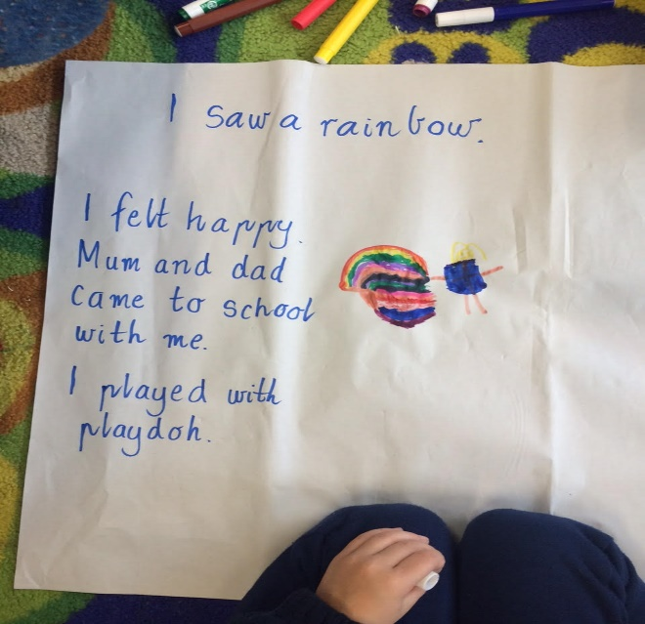 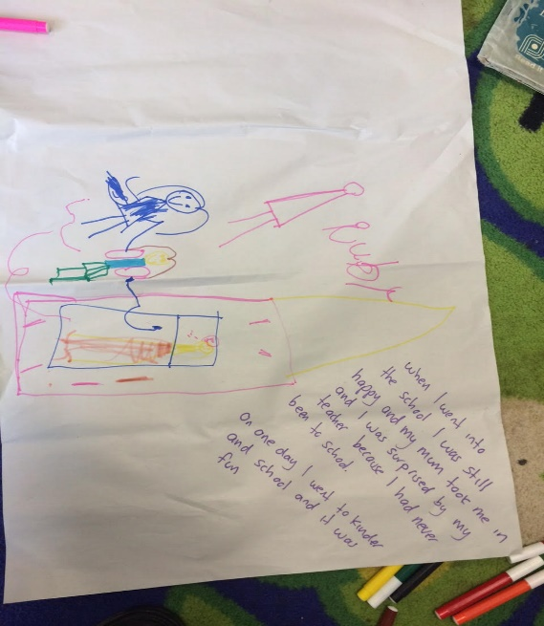
Ruby
Words= Happiness. Family accompanying.
Image = 3 people: Smiling child + motion indicators (mum bridging to school) + school (pinks & yellows with unknown pink teacher)
“I was surprised by my teacher because I had never been to school”
“On one day I went to Kindergarten and school and it was fun”
(confidence)
Boy
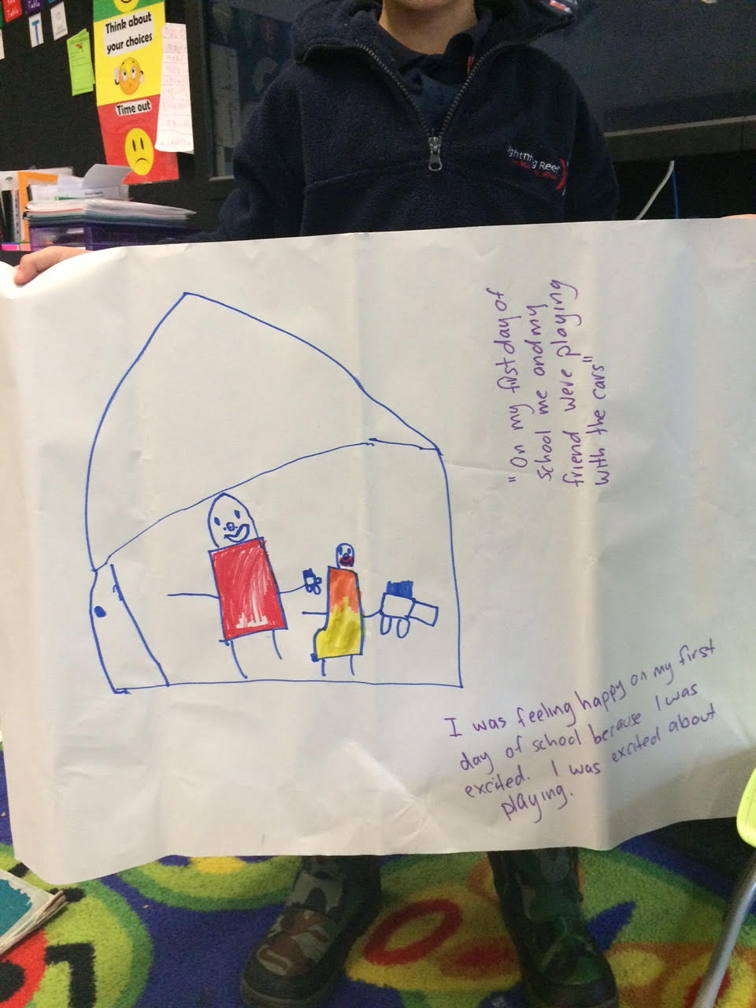
On my first day
Words=Happiness. Excitement. Playing. Friends.
Image =Smiling child reaching to friend. Friend with toy car. (warm colours in school frame)
“I was excited about playing”
(joy)
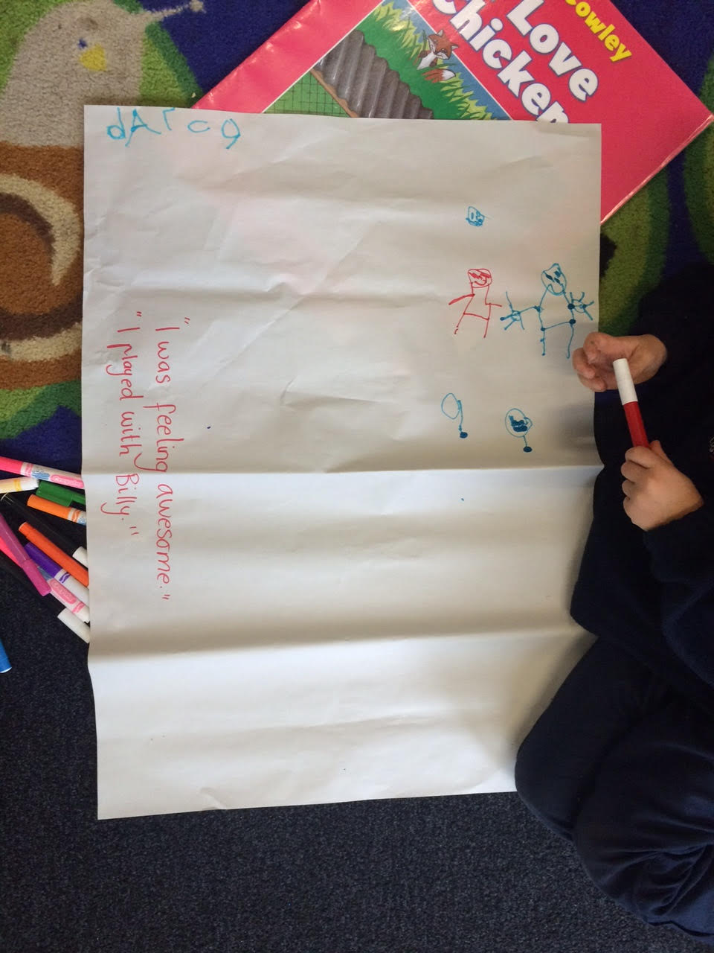
I was feeling awesome
Words= Happiness. Playing.
Image= 2 happy chn (possibly with toys & sun)
“I played with Billy”
(joy)
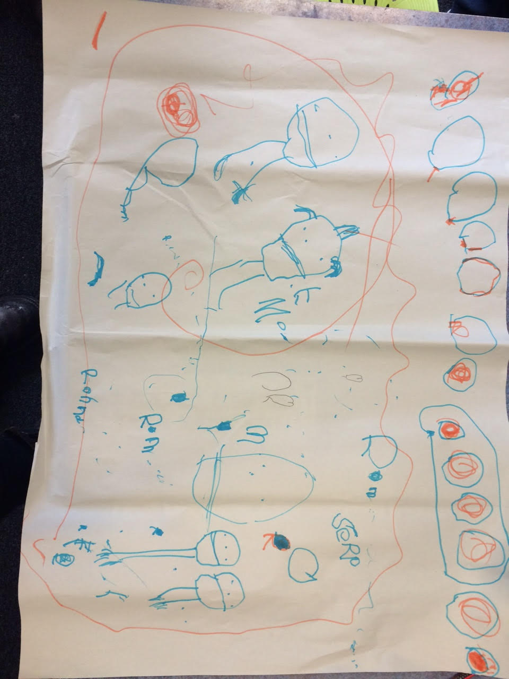
Rhonda
Words=self, mother & a friend
Image=self & mother in a helix including more people moving to the windows of the school; hearts & a great deal of activity
“I want to draw everyone!”
(Sense of belonging)
Wags
Words= Agency. (Anthropomorphism)
Image= enthusiastic activity incl pet dog & balloons”
“I took Wags to school. He likes school!”
(Sense of belonging)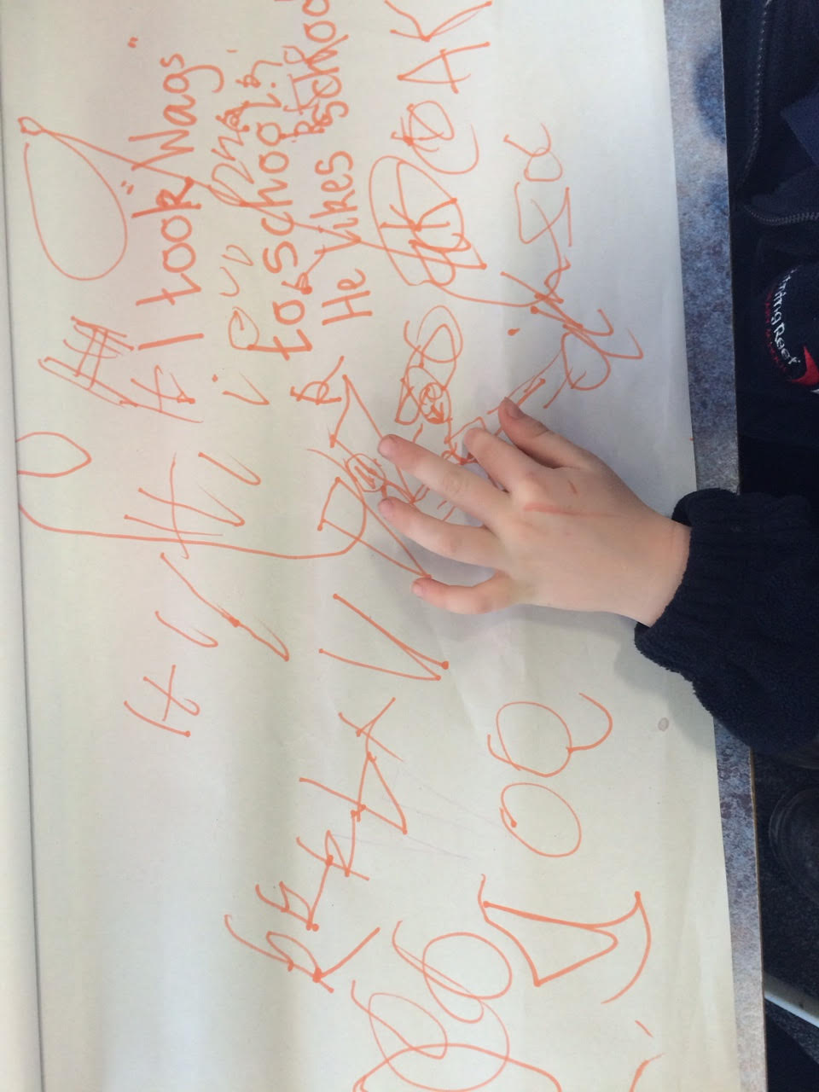
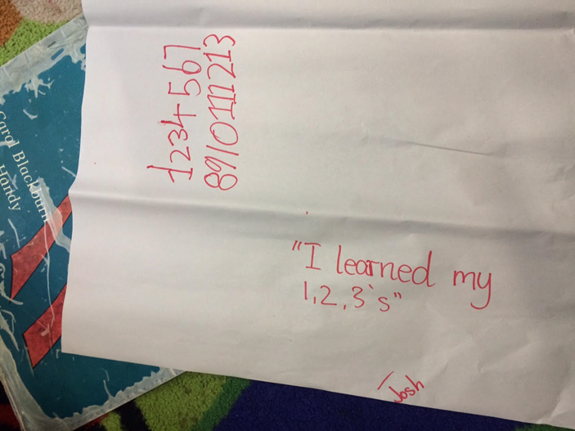 Josh
Words=Learning. Numbers.
Image= single focus mathematics
“I like numbers” (learning)

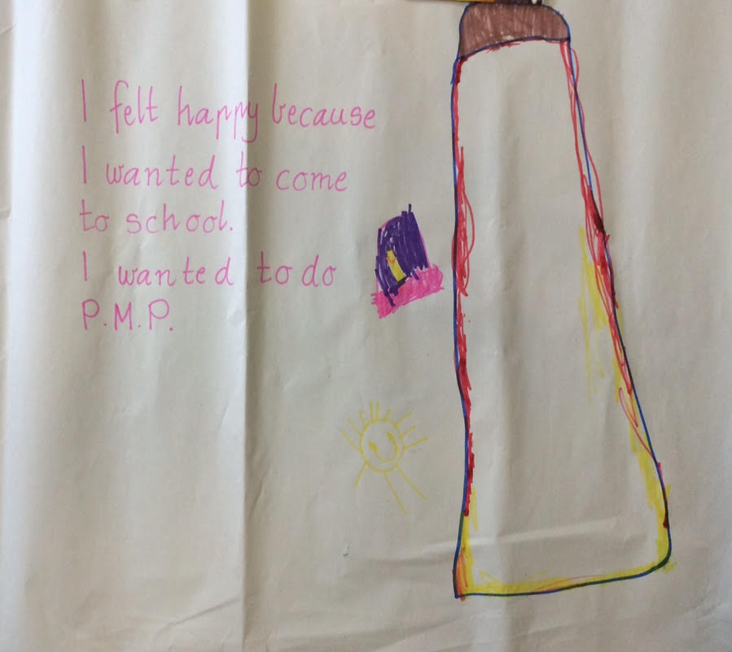

I felt happy
Words=Happiness. Anticipation.
Image=Gym as a major influence with yellow sun & happy child
“This is the gym and Mr X”
(physical activity)
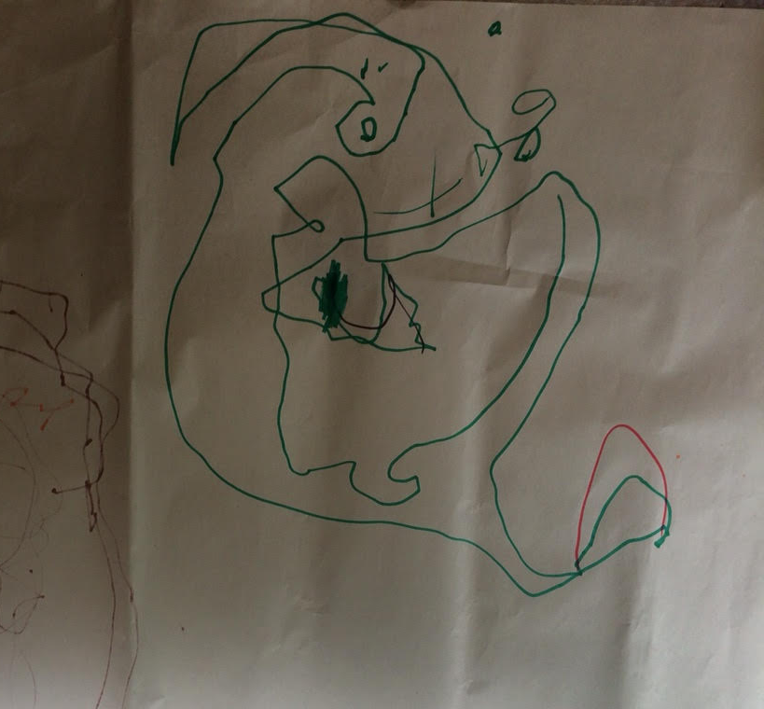Games
Words= Playing.(games)
Image= Treasure map!
“There was lots of games and I played them.”
(activity)
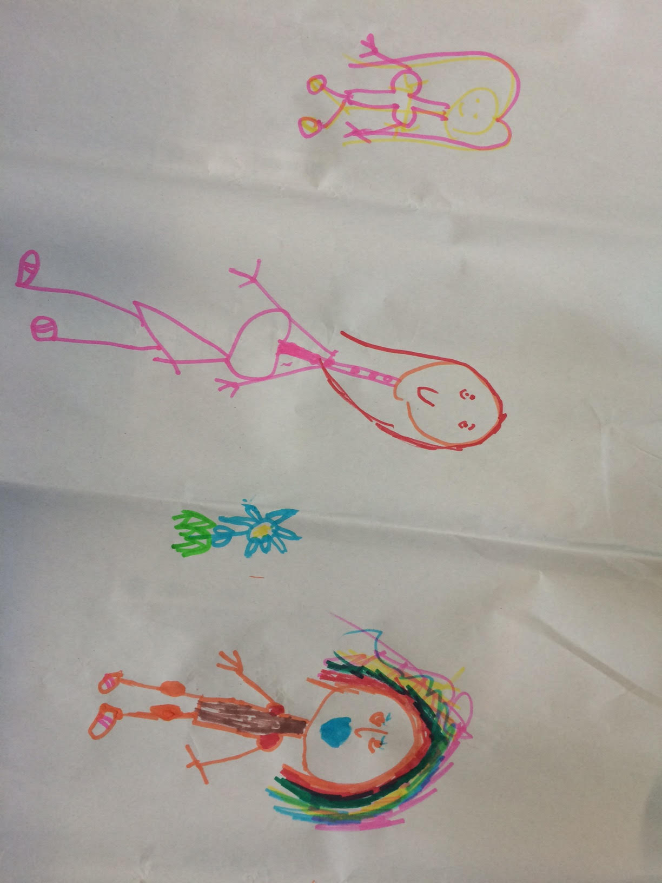
New friends
Words= Friendship
Image= Happiness (warm colours and cheerful flower)
(joy)
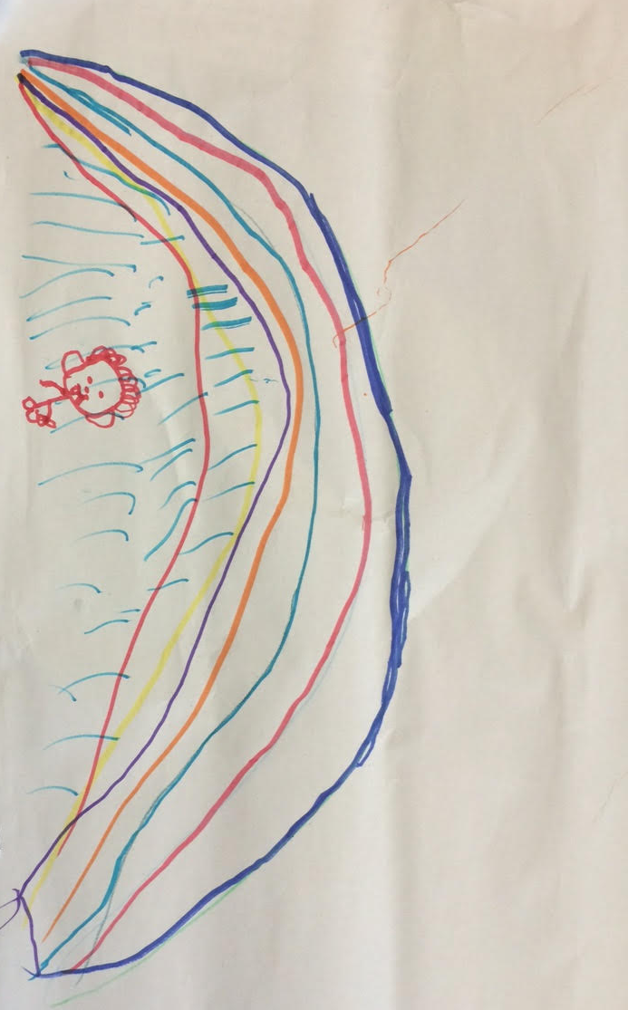Jesse
Words=Happiness.
Image=large, bright enthusiasm for rainbow in the rain associated with starting school; affirmed as a metaphor in his explanation that:
“Rainbows are my favourite thing” (joy)

What helped you get ready to start school? (Ascot Vale West)
- “Found out how we were going to do performing arts, sport, and Spanish from my mum”
- “Because my mum told me”
- “My sister was in this school and she told me what would happen at school”
- “My sister telled me about school but I didn’t understand [I understand now] because I know all of who the teachers are now”
- “My brother telled me”
- “My big sister told me there’s a sport teacher, performing arts, Spanish”
- “My day care told me”
- “When I started kindergarten I was afraid”
- “I thought when the bell rang we were eating lunch outside and my sister told me the rest”

What would you like to tell children from Kindergarten/child care about starting school? (if you have a friend or a brother or sister starting school- what do they need to know?)
(Ascot Vale West)
- “Tell them that we write in school. We taught how to learn. We learn how things go and we do stuff like maths”
- “About buddies; the buddy can help them”
- “I would like to tell my sister when she comes how to not do scribble writing but how to do writing like the kids”
- “No hitting and no kicking!”
- “Don’t be naughty…”
- “How to write and I would tell them how to do maths and not be naught but be nice”
- “Practice how to do 8’s”
- “Not to scribble”
- “How to use strategies to learn about maths and reading”

What information would you have liked to know before you started school?
(Ascot Vale West)
- “My sister was grown up so she couldn’t tell me”
- “I didn’t know when you do writing. [You do it] after reading.”
- “I wanted to know how to use computers and iPads and stuff because I didn’t know how to use it”
- Where the staff room was. I know where it is now…”
- “I found it all when our name lockers. Mine is next to xx. We put our reading journal and writing journal in our tub. We have our name on it. We learn where our table was… When I came to visit the school there was two big kids who showed up. They also showed us where everything was” (Year 5 helpers during orientation visits became Year 6 buddies)
- “My brother showed me around the school- he used to go here”.

