Glossary of terminology commonly used in ACFE

Version: 1.0
Version date: 01/09/2015
Document owner: Manager, ACFE Board Secretariat
Document sponsor: ACFE Board

Adult, Community and Further Education Board
Level 3, 2 Treasury Place, East Melbourne VIC 3002 I GPO Box 4367, Melbourne VIC 3001
T: (03) 9637 2072 F: (03) 9637 3693 E: acfe@edumail.vic.gov.au
W: www.education.vic.gov.au/acfeboard

Document particulars
Title | Glossary of terminology commonly used in ACFE
Last updated | 01/09/15 | Status | Final
Due for review | 01/09/16
Document owner | Manager, ACFE Board Secretariat
Document sponsor | ACFE Board
Approved by | ACFE Board
NOTE:

Copyright info:

Document history
Version | Date | Author | Summary
0.7 | 2/07/2015 | Alison Vickers
1.0 | 01/09/2015 | Alison Vickers | Endorsed by the Regional Governing Project Board

Introduction
This glossary of terms commonly used in adult community and further education (ACFE) is designed to help ACFE Board (Board) members and Regional Council (Council) members understand the terminology used in the sector.
It contains:
- Victorian ACFE programs, organisations, acronyms and jargon
- VET and senior secondary terms, particularly those used by Learn Local organisations
- website links for further information
- related terminology.

Relationship between entities and terminology
Terms have been listed alphabetically for easy reference. As terms are rarely used in isolation, the figures below cluster them into categories to assist understanding.
The terms all relate to pre-accredited and/or accredited learner programs. Many Learn Local organisations offer pre-accredited programs that provide pathways for learners into accredited programs. This means a number of Learn Local organisations are also registered training organisations (RTOs) and/or are non-school providers of senior secondary certificates.
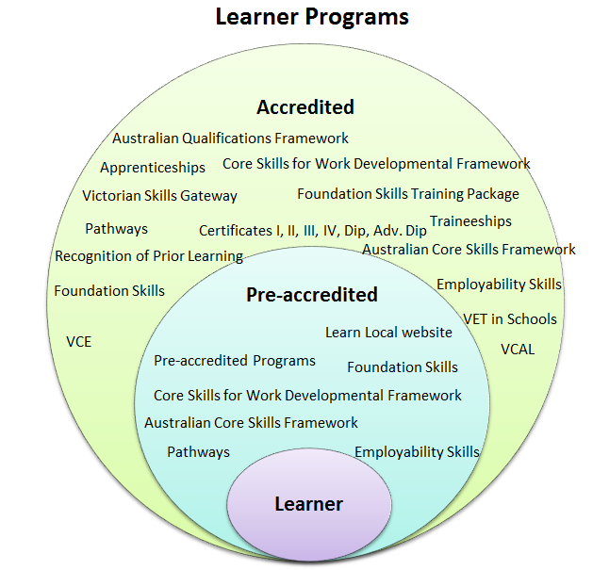 | 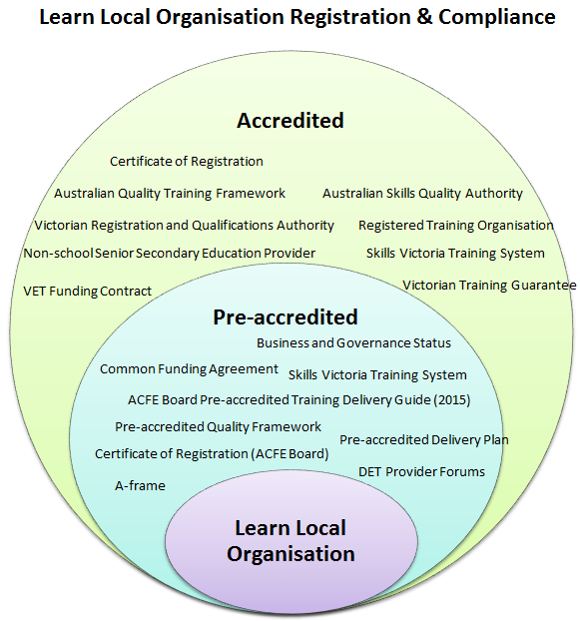
Figure 1: Terminology that typically relates to learner programs that are pre-accredited or accredited. | Figure 2: Terminology that typically relates to Learn Local registration and compliance for pre-accredited and accredited programs.
The Board provides funding, resources and information to Learn Local organisations, and purchases pre-accredited training from Learn Local organisations and adult education institutions. In addition, it provides grant funding and other initiatives for organisations to develop their capacity and support partnerships and innovation. These initiatives are listed below.
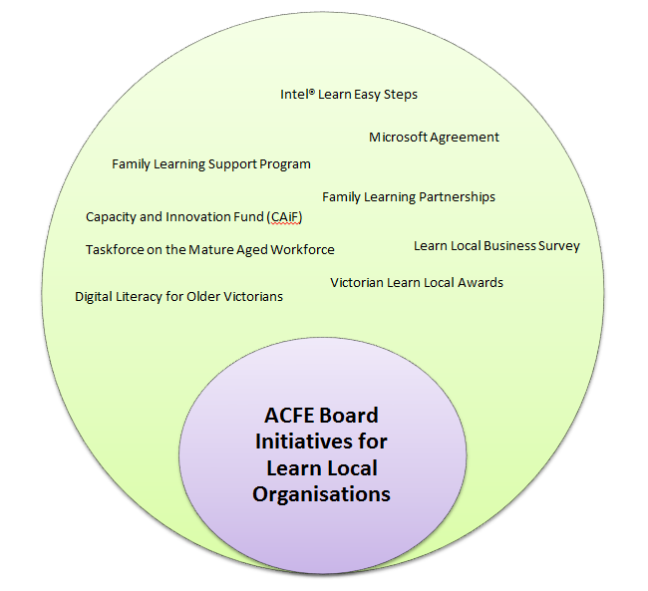
Figure 3: ACFE Board initiatives for Learn Local organisations

Established under the Education and Training Reform Act 2006, the Board is a statutory body that supports the development of adult, community and further education in Victoria. Its relationship to a number of entities is illustrated below and is also briefly explained in this glossary of terminology. The Board and Regional Councils work together to develop the ACFE Board’s Strategic Plan and a yearly ACFE Business Plan. ACFE Chairpersons’ Forums and the ACFE Board Regional Champions facilitate consultation between the ACFE Board and Regional Councils required under the Act. These initiatives bring together the ACFE Board and the eight Regional Councils to discuss key strategic and operational matters in the sector.
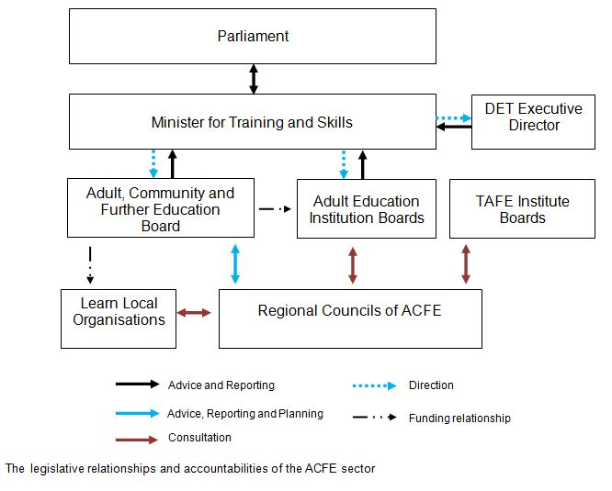
In addition Regional Councils develop their own Regional Council Plan and instigate regional projects.
Accreditation | Accreditation is the process where an accrediting authority approves a program of learning that leads to an Australian Qualifications Framework (AQF) qualification, using the quality assurance standards for the relevant education and training sector.  See accredited training, AQF, accrediting authority
Accredited courses managed by the ACFE Board | The ACFE Board manages the development and maintenance of the following courses accredited by the Victorian Registration and Qualifications Authority (VRQA):  - Certificates in General Education for Adults  - Certificate IV in Tertiary Preparation  - Certificate IV in Liberal Arts  - Course in Recognition of Informal Learning  - Course in Assessment of Informal Learning.  See accredited training, accrediting authority
Accredited training | Accredited training is an accredited program of study leading to Australian Qualifications Framework (AQF) vocational qualifications and credentials that are recognised across Australia. Only registered training organisations (RTOs) that meet government quality standards such as TAFE, private providers and vocational divisions of universities can provide nationally recognised training.  Accredited training includes accredited courses, endorsed training package qualifications and associated subjects.  To access the National Register of accredited training, visit: training.gov.au
Accrediting authority | An accrediting authority is either authorised under legislation or has been given responsibility to accredit programs of learning, leading to Australian Qualifications Framework (AQF) qualifications and/or to register providers to issue AQF qualifications. In the VET sector this is called a Registering Body.  See AQF, Registering Body
ACFE Board Pre-Accredited Training Delivery Handbook (2016) | This document outlines 2016 funding guidelines for the ACFE Board’s purchase of pre-accredited training from Learn Local organisations.  Visit: http://www.education.vic.gov.au/Documents/training/providers/learnlocal/grants/2016%20Pre-accredited%20Delivery%20Handbook.docx  See Learn Local organisations, pre-accredited training
ACFE Board Regional Champions | In this initiative, an ACFE Board member pairs with an ACFE region to improve the links between the ACFE Board and its Regional Council.  Regional Champions provide an additional channel of communication between Regional Chairs/Councils and the ACFE Board, encourage engagement and information exchange between all parts of the ACFE system, and provide Board members with greater opportunity to engage directly with Regional Councils, Learn Local organisations and learners.  See ACFE Board, Regional Councils of ACFE, Learn Local organisations
ACFE Chairpersons’ Forums | To facilitate consultation between the ACFE Board and Regional Councils required under the Act, ACFE Chairpersons’ Forums are held quarterly. They bring together the Chair of the ACFE Board and the Chairs of Regional Councils to discuss key strategic and operational matters.  See ACFE Board, Regional Councils of ACFE
ACFE Strategic Plan and ACFE Business Plan | The ACFE Board and Regional Councils work together to develop the ACFE Strategic Plan and a yearly ACFE Business Plan.  See Learn Local: Focusing on the Future, ACFE Board, Regional Councils of ACFE
Adult and community education (ACE) | ACE is the national term for ACFE. It describes education and training intended principally for adults, including general, vocational, basic and community education, and recreation, leisure and personal enrichment programs.
Adult, community and further education (ACFE) | ACFE is defined in the Education and Training Reform Act 2006 as:  (a) further education; or  (b) secondary education for adults; or  (c) that part of education and training which is directed towards the development of skills and knowledge in relation to work when it is provided by an adult education institution established by or under the Education and Training Reform Act or a community based organisation that is not a TAFE college, commercial provider or industry provider.  See AEIs, Learn Local organisations
Adult Community Education Victoria (ACEVic) | ACEVic is Victoria’s peak policy, industrial and development body for the adult community education sector. ACEVic represents Victoria’s adult community education centres.  Visit: acevic.org.au/
Adult education institutions (AEIs) | The Centre for Adult Education (CAE) and AMES Australia are AEIs. This means they are public providers that operate as statutory entities with their own Boards, which report annually to Parliament. AEI Boards are made up of members appointed by the Minister and a Chair appointed by the Governor in Council.  See AMES Australia, CAE
Adult Learning Australia (ALA) | ALA is the national peak body for the adult and community education (ACE) sector.  Visit: ala.asn.au/
AMES Australia | AMES Australia provides settlement, language, skills and vocational training, and employment assistance to refugees and newly arrived migrants. Its primary source of funds is contracts with the Commonwealth Government.  Visit: www.ames.net.au/  See AEIs
Adult, Community and Further Education (ACFE) Board  (also known as ACFEB) | The ACFE Board is a statutory authority established by the Minister under the Education and Training Reform Act 2006. It supports the development of adult, community and further education in Victoria.  The Board’s statutory roles include planning for and promoting adult learning, allocating resources, developing policies and advising the Minister on matters related to adult, community and further education programs and needs.  See ACFE
A-frame | The A-frame is a system for planning and documenting educational practices that provides a curriculum model and practical tools (the Course Plan and the Learner Plan) for planning and documenting pre-accredited courses. It is a component of the Pre-accredited Quality Framework (PQF).  Visit: www.education.vic.gov.au/training/providers/learnlocal/Pages/pqf.aspx  See PQF
Association of Neighbourhood Houses and Learning Centres (ANHLC) | ANHLC provides strategic leadership for Neighbourhood Houses in Victoria, supporting members with effective statewide advocacy, quality research and timely advice on relevant policy and legislative developments.  Visit: www.anhlc.asn.au/
Australian Core Skills Framework (ACSF) | The ACSF is a tool that assists English language, literacy and numeracy (LLN) practitioners to describe an individual's performance in the five core skills of learning, reading, writing, oral communication and numeracy. It identifies and develops the core skills in three contexts: personal and community; workplace and employment; and education and training.  Visit: www.industry.gov.au/skills/ForTrainingProviders/AustralianCoreSkillsFramework/Pages/default.aspx  See foundation skills, employability skills
Australian Qualifications Framework (AQF) | The AQF is the national policy for regulated qualifications in Australian education and training. It incorporates the qualifications from each education and training sector into a single comprehensive national qualifications framework.  Visit: www.aqf.edu.au/  See accredited training, senior secondary certificates of education
Australian Quality Training Framework (AQTF) | The AQTF is a set of nationally agreed quality assurance arrangements for the training and assessment services delivered by registered training organisations (RTOs) regulated by the Victorian Registration and Qualifications Authority (VRQA).  RTOs regulated by the Australian Skills Quality Authority (ASQA) must comply with every component of the legislation or standards that apply.  Visit: http://www.vrqa.vic.gov.au/registration/Pages/vetqualitydef.aspx  See RTO, VRQA, ASQA, Registering Body
Australian Skills Quality Authority (ASQA) | ASQA is the national regulator for the VET sector. Registered training organisations (RTOs) in the Australian Capital Territory, New South Wales, the Northern Territory, Queensland, South Australia and Tasmania come under ASQA's jurisdiction.  ASQA is also the regulatory body for some RTOs in Victoria and Western Australia that offer courses to overseas students or to students in states under the jurisdiction of ASQA.  Visit: www.asqa.gov.au/  See RTO, VRQA, Registering Body
Business and governance status (BGS) | BGS is a self-assessment process with the outcome attested by a fully qualified accountant. The BGS must be completed annually and submitted to the ACFE Board before an organisation is contracted by the Board.  Visit: www.education.vic.gov.au/training/providers/learnlocal/Pages/network.aspx  See Regional Councils of ACFE, DET Participation Branch
Capacity and Innovation Fund (CAIF) | Administered by the ACFE Board, CAIF is a grants program that provides opportunities for Learn Local organisations to develop and implement projects that meet learner needs and increase participation and attainment in pre-accredited and accredited training programs. It also supports the implementation of ACFE’s Strategic Plan Learn Local: Focusing on the Future.  Visit: www.education.vic.gov.au/training/providers/learnlocal/Pages/acfeboardfund.aspx  See Learn Local organisations, ACFE Board, Learn Local: Focusing on the Future
Certificates of Registration | Certificates of Registration are issued by organisations registered with the ACFE Board. Registration is valid for up to three years, allowing providers access to a range of services and supports, and to use the Learn Local brand.  See Learn Local organisations, Regional Councils of ACFE
Common Funding Agreement (CFA) | A CFA is an agreement, between the ACFE Board and organisations registered with the ACFE Board, for the purchase of delivery and reporting of pre-accredited training as well as other specific purpose grants. The CFA is a ‘whole of government’ standard agreement used for all government contracting.  See Learn Local organisations, ACFE Board
Core Skills for Work Developmental Framework (CSfW) | This framework describes the core non-technical skills identified by Australian employers as important for successful participation in work.  Visit: education.gov.au/core-skills-work-developmental-framework  See employability skills, foundation skills
Council of Adult Education (CAE) | CAE provides learning opportunities through a wide range of programs and services. CAE receives government funding to deliver accredited courses that help adults complete their secondary education and begin or change their career direction. In 2011, CAE formed a partnership with Box Hill Institute and now sits within the Box Hill Institute Group.  Visit: www.cae.edu.au  See AEIs
Department of Education and Training (DET), Participation Branch | ACFE Board planning, policy and decision implementation, and resource allocation are supported by the Participation Branch of the Higher Education and Skills Group’s TAFE and ACFE Governance Division, which comprises a central office and four regional offices. Staff also support the eight Regional Councils of ACFE and Learn Local organisations in meeting the Government’s goals and targets for adult learning and community building. Staff are employed by the Department of Education and Training (DET).  Regional staff facilitate regular Provider Forums for Learn Local organisations. For memos to Learn Local organisations, visit: www.education.vic.gov.au/training/providers/learnlocal/Pages/communications.aspx  See ACFE Board, Regional Councils of ACFE, Learn Local organisations
Digital Literacy for Older Victorians program | This program, provided by Learn Local organisations, supports the development of digital literacy outcomes for learners aged 65 and over.  Visit:www.education.vic.gov.au/training/providers/learnlocal/Pages/digitalliteracy.aspx  See Learn Local organisations
Education and Training Reform Act 2006 (ETRA) | This Act makes provision for adult, community and further education in Victoria including the establishment of the ACFE Board, and the regions of adult, community and further education and their Regional Councils.  It also makes provision for other aspects of education and training including schooling, the teaching profession, VET and accreditation of courses.  To access the Act, visit: www.austlii.edu.au/au/legis/vic/consol_act/eatra2006273/
Employability skills | Employability skills are non-technical skills (also called generic skills or soft skills) that employers say they are looking for in their employees. Research indicates that employers want employees with good technical skills. They also want people who can communicate effectively, work with others, solve problems, take initiative and continue learning in the workplace.  See CSfW
Family Learning Partnerships (FLP) | FLPs raise the educational aspiration, engagement and attainment of parents and their children. Based in settings such as early childhood facilities, schools and community centres, education providers deliver skills instruction for parents that encourage progression to further learning and education.  See Learn Local organisations, accredited training, pre-accredited training
Family Learning Support Program (FLSP) | The FLSP subsidises occasional child care for parents undertaking Victorian Government funded education and training (accredited and pre-accredited) through the Learn Local sector. It links the level of funding to the amount of training provided by a Learn Local organisation and targets subsidies to learners where the cost of child care is a barrier to learning, with a focus on supporting those most in need. Learn Local organisations can opt in to the program.  Visit: www.education.vic.gov.au/Documents/training/providers/learnlocal/memo/2014/pbmemo20141020b.pdf  See Learn Local organisations, accredited training, pre-accredited training
Foundation skills | Foundation skills are the combination of English language, literacy and numeracy skills and employability skills required for participation in work, the community and education and training (adapted from the Standing Council on Tertiary Education Skills and Employment, National Foundation Skills Strategy for Adults, September 2012).  See Foundation Skills Training Package, ACSF
Foundation Skills Training Package | The Foundation Skills Training Package is suite of accredited qualifications and units of competency designed to be used in conjunction with other training packages to support foundation skills development for vocational outcomes. Although the flexibility of the Foundation Skills Training Package enables its use in a wide variety of contexts, it does not replicate any existing accredited course.  Visit: www.ibsa.org.au/foundation-skills-fsk#faq  See accredited training
Intel® Learn Easy Steps | Learn Local organisations can access an internationally-recognised digital literacy program with associated training and curriculum support.  Visit: www.education.vic.gov.au/training/providers/learnlocal/Pages/easysteps.aspx  See pre-accredited training, Learn Local organisations
Learn Local Business Survey (formerly ACE Business Survey) | The ACFE Board commissions an annual survey of Learn Local organisations. Information collected informs policy and planning and promotes the sector’s contribution to the Victorian training system. The survey provides a snapshot of the size, diversity and operations of Learn Local organisations and the opportunities and challenges they encounter in meeting local learner needs. Participation is voluntary.  See DET Participation Branch, ACFE Board
Learn Local organisations | Learn Local organisations are adult, community and further education providers that have registered with the ACFE Board to deliver pre-accredited training.  For information on how to become a Learn Local organisation, visit: www.education.vic.gov.au/training/providers/learnlocal/Pages/network.aspx  For information on the Learn Local sector, visit: learnlocal.org.au/  See ACFE Board
Learn Local: Focusing on the Future | Released in August 2013, Learn Local: Focusing on the Future set out three strategic actions that will assist the sector to sharpen its focus and improve its sustainability and responsiveness. These are refocusing and refining the role of Learn Local, promoting durable networks and co-location of services to improve pathways and sustainability, and building the Learn Local sector’s capability to deliver high-quality education services.  For a copy of Learn Local: Focusing on the Future, visit www.education.vic.gov.au/Documents/about/research/acfepublications/LLfocusingonfuture.PDF  See ACFE Board, Regional Councils of ACFE
Learn Local Organisation Pre-accredited Delivery Plans | A Learn Local organisation develops a Delivery Plan detailing the pre-accredited training it proposes to deliver for the next contractual period, the target learner population and the location of delivery. The Delivery Plan is the basis for development of the common funding agreement (CFA) between the ACFE Board and Learn Local organisation.  For Pre-accredited Delivery Plan templates, visit: www.education.vic.gov.au/training/providers/learnlocal/Pages/deliveryplan.aspx  See Learn Local organisations, ACFE Board, pre-accredited training
Learn Local website | The Learn Local website connects potential learners with their local provider. Users can search for their nearest Learn Local organisation using their suburb and a kilometre radius. The website also provides an overview of learning topics and shares learner stories to encourage interested people to contact their nearest provider and explore options.  Visit: learnlocal.org.au/
Local Learning and Employment Networks (LLENs) | LLENs support young people aged 10 to 19 by improving their participation, engagement, attainment and transition outcomes, including increasing Year 12 or equivalent attainment rates. LLENs are incorporated associations run by Boards or Committees of Management. There are 31 LLENs in Victoria.  LLENs use their knowledge of the region to influence strategic planning and broker partnerships among key stakeholders to support young people to remain engaged, or re-engage, in education or training.  Visit: www.education.vic.gov.au/about/programs/pathways/Pages/llens.aspx?Redirect=1
Microsoft Agreement | The ACFE Board has a three-year (1 Jan 2012 to 31 Dec 2015) agreement with Microsoft that provides licences for a range of software for desktop and notebook computers and servers. Learn Local organisations and adult education institutions can access the Agreement (under varying terms and conditions). A new agreement from 2016 is being negotiated.  Visit: www.education.vic.gov.au/training/providers/learnlocal/Pages/microsoftagreement.aspx
Pathways | Pathways are a path or sequence of learning or experience that can be followed to attain competency, qualifications or employment (adapted from NCVER Glossary of VET).  See pre-accredited training, accredited training, AQF
Pre-accredited training | Pre-accredited training programs are usually short modular courses, designed to give learners confidence and skills, that create pathways to nationally accredited training or employment.  Pre-accredited training focuses on learners who have not achieved Year 9 or an equivalent qualification. Programs must address the particular needs of adults who have experienced barriers to education and find it difficult to undertake accredited programs as their first step back into education and training. The ACFE Board purchases specific types of pre-accredited programs.  Visit: www.education.vic.gov.au/training/providers/learnlocal/Pages/preaccredited.aspx  See pathways, accredited training, AQF
Pre-accredited Quality Framework (PQF) | The PQF is a system of interrelated processes that ensure quality and continuous improvement in planning, developing, implementing and reviewing pre-accredited courses. It provides assurance to learners, the community, employers and the ACFE Board that pre-accredited programs provide quality learning experiences. The Framework includes audit, verification, moderation, A-frame and quality indicators.  Visit: www.education.vic.gov.au/training/providers/learnlocal/Pages/pqf.aspx  See A-frame
Recognition of prior learning (RPL) | RPL is the acknowledgement of a person's skills and knowledge acquired through previous training, work or life experience, which may be used to grant status or credit in a subject or module. It can lead to a full qualification in the VET sector.  Visit: http://www.education.vic.gov.au/victorianskillsgateway/Employers/Pages/Recognition-of-prior-learning.aspx  See accredited training, AQF
Regional Council Plan | To support the implementation of the ACFE Board’s Strategic Plan, Regional Councils develop an annual plan that reflects the strategic priorities of their region. Regional Councils also work on a number of region-based projects and priorities, some of which are described in the ACFE Board’s Annual Report.  Visit: www.education.vic.gov.au/Documents/about/department/201314acfeannualreport.pdf  See Learn Local: Focusing on the Future, ACFE Board
Regional Councils of ACFE | There are eight ACFE Regional Councils, each with nine voluntary members, established by the Minister under the Education and Training Reform Act 2006. The work of each Council is supported by staff from the Department of Education and Training (DET) Participation Branch.  ACFE Regional Councils work with the ACFE Board to fulfil the ACFE mission. The objectives of Regional Councils are aligned with the ACFE Board’s objectives. Regional Council projects and activities contribute directly to the achievement of the Board’s objectives.  Visit: www.education.vic.gov.au/about/department/structure/Pages/acfe.aspx  See DET Participation Branch, ACFE Board, Learn Local: Focusing on the Future
Registered training organisation (RTO) | Training providers are registered by the Australian Skills Quality Authority (ASQA) or in some cases, a state registering and accrediting body. In Victoria this is the Victorian Registration and Qualifications Authority (VRQA). RTOs deliver training and/or conduct assessments and issue nationally recognised qualifications in accordance with the Australian Quality Training Framework (AQTF) or the legislation or standards that apply.  RTOs include TAFE colleges and institutes, adult and community education providers, private providers, community organisations, schools, higher education institutions, commercial and enterprise training providers, industry bodies and other organisations meeting the registration requirements. Approximately 30% of Learn Local organisations are RTOs, delivering a range of accredited training programs.  For the National Register of RTOs, visit: training.gov.au  See accredited training, Learn Local organisations, ASQA, VRQA, AQTF
Registering Body | The authority responsible for registering training organisations and for quality assuring the training and assessment services they provide in accordance with the Australian Quality Training Framework (AQTF) and relevant legislation within each jurisdiction is called the Registering Body. In Victoria a registered training organisation (RTO) will be registered with either the Australian Skills Quality Authority (ASQA) or the Victorian Registration and Qualifications Authority (VRQA).  See AQTF, ASQA, VRQA
Senior secondary certificates of education | In Victoria, the accredited senior secondary certificates of education include the Victorian Certificate of Education (VCE), Victorian Certificate of Applied Learning (VCAL) and the International Baccalaureate (IB). A number of Learn Local organisations are registered with the Victorian Registration and Qualifications Authority (VRQA) as non-school providers of the VCE and/or VCAL, or a single course within the VCE or VCAL (such as VCE Dance or VCAL Personal Development).  For information on VCE and VCAL, including returning to study VCE or VCAL as an adult, visit: www.vcaa.vic.edu.au  For information about registering as a non-school provider of VCE or VCAL, visit: http://www.vrqa.vic.gov.au/registration/Pages/schnonsss.aspx  See AQF, Learn Local organisations, VRQA
Skills Victoria Training System (SVTS) | SVTS is an online reporting system used by Learn Local organisations to report quarterly on pre-accredited training and accredited training if registered as a registered training organisation (RTO). When reporting, organisations must meet requirements for Victorian VET Student Statistical Data Collection Guidelines including requirements to maintain AVETMISS compliance (Australian Standards).  Visit: www.education.vic.gov.au/svts/  See Learn Local organisations, pre-accredited training, accredited training, RTO
Taskforce on the Mature Aged Workforce | The ACFE Board formed the Taskforce on the Mature Aged Workforce to develop advice to the Minister on how the education and training system can support older Victorians to remain connected to paid employment or to continue building relevant skills to enable them to remain in the workforce.  See Learn Local: Focusing on the Future, ACFE Board
Victorian Training Guarantee (VTG) | VTG provides funds for vocational training for people who do not hold a post-school qualification, or who want to gain a higher level qualification than they already hold.  Visit: www.education.vic.gov.au/training/learners/vet/Pages/funding.aspx  See AQF, accredited training
VET funding contract | This is a funding contract between the Department of Education and Training (DET) and registered training organisations (RTOs), including individual TAFE institutes, for the delivery of government subsidised training (accredited training and/or pre-accredited training).  The VET funding contract and related guidelines set out the requirements that training providers must abide by to maintain compliance as contracted providers that receive government subsidy. They set standards of behaviour and minimum requirements for provider practice in the delivery of training services.  See DET Participation Branch, RTO, accredited training, pre-accredited training
VET in Schools (VETiS) | VETiS is a program that allows students to combine a nationally recognised VET qualification with their senior secondary certificate. In Victoria this is the VCE or VCAL. Students participating in VETiS continue to work towards the VCE or VCAL, while the VET component of their studies gives them credit towards a nationally recognised VET qualification. VETiS programs may involve structured work placements (definition adapted from NCVER glossary of terms).  See AQF, accredited training, senior secondary certificates of education, VCAA
Victorian Adult Learning and Basic Education Council (VALBEC) | VALBEC is a peak body for adult literacy, numeracy and basic education fields. It provides information and professional development support for its members, and advocacy and advice on curriculum, government policy and matters that impact on practitioners and learners.  Visit: www.valbec.org.au
Victorian Curriculum and Assessment Authority (VCAA) | VCAA is an independent statutory body providing high quality curriculum, assessment and reporting through developing and implementing:  - Victorian Early Learning and Development Framework 0–8 (VELDF 0–8)  - Foundation to Year 10 Curriculum (AusVELS)  - National Assessment Program – Literacy and Numeracy Testing (NAPLAN)  - Victorian Certificate of Education (VCE)  - Victorian Certificate of Applied Learning (VCAL)  Visit: www.vcaa.vic.edu.au/Pages/index.aspx  See senior secondary certificates of education, VETiS, VRQA
Victorian Learn Local Awards | Held annually, these awards promote the sector by recognising outstanding achievements by learners, practitioners and Learn Local organisations. They reward best practice and innovation, and encourage high performance standards within the sector.  For details on award winners, visit: www.education.vic.gov.au/about/awards/Pages/learnlocal.aspx  See Learn Local organisations
Victorian Registration and Qualifications Authority (VRQA) | The VRQA is the registering body for Victorian registered training organisations (RTOs) that do not offer courses to overseas students or to students in states that come under the jurisdiction of the Australian Skills Quality Authority (ASQA).  A number of Learn Local organisations are also RTOs and the ACFE Board works with the VRQA to improve regulatory arrangements for these organisations.  Visit: www.vrqa.vic.gov.au  See Registering Body, ASQA, Learn Local organisations, ACFE Board
Victorian Skills Gateway | The Victorian Skills Gateway is a one-stop-shop for VET in Victoria. Courses on its website are either regulated qualifications under the Australian Qualifications Framework (AQF), or short training programs comprising units of competency from regulated qualifications. All registered training organisations (RTOs) listed are registered under the Australian Skills Quality Authority (ASQA) or the Victorian Registration and Qualifications Authority (VRQA).  As the Victorian Skills Gateway lists courses that a training provider intends to offer during the next 12 to18 months, it is important to contact the training provider directly to confirm the availability of a course.  Visit: www.education.vic.gov.au/victorianskillsgateway/Pages/home.aspx  See AQF, accredited training, RTO, ASQA, VRQA
Vocational education and training (VET) | VET is post-compulsory education and training, typically Australian Qualifications Framework (AQF) accredited training programs from Certificate I to Advanced Diploma – excluding degree and higher level programs delivered by registered training organisations (RTOs) – that provide people with occupational or work-related knowledge and skills. VET also includes programs that provide pathways for subsequent vocational programs.  Learn Local organisations typically provide pathways from pre-accredited courses into VET accredited training.  See AQF, accredited training, RTO, pathways
Young People Transitioning from Care | This initiative waives tuition fees for government subsidised training for young people in out-of-home care, under custody or guardianship orders, or those aged 21 and under who have recently transitioned from state-based care.  Registered training organisations (RTOs) that form part of the Young People Transitioning From Care Initiative Provider Network can only deliver training under this initiative. Some Learn Local organisations are part of this network.  Visit:www.education.vic.gov.au/training/learners/vet/pages/feeexemptions.aspx  See RTO, Learn Local organisations, accredited training

AQF, Glossary of Terminology, accessed 6 January 2015
NCVER, Glossary of VET, accessed 5 January 2015
AQF, Glossary of Terminology, accessed 6 January 2015
NCVER, Glossary of VET, accessed 14 July 2015
Education and Training Reform Act 2006
Adult Community and Further Education Board Annual Report 2013–14
Pre-Accredited Quality Framework Glossary, State Government of Victoria 2013
AQF, Glossary of terminology, accessed 6 January 2015
NCVER, Glossary of VET, accessed 14 January 2015
NCVER, Glossary of VET, accessed 6 January 2015
NCVER, Glossary of VET, accessed 6 January 2015
NCVER, Glossary of VET, accessed 6 January 2015
NCVER, Glossary of VET, accessed 6 January 2015
NCVER, Glossary of VET, accessed 14 January 2015
Adapted from NCVER, Glossary of VET, accessed 27 January 2015

