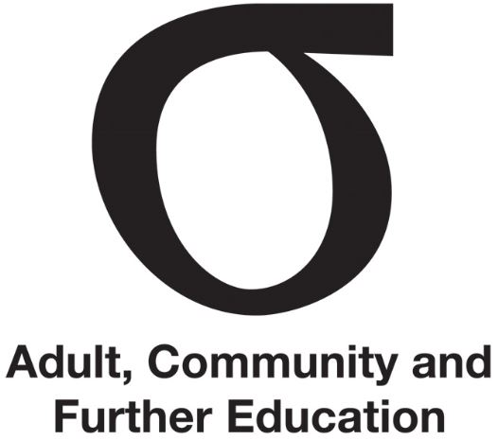 | Membership of Regional Council
Fact Sheet | Membership of Regional Council | May 2016
Audience | Chairperson, all members

This Fact Sheet outlines the membership of Regional Council (Council).

Membership
A Council consists of a minimum of five members appointed by the Minister. One is elected chairperson and one is elected deputy chairperson by the members of the Council.
Under the Education and Training Reform Act 2006 (the Act), the Council can co-opt up to two additional members for up to one year. A co-opted member has the same rights, powers, duties and entitlements as any other member of the Council except that the positions of chairperson and deputy chairperson cannot be held by a co-opted member.
The Act prohibits co-opting the same person more than once.

Attendance
Council members should attend all scheduled meetings and make a positive contribution to discussions.
The office of a member becomes vacant if that member is absent from three consecutive Council meetings without the chairperson’s leave or, in the case of the chairperson, without the Minister’s leave.
Under the Act, the Minister may remove or suspend a member from office. The office of a member becomes vacant if a member:
- becomes bankrupt
- is found guilty of an indictable offence.
If this occurs, the chairperson of the Council should, as soon as possible, advise the ACFE Governance and Planning Unit in writing of the particular circumstances. The ACFE Governance and Planning Unit will then take the necessary action.
The Act provides that a member may resign from the Council by notifying the Minister in writing.

Appointing new members to the Council
If there is a vacancy, the Minister may appoint a new member according to the requirements of the Act.
In appointing members of a Regional Council, the Minister must consider any advice given in a consultation under subsection (2) and ensure that the members of the Council:
- reflect the knowledge, skills and experience of the adult, community education sector; and
- reflect in a fair and balanced way the diversity of the community in that region; and
- have knowledge and experience of governance responsibilities. s. 3.3.21

The skills of Council members
When recruiting new members or co-opted members to Council, the chairperson should consider the balance of current skills and experience of its members and the need for expertise in specific areas.
A Regional Council member skills matrix assessment tool will help determine where experience or skills might need to be sought.
Further information
Fact Sheet | Leading Regional Council
Regional Council skills matrix assessment tool
Regional Councils of Adult, Community and Further Education: Information for prospective members

