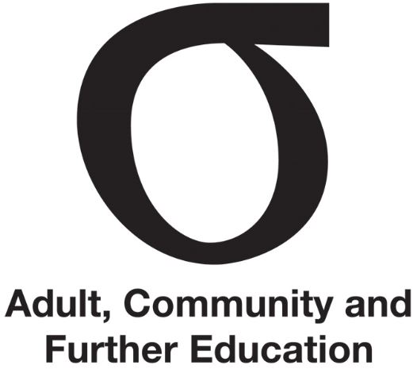 | ACFE Regional Councils
Fact Sheet | ACFE Regional Councils | September 2015
Audience | Key stakeholders

Regional Councils (Councils) are committed to helping disadvantaged learners thrive in adult education in their community. They play a vital role in ensuring Victorians who face barriers accessing education and training get the learning they need to access further education and job opportunities. Councils do this by:
- providing ‘regional intelligence’ to the Adult Community and Further Education (ACFE) Board on the adult education needs of their region
- advising the ACFE Board and monitoring the delivery of adult education in their region
- supporting and promoting adult education in their region.
There are eight Councils established under the Education and Training Reform Act 2006. Each Council has up to nine voluntary members appointed by the Minister for up to three years. The Department of Education and Training supports the work of each Council.
Councils are located in the following regions:
- Barwon South West
- Eastern Metropolitan
- Gippsland
- Grampians
- Hume
- Loddon Mallee
- North Western Metropolitan
- Southern Metropolitan
Each Council draws together different expertise and aspects of local knowledge to advise the ACFE Board on the needs of adult education in its region. Councils also contribute to statewide planning and policy development.

Find out how to support your Regional Council
Contact staff at the Department of Education and Training:

ACFE Board Secretariat
Phone: (03) 9637 2000
Email: acfe@edumail.vic.gov.au

Barwon South Western Regional Council
Phone: (03) 5225 1062
Email: training.participation@edumail.vic.gov.au

Eastern Metropolitan Regional Council
Phone: (03) 8392 9341
Email: training.participation@edumail.vic.gov.au

Gippsland Regional Council
Phone: (03) 8765 5700
Email: training.participation@edumail.vic.gov.au

Grampians Regional Council

Phone: (03) 5225 1062
Email: training.participation@edumail.vic.gov.au

Hume Regional Council
Phone: (03) 8392 9341
Email: training.participation@edumail.vic.gov.au

Loddon Mallee Regional Council
Phone: (03) 5440 3348
Email: training.participation@edumail.vic.gov.au

North Western Metropolitan
Phone: (03) 5440 3348
Email: training.participation@edumail.vic.gov.au

Southern Metropolitan Regional Council
Phone: (03) 8765 5700
Email: training.participation@edumail.vic.gov.au

