Conflict of interest management flowchart
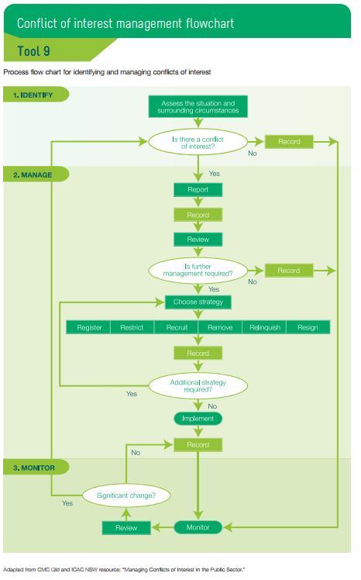

Guide to managing conflicts of interest or duty
Once an interest has been declared and registered, there are several options available to the Regional Council when deciding how to manage a conflict of interest:
- remove – the member does not participate at all in the matter
- restrict – restrictions are placed on the member’s involvement in the matter
- recruit – a disinterested third party is recruited to provide advice (such as a probity adviser, lawyer or governance expert)
- relinquish – the private interest concerned is relinquished
- resign – the member steps down from the position on a temporary or permanent basis.

Remove – the recommended procedure for managing conflicts of interest
The option of removing the conflicted member from decision-making will usually be sufficient to manage the conflict where the conflict is in relation to a single issue. The recommended procedure for dealing with a conflict of interest is for the member with the conflict to:
- leave the room at the start of the relevant agenda item and not return until the start of the next agenda item
- not discuss the matter at all with any other member (either in the meeting or elsewhere)
- not participate in any Board decision on the matter.
This procedure should be followed unless the Regional Council determines and documents clear reasons why the public interest requires the Council to manage the conflict in a different way. Depending on the nature of the conflict, lesser or stronger options may be required. Lesser options include placing restrictions on the conflicted member’s involvement in discussion and decision-making, while stronger options include relinquishment and resignation.

Restrict or recruit – lesser options for managing conflicts of interest
In certain circumstances, factors such as the expertise of the ‘conflicted’ member and/or the composition of the Regional Council may sufficiently affect the public interest for a lesser option such as restricting involvement or recruiting an independent person to be considered.
If the Regional Council is uncertain whether a lesser option is in the public interest, independent advice should be sought.
Following are examples of where, taking into account all the relevant circumstances, the Regional Council may determine that a lesser option is in the public interest.
Member expertise – If the ‘conflicted’ member was appointed on the basis of their knowledge of the issue and/or as a stakeholder representative, it may be in the public interest for them to be present for at least part of the Council’s discussions, to enable the Council to use this knowledge and/or understand key stakeholder views.
Note that if a member who is not conflicted and can provide the required expertise in discussions is absent from the meeting, it will almost always be in the public interest for that part of the discussion to be held over to the next meeting.
Composition of the Board – Some agencies have establishing Acts that require a significant proportion of members to be appointed on the basis of expertise that usually derives from a related financial or non-financial interest. In such cases, even if all members are present at the meeting, there may never be a quorum if all ‘conflicted’ members abstain from certain decisions. In such circumstances, it may be in the public interest for certain members (e.g. whose conflict is not material) to take part in discussion and decision-making on the issue.
Note that if no quorum exists for a decision because members who are not conflicted are absent, it will almost always be in the public interest for the decision to be held over to the next Board meeting.

Relinquish or resign – stronger options for managing conflicts of interest
In some cases, the conflict of interest may be more enduring. That is, members of the public could reasonably form the view that a member’s situation is unacceptable and may damage the reputation of the entity.
It may then be necessary for the member to:
- relinquish their private interests
- resign or temporarily stand down from the other organisation to which the member has a duty
- resign from the Council.
If the Council is uncertain whether the stronger option is in the public interest, independent advice should be sought.

