Victorian Child Health and Wellbeing Survey
Summary Findings 2019

Contents

Contents 5
Background 6
About the data 7
How to read the tables in this report – an example 7
Victoria at a glance – 2019 8
Significant changes from previous surveys 10
Family and the home environment 13
Key findings 13
Exposure to tobacco smoke 14
Prenatal alcohol exposure 14
Family functioning 15
Reading to children 16
Crisis support 16
Food insecurity 17
Financial insecurity 17
Access to basic services 18
Safe neighbourhoods 19
Outdoor spaces 20
Physical health and healthy behaviours 21
Key findings 21
General physical health 22
Asthma 22
Oral health status 23
Fruit intake 23
Vegetable intake 24
Physical activity 25
Electronic media use 25
Behavioural difficulties 27
Key findings 27
Emotional, developmental or behavioural problems 28
Risk of behavioural difficulties 28

Background
The Victorian Child Health and Wellbeing Survey (VCHWS) collects information about the health and wellbeing of Victorian children up to the age of 12. The survey includes questions on family characteristics and the home environment, the child’s physical health and healthy behaviours and development issues.
Between July and September 2019, parents or carers (subsequently referred to as parents) completed interviews on behalf of 5,000 randomly selected Victorian children aged 0-12 years. The broad characteristics of respondents included in the past few surveys are very similar, so comparisons of results for Victorian children can be made over time. This report presents results from 2019, with comparisons to 2017 and 2013.

Table 1. Profile of VCHWS subjects (children aged 0-12) in the 2013, 2017 and 2019 surveys
Selected characteristic | Survey Estimate* (per cent) | Survey Estimate* (per cent) | Survey Estimate* (per cent)
 | 2013 | 2017 | 2019
Area
Metropolitan Victoria | 73.7 | 74.9 | 60.5
Rural Victoria | 26.3 | 25.1 | 39.5
Age group
< 1 year | 8.2 | 7.5 | 7.4
1 to 4 years | 31.8 | 31.7 | 30.9
5 to 8 years | 30.6 | 31.1 | 29.8
9 to 12 years | 29.3 | 29.7 | 31.8
Family type
Couple family | 88.4 | 85.6 | 86.4
One-parent family | 11.5 | 14.2 | 13.4
Health care card status
On a health care card | 25.1 | 24.1 | 22.0
Not on a health care card | 74.1 | 75 | 76.5
* Proportions represent demographic splits following the weighting of survey responses.

About the data
- VCHWS is a cross sectional survey – it is possible to identify associations between variables in the dataset, but we cannot attribute cause and effect.
- There are no controls for confounding factors in the analysis – for example, could the increased frequency of smoking among those on health care cards and in rural households really be due to socioeconomic status or some other variable?
- The estimates provided are based on sample data, and the confidence intervals for each value indicate that there is a 95 per cent probability that the true value lies between the upper and lower limits of the confidence interval. Therefore, if the confidence intervals of two population group values do not overlap, it can be assumed that the true values of the two estimates are unlikely to fall within the same distribution. When this occurs, the two values are considered to indicate a statistically significant difference.

In this report statistically significant changes across surveys are outlined at the beginning of the report and also in the relevant sections and statistically significant differences between population groups are shaded in grey in the tables showing results for the individual measures.

How to read the tables in this report – an example
The tables throughout this report contain results from the 2013, 2017 and 2019 surveys.
Results are presented for all respondents (the Victorian result) and for eight population groups (also referred to as cohorts). Like cohorts are grouped as such, with comparisons in results generally focusing on the following four pairs:
- children living in metropolitan areas and children living in rural areas
- children living in areas of most socioeconomic disadvantage and children living in areas of least socioeconomic disadvantage
- children living in a family with two parents (couple family) and children living in a one-parent family
- children listed as a dependant on a health care card and children not listed as a dependant on a health care card.

Example table: Victorian babies exposed to alcohol in utero, 2019
 | 2019
Victoria | 46.6% | 2019 result for all Victorian children
Metropolitan | 44.3% | Results for children living in metropolitan areas and rural areas are an example of a population group comparison
Rural | 49.2%
Most disadvantaged | 42.8%
Least disadvantaged | 55.0% | Highest proportion of positive responses
Couple family | 48.3%
One-parent family | 21.2% | Lowest proportion of positive responses
Child on a health care card | 29.1%* | An asterix (*) next to a result indicates that the difference between these two population groups in 2019 is statistically significant and not due to chance or error
Child not on a health care card | 49.9%*

Victoria at a glance – 2019

FAMILY AND THE HOME ENVIRONMENT
Proportion of children who… | 2019 result | Comment
lived in a smoke-free home | 81.9% | The proportion of Victorian children living in smoke-free homes has remained stable since 2013. When looking at population groups however, there is a significant difference in 2019 results based on where a child lives (rurality and level of disadvantage), their family type and their health care card status.
were exposed to alcohol in utero | 46.6% | Results for children exposed to alcohol in utero have remained relatively consistent across the last three surveys. In 2019, children who were not on a health care card were more likely to be exposed to alcohol in utero than those on a health care card.
lived with unhealthy family functioning | 7.2% | The 2019 Victorian result for family functioning is similar to previous surveys. Similar proportions of children from metro and rural areas lived in families with unhealthy family functioning while differences between the remaining population groups were significant.
were read to by a family member everyday | 68.6% | The proportion of Victorian children read to daily by a family member has remained stable since 2013. 2019 results show differences for children based on health care card status and the area’s level of disadvantage in which they lived.
had someone to help in a time of crisis | 93.5% | While most Victorian parents had someone to care for their family in an emergency (a result similar to previous surveys), families without children on a health care card were more likely to have crisis support than families with children on a health care card.
had faced food insecurity | 5.9% | The 2019 result for food insecurity is a decline on 2017, however it is not statistically significant. There were however significant differences across all population groups in 2019; noticeably, one-parent families were more likely to face food insecurity (one-in-five) than couple families (one-in-twenty-five).
had faced financial insecurity | 10.6% | Results for financial insecurity have remained stable. In 2019, one-parent families and families with children on a health care card were around three-to-four times more likely to have faced financial insecurity.
had access to basic health services | 90.4% | The 2019 proportion of Victorian families with access to basic services is a significant decrease from both 2017 and 2013. In 2019, there was a significant difference in results based on residential location (rurality and level of disadvantage) and health care card status.
lived in a safe neighbourhood | 95.0% | While slight, the increased proportion (from 2017) of Victorian children living in a safe neighbourhood is statistically significant. Where a child lives (rurality and level of disadvantage), family type and health care card status all had an impact on feelings of neighbourhood safety.
lived near playgrounds or open spaces | 86.7% | Consistent with results from previous surveys, the majority of Victorian families lived near playgrounds or open spaces. In 2019, all family factors showed significant differences in responses apart from family type (one-parent compared with couple families).
PHYSICAL HEALTH AND HEALTHY BEHAVIOURS
Proportion of children who… | 2019 result | Comment
had good health (or better) | 97.9% | As with previous surveys, most Victorian children are in good health. Those on a health care card were significantly less likely to have good health (or better) than children not on a health care card, however the results for both are still high.
had asthma | 11.3% | Asthma rates have remained stable across the last three surveys. In 2019, the proportion of children with asthma was similar for those living in metropolitan and rural areas, however significantly different for children in a one-parent family (compared with couple family) and on a health care card (compared with not on a health care card).
have had a filling | 20.0% | Similar to previous surveys, around one-in-five children had a filling. Rural areas had significantly higher proportions of children with fillings than metropolitan areas, as did areas of most disadvantage (when compared with areas of least disadvantage).
met the national fruit intake guidelines | 74.3% | Around three-in-four children met fruit intake guidelines, a stable result since 2013. In 2019, significant differences between a child’s fruit intake were based on the level of disadvantage of their residential location, their family type and their age.
met the national vegetable intake guidelines | 2.4% | Few children met vegetable intake guidelines; a result consistent with previous surveys. For this measure, there were no significant differences between any population groups.
are active every day | 52.2% | Victorian children were significantly less active than they were in both 2013 and 2017, with only one-half physically active for at least an hour a day. There were no significantly different results between any population groups.
exceeded the recommended screen time usage | 20.2% | More children living in rural areas (than metro areas) or listed on a health care card (than not) were exceeding screen time. The result for all Victorian children remained stable.
BEHAVIOURAL DIFFICULTIES
Proportion of children who… | 2019 result | Comment
had emotional, developmental or behavioural problems | 10.6% | There has been a significant increase in the proportion of Victorian children who have emotional, developmental or behavioural problems since 2013. 2019 results show a significant difference in prevalence of these issues between all population groups.
had low-to-no risk of behavioural difficulties | 81.1% | There has been a significant decrease in the proportion of Victorian children at low-to-no risk of behavioural difficulties since 2013. 2019 results show a significant difference in prevalence of these issues between all population groups.

Significant changes from previous surveys
The following table shows the statistically significant changes over two different time periods:
- firstly, from 2017 to 2019, showing any changes since the previous survey
- secondly, from 2013 to 2019, showing any longer-term and sustained trends.
A significant change highlighted in red means the result has been negative. A significant change highlighted in purple means the result has been positive.

Table 2: Statistically significant changes across 2017 to 2019 and 2013 to 2019
 | FAMILY AND THE HOME ENVIRONMENT
 |  | 2017 – 2019 | 2013 - 2019
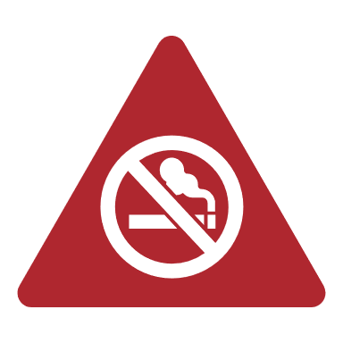 | Living in a smoke free home | n/a | Children living in metropolitan areas
 | Family having access to support in a crisis | Children living in areas of most disadvantage | n/a
 | Family unable to raise $2000 in an emergency | Children living in rural areas | Children living in metropolitan areas  Children living in a couple family
 | Access to basic health services | All children  Children living in a couple family  Children not on a health care card | All children  Children living in a couple family  Children not on a health care card
 | Living in a safe neighbourhood | All children  Children living in a couple family | n/a
 | Living in an area close to playgrounds and open spaces | Children living in a couple family  Children not on a health care card | n/a
 | PHYSICAL HEALTH AND HEALTHY BEHAVIOURS
 |  | 2017 – 2019 | 2013 - 2019
 | Meeting vegetable intake guidelines | Children living in a one-parent family | n/a
 | Physical activity | All children  Children living in metropolitan areas  Children living in rural areas  Children living in a couple family  Children on a health care card  Children not on a health care card | All children  Children living in metropolitan areas  Children living in rural areas  Children living in a couple family  Children on a health care card  Children not on a health care card  Children living in areas of least disadvantage
 | Exceeding recommended screen time | n/a | Children living in rural areas
 | BEHAVIOURAL DIFFICULTIES
 |  | 2017 – 2019 | 2013 - 2019
 | Emotional, development or behavioural issues | n/a | All children  Children living in rural areas  Children living in areas of most disadvantage  Children living in a couple family  Children on a health care card  Children not on a health care card
 | Low or no risk of behavioural difficulties | n/a | All children  Children living in rural areas  Children living in a couple family  Children on a health care card

Family and the home environment

Key findings
2019 results show different outcomes for children based on their health care card status
There was a significant difference between results for children on a health care card and those not on a health care card when looking at all measures relating to family and the home environment. For example:
- Two-thirds lived in a smoke-free home; a result significantly lower than the nearly 90 per cent of children not on a health care card
- Lower proportions were exposed to alcohol in utero (29 per cent as opposed to 50 per cent)
- They were six times more likely to live in families facing food insecurity and four times more likely for financial insecurity
Couple families are feeling safer at home but reporting lower levels of access to services
- Between 2017 and 2019 the proportion reporting they have access to basic health services significantly declined (alongside a similar trend in the overall Victorian result, where results declined from 93.3 per cent to 90.4 per cent).
- Over the same period there was a significant increase in the proportion of couple families reporting they live in a safe neighbourhood (again, alongside an increase in the overall result for Victoria, from 92.4 per cent to 95.0 per cent).

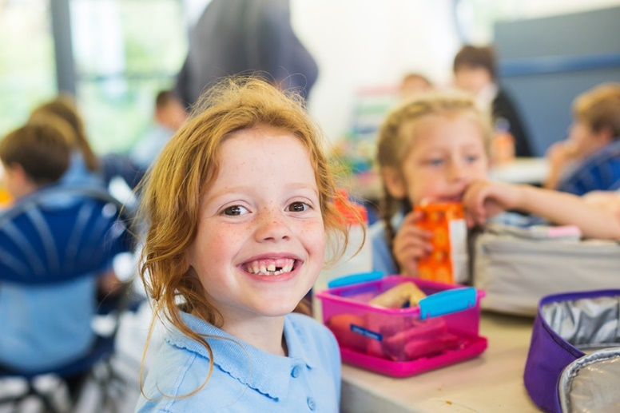

Exposure to tobacco smoke
Babies exposed to tobacco and alcohol in utero may be at risk of developmental and other problems later in life. This can include miscarriage, stillbirth, prematurity, birth defects, and growth and development issues. Children and adults exposed to tobacco while in utero are also at higher risks of certain conditions, including Type 2 diabetes, obesity and respiratory issues.
The VCHWS asks parents how many people within their household are regular smokers.
In 2019:
- Four-in-five Victorian children (81.9 per cent) lived in a home where they were not exposed to smoke. This is the same when compared with results of previous surveys.
- Children living in metropolitan areas, the least disadvantaged areas, in couple families, and not listed as dependents on health care cards were more likely to live in smoke-free homes.

There has been a significant increase in the proportion of children living in a smoke-free home for children living in metropolitan areas (2013 – 2019).

Table 3: Proportion of Victorian children living in a smoke-free home
 | 2013 | 2017 | 2019
Victoria | 81.5% | 81.9% | 81.9%
Metropolitan | 82.1% | 84.1%* | 85.6%*
Rural | 79.8% | 75.4%* | 77.6%*
Most disadvantaged | 70.7%* | 65.5%* | 70.8%*
Least disadvantaged | 89.9%* | 91.4%* | 91.1%*
Couple family | 82.9%* | 84.6%* | 84.0%*
One-parent family | 67.6%* | 68.7%* | 68.7%*
Child on a health care card | 70.0%* | 66.6%* | 68.0%*
Child not on a health care card | 85.2%* | 87.0%* | 86.2%*
* indicates a significant difference between results for population groups for the respective survey year

Prenatal alcohol exposure
The VCHWS asks biological mothers (of children up to the age of one) whether they had drunk alcohol while pregnant (both before and after they knew they were pregnant).
In 2019:
- Approximately half (46.6 per cent) of Victorian babies were exposed to alcohol in utero. This is the same result as found in previous surveys.
- Mothers who did not have children listed on a health care card were more likely to have drunk while pregnant compared with mothers of children on a health care card.
Table 4: Proportion of Victorian babies (aged 0-1) who were exposed to alcohol in utero
 | 2013 | 2017 | 2019
Victoria | 46.7% | 56.2% | 46.6%
Metropolitan | 44.8% | 55.2% | 44.3%
Rural | 52.9% | 59.1% | 49.2%
Most disadvantaged (SEIFA IRSED quintile 1) | 29.3%* | 51.8% | 42.8%
Least disadvantaged (SEIFA IRSED quintile 5) | 57.5%* | 61.3% | 55.0%
Couple family | 47.4% | 57.6% | 48.3%
One-parent family | 36.2% | 40.6% | 21.2%
Child on a health care card | 34.1% | 48.3% | 29.1%*
Child not on a health care card | 49.9% | 58.4% | 49.9%*
* indicates a significant difference between results for population groups for the respective survey year

Family functioning
Healthy family functioning promotes children’s emotional, physical and social wellbeing. Family functioning is considered unhealthy when serious family conflict is present, and the family environment is unsupportive.
The VCHWS asks parents a series of questions about how family members interact (on a day-to-day basis and on an emotional level), make decisions and plan family activities.
In 2019:
- Around seven per cent (7.2 per cent) of Victorian children lived in a home with unhealthy family functioning. This is the same result as found in previous surveys.
- Children living in the most disadvantaged areas, in one-parent families, and listed as dependents on health care cards were more likely to live in families that showed signs of unhealthy family functioning when compared with other cohorts.
Table 5: Proportion of Victorian children living in a family with unhealthy family functioning
 | 2013 | 2017 | 2019
Victoria | 7.6% | 8.1% | 7.2%
Metropolitan | 8.2%* | 8.1% | 7.6%
Rural | 6.0%* | 8.2% | 6.8%
Most disadvantaged | 11.1%* | 12.9% | 10.4%*
Least disadvantaged | 6.3%* | 8.0% | 4.7%*
Couple family | 6.6%* | 6.6%* | 6.2%*
One-parent family | 17.9%* | 15.5%* | 13.6%*
Child on a health care card | 13.7%* | 12.9%* | 11.2%*
Child not on a health care card | 5.6%* | 6.4%* | 5.6%*
* indicates a significant difference between results for population groups for the respective survey year

Reading to children
Reading to children can have a significant positive effect on their reading and cognitive skills and later schooling outcomes regardless of family background. Children who are read to more frequently are more likely to perform better in Year 3 NAPLAN Reading and Numeracy (more so Reading) than those children who are read to less often.
The VCHWS asks parents of children aged under five years of age how many days (in the past week) they, or someone in the family, had read to their child from a book.
In 2019:
- Over two-thirds (68.6 per cent) of Victorian children were read to by a family member every day. This is similar to the results of previous surveys.
- Children living in the most disadvantaged areas were less likely to be read to than those in the least disadvantaged areas. Children listed on a health care card were also less likely to be read to than children not on a health care card.
Table 6: Proportion of Victorian children (under five years old) read to everyday by a family member
 | 2013 | 2017 | 2019
Victoria | 69.6% | 68.9% | 68.6%
Metropolitan | 68.4% | 66.8%* | 66.3%
Rural | 73.1% | 75.8%* | 71.4%
Most disadvantaged | 61.2%* | 59.4% | 59.9%*
Least disadvantaged | 77.9%* | 72.2% | 75.0%*
Couple family | 70.2% | 69.3% | 69.0%
One-parent family | 61.3% | 65.3% | 64.5%
Child on a health care card | 64.7% | 61.9% | 61.8%*
Child not on a health care card | 71.1% | 70.5% | 70.5%*
* indicates a significant difference between results for population groups for the respective survey year

Crisis support
The VCHWS asks parents if they have relatives or friends to care for them or their children in times of an emergency.
In 2019:
- Most Victorian parents (93.5 per cent) had someone to care for them or their children in case of an emergency. This is similar to previous surveys.
- Children who were listed as dependants on health care cards were more likely to live in families without crisis support than those not on a health care card.

There has been a significant increase in the proportion of children living in families with access to crisis support for children living in areas of most disadvantage (2017 – 2019).

Table 7: Proportion of Victorian children living in families with crisis support in times of an emergency
 | 2013 | 2017 | 2019
Victoria | 93.8% | 93.9% | 93.5%
Metropolitan | 93.6% | 93.7% | 92.7%
Rural | 94.4% | 94.3% | 94.5%
Most disadvantaged | 92.7% | 87.2%* | 93.6%
Least disadvantaged | 94.6% | 95.0%* | 93.9%
Couple family | 94.1%* | 94.6%* | 93.8%
One-parent family | 90.3%* | 90.3%* | 91.7%
Child on a health care card | 91.6%* | 90.5%* | 89.8%*
Child not on a health care card | 94.7%* | 95.2%* | 94.7%*
* indicates a significant difference between results for population groups for the respective survey year

Food insecurity
Food insecurity can cause distress and often causes families to rely on unhealthy low-cost foods which has ramifications for children’s health.
The VCHWS asks parents if they had run out of food and couldn’t afford to buy more in the previous 12 months.
In 2019:
- Around six per cent (5.9 per cent) of Victorian parents stated that they had experienced food insecurity sometime in the past 12 months. While this is a decline when compared with results from the previous survey, the change is not statistically significant.
- Children living in rural areas, in the most disadvantaged areas, in one-parent families and listed as dependents on health care cards were more likely to live in families experiencing food insecurity.
Table 8: Proportion of Victorian children living in families that had experienced food insecurity in the previous 12 months
 | 2013 | 2017 | 2019
Victoria | 4.9% | 7.1% | 5.9%
Metropolitan | 4.8% | 6.2%* | 4.4%*
Rural | 5.4% | 9.7%* | 7.7%*
Most disadvantaged | 9.6%* | 13.5%* | 8.9%*
Least disadvantaged | 2.3%* | 2.7%* | 2.9%*
Couple family | 3.5%* | 4.2%* | 3.7%*
One-parent family | 18.7%* | 21.3%* | 20.1%*
Child on a health care card | 13.8%* | 18.7%* | 16.4%*
Child not on a health care card | 2.2%* | 3.3%* | 2.7%*
* indicates a significant difference between results for population groups for the respective survey year

Financial insecurity
Financial hardship and associated social isolation can impact any parent’s ability to provide a healthy and stimulating family environment. This in turn may cause psychological distress for parents and impact on their caregiving capacity.
The VCHWS assesses financial insecurity experienced by parents as not being able to raise $2000 in an emergency.
In 2019:
- Around ten per cent (10.6 per cent) of Victorian parents stated that they would not be able to raise $2000 in an emergency. This is very similar to the previous survey.
- Children living in the most disadvantaged areas, in one-parent families and those listed as dependents on health care cards were more likely to live in families that had experienced financial insecurity when compared with other cohorts.

There has been a significant decrease in the proportion of children living in families facing financial insecurity for: children living in rural areas (2017 – 2019); children living in metropolitan areas and children living in a couple family (2013 – 2019).

Table 9: Proportion of Victorian children living in families that would face financial insecurity in an emergency
 | 2013 | 2017 | 2019
Victoria | 12.3% | 11.5% | 10.6%
Metropolitan | 12.5% | 9.9%* | 10.0%
Rural | 11.6% | 16.2%* | 11.2%
Most disadvantaged | 19.6%* | 25.6%* | 20.5%*
Least disadvantaged | 6.5%* | 4.2%* | 4.3%*
Couple family | 10.2%* | 8.7%* | 8.2%*
One-parent family | 32.5%* | 25.2%* | 25.9%*
Child on a health care card | 27.9%* | 25.2%* | 24.8%*
Child not on a health care card | 7.2%* | 7.0%* | 6.2%*
* indicates a significant difference between results for population groups for the respective survey year

Access to basic services
Access to services can have a substantial impact on an individual’s health and wellbeing. Families that are unable to access basic health services may find that this has significant consequences for their health and wellbeing.
The VCHWS asks parents if there is access to basic health services, such as a health centre or medical clinic, in their neighbourhood.
In 2019:
- Most Victorian parents (90.4 per cent) agreed that there was access to basic health services in their neighbourhood. This is a small but statistically significant decrease when compared with results from previous surveys.
- Children living in metropolitan areas, the least disadvantaged areas and those listed as dependents on health care cards were more likely to live in families that reported access to these services when compared with other cohorts.
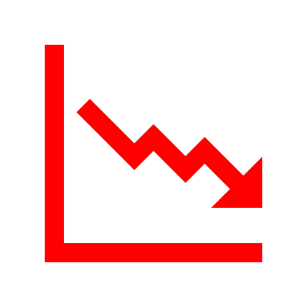 | There has been a significant decrease in the proportion of children living in families with access to basic health services for: all children, children living in a couple family and children not on a health care card (2013 – 2019 and 2017 - 2019).
Table 10: Proportion of Victorian children living in families that have access to basic health services in their neighbourhood
 | 2013 | 2017 | 2019
Victoria | 92.6% | 93.3% | 90.4%
Metropolitan | 95.3%* | 95.8%* | 95.7%*
Rural | 85.1%* | 85.6%* | 84.4%*
Most disadvantaged | 91.1% | 91.8% | 87.6%*
Least disadvantaged | 94.4% | 95.2% | 94.2%*
Couple family | 92.8% | 93.8% | 90.7%
One-parent family | 90.2% | 90.8% | 88.8%
Child on a health care card | 90.1%* | 91.8% | 91.7%*
Child not on a health care card | 93.4%* | 93.8% | 86.8%*
* indicates a significant difference between results for population groups for the respective survey year

Safe neighbourhoods
Children who feel unsafe and report witnessing fights and crime in their community are more likely than others to have lower levels of resilience and engage in risky health behaviours like smoking and trying illegal drugs.
The VCHWS asks parents if they think their neighbourhood is safe.
In 2019:
- Nearly all (95.0 per cent) Victorian parents agreed that their neighbourhood is safe. This is a slight but statistically significant increase when compared with results from 2017.
- Children living in rural areas, the least disadvantaged areas, in couple families and not listed as dependents on health care cards were more likely to live in safe neighbourhoods.

There has been a significant increase in the proportion of children living in a safe neighbourhood for: all children and children living in a couple family (2017 – 2019).

Table 11: Proportion of Victorian children living in families that live in a safe neighbourhood
 | 2013 | 2017 | 2019
Victoria | 95.8% | 92.4% | 95.0%
Metropolitan | 95.3%* | 92.0% | 93.8%*
Rural | 97.1%* | 93.9% | 96.4%*
Most disadvantaged | 87.5%* | 80.8% | 89.0%*
Least disadvantaged | 99.2%* | 97.7% | 98.2%*
Couple family | 96.2%* | 93.3%* | 95.5%*
One-parent family | 91.5%* | 88.0%* | 92.1%*
Child on a health care card | 93.6%* | 86.5%* | 91.4%*
Child not on a health care card | 96.5%* | 94.4%* | 96.2%*
* indicates a significant difference between results for population groups for the respective survey year

Outdoor spaces
Providing the physical infrastructure that children need is another vital ingredient to an inclusive and enabling community. When children have good access to parks and playgrounds, it offers them better opportunities for physical activity.
The VCHWS asks parents whether there are good parks, playgrounds and play spaces in their neighbourhood.

In 2019:
- Most Victorian parents (86.7 per cent) agreed that their neighbourhood had good parks, playgrounds and play spaces, as did most parents in previous surveys.
- Children living in metropolitan areas, the least disadvantaged areas and not listed as dependents on health care cards were more likely to live in neighbourhoods with good play spaces when compared with other cohorts.

There has been a significant decrease in the proportion of children living close to open spaces and playgrounds for: children living in a couple family and children not on a health care card (2017 - 2019).

Table 12: Proportion of Victorian children who live in a neighbourhood with good parks, playgrounds and play spaces
 | 2013 | 2017 | 2019
Victoria | 87.9% | 89.2% | 86.7%
Metropolitan | 91.0%* | 92.7%* | 93.0%*
Rural | 79.4%* | 78.6%* | 79.6%*
Most disadvantaged | 77.4%* | 75.7%* | 80.7%*
Least disadvantaged | 93.7%* | 96.2%* | 93.9%*
Couple family | 88.3%* | 90.0%* | 87.0%
One-parent family | 84.4%* | 85.0%* | 84.9%
Child on a health care card | 84.0%* | 84.1%* | 82.7%*
Child not on a health care card | 89.2%* | 90.8%* | 88.1%*
* indicates a significant difference between results for population groups for the respective survey year

Physical health and healthy behaviours

Key findings
Oral health and nutrition were impacted by where a child lives
- 2019 results show a significant difference, for the first time across the three surveys, between the proportion of children who had had a filling and those who had not based on the level of disadvantage of the area in which they lived. The same is true for the measure of children meeting the recommended daily fruit intake.
Very low proportions of Victorian children meet the minimum nutrition recommendations for vegetables
- Only one-in-forty Victorian children ate the recommended amount of vegetables. Children were not meeting this recommendation regardless of age, residential location or area level of disadvantage, family type or health care card status.
Fewer Victorian children were physically active
- Around one-in-two Victorian children were active for an hour every day. This proportion has significantly decreased since both 2017 and 2013.
- 2019 results did not vary between children based on their residential location or area’s level of disadvantage, family type or health care card status.
Some children were more likely to exceed screen time recommendations
- In 2019, one-in-five Victorian children exceeded the recommended time for screen usage.
- At nearly 27 per cent, children listed on a health care card were significantly more likely to exceed the two-hour recommendation than those not listed on a health care card. These children were also more likely than all other children to exceed the recommendation for screen time.

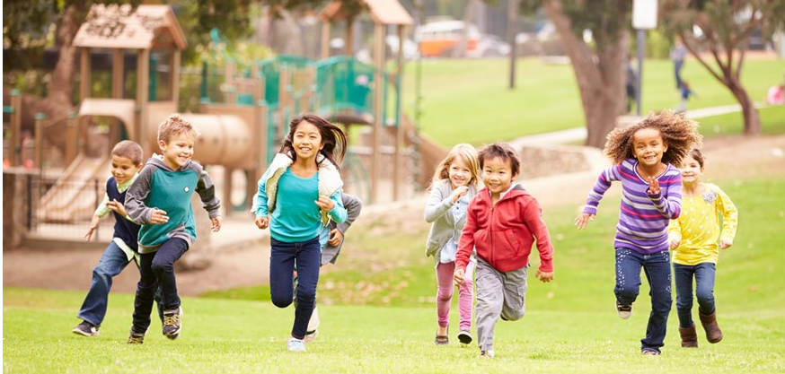

General physical health
A child’s health has been shown to have an impact on their learning outcomes through affecting their energy and concentration levels and ability to learn.
The VCHWS asks parents to rate their child’s general health, from poor through to excellent.
In 2019:
- As in previous surveys, nearly all Victorian parents (97.9 per cent) rated their child’s health as good or better.
- Children not listed as dependants on a health care were more likely to be in better health than those on a health care card.
Table 13: Proportion of Victorian children with good health or better
 | 2013 | 2017 | 2019
Victoria | 97.9% | 97.3% | 97.9%
Metropolitan | 98.0% | 97.4% | 98.1%
Rural | 97.7% | 97.1% | 97.8%
Most disadvantaged | 96.5% | 98.1% | 97.9%
Least disadvantaged | 98.0% | 97.9% | 98.0%
Couple family | 98.0% | 98.0%* | 98.1%
One-parent family | 96.7% | 94.1%* | 96.9%
Child on a health care card | 95.3%* | 95.4%* | 95.0%*
Child not on a health care card | 98.7%* | 98.1%* | 98.9%*
* indicates a significant difference between results for population groups for the respective survey year

Asthma
Asthma is a chronic respiratory condition caused by the narrowing of airways due to inflammation and can negatively impact people’s physical, social and emotional wellbeing, particularly for those who do not manage the condition well.
The VCHWS asks parents of children aged one to 12 years old whether their child has asthma.
In 2019:
- Around 11 per cent (11.3 per cent) of Victorian parents reported that their child had asthma. This is a similar result to previous surveys.
- Children living in one-parent families and those listed as a dependant on a health care card were more likely to have asthma when compared with other cohorts.
Table 14: Proportion of Victorian children (aged 1-12) with asthma
 | 2013 | 2017 | 2019
Victoria | 11.3% | 12.1% | 11.3%
Metropolitan | 10.9% | 11.1% | 10.0%
Rural | 12.6% | 15.2% | 12.8%
Most disadvantaged | 10.4% | 14.0% | 13.5%
Least disadvantaged | 10.8% | 13.6% | 9.2%
Couple family | 11.0% | 10.6%* | 10.7%*
One-parent family | 14.5% | 19.1%* | 15.3%*
Child on a health care card | 13.5%* | 16.6%* | 15.3%*
Child not on a health care card | 10.6%* | 10.4%* | 10.1%*
* indicates a significant difference between results for population groups for the respective survey year

Oral health status
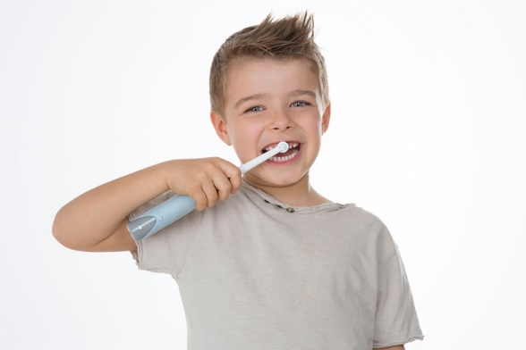
Children with healthy teeth and gums in childhood are more likely to have good dental health as adults. The chances of needing a filling or having tooth decay can be reduced through regular activities such as brushing and flossing, having a healthy diet, and regular trips to the dentist.

The VCHWS asks parents whether their child has ever had a filling.
In 2019:
- One-in-five (20.0 per cent) Victorian children had received a filling, similar to previous survey results.
- Children living in rural areas and the most disadvantaged areas were more likely to have had a filling when compared with other cohorts.
Table 15: Proportion of Victorian children who had received a filling
 | 2013 | 2017 | 2019
Victoria | 19.5% | 17.7% | 20.0%
Metropolitan | 17.9%* | 16.1%* | 17.0%*
Rural | 24.0%* | 22.6%* | 23.4%*
Most disadvantaged | 23.3% | 20.8% | 25.8%*
Least disadvantaged | 18.2% | 15.9% | 16.3%*
Couple family | 19.0%* | 16.4%* | 19.4%
One-parent family | 25.3%* | 23.7%* | 23.3%
Child on a health care card | 21.2% | 22.3%* | 22.9%
Child not on a health care card | 19.0% | 16.2%* | 19.1%
* indicates a significant difference between results for population groups for the respective survey year

Fruit intake
The daily recommended fruit intake for children between the ages of two and 11 is between one to two serves per day (recommendations depend on the age of the child).
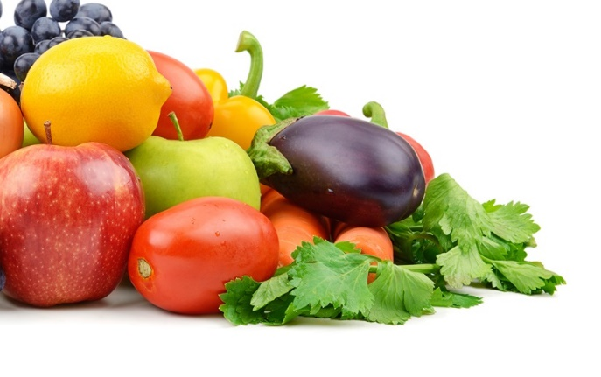
The VCHWS asks parents of children aged four to 12 years old how many serves of fruit (including dried fruit) their child eats daily.
In 2019:
- Three-quarters (74.3 per cent) of Victorian children were meeting the national minimum guidelines for fruit consumption. This is no different to previous survey results.
- Children living in the least disadvantaged areas, in couple families and aged four-to-eight years old were more likely to be meeting the guidelines when compared with other cohorts.
Table 16: Proportion of Victorian children (aged 4-12) meeting fruit intake guidelines
 | 2013 | 2017 | 2019
Victoria | 73.2% | 76.7% | 74.3%
Metropolitan | 72.0%* | 77.0% | 73.6%
Rural | 76.2%* | 75.9% | 75.0%
Most disadvantaged | 70.1% | 72.6% | 69.8%*
Least disadvantaged | 73.5% | 78.0% | 79.0%*
Couple family | 73.8% | 78.0% | 75.7%*
One-parent family | 68.6% | 72.1% | 66.6%*
Child on a health care card | 69.6%* | 74.2% | 71.2%
Child not on a health care card | 74.5%* | 77.9% | 75.3%
Child aged 4 to 8 years | 77.4%* | 81.3%* | 78.0%*
Child aged 9 to 12 years | 67.5%* | 70.7%* | 69.6%*
* indicates a significant difference between results for population groups for the respective survey year

Vegetable intake
The daily recommended vegetable intake for children between the ages of two and 11 is between two-and-a-half and five serves per day (recommendations depend on the age of the child).
The VCHWS asks parents of children aged four to 12 years old how many serves of vegetables (including salad) their child eats daily.
In 2019:
- As in previous surveys, less than five per cent (2.4 per cent) of Victorian children were meeting the national minimum guidelines for vegetable consumption.

There has been a significant decrease in the proportion of children meeting the recommended vegetable intake for: children living in a one-parent family (2017 - 2019).

Table 17: Proportion of Victorian children (aged 4-12) meeting vegetable intake guidelines
 | 2013 | 2017 | 2019
Victoria | 2.9% | 3.8% | 2.4%
Metropolitan | 2.8% | 3.6% | 2.4%
Rural | 3.1% | 4.3% | 2.4%
Most disadvantaged | 2.4% | 3.5% | 2.0%
Least disadvantaged | 2.7% | 2.7% | 2.4%
Couple family | 2.8% | 3.2% | 2.5%
One-parent family | 3.8% | 5.9% | 1.2%
Child on a health care card | 2.7% | 4.5% | 1.8%
Child not on a health care card | 3.0% | 3.4% | 2.5%
Child aged 4 to 8 years | 2.5% | 3.8% | 2.1%
Child aged 9 to 12 years | 3.4% | 3.7% | 2.8%
* indicates a significant difference between results for population groups for the respective survey year

Physical activity
Physical activity and exercise promote healthy growth and development, maintain healthy weight and reduce the risk of disease. Studies have shown that exercise improves concentration and sleep and can alleviate the severity of mental health issues, such as depression and anxiety.
The VCHWS asks parents of children aged five to 12 years old how often their child had been physically active for at least 60 minutes in the past week.
In 2019:
- Around half (52.2 per cent) of Victorian children were physically active for an hour a day. This is a statistically significant decline from 2017 (and also 2013), and one which occurred across most cohorts.

There has been a significant decrease in the proportion of children who were physically active for an hour a day for: all children, children living in metropolitan areas, children living in rural areas, children living in a couple family, children on a health care card and children not on a health care card (2013 – 2019 and 2017 – 2019) and children living in areas of least disadvantage (2017 – 2019).

Table 18: Proportion of Victorian children (aged 5-12) who are physically active for one hour a day
 | 2013 | 2017 | 2019
Victoria | 62.2% | 59.4% | 52.2%
Metropolitan | 60.4%* | 58.2% | 51.4%
Rural | 67.1%* | 62.8% | 53.0%
Most disadvantaged | 62.8% | 63.3% | 53.5%
Least disadvantaged | 60.3% | 59.2% | 49.9%
Couple family | 62.3% | 60.1% | 51.7%
One-parent family | 60.8% | 56.4% | 54.5%
Child on a health care card | 62.9% | 63.2% | 53.4%
Child not on a health care card | 61.9% | 58.2% | 52.2%
* indicates a significant difference between results for population groups for the respective survey year

Electronic media use
Recommendations for children’s screen use are less than two hours with electronic media each day. Research suggests that excessive screen time is associated with developmental risks in children and young people (including sleep, obesity, executive functioning and aggression).
The VCHWS asks parents of children aged five to 12 years old how many hours per day their child uses electronic media, including non-school related computer use, or watching television or DVDs.

In 2019:
- Around one-in-five (20.2 per cent) Victorian children were exceeding the recommended screen time. This is similar to previous surveys.
- Children in rural areas were more likely to exceed recommendations compared to those in metropolitan areas. Children listed on a health care card were also more likely to exceed recommendations compared to those not on a health care card.

There has been a significant increase in the proportion of children exceeding the recommended screen time for: children living in rural areas (2013 – 2019).

Table 19: Proportion of Victorian children (aged 5-12) who exceed recommended screen time
 | 2013 | 2017 | 2019
Victoria | 17.7% | 18.2% | 20.2%
Metropolitan | 18.2% | 17.9% | 17.7%*
Rural | 16.3% | 19.1% | 22.9%*
Most disadvantaged | 24.1%* | 25.7% | 21.3%
Least disadvantaged | 14.2%* | 16.4% | 17.6%
Couple family | 16.7%* | 16.5% | 19.6%
One-parent family | 25.1%* | 23.6% | 23.0%
Child on a health care card | 24.5%* | 24.6%* | 27.6%*
Child not on a health care card | 15.3%* | 15.7%* | 17.6%*
* indicates a significant difference between results for population groups for the respective survey year

Behavioural difficulties

Key findings
More Victorian children are showing signs of developmental issues
- Since 2013 there has been a significant increase in the proportion of Victorian children with development issues. This is particularly true for children living in rural areas, couple families and on a health care card.
- In 2019, children on a health care card were nearly five times as likely as those not on a health care card to have emotional, developmental or behavioural problems.
Where a child lives is now having an impact
- For the first time across the last three surveys, results show a significant difference in the proportion of children with behavioural difficulties according to whether they live in rural or metropolitan areas.

Emotional, developmental or behavioural problems
Beginning school with behavioural and emotional problems is an indicator of poorer academic achievement. Analysis has shown that higher proportions of children who started school at low risk of emotional and behavioural problems (than moderate to high risk children) achieved in the top two bands in Year 3 NAPLAN Reading.
The VCHWS asks parents if their child has any kind of emotional, developmental or behavioural problem for which they need or get treatment or counselling for.
In 2019:
- Around one-in-ten (10.6 per cent) Victorian children had an emotional, developmental or behavioural problem. This is comparable to the previous survey, however, is a significant increase on results for 2013.
- There were significant differences in the prevalence of emotional, developmental or behavioural problems between all population groups in 2019. Higher proportions of children from one-parent families and children listed on a health care card were observed to have emotional, developmental or behavioural problems than all other children.

There has been a significant increase in the proportion of children with emotional, developmental or behavioural problems for: all children, children living in rural areas, children living in areas of most disadvantage, children living in a couple family, children on a health care card and children not on a health care card (2013 – 2019).

Table 20: Proportion of Victorian children with emotional, developmental or behavioural problems
 | 2013 | 2017 | 2019
Victoria | 7.1% | 10.1% | 10.6%
Metropolitan | 6.8% | 9.6% | 8.8%*
Rural | 8.0% | 11.9% | 12.5%*
Most disadvantaged | 7.2% | 14.0% | 14.3%*
Least disadvantaged | 6.3% | 7.4% | 7.6%*
Couple family | 5.7%* | 7.7%* | 8.9%*
One-parent family | 20.3%* | 22.2%* | 21.1%*
Child on a health care card | 18.7%* | 24.0%* | 25.6%*
Child not on a health care card | 3.5%* | 5.6%* | 5.7%*
* indicates a significant difference between results for population groups for the respective survey year

Risk of behavioural difficulties
In 2019:
- Four-in-five (81.1 per cent) Victorian children aged four-to-12 years old were at low or no risk of behavioural difficulties, a result comparable to 2017 but significantly lower than the result in 2013.
- There were significant differences in the risk of behavioural difficulties between all population groups in 2019. Lower proportions of children from one-parent families and children listed on a health care card were observed to be at a lower risk of behavioural difficulties than all other children.

There has been a significant decrease in the proportion of children at low or no risk of behavioural difficulties for: all children, children living in rural areas, children living in a couple family and children on a health care card (2013 – 2019).

Table 21: Proportion of Victorian children (aged 4-12) at low or no risk of behavioural difficulties
 | 2013 | 2017 | 2019
Victoria | 86.4% | 81.3% | 81.1%
Metropolitan | 86.8% | 82.7% | 83.7%*
Rural | 85.3% | 77.6% | 78.3%*
Most disadvantaged | 82.9%* | 70.4%* | 75.8%*
Least disadvantaged | 90.5%* | 84.2%* | 86.9%*
Couple family | 87.9%* | 83.7%* | 83.7%*
One-parent family | 74.9%* | 72.2%* | 68.0%*
Child on a health care card | 74.1%* | 66.9%* | 61.0%*
Child not on a health care card | 90.7%* | 87.0%* | 88.4%*
* indicates a significant difference between results for population groups for the respective survey year

The VCHWS uses the General Functioning Scale of the McMaster Family Assessment Device to assess family functioning.
A copy of the Australian dietary guidelines is available here: https://www.eatforhealth.gov.au/guidelines.
A copy of the Australian dietary guidelines is available here: https://www.eatforhealth.gov.au/guidelines.
https://www1.health.gov.au/internet/main/publishing.nsf/Content/health-pubhlth-strateg-phys-act-guidelines
Royal Australian College of General Practitioners, https://www.racgp.org.au/
2017 State of Victoria’s Children Report: A focus on health and wellbeing
Kalb, G. & van Ours, J.C., 2013. Reading to Young Children: A Head-Start in Life? Melbourne Institute of Applied Economic and Social Research. Working Paper No. 17/13.
2017 State of Victoria’s Children Report: A focus on health and wellbeing
2017 State of Victoria’s Children Report: A focus on health and wellbeing
2017 State of Victoria’s Children Report: A focus on health and wellbeing
2017 State of Victoria’s Children Report: A focus on health and wellbeing
2017 State of Victoria’s Children Report: A focus on health and wellbeing
Victoria’s Better Health Channel, https://www.betterhealth.vic.gov.au/campaigns/a-healthy-start-to-school/healthy-eating
2017 State of Victoria’s Children Report: A focus on health and wellbeing
Department of Health and Human Services, 2018. Your health: Report of the Chief Health Officer Victoria, 2016. State of Victoria, Melbourne. Available at: https://www2.health; Brennan, D.S., Spencer, A.J., Roberts-Thomson, K.F., 2008. Tooth loss, chewing ability and quality of life. Quality of Life Research: an international journal of quality of life aspects of treatment, care and rehabilitation, vol. 17, no. 2, pp. 227-235. vic.gov.au/Api/downloadmedia/%7BE0F7BDCD-85D0-43B7- BFC6-DA9D8727081E%7D
2017 State of Victoria’s Children Report: A focus on health and wellbeing
Radesky, J.S., Christakis, D.A., 2016. Increased Screen Time: Implications for Early Childhood Development and Behaviour. Pediatric Clinics of North America, Vol 63(5), pp. 826-839
2017 State of Victoria’s Children Report: A focus on health and wellbeing

