**Victorian Child And Adolescent Outcomes Framework**

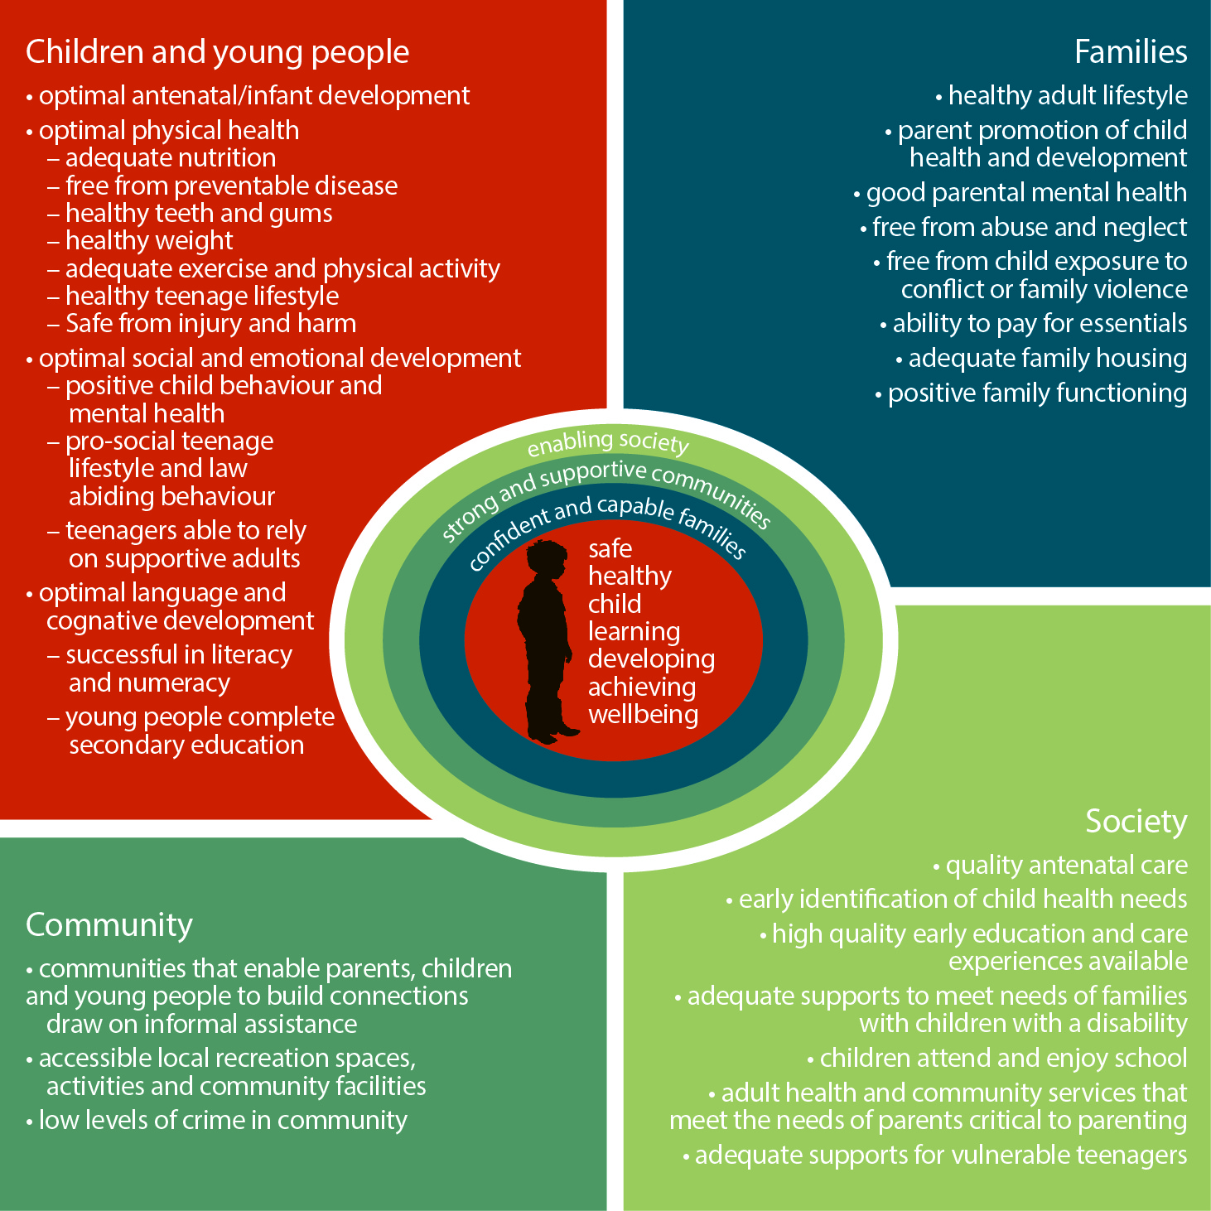

| **Indicator Number** | **Indicator** | **Data Custodian** | **Source** |
| --- | --- | --- | --- |
| **THE CHILD** | | | |
| **Optimal Antenatal and Infant Development** | | | |
| 1.1 | Low birth weight | Department of Health and Human Services | Perinatal Data Collection Unit |
| 1.2 | Infant mortality rate | Department of Health and Human Services | Consultative Council on Obstetric & Paediatric Mortality & Morbidity |
| 1.3 | Child mortality rate | Department of Health and Human Services | Consultative Council on Obstetric & Paediatric Mortality & Morbidity |
| 1.4 | Perinatal Mortality Rate | Department of Health and Human Services | Consultative Council on Obstetric & Paediatric Mortality & Morbidity |
| 1.5 | Sudden Infant Death Syndrome (SIDS) rate for infants | Department of Health and Human Services | Consultative Council on Obstetric & Paediatric Mortality & Morbidity |
| 1.6 | Rate of birth defects | Department of Health and Human Services | Victorian Births Defects Register |
| 1.8 | Proportion of children exposed to alcohol while in utero | Department of Education and Training | The Victorian Child Health and Wellbeing Survey |
| 1.9 | Proportion of children exposed to tobacco while in utero | Department of Education and Training | The Victorian Child Health and Wellbeing Survey |
| 1.10 | Proportion of women who used illicit drugs during pregnancy | Department of Health and Human Services | To be advised |
| **Adequate Nutrition** | | | |
| 2.1 | Proportion of infants breastfed | Department of Education and Training | Maternal Child Health collection |
| 2.2a | Proportion of children who eat the minimum recommended serves of fruit and vegetable every day | Department of Education and Training | The Victorian Child Health and Wellbeing Survey |
| 2.2b | Proportion of young people who eat the minimum recommended serves of fruit and vegetable every day | Department of Education and Training | Victorian Student Health and Wellbeing Survey |
| **Free from Preventable Diseases** | | | |
| 3.1a | Proportion of children who are fully vaccinated | Australian Government Department of Health and Human Services / Victorian Department of Health and Human Services | Australian Childhood Immunisation Registry |
| 3.1b | Proportion of young people who are fully vaccinated | Department of Health and Human Services and Human Services | School Immunisation Program |
| 3.2 | Notification rate of vaccine preventable illnesses | Department of Health and Human Services | The Notifiable Diseases Surveillance System |
| 3.3 | Proportion of young people aware of sun protection | Department of Education and Training | Victorian Student Health and Wellbeing Survey |
| **Optimal Social and Emotional Development** | | | |
| 4.1 | Proportion of children who are developmentally vulnerable | Australian Government Department of Education (Social Research Centre) | Australian Early Development Census |
| **Healthy Teeth and Gums** | | | |
| 5.1 | Rate of potentially preventable hospital admissions for dental conditions for children | Department of Health and Human Services | Victorian Admitted Episodes Dataset |
| 5.3a | Proportion of children who brush their teeth twice a day | Department of Education and Training | The Victorian Child Health and Wellbeing Survey |
| 5.3b | Proportion of young people who brush their teeth twice a day | Department of Education and Training | Victorian Student Health and Wellbeing Survey |
| **Healthy Weight** | | | |
| 6.1 | Proportion of children who are overweight and obese | Department of Education and Training | Victorian Student Health and Wellbeing Survey |
| 6.2 | Proportion of young people who are underweight | Department of Education and Training | Victorian Student Health and Wellbeing Survey |
| **Optimal Physical Health** | | | |
| 7.1 | Proportion of children and young people with Diabetes | Australian Institute of Health and Welfare | National Diabetes Registry |
| 7.2a | Proportion of children with special health care needs | Department of Education and Training | The Victorian Child Health and Wellbeing Survey |
| 7.2b | Proportion of young people with special health care needs | Department of Education and Training | Victorian Student Health and Wellbeing Survey |
| 7.3a | Proportion of children with asthma | Department of Education and Training | The Victorian Child Health and Wellbeing Survey |
| 7.3b | Proportion of young people with asthma | Department of Education and Training | Victorian Student Health and Wellbeing Survey |
| 7.4a | Proportion of children with current asthma who have a written asthma plan | Department of Education and Training | The Victorian Child Health and Wellbeing Survey |
| 7.4b | Proportion of young people with current asthma who have a written asthma plan | Department of Education and Training | Victorian Student Health and Wellbeing Survey |
| 7.6 | Key causes of hospitalisation | Department of Health and Human Services | Victorian Admitted Episodes Dataset |
| 7.7a | Proportion of children with an allergy that leads to anaphylaxis | Department of Education and Training | School Entrant Health Questionnaire |
| 7.7b1 | Proportion of young people with an allergy that leads to anaphylaxis | Department of Education and Training | Victorian Student Health and Wellbeing Survey |
| 7.7b2 | Proportion of young people with an allergy that leads to anaphylaxis, who have an anaphylaxis plan | Department of Education and Training | Victorian Student Health and Wellbeing Survey |
| 7.8a | Proportion of children with 'good health' | Department of Education and Training | The Victorian Child Health and Wellbeing Survey |
| 7.8b | Proportion of young people with 'good health' | Department of Education and Training | Victorian Student Health and Wellbeing Survey |
| 7.9 | Proportion of children and young people with a disability | DET; Department of Health and Human Services; ABS | Early Childhood Intervention Services; Disability Support Register; Survey of Disability Ageing and Caring |
| 7.10 | Cancer Incidence | The Cancer Council Victoria | The Victorian Cancer Registry |
| **Optimal Language and Cognitive Development** | | | |
| 8.1 | Proportion of children whose parents report one or more concern with child speech and language on entry to school | Department of Education and Training | School Entrant Health Questionnaire |
| **Adequate Exercise and Physical Activity** | | | |
| 9.1a | Proportion of children who do the recommended amount of physical activity every day | Department of Education and Training | The Victorian Child Health and Wellbeing Survey |
| 9.1b | Proportion of young people who do the recommended amount of physical activity every day | Department of Education and Training | Victorian Student Health and Wellbeing Survey |
| 9.2a | Proportion of children who use electronic media for more than two hours per day | Department of Education and Training | The Victorian Child Health and Wellbeing Survey |
| 9.2b | Proportion of young people who use electronic media for more than two hours per day | Department of Education and Training | Victorian Student Health and Wellbeing Survey |
| **Positive Child Behaviour and Mental Health** | | | |
| 10.1 | Proportion of children with emotional or behaviour difficulties | Department of Education and Training | The Victorian Child Health and Wellbeing Survey |
| 10.2 | Proportion of children' whose parents are concerned with their behaviour | Department of Education and Training | School Entrant Health Questionnaire |
| 10.3a | Proportion of children who are bullied | Department of Education and Training | Attitude to School Survey |
| 10.3b1 | Proportion of young people who are experiencing cyber-bullying | Department of Education and Training | Victorian Student Health and Wellbeing Survey |
| 10.3b2 | Proportion of young people who are bullied most days | Department of Education and Training | Victorian Student Health and Wellbeing Survey |
| 10.5 | Rate of intentional self-harm in young people | Monash University | Monash University Accident Research Centre |
| 10.6 | Proportion of students who report feeling connected with their school | Department of Education and Training | Attitude to School Survey |
| 10.7 | Psychiatric hospitalisation rate for young people | Department of Health and Human Services | Victorian Admitted Episodes Dataset |
| 10.8 | Proportion of young people with the highest level of psychological distress | Department of Education and Training | Victorian Student Health and Wellbeing Survey |
| 10.10 | Proportion of young people who have a high level of emotional wellbeing | Department of Education and Training | Victorian Student Health and Wellbeing Survey |
| **Successful In Literacy and Numeracy** | | | |
| 11.1 | Percentage of students achieving national benchmark in literacy | Department of Education and Training | NAPLAN |
| 11.2 | Percentage of students achieving national benchmark in numeracy | Department of Education and Training | NAPLAN |
| **Safe from Injury and Harm** | | | |
| 12.1 | Age specific death rates from injuries and poisoning | Monash University | Monash University Accident Research Centre |
| 12.2 | Age specific hospitalisation rates from injuries and poisoning | Monash University | Monash University Accident Research Centre |
| 12.3 | Crime where the victim was a child or young person (Rate) | Victoria Police | Law Enforcement Assistance Program |
| 12.4 | Age specific death rate from suicide | Monash University | Monash University Accident Research Centre |
| 12.5 | Rate of unintentional injury related long bone fractures in young people | Monash University | Monash University Accident Research Centre |
| **Prosocial Teenage Lifestyle and Law Abiding Behaviour** | | | |
| 13.1 | Most common offences for young people in custodial detention | Department of Health and Human Services | Client Relationship Information System |
| 13.2 | Crime where the offender was a child or young person (Rate) | Victoria Police | Law Enforcement Assistance Program |
| 13.3 | Young people 10-17 years under community based supervision (Rate) | Department of Health and Human Services | Client Relationship Information System |
| 13.4 | Young people 10-17 years in youth justice facilities(Rate) | Department of Health and Human Services | Client Relationship Information System |
| 13.5 | Number of cautions issued to young people | Victoria Police | Law Enforcement Assistance Program |
| **Healthy Teenage Lifestyle** | | | |
| 14.1 | Teenage fertility rate | Department of Health and Human Services | Perinatal Data Collection Unit |
| 14.3a | Proportion of young people who drink alcohol | Department of Education and Training | The Victorian Adolescent Health and Wellbeing Survey |
| 14.3b | Proportion of young people who smoke cigarettes | Department of Education and Training | The Victorian Adolescent Health and Wellbeing Survey |
| 14.3c | Proportion of young people who sniff glue or chrome | Department of Education and Training | The Victorian Adolescent Health and Wellbeing Survey |
| 14.3d | Proportion of young people who use marijuana or other illegal drugs | Department of Education and Training | The Victorian Adolescent Health and Wellbeing Survey |
| 14.4 | Age of initiation in young people of drug use (alcohol, tobacco and illicit drugs) |  | To be confirmed |
| 14.5 | Proportion of young people who have had sexual intercourse | Department of Education and Training | Victorian Student Health and Wellbeing Survey |
| 14.6 | Age of initiation of sexual intercourse in young people | Department of Education and Training | Victorian Student Health and Wellbeing Survey |
| 14.7 | Proportion of young people practicing safe sex by using a condom | Department of Education and Training | Victorian Student Health and Wellbeing Survey |
| 14.8 | Proportion of young women who have used contraception to avoid pregnancy |  | To be confirmed |
| 14.9 | Rate of notifications of sexually transmissible infections in young people | Department of Health and Human Services | The Notifiable Diseases Surveillance System |
| **Teenagers able to rely on supportive adults** | | | |
| 15.1 | Proportion of young people who have a trusted adult in their life | Department of Education and Training | Victorian Student Health and Wellbeing Survey |
| **Young People Complete Secondary Education** | | | |
| 16.1 | Year 10-12 apparent retention rate | Department of Education and Training | August School Census |
| 16.2a | Proportion of students successfully completing year 12 or equivalent | Department of Education and Training | Victorian Curriculum and Assessment Authority and Skills Victoria data |
| 16.3 | Proportion of early school leavers who are looking for work in the year after leaving school | Department of Education and Training | On Track Survey |
| 16.4a | Proportion of young people who are engaged in full time education or work (or a combination of both) | ABS | ABS Survey of Education and Work |
| 16.4b | Proportion of young people who are not engaged in full-time employment, education or training (or a combination of both) |  | ABS Census |
| **THE FAMILY** | | | |
| **Healthy Adult Lifestyle** | | | |
| 17.1a | Proportion of children exposed to tobacco smoke in the home | Department of Education and Training | The Victorian Child Health and Wellbeing Survey |
| 17.2a | Proportion of parents who report long term risky drinking | Department of Health and Human Services | Victorian Population Health Survey |
| 17.2b | Proportion of parents who report short term risky drinking | Department of Health and Human Services | Victorian Population Health Survey |
| **Parent Promotion of Child Health and Development** | | | |
| 18.1 | Proportion of children who are read to by a family member every day | Department of Education and Training | The Victorian Child Health and Wellbeing Survey |
| 18.2 | Proportion of infants put on their back to sleep from birth | Department of Education and Training | The Victorian Child Health and Wellbeing Survey |
| 18.3 | Proportion of parents aware of sun protection | Department of Education and Training | The Victorian Child Health and Wellbeing Survey |
| **Good Parental Mental Health** | | | |
| 19.1 | Proportion of mothers with post-natal depression |  | To be confirmed |
| 19.2a | The proportion of children and young people (aged 0-17) who have parents with mental health difficulties | Department of Health and Human Services and Human Services | Victorian Population Health Survey |
| 19.2b | The proportion of children (aged 0-12) who have parents with mental health difficulties | Department of Education and Training | The Victorian Child Health and Wellbeing Survey |
| **Free from Abuse and Neglect** | | | |
| 20.1 | Rate of substantiated child abuse | Department of Health and Human Services | Client Relationship Information System ( |
| 20.2 | Rate of children on child protection orders | Department of Health and Human Services | Client Relationship Information System |
| 20.3 | Rate of children in out of home care | Department of Health and Human Services | Client Relationship Information System |
| **Free from Child Exposure to Conflict or Family Violence** | | | |
| 21.1 | Proportion of mothers exposed to partner violence | ABS | ABS Personal Safety Survey |
| 21.2 | Proportion of family violence incidents where children and young people are involved as other parties | Victoria Police | Law Enforcement Assistance Program |
| **Ability to Pay for Family Essentials** | | | |
| 22.1 | Parental employment status | ABS | ABS Census of Population and Housing |
| 22.2 | Median household income | ABS | ABS Census of Population and Housing |
| 22.3 | Average Real Equivalised disposable household income for household with children in the 2nd and 3rd income deciles | ABS | ABS Survey of Income and Housing |
| 22.4a | Proportion of children from families that ran out of food and couldn't afford to buy more | Department of Education and Training | The Victorian Child Health and Wellbeing Survey |
| 22.4b | Proportion of young people from families that ran out of food and couldn't afford to buy more | Department of Education and Training | Victorian Student Health and Wellbeing Survey |
| 22.5a | Proportion of parents who have attained a non-school qualification higher than year 12 or equivalent | ABS | ABS Census of Population and Housing |
| 22.5b | Proportion of parents who have not completed Year 12 or equivalent | ABS | ABS Census of Population and Housing |
| 22.6 | Proportion of young people who experience hardship because of a shortage of money | Department of Education and Training | Victorian Student Health and Wellbeing Survey |
| **Adequate Family Housing** | | | |
| 23.1 | Specialist Homelessness Services assistance rate for children and young people | Department of Health and Human Services | Specialist Homelessness Services Collection, AIHW |
| 23.2 | Public housing retention rate for families with children | Department of Health and Human Services | Office for Housing-Public Housing |
| 23.3 | Percentage of public housing tenants who are families with children | Department of Health and Human Services | Office for Housing-Public Housing |
| 23.4 | Percentage of family income spent on housing | ABS | ABS Census of Population and Housing |
| 23.5 | Percentage of clients receiving emergency housing services that are aged 13-18 years | Department of Health and Human Services | Office for Housing-Public Housing |
| **Positive Family Functioning** | | | |
| 24.1a | Proportion of children living in families with healthy family functioning | Department of Education and Training | The Victorian Child Health and Wellbeing Survey |
| 24.1b | Proportion of young people living in families with healthy family functioning | Department of Education and Training | Victorian Student Health and Wellbeing Survey |
| 24.2 | Proportion of children with high levels of family stress | Department of Education and Training | School Entry Health Questionnaire |
| 24.3 | Proportion of children and young people living in two and one parent families | ABS | ABS Census of Population and Housing |
| 24.4 | Proportion of children and young people who have a parent involved in the criminal justice system | Department of Justice | Corrections Intake Files |
| **THE COMMUNITY** | | | |
| **Communities That Enable Parents, Children and Young People to Build Connections and Draw Informal Assistance** | | | |
| 26.1 | The proportion of children from families who are able to get support in time of crisis/when needed | Department of Education and Training | The Victorian Child Health and Wellbeing Survey |
| 26.2 | The proportion of families with children able to raise $2000 within two days in an emergency | Department of Education and Training | The Victorian Child Health and Wellbeing Survey / Victorian Population Health Survey |
| 26.3 | The proportion of children with parents who have someone to turn to for advice when having problems | Department of Education and Training | The Victorian Child Health and Wellbeing Survey |
| 26.4 | The proportion young people who have someone to turn to for advice when having problems | Department of Education and Training | Victorian Student Health and Wellbeing Survey |
| 26.5 | Percentage of young people who feel valued by society, be involved in voluntary and local activities |  | To be confirmed |
| 26.6 | Percentage of parents who believe their community is an accepting place for people from diverse cultures and backgrounds | Department of Health and Human Services | Victorian Population Health Survey |
| 26.7 | Opportunities for families to participate in community, cultural and recreational activities | Department of Health and Human Services | Victorian Population Health Survey |
| 26.8 | Proportion of young people who are satisfied with the quality of their life | Department of Education and Training | Victorian Student Health and Wellbeing Survey |
| 26.9a | Percentage of parents who believe they have the opportunity to have a say on issues that matter to them | Department of Health and Human Services | Victorian Population Health Survey |
| 26.9b | Percentage of young people who believe they have the opportunity to have a say on issues that matter to them |  | To be confirmed |
| **Accessible Local Recreation Spaces, Activities and Community Facilities** | | | |
| 27.1 | Proportion of families who are not always able to access the type of fresh food they would like | Department of Health and Human Services | Victorian Population Health Survey |
| 27.2 | Proportion of families living in neighbourhoods with basic services | Department of Education and Training | The Victorian Child Health and Wellbeing Survey |
| 27.3a | Proportion of children living in neighbourhoods with good parks, playgrounds and play-spaces | Department of Education and Training | The Victorian Child Health and Wellbeing Survey |
| 27.3b | Proportion of young people living in neighbourhoods with good parks, playgrounds and play-spaces |  | To be confirmed |
| 27.4 | Proportion of children living in neighbourhoods with close affordable public transport |  | To be confirmed |
| 27.5 | Proportion of young people whose lack of access to transport impacts on their capacity to achieve key work and/or life goals |  | To be confirmed |
| **Low Levels of Crime in Community** | | | |
| 28.1a | Proportion of children who feel safe | Department of Education and Training | The Victorian Child Health and Wellbeing Survey |
| 28.1b | Proportion of young people who feel safe | Department of Education and Training | Victorian Student Health and Wellbeing Survey |
| 28.2 | Rate of recorded crime in the community | Victoria Police | Law Enforcement Assistance Program |
| **SUPPORTS AND SERVICES** | | | |
| **Quality Antenatal Care** | | | |
| 29.1 | Rate of pregnant women offered appropriate smoking interventions in public hospital | Department of Health and Human Services | Consultative Council on Obstetric & Paediatric Mortality & Morbidity |
| 29.2 | Rate of caesarean sections in standard primiparae in public hospitals | Department of Health and Human Services | Consultative Council on Obstetric & Paediatric Mortality & Morbidity |
| **Early Identification of and Attention to Child Health Needs** | | | |
| 30.1 | Proportion of children with parents concerned about their vision | Department of Education and Training | School Entrant Health Questionnaire |
| 30.3 | Proportion of infants receiving a maternal and child health service home consultation | Department of Education and Training | Maternal and Child Health collection |
| 30.5 | Proportion of children attending the 3.5 year ages and stages visit | Department of Education and Training | Maternal and Child Health collection |
| 30.6 | Proportion of children in first year of primary school who have been assessed by the school nurse | Department of Education and Training | School Nursing Information System |
| 30.7 | Placement stability for children in a single out-of-home care episode | Department of Health and Human Services | Client Relationship Information System |
| 30.8 | Proportion of all children aged under 12 years in out-of-home-care who are placed in home based care | Department of Health and Human Services | Client Relationship Information System |
| 30.9 | Proportion of all children aged under 12 years of age in out of home care who are placed with relatives/kin | Department of Health and Human Services | Client Relationship Information System |
| 30.10 | Proportion of Aboriginal children in out of home care who are placed in accordance with the Aboriginal Child Placement Principle | Department of Health and Human Services | Client Relationship Information System |
| 30.11 | Proportion of children who are the subject of child abuse substantiations within 3 months after an initial decision not to substantiate | Department of Health and Human Services | Client Relationship Information System |
| 30.12 | Proportion of children who are the subject of a child abuse notification within 12 months of a notification | Department of Health and Human Services | Client Relationship Information System |
| 30.13 | Proportion of re-substantiations within 12 months | Department of Health and Human Services | Client Relationship Information System |
| 30.14 | Number of clients enrolled in enhanced Maternal and Child Health Services | Department of Education and Training | Maternal and Child Health collection |
| **High Quality Early Education and Care Experiences Available** | | | |
| 31.1a | Kindergarten participation rate | Department of Education and Training | Kindergarten Management system |
| 31.1b | Aboriginal kindergarten participation rate | Department of Education and Training | Kindergarten Management system |
| 31.1c | Number of children enrolled in Early Start Kindergarten | Department of Education and Training | Kindergarten Management system |
| 31.3 | Proportion of children attending kindergarten whose placement attracts a kindergarten fee subsidy. | Department of Education and Training | Kindergarten Management system |
| 31.4 | Number of four year old kindergarten enrolments in a long day care or integrated children’s services setting | Department of Education and Training | Kindergarten Management system |
| **Adequate Supports to Meet Needs of Families with Children with Disabilities** | | | |
| 32.1 | Number of ECIS places and packages funded annually | Department of Health and Human Services/DET | Manual report from Regions |
| **Children Attend and Enjoy School** | | | |
| 33.1 | Average number of days absent in primary and secondary school | Department of Education and Training | Administrative records |
| 33.2 | Percentage of Student perception of connectedness with peers | Department of Education and Training | Attitude to School Survey |
| 33.3 | Level of parental satisfaction with schooling | Department of Education and Training | Parent Satisfaction Survey |
| **Adequate Adult Health and Community Services to Meet Needs of Parents Critical to Parenting** | | | |
| 34.1 | Number of families accessing Family and Community Support Services | Department of Health and Human Services | Client Relationship Information System |
| 34.2 | Primary school aged students who required follow up were seen by the school nursing program | Department of Education and Training | School Nursing Information System |
| **Adequate Supports for Vulnerable Teenagers** | | | |
| 35.1 | Proportion of young people who feel that they can access physical health services when needed | Department of Education and Training | Victorian Student Health and Wellbeing Survey |
| 35.2 | Proportion of young people who feel that they can access mental health services when needed | Department of Education and Training | Victorian Student Health and Wellbeing Survey |
| 35.3 | Proportion of young people who feel that they can access dental services when needed | Department of Education and Training | Victorian Student Health and Wellbeing Survey |