Early Bird Catches the Worm: The Causal Impact of Pre-school Participation and Teacher Qualifications on Year 3 NAPLAN Outcomes
This research looks at the causal impact of attendance at pre-school in the year prior to starting formal schooling on Year 3 NAPLAN outcomes. It also examines the effect of specific pre-school teacher qualifications on Year 3 NAPLAN scores.
Key Findings
- Attendance at pre-school has a significant positive impact on later NAPLAN outcomes, particularly in the domains of Numeracy, Reading and Spelling.
- The direct causal effects of pre-school attendance are equivalent to 10 to 20 NAPLAN points or 15 to 20 weeks of schooling at the Year 3 level, three years after attending pre-school.
- Children who did not attend pre-school would have gained more from attending pre-school than those who actually attended.
- Children whose pre-school teacher had a diploma or degree in early childhood education or child care gained the most from attending pre-school – the level and specialisation of pre-school teacher qualifications are important.
- Children whose pre-school teacher had only a certificate level qualification in child care or early childhood teaching or had no relevant childcare qualification showed no significant benefit from attendance at pre-school.

This research is a result of a partnership arrangement between the Department of Education and Early Childhood Development and the Melbourne Institute of Applied Economic and Social Research.

Introduction
Many studies have shown that there are significant benefits for children who attend high quality pre-school programs, including better intellectual development and higher levels of concentration, sociability and independence. Some of the best known evidence of the benefits of high quality early education experiences on later development comes from targeted early intervention programs undertaken in the United States. Studies of typical large-scale pre-school programs also find evidence of significant short-term benefits for cognitive outcomes. However, universal access programs often had weaker effects than the targeted programs.
Recent studies of the relationship between pre-school teacher qualifications and children’s cognitive outcomes have found mixed results about the most appropriate and effective type of qualification for pre-school teachers, and there is no conclusive evidence that a pre-school teacher with a Bachelor degree, or any other specific level of education, will ensure a high-quality pre-school classroom or better cognitive outcomes.
This study analyses the impact of attendance at Australian pre-school programs in the year prior to formal schooling on later literacy and numeracy outcomes in Year 3. In addition, we examine differences in the benefits from pre-school attendance according to the type of qualification held by the pre-school teacher.
Using data from the Longitudinal Survey of Australian Children (LSAC), we examine the impact of pre-school attendance for children who were aged between 4 and 5 in 2004 and in Year 3 in 2008, a sample of 2229 children from across Australia. Students' literacy and numeracy skills in Year 3 are measured by their achievement on the National Assessment Program — Literacy and Numeracy (NAPLAN) tests for the domains of Numeracy, Reading, Spelling, Writing and Grammar.
Compared to children who did not attend pre-school in 2004, average NAPLAN scores were 20 to 30 points higher among children who had attended some type of pre-school program (Figure 1).

Figure 1: Average NAPLAN Scores in Year 3, by pre-school attendance
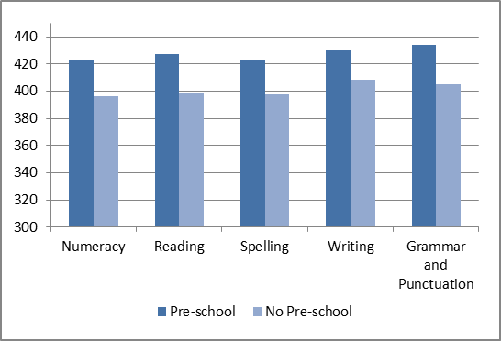
Methods
DESCRIPTIVE METHODS: It is important to note that the differences in test scores between children who attended a pre-school program and those who did not should not be regarded as causal, as they may reflect other characteristics which may be correlated with both pre-school attendance and NAPLAN test scores. To control for these differences in characteristics, multivariate regressions are conducted. The average effect of pre-school attendance on Year 3 test scores, controlling for a rich set of socio-demographic characteristics, is estimated using ordinary least squares (OLS). To identify differences in the benefits of pre-school attendance at different points on the test score distribution, the method of quantile regression is used.
CAUSAL METHODS: Children’s pre-school experiences are not randomly determined. For example, parents who place a high value on their children’s education may be more likely to enrol their children in a high quality pre-school program. Therefore, better educational outcomes are not likely to be due entirely to the pre-school program, but also to greater parental support. It is important to account for this bias. To address this issue, the quasi-experimental method of propensity score matching is used to estimate the Average Effect of Treatment on Treated (ATT) and the Average Effect of Treatment on Untreated (ATU). The key assumption of propensity score matching is that both the outcome of interest (NAPLAN score) and the treatment assignment (attendance at pre-school) do not depend on unobservable characteristics (e.g. parental involvement). If students in the treatment (pre-school) and untreated (no pre-school) groups have the same propensity score, then the difference between the treatment and control outcome means is an unbiased estimator of the treatment effect. The ATT estimates can be interpreted as the difference in the average NAPLAN scores between the group of students who attended pre-school and the matched set of students who did not attend pre-school. The ATU estimates tell us how much higher the NAPLAN scores of children who did not go to pre-school might have been, if they had attended pre-school.
To account explicitly for innate ability, the models were re-estimated with an additional control for the child’s score on the “Who Am I?” test that was taken at the time of the 2004 interview. The “Who Am I?” test is based on previous research about the use of copying and writing tasks for the assessment of children’s developmental level and school readiness. It provides a reliable measure of development which is valid across cultural groups and among children whose knowledge of English is limited.
We examine the effects of specific pre-school teacher qualifications on Year 3 NAPLAN outcomes by dividing the group of children who attended pre-school in 2004 into five groups according to the qualification level of their teacher, and estimating the ATT for each treatment group using children who did not attend pre-school as the control group.
Findings
The Benefits of Pre-school Attendance
DESCRIPTIVE FINDINGS: After controlling for a rich set of socio-demographic characteristics, we find a significant positive association between pre-school attendance and Year 3 NAPLAN test scores. The magnitude of the effect varies according to the domain being considered, with the most significant effects in the domains of Reading, Spelling and Numeracy, and no significant effect for Writing or Grammar once ability is controlled for (Figure 2).

Figure 2: Comparison of benefits of pre-school attendance when controlling for innate ability

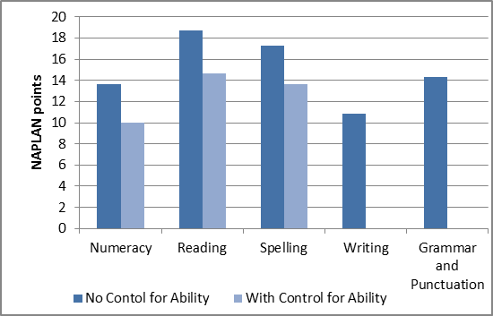

Quantile estimates indicate that for Numeracy, the magnitude of the pre-school coefficient is largest at the cut point between Bands 5 and 6. This result suggests that it is the strongest students who benefit most from attending pre-school, while students at the lower end of the distribution seem to gain no significant advantage. For Reading, students whose test scores are just above the National Minimum Standard gain the most from having attended pre-school, and the magnitude of the effect, while still significant, is lower at the top end of the test score distribution. For Spelling, the benefits of having attended pre-school are largest at the top end of the distribution, but children with Spelling scores at the lower end of the distribution also gain some benefit from attending pre-school.
CAUSAL FINDINGS: Estimation of the Average Treatment Effect on Treated (ATT) using propensity score matching indicates that children who attended pre-school score 18 to 20 points significantly higher in Reading, Spelling and Numeracy compared to children who did not attend pre-school. For Writing, the estimated ATT is around 13 points; and for Grammar, the estimated ATT is not statistically significant (Figure 3). The Average Treatment Effect on Untreated (ATU) is significant for all five domains, and higher than the ATT. This result implies that children who did not attend pre-school would have gained more from attending pre-school than those who actually attended.
Directly controlling for the Who Am I? ability score in the matching process reduces the ATT estimates by only 2 to 4 points, depending on the domain being considered, but the estimates for Numeracy, Spelling and Reading remain statistically significant. This result suggests that in general, any bias resulting from innate ability is not likely to have a dramatic effect on our estimates of the effects of pre-school participation. When controls for the home learning environment (e.g. at home activities including reading, playing games, drawing and listening to music with parents) are included in the set of matching variables, the estimates remain statistically significant for the same domains of Numeracy, Spelling and Reading.

Figure 3: Average Treatment Effects on Treated and Untreated
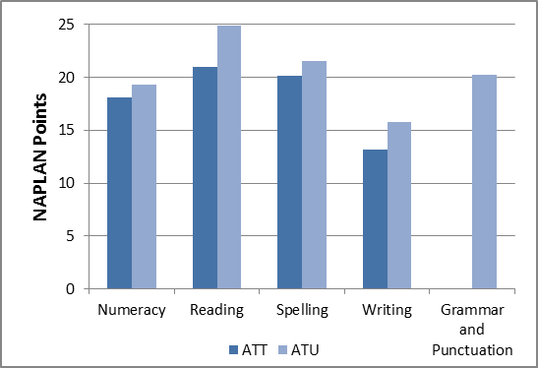

These causal ATT estimates are substantial, given that one year of schooling at the Year 3 level is represented by 52 NAPLAN points, with pre-school amounting to 30–40% of the learning impact of one additional year of schooling, 3 years after the fact.
The Importance of Pre-school Teacher Qualifications
Over 90 per cent of children in our sample attended a pre-school or kindergarten program of some sort in the year before starting school. However, there is likely to be considerable variation in the type and quality of programs attended. For this reason, we estimate the effects of specific pre-school teacher qualifications on Year 3 NAPLAN outcomes.
The teacher qualifications included in the analysis were:
1. Early Childhood Teaching Degree
2. Other Teaching Degree
3. Advanced Diploma, Diploma, Associate Diploma in children’s services or early childhood teaching
4. Certificate level qualification in children’s services or early childhood teaching
5. Other degree (such as nursing)
DESCRIPTIVE FINDINGS: OLS estimates comparing the effects of specific teacher qualifications with the control group of children who had not attended preschool indicate that children whose pre-school teacher had a relevant degree or diploma qualification received significantly higher NAPLAN scores in all domains but Grammar. The magnitude of these effects ranged from 11 to 23 points depending on the NAPLAN domain and the specific teacher qualification. After explicitly controlling for the ability of the child, there is a significant positive association between having attended pre-school with an appropriately qualified teacher and average NAPLAN outcomes for Spelling and Reading in Year 3.
CAUSAL FINDINGS: ATT estimates confirm our OLS results concerning the impact of specific teacher qualifications. Compared to children who did not attend pre-school, children who had a pre-school teacher with a relevant degree or diploma qualification had significantly higher average scores in their Year 3 NAPLAN tests for Numeracy, Reading and Spelling.
After directly controlling for pupil ability, the estimated effects of having a degree-qualified pre-school teacher who did not specialise in early childhood education are no longer statistically significant. This result supports the conclusion that there are significant benefits to be gained from pre-school teachers who are specifically trained in developmentally appropriate teaching practices for young children. When the ATT is estimated with the group of children whose pre-school teacher had a degree or diploma qualification specialising in early childhood education or child care as the treatment group and the group who did not attend pre-school at all as the control group, the estimated benefits range from 14 points for Numeracy and Spelling to 18 points for Reading.

POLICY IMPLICATIONS
The Council Of Australian Governments agreement ensuring that all children have access to a high quality early childhood education program delivered by a degree-qualified early childhood teacher in the year before formal schooling, along with the introduction of the new National Quality Standard for early childhood education and care providers in Australia are likely to have substantial long-term benefits, particularly for children who would not have had the opportunity to attend a pre-school with a suitably qualified teacher if these reforms had not taken place. Even three years after the pre-schooling has taken place, NAPLAN scores of Year 3 children are significantly higher than those who had not attended pre-school.
In terms of later NAPLAN outcomes, pre-school teachers should have at least a diploma level qualification for maximal program impact. Some children — possibly those who would gain the most from attending a high quality pre-school program — might still miss out because of “loopholes” in the new National Quality Framework that will be introduced in January 2014.
For example, child care centres in Australia may be able to avoid the requirement for an early childhood teacher to be present at all times if:
- there are fewer than 25 children attending the facility; or
- high proportion of staff are not actually qualified but “actively working towards” a relevant qualification, likely leading to the quality of the program being lower.
The Victorian Government has a range of key programs to support the early childhood workforce in the context of rising demand and sectoral reform. These include:
- A scholarship and incentives fund to help existing educators upgrade their qualifications and to attract qualified professionals to hard-to-staff locations such as rural communities, aboriginal services and low income areas.
- Professional development to build the knowledge and professionalism in areas such as leadership and educational practice
- Scholarships to support more aboriginal educators to become early childhood teachers.
Since 2010, more than 1400 early childhood professionals working in early childhood services have received Victorian Government scholarships to upgrade or attain an early childhood qualification.
Funding of approximately $22.6million (between 2010 and 2013) has been made available to the early childhood education and care workforce to support rising demand and sectoral reform. The long-run causal impacts of early childhood education and the additional benefit of highly qualified pre-school teachers on NAPLAN test scores three years later demonstrate the importance and value of Australia’s pre-school system.
FURTHER INFORMATION
This summary paper is based on the 2013 research report, The Causal Impact of Pre-school Participation and Teacher Qualifications on Year 3 NAPLAN Cognitive Tests authored by: D. Warren and J. P. Haisken-DeNew. The research report was developed through the Research and Evaluation Partnerships between DEECD and the Melbourne Institute of Applied Economic and Social Research.

In some states these programs are referred to as kindergarten, in others they are called pre-school. Throughout this paper “pre-school” refers to any early childhood education program attended in the year prior to starting formal schooling.
Schweinhart, L.J., Montie, J., Xiang, Z., Barnett, W.S., Belfield, C.R. and Nores, M. (2005) Lifetime effects: The High/Scope Perry Pre-school study through age 40. Monographs of the High/Scope Educational Research Foundation, 14. Michigan: High/Scope Press.
Barnett, W.S. (1995) ‘Long-term effects of early childhood programs on cognitive and school outcomes’ in The future of children: Long-term outcomes of early childhood programs, 5(3), 25-50.
Barnett, W.S. (1995) ‘Long-term effects of early childhood programs on cognitive and school outcomes’ in The future of children: Long-term outcomes of early childhood programs, 5(3), 25-50.
This category includes those who were studying for, but had not yet completed, a relevant qualification.

