Victorian Child Health and Wellbeing Survey

Summary findings 2013

Published by the
Performance and Evaluation Division
Department of Education and Training
Melbourne 2015

© State of Victoria (Department of Education and Training) 2015
The copyright in this document is owned by the State of Victoria (Department of Education and Training), or in the case of some materials, by third parties (third party materials). No part may be reproduced by any process except in accordance with the provisions of the Copyright Act 1968, the National Education Access Licence for Schools (NEALS) (see below) or with permission.
An educational institution situated in Australia which is not conducted for profit, or a body responsible for administering such an institution may copy and communicate the materials, other than third party materials, for the educational purposes of the institution.
Authorised by the Department of Education and Training
2 Treasury Place, East Melbourne, Victoria, 3002.

Contents

Background 5
When interpreting the VCHWS data… 6
Comparing respondents 6
Key statistics at a glance 7
Outcome: Optimal antenatal and infant development 8
Prenatal health 8
Outcome: Optimal physical health 9
Proportion of children with ‘good health’ 9
Asthma (children aged 1 to 12 years) 9
Outcome: Healthy teeth and gums 9
Oral health status (children aged 6 months to 12 years) 9
Oral health behaviours 9
Outcome: Adequate exercise and physical activity 9
Physical activity and inactivity 10
Outcome: Adequate nutrition 11
Fruit and vegetable intake 11
Outcome: Healthy adult lifestyle 11
Exposure to tobacco smoke 11
Outcome: Parent promotion of child health and development 12
Reading to children 12
Outcome: Ability to pay for family essentials 13
Finances 13
Outcome: Positive family functioning 13
Social and emotional health 13

This page is left intentionally blank

Background
In 2005, the Victorian Government endorsed the Victorian Child and Adolescent Outcomes Framework, comprising 35 outcomes on the health, safety, learning, development and wellbeing of children aged up to 18 years, within an ecological context. The Victorian Child and Adolescent Monitoring System (VCAMS) has been established to enable regular monitoring and reporting against this framework to support government and community action. The system is intended to facilitate more informed decision-making across government through better access to validated outcome measures for children and families.
Victorian Government departments hold a large amount of information on how children are faring, as does the Australian Bureau of Statistics and non-Government research bodies. Where possible, these data are used to report against the VCAMS indicators. However, this gives only a partial picture; initially there were many VCAMS indicators for which data were not readily available.
The Victorian Child Health and Wellbeing Survey (VCHWS) was designed to address data gaps identified via the Child and Adolescent Outcomes Framework. Issues covered in the VCHWS include child health, growth, asthma, nutrition (including breastfeeding), oral health, child activities, reading, injury, child behaviour, family functioning, parental health, parental mental health and health in pregnancy. The survey was first conducted in 2006, and repeated in 2009 and 2013. This report presents findings from the 2013 survey.
The aims of VCHWS are to:
- provide baseline and ongoing data that will be used to support and inform planning, implementation and evaluation of child health, wellbeing, development and learning policies, services and programs throughout Victoria
- enable comparisons of how children are faring over time, in 17 local areas, and in major demographic groups throughout Victoria.
Interviewing for the VCHWS took place between October and December 2013.
Parents completed interviews on behalf of 7,000 randomly selected Victorian children aged under 13 years. A response rate of 73 per cent was achieved. A profile of respondents is provided in Table 1.
Data will feed into the 2013-14 annual report on the state of Victoria’s children. Data relates to children aged from birth to 12 years of age unless otherwise stated.
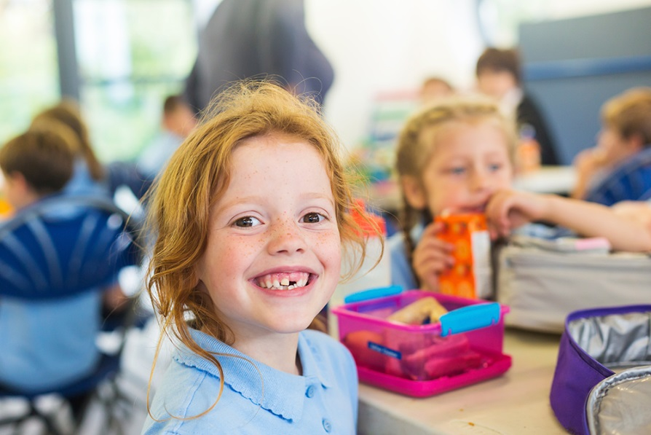

When interpreting the VCHWS data…
- VCHWS is a cross sectional survey – it is possible to identify associations between variables in the dataset but we cannot attribute cause and effect.
- There are no controls for confounding factors in the analysis – for example, could the increased frequency of smoking among those on health care cards and in rural households really be due to socio economic status or some other variable?
- The estimates provided are based on sample data, and the confidence intervals indicate that there is a 95 per cent probability that the true value lies between the upper and lower limits of the confidence interval. Therefore, if the confidence intervals of two population groups do not overlap, it can be assumed that the true values of the two estimates are unlikely to fall within the same distribution.
Comparing respondents
The broad characteristics of respondents included in the 2009 and 2013 surveys were very similar - therefore it has been deemed appropriate to compare results from the two surveys (see Table 1).
Table 1: Profile of subjects (children aged 0 to 12 years) in the 2009 and 2013 VCHWS
Selected characteristic | Survey Estimate* (per cent)  2009 | Survey Estimate* (per cent)  2013
Sex
Male | 51.3 | 51.3
Female | 48.7 | 48.7
Age group
< 1 year | 8.0 | 8.2
1 to 4 years | 30.3 | 31.8
5 to 8 years | 30.4 | 30.6
9 to 12 years | 31.3 | 29.3
Area
Metropolitan Victoria | 71.1 | 73.7
Rural Victoria | 28.9 | 26.3
Cohort
Aboriginal or Torres Strait Islander | 1.4 | 1.3

* Proportions represent demographic splits following the weighting of survey responses.

Key statistics at a glance
Area | 2013 value | Trend (from 2009) | Cohorts/areas of note
Prenatal health – children exposed to alcohol in utero | 46.7% | 13.1% | Children from areas of low socioeconomic disadvantage were more likely to be exposed the alcohol in utero than children from areas of high socioeconomic disadvantage.
General health – children with ‘good, very good or excellent’ health | 97.9% | 0.6% | Parents of children listed on a Health Care Card were less likely to rate their child’s health as ‘good, very good or excellent’.
Asthma – children with current asthma | 11.3% | 0.1% | Boys were significantly more likely to have current asthma than girls.
Oral health – children who have had a filling | 19.5% | 2.0% | Children in regional Victoria were significantly more likely to have had a filling compared with children in metropolitan Victoria.
Physical activity –children aged 5-12 who are active for 60 minutes a day | 62.2% | 1.9% | Children in regional Victoria were more likely to meet the physical activity guidelines compared with children in metropolitan Victoria.
Electronic media – children aged 5-12 who exceed recommended screen time | 17.7% | 1.1% | Boys were more likely to exceed recommended daily screen time limits than girls.
Nutrition –children meeting fruit intake guidelines | 73.2% | NA | Guidelines changed in 2013. Children in regional Victoria were more likely to meet fruit guidelines compared with children in Metropolitan areas.
Nutrition–children meeting vegetable intake guidelines | 2.9% | NA | Guidelines changed in 2013
Exposure to tobacco smoke– children living in a smoke free home | 81.5% | 6.7% | Children listed on a Health Care Card were significantly more likely to be exposed to tobacco smoke in the home compared with other children.
Reading–children under 5 read to every day by a family member | 69.6% | 4.7% | Children in more advantaged socioeconomic areas were more likely to be read to every day than children in more disadvantaged areas.
Food insecurity – children from households reporting running out of food in the last 12 months | 4.9% |  | One parent families were far more likely than couple families to experience food insecurity.
Financial insecurity–children from households unable to raise $2000 in an emergency | 12.3% | 0.8% | One parent families were far more likely than couple families to experience financial insecurity.
Family functioning –children from families with unhealthy family functioning | 7.6% | 0.7% | Children from one parent families and from areas of high socioeconomic disadvantage were more likely to be living in families with unhealthy functioning.

Outcome: Optimal antenatal and infant development

Prenatal health
Around half of Victorian mothers (46.7 per cent) recalled drinking alcohol at some point during pregnancy, however most had done so in moderation. This was a significant drop from 2009, where 59.8 per cent of mothers reported drinking alcohol during pregnancy. Consumption of alcohol was less common once women were aware of the pregnancy (see Figure 1).
Women from higher socioeconomic areas were more likely to drink in pregnancy (57.5 per cent in the least disadvantaged SEIFA quintile compared with 29.3 per cent in the most disadvantaged).
The VCHWS also collected data on whether mothers had “binged” (drinking more than 4 alcoholic drinks in one day) on alcohol during pregnancy. 18.3 per cent of mothers with infants aged under 2 years recalled binge drinking during their pregnancy. Women were most likely to have binged on alcohol early in their pregnancy, before awareness of the pregnancy.
Figure 1: Proportion of Victorian mothers with infants under 2 years who recalled drinking alcohol during pregnancy, by stage of pregnancy, 2009 and 2013

Outcome: Optimal physical health

Proportion of children with ‘good health’
Most Victorian children were reported to have ‘good health’ or better in 2013 (97.9 per cent), similar to the 2009 survey results (98.5 per cent). Parents of children listed on a Health Care Card were less likely to rate their child’s health as ‘good, very good or excellent’ (95.3 per cent compared with 98.7 per cent for other children).

Asthma (children aged 1 to 12 years)
Around one in ten (11.3 per cent) of children had current asthma (had ever been diagnosed with asthma by a doctor, and had experienced asthma symptoms or taken asthma medication in the past year), and of these, 67.2 per cent had an asthma action plan in place.
Boys were significantly more likely to have current asthma (13.2 per cent) than girls (9.4 per cent).

Outcome: Healthy teeth and gums

Oral health status (children aged 6 months to 12 years)
The majority of children (76.2 per cent) were reported to have excellent or very good oral health.
- 19.5 per cent children had a filling.
- 8.2 per cent of children have had a tooth extracted.
Reports of children’s oral health status did not differ from the 2009 data. As in 2009, there was compelling evidence that children living in regional Victoria were more likely to have experienced dental health problems. Significantly higher proportions of children in regional Victoria had had a filling (24.0 per cent compared with 17.9 per cent in metropolitan Victoria), and had had a tooth extracted due to a dental problem (11.3 per cent compared with 7.1 per cent).
The disparity in the oral health status of children living in regional and metropolitan areas of Victoria is likely to be explained (in part) by access to fluoridated drinking water.

Oral health behaviours
As in 2009, most children aged 8 to 12 years were reported to brush their teeth at least twice a day (74.0 per cent in 2009, 70.7 per cent in 2013).
Parents with children aged under 8 years are advised to assist with tooth brushing as young children lack the manual dexterity to brush their teeth effectively (Dental Health Services Victoria
General Dental advice for Children). Most parents reported assisting their child to brush their teeth either once a day (35.4 per cent) or twice a day or more (42.2 per cent). Approximately one in eight children (13.4 per cent) had a parent or carer who reported never assisting their child with tooth cleaning.
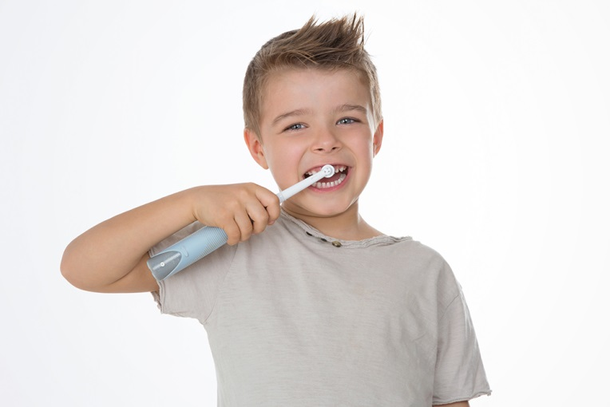

Outcome: Adequate exercise and physical activity

Physical activity and inactivity
In 2013, 62.2 per cent of children aged 5 to 12 years were reported to be physically active for at least 60 minutes every day. This proportion was similar in 2009 (60.3 per cent)
As in 2009, children living in rural Victoria were more likely to meet physical activity guidelines, and there was again evidence of a drop in physical activity as children aged.
Boys were also more likely to meet physical activity guidelines compared to girls.
Inactivity was monitored by asking parents to report on their child’s use of electronic media (including screen time spent in front of computers, television, DVDs, etc). National guidelines recommend children should not exceed more than two hours with electronic media each day.
A minority of children (17.7 per cent) aged 5 to 12 years exceeded the recommended screen time, similar to the proportion of children estimated to exceed the guidelines in 2009 (18.8 per cent).
While boys were more likely to be meeting physical activity guidelines, they were also more likely to be exceeding two hours a day with electronic media (see Figure 2).
Figure 2: Proportion of Victorian children aged 5 to 12 years meeting physical activity guidelines, and proportion exceeding electronic media guidelines, 2009 and 2013

The most common method of travelling to school was by car. On average, Victorian children made 6.9 trips to school by car (out of a possible 10 trips) in a usual week, compared to just 2.0 trips on foot. For children living within 2km of their school, the car was still the predominant method of transport. On average, these children made 6.0 trips to school by car in a usual week compared to 3.4 trips on foot. Trips to school made by bike or public transport were relatively uncommon.

Outcome: Adequate nutrition

Fruit and vegetable intake

Fruit
In 2013, the majority of Victorian children (73.2 per cent) aged 4 to 12 years met the national recommendations for the minimum daily intake of fruit (excluding fruit juice). Younger children were more likely to meet the recommended intake (77.4 per cent of children aged 4 to 8 years, compared with 67.5 per cent of children aged 9 to 12 years).
Children living in regional Victoria were more likely to consume adequate serves of fruit (76.2 per cent) compared with children in Metropolitan areas (72.0 per cent). Children listed on a health care card were less likely to consume the recommended amount of fruit (69.6 per cent) compared with other children (74.5 per cent).
National Health and Medical Research Council (NHMRC) guidelines for fruit consumption changed in 2013, so the data are not comparable for 2009.

Vegetables
Only a small proportion of children aged 4 to 12 years met the national recommendations for minimum daily intake of vegetables in 2013 (2.9 per cent), which range from 4.5 to 5.5 serves of vegetables or legumes per day depending on age and gender.
National Health and Medical Research Council (NHMRC) guidelines for vegetable consumption changed in 2013, so the data are not comparable for 2009.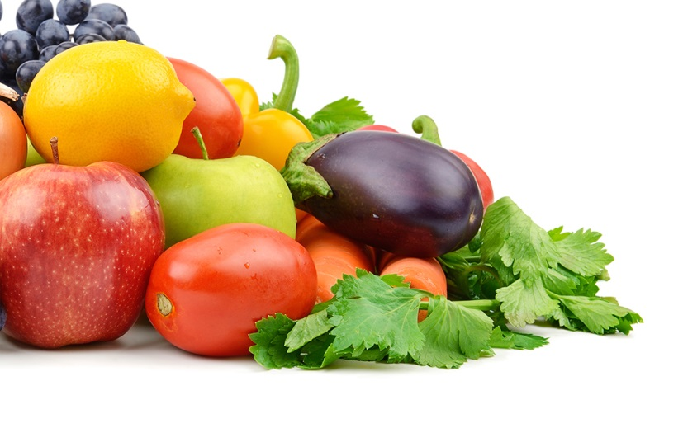

Outcome: Healthy adult lifestyle

Exposure to tobacco smoke
The majority of Victorian children live in smoke free households.
In 2013, 81.5 per cent children aged under 13 years were reported to live in a smoke free household (a household where no adult was reported to be a smoker). This compared favourably to the 2009 data, when 74.8 per cent of children were reported to live in smoke free households.
In both the 2009 and 2013 surveys, children living in rural Victoria and children listed as dependents on Health Care Cards were more likely to live with a smoker.
Among those children who did not live in smoke free households, 93.0 per cent lived with a smoker (or smokers) who reported always smoking outside the home. In 2009, the proportion of children who lived with smokers who always reported smoking outside was lower (85.8 per cent).

Outcome: Parent promotion of child health and development

Reading to children
In 2013, 46.4 per cent of children aged from 6 months to 12 years were being read to on a daily basis by a family member. This was similar to the proportion of children who were read to on a daily basis in 2009 (48.3 per cent).
Not surprisingly, preschool aged children were most likely to be read to by a family member. Over two thirds (69.6) per cent of children aged under 5 years were read to on a daily basis in 2013, representing a slight drop from 2009 (74.3 per cent). Preschool aged children from areas of low socioeconomic disadvantage were significantly more likely to be read to every day (77.9 per cent in SEIFA quintile 5) compared with children from areas of high socioeconomic disadvantage (61.2 per cent in SEIFA quintile 1).
While only around half of parents read to children aged 6 to 11 months in 2013 (47.6 per cent), this proportion rose sharply to 69.1 per cent for 1 year olds. Reading to children peaked at 75.4 per cent for 2 year olds (see Figure 3), then declined slightly though the preschool years, followed by a steep drop as children move through school.
On average, children aged 5 to 12 years of age read to themselves for pleasure for an estimated 4.3 hours a week.

Figure 3: Proportion of Victorian children read to every day by a family member, by age, 2013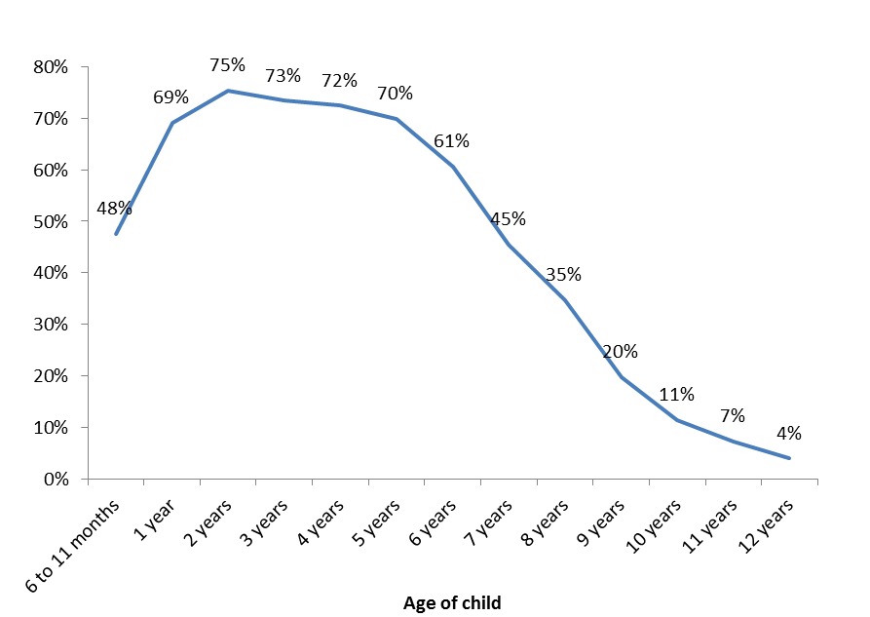

Outcome: Ability to pay for family essentials

Finances
Approximately one in twenty (4.9 per cent) children aged 0 to 12 came from a household where the main carer reported that there had been a time in the last 12 months when they had run out of food and had not been able to afford to buy more (ie. ‘food insecure’ households). One parent families were far more likely to experience food insecurity (18.7 per cent compared with 3.5 per cent of couple families).
As in 2009, the most common sources of support reported for families who had run out of food were relatives (32.3 per cent), welfare agencies (22.3 per cent) and friends (10.9 per cent).
- 17.5 per cent of children from food insecure households had a main carer who reported skipping a meal when food had run out.
- 12.3 per cent of children were from households where the main carer reported that they would not be able to raise $2000 in an emergency - a similar proportion to 2009.
As in 2009, one parent families were less likely to report financial security. 32.5 per cent of one parent families reported that they would not be able to raise $2000 in an emergency compared to 10.2 per cent of couple families. Similarly, 18.7 per cent of one parent families reported that their household had run out of food in the previous 12 months compared to 3.5 per cent of couple families.

Outcome: Positive family functioning

Social and emotional health
Family functioning was assessed using the General Functioning Scale of the McMaster Family Assessment Device. 7.6 per cent of Victorian children were from families classified as having unhealthy family functioning. However, the result was not significantly different to 2009, where 6.9 per cent of children were estimated to come from families with unhealthy family functioning. Children from areas of high socioeconomic disadvantage were significantly more likely to live in families with unhealthy family functioning (11.1 per cent in SEIFA quintile 1) compared with children from areas of low socioeconomic disadvantage (6.3 per cent in SEIFA quintile 5). One parent families were also much more likely to show unhealthy functioning (17.9 per cent) compared with couple families (6.6 per cent).
Within the VCHWS, the child’s main carer was invited to complete the Kessler 6, a tool to identify adults at risk of mental health problems. In the 2013 survey, a small minority (3.1 per cent) of children had parents who were classified as being at risk of mental health problems. There was no evidence to suggest that the proportion of parents identified as being at risk of mental health problems was any different to 2009, when 3.7 per cent, of children had a main carer at risk of experiencing mental health difficulties.

DHS Area Maps

