SHEPPARTON
EDUCATION PLAN
2021

STAGE III – PRIMARY EDUCATION

Acknowledgement of Country

The Victorian Government and the Department of Education and Training acknowledge the Yorta Yorta and Bangerang Clans, Traditional Owners of the lands of Shepparton, and pays its respects to their Elders past, present and future.

The Department of Education and Training is committed to honouring Aboriginal and Torres Strait Islander peoples’ unique cultural and spiritual relationships to the land, waters and seas and their rich contribution to society.

EXECUTIVE SUMMARY

The government primary schools of Greater Shepparton serve rich and diverse local communities. They are staffed by committed teachers, support staff and leaders who are supported in their work by families and a range of community organisations.
Like many parts of Victoria, the schools of the Greater Shepparton area face a complex task in achieving excellence and equity for all students. While many students thrive in its primary schools, a significant cohort of students within Greater Shepparton face considerable socio-economic disadvantage. These children have experienced some of the lowest educational, health and wellbeing outcomes in Victoria. Despite the considerable efforts and investment of the schools and the wider community, the link between the disadvantage these students face and their school achievements persists.
While there are examples of strong practice in our schools, excellence in education has not yet been consistently achieved for students across all schools, or consistently within the schools themselves.
Our schools work hard to provide students with high quality education opportunities, including ensuring that all students can access the kinds of specialist curriculum programs, extension learning experiences and extra-curricular activities accessed by children in metropolitan areas.
The Shepparton Education Plan – Stage III – Primary Education recognises both the challenges and opportunities of regional education in a diverse community and celebrates all those working to support the young people of Greater Shepparton. It recognises the government and community’s collective responsibility for transforming education.
Only by working together with local services and community members, can our schools be the best they can be and meet the needs of our young people. This Plan outlines the opportunity to build on the great work already happening across the Greater Shepparton community and outlines how we will work towards common goals and achieve real change.
Consultation undertaken with students, families, schools, and community leaders has challenged us to consider what excellence and equity looks like for the young people of Greater Shepparton.
This has provided a clear call to action to ensure all Greater Shepparton primary schools provide inclusive learning environments that meet the needs of every student and allow them to thrive.
It is this call to action that the Shepparton Education Plan – Stage III – Primary Education aims to respond to and achieve.
The Shepparton Education Plan – Stage III - Primary Education identifies six desired outcomes that align with the opportunities identified through consultation, each with accompanying priority actions.

Opportunity | Outcomes
Inclusion across the community | All members of every school community are valued and supported to fully participate, learn, develop, and succeed within inclusive school cultures.
Achieving excellence in teaching and learning | Our schools deliver Excellence in Teaching and Learning that achieves growth in outcomes for all students.
Meeting the health and wellbeing needs of all students | The Health and Wellbeing of all Children is supported to provide their best opportunity to learn and thrive.
Enhancing transitions | All children and families experience a Positive and Supportive Transition Program that promotes school readiness, from Early Childhood Education and Care to Foundation and from Years 6 to Year 7 (primary to secondary).
Strengthening opportunities | All students will be able to articulate and explore their Aspirations for the Future and to Pursue Opportunities for personal enrichment and extension of their education.
Building pride and confidence in our schools | All public primary schools in Greater Shepparton are well regarded as Strong and Successful Schools by their local community.

The Shepparton Education Plan reflects the Victorian Government’s investment of more than $10.8 billion to make Victoria the Education State so that everyone can get a great education, no matter their background or where they live.
The Shepparton Education Plan – Stage III – Primary Education is the third of four separate stages that make up the Shepparton Education Plan. It is a long-term plan to transform education in Shepparton to help young people get the best possible start in life.
The Shepparton Education Plan looks at learning from birth to post-secondary school. The first stage focused on secondary education, and the creation of the new Greater Shepparton Secondary College. The College opened its doors at the beginning of 2020, equipped to meet the needs and aspirations of young people across the area. A single-site campus is being built and expected to be finished by late 2021. The second stage, the Stage II Early Years Plan, focussed on the educational journey of children from birth to school.
In line with the approach for the other stages, a more detailed implementation strategy will follow publication of this document to guide the delivery of Shepparton Education Plan — Stage III – Primary Education.
The outcomes and actions of the Stage III – Primary Education Plan should also be read in conjunction with those established as part of the Stage II – Early Years Plan and Stage I – Secondary Years Plan. Implementation of each of these plans will be informed by the other.

Contents
EXECUTIVE SUMMARY 3

1 - INTRODUCTION 7
Victoria - the Education State 7
Education plans 7
The Shepparton Education Plan 8
How the Shepparton Education Plan was developed 8
Shepparton Education Plan – Stage III – Primary Education 9

2 - THE CASE FOR CHANGE 12

3 - THE COMMUNITY OF GREATER SHEPPARTON 18
Overview 18
Greater Shepparton’s education sector 21
Greater Shepparton organisations supporting primary education 23

4 - THE PRIMARY EDUCATION POLICY FRAMEWORK 24
Framework for Improving Student Outcomes (FISO) 24
Professional Learning Communities.…………………………….…………………………………….26
Victorian Teaching and Learning Model 26
Student Voice …………………………………………………………………………………………….27
Equity Funding 27
Marrung Aboriginal Education Plan 2016-2026 27
Disability Inclusion Strategy …………………………………………………………………………….28
Health and Wellbeing Initiatives 28

5 - A GREATER SHEPPARTON RESPONSE – OUTCOMES & ACTIONS 30
Inclusion across our community 31
Achieving excellence in teaching and learning 32
Meeting the health and wellbeing needs of all students 34
Enhancing transitions 36
Strengthening opportunities 38
Building pride and confidence in our schools 40

APPENDICES 42

REFERENCES: 51

1 - INTRODUCTION

Victoria - the Education State
The Victorian Government has invested more than $10.8 billion to make Victoria the Education State to improve outcomes for every student, in every classroom, in every school in every community.
The Education State promotes excellence across the curriculum, supports the health and wellbeing of students, and aims to break the link between disadvantage and student outcomes.
The following targets reflect the Education State ambition to improve outcomes for children and young people:
- Learning for Life
  - More students achieving excellence in reading, maths, science, critical and creative thinking, and the arts
- Happy, Healthy and Resilient Kids
  - Building the resilience of our children, and encouraging them to be more physically active
- Breaking the Link
  - Ensuring more students stay in school and breaking the link between disadvantage and outcomes for students
- Pride and Confidence in our Schools
  - Making sure every community has access to excellence, in every government school and classroom.

Education plans
Education plans are typically delivered in areas where there are complex challenges to improving achievement, wellbeing and engagement in education for children and young people. Collaboration between community and service providers is needed to transform education outcomes. Apart from Shepparton, education plans are operating, or in development, for:
- Bendigo
- Flemington
- Frankston North
- Footscray
- Lilydale District and Upper Yarra
- Oakleigh
- Bayswater.

Education plans help identify and address the unique challenges and priorities of a local community, and can involve:
- early childhood services
- government and non-government schools
- TAFEs
- universities
- community and cultural organisations
- local businesses and industry
- local government and other government agencies.

The Shepparton Education Plan
The Greater Shepparton region, which includes the larger centres of Shepparton and Mooroopna, faces complex and multi-faceted challenges to realising equity and educational outcomes.
The Shepparton Education Plan presents an ambitious, comprehensive framework to facilitate impactful change. It aims to address the region’s challenges and to support its young children to thrive in school and in life through the transformative power of education.
The Plan seeks to give Shepparton’s young people more options and opportunities, improve the transition through each stage of education, equip teachers with more effective training and resources, and develop contemporary school infrastructure.

How the Shepparton Education Plan was developed
The Shepparton Education Plan was informed by a comprehensive community consultation process. More than 6,500 individual comments were gathered and analysed from the broader community. Ongoing feedback during the developmental phase was achieved through engagement with 39 community and government organisations.
A strategic advisory group was formed, along with its five working parties, to ensure coherence across the Plan’s four stages. The group provides strategic advice to the Department of Education and Training (the Department) through its North East Victoria Regional Director. In late 2017, the group recommended that the Shepparton Education Plan’s initial focus should be on improving outcomes in the secondary education space, followed by early years settings.
The stages of the Shepparton Education Plan were then formulated as:
Stage I: Secondary Education
Stage II: Early Years
Stage III: Primary Education
Stage IV: Tertiary Education and Skills

The strategic advisory group has since been renamed the Shepparton Education Plan Project Board. It continues to provide strategic advice and oversee the work of the following working parties:
- Early Years
- Priority Cohorts and Partnerships
- Industry Partnerships & Further Education
- Koorie Engagement Group
- Project Control Groups for infrastructure builds

SHEPPARTON EDUCATION PLAN – STAGE III – PRIMARY EDUCATION
Primary Education is an integral part of the Shepparton Education Plan.
The term Primary Education refers to Foundation to Year 6.
The outcomes and actions developed as part of the Shepparton Education Plan -Stage III – Primary Education consider the extensive government policy and investment in this space and build on the existing investment in Greater Shepparton.
However, this investment has not achieved consistent improved outcomes, with data showing the need for further change to improve educational outcomes in Greater Shepparton.
Education System Design (Primary) Working Party
In 2018, an Education System Design (Primary) Working Party was established under the umbrella of the Shepparton Education Plan. Members of this working party consisted of education experts, and school and Department leaders. The Department’s North East Victorian Region identified members based on their qualifications, knowledge and experience.
The working party was asked to review the primary education offering of Greater Shepparton, with a focus on:
- transition — from kindergarten to primary school; within primary school, and into secondary school
- STEM (Science, Technology, Engineering and Maths)
- an inclusive learning environment
- a safe and stimulating learning environment
- increased collaboration for excellence in teaching and learning
- parent and family engagement.
As part of its review, the working party looked beyond its membership to collaborate with the Department of Education and Training’s engagement team to support effective community consultation during the second half of 2018. The working party analysed a range of data to inform development of key themes to be explored during the community consultation:
- Australian Early Development Census outcomes
- Foundation students – English Online reading, writing, and speaking and listening outcomes
- the experiences of parents and students of Kinder to Foundation and Year 6 to Year transitions
- NAPLAN Data – both overall outcomes and growth in student outcomes
- Attendance data.
Community consultation
The Department began its consultation on the Shepparton Education Plan in mid-2017. It conducted nine workshops, collected 185 online survey forms and received 4,750 individual comments. Together, the feedback provided important insights into the key challenges the Greater Shepparton community faced to improve the educational outcomes of its young people.
In 2018, more focused engagement with primary stakeholders commenced, engaging students, families, teachers, government organisations, specialist agencies and the wider community.
The Department listened to the Greater Shepparton community to hear its vision of education from kindergarten to primary school, including how children are supported as they transition into and out of primary school.
Consultation took place in a range of settings and contexts, including briefings, workshops, community and school-based meetings, school barbecues, surveys, and an online discussion board.
Promotion of the consultation involved newspaper advertising, social media, distribution of information packs and postcards to the Greater Shepparton City Council, early learning centres, schools, and a range of community organisations, including libraries, sporting facilities and community centres. The Greater Shepparton City Council and local schools supported this promotional effort via their own social media channels, emails, and newsletter updates.
The consultation process connected with 17,738 people through various social media platforms. There were also 225 face-to-face conversations, 34 comments collected via the online discussion board, 117 online survey responses collected, and 665 visits made to an online engagement portal.
Targeted consultation on outcomes and actions
Following the work of the Education System Design (Primary) Working Group and the community consultation, a draft set of outcomes and actions was developed. These outcomes and actions were revisited in 2021, and further targeted consultation was undertaken, including:
- individual feedback sessions were held with school principals of the Greater Shepparton area
- a survey and in-person feedback sessions were provided for members of all school councils from the Greater Shepparton area
- targeted feedback was sought through the community hubs at St George’s Rd Primary School and Wilmot Road Primary School
- a briefing session was held with all other Shepparton Education Plan Working Parties, with a survey provided for feedback
- feedback sessions were held with key Department Goulburn Area staff members.

2 - THE CASE FOR CHANGE

Community feedback and the data collected from Greater Shepparton’s primary schools revealed two key findings.
There are real strengths in primary education across the community. This can be seen in both the outcomes being achieved by some students, and the teaching, learning and wellbeing practices being implemented to support students and families.
However, it is evident that strong outcomes are not being achieved by all students, and that not all students and families are experiencing consistently excellent practice.
The clear challenge for Greater Shepparton’s primary schools is to provide excellence and equity for all students, and for this to be consistently delivered both within schools and across the schools. Schools have the opportunity to build upon the existing examples of strong outcomes and practices.
This opportunity must be managed with reference to the range of contexts of Greater Shepparton’s primary schools. There are large, centrally located schools within Shepparton, along with far smaller schools located in townships some distance from the city centre. The region also includes schools with high proportions of students from low-socioeconomic, Koorie and/or English as an Additional Language backgrounds.
A review of the community consultation, relevant data, policy and research, and direct school engagement identified a clear case for change. Both challenges and opportunities emerged around six themes:
- inclusion across our community
- achieving excellence in teaching and learning
- meeting the health and wellbeing needs of all students
- enhancing transitions
- strengthening opportunities
- building pride and confidence in our schools.

- Inclusion across the Greater Shepparton community
A clear, consistent theme concerned the level of inclusiveness of Greater Shepparton’s schools to all members of their communities. Consideration was given to the teaching and learning provided to all students, the supports in place for individual students, and the overall school cultures.
It also included feedback regarding inclusion of the diverse range of communities that make up Greater Shepparton, including Koorie communities, culturally and linguistically diverse communities, students and families from a range of socio-economic backgrounds, those who identify at LGBTIQ+, and those students and families with a disability or additional needs. It was recognised that while the need for inclusion goes beyond our schools, schools play a critical leadership role.
While good inclusive practices were identified, there is an opportunity to deepen this work. This includes the need for supporting greater consistency of these practices across our schools. Ultimately the feedback from the community was that some families and students do not always feel seen, heard or supported and are not always in a position to fully participate in school life as a result.

- Achieving excellence in teaching and learning
Achieving the best outcomes for all primary school age students in Greater Shepparton remains an ongoing challenge. Encouragingly, the academic achievement of primary age students in Greater Shepparton has improved over recent years. Since 2015, 77 per cent of Greater Shepparton schools have improved Year 5 Reading results, and 64 per cent of schools have improved Year 5 Numeracy results in NAPLAN. This improvement is greater than the state average improvement of 63 per cent and 55 per cent respectively.
However, NAPLAN scores are lower than the state average across all year levels in Reading and Numeracy. There are also fewer students in the top two bands of NAPLAN in both Year 3 and Year 5 compared to the stage average.
The relative growth data demonstrates that schools consistently struggle to achieve the same levels of growth for students compared to schools in other parts of the state. Students in Greater Shepparton consistently achieve lower growth than their peers in both Reading and Numeracy, with fewer students achieving high or medium growth compared to the state average.
The proportion of Year 5 and Year 7 students achieving high or medium growth in Numeracy, relative to students who were at a similar starting level in Year 3 and 5, respectively has also declined slightly between 2015 and 2019.
There have been slight improvements in Reading growth at year 5 and year 7, although the proportion of students achieving high or medium growth is still lower than the state average.
A call to action
We can see that a number of schools are achieving positive results and seeing improvements which presents a significant opportunity for the sharing of practice across schools. Our school networks have examples of schools working together, providing the foundation for purposeful and targeted collaboration to improve outcomes.
Access to professional learning was identified as being difficult, although the increased use of technology over the past 12 months presents a significant opportunity for blended models in the future. The announcement of the Victorian Academy of Teaching and Leadership also provides a significant opportunity.
The varied outcomes across Greater Shepparton present a clear call to action for schools to work together to ensure all students are achieving the best possible learning outcomes.
Feedback from schools demonstrated they were aware of this challenge and willing to take it on. School leaders recognised the importance of consistency in implementing the Victorian Teaching and Learning Model (VTLM). Using consistent implementation to drive improvement in student outcomes, is an excellent opportunity for schools to collaborate and build understanding and implementation of best practice across Greater Shepparton.

- Meeting the health and wellbeing needs of all students
While many students are thriving, a strong link continues to exist between the disadvantage faced by a large number of Greater Shepparton’s students and their academic, health and wellbeing outcomes.
The Australian Early Development Census (AEDC) data for the Greater Shepparton area is completed at the commencement of Foundation. It shows that children are twice as likely to be developmentally delayed across nearly all domains, as compared to the state average. Nearly 31 per cent of Foundation students are developmentally vulnerable in at least one domain, as compared to 20 per cent state-wide. Concerningly, Greater Shepparton’s outcomes have declined over the past 10 years.
As previously noted, while there are fewer Greater Shepparton students in the top two bands of NAPLAN Reading and Numeracy compared to the state average at all year levels, this is more pronounced for Greater Shepparton students in low SES schools and Koorie students.
Fewer than one in four students are in the top two bands for Year 3 Reading in the most disadvantaged schools in Shepparton, compared to more than one in three across the state in similarly disadvantaged schools. In Year 5, this falls to about one in eight students in the top two bands for Reading, compared to one in five across the state. Similar gaps are seen for Year 3 and Year 5 Numeracy results.
Koorie students
Consistent with results seen across the state, Koorie students in Greater Shepparton do not achieve at the same level as their non-Aboriginal peers. The proportion in the top two bands of NAPLAN results for both Reading and Numeracy declines as students move through year levels.
The proportion of Koorie students in the top two bands for NAPLAN Reading and Numeracy across all year levels in Greater Shepparton is also lower than for Koorie students state-wide. However, there has been some improvement over recent years. Between 2015 and 2019, there has been greater improvement in the proportion of Koorie students in Greater Shepparton achieving in the top two bands of Year 3 Reading and Numeracy than there has been for Koorie students state-wide. This improvement is also greater than that seen in non-Aboriginal students.
Attendance
The gap in outcomes for Greater Shepparton’s disadvantaged and vulnerable students includes key engagement outcomes, such as attendance.
In Greater Shepparton, improving student attendance remains a priority for primary schools. Between 2016 and 2019, average absence days increased by around 1.5 days for both primary and secondary age students.
Among primary schools in Greater Shepparton over the past five years, most schools had more students with more than 30 days of annual absence than the state average. For about half of the schools, the proportion of students with high absences has been increasing over the past two years.
Improving outcomes and the case for transformational change
The persistent gap in outcomes for Greater Shepparton’s disadvantaged and vulnerable students, demonstrates the need for transformational change to address this disadvantage.
Despite the strong focus on school improvement across all schools and the investment of resources by the Department and other community agencies and organisations in health and wellbeing, more needs to be done.
Community consultation identified that improving the learning outcomes for disadvantaged and vulnerable students also requires ensuring that health and wellbeing needs are being met. Community members recognised and valued existing supports, including school-based wellbeing staff and programs such as breakfast clubs.
At the same time, community members saw the need for other supports, including increased access to mental health resources. They also believe that these health and wellbeing services should be co-ordinated and co-located within the school environment, including allied and maternal health.
Greater Shepparton schools recognised how critical it is to meet the health and wellbeing needs of students to successfully close the gap in learning outcomes. They identified several challenges to meeting these needs, including:
- access to sufficient allied health and mental health services
- coordinating the supports on offer from both the Department and external services
- consistency of health and wellbeing approaches across schools and within schools
- adequate support for staff.
It was also recognised that supports needed to be implemented earlier to form strong relationships with families and to wrap around the child.
Ultimately, it was clear through the consultation and feedback that considerable efforts are being put into addressing disadvantage, however it appears critical that the community comes together to achieve greater coordination and alignment to succeed.

- Enhancing transitions
Some participants in the community consultation felt that students and parents could be better supported to be prepared for the transition from kindergarten to primary school, and from primary to secondary. There were suggestions about providing families with better information, commencing transition activities earlier and providing more opportunities for students and families to visit schools.
Families and students also raised concerns and questions regarding differences in the learning approaches between both early childhood education and care settings and primary school, and then between upper primary and early secondary. Families of pre-school-aged children raised questions about the emphasis on play during Kindergarten, rather than more formal learning, and whether this adequately prepares students for Foundation. At the same time, secondary students reported challenges adjusting to the different ways of learning and working once they commenced at secondary school.
The Education System Design (Primary) Working Party identified similar challenges and barriers, including the need for:
- more effective sharing of information between early childhood education and care settings, schools, and families
- increased contact and collaboration with families
- students and families to engage with their new school earlier.
The Working Party also identified that there is much greater scope for increased collaboration between primary and secondary teaching staff, particularly in the middle years. Such collaboration is not universal, however efforts have been made to address this over the past two years.
The links between educational settings have been a focus area for improvement in recent years. Greater Shepparton Secondary College has made considerable efforts over the past two years to provide a more comprehensive, tiered approach to transition. The sharing of data between primary and secondary school has also been improved.
Additionally, the Shepparton Education Plan – Stage II – Early Years contains clear actions to enhance transitions from early childhood education and care settings to Foundation. Both initiatives present considerable opportunities for highly effective transition processes within and across Greater Shepparton’s education settings.

- Strengthening opportunities
A clear theme of the consultation with the community and schools was around challenges in providing students with access to a full range of learning opportunities.
Community consultation raised the need for more opportunities to extend and challenge capable students. It was stated that this should go hand in hand with making sure students requiring intervention and additional support are having their learning needs met. Community members also stated that it was important for schools to provide a broad range of subjects across the curriculum.
The Education System Design (Primary) Working Party noted the need to support the aspirations of students, especially at the upper primary level. There is a significant opportunity to increase student engagement by connecting the curriculum to students’ aspirations. Schools identified challenges with providing adequate and consistent access to students of all specialist areas, including STEM and all areas of the Arts, as well as applied learning opportunities.
The community and school feedback suggested that the limited access to some of these learning opportunities may have an impact on student engagement in both upper primary and secondary.

- Building pride and confidence in our schools
Feedback from the community confirmed a strong history of families choosing to enrol their child in schools that are not their designated neighbourhood school. School curriculum, perceptions of school culture and reputation were identified as key factors informing these decisions. This suggests families don’t always feel a connection to their designated neighbourhood school, and/or that they are concerned about the quality of education or the environment in some schools. It is possible the community is not aware of the strengths of each school. As noted previously, the community perceives inconsistency in both outcomes and practice across schools, which needs to be addressed.
There has been a decline in enrolments at our government primary schools over recent years, as families have sought out non-government alternatives. Students have also been exiting part way through primary school to non-government schools to ensure entry at Year 7. This trend continues with the transition from Year 6 to secondary school. The establishment of the new Greater Shepparton Secondary College provides students with expanded subject choice and access to state of the art facilities to support learning and wellbeing.
As mentioned above, schools identified the attraction and retention of staff as a challenge. This in turn has an impact on the culture of the school, and the relationship that the school has with its local community.

3 - THE COMMUNITY OF GREATER SHEPPARTON

Overview
Greater Shepparton City Council (GSCC) is the fifth-largest city in regional Victoria, with a population of just more than 66,000. Located 180km from Melbourne, the GSCC is a major service centre and transport hub for the Goulburn Valley and Southern Riverina area of New South Wales.
The local government area (LGA) covers three main urban centres: Shepparton, Mooroopna and Tatura as well as a number of smaller towns. Three-quarters of the municipality’s population live in Shepparton and Mooroopna.
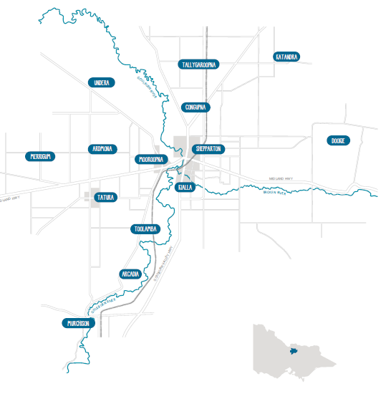
Population growth
According to Profile ID data for the local government area of Greater Shepparton, the forecast population for 2021 is 69,850. This is forecast to grow to 83,234 by 2036. Greater Shepparton is considered a regional centre within Victoria.
Looking back over the past seven years of Greater Shepparton’s population, Shepparton has a strong growth rate, ranging from 0.71 per cent to 1.44 per cent, adding around 449 to 880 people each year to the overall population. This is comparable to Victoria overall. Over the same time Victoria posted a population growth rate range of 0.35 per cent to 2.55 per cent.
By 2036, Greater Shepparton is expected to experience a 20 per cent increase in the number of school-aged children, reflecting the Victoria state-wide projection of 19.3 per cent. The expected growth rate in children aged 0-4 and 5-9 is around 7 per cent, consistent with Victoria’s anticipated growth rate.
Map of Greater Shepparton. Courtesy of the State of Greater Shepparton’s Children Report 2019.
These population statistics indicate that Greater Shepparton is a growing regional centre, with an increasing number of young families and school-aged children to call it home in the decades to come.
The Koorie community
Outside of Melbourne, Greater Shepparton has Victoria’s largest concentration of people who identify as Aboriginal and Torres Strait Islanders, referred to as Koorie. The figure of nearly 2200 people is more than twice the regional Victorian average, and approximately 3.4 per cent of the Greater Shepparton.
However, anecdotal evidence suggests that these figures are under-represented. Greater Shepparton’s Aboriginal and Torres Strait Islander population could be nearly three times this, with a population of nearly 6,000. Approximately 30 per cent of the total Koorie population in Greater Shepparton is under 11 years of age.

A culturally and linguistically diverse community
Greater Shepparton is also known for being a diverse multicultural community. The 2016 Australian Bureau of Statistics (ABS) Census showed 14.9 per cent (9459 individuals) of the population identified as being born in a country other than Australia. Most of these (11.5 per cent) were born in countries where English is not the first language.
Greater Shepparton has been a primary humanitarian settlement site over the past few decades, particularly in the past 15-20 years. Refugees have resettled from origin countries such as Iraq, South Sudan, Burundi, the Congo, Rwanda, Tanzania, Pakistan, Iran, and Afghanistan. Greater Shepparton has also experienced significant secondary settlement, with many migrants drawn to the region by seasonal work opportunities, lower cost of living, and community connections.

Greater Shepparton disadvantage
According to Socio-Economic Indexes for Areas (SEIFA) data obtained in the 2016 Census, Shepparton Local Government Area (LGA) is the 14th most disadvantaged LGA in Victoria (out of 79 Victorian LGAs). The most disadvantaged communities are concentrated in pockets in North and South Shepparton, and Mooroopna. These areas are also most at risk of vulnerability, including high concentrations of new arrivals and refugee families, families living in social housing, people known to be experiencing family violence, and those experiencing the impacts of substance abuse and poverty.
The Greater Shepparton City Council’s State of Greater Shepparton’s Children Report 2019 finds that currently 10.2 per cent of Greater Shepparton’s children are reported to be living in circumstances with high levels of family stress.
These sources of family stress and disadvantage can be seen across several measures, including the proportion of children on child protection orders, report rates for family violence incidents, proportion of children in out of home care, crimes where children are the victim, and access to transport and food insecurity.
Across all these measures, Greater Shepparton records rates greater than the Victorian average. In many instances, these measures have worsened even further over the past five to 10 years rather than improved.
Unfortunately, this level of disadvantage is reflected in the outcomes of Greater Shepparton’s young people from the time they commence Foundation.
The Australian Early Development Census (AEDC) is conducted nationwide every three years to measure how young children have developed by the time they start their first year of full-time school. The AEDC looks at groups of children in a community, not individuals.
The latest AEDC in 2018 involved 905 children in the Greater Shepparton area, plus 71 teachers from 41 government and non-government schools. Data is gathered in five key areas of early childhood development (referred to as domains):
- physical health and well-being
- social competence
- emotional maturity
- language and cognitive skills (school-based)
- communication skills and general knowledge.
Results from the latest census conducted in 2018 show a continued decline in how the city’s children are developing before they reach primary school. Children living in Greater Shepparton are starting school lagging behind their peers in metropolitan areas and other regional centres in several key developmental areas.
Key AEDC results for Greater Shepparton:
- 19.2 per cent of Greater Shepparton children exit early childhood settings vulnerable in two or more domains — nearly twice the Victorian average of 10.1 per cent. This figure has increased from 11.6 per cent since 2014
- 31 per cent of all students in 2018 were vulnerable in at least one domain
- the vulnerability data from 2009 to 2018 has significantly increased across all five domains.

AEDC 2018 Data for Greater Shepparton
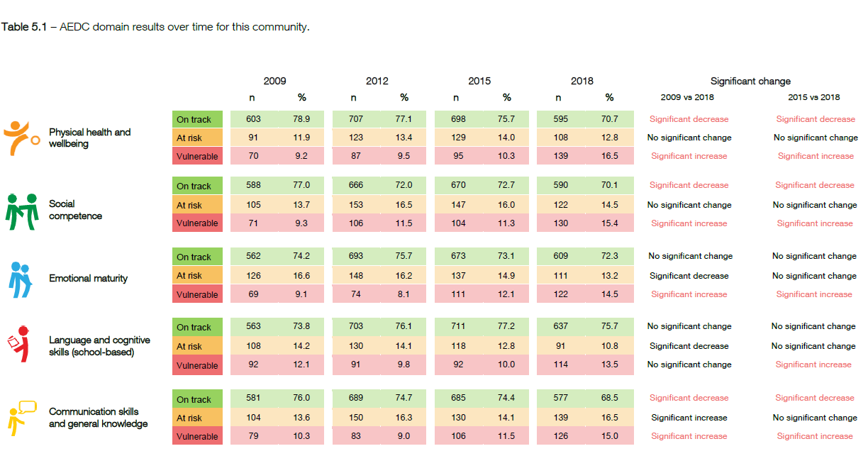

Within our schools, the Department provides additional funding – known as equity funding – based on disadvantage, as measured by parental education and occupation. Across Greater Shepparton’s schools, 42 per cent of students attract equity funding, demonstrating a high level of disadvantage across cohorts. Further information on equity funding is provided in Section 4.

greater shepparton’s education sector
Government primary schools in Greater Shepparton
There are 28 primary schools in Greater Shepparton, along with Verney Rd Specialist School that also services primary aged students. There is significant variation across these schools, both in size and the diverse communities they serve. The schools work within two separate networks — the schools located within the town of Shepparton work in the Shepparton Urban Network and those in the wider Greater Shepparton area are part of the Greater Shepparton Network.
Appendix 1 provides key information regarding each school, including their:
- 2021 enrolments
- Index of Community Socio-Educational Advantage (ICSEA) value
- percentage of students who are equity funded
- percentage of students who either identify as Aboriginal and/or Torres Strait Islander or who have English as an Additional Language (EAL).
This data reflects the range of contexts the schools work within. This includes a broad range in the size of schools — from schools of more than 400 students, to several schools of under 20 students.
There are also a mix of socio-economic profiles across the schools. This includes seven of 28 primary schools that have an ICSEA value above the national average of 1,000. There are also seven primary schools that serve communities experiencing significant disadvantage, with ICSEA values below the tenth percentile.
Finally, Greater Shepparton’s diverse communities are reflected within its primary schools, with several schools serving large Koorie and/or multicultural communities (as reflected in the percentage of students from an EAL background).

Specialist education — Verney Road School
Verney Road School is a Victorian Government school in Shepparton. The school supports students with a mild to profound intellectual disability who are funded under the Program for Students with Disabilities (PSD). Many students have multiple diagnoses of disability, including Autism Spectrum Disorder (ASD), Down Syndrome, Attention Deficit Hyperactivity Disorder (ADHD), associated impairments such as sensory and physical impairments and/or challenging behaviours.
Students’ ages range from 3 to 18 years. The school has an Early Education Unit and three school-aged sections — early, middle and senior years. Enrolments in 2021 are 222, which includes 20 early education students.
Verney Road assists many mainstream schools with inclusion and transition arrangements. The school provides an early years outreach service that supports mainstream pre-school and in homes.

New Integrated Early Learning Centre (IELC) for Mooroopna
Readiness for school has been identified as a challenge and an opportunity in the Greater Shepparton area.
The Department and the Colman Foundation have partnered with Mooroopna Primary School, along with Greater Shepparton City Council as the early childhood education and care service, and other service providers, to embed the Our Place model at a new Integrated Early Learning Centre (IELC) in Mooroopna.
The IELC will offer kindergarten for three and four-year-olds, long-day care services, and maternal and child health care for local families. The IELC will be located at Mooroopna Primary School, with places for approximately 100 children.
The IELC will improve readiness for school and the likelihood of experiencing success — both important elements in reducing the effects of disadvantage.
It is envisaged that the IELC at Mooroopna will serve as a model that could be reflected in future years across Greater Shepparton.

Secondary education – Greater Shepparton Secondary College
The first stage of the Shepparton Education Plan saw the creation of the new Greater Shepparton Secondary College. Shepparton High School, McGuire College, Mooroopna Secondary College and Wanganui Park Secondary College merged to form one new school. The College opened its doors at the beginning of 2020 committed to meeting the needs and aspirations of young people across the region. A single-site campus is being built and will openat the beginning of the 2022 school year.
The new single-site campus is a $119m project that will provide a state-of-the-art facility for the secondary students of Greater Shepparton. It will deliver contemporary classrooms and specialist learning spaces not experienced by local public secondary students for decades. The new school site will have a capacity of up to 2,700 students.

greater shepparton organisations supporting primary education
Various services and organisations in Greater Shepparton work collaboratively with schools to support and provide opportunities to students.
Local services and organisations include:
- Goulburn Valley Local Aboriginal Education Consultative Group (GVLAECG)
- Greater Shepparton Lighthouse Project
- Smith Family
- Ethnic Council
- Neighbourhood School Paediatric Clinic Project (Dr Peter Eastaugh)
- Child and Adolescent Mental Health Service (CAMHS)
- The Bridge Youth Services
- Uniting Kildoan
- Community Hubs Australia
- Family services (including Child First, Family Care, Primary Care Connect, Catholic Care)
- Rumbalara Aboriginal Co-operative
- Ganbina
- City of Greater Shepparton Communities for Children
- Best Start
- Shepparton Rotary Club

4 - THE PRIMARY EDUCATION POLICY FRAMEWORK
The Shepparton Education Plan – Stage III – Primary Education takes its policy lead from the Department’s Framework for Improving Student Outcomes (FISO). Several other policies and plans influence the provision of primary education in Greater Shepparton, including:
- Professional Learning Communities
- Victorian Teaching and Learning Model
- Student Voice
- Equity Funding
- Marrung Aboriginal Education Plan 2016 – 2026
- Disability Inclusion Strategy
- Health and wellbeing policies and initiatives.

FRAMEWORK FOR IMPROVING STUDENT OUTCOMES (fiso)
The Framework for Improving Student Outcomes (FISO) is a mechanism for driving continuous improvement in schools to ensure student achievement, engagement and wellbeing.
Schools combine FISO with robust evidence and effective inquiry processes to highlight strengths and identify areas of existing practice that need improvement.
It uses a common language, cycle of improvement and set of success criteria to define improvement, all based on the best available evidence. From the classroom, to networks, to the system as a whole, FISO supports improvement as a system.
FISO provides the evidence base, advice, guidelines, tools and resources to support schools as they implement the Education State initiatives to improve outcomes for all children and young people.
The Framework includes these key elements:
- Improvement Cycle: Helps schools to implement an effective and continuous process of self-evaluation, review and diagnosis of areas which require attention. The cycle guides improvement sequencing, including how schools report activities, outcomes and plans to their communities.
- Improvement Model: Contains six high-impact improvement initiatives:
  - Building practice excellence: Under this initiative, teachers, principals and education support staff work together across schools to build knowledge and expertise; develop, test and strengthen teaching and assessment approaches; master the use of learning interventions; and enhance feedback to students and staff.
  - Curriculum planning and assessment: Under this initiative, schools embed a culture of curriculum planning and then assessment of the impact of learning programs, adjusting task, content and practice to suit individual student needs to accelerate student progress and ensure all students can reach their potential.
  - Building leadership teams: Under this initiative, schools will:
    - develop the capabilities of their leadership teams in using evidence and proven coaching and feedback methods,
    - build a culture that is focused on improved performance,
    - strengthen their succession planning and
    - strengthen the induction of new teachers into the professional learning culture of their school.
  - Empowering students and building school pride: Under this initiative, the whole school community engages with students so they have a voice in the learning process, fully and proudly participate in school life and have a greater say in the decisions that affect their learning and their lives at school.
  - Setting expectations and promoting inclusion: Under this initiative, schools work across their communities to implement a shared approach to supporting the health, wellbeing, inclusion, and engagement of all students. This includes building teachers’ understandings of positive behaviour support and engagement practices, and ensuring students have the tools and skills to develop positive and self-regulating behaviours.
  - Building communities: Research shows that parent and community involvement in school life and operations is one of the factors most closely associated with improved student learning outcomes. Under this initiative, schools build relationships within their broader communities by partnering with organisations in the community sector. Such partnerships enable fuller use of existing community resources and capabilities, and increase the efficacy of services delivered ‘inside the school gate’.
- Improvement Measures: The improvement measures are a range of data sets across various aspects of schooling that provide schools with a reliable instrument to evaluate and monitor the effect of their self-improvement efforts on student outcomes.
  - The measures assist schools in implementing the improvement cycle, providing a common evidence base for schools' self-evaluation, strategic planning, performance and development processes and reviews.
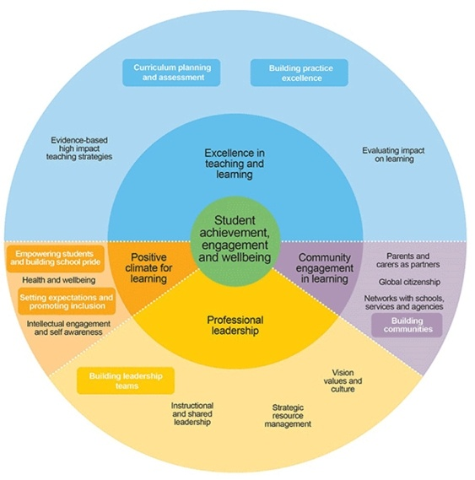

Professional learning communities
Professional learning communities (PLCs) are an approach to school improvement where groups of teachers work collaboratively at the school level to improve student outcomes.
PLC schools start from a simple idea — students learn more when their teachers work together. Building a PLC is a proven way for schools to increase student learning by creating a culture that is:
- focussed on continuous improvement by linking the learning needs of students with the professional learning and practice of teachers
- committed to professionalism fuelled by collaborative expertise.

victorian teaching AND learning model
The Victorian Teaching and Learning Model (VTLM) was introduced by the Victorian Government in 2018 to support whole-of-school improvement and build teacher capability. It brings the Framework for Improving Student Outcomes (FISO) into the classroom, and creates line of sight between whole-school improvement and classroom practice.
The model provides a vision for all of our students:
‘All students are empowered to learn and achieve, to experience high quality teaching practice and the best conditions for learning which equip them with the knowledge, skills and dispositions for lifelong learning and to shape the world around them.’
Alongside this vision sit a number of important tools and resources, which support all schools to achieve the best outcomes for their students:
- The practice principles are nine signature practices which have been shown to make a difference in improving student achievement and motivation;
- The pedagogical model describes what effective teaching looks like in the classroom and helps teachers apply the practice principles; and
- The high impact teaching strategies (HITS) are ten instructional practices that reliably increase student learning wherever they are applied.

Student Voice
Victoria’s vision for learning recognises the fundamental importance of empowering students and the contribution that student voice, agency and leadership make to improved student outcomes, health, and wellbeing.
The vision outlines the collective aspiration for all students to achieve and grow as learners, and to generate their own course for lifelong learning. Students will be empowered to take ownership of their learning, make purposeful contributions to their learning environments, and tackle issues arising in the world around them.
Young people who find their own voice in supportive school environments are more likely to develop a confident voice, a capacity to act in the world, and a willingness to lead others. By empowering students, their engagement is enhanced, and participation enriched in the classroom, school, and community. Students are to be supported to ‘own’ their learning and development and create a positive climate for learning.

EQUITY FUNDING
Equity funding is additional funding that schools receive to help students who face challenges achieving the desired learning outcomes. This may be due to family circumstances, health or disability.
Equity funding supports the Education State objective of reducing the disparities in student achievement – aiming to break the link between disadvantage and outcomes. It also aims to close the gaps that are evident between regions, schools and even classes within schools.
This funding must be used by schools to support the targeted students and this must be a key part of school’s improvement initiatives.

Marrung Aboriginal Education Plan 2016-2026
The Marrung Aboriginal Education Plan 2016-2026 sets a vision for our state where:
- the rich and thriving culture, knowledge and experience of our First Nations peoples are celebrated by all Victorians
- our universal service systems are inclusive, responsive and respectful of Koorie people at every stage of their learning and development journey
- every Koorie person achieves their potential, succeeds in life, and feels strong in their cultural identity
This vision provides clear, important work for all primary schools. It encompasses a number of important actions for schools.
- Create a positive climate for learning and development where services demonstrate the highest levels of respect and inclusion and, as a result, Koorie children and learners of all ages feel strong in their identity within all services.
- Build community engagement in learning and development so that, through partnership and collaboration, services work together with Koorie people to find innovative ways to improve outcomes in local communities.
- Build a culture of professional leadership where success for Koorie Victorians is core business for all educational leaders.
- Achieve excellence in teaching, learning and development at all stages so that:
- young Koorie children are on track in their health, development and well-being, and their early learning experience sets them up for life
- Koorie students engage fully throughout their schooling years and gain the knowledge and skills to excel at year 12 or its equivalent
- Koorie learners transition successfully into further education and employment and have opportunities to access education at all stages of life.

DISABILITY INCLUSION STRATEGY
The Victorian Government is investing nearly $1.6 billion over four years in Disability Inclusion to ensure that every Victorian student, no matter their background or circumstance, is given every chance to reach their potential.
The initiative will build on the significant work already undertaken to support inclusive education and introduces a new tiered funding model, a new Disability Inclusion Profile, and a suite of initiatives to build skills and knowledge in inclusive education.
The new tiered funding model and Disability Inclusion Profile will be introduced to Greater Shepparton’s primary schools in 2024. However, the package provides additional supports that can be accessed immediately, including information, advice, and resources to support parents to engage with schools as partners in student learning. The package also includes more resources for schools to better understand the learning needs of students in the classroom and to undertake evidence-based teaching practices.

HEALTH and WELLBEING POLICIES and INITIATIVES
Schools play a key role in providing a positive and inclusive learning environment for all students. They can equip young people with the personal skills to support their mental health and wellbeing. A range of Department health and wellbeing-focused policies and initiatives are in place to support Greater Shepparton’s primary schools, including:
- Student Support Services team
- Health and Wellbeing Key Contacts
- Primary Welfare Officers
- Koorie Education Support Officers
- school nurses
- chaplaincy services
- Child Protection and Child Safe Standards and processes (PROTECT)
- mental health supports and advice
- bullying supports and advice, including Safe Schools
- family violence supports
- youth justice supports
- attendance policy and guidance
- healthy eating and physical activity supports and advice
- Breakfast Clubs
- LOOKOUT Centre (Out-of-home care supports)
- Respectful Relationships
- School-Wide Positive Behaviour Supports
- support for students with disability and additional needs.

5 - A GREATER SHEPPARTON RESPONSE – outcomes and actions

Making a difference for Greater Shepparton
The Shepparton Education Plan aims to be transformational for the children and families of the Greater Shepparton region. All working parties of the Plan have been challenged to consider ‘what would make a difference’ for Greater Shepparton.
The Plan’s vision, developed in 2017, is a cornerstone for its planning and activities, and serves as a reminder of our ‘why’.
“The Shepparton Education Plan will ensure all children and young people have a positive future and families, schools and our community will help them get there through learning and caring”.
The Shepparton Education Plan – Stage III - Primary Education Plan must seek to do things differently or run the risk of watching the challenges in primary education outcomes continue.
While this Plan has referred specifically to Greater Shepparton, about 40 pieces of local state, national and international policy, research and reports were also examined and correlated within the Shepparton community context.
It is important to note that the outcomes and actions outlined in this Plan do not seek to replace or duplicate existing education policy, either planned or under implementation. Rather, these recommendations complement this body of work and collectively serve to support the young children in Greater Shepparton to achieve similar outcomes to their counterparts across the state and nationally.
These outcomes and actions must also be read in conjunction with those established as part of the Stage II – Early Years Plan and Stage I – Secondary Education Plan. The work of implementing each of these plans will be informed by the other.

Desired Outcomes
The Shepparton Education Plan – Stage III — Primary Education identifies six Desired Outcomes, each with their own accompanying actions, for the Greater Shepparton community:
- All members of every school community are valued and supported to fully participate, learn, develop and succeed within an inclusive school culture
- Our school delivers Excellence in Teaching and Learning that achieves growth in outcomes for all students
- The Health and Wellbeing of all Children is supported to provide their best opportunity to learn and thrive
- All children and families experience a Positive and Supportive Transition Program that promotes school readiness, from early childhood education and care to Foundation, and from Years 6 to Year 7 (primary to secondary)
- All students will be able to articulate and explore their Aspirations for the Future and to Pursue Opportunities for personal enrichment and extension of their education.
- All public primary schools in Greater Shepparton are well regarded as Strong and Successful Schools by their local community.

INCLUSION across our community
Background
Community and school feedback prioritised the need to ensure schools are inclusive of all students and families. Community members see this as a community wide challenge, however, they also recognise that schools have an important opportunity to lead the community in this area.
The Greater Shepparton community is made up of families and students of many different backgrounds. It was recognised through consultation that some families and students do not always feel valued by their school. They have expressed that they feel that there may not always seem to be the same opportunities to participate in the learning, wellbeing programs and wider school activities and events that other students and families take part in.
The extent to which students and their families feel included affects their feeling of safety within the school and classroom environment. The Framework for Improving Student Outcomes (FISO) identifies positive, trusting, and supportive relationships and environments as critical to this sense of safety, and this safety essential for students feeling connected and engaged in their learning. FISO also states that participation and a positive sense of culture and identity are closely linked to student wellbeing and also their growth and achievement.
The importance of inclusion is also emphasised by a range of Department policies that support Victoria’s diverse communities. These include the Marrung Aboriginal Education Plan, which identifies the highest level of inclusion of Koorie students as a key action to ensure they feel strong in their identity. Additionally, the Disability Inclusion Strategy emphasises the importance of building skills and knowledge in inclusive education.
When speaking with community members and organisations about how to achieve this, several key qualities of an inclusive approach were identified. These included the fundamental importance relationships built on love, care, and unconditional positive regard. Alongside this, community members saw the need for a strengths-based approach to achieving equity.
Finally, it was recognised that the experiences of students and families must be central to all actions, including how the impact of collective efforts are evaluated.

Desired Outcome
All members of every school community are valued and supported to fully participate, learn, develop and succeed within an inclusive school culture
Actions
- In partnership with students, families, and the community, pursue best practice implementation of the Department’s inclusion policies and frameworks across Greater Shepparton primary schools. Inclusion in this context includes students and families from all socio-economic backgrounds, Koorie and culturally and linguistically diverse communities, all genders, LGBTQI+ identifying students and family members, and those with disabilities and additional needs.
- Engage with the newly formed Cultural Inclusion Steering Committee for the Shepparton Education Plan to inform a culturally inclusive action plan in primary schools.
- Support the achievement of this outcome through a high-quality professional learning program for all primary school staff.

Additionally, inclusion across the Greater Shepparton community is critical to many of the outcomes and actions of this Plan. These actions will be implemented across all stages of the Shepparton Education Plan.

ACHIEVING EXCELLENCE IN TEACHING and LEARNING
Background
Community feedback made it clear that greater consistency was needed across Greater Shepparton’s schools in terms of practice and outcomes. While this has been assisted by the introduction of the Victorian Teaching & Learning Model in 2018, it has also reinforced its importance. Schools also recognised they needed to continue their efforts to ensure consistency in practice within their schools. The gap in the outcomes between Greater Shepparton’s students and those in other areas supports the need for this focus.
A focus on excellence in teaching and learning clearly aligns with the Framework for Improving Student Outcomes (FISO) — it is one of its four priority areas. FISO raises several important considerations for the schools including:
- there is a clear, documented curriculum developed through strong processes, closely linked to assessment and pedagogy
- it is critical to have ongoing evaluation on the impact of learning at all levels — within the classroom, year levels, across the whole school and even across the network
- the importance of focused, evidenced-based, and collaborative professional learning through Professional Learning Communities (PLCs) to drive the change and build practice
- that expertise in these areas is built through networks and Communities of Practice, and that these external supports are important to ensuring there is the quality of professional learning necessary.
Several trends within the data also shed light on the stages of schooling to specifically focus on. The substantial gap in local AEDC and English Online data, including with reading and language skills, made clear the importance of an Early Years focus.
Evidence for Learning’s Guidance Report: Improving Literacy in Lower Primary identifies the critical nature and impact of intervening in the early years and building beginning literacy skills. These and other resources, including the Department’s Literacy Toolkit, provide a clear picture of best practice. This includes the importance of oral language and a comprehensive early reading instructional model for Greater Shepparton schools to work towards. It is also critical to consider students’ mastery of these early literacy and numeracy skills at this stage.
Additionally, the decline in NAPLAN results as students progress through school, including in Year 5 and Year 7, along with feedback around a decline in engagement, point to the importance of efforts in the Middle Years.
As the work of education researcher Professor John Hattie and others identifies, as students become invested in their own learning, they gain a better understanding of what good learning is and its purpose. This enables them to evaluate their own work, and to discuss progress and achievement more purposefully with teachers, each of which has a significant effect on achievement. Consistent practices in the Middle Years are also an important support for students as they transition from Year 6 to Year 7, complementing the work of Outcome 4.
The nature of the Shepparton Education Plan, covering all stages of schooling, provides substantial opportunities to pursue innovation and best practice in these areas.
Finally, it was recognised across the community that there is both the desire and the need for families to be more connected to their children’s learning. The experience of remote learning over the past 12 months has made clear the great potential for more family involvement and there are many good examples to build upon. FISO also emphasises the importance of parents and families being partners in learning, as well as school improvement efforts.

Desired Outcome
Our schools deliver Excellence in Teaching and Learning that achieves growth in outcomes for all students.
Actions
- Embed professional learning communities that have an unremitting focus on collaboration to secure outstanding teaching and learning within and beyond each school, with students at the heart of all decisions.

- Establish teaching and learning working groups that use the FISO improvement cycle to pursue innovation and best practice in both Early Years (Kinder-Year 2) and Middle Years (Year 5-8) (note links to SEP Stage I Secondary, Stage II Early Years and Stage IV Tertiary and Industry Plan).
- Strengthen the implementation of the Victorian Teaching and Learning model, emphasising the inclusion of all students and families through strong opportunities for student voice and agency and to connect school learning with home learning.
- Provide local access to high-quality professional learning opportunities through a strong partnership with the Victorian Academy of Teaching and Leadership.

MEETING THE HEALTH and WELLBEING NEEDS OF ALL STUDENTS
Background
A review of both the academic and the health and wellbeing outcomes for Greater Shepparton reveals an urgent need to address the gap between its disadvantaged and vulnerable students and their peers. To address this, there is a need for transformational change in how both disadvantaged and vulnerable students and their families are supported.
Across the community, feedback was provided about many different programs and supports being offered to students and families. There was great appreciation for these, and a clear desire on the part of schools and community organisations to provide this support.
However, feedback also confirmed greater collaboration was needed across all in the community — students, families, teachers, school leaders, services and the Victorian Government — to ensure health and wellbeing needs are being supported in the most effective ways possible.
While some additional programs and supports may be required to meet some unmet needs, how all stakeholders work together to identify and then meet the needs of Greater Shepparton’s children is most significant.
The work of the Education Redesign Lab at Harvard University finds this work — the how — critical when trying to improve outcomes for students where there is a high level of disadvantage. Its research finds that the work of school improvement cannot just focus on teaching and the curriculum — it must centre on the student and make sure their needs are being met.
In Broader, Bolder, Better: How Schools and Communities Help Students Overcome the Disadvantages of Poverty, Paul Reville and Elaine Weiss advocate ‘integrated student supports’ to achieve this. Schools, communities, and services must be brought together to provide a coordinated response.
There are several groups and initiatives working to support the Greater Shepparton community and its children, including those mentioned in Section 3. The Shepparton Education Plan provides an exciting opportunity to examine these efforts and to build upon them to make sure the needs of all our students and school communities are being met.
Community members and organisations also identified this as an opportunity to make sure the strengths of students and families were considered. The community also was considered as a starting point for developing a plan to meet the health and wellbeing needs of its young people.
This is supported by the Framework for Improving Student Outcomes’ priority areas ‘Positive Climate for Learning’ and ‘Community Engagement in Learning’. FISO provides several important considerations in these areas:
- central to supporting the health and wellbeing of students are their relationships with school staff
- schools utilise a range of interventions to support the health and wellbeing of students, including social-emotional learning for all students and targeted interventions (including external services) for those students who require more
- schools maximise engagement through clear, strong approaches to both behaviour and attendance
- schools ensure all students and their families feel respected, included, and safe
- partnerships between schools, specialist services and community organisations can support improved health and wellbeing outcomes, and it is important that these partnerships act strategically
- it is critical for schools to develop meaningful partnerships with parents, carers, and family.
These elements of FISO are complemented by a range of Department health and wellbeing supports and initiatives, including — but not limited to — the Marrung Aboriginal Education Plan, Student Support Services, PROTECT, the LOOKOUT Centre and school-wide positive behaviour supports, all of which are being implemented in schools.
Schools must also develop a local student engagement policy that provides the basis on which schools develop and maintain safe, supportive, and inclusive school environments. Feedback demonstrates that implementation of these can be strengthened and must be coordinated as part of a broader effort to improve the health and wellbeing outcomes of students.
Additionally, while schools recognised the importance of parents and families working as partners, barriers for some families being able to participate equitably were also identified. Often these are Greater Shepparton’s most disadvantaged and vulnerable families. It is important to work to understand these barriers better, and to then address them.
The attendance outcomes for the schools of Greater Shepparton demonstrates a clear need to focus efforts on this key measure. Research establishes a clear link between attendance and academic achievement. The Student Attendance and Educational Outcomes: Every Day Counts report by Hancock et al (2013) found that any absence from school saw a decline in average academic achievement on NAPLAN and this decline continued as the absence rate increased. Their research revealed there is no ‘safe’ threshold.
Finally, there was feedback from both schools and the community about the importance of whole school programs that support the health and wellbeing needs of all students. This aligns with the findings and recommendations of the recently released report of the Royal Commission into Victoria’s Mental Health System. There are several examples of these in practice across Greater Shepparton, and there are great opportunities for collaboration to ensure these are working effectively to support students.

Desired Outcome
The Health and Wellbeing of all Children is supported to provide their best opportunity to learn and thrive.
Actions
- Identify (or establish) the most appropriate governance arrangements to ensure collaboration between schools, the Department and other relevant government agencies, community service providers and community leaders and volunteers to align and co-ordinate the range of support needed by all students. This work may include:
  - establishing a common health and wellbeing framework across all schools to ensure a safe and inclusive environment for all students, and targeted support for our most vulnerable
  - adopting (or adapting) a wellbeing monitoring and data management tool to inform identification of needs and response
  - establish a school/family partnership project to establish and implement best practice for working in partnership with all families.
- Review and update the Greater Shepparton school engagement and attendance plan
- Implement evidence-informed whole-school and targeted initiatives to meet the social emotional and mental health needs of all students.

ENHANCING TRANSITIONS
Background
Across the feedback received, there was a clear desire for more support to help students through the transitions between both Kinder to Foundation, and from Year 6 to Year 7. This includes a range of opportunities, in line with a tiered approach, for students and families to play more of a partnership role.
The Framework for Improving Student Outcomes encourages schools to establish strong partnerships with both services and other schools to support the learning and wellbeing of students, including transitions.
Additionally, the Department’s Transition: A Positive Start to School Resource Kit identifies the importance of transition to school to children’s later life outcomes. This can be impacted by both the change of setting, which can be a source of anxiety, uncertainty, and confusion, as well as the continuity of learning and engagement.
Finally, positive starts to school that lead to stronger and ongoing connections with school have been identified as a factor in disrupting cycles of disadvantage. The Transition: A Positive Start to School Resource Kit outlines several important considerations:
- relationships are at the core of positive transitions — between professionals and between professionals, students and families
- there must be equity and diversity in effective transitions, which includes extra supports for some students
- there should be continuity of learning, which includes both some consistency of the educational experience of students, as well as the coordination of learning and data between professionals.
With regards to the Year 6 to Year 7 transition, educational leader Mary Jean Gallagher identifies the importance of ‘good hands people’. These are people who care for and support the students through the transition and then hold on to them through secondary schooling.
This is critical, as research shows early secondary experience to be a reliable indicator of ongoing engagement. Ms Gallagher also encourages schools to consider the coherence and continuity of the learning and transition experience, especially for vulnerable students who don’t necessarily hold the ‘secret codes’ for success.
The Shepparton Education Plan presents significant opportunities in this area, given its scope of Early Years through to post-secondary education. Since the merging of the secondary schools in Stage I commenced in 2019, there has already been a more coordinated and streamlined approach to transition from Year 6 and 7. There is the opportunity to continue to build upon this as part of this outcome.

Desired Outcome
All children and families experience a Positive and Supportive Transition Program that promotes school readiness, from early childhood education and care to Foundation, and from Year 6 to Year 7 (primary to secondary).
- Establish a more structured kindergarten to school transition program that strengthens relationships and promotes collaboration and information sharing between early childhood and education and care and school staff
- Strengthen the application of the tiered Year 6-7 transition program and enhance collaboration between primary and secondary school staff.
- Ensure families and students are partners in the transition process through involvement in planning, consistent information sharing and regular contact.

STRENGTHENING OPPORTUNITIES
Background
A common theme of the consultation with families was the need for students to have access to a wide range of learning opportunities, including opportunities for extension where students have a particular interest or strength. At the same time, principals and teachers identified the importance of linking learning to students interests and aspirations as a means of lifting engagement, especially in the later years of primary school. Having access to both the resources and community partnerships to provide such a wide range of experiences was identified as a common barrier to this.
The Framework for Improving Student Outcomes, across several priority areas, provides key considerations:
- students’ learning should have strong connections to the world around them
- providing a range of opportunities for students and giving them a say in these opportunities provides strong opportunities for student voice, agency, and leadership
- strong community engagement is a key tool to enrich the curriculum through applied learning, and to build aspirations and understanding of different career and study opportunities.
The Department’s Expert Advisory Panel for Rural and Regional Students (2019) found a key challenge for regional schools was curriculum provision. This included less teachers with specialist knowledge, smaller schools that made it harder to provide a range of opportunities, barriers to inter-school collaboration, and the cost of providing external learning opportunities given the distance to metropolitan areas.
These barriers pose significant challenges with providing students a range of curriculum and extension opportunities, both of which can have an impact on student achievement and engagement. As the Department’s Professional Practice Note on differentiation makes clear, where a ‘one-size fits all’ learning pathway and environment exists in classrooms, it increases the risk of disengagement. This applies to those students who require additional support and those who are highly able or gifted. The Department’s Student Excellence Program, including the Victorian High-Ability Program and High-Ability Toolkit, is designed to support students, teachers, and schools to participate in and cultivate extension opportunities.
Feedback from Greater Shepparton’s schools suggest a limited number of students have been identified for these opportunities to date, suggesting the opportunity for collaboration on localised opportunities for students.
Research also shows the need for a targeted approach to opportunities when it comes to disadvantaged and vulnerable cohorts. In Broader, Bolder, Better: How Schools and Communities Help Students Overcome the Disadvantages of Poverty, Paul Reville and Elaine Weiss cite a significant gap in the learning opportunities that occur for disadvantaged students outside of school.
They identify after-school and extra-curricular activities as key supports communities should seek to provide disadvantaged students as they miss out considerably on these opportunities compared to their non-disadvantaged peers.
Additionally, a focus on aspirations and careers has been found to be an impactful intervention for disadvantaged students and those from all backgrounds. The Evidence for Learning Australasian Research Summary: Aspirations Interventions states that these interventions should focus on providing students with the knowledge and skills for how to progress towards the aspirations they hold, rather than just on the aspirations themselves.
At the same time, there are opportunities to broaden the aspirations of Greater Shepparton’s young people, which can be limited in scope when growing up in regional contexts (Alloway and Dalley-Trim, 2009). Utilising virtual learning experiences poses a significant opportunity in this area.

Desired Outcome
All students will be able to articulate and explore their Aspirations for the Future and to Pursue Opportunities for personal enrichment and extension of their education.
Actions
- Explore the establishment of shared facilities/resources to ensure that all primary school students have an equal opportunity to engage in a range of aspiration, enrichment and extension activities.
  - Pursue the establishment of shared facilities/resources in partnership with students, families and community organisations and volunteers to ensure it reflects our community’s strengths and interests.
  - This could include:
    - cultural learning programs, including engaging with the local Koorie community and Greater Shepparton’s many other diverse, multicultural communities
    - a range of specialist curriculum programs including Science, Technology, Engineering and Maths (STEM), the Arts, and Physical Education
    - a Year 5 and 6 Aspirations and Careers curriculum
    - local extension opportunities, including partnerships with tertiary institutions and business to provide integrated learning and masterclasses
    - extra-curricular programs, including in the sports and arts.

building pride and confidence in our schools
Background
Feedback from community members made it clear there were different perceptions of the range of primary schools across the Greater Shepparton area. This implies that all schools are not necessarily seen as strong schools, including by their local community. This has been reflected within enrolment trends over the past several years.
The importance of great teachers was also raised. Both community members and school leaders identified that there are great teachers in the community, however school leaders also spoke about significant challenges around attracting — and then keeping — such teachers. A further challenge is both attracting and then supporting all levels of school leadership.
This is reflected in the findings of the Department’s Expert Advisory Panel for Rural and Regional Students (2019). The panel recommended consideration of financial and other incentives that could be provided to attract staff and the support, including professional development, given to both teachers and leaders.
The importance of this work is emphasised by the Framework for Improving Student Outcomes, which identifies professional leadership as a priority area. This includes instructional leadership, which is the ability of leaders to model and lead excellence in teaching and learning, as well as shared leadership, which concerns the ability of principals to share leadership roles and responsibilities across a range of staff. Challenges with attracting and retaining both teachers and school leaders are a significant barrier to this.

Desired Outcome
All government primary schools in Greater Shepparton are well regarded as Strong and Successful Schools by their local community.
Actions
- Support the attraction and retention of strong teachers and school leaders, through exploration of a workface strategy and additional supports and incentives.

- Provide high-quality support to beginning teachers and aspiring leaders.

- Develop a plan for individual communities to deeply engage with their local schools
  - Engage in a provision and planning process with all Greater Shepparton’s primary schools to develop a transitional built capacity cap and plan, including maximum in zone and out of zone enrolments
  - Establish a communications strategy to build public awareness and confidence in public education
  - Early childhood and care services and schools will work in partnership to strengthen the Placement Policy and its implementation

APPENDICES

APPENDIX 1 – GREATER SHEPPARTON’S GOVERNMENT PRIMARY SCHOOLS
Note: G.S. refers to the Greater Shepparton Network and S.U. refers to the Shepparton Urban Network.
School | Network | 2021 Enrolments | ICSEA | % Equity Funded | % Koorie students | % EAL students
Ardmona PS | G.S. | 28 | 832 | 68% | 28% | 0%
Bourchier St PS | S.U. | 602 | 979 | 41% | 12% | 12%
Congupna PS | G.S. | 81 | 1016 | 25% | 4% | 0%
Currawa PS | G.S. | 13 | 1039 | 23% | 0% | 38%
Dhurringile PS | G.S. | 2 | 963 | 100% | 0% | 0%
Dookie PS | G.S. | 43 | 993 | 30% | 2% | 0%
Gowrie St PS | S.U. | 220 | 844 | 77% | 34% | 11%
Grahamvale PS | S.U. | 383 | 1034 | 17% | 2% | 8%
Guthrie St PS | S.U. | 478 | 998 | 28% | 11% | 7%
Harston PS | G.S. | 8 | 921 | 75% | 0% | 0%
Katandra West PS | G.S. | 62 | 981 | 21% | 8% | 0%
Kialla Central PS | S.U. | 73 | 1035 | 16% | 4% | 1%
Kialla West PS | S.U. | 215 | 1031 | 10% | 1% | 2%`
Lemnos PS | G.S. | 14 | 844 | 71% | 57% | 7%
Merrigum PS | G.S. | 15 | 903 | 80% | 47% | 7%
Mooroopna North | G.S. | 29 | 933 | 34% | 21% | 0%
Mooroopna Park PS | G.S. | 117 | 801 | 84% | 37% | 3%
Mooroopna PS | G.S. | 232 | 898 | 59% | 16% | 4%
Murchison PS | G.S. | 84 | 947 | 50% | 13% | 0%
Orrvale PS | S.U. | 364 | 982 | 25% | 7% | 7%
Shepparton East PS | S.U. | 276 | 998 | 27% | 3% | 2%
St George’s Rd PS | S.U. | 402 | 851 | 79% | 13% | 51%
Tallygaroopna PS | G.S. | 80 | 992 | 14% | 6% | 0%
Tatura PS | G.S. | 214 | 971 | 32% | 7% | 1%
Toolamba PS | G.S. | 138 | 1021 | 11% | 4% | 0%
Undera PS | G.S. | 21 | 945 | 43% | 0% | 0%
Wilmot Rd PS | S.U. | 282 | 867 | 85% | 7% | 48%
Zeerust PS | G.S. | 9 | 1007 | 11% | 0% | 0%

APPENDIX 2 – GREATER SHEPPARTON POPULATION DATA

1. Forecast Population for Greater Shepparton

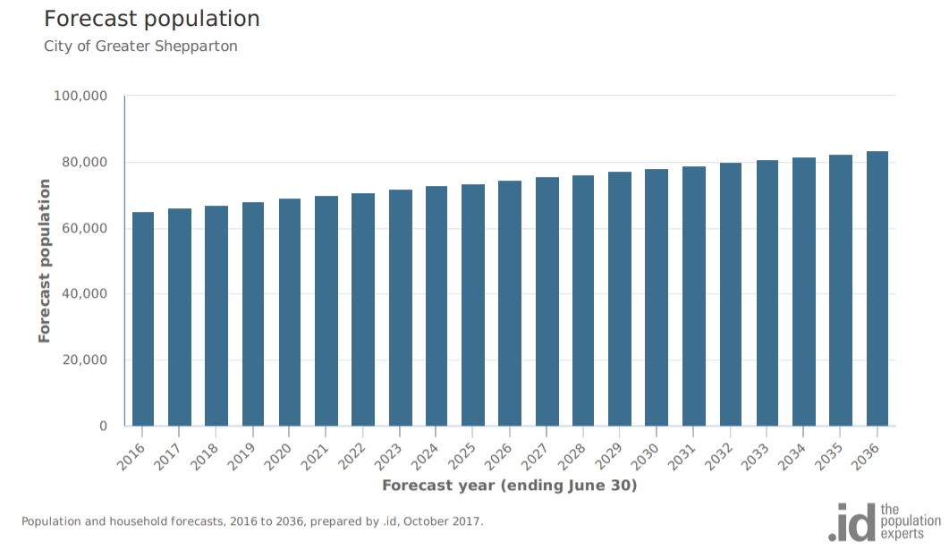
Source: https://forecast.id.com.au/shepparton Accessed 23/4/2020

2. Shepparton population growth rates since 2011
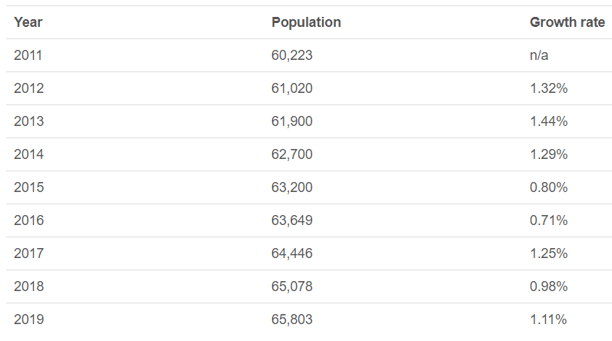
Source: http://www.population.net.au/shepparton-population/ Accessed 23/4/20

3. Victorian population growth rates since 2011
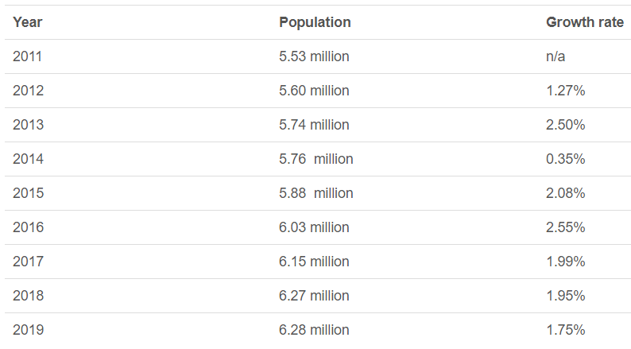
Source: http://www.population.net.au/population-of-victoria/. Accessed 23/4/2020

4. Age structure of Greater Shepparton population
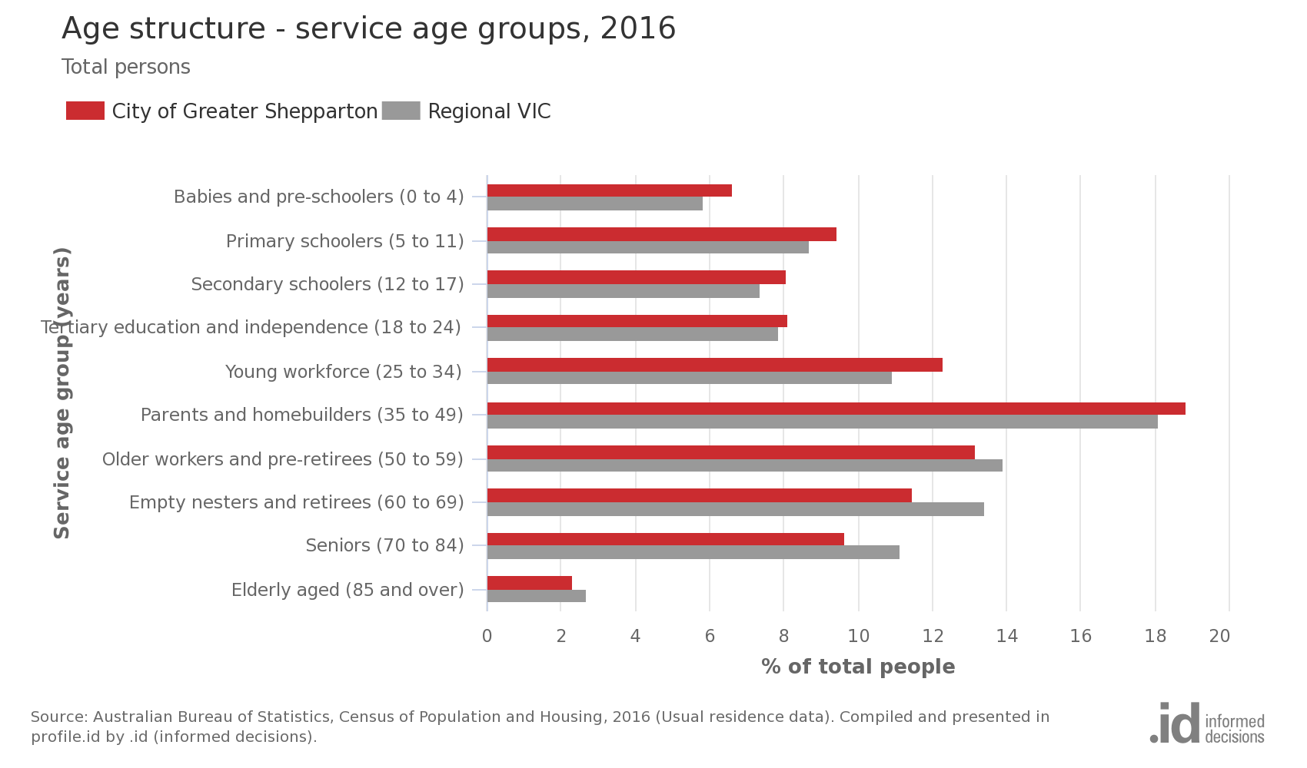
Source: https://profile.id.com.au/shepparton Accessed 19/01/2021

5. Aboriginal and Torres Strait Islander population

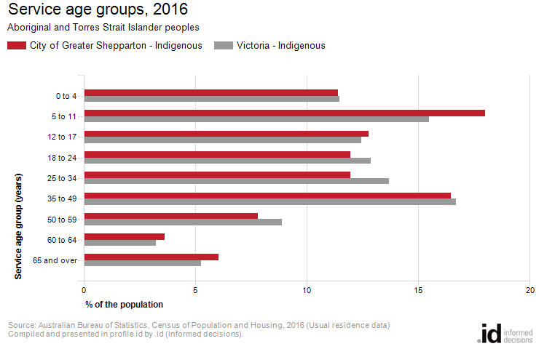

Australian Bureau of Statistics, Census of Population and Housing 2011 and 2016.
Source: https://profile.id.com.au/shepparton Accessed 19/01/2021

6. Birthplace – ranked by size

City of Greater Shepparton - Overseas born (Usual residence) | 2016 |  |  | 2011 |  |  | Change
Birthplace | Number | % | Regional VIC % | Number | % | Regional VIC % | 2011 to 2016
India | 1,202 | 1.9 | 0.6 | 805 | 1.3 | 0.4 | +397
United Kingdom | 1,061 | 1.7 | 3.2 | 1,082 | 1.8 | 3.5 | -21
Italy | 846 | 1.3 | 0.5 | 985 | 1.6 | 0.6 | -139
Afghanistan | 755 | 1.2 | 0.1 | 557 | 0.9 | 0.1 | +198
New Zealand | 715 | 1.1 | 1.0 | 606 | 1.0 | 1.0 | +109
Iraq | 464 | 0.7 | 0.1 | 389 | 0.6 | 0.1 | +75
Philippines | 394 | 0.6 | 0.4 | 227 | 0.4 | 0.3 | +167
Albania | 264 | 0.4 | 0.0 | 328 | 0.5 | 0.0 | -64
Turkey | 247 | 0.4 | 0.1 | 329 | 0.5 | 0.1 | -82
Pakistan | 227 | 0.4 | 0.1 | 63 | 0.1 | 0.0 | +164
Malaysia | 212 | 0.3 | 0.2 | 87 | 0.1 | 0.1 | +125
Netherlands | 202 | 0.3 | 0.5 | 213 | 0.4 | 0.6 | -11
Taiwan | 196 | 0.3 | 0.1 | 26 | 0.0 | 0.0 | +170
Greece | 163 | 0.3 | 0.1 | 164 | 0.3 | 0.1 | -1
China | 160 | 0.3 | 0.3 | 136 | 0.2 | 0.2 | +24
Sri Lanka | 139 | 0.2 | 0.1 | 97 | 0.2 | 0.1 | +42
Samoa | 125 | 0.2 | 0.0 | 53 | 0.1 | 0.0 | +72
Germany | 123 | 0.2 | 0.4 | 125 | 0.2 | 0.5 | -2
South Africa | 120 | 0.2 | 0.2 | 76 | 0.1 | 0.2 | +44
Iran | 120 | 0.2 | 0.1 | 53 | 0.1 | 0.0 | +67
Congo, Democratic Republic of | 111 | 0.2 | 0.0 | 62 | 0.1 | 0.0 | +49
Sudan/South Sudan | 110 | 0.2 | 0.0 | 147 | 0.2 | 0.1 | -37
Kuwait | 92 | 0.1 | 0.0 | 80 | 0.1 | 0.0 | +12
United States of America | 82 | 0.1 | 0.2 | 68 | 0.1 | 0.2 | +14
Ireland | 80 | 0.1 | 0.2 | 71 | 0.1 | 0.2 | +9
Thailand | 79 | 0.1 | 0.1 | 65 | 0.1 | 0.1 | +14
North Macedonia | 76 | 0.1 | 0.1 | 78 | 0.1 | 0.1 | -2
Nigeria | 58 | 0.1 | 0.0 | 35 | 0.1 | 0.0 | +23
Canada | 47 | 0.1 | 0.1 | 38 | 0.1 | 0.1 | +9
Hong Kong | 44 | 0.1 | 0.1 | 18 | 0.0 | 0.0 | +26
Fiji | 42 | 0.1 | 0.1 | 23 | 0.0 | 0.0 | +19
Indonesia | 40 | 0.1 | 0.1 | 16 | 0.0 | 0.1 | +24
Vietnam | 40 | 0.1 | 0.1 | 29 | 0.0 | 0.1 | +11
Serbia / Montenegro (fmr Yugoslavia) | 37 | 0.1 | 0.1 | 50 | 0.1 | 0.1 | -13
Zimbabwe | 37 | 0.1 | 0.0 | 23 | 0.0 | 0.0 | +14
Croatia | 35 | 0.1 | 0.2 | 44 | 0.1 | 0.2 | -9
Bangladesh | 34 | 0.1 | 0.0 | 16 | 0.0 | 0.0 | +18
Spain | 28 | 0.0 | 0.0 | 24 | 0.0 | 0.0 | +4
Saudi Arabia | 28 | 0.0 | 0.0 | 29 | 0.0 | 0.0 | -1
Nepal | 25 | 0.0 | 0.0 | 16 | 0.0 | 0.0 | +9
South Korea | 25 | 0.0 | 0.0 | 14 | 0.0 | 0.0 | +11
Singapore | 24 | 0.0 | 0.0 | 20 | 0.0 | 0.0 | +4
Poland | 24 | 0.0 | 0.1 | 25 | 0.0 | 0.1 | -1
Tonga | 22 | 0.0 | 0.0 | 16 | 0.0 | 0.0 | +6
Egypt | 21 | 0.0 | 0.0 | 31 | 0.1 | 0.0 | -10
France | 20 | 0.0 | 0.1 | 22 | 0.0 | 0.0 | -2
Syria | 20 | 0.0 | 0.0 | 15 | 0.0 | 0.0 | +5
Tanzania | 19 | 0.0 | 0.0 | 26 | 0.0 | 0.0 | -7
Malta | 18 | 0.0 | 0.1 | 22 | 0.0 | 0.1 | -4
Kenya | 17 | 0.0 | 0.0 | 29 | 0.0 | 0.0 | -12
Papua New Guinea | 15 | 0.0 | 0.0 | 13 | 0.0 | 0.0 | +2
Austria | 14 | 0.0 | 0.1 | 18 | 0.0 | 0.1 | -4
Japan | 13 | 0.0 | 0.0 | 5 | 0.0 | 0.0 | +8
Romania | 13 | 0.0 | 0.0 | 10 | 0.0 | 0.0 | +3
Morocco | 13 | 0.0 | 0.0 | 6 | 0.0 | 0.0 | +7
Switzerland | 13 | 0.0 | 0.0 | 11 | 0.0 | 0.0 | +2
Lebanon | 12 | 0.0 | 0.0 | 16 | 0.0 | 0.0 | -4
East Timor | 11 | 0.0 | 0.0 | 8 | 0.0 | 0.0 | +3
Russian Federation | 10 | 0.0 | 0.0 | 6 | 0.0 | 0.0 | +4
United Arab Emirates | 10 | 0.0 | 0.0 | 0 |  | 0.0 | +10

Source: https://profile.id.com.au/shepparton Accessed 19/01/2021

7. Language spoken at home
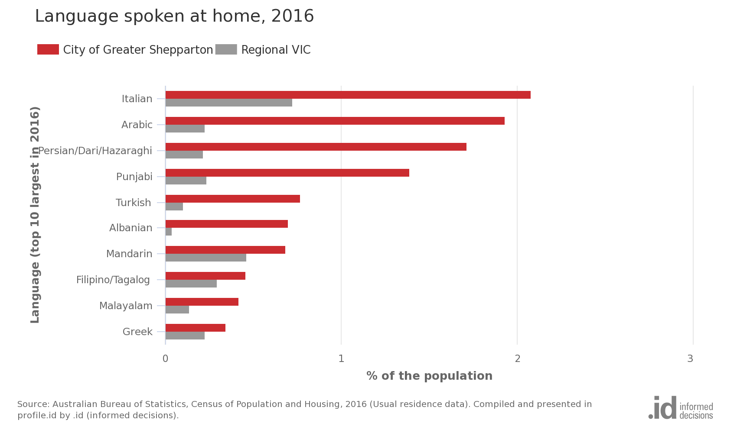
Source: https://profile.id.com.au/shepparton Accessed 19/01/2021

8. Index of relative socio-economic disadvantage

City of Greater Shepparton's small areas and benchmark areas
Area | 2016 index | Percentile
Shepparton Surrounds South | 1,067.5 | 86
Kialla Urban | 1,055.2 | 80
Rural North | 1,034.0 | 67
Rural East | 1,030.5 | 64
Shepparton North East | 1,030.2 | 64
Shepparton Surrounds East | 1,020.8 | 57
Victoria | 1,010.0 | 51
Australia | 1,001.9 | 46
Rural South | 998.7 | 44
Rural North West | 985.6 | 37
Regional VIC | 977.0 | 32
Hume Region | 975.2 | 32
Tatura | 967.6 | 28
Moira Shire Council | 951.0 | 22
City of Greater Shepparton | 948.0 | 21
Shepparton North Central | 938.1 | 18
Shepparton Urban Centre | 931.3 | 16
Shepparton North West | 907.2 | 11
Mooroopna | 896.3 | 9
Shepparton South | 888.6 | 8
Shepparton South East | 845.6 | 5
Shepparton Central | 842.3 | 4

Source: Australian Bureau of Statistics, Census of Population and Housing 2016
Source: https://profile.id.com.au/shepparton Accessed 19/01/2021

REFERENCES:
Alloway, N., and Dalley-Trim, L., 2009, ‘High and dry’ in rural Australia: Obstacles to student aspirations and expectation, Melbourne.
Commonwealth of Australia 2019, Australian Early Development Census, Community Profile for Greater Shepparton 2018, Melbourne.
Education Redesign Lab, Harvard Graduate School of Education, 2018, Building City-Wide Systems of Opportunity for Children, Boston.
Evidence for Learning, 2020, Australasian Research Summary: Aspirations Interventions, Melbourne.
Evidence for Learning, 2020, Guidance Report: Improving Literacy in Lower Primary, Melbourne.
Expert Advisory Panel for Rural and Regional Students, 2019, Recommendations for the Minister for Education on Improving Educational Outcomes for Students in Rural and Regional Victoria, Melbourne.
Gallagher, M.J., 2020, Positive Transitions: Presentation to North East Victoria Region, Ontario.
Greater Shepparton City Council, 2020, Greater Shepparton Best Start Early Years Plan 2020-2025, Shepparton.
Greater Shepparton City Council, 2019, State of Greater Shepparton’s Children Report 2019, Shepparton.
Greater Shepparton Lighthouse Project 2019, Greater Shepparton’s Community Strategy for Children and Young People, GSCC, Shepparton.
Greater Shepparton Lighthouse Project 2018, One Thousand Conversations, GSCC, Shepparton.
Hancok, K.J. et al, 2013, Student Attendance and Educational Outcomes: Every Day Counts, Telethon Institute of Child Health Research, University of Western Australia.
Hattie, J. 2012, Visible Learning for Teachers: Maximising Impact for Learning, Melbourne
McKenzie, F. 2019, What it means to walk alongside: exploring the Our Place partnership, Our Place, Doveton, Victoria.
Ministerial Council on Education, Employment, Training and Youth Affairs 2008, Melbourne Declaration on the Educational Goals for Young Australians, Melbourne.
Reville, P. and Weiss, E., 2019, Broader, Bolder, Better: How Schools and Communities Help Students Overcome the Disadvantages of Poverty, Boston.
The Department of Education and Training, 2018, Every Day Counts: Primary School Attendance, Melbourne.
The Department of Education and Training, 2018, Greater Shepparton Early Learning Profile, Melbourne.
The Department of Education and Training, 2020, FISO Continua of Practice for School Improvement, Melbourne.
The Department of Education and Training, 2016, Marrung Aboriginal Education Plan 2016-2026, Melbourne.
The Department of Education and Training, 2019, Professional Practice Note 16: Excellence in differentiation to increase student engagement and learning outcomes, Melbourne.
The Department of Education and Training, 2020, Student Excellence Program, Melbourne.
The Department of Education and Training, 2020, Supporting a Positive Start to Secondary School in 2021, Melbourne.
The Department of Education and Training, 2020, The Pedagogical Model, Melbourne.
The Department of Education and Training, 2020, The Victorian Teaching and Learning Model, Melbourne.
The Department of Education and Training 2017, Transition: A Positive Start to School Initiative Resource Kit, Melbourne.

EAL stands for English as an Additional Language

