SHEPPARTON EDUCATION PLAN
2021

STAGE TWO – EARLY YEARS

Acknowledgement of Country

The Victorian Government and the Department of Education and Training acknowledge the Yorta Yorta and Bangerang Clans, Traditional Owners of the lands of Shepparton, and pays its respects to their Elders past, present and future.

The Department of Education and Training is committed to honouring Aboriginal and Torres Strait Islander peoples’ unique cultural and spiritual relationships to the land, waters and seas and their rich contribution to society.

EXECUTIVE SUMMARY

For decades, the young children of Greater Shepparton have experienced some of the lowest educational and health and wellbeing outcomes, and the highest levels of social disadvantage in Victoria.
Despite policy reform and unprecedented investment, the steady, downward trend continues.
The Shepparton Education Plan – Stage Two – Early Years proposes a range of outcomes and supporting actions to identify the cause of this downward trend and help reverse the decline.
The Plan reflects the Victorian Government’s investment of more than $5 billion to make Victoria the Education State so everyone can get a great education, no matter their background or where they live.
The Shepparton Education Plan – Stage Two – Early Years is the second of four separate stages that make up the Victorian Government’s Shepparton Education Plan. The Shepparton Education Plan is a long-term plan to transform education in Shepparton to help young people get the best possible start in life. It looks at learning from birth to post-secondary school.
The Shepparton Education Plan – Stage One – Secondary focused on the secondary education component. This saw the creation of the new Greater Shepparton Secondary College, through the merging of Shepparton High School, McGuire College, Mooroopna Secondary College and Wanganui Park Secondary College. Greater Shepparton Secondary College opened its doors at the beginning of 2020, committed to meeting the needs and aspirations of young people across the region. A single-site campus for Greater Shepparton Secondary College is being built and is expected to be finished by late 2021.
The second stage — the Shepparton Education Plan – Stage Two – Early Years — focusses on the educational journey of children from birth to school. It proposes a range of outcomes and supporting actions to ensure local children have access to integrated, effective, and inclusive early childhood education and care services.
The Plan identifies 17 desired outcomes, each with accompanying priority actions. Key themes include:
- strengthened inter-agency collaboration with families to share information of a child’s journey through the early years, and for this data be centrally collected
- examination of the transition process from early childhood education and care settings in Greater Shepparton to provide children the best start possible as they commence school
- ensure all families and children are supported by, and can engage with, the early childhood educational framework of Greater Shepparton.
The table below outlines the opportunities and desired outcomes identified during the development of the Early Years stage of the Shepparton Education Plan.

Table 1: Opportunities and Desired outcomes
Opportunities | Desired outcomes
Collaboration with families | - The Greater Shepparton community has a greater awareness of the role of parents and families as the primary influence on children’s learning and development.  - Parents and families maximise the opportunity for their children to participate in early childhood education and care services in Greater Shepparton.
Pre-engagement: Inclusion and access | - There are a range of early years environments, all of which are inclusive.  - Increased diversity and engagement of children and families participating in early years programs.
Education and learning: Tracking the journey | - Provide high-quality early childhood education and care that meets the needs of all children in Greater Shepparton.  - Streamline the data collection process among early childhood education and care service providers to reduce the repetition and confusion for families engaging with multiple services.
Education and learning: Excellence in service delivery | - Providing excellence in early childhood education and care services in Greater Shepparton is supported.  - Teachers and early childhood educators are supported to improve outcomes for children living in Greater Shepparton.
Preparing our children:  Transition to school | - Children and their families are provided with a consistent, targeted, and flexible transition experience.
Preparing our children for transition:  Play therapy approach | - Equity and access is provided to all children in Greater Shepparton to support their best educational outcomes.  - Early childhood education and care services identify children who would benefit from play therapy early and arrange access.
Alignment of services to support health and wellbeing | - Greater Shepparton children and families are provided with well-connected primary and allied health services during the early years.  - Greater Shepparton children develop the emotional resilience, skills, and capabilities they need to lead active, satisfying, and productive lives.
An Integrated Early Learning Centre (IELC) at Mooroopna | - Provide a wrap-around, integrated approach to early childhood education and care services in safe, inclusive spaces for children, families, and community; using the Integrated Early Learning Centre (IELC) in Mooroopna as a model.
Measures, targets, and performance monitoring | - Improved Australian Early Development Census (AEDC) results for the children of Greater Shepparton.  - Improved participation and attendance rates of Greater Shepparton children in early childhood education and care services.  - Improved school readiness for the children of Greater Shepparton.

In line with the approach for Stage One (Secondary) of the Shepparton Education Plan, a more detailed implementation strategy will follow publication of this document to guide the delivery of Shepparton Education Plan — Stage Two – Early Years.
CONTENTS

EXECUTIVE SUMMARY 3

1 - INTRODUCTION 8
Victoria - the Education State 8
Education plans 8
The Shepparton Education Plan 9
How the Shepparton Education Plan was developed 9

2 - THE CASE FOR CHANGE 11
Importance of the early years 11
Shepparton Education Plan – Stage Two — Early Years 12
Desired Outcomes 13

3 - THE COMMUNITY OF GREATER SHEPPARTON 14
Overview 14
Early childhood education and care services, and partners 16

4 - THE EARLY YEARS POLICY FRAMEWORK 22
Victorian Early Years Learning and Development Framework 22
Early Childhood Reform Plan: Ready for Kinder, Ready for School, Ready for Life (2017) 23
School Readiness Funding 23
Three-Year-Old Kindergarten 24
Marrung Aboriginal Education Plan: 2016-2026 24
Greater Shepparton Local Government Area — Best Start Early Years Plan: 2020-2025 24

5 - COMMUNITY CONSULTATION 26

6 - A GREATER SHEPPARTON RESPONSE – OUR OPPORTUNITIES 29
Pre-Engagement: Collaborating with Families 30
Pre-Engagement: Inclusivity and Access 31
Education and Learning: Tracking the Journey 32
Education and Learning: Excellence in service delivery 34
Preparing our children: Transition to school 35
Preparing our children: Play therapy approach 37
Alignment of services to support health and wellbeing 37
An Integrated Early Learning Centre at Mooroopna 39
Measures, targets and performance monitoring 39

APPENDICES 41

REFERENCES 52

1 INTRODUCTION

Victoria - the Education State
The Victorian Government has invested more than $5 billion to make Victoria the Education State to improve outcomes for every student, in every classroom, in every school, in every community.
The Education State promotes excellence across the curriculum, supports the health and wellbeing of students, and aims to break the link between disadvantage and student outcomes.
The following targets reflect the Education State ambition to improve outcomes for children and young people:
- Learning for life
  - More students achieving excellence in reading, maths, science, critical and creative thinking, and the arts
- Happy, healthy, and resilient kids
  - Building the resilience of our children, and encouraging them to be more physically active
- Breaking the link
  - Ensuring more students stay in school and breaking the link between disadvantage and outcomes for students
- Pride and confidence in our Schools
  - Making sure every community has access to excellence, in every government school and classroom.

Education plans
Education plans are typically delivered in areas where there are complex challenges to improving achievement, wellbeing, and engagement in education for children and young people. Collaboration between community and service providers is needed to transform education outcomes. Apart from Shepparton, education plans are operating, or in development, at:
- Bendigo
- Flemington
- Frankston North
- Footscray Learning Precinct
- Lilydale District and Upper Yarra
- Oakleigh
- Bayswater

Education plans help identify and address the unique challenges and priorities of a local community, and can involve:
- early childhood education and care services
- government and non-government schools
- TAFEs
- universities
- community and cultural organisations
- local businesses and industry
- local government and other government agencies.

The Shepparton Education Plan — background
The Greater Shepparton region, which includes the townships of Shepparton and Mooroopna, faces particularly complex and multi-faceted challenges to realising equity and educational outcomes.
The Shepparton Education Plan presents an ambitious, comprehensive framework to facilitate impactful change. It aims to address the region’s significant challenges and to support its young children to thrive in school and in life, through the transformative power of education.
The Plan seeks to give Greater Shepparton’s young people more options and opportunities, improve the transition through each stage of education, equip teachers with more effective training and resources, and develop contemporary secondary school infrastructure.

How the Shepparton Education Plan was developed
The Shepparton Education Plan was informed by a comprehensive community consultation process. More than 6,500 individual comments were gathered and analysed from the broad community. Ongoing feedback during the developmental phase was achieved through links to 39 community and government organisations.
A strategic advisory group was formed, along with several working parties, to ensure coherence across the Plan’s four stages. The group provided strategic advice to the Department of Education and Training through the North East Victoria Regional Director. In late 2017, the group recommended that the Shepparton Education Plan’s initial focus should be on improving outcomes in the secondary education space, followed by early years settings.
The stages of the Shepparton Education Plan were then formulated as:
Stage 1: Secondary Education
Stage 2: Early Years
Stage 3: Primary Education
Stage 4: Tertiary Education and Skills

The strategic advisory group has since been renamed the Shepparton Education Plan Project Board. It continues to provide strategic advice and oversee the following working parties:
- Early Years
- Priority Cohorts and Partnerships
- Industry Partnerships & Further Education
- Koorie Engagement Group
- Project Control Groups for infrastructure builds

2 THE CASE FOR CHANGE
The gap between children in Greater Shepparton and their Victorian counterparts continues to grow. It is a gap that experts say is almost impossible to claw back by the time a child reaches Year 12. That is, if the child has not disengaged from learning entirely before then.
By the time the children of Greater Shepparton begin school, they are:
- twice as vulnerable in critical development domains than the Victorian average
- double the risk of developing behavioural and emotional problems than their state-wide counterparts
- twice as likely to have experienced stress in their family home, such as parental alcohol or drug problems, child abuse or have witnessed violence, compared to the whole of Victoria.
Nearly 70 per cent of local children spend their early years living in the greatest social disadvantage — triple the state average.
Despite the best efforts of education providers, local government and community service agencies, the educational outcomes of children in Greater Shepparton continue to decline.
The early years landscape is crowded with government departments, supporting agencies and community organisations each working hard to help children in Greater Shepparton. However, more collaboration is needed to join up this effort and close the gap of educational and social disadvantage.

Importance of the early years
We know that more than any other time, early childhood education and care shapes who children will become and what kind of life they will lead.
The State of Victoria’s Children Report (Department of Education and Training, 2016) and the Department’s Early Childhood Reform Plan (2017) describe the early years as the best time to build strong foundations for lifelong health and learning. It is also a critical time for physical development, and a starting point for the creation of strong social, emotional, and learning skills.
The first three years of life particularly, represent a critical period for learning. Children who experience challenging home learning environments during this stage are particularly vulnerable to lower child and adult outcomes. A child’s positive experience during the early years creates a precedent for a life-long, successful learning journey.
Research also underscores the importance of continuity of learning for young children from 0 to 8 years of age as they move between various settings in the early years, including home, early childhood education and care services, and school. Student transition from early years to primary education has also been identified as a key improvement opportunity.

Shepparton Education Plan — Stage Two — Early Years
Across Australia, the conventional age for children described as being in the early years category is birth to eight years. This document — the second in a suite of four as part of the Shepparton Education Plan — refers to the early years age span as birth to school. This acknowledges that there will be significant collaboration and crossover from the Early Years Plan to Stage Three — the Primary Education Plan.
The term ‘early years’ refers to the range of services that a young child may experience before beginning primary school. These can include maternal and child health services, supported playgroups, and early childhood education and care (ECEC) services that include kindergarten, long day care and family day care.
The recommendations developed as part of the Shepparton Education Plan – Stage Two — Early Years recognise the extensive government policy and investment in this space, specifically the implementation of the Early Childhood Reform Plan and School Readiness Funding. These initiatives, including the planned roll out of funded three-year-old Kindergarten in 2022, will greatly benefit the learning, health and wellbeing of the children of Greater Shepparton.

Shepparton Education Plan Early Years Working Party
A Shepparton Education Plan Early Years Working Party was formed in 2017 to collate place-based information regarding early years service provision and priorities for Greater Shepparton. Members are made up of a broad spectrum of representatives from local early childhood education and care settings, service providers, and government.
The Shepparton Education Plan Early Years Working Party aims to:
- improve outcomes for children in Greater Shepparton through engagement in quality early childhood education and care programs
- champion the establishment of best practice integrated models for early years services in Greater Shepparton
- support the establishment of the Mooroopna Integrated Early Learning Centre (IELC).
Specifically, this working party supports the overall Shepparton Education Plan by:
- helping to develop the Shepparton Education Plan Early Years Plan
- monitoring the roll-out of the Shepparton Education Plan Early Years Plan outcomes and actions
- advocating the integrated early learning centre (IELC) model throughout Greater Shepparton
- assisting with the evaluation of the new Mooroopna IELC facility.

Desired Outcomes
The Shepparton Education Plan – Stage Two — Early Years identifies 17 desired outcomes, each with their own accompanying actions, for the Greater Shepparton community.
- The Greater Shepparton community has a greater awareness of the role of parents and families as the primary influence on children’s learning and development.
- Parents and families maximise the opportunity for their children to participate in early childhood education and care services in Greater Shepparton
- A range of early years environments are available in Greater Shepparton, all of which are inclusive.
- Increased diversity and engagement of children and families participating in early years programs.
- Provide high-quality early childhood education and care that meets the needs of all children in Greater Shepparton.
- Streamline the data collection process among early childhood education and care service providers to reduce repetition and confusion for families engaging with multiple services.
- Strong support for excellence in the provision of early childhood education and care services in Greater Shepparton.
- Teachers and early childhood educators are supported to improve outcomes for children living in Greater Shepparton
- Children and their families are provided with a consistent, targeted, and flexible transition experience.
- Equity and access is provided to all children in Greater Shepparton to support their best educational outcomes.
- Early childhood education and care services identify children who would benefit from play therapy early and arrange access
- Greater Shepparton children and families are provided with well-connected primary and allied health services during the early years
- Greater Shepparton children develop the emotional resilience, skills, and capabilities they need to lead active, satisfying, and productive lives
- Provide a wrap-around, integrated approach to early childhood education and care services in safe, inclusive spaces for children, families, and community, using the Integrated Early Learning Centre in Mooroopna as a model
- Improved Australian Early Development Census (AEDC) results for the children of Greater Shepparton
- Improved participation and attendance rates of Greater Shepparton children in early childhood education and care services
- Improved school readiness for the children of Greater Shepparton.

3 THE COMMUNITY OF GREATER SHEPPARTON

Overview
Greater Shepparton City Council (GSCC) is the fifth-largest city in regional Victoria, with a population of just over 66,000 people. Located 180km from Melbourne, Greater Shepparton is a major service centre and transport hub for the Goulburn Valley and Southern Riverina area of New South Wales.
The Greater Shepparton local government area (LGA) covers three main urban centres: Shepparton, Mooroopna and Tatura. Three-quarters of the municipality’s population live in Shepparton and Mooroopna.
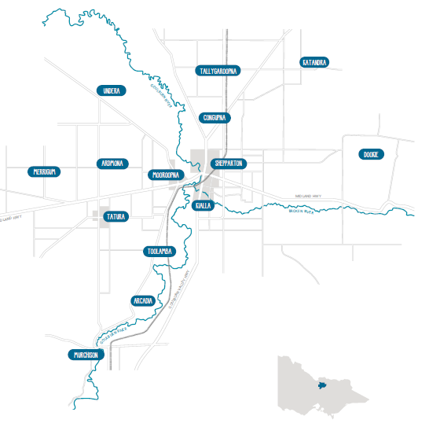
Population growth
According to Profile ID data for the local government area of Greater Shepparton, the forecast population for 2021 is 69,850 people. This is forecast to grow to 83,234 people by 2036. Greater Shepparton is considered a regional centre within Victoria.
Looking back over the past seven years of Greater Shepparton’s population, Population Australia (2019) cites a strong growth rate, ranging from 0.71 per cent to 1.44 per cent, adding around 449 to 880 people each year to the overall population. This compares reasonably with Victoria overall. Over the same time, Victoria posted a population growth rate range of 0.35 per cent to 2.55 per cent.
By 2036, Greater Shepparton is expected to experience a 20 per cent increase in the number of school-aged children, reflecting the Victoria state-wide projection of 19.3 per cent. The expected growth rate in children aged 0-4 and 5-9 is around 7 per cent, consistent with Victoria’s anticipated growth rate.
Map of Greater Shepparton. Courtesy of the State of Greater Shepparton’s Children Report 2019.
These population statistics indicate that Greater Shepparton is a growing regional centre, with an increasing number of young families and school-aged children to call it home in the decades to come.

A culturally and linguistically diverse community
Greater Shepparton is known for being a multicultural community. The 2016 Australian Bureau of Statistics (ABS) Census indicated that 14.9 per cent (9,459 individuals) of the population identified as being born in a country other than Australia. Most of these (11.5 per cent) were born in countries where English is not the first language.

The Koorie community
Outside of Melbourne, Greater Shepparton has Victoria’s largest concentration of people who identify as Aboriginal and Torres Strait Islanders, referred to as Koorie. The figure of nearly 2,200 Koorie people is approximately 3.4 per cent of the Greater Shepparton population, more than twice the regional Victorian average.
However, anecdotal evidence suggests that these figures are under-represented. Greater Shepparton’s Aboriginal and Torres Strait Islander population could be nearly three times this, with a population of nearly 6,000. Approximately 30 per cent of the total Koorie population in Greater Shepparton are under 11 years of age.
The Greater Shepparton community has two defining features – a high number of Koorie people, and multicultural people and communities.

Greater Shepparton outcomes
The Australian Early Development Census (AEDC) is conducted nationwide every three years to measure how young children have developed by the time they start their first year of full-time school. The AEDC looks at groups of children in a community — not individuals.
The latest AEDC in 2018 involved 905 children in the Greater Shepparton area, plus 71 teachers from 41 government and non-government schools. Data is gathered in five key areas of early childhood development (referred to as domains):
- physical health and well-being
- social competence
- emotional maturity
- language and cognitive skills (school-based)
- communication skills and general knowledge.
Results from the 2018 AEDC show a continued decline in how the children of Greater Shepparton are developing before they reach primary school. Children living in Greater Shepparton are starting school lagging behind their peers in metropolitan areas and in other regional centres, across several key developmental areas.

Key AEDC results for Greater Shepparton:
- 19.2 per cent of Greater Shepparton children exit early childhood education and care settings vulnerable in two or more domains — nearly twice the Victorian average of 10.1 per cent
- significant increases from 2015 to 2018 vulnerability data across all five domains
- in terms of data more specific to Mooroopna, 65.7 per cent of children starting at Mooroopna Primary School are developmentally vulnerable in two or more domains. This is anticipated to be reflective of the data for all primary schools in Mooroopna.

AEDC 2018 Data for Greater Shepparton

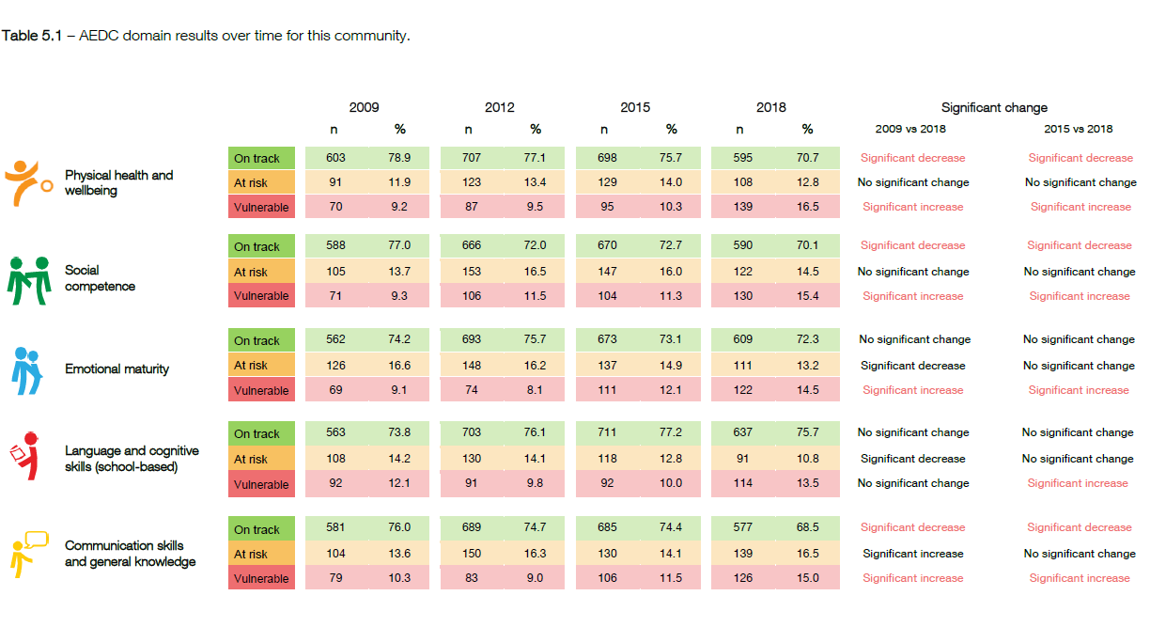

Early childhood EDUCATION AND CARE services and partners
Early childhood education and care services in Greater Shepparton
In 2020, there were 37 early childhood education care and care services in Greater Shepparton receiving State Government year-before-school kindergarten funding. Greater Shepparton City Council operates 15 of these kindergarten services.
According to Socio-Economic Indexes for Areas (SEIFA) data obtained in the 2016 Census, Shepparton local government area (LGA) is the 14th most disadvantaged LGA in Victoria (out of 79 Victorian LGAs).

The most disadvantaged communities are concentrated in pockets in North and South Shepparton, and Mooroopna. These areas are also most at risk of vulnerability, including high concentrations of new arrivals and refugee families, families living in social housing, people known to be experiencing family violence, and those experiencing the impacts of substance abuse and poverty.
Maternal and child health data indicates a promising figure of 100 per cent family engagement with home visits in the first two weeks of a child’s birth. However, this number tapers off to lower than Victorian averages at the four-month period. It reduces further at the 3.5 years Key Age and Stage visits.
Consistent with the rest of Victoria, the eligible population enrolled in four-year-old kindergarten is high. However, anecdotal evidence indicates that actual attendance at kindergarten is relatively low and does not mirror enrolment figures.
- Maternal and Child Health
The maternal and child health program is funded and overseen by the Department of Health and Human Services (DHHS) and provided by local councils across the state. Engagement with maternal and child health nurses can reduce preventable developmental and behavioural issues. Participation also facilitates early diagnosis and treatment of conditions that influence children’s learning such as vision and hearing difficulties, and the ability to work with families proactively in the early stages of a child’s development.
In Greater Shepparton, maternal and child health services are provided by Greater Shepparton City Council.
- Kindergarten
It is widely accepted that children who participate in early childhood education and care services demonstrate greater social competence and higher levels of academic achievement. Participation also helps children and their families prepare for an effective transition into primary education settings.
In Victoria, four-year-old children who are in the year before school can attend 15 hours of kindergarten each week.
The Victorian Government is rolling out funded three-year-old Kindergarten, which will provide all children with access to at least five hours per week by 2022. Program hours will increase to 15 hours per week by 2029. Kindergarten programs will be run in sessional kindergartens and long day care centres. They will be available in certain areas from 2020, and across the state (including Greater Shepparton) from 2022.
- Early Start Kindergarten
Free or low-cost kindergarten is provided to eligible three-year-old children where programs are delivered by a qualified teacher. A child is eligible if they are known to Child Protection, have been referred to ChildFirst, or are Aboriginal and/or Torres Strait Islander.
In Greater Shepparton, Early Start Kindergarten is supported by all government-funded kindergarten services. However, it may be limited by the availability of (overall) funded places at a facility.
- Best Start
Best Start is a Victorian Government-funded localised, place-based prevention and early intervention program. It aims to improve the health, development, learning and wellbeing of all Victorian children from conception through to transition to school (up to eight years old). Greater Shepparton City Council has coordinated the Best Start program in Greater Shepparton since 2003.

Greater Shepparton organisations supporting the early years
Various services in Greater Shepparton have been working collaboratively over several years to support children and families with a localised response. However, increased integration of service provision and new models are required to address the needs of young children and families in Greater Shepparton. Local services include:
- Greater Shepparton Lighthouse
Greater Shepparton Lighthouse arose out of two major community forums held in Greater Shepparton in 2011 and 2012. The forums were held in response to community concern about poor outcomes and persistent disadvantage across the city.
The forums attracted local leaders from business, community, multicultural, Aboriginal, health, education, and philanthropic organisations. All agreed the top priority was the need to improve childhood wellbeing and educational outcomes.
The Greater Shepparton Lighthouse was established in 2014 to activate the whole community to ‘wrap around’ and support the city’s young people to realise their full potential and thrive.
Greater Shepparton Lighthouse has delivered community services in the early years space, and collated valuable information and improvement opportunities using its consultative roundtables model.
- City of Greater Shepparton Communities for Children
The City of Greater Shepparton Communities for Children (CGSCFC) program was established in October 2011, with Catholic Care Sandhurst (formerly Centacare) as the facilitating partner.
This Australian Government initiative aims to improve the health, development and wellbeing of children aged 0-12 years and their families by focusing on prevention and early intervention approaches that bring about positive family functioning, safety, and child development.
As one of 10 trial ‘enhanced’ sites in Australia, Shepparton also focusses on vulnerable and disadvantaged families. Since its inception, CGSCFC has facilitated 16 projects with 14 community partners to deliver a broad range of activities, including health and wellbeing programs, school hubs, playgroups, ante-natal and young parent support.

- Colman Foundation
The Colman Foundation, established in 2005, is a philanthropic organisation that supports the achievement of improved social outcomes by placing education at the heart of a disadvantaged community. The Colman Foundation developed the ‘Our Place’ approach to promote positive education outcomes for children and families in disadvantaged communities.
In November 2017, the Department signed a partnership agreement with the Colman Foundation to establish 10 Our Place sites across Victoria.
The Our Place model creates a shared entrance between the government school and early learning centre and provides facilities where parents and families can access a range of services including early childhood, school, and adult education.
Doveton College is one of the first iterations of the ‘Our Place’ model where the Colman Foundation has established an integrated, place-based, family focused hub as a core part of the school. In five years, the ‘Our Place’ approach has made a significant impact at the school. It has also been used as a best practice and developing model, demonstrating how change can be effected in the early years space.
Findings of the Doveton College model show:
- more children are starting school healthy and ready to succeed at school
- engagement in learning and academic performance is growing year on year
- children and families are participating in the community
- adults are engaging in education and training and getting jobs.

New Integrated Early Learning Centre (IELC) for Mooroopna
Readiness for school has been identified as a challenge but also an opportunity in the Greater Shepparton area.
The Department and the Colman Foundation will partner with Mooroopna Primary School, along with Greater Shepparton City Council (as the early childhood education and care service provider) and other service providers, to embed the Our Place model at a new Integrated Early Learning Centre (IELC) in Mooroopna, which will open in the first half of 2021.
The IELC will offer kinder for three and four-year-olds, long day care services, and maternal and child health care for local families. The IELC will be located at Mooroopna Primary School, with places for approximately 100 children.
The IELC will improve readiness for school and the likelihood of experiencing success — both important elements in reducing the effects of disadvantage. It is envisaged that the IELC at Mooroopna will serve as an effective model that could be reflected in future years across Greater Shepparton.

Verney Road School
Verney Road School is a Victorian Government educational facility in Shepparton. Students have a mild to profound intellectual disability and are funded under the Program for Students with Disabilities (PSD). Many students have multiple diagnoses of disability, including Autism Spectrum Disorder (ASD), Down Syndrome, Attention Deficit Hyperactivity Disorder (ADHD), associated impairments such as sensory, and physical impairments and/or challenging behaviours.
Students ages range from 3 to 18 years. The school has an early education unit and three school-aged sections — early, middle, and senior years. Enrolments in 2020 were 199 students.
There are 20 children participating in the Verney Road School Early Years Program, which requires staff to hold formal primary school teaching qualifications. Not all children who attend the program at Verney Road School have an intellectual disability, with some transitioning to mainstream schools. However, last year 18 children from the early years program remained at Verney Road School to commence primary school. The Verney Road School Early Years Program is currently at capacity.
Verney Road School offers guidance to many mainstream schools with inclusion to support student transition arrangements. The school also provides an early years outreach service that supports mainstream pre-school and in homes.

Lulla’s Children and Family Day Care Centre
Lulla’s Children and Family Day Care Centre provides both long day care and kindergarten programs specifically for 60 Koorie children in Greater Shepparton. The centre aims to reinforce cultural identity while building confidence and self-esteem.
The centre utilises an integrated care model to provide a range of other community, secondary, and tertiary services to work alongside the core universal services operating in the Shepparton area for children. These services include community health services (e.g. speech therapists, occupational therapists), services by mental-health professionals, and parenting services. Parent groups and playgroups also operate on site.

Rumbalara Aboriginal Co-operative
- Cradle-2-Kinder program (Yarka Daya)
Rumbalara's Cradle-2-Kinder program is a whole-of-family service for mothers, fathers, children, and babies. Services include pre-birth support, intensive and long-term interventions, and case-work support until a child reaches four years of age. The Aboriginal Cradle-2-Kinder program provides support for dads and fathers-to-be.
This program helps parents build their confidence and capacity to provide for their baby’s and children's health, safety, and development. It also helps build self-reliance and financial wellbeing by providing access to education, vocational training, and employment services.
The program brings together a strong case-work network to address potential areas of concern and vulnerability. It provides intensive and specialised early-parenting support to strengthen relationships between parents and children, and helps parents meet the health, development, safety, and wellbeing needs of babies, infants, and young children.
- Rumbalara Bush Kindergarten
Rumbalara, in association with the Save the Children Early Learning Centre in Mooroopna, operates a Bush Kindergarten program. Bush Kindergarten is a model of 'unconstructed natural play' that encourages children to take the lead and play in the natural environment around them.

4 THE EARLY YEARS POLICY FRAMEWORK
The Shepparton Education Plan – Stage Two – Early Years takes its policy lead from The Victorian Early Years Learning and Development Framework (2016). However, several other policies and plans influence the provision of early years and support services.
An analysis of early years policy frameworks has identified key themes, challenges, and opportunities. This work has informed the place-based response for Greater Shepparton.
Existing complementary early years plans and projects include:
- Victorian Early Years Learning and Development Framework (2016)
- Early Childhood Reform Plan (2017)
- School Readiness Funding
- Three-Year-Old Kindergarten
- Marrung Aboriginal Education Plan: 2016 – 2026
- Greater Shepparton Best Start Early Years Plan: 2020-2025.

Victorian Early Years Learning and Development Framework
The Victorian Early Years Learning and Development Framework (VEYLDF) adopts a comprehensive approach to children’s learning and development.
The VEYLDF recognises children’s health and wellbeing as crucial enablers for learning and development from birth. The VEYLDF contends that children hold rights and are competent learners with a capacity to learn from birth.
The VEYLDF’s vision and purpose is to guide early childhood professionals in a collective effort with families toward the achievement of the nationally agreed Early Years Learning Outcomes (Early Years Learning Framework for Australia 2009) where children from birth to eight years of age:
- have a strong sense of identity
- are connected with and contribute to their world
- have a strong sense of wellbeing
- are confident and involved learners
- are effective communicators.
The VEYLDF links the agreed learning outcomes from the Early Years Learning Framework for Australia (2009) to the first three levels of the Victorian Curriculum F-10, which supports continuity of learning. The outcomes provide a shared language for all early childhood professionals and families to use when planning for children’s learning and development.
The VEYLDF identifies eight ‘Practice Principles’ for learning and development. These principles describe the most effective way for early childhood professionals to work together with children, families, and other professionals to facilitate learning and development. The principles are based on the pedagogy of the Early Years Learning Framework for Australia and evidence of the best ways to support children’s learning, development, and wellbeing.
The VEYLDF guides early childhood professionals to work together with families to support their children, embracing and responding to the cultural and linguistic diversity of the Victorian community and diverse approaches to child rearing.
In particular, the VEYLDF recognises and respects Aboriginal cultures and their unique place in the heritage and future of Victoria.

Early Childhood Reform Plan: Ready for Kinder, Ready for School, Ready for Life (2017)
The Early Childhood Reform Plan (2017) outlines the Victorian Government’s vision for early childhood and the reforms planned to create a higher quality, more equitable and inclusive early childhood system. The Plan aims to lift outcomes for all children, particularly for children and families who need extra support. Other key elements include:
- investment of $202.1 million directed towards increasing the quality and accessibility of kindergarten programs
- help for parents with the challenge of parenting and access to the expertise of the maternal and child health workforce
- increased funding for kindergartens (via School Readiness Funding) to deliver high-quality early learning programs, reducing disadvantage, and making the system more inclusive and accessible
- support for Koorie families, and for families who make the transition to the National Disability Insurance Scheme.

School Readiness Funding
The Victorian Government’s Early Childhood Reform Plan (2017) has delivered a fundamental shift in the way kindergartens receive funding to provide support programs and services to their children. School Readiness Funding is a key initiative in the Early Childhood Reform Plan (2017).
School Readiness Funding is driven by data and services, and supports are allocated based on information gathered on a local level. This requires kindergartens to annually select specialist services such as:
- speech, language, or literacy
- additional educators, coaching and backfill to support professional learning
- allied health services
- trauma support, secure attachment and mental health, social and emotional wellbeing
- support for cultural and linguistically diverse children and families
- parenting support
- access and inclusion programs to support children to participate and thrive in kindergarten
- most funding must be used to support outcomes for children in priority areas based on the VEYLDF, and each service has the capacity to select specialist services based on their cohort of students. The three priority areas are:-
  - communication (language development)
  - wellbeing (social and emotional)
  - access and inclusion.

Three-Year-Old Kindergarten
Another pillar of the Victorian Government’s reform of the early years landscape is the introduction of funded kindergarten programs for all three-year-old children by 2022.
Implementation will be staged, with six Victorian councils, including Strathbogie Shire (located in Goulburn Area), among the first six municipalities to deliver three-year-old Kindergarten in 2020, with an additional 15 LGAs in 2021. All children will have access to at least five hours per week of funded three-year-old Kindergarten by 2022, with the hours of programming to increase to 15 hours per week for all children by 2029. This includes the Greater Shepparton local government area.
Every new Victorian primary school set to open from 2021 will have a kindergarten on-site or next door.

Marrung Aboriginal Education Plan: 2016-2026
The Marrung Aboriginal Education Plan 2016-2026 sets out a ten year vision for an education system that views Koorie culture as an asset and supports Koorie learners to be confident in their culture and identity.
Marrung’s early years focus seeks to build on the VEYLDF by developing an understanding of Koorie culture and history among teachers and other practitioners. The Plan aims to promote equity, diversity, and high expectations for all children, including Koorie children and families.
It also aims to further support Koorie parents as the first educators of their children by providing improved connection with early years services. A dedicated literacy and numeracy program during primary school, also part of the Marrung Aboriginal Education Plan, is offered to Koorie students who are not yet meeting Year 3 reading and numeracy benchmarks by Years 4 and 5.

Greater Shepparton Local Government Area — Best Start Early Years Plan: 2020-2025
Greater Shepparton City Council plays a critical role in the investment and delivery of services and recreational opportunities across the municipality, including:
- early years services, such as maternal and child health, playgroups, kindergartens, and childcare
- facilities, activities and programs for children, such as playgrounds, walking and bike tracks, Children’s Week, and activities in the park
- coordinating the planning and service development of the Best Start Program and the Best Start Early Years Plan.
The Greater Shepparton Best Start Program was introduced in 2003 as one of the five inaugural Best Start sites across Victoria. Best Start aims to improve the health, development, learning and wellbeing of all Victorian children aged 0-8 years of age. The program focusses on prevention and early intervention and a strengthening of universal early years services to boost their ability to respond to the diverse needs of local children and families.
The Best Start plan is developed in consultation with key stakeholders and community members who identify priority areas of focus for the plan, with revision every five years. The latest Best Start Plan includes an Early Years Action Plan to achieve outcomes set out under ‘Play, Learn, Thrive, Voice and Share’.
While Best Start has made progress since 2003, more work is needed to develop all early years services to realise the vision of providing ‘wrap-around’ support and resources for vulnerable children and their families.
The Best Start Early Years Plan 2020-2025 will be underpinned by an action plan. The Plan will be developed in consultation with the community and key stakeholders to determine the best ways to achieve its outcomes. It will be a living document to allow the partnership and workgroups to respond to current and emerging needs.

5 COMMUNITY CONSULTATION
The Shepparton Education Plan team collated the qualitative findings of two key community consultation activities in relation to the Plan’s Early Years stage. The Victorian School Building Authority (VSBA) facilitated a broad round of consultation during August and September 2018, focussing on Early Years and Primary education stages, while Greater Shepparton Lighthouse Foundation identified themes of community need during its consultation activities in 2018 through to 2020.
The VSBA canvassed the Greater Shepparton community on its vision of education from kindergarten to primary school, including how children are supported as they transition into and out of primary school. Consultation took place in a range of settings and contexts, including briefings, workshops, community and school-based meetings, school BBQs, surveys, and an online discussion board.
Promotion of the consultation involved newspaper advertising, social media, distribution of information packs and postcards to the Council, early learning centres, schools, and a range of community organisations, such as libraries, sporting facilities and community centres. The Greater Shepparton City Council and local schools supported this promotional effort via their own social media channels, emails, and newsletter updates.
The consultation process connected with 17,738 people through various social media platforms. There were also 225 face-to-face conversations, and 34 comments collected via the online discussion board. Up to 117 online survey responses were collected, and 665 visits were made to an online engagement portal.

Community consultation findings
Feedback about education and outcomes in Shepparton covered a broad range of complex educational and social issues. Overall, respondents indicated there was a need to change the current approach to education in Shepparton. People who participated in the consultation process felt that students, families, teachers, principals, community service providers and the Victorian Government needed to come together to make changes and improve opportunities for people in Shepparton.
Clearly, the Shepparton community wanted its young people to aim higher and pursue success in their chosen pathways. They expressed clear ideas about the kind of support needed to help every student reach their full potential.
Once all feedback was received and collated, clear beliefs and opportunities for action emerged:
- Create a solid foundation for future success
The Greater Shepparton community believes kindergarten helps children develop social and emotional skills that will help them succeed in school. Feedback confirmed that kindergarten provides structure and routine for children and develops their independence. However, it was identified that more support is needed for working parents to manage the logistical challenge of kindergarten hours. Providing after-care on short kinder days was suggested in the feedback to support working families.
- Understanding play-based education
Some parents indicated that they were concerned about the balance between play and more formal learning activities in early childhood education and care settings. Communicating the value of early childhood education, particularly the role of play-based learning, presents as an opportunity. Working with parents as their child’s first educators to enhance their understanding of play-based education is key.
- Prepare children and students for transition and help everyone through the change
Some participants felt students and parents could be better prepared for the transition from kindergarten to primary school, and from primary to secondary school. Children starting Foundation too early were not ready for the academic and social challenge of school. Participants suggested providing more information to parents as early as possible would help address this.
- Provide access to services and programs that support children, students, and parents
Feedback from Shepparton and Mooroopna communities indicated a desire for more services and support options for students and parents. They were particularly keen for health services in the early years service and school environment to provide access to wellbeing programs, a school nurse and maternal child and health programs.
Services that provide mental health support, such as counsellors, emerged as a priority for the Greater Shepparton community. The capacity to offer therapeutic programs (including play therapy) for children with trauma backgrounds within early childhood education and care settings was also considered valuable.

Greater Shepparton Lighthouse Project insights
The themes reported through the Greater Shepparton Lighthouse Project community consultation process generally align with those outlined above. However, they were obtained using a different model of consultation, which the Greater Shepparton Lighthouse Project refers to as ‘deep listening’.
Greater Shepparton Lighthouse Project identified community concerns around loneliness, isolation, and marginalisation. These concerns, coupled with the themes identified by the VSBA, offer an insight into some of the reasons underpinning the decline in outcomes for Greater Shepparton children.
The priority areas identified by the Greater Shepparton Lighthouse Project are therefore less system oriented and more individual/community based. These include initiatives for local children to:
- have their health, developmental and wellbeing (social, emotional, physical, and cognitive) needs met
- feel safe, loved, and valued
- are educated so they can reach their potential
- be equipped with the resilience and skills needed to navigate successfully through life
- be connected to trusted adults, community, culture, and opportunities
- be part of a cohesive, supportive, and functioning family or family-like situation
- be part of a family with access to adequate and reliable income
- be supported to transition successfully to work or further study.
The findings from both community consultation activities are, for the most part, consistent with policies and the range of data examined to develop this Plan. However, one difference relates to kindergarten attendance in Greater Shepparton.
As noted above, the Greater Shepparton community believes in early childhood education, and enrolment data indicates nearly all local students are enrolled. However, attendance figures captured by some kindergartens during the development of this Plan indicate that attendance figures are lower than enrolment figures.
Early years professionals advised that this could be attributed to two factors:
- the value of early childhood education is not always recognised by some communities, particularly in the multicultural community
- families face barriers, such as such as transportation, cost, or challenges involved with managing family, which make it difficult to engage with a kindergarten, and/or for their child to regularly attend.

6 A GREATER SHEPPARTON RESPONSE – OUR OPPORTUNITIES
Making a difference for Greater Shepparton
The Shepparton Education Plan aims to be transformational for the children and families of the Greater Shepparton region. All working parties involved have been challenged to consider ‘what would make a difference’ for Greater Shepparton.
The Plan’s overall vision, developed in 2017, is a cornerstone of its planning and activities, and serves as a reminder of our ‘why’.
“The Shepparton Education Plan will ensure all children and young people have a positive future and families, schools and our community will help them get there through learning and caring”.
The Shepparton Education Plan – Stage Two: Early Years plan must seek to do things differently or run the risk of watching the current decline in early childhood and education outcomes continue.
While this Plan has referred specifically to Greater Shepparton, about 40 pieces of local, state, national and international items of policy, research and reports were also examined and correlated within the Shepparton community context.
In developing the Plan, the Shepparton Education Plan Early Years Working Party analysed and structured recommendations around three broad stages of a child’s experience during their early years.
These three stages are:
- pre-engagement in early years services
- education and learning
- transition to primary school.
It is important to note that recommendations outlined in this Plan do not seek to replace or duplicate existing early childhood education and care policy, either planned or under implementation. Rather, these recommendations seek to complement this body of work and collectively serve to support the young children in Greater Shepparton achieve similar outcomes to their counterparts across the state and nationally.
Desired outcomes (the aim) and priority actions for the Shepparton Education Plan – Stage Two - Early Years plan have been summarised under each stage of a child’s continuum — from pre-engagement in early years services through to primary school transition. Each of these actions is then outlined in further detail.

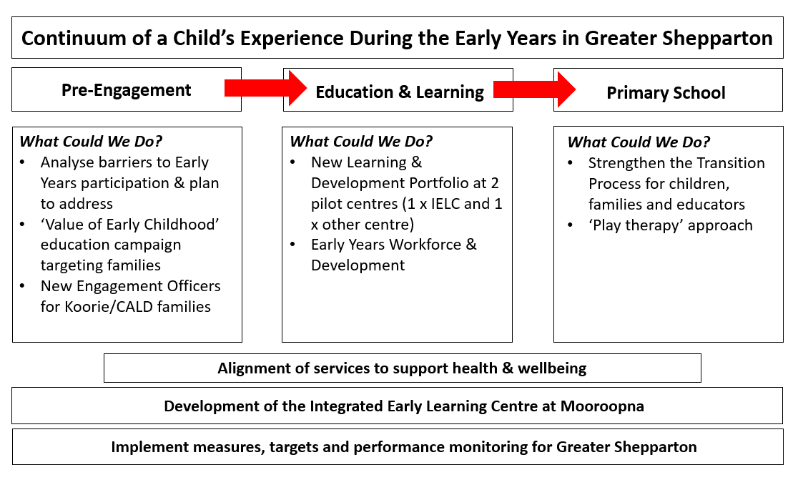

Pre-Engagement: Collaborating with Families
Background
Quality early childhood education and care is best considered as an investment, not a cost. Investment in early childhood education and care provides a strong return, with studies consistently indicating benefits of two to four times the costs (Lifting Our Game, 2017).
However, parents can find navigating early childhood education and services complex. According to Lifting Our Game, a Report of the Review to Achieve Educational Excellence in Australian Schools through Early Childhood Interventions (Pascoe & Brennan, 2017), some common barriers to families connecting with education and services during the early years can include:
- Cost
Parents’ preferences and understandings about the benefits of early education and child development, service operating hours and location, limited transport options to and from services, services not meeting needs or being inclusive, lack of awareness of available services and administrative complexity.
- Cultural issues
Lower participation of Indigenous families in early learning programs may also relate to cultural issues, fear of racism or being negatively judged, distrust of government and early childhood services, along with staffing issues such as recruiting and retaining Indigenous staff.

- Complexity
Poor alignment between objectives of different levels of government, inconsistencies in relation to service eligibility and subsidies, and the complexity that parents face in navigating their way through a mixed market sector with multiple funders and settings.
In Shepparton
Any place-based response for Greater Shepparton needs to recognise the city’s cultural diversity and levels of social disadvantage experienced by families. The ability to effectively communicate the value of early childhood education to parents and carers in a range of ways, not just in written communication, is key.
Desired Outcomes
- The Greater Shepparton community has a greater awareness of the role of parents and families as the primary influence on children’s learning and development.
- Parents and families maximise the opportunity for their children to participate in early childhood education and care services in Greater Shepparton.
Actions
- Analyse the barriers that limit families participating in early childhood education and care services and programs.

- Undertake a targeted engagement campaign to improve community understanding of the important role families play as a child's first educator, and the value of participating in early childhood education and care programs.

As part of the campaign, cultural engagement officers would be appointed to liaise directly with Koorie and CALD families in their homes and communities. These cultural engagement officers would provide feedback on any family or cultural needs for inclusion in a new, digital Learning and Development Portfolio, which would be created for each child participating in early childhood education and care programs.

Pre-Engagement: Inclusivity and Access
Background
Victoria has a strong track record in developing and implementing policy initiatives that seek to address disadvantage and provide inclusive, accessible education opportunities.
Equity and diversity underpin the VEYLDF, while the Department of Education and Training’s Early Childhood Reform Plan (2017) has boosted funding for Early Start Kindergarten.
Further, the Department’s Kindergarten Inclusion Support program similarly provides opportunity for children with disabilities, high support needs and/or complex medical needs to be engaged and participate in all aspects of kindergarten life on the same basis as their peers.
The Marrung Aboriginal Education Plan 2016-2026 aims to improve access to, and participation in, early childhood services including maternal and child health, supported playgroups and kindergarten programs. Marrung recommends further supporting Koorie parents as first educators of their children by strengthening the suite of supports available to Koorie families. Koorie Engagement Support Officers and Preschool Field Officers provide additional support.
Evidence shows progressively expanding universal access to 600 hours per year of a quality early childhood education program for three year olds, with priority given to disadvantaged families, is the single most impactful reform Australia could undertake. International comparisons highlight it as the biggest gap in the current system at the time the report was published (Lifting Our Game, 2017). The Victorian Government’s Early Years Reform Plan, through the roll out of three-year-old kindergarten, is delivering on this recommendation.
Desired Outcomes
- A range of early years environments are available in Greater Shepparton, all of which are inclusive.
- Increased diversity and engagement of children and families participating in early years programs.
Actions
- Review the impact on early years participation in programs, such as Early Start Kindergarten, Kindergarten Inclusion Support, and the allocation of pre-purchased kindergarten places.

- Develop a multi-agency review of infrastructure capacity impacts in Greater Shepparton in response to any increase in attendance volumes brought by the Early Start Kindergarten program and/or the potential, broader funding of three-year-old kindergarten.

Education and Learning: Tracking the Journey
Background
The foundations for a child’s long-term development are laid in early childhood. We know that quality early childhood education and care programs can help children. Early childhood learning is particularly important for children who start from a position of disadvantage. If children start behind their peers, they often stay behind. Once the gap opens, it is very difficult to close. Children vulnerable on even one AEDC domain are half as likely to achieve in the top two NAPLAN reading bands in Year 3, and even less likely in Year 5.
Student absence and retention rates are major barriers to successful education and represent underlying issues such as low student aspiration, engagement in learning and pride in their school, all of which were identified as concerns during consultation with community.

In Shepparton
Enrolments in kindergarten and other childcare settings in Greater Shepparton are relatively strong when compared with the state average. Both government and non-government providers collect attendance data in various formats, however this data is not centrally captured.
Data obtained from three early childhood education and care services in Greater Shepparton in 2019 and 2020 reveal similar patterns of low attendance after initial enrolment, particularly by families experiencing higher levels of social disadvantage.
Early childhood education and care services also advise that families often engage with a range of health and wellbeing support agencies and early years programs before their child begins school. Each entity may collect similar family information, albeit in different contexts for different purposes. Once again, there is no central repository of this information in Victoria. This silo approach to information collection risks important details not being shared with other support agencies and organisations engaged with families and can result in unnecessary distress for families in needing to ‘re-tell their stories’.
Desired Outcomes
- Provide high-quality early childhood education and care that meets the needs of all children in Greater Shepparton.
- Streamline the data collection process among early childhood education and care providers, to reduce repetition and confusion for families engaging with multiple services.
Actions
- Create digital Learning and Development Portfolios for children in Greater Shepparton to be trialled at the IELC Mooroopna and one other centre.
Portfolios could:
  - capture a comprehensive picture of a child's early years experience, providing a key tool to enhance learning and development, mitigate academic, developmental, and social vulnerability, and improve transition to school
  - be a multi-disciplinary repository of information collected by educators, health practitioners and support service providers
  - be portable, 'following' children along their learning and development pathways as they access a range of early childhood services
  - be developed in collaboration with families
  - include Individual Learning Plans for all children — a practice currently used by programs such as Out of Home Care
  - must ensure privacy in the treatment of health information
  - record attendance data
Ideally, the Learning and Development portfolios would be built as an extension of existing data management platforms. They could reflect those used for maternal and child health data, or the Insight Assessment Platform utilised by the Victorian Curriculum and Assessment Authority (VCAA), which currently hosts the Transition Learning and Development Statements. The Learning and Development portfolio should include the child’s Transition Learning and Development Statements to strengthen school transition.
- Develop and implement attendance tracking processes for early childhood education and care services in Greater Shepparton.
Tracking attendance at early childhood education and care services is a key step to developing an understanding of a child’s stage of development, their engagement in education, and support service needs.

Education and Learning: Excellence in service delivery
Background
High quality early childhood education and care services make a difference. They benefit a child’s wellbeing and learning and continues into adulthood. According to The State of Victoria’s Children Report (Department of Education and Training, 2016), early childhood education and care services with lower child-to-staff ratios, better qualified staff, high quality learning environments and relationships between educators and children, have a greater positive impact on children’s cognitive development.
A strong community of practice among professionals involved in the provision of early childhood education and care plays a key role in service delivery. Communities of practice can provide support, build capacity, and reduce duplication.
Several years ago, a localised alliance was developed in Greater Shepparton to bring together a range of early years professionals, including maternal and child health personnel, early childhood educators, allied health practitioners, school nurses, Foundation to Year 2 primary teachers and Koorie Educational Support Officers (KESOs).
Forums were held covering professional learning topics such as child assessment practices from maternal child health services through to Year 1, implementing the VEYLDF, and working collaboratively in targeted communities with a high level of disadvantage to improve outcomes for children in those localities.
Feedback from the forums was very positive and led to a targeted project in Mooroopna that saw early childhood teachers and Foundation teachers work in partnership by attending each other’s service and observing play-based and curriculum-based teaching practices.
Desired Outcomes
- Strong support for excellence in the provision of early childhood education and care services in Greater Shepparton.
- Teachers and early childhood educators are supported to improve outcomes for children living in Greater Shepparton.
Actions
- Develop a workforce strategy that reflects the specific place-based needs of the early childhood workforce in Shepparton. This could consider:
- service leadership capability
- development of a strategic workforce attraction strategy, particularly recognising the additional workforce needed to implement three-year-old Kindergarten
- connections and links with other local education providers including schools
- ongoing professional development, including support for the delivery of three-year-old Kindergarten workforce diversity and engagement with parents.
- Nominate practitioner 'champions’ among Greater Shepparton early childhood education and care services to act as ambassadors for the workforce strategy.
- Re-establish a localised alliance network incorporating early childhood educators, Foundation to Year 2 primary teachers, primary school nurses, maternal and child health personnel and Koorie Educational Support Officers (KESOs) to provide a community of practice focussed on strengthening the transition to school process.
- Strengthen practitioner understanding of the impacts of trauma and mental health on a child's learning.
- Investigate the need for dedicated professional development for early childhood educators in child safety.

Preparing our children: transition to school
Background
The process of transition occurs for children every day. As highlighted in the Victorian Early Years Learning and Development Framework (VEYLDF), a child may move from parental care to a grandparent or move into an early childhood education and care service, and between the rooms within individual services. As children become older, they may transition into a kindergarten program and then to school.
Successful transitions require professionals to actively foster responsive relationships with each child and their families, as well as with each other. They must recognise the importance of continuity and consistency while acknowledging change.
In 2009, the Department of Education and Training released the Transition: A Positive Start to School initiative. The initiative aimed to improve the experiences of children and families starting school by enhancing the development and delivery of transition programs. It was accompanied by a transition kit (updated in 2017) and introduced Transition Learning and Development Statements. A child's Transition Learning and Development Statement (TLDS) summarises their abilities as they start school and identifies their individual approaches to learning. It is passed on to the child's future school.
In 2015, The Victorian Auditor General published a report on education transitions. In the same year, the Department of Education and Training commissioned a series of consultations on transition to school across Victoria. The consultation obtained qualitative feedback from key stakeholders to further strengthen understanding of current transition approaches, including Transition Learning and Development Statements, and supporting resources.
The consultation identified opportunities for improvement, including the need for:
- additional resources to support children from diverse backgrounds and those experiencing disadvantage
- strengthening communication between early childhood educators and school teachers, including through local transition networks
- improvements to the Transition Learning and Development Statements
- better evaluation of local transition approaches and outcomes.
In Greater Shepparton, the transition from kindergarten to primary school is a varied process, functioning without the use of universal timelines and generic application forms such as those used during the transition from Year 6 to Year 7. Some schools host ‘open days’ and information sessions for prospective/new parents and carers to ask questions. Other schools encourage applications to be submitted by a certain date. However, this is not a formalised arrangement across Greater Shepparton.
Most Greater Shepparton kindergartens and community based childcare services participate in ‘speed-dating’ afternoons/evenings to hand over the Transition Learning and Development Statements to Foundation teachers. This is used as an opportunity to discuss children with more complex needs.
Desired Outcome
- Children and their families are provided with a consistent, targeted, and flexible transition experience.
Actions
- Evaluate and strengthen the transition process from kindergarten to primary school for children in Greater Shepparton, which would examine:
  - maximising the use of Transition Learning and Development Statements
  - the impact/integration of existing programs provided by government and non-government entities, including Koorie families and those engaged with the NDIS
  - processes to identify the need for additional transition activities for children and families, and the role of practitioners
  - utilisation of Learning and Development Portfolios.

Preparing our children: play therapy approach
Background
Play is a natural way for children to learn. Play therapy can allow children to use play to work through trauma-based issues. When implemented by skilled practitioners, it enables an age appropriate and non-threatening diagnosis and intervention. The Australian Early Development Census (AEDC) data for Greater Shepparton is cause for concern in terms of the vulnerability of local children:
The 2019 Greater Shepparton School Entrant Health Questionnaire findings show:
- 11.2 per cent start school at risk of developing behavioural and emotional problems, while the state average is 6.7 per cent
- by the time children start school at Foundation level, they are twice as likely to have experienced stress in their family home, such as parental alcohol or drug problems, child abuse or witnessed violence compared to whole of Victoria
- 60.7 per cent of children spend their early years living in an area with the greatest social disadvantage — triple the state average.
Desired Outcomes
- Equity and access is provided to all children in Greater Shepparton to support their best educational outcomes.
- Early childhood education and care services identify children who would benefit from play therapy early and arrange access.
Actions:
- Explore opportunity for a play therapy model to be implemented equitably across Greater Shepparton.

Alignment of services to support health and wellbeing
Background
A child’s wellbeing from birth is a prerequisite for future success in learning. Access to high-quality education provides significant short-term and lifelong benefits in terms of academic outcomes, resilience, creativity, health and wellbeing, and economic participation. However, parents can find navigating early childhood education and care services complex. This is especially the case for children and families with additional support needs.
The Department has invested $55.3 million via School Readiness Funding to lift the outcomes for children, particularly those experiencing educational disadvantage. The funding will ensure services will have increased access to a range of high quality, evidence-informed programs and supports. While the signs are good in terms of the impact of School Readiness Funding, data on improved child outcomes will not be available for some time. School Readiness Funding commenced in the Greater Shepparton local government area in 2020.
Identifying a child’s needs to support their health and wellbeing, and the capacity of the service system in Greater Shepparton to respond, is also important. Families will be more likely to connect with support services if they are familiar with them. This is preferred over families being surprised when their child starts school and is then identified as requiring urgent support to enable them to learn.
The Marrung Aboriginal Education Plan 2016-2026 states that more than 25 per cent of young Koorie children have a health or development concern, and more than 20 per cent have two or more concerns. This is compared with a state-wide figure of 14.7 per cent. Marrung states that more Koorie families need to participate in early years services, including maternal and child health, supported playgroups, and kindergarten. It recommends collaboration with Koorie communities to co-design culturally responsive programs as a way of achieving greater participation in early years programs.
Desired Outcomes
- Greater Shepparton children and families are provided with well-connected primary and allied health services during the early years.
- Greater Shepparton children develop the emotional resilience, skills, and capabilities they need to lead active, satisfying, and productive lives.
Actions
- Supply/transfer information collected during the provision of services to a child's Learning and Development Portfolio.
- Investigate feasibility of providing community mentors/role models for children and families, particularly for Koorie and CALD communities to support their access to primary and allied health services.
- Analyse local initiatives that support the health and wellbeing of children aged 0-8 years in Greater Shepparton.
- Explore the opportunity for developing new initiatives that may be needed to strengthen existing local programs focussing on wellbeing of children. Any new initiative must:
- be evidence based to fill any service gaps — new research may be required for benchmarking purposes
- align with or complement School Readiness Funding and the change it brings to support services in kindergartens
- be developed in collaboration with government agencies, community groups and like-minded networks
- deepen early years practitioners understanding of how to support children and their families
- consider the cultural needs and diversity of children in Greater Shepparton.

An Integrated Early Learning Centre at Mooroopna
Background
Research shows well-connected services that collaborate to deliver programs across systems and sectors significantly improve learning and development outcomes for children.
Equally important is the relationship service providers have with a community to ensure they fully understand the needs of children and how their development during the early years can be most effectively supported.
An integrated early learning centre (IELC) in Mooroopna will aim to bring together a range of professional services that will meet education, care, health, and support needs of families with children undertaking the first steps of their learning and development journey.
The IELC will improve outcomes for children and increase their likelihood of experiencing success — both important elements in reducing the effects of disadvantage. The centre will reflect the Education State targets of Learning for Life, Happy, Healthy and Resilient kids, and Breaking the Link.
The Colman Foundation, in partnership with the Department of Education and Training, will bring its Our Place – Integrated Learning Communities’ model to the IELC at Mooroopna. The arrangement is underpinned by a collaborative approach to service delivery that relies on data and evidence to inform decision-making and ensure high-quality, effective service delivery. Construction is well underway, with the centre expected to open in the first half of 2021.
Desired Outcome
- Provide a wrap-around, integrated approach to early childhood education and care services in safe, inclusive spaces for children, families, and community, using the Integrated Early Learning Centre in Mooroopna as a model.
Actions
- Evaluation of the Mooroopna Integrated Early Learning Centre model post-implementation to inform future work.
- Develop a data and information strategy with relevant early years agencies. Collected data would be added to a child’s Learning and Development Portfolio to help track their early years journey to school.

Measures, targets and performance monitoring
Background
Targets and measures need to be set to monitor performance in the areas identified for improvement to reduce academic, developmental, and social vulnerability, and enhance school readiness. The development of appropriate measures and targets for Greater Shepparton is also considered important to:
- improve data to support decision-making
- enhance collaboration between early childhood education and care services
- track kindergarten enrolment and attendance, with the ability to respond appropriately at a centre or system level
- track longitudinal data regarding Greater Shepparton children
- establish agreed processes for performance monitoring across the 37 early years services in Greater Shepparton.
Desired Outcomes
- Improved Australian Early Development Census (AEDC) results for the children of Greater Shepparton.
- Improved participation and attendance rates of Greater Shepparton children in early childhood education.
- Improved school readiness for the children of Greater Shepparton.
Action:
- Implement a project to establish measures, targets and performance monitoring for Greater Shepparton and seek agreement from the early childhood education and care sector.

APPENDICES

APPENDIX A: GREATER SHEPPARTON POPULATION DATA

1. Forecast Population for Greater Shepparton
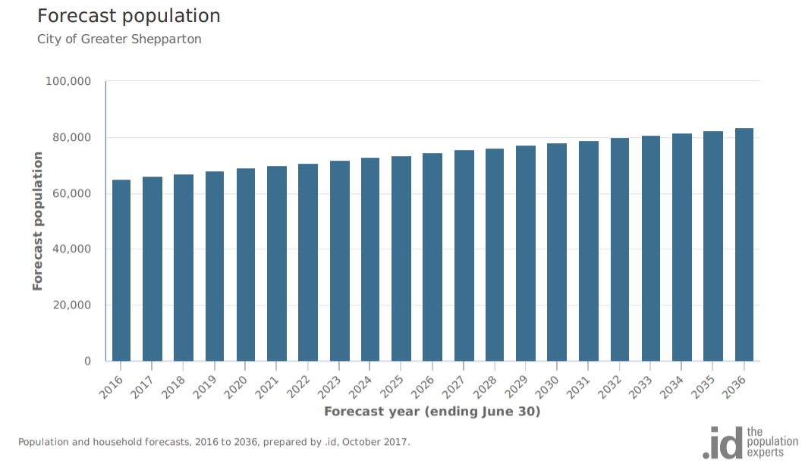
Source: https://forecast.id.com.au/shepparton Accessed 19/01/2021

2. Shepparton Population Growth Rates since 2011
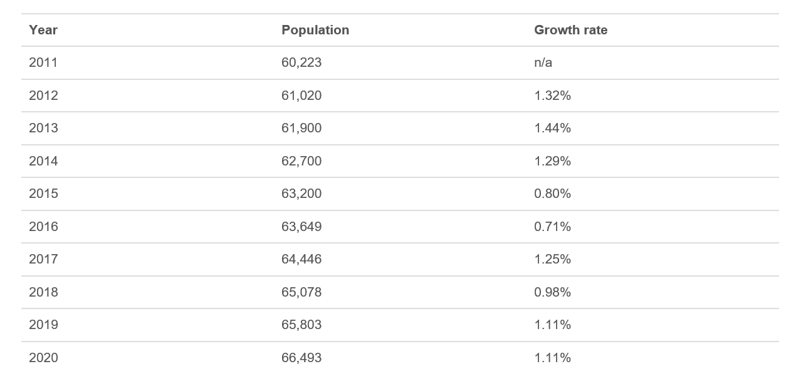
Source: http://www.population.net.au/shepparton-population/ Accessed 19/01/2021
3. Victorian Population Growth Rates since 2011

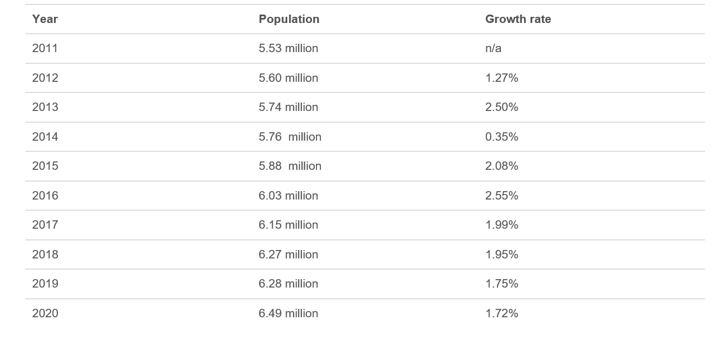
Source: http://www.population.net.au/population-of-victoria/. Accessed 19/01/2021

4. Age Structure of Greater Shepparton Population
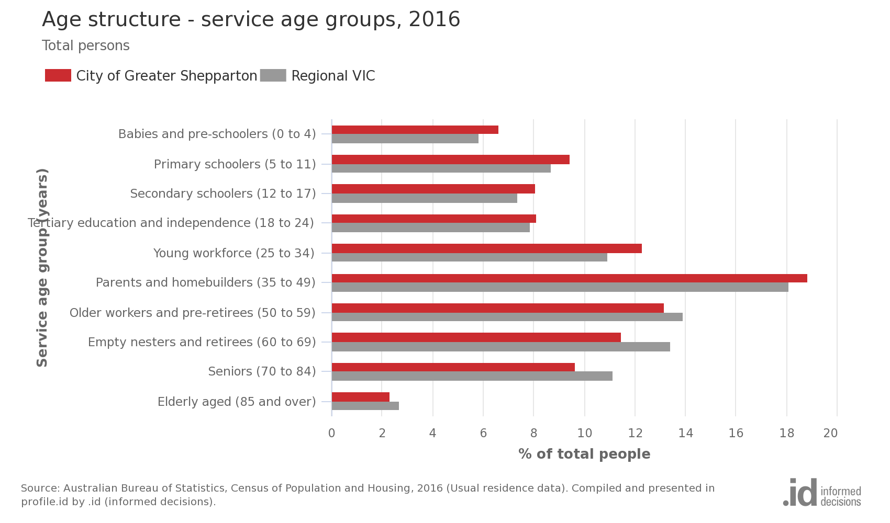
Source: https://profile.id.com.au/shepparton Accessed 19/01/2021

5. Aboriginal and Torres Strait Islander Population
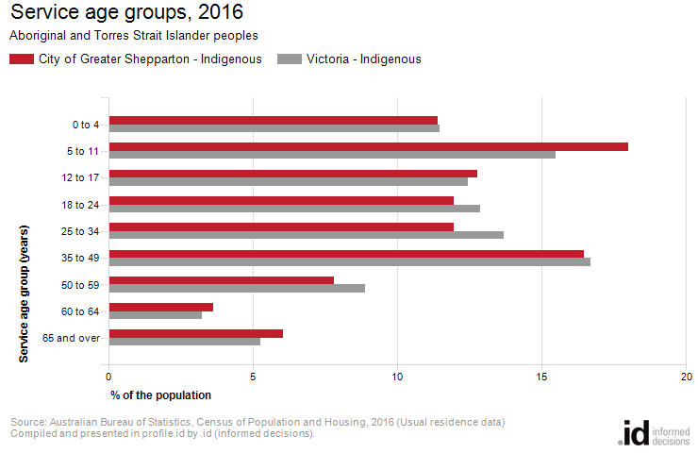

Australian Bureau of Statistics, Census of Population and Housing 2011 and 2016.
Source: https://profile.id.com.au/shepparton Accessed 19/01/2021

6. Birthplace – Ranked by size

City of Greater Shepparton - Overseas born (Usual residence) | 2016 |  |  | 2011 |  |  | Change
Birthplace | Number | % | Regional VIC % | Number | % | Regional VIC % | 2011 to 2016
India | 1,202 | 1.9 | 0.6 | 805 | 1.3 | 0.4 | +397
United Kingdom | 1,061 | 1.7 | 3.2 | 1,082 | 1.8 | 3.5 | -21
Italy | 846 | 1.3 | 0.5 | 985 | 1.6 | 0.6 | -139
Afghanistan | 755 | 1.2 | 0.1 | 557 | 0.9 | 0.1 | +198
New Zealand | 715 | 1.1 | 1.0 | 606 | 1.0 | 1.0 | +109
Iraq | 464 | 0.7 | 0.1 | 389 | 0.6 | 0.1 | +75
Philippines | 394 | 0.6 | 0.4 | 227 | 0.4 | 0.3 | +167
Albania | 264 | 0.4 | 0.0 | 328 | 0.5 | 0.0 | -64
Turkey | 247 | 0.4 | 0.1 | 329 | 0.5 | 0.1 | -82
Pakistan | 227 | 0.4 | 0.1 | 63 | 0.1 | 0.0 | +164
Malaysia | 212 | 0.3 | 0.2 | 87 | 0.1 | 0.1 | +125
Netherlands | 202 | 0.3 | 0.5 | 213 | 0.4 | 0.6 | -11
Taiwan | 196 | 0.3 | 0.1 | 26 | 0.0 | 0.0 | +170
Greece | 163 | 0.3 | 0.1 | 164 | 0.3 | 0.1 | -1
China | 160 | 0.3 | 0.3 | 136 | 0.2 | 0.2 | +24
Sri Lanka | 139 | 0.2 | 0.1 | 97 | 0.2 | 0.1 | +42
Samoa | 125 | 0.2 | 0.0 | 53 | 0.1 | 0.0 | +72
Germany | 123 | 0.2 | 0.4 | 125 | 0.2 | 0.5 | -2
South Africa | 120 | 0.2 | 0.2 | 76 | 0.1 | 0.2 | +44
Iran | 120 | 0.2 | 0.1 | 53 | 0.1 | 0.0 | +67
Congo, Democratic Republic of | 111 | 0.2 | 0.0 | 62 | 0.1 | 0.0 | +49
Sudan/South Sudan | 110 | 0.2 | 0.0 | 147 | 0.2 | 0.1 | -37
Kuwait | 92 | 0.1 | 0.0 | 80 | 0.1 | 0.0 | +12
United States of America | 82 | 0.1 | 0.2 | 68 | 0.1 | 0.2 | +14
Ireland | 80 | 0.1 | 0.2 | 71 | 0.1 | 0.2 | +9
Thailand | 79 | 0.1 | 0.1 | 65 | 0.1 | 0.1 | +14
North Macedonia | 76 | 0.1 | 0.1 | 78 | 0.1 | 0.1 | -2
Nigeria | 58 | 0.1 | 0.0 | 35 | 0.1 | 0.0 | +23
Canada | 47 | 0.1 | 0.1 | 38 | 0.1 | 0.1 | +9
Hong Kong | 44 | 0.1 | 0.1 | 18 | 0.0 | 0.0 | +26
Fiji | 42 | 0.1 | 0.1 | 23 | 0.0 | 0.0 | +19
Indonesia | 40 | 0.1 | 0.1 | 16 | 0.0 | 0.1 | +24
Vietnam | 40 | 0.1 | 0.1 | 29 | 0.0 | 0.1 | +11
Serbia / Montenegro (fmr Yugoslavia) | 37 | 0.1 | 0.1 | 50 | 0.1 | 0.1 | -13
Zimbabwe | 37 | 0.1 | 0.0 | 23 | 0.0 | 0.0 | +14
Croatia | 35 | 0.1 | 0.2 | 44 | 0.1 | 0.2 | -9
Bangladesh | 34 | 0.1 | 0.0 | 16 | 0.0 | 0.0 | +18
Spain | 28 | 0.0 | 0.0 | 24 | 0.0 | 0.0 | +4
Saudi Arabia | 28 | 0.0 | 0.0 | 29 | 0.0 | 0.0 | -1
Nepal | 25 | 0.0 | 0.0 | 16 | 0.0 | 0.0 | +9
South Korea | 25 | 0.0 | 0.0 | 14 | 0.0 | 0.0 | +11
Singapore | 24 | 0.0 | 0.0 | 20 | 0.0 | 0.0 | +4
Poland | 24 | 0.0 | 0.1 | 25 | 0.0 | 0.1 | -1
Tonga | 22 | 0.0 | 0.0 | 16 | 0.0 | 0.0 | +6
Egypt | 21 | 0.0 | 0.0 | 31 | 0.1 | 0.0 | -10
France | 20 | 0.0 | 0.1 | 22 | 0.0 | 0.0 | -2
Syria | 20 | 0.0 | 0.0 | 15 | 0.0 | 0.0 | +5
Tanzania | 19 | 0.0 | 0.0 | 26 | 0.0 | 0.0 | -7
Malta | 18 | 0.0 | 0.1 | 22 | 0.0 | 0.1 | -4
Kenya | 17 | 0.0 | 0.0 | 29 | 0.0 | 0.0 | -12
Papua New Guinea | 15 | 0.0 | 0.0 | 13 | 0.0 | 0.0 | +2
Austria | 14 | 0.0 | 0.1 | 18 | 0.0 | 0.1 | -4
Japan | 13 | 0.0 | 0.0 | 5 | 0.0 | 0.0 | +8
Romania | 13 | 0.0 | 0.0 | 10 | 0.0 | 0.0 | +3
Morocco | 13 | 0.0 | 0.0 | 6 | 0.0 | 0.0 | +7
Switzerland | 13 | 0.0 | 0.0 | 11 | 0.0 | 0.0 | +2
Lebanon | 12 | 0.0 | 0.0 | 16 | 0.0 | 0.0 | -4
East Timor | 11 | 0.0 | 0.0 | 8 | 0.0 | 0.0 | +3
Russian Federation | 10 | 0.0 | 0.0 | 6 | 0.0 | 0.0 | +4
United Arab Emirates | 10 | 0.0 | 0.0 | 0 |  | 0.0 | +10

Source: https://profile.id.com.au/shepparton Accessed 19/01/2021

7. Language spoken at home
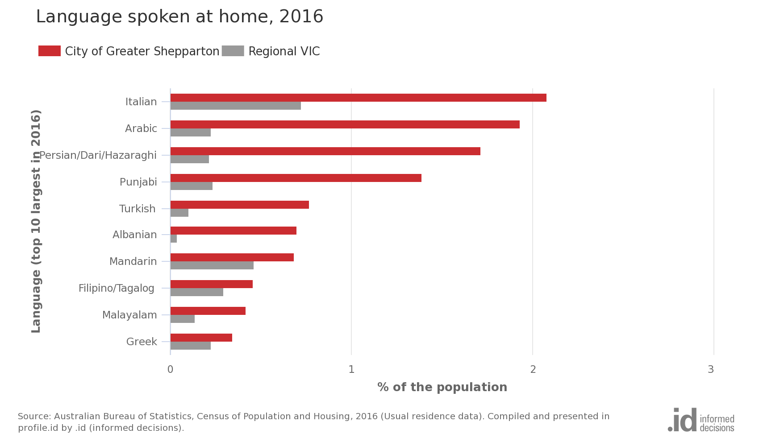
Source: https://profile.id.com.au/shepparton Accessed 19/01/2021

8. Index of Relative Socio-economic Disadvantage

City of Greater Shepparton's small areas and benchmark areas
Area | 2016 index | Percentile
Shepparton Surrounds South | 1,067.5 | 86
Kialla Urban | 1,055.2 | 80
Rural North | 1,034.0 | 67
Rural East | 1,030.5 | 64
Shepparton North East | 1,030.2 | 64
Shepparton Surrounds East | 1,020.8 | 57
Victoria | 1,010.0 | 51
Australia | 1,001.9 | 46
Rural South | 998.7 | 44
Rural North West | 985.6 | 37
Regional VIC | 977.0 | 32
Hume Region | 975.2 | 32
Tatura | 967.6 | 28
Moira Shire Council | 951.0 | 22
City of Greater Shepparton | 948.0 | 21
Shepparton North Central | 938.1 | 18
Shepparton Urban Centre | 931.3 | 16
Shepparton North West | 907.2 | 11
Mooroopna | 896.3 | 9
Shepparton South | 888.6 | 8
Shepparton South East | 845.6 | 5
Shepparton Central | 842.3 | 4

Source: Australian Bureau of Statistics, Census of Population and Housing 2016
Source: https://profile.id.com.au/shepparton Accessed 19/01/2021
9. City of Greater Shepparton Maternal Child Health Service Participation Rates

2016-17
 | Home visit | 2wk | 4 wk | 8 wk | 4 mth | 8 mth | 12mth | 18mth | 2 yrs | 3.5yrs
Non-ATSI | 102% | 96 | 93 | 97 | 96 | 91 | 87 | 74 | 75 | 79
ATSI | 99% | 84 | 84 | 80 | 69 | 63 | 66 | 71 | 67 | 60

2017-18
 | Home visit | 2wk | 4 wk | 8 wk | 4 mth | 8 mth | 12mth | 18mth | 2 yrs | 3.5yrs
Non-ATSI | 100% | 98 | 98 | 97 | 90 | 84 | 81 | 79 | 79 | 74
ATSI | 98% | 81 | 92 | 72 | 73 | 70 | 65 | 70 | 76 | 80

2018-19
 | Home visit | 2wk | 4 wk | 8 wk | 4 mth | 8 mth | 12mth | 18mth | 2 yrs | 3.5yrs
Non-ATSI | 98% | 94 | 94 | 92 | 97 | 88 | 88 | 79 | 76 | 67
ATSI | 90% | 77 | 80 | 91 | 83 | 73 | 71 | 61 | 60 | 69

Notes:
- Data is expressed as percentage
- CALD data was not available to include as a separate group in this representation

APPENDIX B: EARLY CHILDHOOD EDUCATION & CARE SETTINGS IN GREATER SHEPPARTON

Service Provider | Service Name
Greater Shepparton City Council | Alexandra Street Kindergarten
 | Arthur Mawson Children's Centre
 | Arthur Dickmann Childcare Centre
 | Colliver Road Children's Centre
 | Dolena Young Kindergarten
 | Echuca Road Kindergarten
 | Frank R Pullar Childcare Centre
 | Gowrie Park Kindergarten
 | Isabel Pearce Kindergarten
 | Katandra West Early Childhood Centre
 | Leslie Gribble Children's Centre
 | Nancy Vibert Child Care Centre
 | Patricia Smith Children's Centre
 | Rodney Neighbourhood Kindergarten
 | Tallygaroopna Children's Centre
ASKK Pty Ltd | Apple Blossoms Early Learning - Mooroopna
Kaja Holdings Pty Ltd | Balaclava Road Child Care Centre
G8 Education Limited | Community Kids Shepparton Early Education Centre
Willowgum Early Learning Centre Pty Ltd | Florina Pre-School and Daycare
Goodstart Early Learning Ltd | Goodstart Early Learning Shepparton - Archer Street
Goodstart Early Learning Ltd | Goodstart Early Learning Shepparton - Bourchier Street
Gowrie Street Primary School Shepparton | Gowrie Street Preschool and Occasional Care
Kaja Holdings Pty Ltd | Guthrie Street Child Care Centre
Inspira Kids Early Learning Centre Shepparton Pty Ltd | Inspira Kids Early Learning Centre
Kialla Children's Centre Inc | Kialla Children's Centre
Knight St Pre School and Child Care Centre Pty Ltd | Knight Street Preschool and Child Care Centre
Lulla's Children and Family Centre Aboriginal Corporation | Lulla's Children and Family Centre
Goulburn Region Pre-School Association Inc | Merrigum Kindergarten and Early Childhood Services
Goulburn Region Pre-School Association Inc | Murchison Kindergarten and Early Childhood Service
Think Childcare Services Pty Ltd | Nido Early School Shepparton
Save The Children Australia | Save the Children Kindergarten - Mooroopna
St Mel's Kindergarten Inc | St Mel's Kindergarten
Tatura Children's Centre Inc | Tatura Children's Centre
Goulburn Region Pre-School Association Inc | Toolamba Preschool
Goulburn Region Pre-School Association Inc | Undera Kindergarten
KJ & CJ Beer-Brewer Pty Ltd | Wyndham Early Learning

APPENDIX C: THE AUSTRALIAN EARLY DEVELOPMENT CENSUS

About the Australian early development census domains
The Australian version of the Early Development Instrument consists of approximately 100 questions across five key domains. All are closely linked to child health, education, and social outcomes:
- physical health and wellbeing
- social competence
- emotional maturity
- language and cognitive skills (school based)
- communication skills and general knowledge.
For each of the five domains, children receive a score between zero and 10, where zero is most developmentally vulnerable.
Australian Early Development Census results are reported as percentage of children who are:
- developmentally on track
- developmentally at risk
- developmentally vulnerable
on each domain.
These domains have been shown to predict children’s later outcomes in health, wellbeing, and academic success.

APPENDIX D: SCHOOL ENTRANT HEALTH QUESTIONNAIRE DATA

Key Findings from the School Entrant Health Questionnaire 2019 for Greater Shepparton

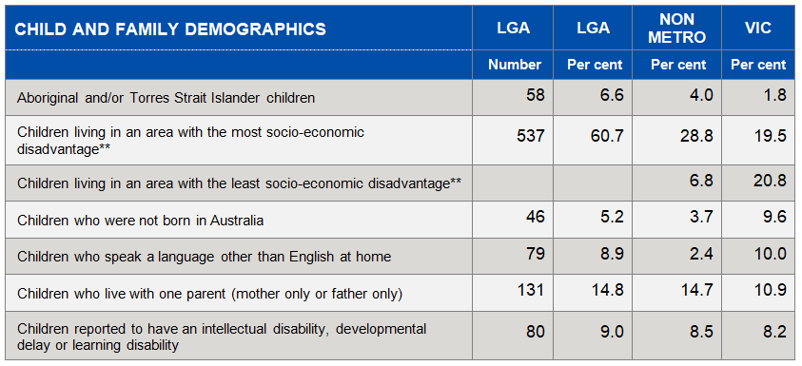

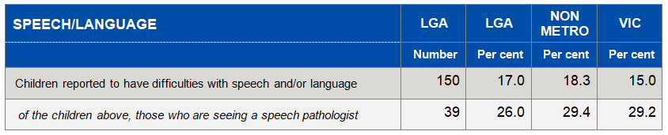

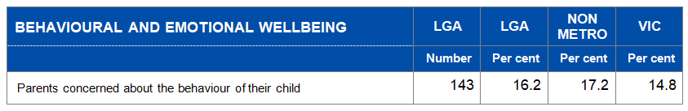
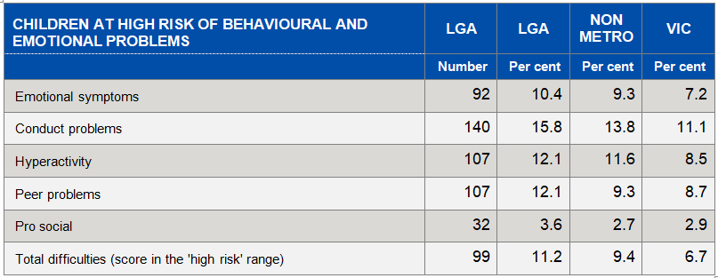

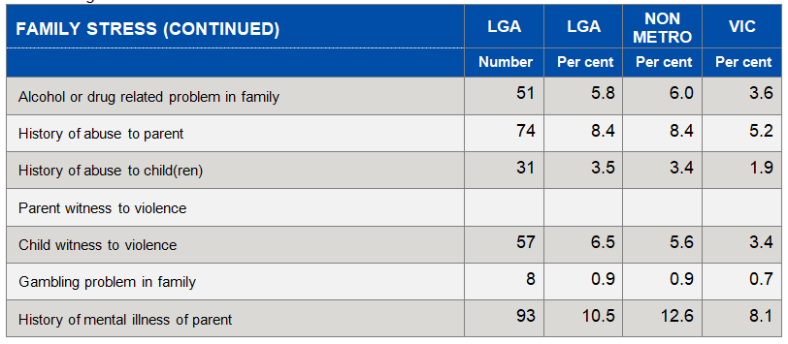

REFERENCES
Australian Government Department of Education and Training 2009, Belonging, Being and Becoming: The Early Years Learning Framework for Australia, Council of Australian Governments, Barton ACT
Clear Horizon, 2020, Lighthouse Evaluation Report, Cremorne NSW
Commonwealth of Australia 2019, Australian Early Development Census, Community Profile for Greater Shepparton 2018, Melbourne
Doveton College, 2013, Doveton College: The Early Days, Doveton, Victoria
Greater Shepparton City Council 2020, Greater Shepparton Best Start Early Years Plan 2020-2025, Shepparton
Greater Shepparton Lighthouse Project 2019, Greater Shepparton’s Community Strategy for Children and Young People, GSCC, Shepparton.
Greater Shepparton Lighthouse Project 2018, One Thousand Conversations, GSCC, Shepparton.
McKenzie, F. 2019, What it means to walk alongside: exploring the Our Place partnership, Our Place, Doveton, Victoria.
Ministerial Council on Education, Employment, Training and Youth Affairs 2008, Melbourne Declaration on the Educational Goals for Young Australians, Melbourne
Moore,T., Arefadib, N., Deery, A., West, S. 2017, The First Thousand Days: An Evidence Paper, Centre for Community Child Health, Parkville Victoria
Pascoe, S. and Brennan, D. 2017, Lifting our Game, A Report of the Review to Achieve Educational Excellence in Australian Schools Through Early Interventions, Three’s A Crowd (Authorised by the Victorian Government), Melbourne
The Council of Australian Governments 2008, Communique. Indigenous Reform – Closing the Gap, Sydney NSW
The Council of Australian Governments 2009, Investing in the Early Years – A National Early Childhood Development Strategy, Canberra ACT
The Department of Education and Training 2015, Transition: A Positive Start To School Initiative Consultation 2015, Melbourne
The Department of Education and Training, 2016, Marrung Aboriginal Education Plan 2016-2026, Melbourne
The Department of Education and Training 2016, The State of Victoria’s Children Report, Melbourne
The Department of Education and Training 2016, Victorian Early Years Learning and Development Framework (for all children from birth to eight years), Melbourne
The Department of Education and Training 2017, Early Childhood Reform Plan: Ready for kinder, Ready for school, Ready for life, Melbourne
The Department of Education and Training 2017, Transition: A Positive Start To School Initiative Resource Kit, Melbourne
The Department of Education and Training, 2018, Greater Shepparton Early Learning Profile, Melbourne
The Department of Education and Training, 2019, Framework for Improving Student Outcomes (cycle poster), Melbourne
The Department of Education and Training 2019, What is the role of the Department of Education and Training in lifting quality in early childhood education?, Melbourne
The Department of Education and Training 2019, Kindergarten Vulnerability Data Collection 2019, Shepparton Victoria
The Department of Education and Training 2020, Outcomes for Victorian Children at School Entry – Findings from the School Entrant Health Questionnaire for Greater Shepparton 2019 Melbourne
The Department of Environment, Land, Water and Planning 2019, Victoria in Future 2019 - Population Projections 2016 to 2056, July 2019, Melbourne
The Department of Health and Human Services 2019, Maternal Child Health Annual Report – Greater Shepparton City Council, Melbourne
The Department of Premier and Cabinet, Victorian Government 2018, Victorian Aboriginal Affairs Framework 2018-2023, Melbourne
The University of Melbourne, Melbourne Graduate School of Education 2016, The E4Kids study: Assessing the effectiveness of Australian early childhood education and care programs, Melbourne
United Nations 1989, Convention on the Rights of the Child, New York City, USA

