150 Years of Public Education

Teaching and Learning Resources
for Foundation – Level 2

Foundation – Level 2

Acknowledgment
We acknowledge the Traditional Owners of the land, and pay our respects to their Elders past, present and emerging.
These lessons are about the history of education, and we would like to acknowledge that education in Victoria began more than 60,000 years ago when Aboriginal communities and Elders taught the youngest people the life skills and values that they wished them to embody.
Aboriginal and Torres Strait Islander people should be aware that this resource may contain images and content about deceased persons.
Some material in this resource or the recommended further reading may reflect the period in which the item was written or created and may not be considered appropriate today. These do not reflect the views of the authors and are provided only for historical context.

Introduction
To commemorate the 150th anniversary of public education in Victoria, the Department of Education and Training has published a collection of resources that link the history of education and schooling to the relevant parts of the curriculum at all levels F-6. Teachers should confer with colleagues to ensure that students encounter a variety of these topics and develop a breadth of historical skills during their progress through the school.
This unit introduces students to the changing face and role of education over time, with particular focus on the educational experiences of students and their families. It introduces students to the changes in schooling and education since the passing of The Education Act of 1872 which enacted free, compulsory and secular education. A range of activities are provided in this learning sequence, which addresses learning descriptors from the Level F-2 History curriculum from the Victorian Curriculum. Choose the activities that you feel would most benefit your student’s learning and support the development of historical and critical thinking skills.

Victorian Curriculum Connections

Victorian Curriculum Achievement Standards

History
By the end of Level 2, students explain aspects of daily life to identify how some aspects have changed over time, while others have remained the same. They describe personal and family life, a person, a site, or an event of significance in the local community.
Students use sources (physical, visual, oral) including the perspectives of others (parents, grandparents) to describe changes to daily life and the significance of people, places or events. They compare objects from the past and present. Students create a narrative about the past using terms and a range of sources.

Key Questions addressed:
- What is my personal and family history?
- How has family life changed or remained the same over time?
- What remains of the past are important to the local community? Why?
- How have changes in technology shaped our daily life?

Relevant Victorian Curriculum Content Descriptions:

History
Sequence significant events about personal and family history to create a chronological narrative (VCHHC053)
Identify perspectives about changes to daily life from people in the past or present (VCHHC055)
Identify examples of continuity and change in family life and in the local area by comparing past and present (VCHHC056)
Identify the significance of a person and/or place in the local community (VCHHC057)
Who the people in their family are, describe where they were born and raised and how they are related to each other and how their stories are communicated and shared (VCHHK058)
Differences in family structures of families and the role of family groups today, and what they have in common and how these have changed or remained the same over time (VCHHK059)
How the present, past and future are signified by terms indicating and describing time (VCHHK060)
Differences and similarities between students' daily lives and perspectives of life during their parents’ and grandparents’ childhoods, including family traditions, leisure time and communications (VCHHK061)
The effect of changing technology on people’s lives and their perspectives on the significance of that change (VCHHK065)

Mathematics
Foundation: Sort, describe and name familiar two-dimensional shapes and three-dimensional objects in the environment (VCMMG081)
Level 1: Recognise and classify familiar two-dimensional shapes and three-dimensional objects using obvious features (VCMMG098)
Level 2: Describe and draw two-dimensional shapes, with and without digital technologies (VCMMG120)
Describe the features of three-dimensional objects (VCMMG121)

Learning Intentions
Learners will:
- Identify and sequence their own experiences of education using a timeline.
- Understand that the experiences of education for their family members may be different to their own and explain some of these differences.
- Recognise that changes in technology have changed the way that education occurs in schools.
- Compare artefacts of schools from the past and present, identifying similarities and differences.

Success Criteria
Learners can:
- Use timelines to sequence historical events relevant to their own lives and their school.
- Explain the differences and similarities between their own school experiences and someone from a different generation.
- Examine changes in technology in school and discuss what impacts these might have had.
- Identify and classify common school artefacts as being from the past or present.

Learning Activities

Materials and Texts
- Slide pack resource, indicated by
  - includes student prompts and graphic organisers to support student learning activities
- School memorabilia and historical items
- Tablet or camera to take images around the school (optional)
- Shape blocks or paper shapes
- Scissors and glue sticks

Get started
Introduce the unit of study to students, explaining that they are going to learn about changes to education throughout Victoria’s history. The teacher will provide explicit teaching of historical information to establish a common framework of understanding. Background reading for teachers is available in the background reading section of this document, with more extensive information available on FUSE.
Explain to students that they are going to explore their personal, family and school history. Ask students to share what they think we might be talking about when we say the word ‘history’. Record students’ ideas and questions on an anchor chart or wonder wall. To accelerate the learning process and support the learning of students of diverse abilities, the teacher should answer some of these questions, and identify others as topics for potential inquiry.
Introduce and teach vocabulary to support student learning in the unit. Students may not be familiar with some of the words we use when we talk about history and the past.

Creating a personal timeline
Explain to students that we all experience important events in our lives. Provide some examples from your own life, such as starting school, going to secondary school, finishing secondary school, starting teaching etc.
Introduce students to the idea of using a timeline to record and sequence important things that happen in our lives. Ask students to provide ideas of the important events that have happened to them. Record students’ ideas. Examples may include that they were born, that younger sibling(s) were born, they started to walk, they got their first tooth, they started to talk, they moved to Australia, they moved house, they started kinder, they started Prep/Foundation etc.
An example timeline that is available from the resources pack to share with students as an example. Ask students to share what they notice about the model timeline – for example the order of events and the type of events included.
Explain to students that they are going to create a timeline that records the important events of their own life, using some of the events the class shared earlier. Demonstrate how to create the timeline, with the starting point as the year they were born. Ask students to select several events from the list they created and to indicate where on the timeline they should be placed. Indicate the events that happened earlier in their life, and explained that this is the PAST, and what is happening now is called the PRESENT.
Provide students with a copy of the blank My Timeline handout (optional) or a sheet of paper which they can use to complete their own timeline. Students draw images to show the main ideas.
Enable students by reducing the number of events that students record, providing a vocabulary list, or providing images for them to stick onto their activity sheet.
Extend students by asking them to include additional events, and to write a sentence explaining the event they have chosen, and why they chose to include it on their timeline.

Going deeper

Classrooms past, present and future
Explain to students that they are going to investigate what classrooms were like in the past and compare it to what classrooms are like now. Watch the “Then and Now” video available on the 150 years of public education in Victoria website which includes images of past and current schools.
Show students images from this section of the student powerpoint pack. Ask students what they notice about the classrooms. Examples may include that the students are all sitting in long rows, that many different ages of students are in the same classroom, there are many students in one room, some of the physical aspects of the classroom, that students are not wearing uniforms etc.
Focus on the technologies that can be seen in the images and compare these to what are available in your classroom today (for example, kerosene lamps compared to electric lights, slates and pencils compared to tablets and laptops). Show students the ‘Technology in schools’ slide from the student slide pack. Ask students which of the technologies are familiar, and which are not. Use question prompts to promote discussion, including:
- Do you recognize any of these items?
- Do you use any of them in class today?
- Are there any items that you don’t know?
- What do you think they are used for?
Ask students to predict how long ago these items might have been in use in classrooms. Using the timeline slide in the student powerpoint pack, support students to place the items in chronological order.
Ask students to describe what they can see in their current classroom. Support students to compare their current classroom to the classrooms in the past. Have students identify things that are different, and things that are the same. Ask students to sort images into the categories ‘past’, ‘present’ and ‘both’. Sorting cards are available in the teacher resources section of the student powerpoint for printing or sorting digitally on a screen. You could create additional cards using images from your own classroom to extend this activity.

School life in the past
Explain to students that they are going to investigate what school was like in the past by interviewing an older person, such as a parent, grandparent, teacher or other older person they are familiar with.
Discuss some of the topics that students are interested in asking the person they will be interviewing. Model how to write suitable interview questions based around these topics. Examples of questions might include:
- When were you born?
- How old were you when you started school?
- How old were you when you finished school?
- Did you have to go to school?
- What school did you go to?
- How did you get to school?
- What did you learn about at school?
- What was your favourite subject?
- What were your favourite games and activities?
- What was your playground like?
Enable students by collaboratively creating questions and preparing a question sheet they can use to conduct their interview.
Extend students by encouraging them to develop their own interview questions, and to consider how they might present the information in an interesting way.

Create a class display that collates the interview responses, using a “Then, Now, Reflection” Chart. In the ‘Then’ column, record information provided by the interviewees about what school was like in the past. In the ‘Now’ column, add an example of what school is like today, then in the ‘Reflection’ column, students can reflect on what some of the causes of the transition might be. See an example below:

Then | Now | Reflection
Students walked or rode horses to school. | Students walk, ride bikes or scooters, or get driven to school. | Not everyone was able to afford to buy a car. Now, technology changes mean that cars, bikes and scooters are more affordable for most people.

Go further: Consider inviting a grandparent, parent or another person who previously attended the school to visit the class as a guest speaker to explain what the school was like for them, and the changes that have happened since they were a student at the school.

School History Walk
Explain to students that you are going to create a class timeline that records the key events for the school. If possible, immerse students in the history of your school by creating a display of historical documents or artefacts, such as books that were produced by previous classes, photographs, and any other memorabilia. If your school is one of the schools that has been open since the passing of The Education Act of 1872, you could also show students the information available about your school on the 150 years of Public Education in Victoria website.
Take students on a walking tour around the school grounds, looking for sources of evidence that tell something about the history of the school. For example, students may find a Foundation Stone, the school sign and number, different types of buildings, or honour boards. If possible, have students take photos or draw the examples that they find.
Use the information discovered on the history walk, and any other information available about the history of the school, to create a timeline that shows the key events that have occurred, such as the opening of the first school building, any new buildings, when the current principal started, when the classroom teacher started, and any other important events.
Go further: Consider making a large display of the timeline, which students can illustrate, to hang in the classroom or in a prominent place in the school. Invite members of the school community to contribute information, photographs and other memorabilia that help to tell the story of the school.

Shapes of school buildings
Share images from the student powerpoint pack showing different schools build during different eras. Ask students what they notice about the buildings from the different eras. Discuss how the shapes and materials that were used in buildings have changes over time.
Discuss with students some of the different shapes that they can see in the different buildings. Demonstrate the different shapes that can be seen using digital tools or drawing shapes on a printed copy of the images. Label and name the shapes that students identify.
Model to students how familiar shapes such as triangles, circles and squares can be combined to make interesting composite shapes. Encourage students to replicate building designs from the past using pattern blocks, creating a collage using paper shapes or using digital art tools.
Take students on a shape walk around the school. What shapes can they see that make up the school buildings? If possible, have students take photographs of interesting shapes that they see.
Students use pattern blocks, make a collage from paper shapes or use digital tools to recreate the school buildings or replicate interesting shapes that they found. Students name and label the familiar shapes that they find.
Ask students why they think that the shapes and materials used in building might have changed over time. Prompt students to consider the availability of materials, changing technologies and new, light building materials mean have led to changes in the ways that buildings can be designed and built.

Playtime now and then!
Lead a discussion with students about the favourite games and activities they like to play at school during break times. Record student responses and collate the information using a pictograph to show students’ preferred activities.
Consider creating a poster with photographs of students doing those activities for display in the classroom. Compare the list of activities selected by students to those that were identified as part of the interviews with an older person, if asked. Share images of playgrounds from the past in the student powerpoint pack. Ask students to identify activities that are the same, and those that are different to what they play now.
Support students to explore different games that children in the past might have played at school. Examples include hopscotch, tag games, skipping ropes, origami, board games, strings, elastics and knucklebones and jacks. The Australian Children’s Folklore Collection available online from Museums Victoria includes images of different games played by students in the past. Descriptions of historical games played in Australia in the early to mid 20th century are available from the play and childlore section of the Museums Victoria Collection.
Go further: Consider arranging a games afternoon for families to share the games of their childhood with your students. In particular, encourage parents who did not go to school in Australia, and Aboriginal and Torres Strait Islander families to share the games and activities they played as children.

Reflect and consolidate

Plan a time capsule
Support students to reflect on the types of items and activities that helped them understand more about the school in the past. Based on this information, facilitate a discussion with students about what might help students 150 years in the future understand more about school today in 2022.
Introduce the idea of a time capsule and what it is used for. Ask students to brainstorm ideas for what might be placed into a time capsule, that if opened in 150 years from now would tell students about school today. What items would they select?
Provide students with the time capsule activity sheet, or a plain piece of paper to draw the contents of their time capsule. Students share their selections with the class, providing an explanation for why they have selected these items (e.g. uniform, pens, photos, copy of the school song etc) as being important to show students in the future.
Go further: Collect items and memorabilia to put into an physical time capsule that can be retained in your school for future students to explore school life in 2022. Encourage students to identify and contribute suitable items into the time capsule.

Schools of the future
Encourage students to imagine what schools of the future might look like. Do they think schools will look different or look the same as they do now? Do they think that some of the things that we have in classrooms now will still be used in the future?
Lead a discussion about what students have learnt about schools in the past, and what they think schools of the future might be like. Students draw what they imagine a school or classroom of 100 years in the future might look like.
Alternatively, provide students with a copy of the “Schools of the past, Schools today and Schools of the future” thinkboard to complete as a snapshot of their learning.

Teacher Materials and Resources

How to research and present the history of your school

Where should I look for information on my school?
Many Victorian primary schools have a long and rich history. Even if your school is in a new suburb, or was recently built, there is probably historical information that students can research as, there probably are or were older schools that existed in your area.
The Education Act 1872 stipulated that students were only excused from attending school if they lived further than two miles (3.2 km) away from any school. Consequently, the Department of Education worked to establish schoolhouses in both metropolitan and regional Victoria. The suburb where you live might once have been an agricultural area or a mining region that would certainly have had schools for the children of farmers or miners. Your current school may have replaced several schools or amalgamated (been joined with another one). If your school is new, you might have students research one of the schools that used to exist in your area instead.
150 Years of Public Education school profiles
Students can begin their research by checking the 150 Years of public education website. If your school is not listed, students have some great sleuthing ahead!
School archives
Does your school have an archive? The best person to ask is your school librarian and the administration staff. Sometimes, historical documents, photos and artefacts can be found tucked away in storerooms.
The sort of things that might be found in your school archive could include:
- photographs of past students, teachers or buildings
- documents from the 100th anniversary of public education in Victoria in 1972
- a time capsule made by past students from your school
- audio or audiovisual recordings
- past school uniforms or bags
- student workbooks
- defunct learning technologies such as a typewriter or an inkwell.

You might ask to borrow some items to display in a school exhibition, discuss in class or photograph for a research project.
Interview past students
Using the historical records you find, your class can contact past students or teachers and organise to interview them about their experiences at your school.
Watch this video to get some inside information about how to conduct a great historical interview.
A helpful way to get your interview candidates reminiscing about their school experiences is to show them pictures.
Social media
You can use your school’s social media accounts to let your school community know that you are seeking historical information and memories about local schools. You can send a request to your students’ families to do a call-out through their social media networks.
There are several Facebook accounts with the title ‘I Grew Up In …’ (e.g., I grew up in Collingwood). People regularly post photographs and memories from their school days.

Local historical society
Most suburbs or shires have a historical society staffed by volunteers. They collect both records and memories from local residents so that the history of the area can be documented and preserved. Most would be very pleased to help you research the history of your school or past schools in your region.
The volunteers at the historical society might also be long-term residents of the area and potential interviewees.
Local library
Your local library is one of the best places to find books on your suburb or shire. The librarian might also be able to point you towards any files relating to local schools held in the collection. Library noticeboards can also be a good place to let the community know that you are looking for information about the history of your school. Make sure that all correspondence is sent directly to the school rather than your personal contact details.
Trove
Do a search of historical newspapers using Trove. Make sure that you try both your school’s current name and any other iterations of the name from the past. For example, the local primary school in Bacchus Marsh went through several name changes.
The school opened in May 1850 and amalgamated with three other small schools in April 1863 to become Bacchus Marsh Central Common School. It later became Bacchus Marsh State School and was renamed Bacchus Marsh Primary School in 1970.
If you are searching online records, you will need to try ‘Bacchus Marsh school’ and all of these different school names as key search terms. Also, be aware that there may be schools with similar names in other states.
Museums Victoria online collection
Museums Victoria has a large archive dedicated to childhood. It doesn’t just contain objects, but also stories, poems, jokes, songs and games.

How can students share what they have learnt?

Historical timelines
One of the most effective ways to show how education in Victoria and your school has evolved is through a timeline. There are many innovative ways that your class can share your findings with visitors to a school. Some ideas include:
- create a giant timeline going down the hall of your school, in the gym or playground
- decorate a series of classrooms to each represent a decade of education in Victoria or at your school
- make a digital timeline to go on your school website (You can use the 150 Years of Public Education website to see what kind of information you might include.)
- videorecord a mini documentary about an aspect of life at school in 1872, 1917, 1972 and today? It could be about an example of the curriculum, how students spoke to their teachers, or the kind of equipment used for their school lessons.
Remember to acknowledge on your timeline that education was occurring in your area before European settlement through the types of education experienced by children in local Aboriginal communities.

Engaging your audience
Brainstorm ideas with your students of different ways they could share what they have learnt with the wider school community. Some ideas include:
- use mannequins to show changes in uniform or clothing worn by children over time
- hold a historical fashion parade
- write and perform some short scenes at your school assembly on how students learnt in the past
- work with your school art teacher to recreate historical lessons such as making an embroidery sampler
- create a session on how students used to exercise at school or play games at recess. Your class could lead a session for other year levels to try them out
- Invite a guest into your classroom to act as a ‘school inspector’ and to give a report on you and your students. Read some of the inspector reports available on the 150 Years of Public Education website. Here are some examples from Brown Hill Primary School near Ballarat. They contain reports by inspectors from between 1914 and 1922.
- The ‘then and now’ method of display is an effective way to show change over time. It can be achieved with images, report cards, video clips, everyday school items, 3D displays, samples of student work, or demonstrations. Some examples of topics for research and discussion are listed below.
Then | Now | Reflection
Teachers used blackboards, chalk and dusters. | Teachers used whiteboards with markers or interactive whiteboards. | Both technologies were designed to enable teachers to write and erase information repeatedly. Chalk dust was messy and considered unhealthy.

Suggested Excursions and Incursions

National Trust of Victoria
The National Trust of Victoria offers a Mrs Sargood goes to school incursion where students in Years F-6 can experience the nineteenth-century Victorian approaches to education, manners and punishment. Incursions such as these can be an excellent way to inspire your historical research.

Heritage centres and Museums
Local heritage centres, parks and experiential centres provide opportunities for students to experience life in the past. Examples include:
- Budj Bim Cultural Landscape
- Brambuk National Park and Cultural Centre
- State Library of Victoria
- Museums Victoria
- Walhalla Historic Township
- Eureka Centre, Ballarat
Commercial operators such as Sovereign Hill in Ballarat, Coal Creek in Korumburra, Old Gippstown in Moe, Pioneer Settlement in Swan Hill, Flagstaff Hill Maritime Museum and Village in Warrnambool and the Port of Echuca Discovery Centre also offer opportunities for students to explore the past.

Background reading for teachers
This background reading material is adapted from material prepared by the History Teachers Association of Victoria to support the 150 years of public education in Victoria program. Copies of the full teacher resources are available on FUSE/the 150th website.

Introduction
Education in Victoria occurred prior to the Education Act 1872, with children having received schooling in both formal and informal environments. For over 60,000 years, children from Aboriginal families learnt traditional knowledge such as creation stories and oral histories, hunting and gathering food, cultural protocols, and making tools, weapons, and shelters.

Aboriginal education history
The Education Act 1872 (Parliament of Victoria) was founded on Western principles of what children needed to learn. When researching the history of your school, it is important to consider how children were educated in your area before European colonisation. What do you know about the Aboriginal history of your area? How did parents, Elders and communities educate young people? What was considered an important life skill?
Objects and artefacts can tell us a great deal about the types of knowledge and skills that Aboriginal children would have been taught growing up in their Community. These included learning to build bark shelters, weaving nets and baskets to be used for fishing traps, collecting and storing food, and objects used in religious ceremonies. Aboriginal children also learnt the values, beliefs and cultural practices of their communities from their Elders and other family members.
The Western style of education offered by the national, denominational, common and state schools from 1851 in Victoria was very different to traditional Aboriginal knowledge and teachings. Prior to colonisation, Aboriginal children learnt about the history of their communities, wayfinding, spiritual stories, art, sewing garments such as possum skin cloaks, weaving containers, woodworking of tools and weapons, bush medicine, cultural protocols, and how to hunt and gather food.
“I always tell them the story about our people making cordial out of the banksias. We used to put the banksia tops in a bowl of water and leave it sit there overnight and all the sugar came out of the banksia. They used to feed it to the babies in the heat and it kept water and liquid in them. It’s things like that that make children in awe because like I tell them, we lived with the land. The land was our friend and we were land’s friend. If we look after the land, it’s going to look after us.” - Gloria Whalan, Aboriginal Life in Gippsland – A Senior’s Perspective (Koorie Heritage Trust & Network Aboriginal Disability and Aged Care Agencies 2016)
Western learning styles also contrasted with Aboriginal learning processes, which were holistic, relied heavily on context, engaged visual-spatial skills, and were often delivered in an informal manner.
“Learning was largely a matter of observation and imitation of the actions of older people and to a much lesser extent by verbal instruction from those who were older. Much learning was unstructured and took place within concrete contexts. The early education of Aboriginal children was undertaken by those with whom they were intimate and kin. It was only later in life, particularly in the context of initiation or in the learning of religious knowledge and ritual, that verbal instruction was given in a more formal and structured way, and that information was imparted by people who were strangers or relative strangers.” (Blanchard 1985 as cited in Hughes & More 1997)
Aboriginal education was delivered in language that encompassed their world view, shared and inherited knowledge, and identity. In Victoria there were roughly 38 distinct, separate languages, though there would have been some overlap between them, and most people would have spoken multiple languages.
“Aboriginal languages are very unique and have very specific linguistic traits that reflect culture. For example, in many Aboriginal languages, the words you use differ significantly depending on who you’re speaking with and how you are connected to that person through kinship systems. This shows how important relationships to kin and Community are in our culture.
Language also represents a connection to our ancestors, who have spoken these words and told stories for thousands and thousands of years.” Languages (Deadly Story 2022)
Compulsory education was used by the Australian and Victorian governments to assimilate Aboriginal communities and individuals into Anglo-European culture. They were taught Western laws, morals, values, numeracy, literacy and religious doctrine. They were not allowed to speak in their own languages.
Aboriginal learning opportunities were typically segregated, in that it was rare for Aboriginal and European children to attend the same school or, if they did, at the same time. Merri Creek Aboriginal School was established in 1846 by the Collins Street Baptist Church. The school was attended by both girls and boys, including the children of Wurundjeri tribal leader Billibellary. The teachers were European, and the students learnt a mix of academic, agricultural and domestic skills and even built a public bridge across the Merri Creek. This was typical of the education provided to Aboriginal children, who were only being prepared for a life of unskilled - and sometimes unpaid - labour. One of the complaints against one teacher, Edward Peacock, was that he spent much of the time preaching to students. The school closed in 1851 due to low enrolments.

Education following Colonisation
Following colonisation, when Europeans arrived in Australia, female convicts were often tasked with overseeing the education of young charges. Children from wealthy families were often more formally educated by a tutor or governess in their own home.
From 1851 onwards, after Victoria separated from the colony of New South Wales, formal education in the colony evolved through several stages.

The three stages of state education in Victoria
1851–1862 | National and denominational schools
1862–1872 | Common schools
1873–present | State schools

Denominational schools
Denominational schools gained strength during mass immigration to the state of Victoria in the 1850s due to the Gold Rush. These schools were founded by and affiliated with a church body and governed by the Denominational School Board, founded in 1848. The Board was structured into four units, each representing a key denomination: Roman Catholic, Anglican, Presbyterian, and Wesleyan. Religious education was integrated into the curriculum, ethos, and the general activities of the school community. Many of the early Victorian schools were denominational, as church bodies had the social infrastructure and funds to establish and run them.
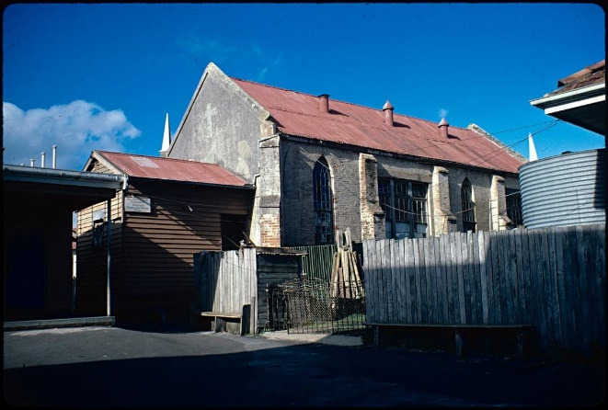
Caption: Old Catholic Church and denominational school in Portland. The school is the small room attached to the back of the church. The school was founded by Reverend Michael Stevens in 1849 and was the second Catholic denominational school to be opened in Victoria.
Source: Laurie Burchell collection of photographs of Victoria schools, State Library Victoria.

National schools
National schools were run by the National School Board and operated between 1851 and 1863. They were non-sectarian, meaning that religious education was separate to the general teaching. It ran parallel to the denominational school system and was used primarily by families who were not as wealthy as those attending denominational schools.
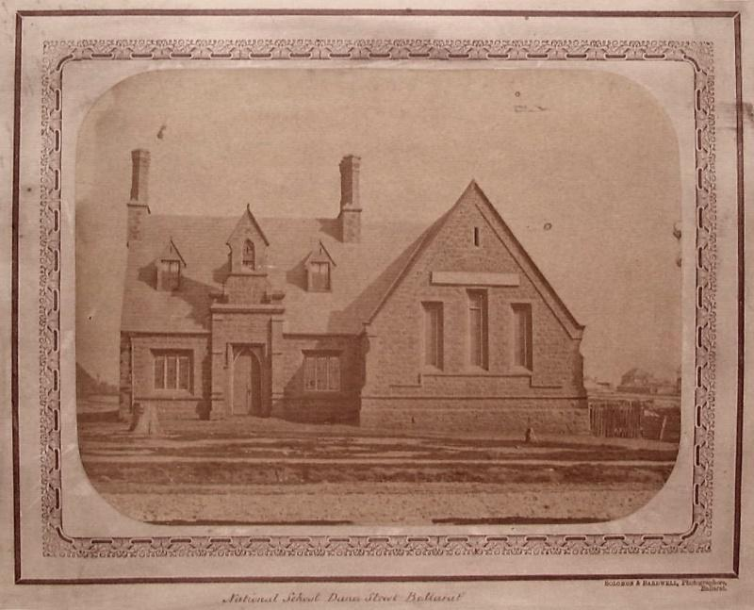
Caption: A national school, Dana Street, Ballarat 1861.
Source: Solomon & Bardwell, Pictures Collection, State Library Victoria.

Common schools
In 1862, the Common Schools Act led to the cessation of national schools and the formation of the Board of Education. Denominational schools continued to be funded along with common schools, but there was a strong movement towards the idea of secular education. Common schools were now the mainstream source of schooling in Victoria and were committed to providing at least four hours of secular education between the hours of 9.00 am and 4.00 pm. Schooling still incurred a fee but orphans or children from destitute families had their fees paid by the Board of Education.

Private school ventures
Many private and government schools were founded by individuals who had been well educated and were passionate about education. Many of these founders were women who initially ran the schools from their own homes before moving to bigger premises. Their schools often began as a way of offering education to girls and young women. Many schools began as private ventures before being purchased by the state government. Baringhup School is an example of a school that opened as a private school in 1869. It became a common school in 1870 and later a state school in 1970.
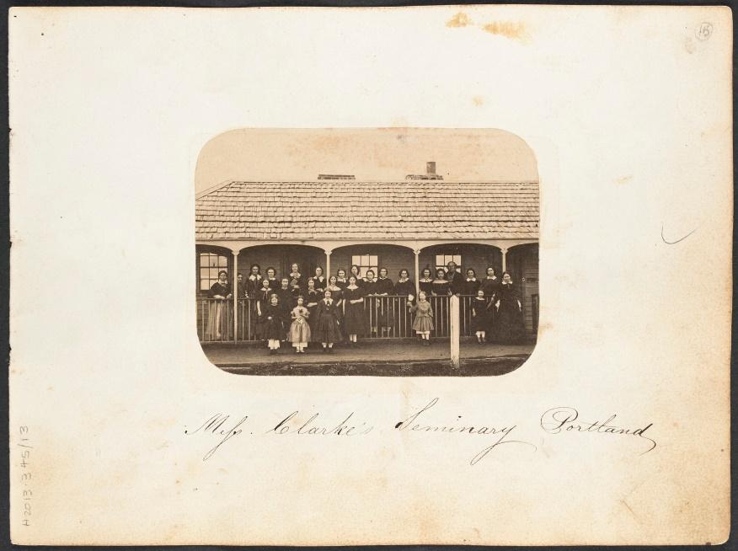
Caption: Miss Clarke’s seminary, Portland ca. 1859. A private school for girls.
Source: Thomas Hannay, Pictures Collection, State Library Victoria.

Ragged schools
Ragged schools were founded for children who came from families severely impacted by poverty and who could not afford the fees charged by national, common or denominational schools. It was understood by the teachers that the children attending may be dressed in ragged clothing, have no shoes, be unwashed, suffer from malnutrition and have intermittent attendance.
The first ragged school was founded in 1859 by Hester Hornbrook on Cambridge Street, Collingwood. Soon, more opened, each catering for between thirty-five and fifty students. Although not governed by the Denominational School Board, the teachings of the school were underpinned by religious, evangelical and moral philosophies. The ragged schools system provided opportunities to many children born into poor families, but in the spirit of religious salvation. Poor families were considered responsible for their own destitution through poor decision-making and moral depravity.
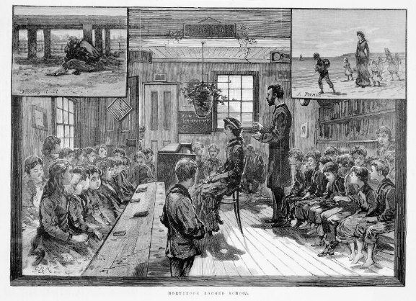
Caption: Illustration of Hornbrook Ragged School off Little Lonsdale Street, 1884. Note that several of the children sitting on the right bench are not wearing shoes.
Source: David Syme and Co. Illustrated Australian news collection, State Library Victoria.

Classrooms were furnished with wooden desks and benches. Equipment usually included a blackboard, writing slates for students, a world globe, a small supply of books, and the requisite portrait of the reigning British king or queen.

Curriculum and pedagogy
Prior to the Education Act 1872, National, denominational and common schools taught a range of core subjects including spelling, reading, writing, dictation, composition, grammar, geography, arithmetic, geometry, mensuration (a type of geometry dedicated to the measurement of length, area and volume), algebra, bookkeeping, vocal music (singing) and drawing, plus needlework for the girls.
The Education Act 1872 introduced standardised education, stipulating which subjects would be taught in Victorian schools. Core subjects were Reading, Writing, Arithmetic, Grammar and Geography. ‘Extras’ were some form of physical activity, and sewing or needlework for female students. An accurate command of the English language was at the forefront of education during this period. It was tied to ideas of model citizenship, class and social etiquette. Handwriting was also considered an important quality of well-educated children and adults.
The emphasis on different aspects of education changed over time as approaches to pedagogy and learning technologies changed. Many schools shaped their extracurricular activities according to the advice of school inspectors. Organising a school branch of the Gould League of Bird Lovers was generally approved.
With the advent of the twentieth century, new subjects such as social studies were integrated into the state school curriculum.

Women and education
Women have been stalwart contributors to the history of education in Victoria, both as members of the teaching workforce and as volunteers through mothers’ clubs, school boards and other voluntary activities.
Dame schools
Many of the earliest private schools in the colony of Victoria were founded by women and run out of a private home. Students were taught academic skills alongside social etiquette and female arts such as needlework. These institutions incurred a small fee and were referred to as ‘dame schools’. The earliest dame school in Australia was founded in 1789 by a female convict named Isabella Rosson. In several cases, dame schools became large and significant educational institutions, such as Carlton State School, founded by Grace Pullar in 1858. The school was later renamed as the Faraday Street Common School, then the Faraday Street State School (No. 112). It closed in 1972 and is now the Kathleen Syme Education Centre.

Female students
Some of the challenges female students faced in the colony of Victoria related to the expectation that they would only need a basic education, as very few professional careers were offered to women at the time. They were less likely to undertake the more academic subjects. Only girls who attended private schools, were from wealthy families, or had a home tutor or governess were likely to study languages.
After the Education Act 1872
Teaching, along with nursing or becoming a governess, was one of the few professional careers available to women in the nineteenth century. Female teachers made up 48 per cent of the teaching profession in Victoria by 1866 and were highly valued for their ability to impart moral values in education. Under the National and Common School Boards, married women were allowed to teach or superintend schools—although, generally, they were paid less than male teachers. This was also evident in the denominational and ragged schools systems.
The Education Act 1872 signalled a new regime in educational administration that initially had a negative impact on female educators. This, in partnership with an unstable economy, meant that female teachers began to lose both rights and responsibilities as educators in the Victorian state school system. The Public Service Act 1889 stripped women of the right to work as teachers when they married, stating that they had to leave the public service. There was a small concession in that the amended 1890 Public Service Act (Article 14) allowed women (on the recommendation of the Governor in Council) to be employed as a sewing mistress.

Victorian Lady Teachers’ Association
The Victorian Lady Teachers’ Association (VLTA) was founded in 1885 in response to the marginalisation and unfair treatment of female teachers by the Victorian Education Department. They campaigned against the higher salaries awarded to their male counterparts, the exploitation of female workers, and the lack of superannuation schemes for female teachers in Victoria. They lobbied political figures and were outraged by the exclusion of women from the 1913 Teachers Act.
In addition to campaigning for the rights of women, the VLTA also tried to safeguard the educational opportunities for girls, especially when it was proposed that female students should be removed from academic lessons to train in domestic science two days a week.

Migrant student experiences
Some of the first education services for non-British migrant students were made on the goldfields of Victoria as Chinese miners arrived to seek their fortune. Initially, immigrants were single men, but over time men brought their wives and children with them. For those who wished to stay permanently in Australia, education would be a necessary step in planting their roots.
Many of the schools on the goldfields were denominational, although people of any religion could attend. The chief issues for teachers were language barriers, different religious beliefs among their pupils, and the nomadic nature of goldfield families who often moved around. Many church educators were not new to teaching non-English-speaking students due to a culture of overseas missionary work. In Ballarat, Reverend William Young began learning Chinese with locals and offering night classes to migrants and their children.
Impact of the Education Act 1872
Each decade of Australia’s colonial history has brought new migrants to Victoria—initially British and Chinese, later including Italians, Greeks, Vietnamese, Afghanis, Sudanese, and most recently Ukrainians.
Migrants were one of the key groups to benefit from and appreciate the stipulation that education was ‘free, compulsory and secular’. Many groups arrived in Australia due to economic issues in their homeland or to improve their socio-economic status. Although sometimes they had been professionals in their countries of origin, the language barrier meant that they had to take unskilled jobs and subsequently earn less income. In many cases, they came from countries where education was not free, and some had limited formal education.
The compulsory aspect of the Education Act 1872 was viewed positively by most migrants, as they saw education as an opportunity for their children to gain security and prosperity in their new homeland. Many migrant children were the first in their family to complete secondary schooling or attend university. This ethos often meant that educators were highly appreciated by migrant families.
The large wave of post-war immigration from Europe in the 1950s and 1960s changed the dynamic of public education in Victoria. Teachers were not equipped to teach students from non-English-speaking backgrounds and as a result many children struggled to engage with or understand their lessons. The ideology associated with the assimilation policy meant that students were simply expected to adapt. Many accounts show a clear division between students from English-speaking and non-English-speaking countries during this period. Students often suffered due to racist ideologies or stereotyping.
Because of the secular nature of Victorian public education, children from Jewish, Greek Orthodox, Hindu, Muslim or other faiths were not required to receive Christian religious instruction. However, being removed from the class during the religious education sessions that were delivered in schools by external providers sometimes made these students feel conspicuous and different from their peers.
Many children who immigrated between the 1970s and 2000s had come from countries such as Vietnam, Somalia, Ethiopia and Sudan and had suffered trauma due to wars in their own countries. Many had arrived without their parents, had grown up in refugee camps, and had never experienced formal education. It wasn’t until Victoria adopted a multiculturalism policy in the late 1970s and 1980s that education underwent a large shift to improve access and experiences for children from migrant families.

Students with disabilities
After the passing of the Education Act 1872 (Article 13, Clause 2), one of the key exemptions to the requirement to attend school related to health and disability. The Act was formed with the understanding that universal education would be beneficial to all Victorians, so several institutions were founded to ensure that students who had been born with, or acquired, disabilities could still attend school.
Victorian Asylum and School for the Blind
In the nineteenth century, blindness affected many children due to eye disease. To provide a suitable formal education, the Victorian Asylum and School for the Blind was opened in 1866. Children and young adults who attended lived onsite. The use of the term ‘asylum’ is confronting because it linked blindness with a lack of capability and a need to be protected from the world. It was also used in relation to mental health facilities. Students who attended the school learnt academic skills similar those in the mainstream schooling system. Additionally, they learnt a trade that could help them to become more financially independent. These included brush making, basket making, mat making, wool work, commercial or domestic laundry skills, knitting and needlework.
1970s to the present
Educational opportunities for students with long-term illnesses and disabilities improved during the second half of the twentieth century. More facilities for students with disabilities were included in mainstream education. These included ramps, modified toilets and hearing loops, although it was well into the twentieth century before all schools complied with accessibility regulations. Programs such as distance learning and the advent of online learning also increased the capacity for students who could not attend mainstream schools.

References
Budj Bim Cultural Landscape (2022) Budj Bim education programs, Budj Bim Cultural Landscape website, © Copyright Budj Bim Cultural Landscape, accessed 4 October 2022.
Burchell L (ca. 1970 – 1999) Old catholic church and denominational school Portland (common school no. 510) [photograph], H2006.165/307, Laurie Burchell collection of photographs of Victoria schools, State Library Victoria, accessed 14 September 2022.
City of Ballarat (2022) Eureka centre Ballarat, © Copyright City of Ballarat, accessed 4 October 2022.
David Syme and Co. (1884) Hornbrook Ragged School [picture], PCINF IAN 20-02-84 P.20, Illustrated Australian news collection, State Library Victoria, accessed 14 September 2022.
Deadly Story (2022) Languages, Deadly Story website, © Copyright Deadly Story, accessed 4 October 2022.
Department of Education and Training (DET) (2022) ‘Then and now’ [video], 150 years of public education in Victoria, DET website, © Copyright State Government of Victoria, accessed 30 September 2022.
DET (2022), 150 years of public education in Victoria, DET website, © Copyright State Government of Victoria, accessed 30 September 2022.
DET (2022) 150 years: Brown Hill Primary School, DET website, © Copyright State Government of Victoria, accessed 4 October 2022.
Hannay T (ca. 1859) Miss Clarke’s seminary, Portland [photographic print], H2013.345/13c, Pictures Collection, State Library Victoria, accessed 14 September 2022.
History Teachers’ Association of Victoria (HTAV) (2021) ‘How to conduct an oral history interview’ [video], HTAV, Vimeo, accessed 30 September 2022.
Hughes, P & Moore, AJ (1997) ‘Aboriginal Ways of Learning and Learning Styles’, Annual Conference of the Australian Association for Research in Education, Brisbane, 4 December 1997.
Koorie Heritage Trust & Network Aboriginal Disability and Aged Care Agencies (2016) ‘Aboriginal life in Gippsland – A seniors perspective’ [video], Aboriginal life in Victoria: Gippsland reflections, Koorie Heritage Trust website, © Copyright Koorie Heritage Trust, accessed 4 October 2022.
McFadzean M (2004) Australian Children’s Folklore Collection (ACFC), Museums Victoria Collection website, © Copyright Museums Victoria, accessed 4 October 2022.
Museums Victoria (2022) Learning – Onsite programs, Museums Victoria website, © Copyright Museums Victoria, accessed 4 October 2022.
Museums Victoria (2022) Museums Victoria Collections, Museums Victoria website, © Copyright Museums Victoria, accessed 4 October 2022.
National Library of Australia (2022) Trove, © Copyright National Library of Australia & Trove partners, accessed 4 October 2022.
National Trust Victoria (2022) Mrs Sargood Goes to School, National Trust Victoria website, © Copyright National Trust, accessed 4 October 2022.
Parks Victoria (2022) Brambuk the National park and cultural centre, Parks Victoria website, © Copyright Parks Victoria, accessed 4 October 2022.
Parliament of Victoria (1872) Education Act, State Government of Victoria.
Solomon & Bardwell (1861) National School Dana Street Ballarat [picture], H2044, Pictures Collection, State Library Victoria, accessed 14 September 2022.
State Library Victoria (2022) School Programs, State Library Victoria website, © Copyright State Library Victoria, accessed 4 October 2022.
Visit Victoria (2022) Walhalla, Visit Victoria website, © Copyright State Government of Victoria, accessed 4 October 2022.

