July 2019
Report to Victorian Department of Education and Training
Respectful Relationships Evaluation 2017-18
Phase One Evaluation Summary

About ACIL Allen
ACIL Allen is a leading independent economics, policy and strategy advisory firm, dedicated to helping clients solve complex issues.
Our purpose is to help clients make informed decisions about complex economic and public policy issues.
Our vision is to be Australia’s most trusted economics, policy and strategy advisory firm. We are committed and passionate about providing rigorous independent advice that contributes to a better world.
© ACIL Allen 2021

Executive summary

Introduction
The Respectful Relationships initiative is a whole-of-school approach to embedding a culture of respect and gender equality via the curriculum, policies, practices and the whole school environment.
The Victorian Government allocated $21.8 million in 2016 to implement Respectful Relationships in schools and early childhood education settings across Victoria. An additional $22.8 million in funding was announced in 2018 to continue to deliver the Respectful Relationships initiative.
The Victorian Department of Education and Training (the Department) commissioned ACIL Allen Consulting to conduct an evaluation of the initial rollout of the Respectful Relationships initiative. The purpose of the evaluation was to examine the effectiveness of implementation and to capture early signs of impact on school communities and funded kindergarten programs.
The evaluation has examined the implementation and impact of the Respectful Relationships initiative on Victorian school communities over the 2017-18 period, incorporating the experience of the 1,015 participating schools (including 151 Lead schools and 864 Partner schools) and 34 dedicated Respectful Relationships workforce staff. This was gathered through:
— comprehensive site visits at 20 schools across Victoria, including interviews and focus groups with school leadership, school staff, students, parents, community organisations and the Respectful Relationships workforce to produce rich qualitative data;
— surveys of school staff and secondary students of Lead and Partner schools, and community organisations currently working with the Respectful Relationships initiative, to produce quantitative data on the Respectful Relationships initiative; and
— four focus groups with early childhood educators who had undertaken the Respectful Relationships professional learning, to capture post-training perspectives on the content and impact of the sessions.
The findings of the 2017-2018 evaluation will support the continued implementation of the Respectful Relationships initiative over 2019 to 2020. As the evaluation was undertaken in the early stages of implementation, it provides a comparison point to measure changes in knowledge, skills, attitudes and behaviours in future phases of the Respectful Relationships initiative.

Implementation
The key components of the Respectful Relationships initiative were established over 2017 and 2018, including recruitment of the Respectful Relationships workforce, enlistment of more than 1,000 Lead and Partner schools, creation of a suite of professional learning opportunities and dissemination of key resources.
Lead and Partner schools have made significant progress in implementing the Respectful Relationships initiative, with comprehensive activity underway against most elements of the whole-of-school approach. The support provided by the Respectful Relationships workforce, in particular through local professional learning activities, has played an essential role in assisting implementation. School communities have been receptive, and parent feedback indicates broad based support for the objectives of the Respectful Relationships initiative.
The Respectful Relationships initiative is supported by a comprehensive professional learning program for school communities. Figure ES 1 shows the breakdown of school staff survey responses across the suite of professional learning opportunities. The results indicate that professional learning has been largely effective in supporting implementation of the Respectful Relationships initiative, with 76 per cent of school staff on average agreeing that they felt well supported to implement the Respectful Relationships Initiative through professional learning.
Figure ES 1 School staff survey responses – Professional learning
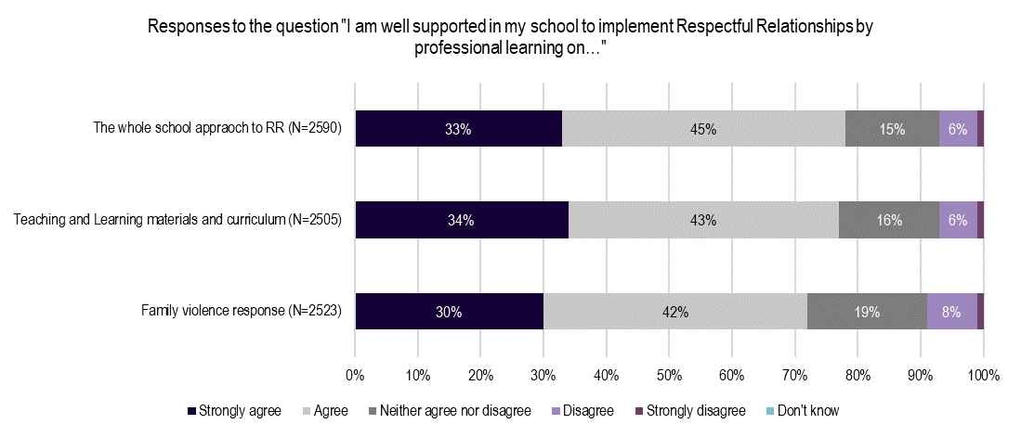Note: This chart excludes respondents who answered “I have not been involved in this aspect of Respectful Relationships” and missing responses.
Source: School Staff Follow Up survey, 2018.
The Department has developed guiding resources to assist schools in implementing the Respectful Relationships initiative, including the Resilience, Rights and Respectful Relationships (RRRR) teaching and learning materials and the Respectful Relationships: A Resource Kit for Victorian Schools. School staff reported that the RRRR materials provided comprehensive and well-researched subject matter, in an accessible and flexible format, with 82 per cent of school staff reporting that they felt well supported by the RRRR materials (Figure ES 2).
Figure ES 2 School staff survey – RRRR Teaching and Learning materials
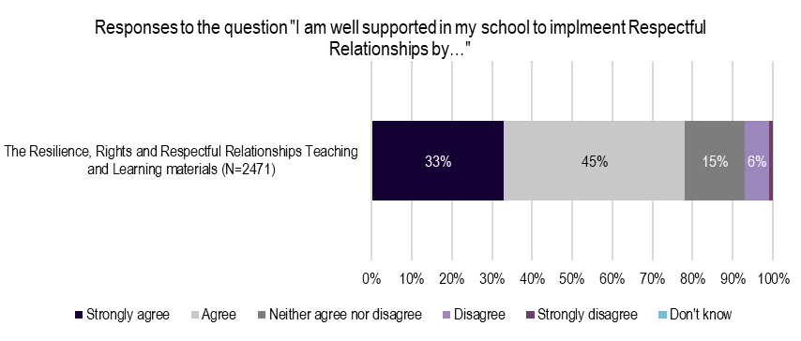
Note: This chart excludes respondents who answered “I have not been involved in this aspect of Respectful Relationships” and missing responses.
Source: School Staff Follow Up survey, 2018.
Notwithstanding these achievements, some elements of the Respectful Relationships initiative have presented challenges – namely, the simultaneous onboarding of Lead and Partner schools, the delayed availability of supporting resources to guide implementation, and difficulties in engaging the broader school community (for example, parents and community organisations) while schools were initially focused on building internal capabilities.
Consultations with school communities across Victoria identified a number of effective strategies to address these challenges, including leveraging existing school relationships to support Communities of Practice, proactive engagement approaches for integrating parents into Respectful Relationships-related activities, and locally-based partnerships to build broader community engagement and promote the key messages of the Respectful Relationships initiative.
The effectiveness of these practices demonstrate the potential for the Respectful Relationships initiative to adapt and respond to local contexts, while delivering against the core objectives. This provides support for the overall design of the Respectful Relationships initiative’s design.

Impact
There is a strong foundation for the work of the Respectful Relationships initiative. School staff have shown the strongest improvements in positive attitudes toward gender equality, respectful relationships and the prevention of family violence through the evaluation (Figure ES 3). The baseline and follow up surveys highlight that 89 per cent and 92 per cent (respectively) of staff were supportive of gender equality while 91 per cent and 98 per cent (respectively) of staff had attitudes that aligned with the objectives of preventing family violence. This is to be expected, given the majority of implementation efforts have focused on building school staff capability.
Figure ES 3 Teaching staff attitudes towards gender equality and preventing family violence
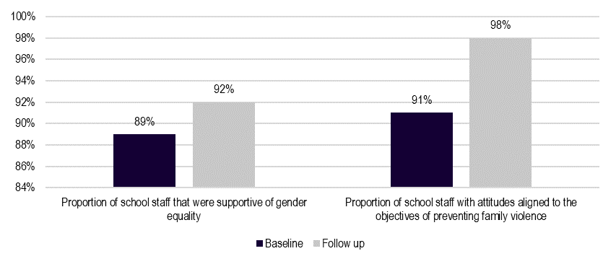
Source: School staff surveys, 2018.
Given the cultural change sought by the Respectful Relationships initiative, it is to be expected that significant time will be required to generate measurable outcomes across the whole school community. Schools recognised the need for continued effort to produce the breadth of impact anticipated from the Respectful Relationships initiative.
‘It’s a generational shift for the kids, we need to educate the kids while we’re educating ourselves as a school and an educational community, including parents.’ (School staff)
Noting the time required, the evaluation identified early signs of change in school communities in relation to school culture, respectful relationships, and gender equality.
All schools consulted had conducted baseline assessments and were either in the process of updating, or had updated, their policies and procedures to promote gender equality. Schools saw this as a valuable step in reflecting on the school as a workplace and identifying gaps in their current approaches.
‘I think the thing that has had the most impact on me is the subliminal stuff, talking about how there’s things that occur that we’re not really aware of all the time. There’s things we say, the books we’re choosing, the activities we’re doing in the school. It’s made me a bit more aware.’ (Teacher)
Some schools had taken active approaches to create opportunities for inclusion, such as introducing a mixed-gender sports teams, while others observed the changes occurring without a need for deliberate intervention.
‘We’ve seen big changes around footy and the kids being a lot more inclusive of the girls. There’s more girls that want to play and want to get involved.’
(Primary school principal)
The Respectful Relationships initiative has contributed to improved relationships between staff and students through the provision of a platform and common language for school staff and students. School staff noted that the Respectful Relationships initiative provided an opportunity for reflection and opened up thoughtful dialogue, which was changing how staff interact with each other, and with students. Students reported that their interactions had become more respectful, with teachers taking more time to listen to students, respect their concerns and work with them to develop solutions.
There was an observed increase in staff and students’ willingness to engage in discussions about sensitive topics using the language of the Respectful Relationships initiative. This has helped in developing the social and emotional literacy of students, with staff reporting that students’ were demonstrating improved their understanding of their own strengths, those of others, their understanding of nuanced emotions, and improved coping strategies.
‘Students are more willing to come and talk to you if people are being mistreated, it’s given them new ways of expressing themselves.’
(Primary school teacher)
Feedback from school staff, students and parents reported positive changes in their knowledge and behaviour as a product of participation in the Respectful Relationships initiative. A key area of impact related to the increased staff awareness of gender concepts, including gender equality, negative stereotyping and implicit bias.
‘From where we started, staff have a greater understanding…of the gender stereotypes that are portrayed within the school. Everyone is more aware, changing our language to “Who would like to be involved?” rather than “I need five strong boys”.’ (Primary school principal)
While the impact on students’ attitudes toward gender equality was of a smaller magnitude, students were demonstrating initial improvements regarding improved knowledge on gender norms and stereotypes, greater acceptance of gender diversity, and increasingly inclusive behaviours.
A common example related to students correcting other students or teachers, or even their own parents, when inappropriate comments were made. Some parents reported that the initiative had supported discussions in the home. In turn, this had encouraged parents to rethink the behaviours they were modelling for their children.
‘I can’t remember having those conversations with my older son, but my younger child is having conversations about being inclusive of people regardless of what they’re going through.’ (Parent)

Respectful Relationships professional learning for early childhood educators
The Respectful Relationships professional learning for early childhood educators is one of the five components of the Respectful Relationships initiative. The aim is to support educators to create cultures of respect, positive conflict resolution and equality in their program delivery.
The initial rollout of the professional learning for early childhood educators included 25 workshops delivered in the North Eastern Victoria Region (Inner and Outer Eastern areas), reaching 511 participants. The professional learning is expected to be rolled out state-wide to up to 5,000 early childhood educators in funded kindergartens in 2019 and 2020.
The professional learning was positively received by participants, with educators expressing strong support for the availability of Department-endorsed professional learning on family violence and gender equality. Survey data from Monash University, contained in the RR Early Childhood Professional Learning Interim Report, identifies positive outcomes from participants. A total of 347 participants (68 per cent) completed the participant feedback survey, with responses highlighting that:
— 90.5 per cent strongly agreed/agreed that they had increased knowledge of gender equality as a prevention of family violence
— 90.5 per cent strongly agreed/agreed that they had increased knowledge of the drivers of family violence
— 90.7 per cent strongly agreed/agreed that they had increased capacity to promote and build respectful relationships with children and each other
— 86.9 per cent strongly agreed/agreed they had increased capacity to plan and deliver a program that supports respectful relationships and gender equality.
Feedback received from early childhood educators indicated that the professional learning provided a valuable opportunity, increasing their understanding of family violence. There was an opportunity to improve the tailoring of the material, in recognition of the different educational levels and prior exposure to family violence-related programs for early childhood educators.
However, there were mixed perspectives on the impact of the professional learning on knowledge of gender equality and capacity to embed respectful relationships in their practice. Educators expressed interest in professional learning on strategies, techniques and resources to assist them in translating concepts to practice. The professional learning would thus benefit from clear alignment of content with the parameters and scope of early childhood educator roles.

Conclusion
There has been significant progress made towards implementing the Respectful Relationships program, with over 1000 Lead and Partner schools recruited, the creation of professional learning opportunities, and the dissemination of key resources. The Respectful Relationships initiative has been well received by school communities, students and parents. The supports provided through the Respectful Relationships initiative have aided implementation in school; however, at the same time, there are opportunities for improvement in relation to the design and implementation of the Lead and Partner school model, and the accessibility of professional learning, and consistency of approaches across the state.
The Respectful Relationships initiative has been implemented in the context of strong pre-existing school staff attitudes toward gender equality, family violence, relationships and school policies and culture. While generally also positive, student attitudes were more varied and have greater scope for improvement. When considered together, the qualitative and quantitative data indicate that the teaching workforce and school staff show the strongest improvements in knowledge, attitudes and behaviours toward gender equality and the prevention of family violence. While acknowledging that these are early indicators only, it is reasonable to expect that such improvements should begin to be evident in student populations in the near term, as schools further progress delivery of the curriculum and implementation of the initiative.
The early childhood workforce has benefited from the professional learning provided. Early childhood educators reported that the professional learning improved their understanding of family violence, noting the importance of information grounded in statistics to reaffirm the scale and extent of the issue. While perspectives on the professional learning were largely positive, there was a consistent demand for more strategies, techniques and resources to assist educators in translating concepts to practice. The feedback received on the impact of the professional learning highlights the need to tailor the material to suit participant cohorts (for example, a beginner/advanced model) and the early childhood context.

