SKILLS FIRST YOUTH ACCESS INITIATIVE: Referral Form
HELPING bridge the gap between education and disadvantage for young people in victoria

This Referral Form must be completed in order to obtain a tuition fee waiver under the Skills First Youth Access Initiative. Please refer to the Skills First Youth Access Initiative: Guide Book prior to completing this form. The Skills First Youth Access Initiative provides a tuition fee-waiver for Victorian young people undertaking government subsidised accredited training who:
- are aged 24 years or under at the time of first commencing education and training; and
- have been or currently are on a Child Protection Order or a Youth Justice Order (but not currently in custody); or
- are an Education First Youth Foyer resident.

Figure 1 outlines the Skills First Youth Access Initiative referral process.

START

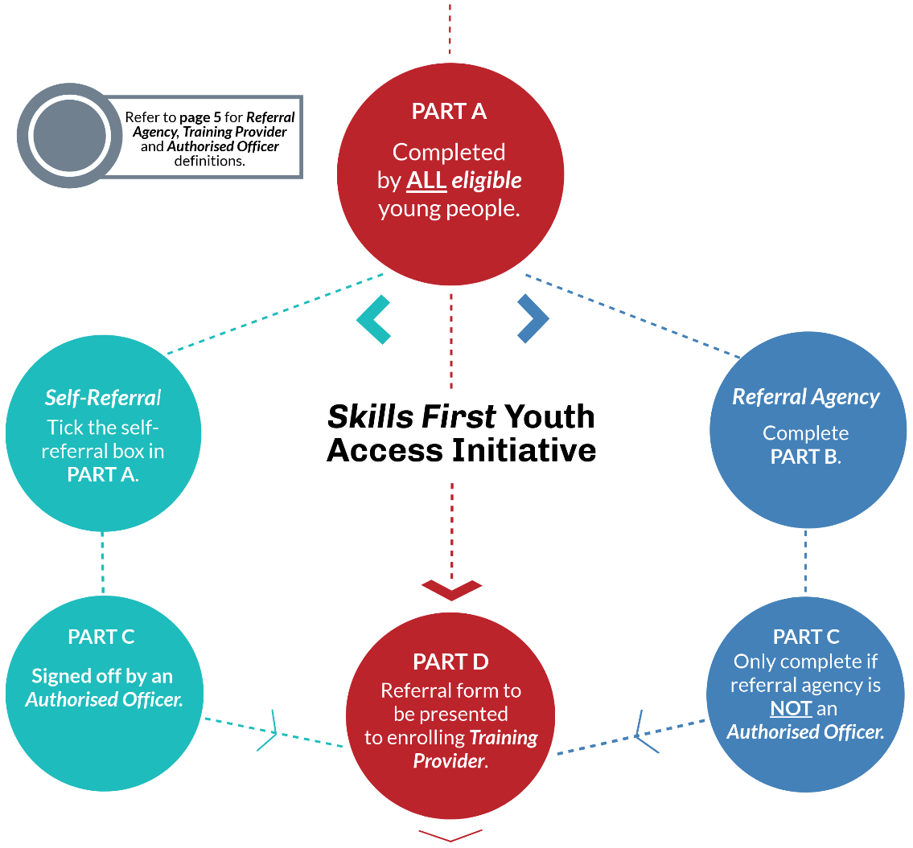
COMPLETE TRAINING

SKILLS FIRST YOUTH ACCESS INITIATIVE – REFERRAL FORM
PART A – To be completed by the eligible young person
Name:_________________________________________ Date of birth: ____/_____/____
Phone / Mobile:__________________________________ Email: ________________________________
- Privacy statement: If you’ve previously been on a Youth Justice Order and are no longer managed by a youth justice case worker, you can email a copy of your referral form with PART A completed and signed to youthaccessinitiativeeligibilty@justice.vic.gov.au to have your eligibility confirmed. By signing and sending the form to the Department of Justice and Community Safety (DJCS) you’re consenting to your personal information regarding any previous youth justice history being shared with the Department of Education and Training (DET) and the enrolling training provider for the purpose of accessing the tuition fee-waiver.
- If you’ve previously been on a Child Protection Order and are no longer engaged with a child protection service, please contact the leaving care hotline on:1300 532 846 or email: leavingcare@mcm.org.au for assistance in authorising eligibility for the Youth Access Initiative.
I (Print Name) _____________________________________, consent to the information provided on this form being shared between Referral Agencies, Authorised Officers, DET, DJCS, Department of Health and Human Services (DHHS) and Training Providers for the purpose of assessing my eligibility to the tuition fee-waiver under the Youth Access Initiative.
Signed: ________________________________________ Date: ______/______/______
PART A must be completed by the eligible young person for information sharing. If the participant is under 16 years of age, their legal guardian should complete it.
 Tick this box if you are self-referring without the support of a Referral Agency and proceed to PART C.
PART B – To be completed by the Referral Agency
If the Referral Agency staff member completing the form is an Authorised Officer (see page 5 for definition), do not complete PART C.
Name of Referring Agency:________________________________________________________________
Is the Referral Agency staff member an Authorised Officer (see page 5 for definition)? YES / NO
Print Name of Referring Agency Staff: ________________________________________
I confirm that the young person described in Part A (tick all the appropriate boxes):
 is currently 24 years of age or under; and
▪ ‘has been’ or is ‘currently on’ a Child Protection Order or a Youth Justice Order (but is not currently in custody); OR
▪ is an Education First Youth Foyer resident; and
▪ wants to enrol in suitable government subsidised training at an appropriate training provider as described in the Skills First Youth Access Initiative: Guide Book.

Signed: ________________________________________ Date: ______ /______/______
Phone / Mobile:________________________________ Email: ________________________________
PART C – To be completed by an “Authorised Officer” from one of the following:
- the Department of Health and Human Services (DHHS)
- the Department of Justice and Community Safety (DJCS)
- or an Education First Youth Foyer
If PART B is completed by an Authorised Officer, do not complete PART C.
I confirm that the young person described in Part A (tick all the appropriate boxes):
 will be 24 years of age or under; and
▪ ‘has been’ or is ‘currently on’ a Child Protection Order or a Youth Justice Order, (but is not currently in custody); OR
▪ is an Education First Youth Foyer resident; and
▪ wants to enrol in suitable government subsidised training at an appropriate training provider as described in the Skills First Youth Access Initiative: Guide Book.
Name of staff member: _______________________________ Position: __________________________
Name of the Department: _____________________________________________________________
Division: _______________________________ Branch / Unit: _______________________________
Signed: ________________________________________Date: ______/______/______
Phone / Mobile:________________________________ Email: ________________________________
PART D – To be completed by a representative of the enrolling Training Provider
- The young person is eligible to enrol in government subsidised training under Skills First and has been enrolled in a suitable course.
- The eligible young person has been granted a waiver of their student tuition fees under the Skills First Youth Access Initiative.
Enrolling training provider must keep the ORIGINAL referral form and give a COPY to the enrolling young person and Referral Agency (where applicable).
Name of the Training Provider: ________________________________________________________
Address of the Training Provider: ______________________________________________________
TOID: ______________________________ Course Code:_________________________________
Course Name: _____________________________________________________________________
Course Start Date: ____________________ Expected Course End Date: _____________________
Contact Name: _______________________________ Phone / Mobile: _______________________

IMPORTANT MATTERS TO NOTE

Referral Agency

Any organisation based in Victoria that currently receives funding from or is contracted by the Victorian Government or the Commonwealth Government to provide services to children, young people and/or families can act as a Referral Agency for the Skills First Youth Access Initiative and support the eligible young person in completing the Referral Form and enrolling in a suitable course. All Referral Agencies are required to retain a COPY of this Referral Form for audit purposes.

Authorised Officers

Authorised Officers can sign off on the eligibility of a young person for the Skills First Youth Access Initiative. These include Post-Care Support staff, Education First Youth Foyer authorised staff, Youth Justice case managers, central DJCS authorised staff, and Parkville College.

Training Providers

Skills First contracted Training Providers approved to offer a tuition fee waiver under the Youth Access Initiative (being only TAFE and Dual Sector Universities and Learn Local organisations), must NOT charge eligible Youth Access Initiative young people any tuition fees for government subsidised accredited training.

Relevant training providers are required to retain the ORIGINAL of this Referral Form for audit purposes, and return a copy to the Referral Agency (where relevant), and to the enrolling student. The Training Provider will receive a contribution from DET for the tuition fee-waiver under the Skills First Youth Access Initiative.

The Training Provider must report all training delivered to the eligible young person under the Skills First Youth Access Initiative in accordance with the reporting requirements outlined in the Victorian VET Student Statistical Collection Guidelines, including using the Fee Exemption/Concession Type Identifier ‘E’.

