Annie Ngo

Rationale
This whimsical and playful design expresses the power of literature in transforming a child. I have incorporated a range of dynamic shapes swirls and spirals that capture the child-like wonder and curiosity I too as a kid experienced when I read fairytales and other books. I wanted to capture the idea of growth as a fluid and magical process, incorporating key works such as “learn” “discover” and “explore” to highlight the different ways reading helps others to grow.

Charlie Robert

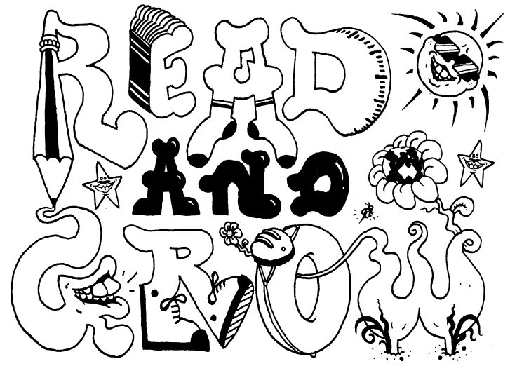

Rationale

For me, prep was a year of fascination, learning and imagination, so I tried to incorporate those themes into some playful letters spelling ‘Read and Grow’, depicted as some of the early things that preps are taught, such as reading, writing and measurement, through a simple cartoon style that would hopefully excite preps for their years of schooling ahead.

Emma Panozzo

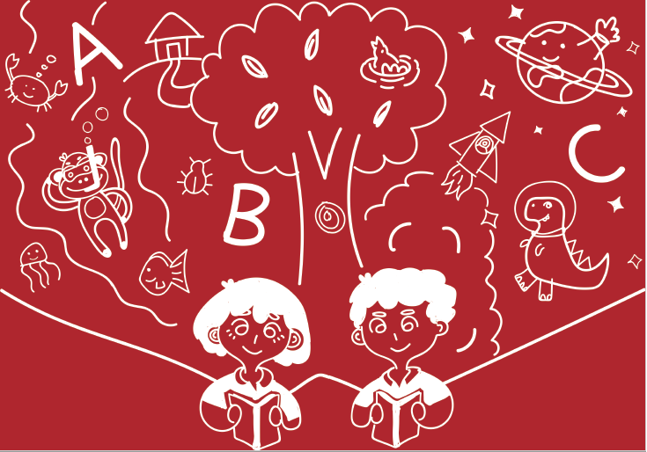

Rationale

As preps enter school and get a taste of independence, reading is a skill that plays a big part in the way they grow to understand the world. In my design I wanted to show the wonder and opportunity of reading, it's a way in which you can learn about the world and also unlock your imagination and creativeness.

Esther Liu

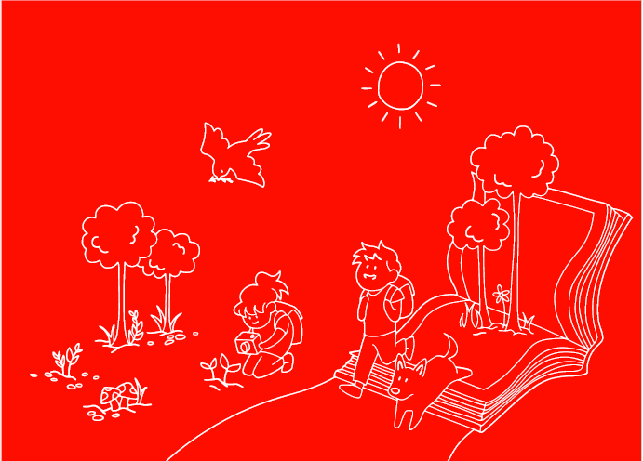

Rationale

I interpreted the “grow” part of the theme both physically, represented in the greenery incorporated into the design, and figuratively, as in maturing. In my design, the children leap out of an open book, ready to explore and embark on an adventure, representing how reading fosters a wonderful curiosity, and is a gateway into broadening horizons and “growing” their worlds.

Jamie Tung

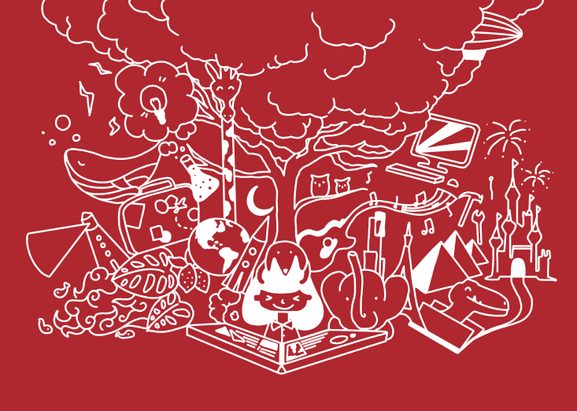

Rationale

My Illustration displays a little bit on how books effected my childhood. It shows how reading can unlock unlimited possibilities and teach you anything you wish to learn. The little girl symbolizes the childhood stages of prep and the large tree behind portrays growth metaphorically. The various objects surrounding the tree expresses the endless possibilities of learning and curiosity.

Kristie Anderson

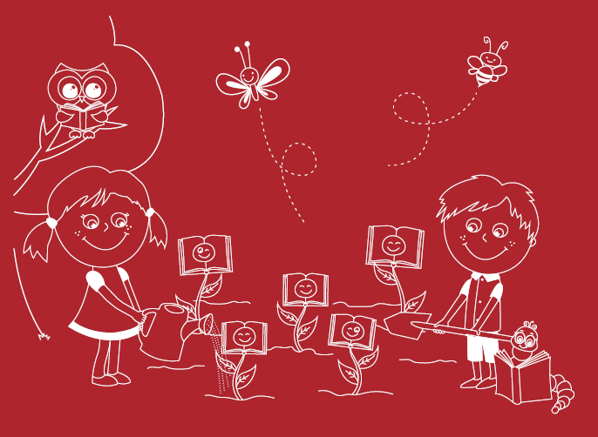

Rationale

Within my design I have taken both a literal and metaphorical approach; literal being plants symbolising growth, and books reflecting reading. My metaphorical approach focuses on the children gardening as reading a book is like planting a seed of knowledge, this seed grows with every book, allowing for the child to flourish in life into the beautiful flower they are.

Leyton Abduli

Rationale

Once a child open's a book for the very first time whether that be at home or in prep, a light shines in their eyes with a desire to be something or someone. Therefore, talent was held into throughout the creation of the design emphasising oneself 'growing' into an individual in which they inspire to become through their talents.

Magenta Blair

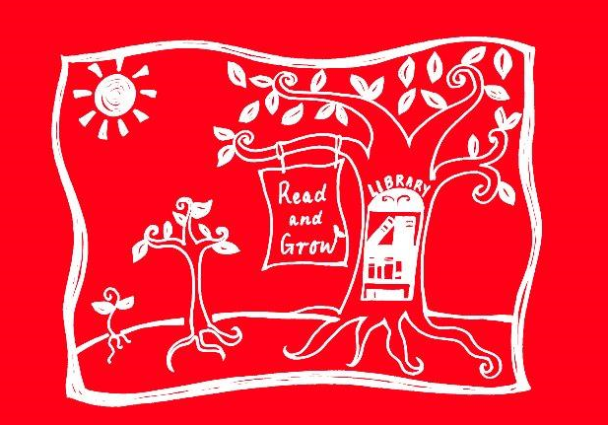

Rationale

My logo reflects 'Read and Grow', through a growing tree. This represents a student's growth, as they read, their knowledge grows. The image illustrates stages of tree growth; seedling, sapling, mature tree, depicting different levels of reading. The more a child reads, the more they 'branch' out in their knowledge, the roots deepening their growing and learning.

Sabine Schiavone

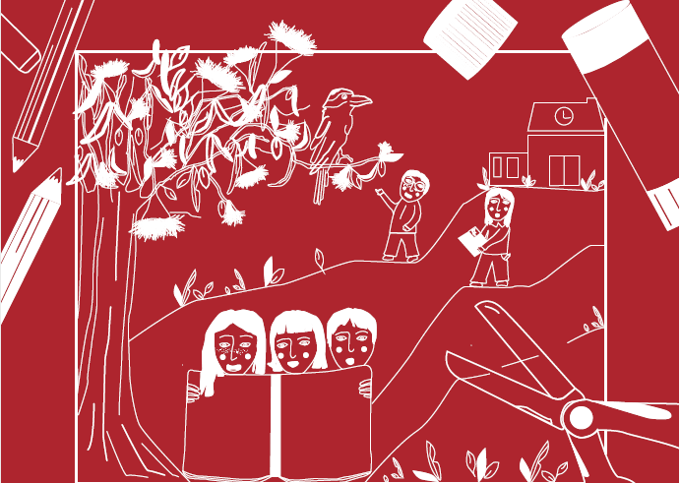

Rationale

The theme of read and grow is depicted through the outdoors, with a dynamic environment, allowing children to explore and open their eyes to new things, encouraging them to understand that they are able to learn anywhere and everywhere with their class mates and teachers. I wanted to convey children being able to create and discover their own ideas and creativity.

