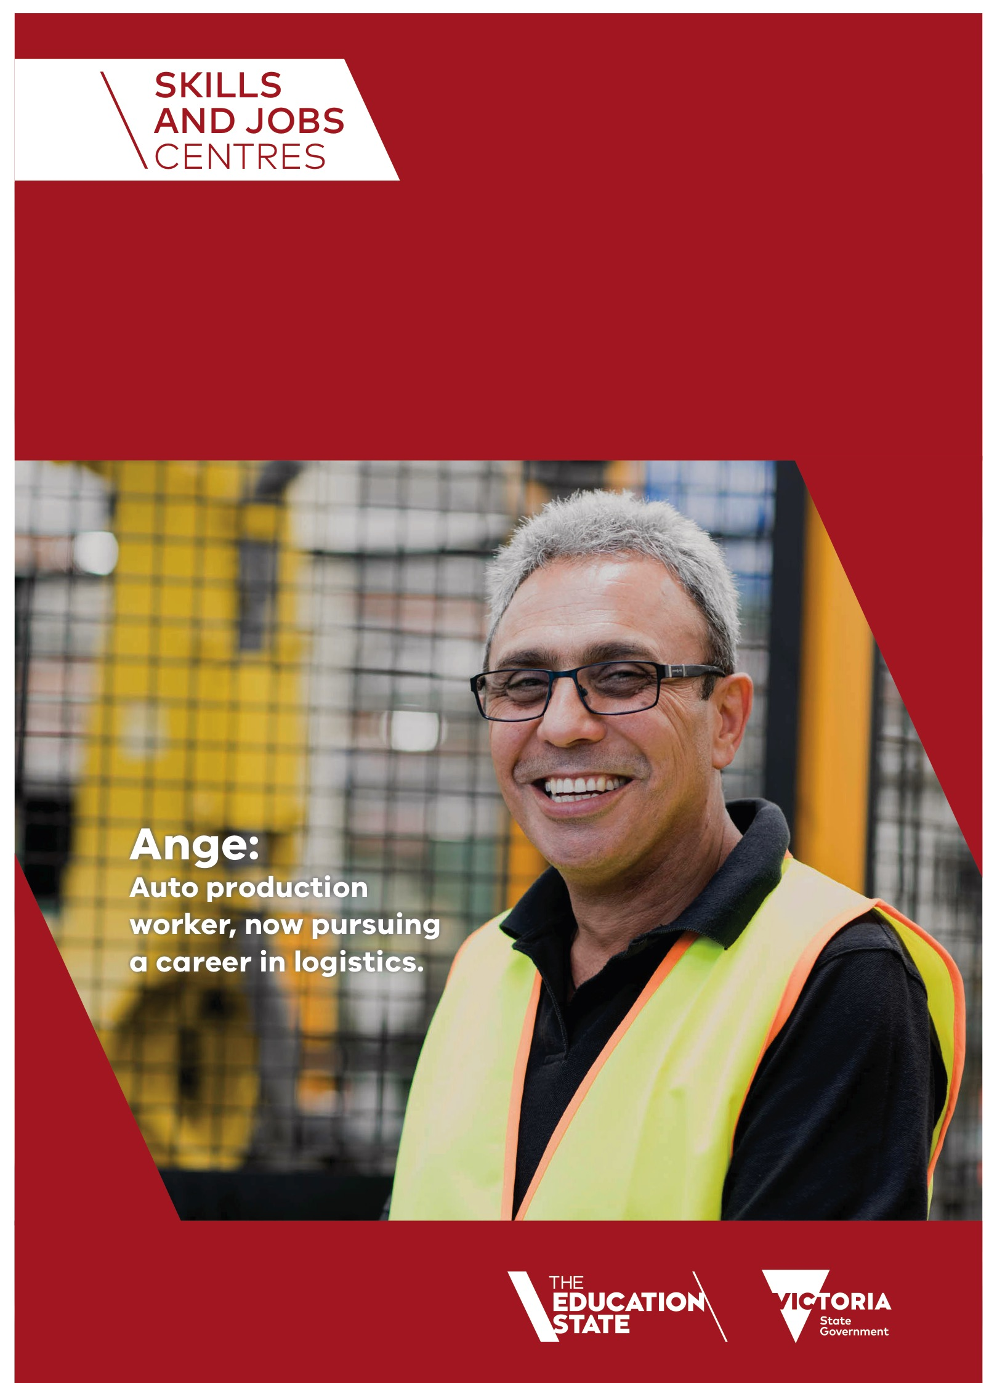

Transfer your skills.
Transform your life.
Important information for employees affected by
the closing of the automotive industry in Victoria.

Closure of the automotive manufacturing industry will affect many Victorian workers. The Victorian Government, through its Automotive Supply Chain Training Initiative, is providing support and services that will help you.

What do I do next?
For those of you facing an uncertain future due to the closure of the automotive
manufacturing industry, there is support available to guide you through to the next
steps in your career transition.
Knowing what to do and when, can be daunting so we’ve come up with a checklist
to help.
- Do you know when you are going to be made redundant?
- Has your employer spoken to you about what support services are offered by the Victorian Government?
- Have you thought about what job you’d like to do next?
- Do you have a current resume?
- Have you considered further training?
- Do you know what your final pay is likely to include and how this may affect your family budget?
- Have you discussed your financial future with a financial advisor?
What help is available to me?
• Special access to government subsidised training (supply chain workers only).
• Specialist Skills and Jobs Centres which will assist you and your family.
• Careers and transition advice provided by career coaching specialists.
• Help to identify training options and register with a training provider.

Further information about the support services available
The Government’s Automotive Supply Chain Training Initiative (ASCTI) support package has three key services.
Skills and Jobs Centre
Specialist skills and jobs centres catering to the needs of employees of automotive supply chain companies have been established in:
• Broadmeadows
• Dandenong
• Chadstone
• Sunshine
Skills and Jobs Centres offer employees in transition and their families, access to a suite of services including:
• Careers advice and guidance
• Training advice and support
• Workshops and information sessions
• Information regarding job opportunities
• Referrals to other support services
Victorian Training Guarantee
Employees of the Victorian automotive supply chain sector have been given greater access to government subsidised training. Access is usually restricted to those seeking to enrol in qualifications at a higher level than what they already have. This has been waived under this support package to enable workers to retrain in industries with identified jobs growth and skills shortages.
Career and Transition Advice Services (CTAS)
Independent, qualified, careers advisers have been engaged by the Victorian Government to provide Victorian employees of the automotive supply chain sector with free, personalised professional career planning and reskilling options. Employees are entitled to attend a workshop and follow-up one-on-one sessions with a careers adviser either at work or at a Skills and Jobs Centre.
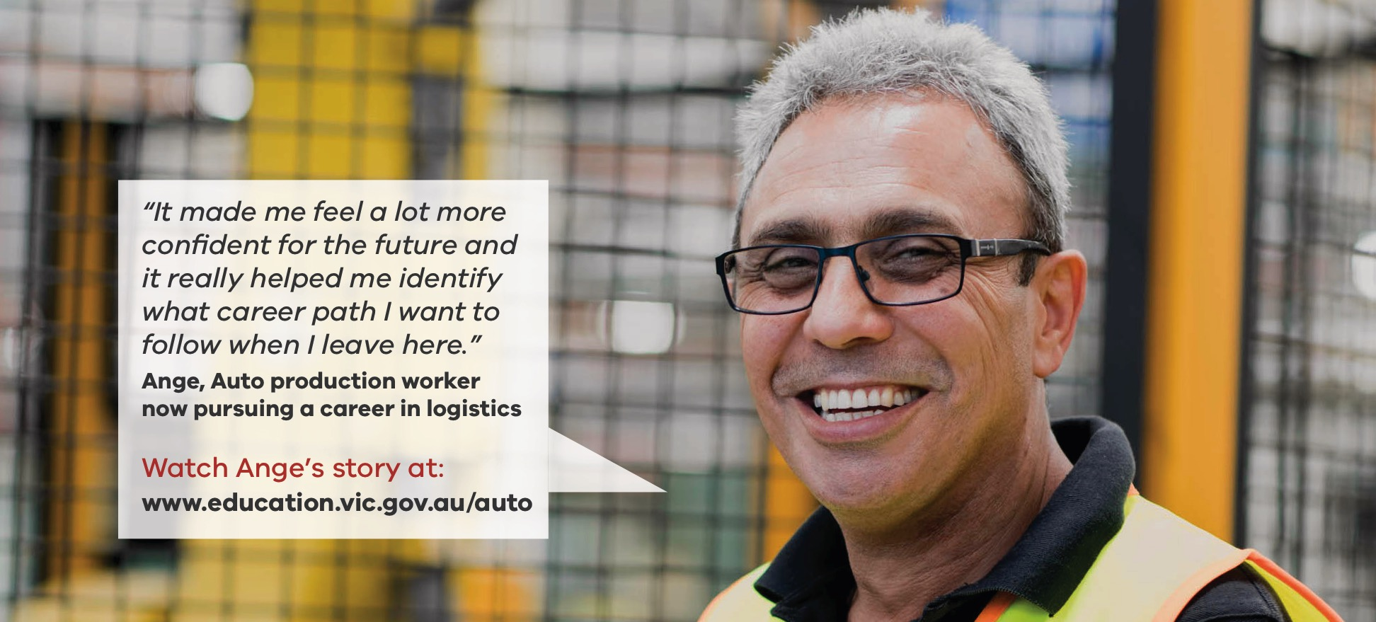
CONTACT
There are numerous ways you can find out more information to help
you make use of the government support services available.

SPECIALISED AUTOMOTIVE SKILLS AND JOB CENTRES
BROADMEADOWS
Kangan Institute
Pearcedale Parade
Broadmeadows 3047

DANDENONG
Chisholm Institute
311 Lonsdale Street
Dandenong 3175

CHADSTONE
Holmesglen Institute
Corner Batesford & Warrigal Roads
Chadstone 3148

SUNSHINE
Victoria Polytechnic
460 Ballarat Road
Sunshine 3020

ADDITIONAL SKILLS AND JOBS CENTRES
ARE BEING ESTABLISHED AT:
Footscray (Victoria Polytechnic)
Melbourne CBD (CAE, William Angliss and RMIT University)
Box Hill (Box Hill Institute)
Northland (Melbourne Polytechnic)
Ringwood (Swinburne University of Technology)
Bundoora (RMIT University)
Geelong (The Gordon)

Phone 134 389
WEB www.education.vic.gov.au/auto
IN PERSON Skills and Jobs Centres
EMAIL auto.industry@edumail.vic.gov.au

