Adolescence and Autism Spectrum Disorders

Dr. Avril V. Brereton

When considering the issue of adolescence and its effect on young people with ASDs, we need to think about the changes that this stage of life and development bring to all young people.

What is Adolescence?

Adolescence is the period and process of development from child to adult. The word adolescent is derived from the Latin word adolescence meaning to grow. Now we use the term adolescence when we refer to young people who are no longer children but are not yet adults. Adolescence begins at the time of puberty when sexual development begins, at around 11-14 years of age. It ends with the social transition to independence from the family but there is no clear marker of when that time is. In our society, some young people are not independent of their parents until their early twenties.

Changes in thinking

Adolescence brings about changes in thinking in the young person. Piaget (1952) developed a cognitive- developmental theory to explain the development and functioning of the mind. The pre-adolescent thinks in a concrete way, speaking of specific people, events and objects. He/she cannot understand concepts such as the relationship between the individual and society. In most children thinking becomes more abstract between eleven to fourteen years of age. By fourteen years of age the adolescent can conjure up make-believe situations, think about hypothetical possibilities, what might be, the future and the remote. For example an adolescent can think about what he/she is thinking about and reflect on his/her thoughts. As thought becomes more abstract, the adolescent begins to understand that a community of people is bound

together by largely invisible rules and obligations (Hoffman et al., 1988). This ability to deal with abstractions and logical possibilities was described by Piaget (1952) as the stage of formal operations, the final stage of cognitive development.

Adolescence brings changes in cognition (thinking) which are reflected in changed feelings and behaviour including:

• Improved ability to use speech to express self

• Tendency to revert to more childish behaviour, particularly when stressed

• Mostly interested in the present, with limited thoughts of the future

• Rule and limit testing

• More consistent evidence of a conscience and sense of morality

• Realization that parents are not perfect

• Self preoccupation and tendency to take things personally (self reference)

• Inconsistent beliefs, ideas and behaviours

Who am I now?

Adolescence also brings major change with regard to a person’s sense of identity. According to psychologist Erik Erikson (1968), babies are born with some basic capabilities and each has his/her own temperament. As a person ages, he/she passes through eight developmental stages (Erikson calls them "psychosocial stages") in which identity develops. Each stage is characterized by a different psychological "crisis" which must be resolved by the person before he/she can move on to the next stage. If the person copes with a particular crisis in a maladaptive manner, the outcome will be more struggles with that issue later in life. To Erikson, the sequence of these stages is set by nature

**1**

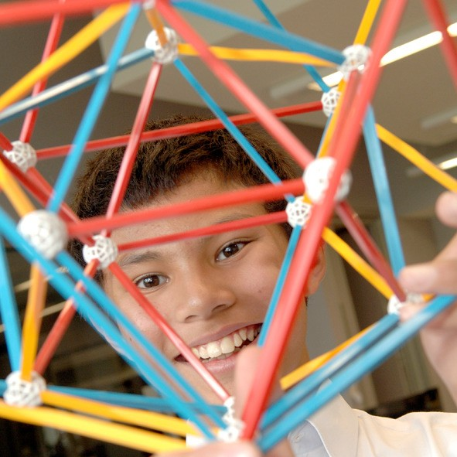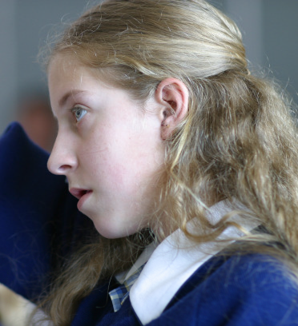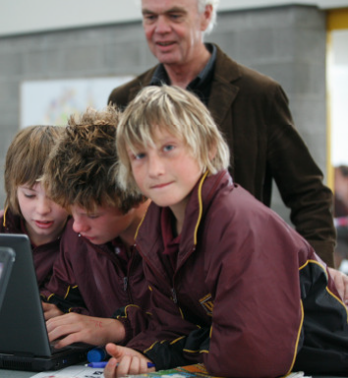

**Adolescence and Autism Spectrum Disorders Fact Sheet Two**

(Berger, 2001). His fifth stage of identity development occurs at the time of adolescence (12 – 18 years) and describes identity versus role confusion. This is the crossroad between childhood and maturity. The adolescent grapples with the question “Who am I?” Berger (2001) described this as a stage when adolescents must establish basic social and occupational identities. They are trying to develop an identity but also struggle with doubt about themselves and who they are, or are to become. Adolescents are interested in finding out who they are, what they are all about and where they are headed in life. Erikson described adolescents as entering a “psychological moratorium” a gap between the security of childhood and the autonomy of adulthood.

Another typical feature of most adolescents is that they

have times when they are totally self-centred, which may frustrate parents and other adults. During early adolescence, the young person usually becomes acutely self-conscious with an “I’m me and everyone is looking at me” point of view. During adolescence, friends and peers become increasingly important as the young person deals with physical and emotional changes. For most, the society of peers is the key social agent. Association with a particular peer group will determine dress, hair style, use of slang, interest in music, and other interests or pursuits. Outsiders are excluded from the peer group. During this period of self focus, adolescents also pay particular attention to the peer group as a social form of self-regulation. “What do the others think of me and how I look and the things I do and say?” “Do I fit in?”

Social relationships and friendships

The social relationships between typically developing peers reach their height of importance during adolescence. Peers provide a protective group in which to establish independence from parents, develop social knowledge, awareness and competence. This intense attachment to the peer group allows adolescents to begin to develop their sense of direction for adult life. Peer groups also strongly influence both positive aspects of behaviour, such as community service, and negative aspects such as smoking, depending on the nature of the peer group leaders and the degree of school and family support provided. Making friends, feeling left out or unpopular and noticing differences in each other become much more important. Adolescents begin to notice differences such as race, class and gender in a way that was less important in childhood as they divide people into groups, hierarchies or pecking

orders. Their differences and similarities help them discover who they are in relation to others. They also discover this by understanding what others think about them.

During childhood the rules for social interaction are fairly clear and concrete but become more abstract and flexible allowing for exceptions during adolescence. Some social rules are even unspoken, but most adolescents know what these unspoken rules are and how to behave. For example some swearing may be understood as acceptable among peers but the unspoken rule is that this is not allowed in front of their friends’ parents. Socially, peer interaction has less structure as adolescents spend more time sitting around or parading about together, talking and watching others. Language also becomes more complex as vocabulary develops and slang increases (e.g. sarcasm, irony and cynicism). Early adolescence is an important time for same sex friendships and the development of close friendships. It is these early special same sex friendships that prepare the young person for later opposite sex friendships and adult relationships. During adolescence, as interest in the opposite sex increases, the peer group usually changes and become a mixed sex peer group that will eventually lead to dating and sexual relationships. Learning to be part of activity groups is another aspect of social development during adolescence. Many young people will join activity or hobby groups, sporting teams or clubs at this time. Groups such as these provide opportunities to learn about interacting with others socially and also earn about the social structure. Young people in these groups might look up to, emulate and relate to the group leader such as the teacher or coach, who will act as a role model or confirm the youth’s growing sense of self. Other more distant, older young people or young adults may be a focus of intense interest or fantasized attachment, such as a pop singer or a religious leader.

Temperament

The temperament of the young person contributes to his/her social learning and participation. Some will choose small special interest-based peer groups with a limited number of friends while others may choose to become part of a diverse group. Failure to develop friendships and be part of a supportive peer group during adolescence will make it more difficult for the person to cope with the social demands that are part of adulthood, including work place environments, independent living and relating to other adults.

Adolescents further develop awareness of others’ feelings and perspectives – an understanding that others may view situations and experiences differently. As the number of social experiences outside of the family circle grows they experience different social contexts and become aware of the complex nature of social interactions and social rules.

Some adolescent feelings and behaviours arising from changes in social / personality development:

• Struggle with sense of identity “Who am I?”

• Moodiness

• Interests influenced by peer group

• Worries about being normal

• Frequently changing relationships

• Concerns about physical and sexual attractiveness to others

Social skills and personality development in adolescents with ASDs

Adolescents with ASDs usually have to respond to changes in social skills and personality development without the opportunity for peer group discussion and support. If adolescents with an ASD do not have the opportunity to talk to with and learn from other adolescents, it can be helpful for them to talk to parents and teachers who have “been there” and know about adolescence, have life experience and the maturity that comes with age. It is important to recognize the complexities of this time of change and the conflict that adolescents with ASDs (usually those who are higher functioning) feel, for example about needing to be an independent person and separate from parents and family. Some have worries about work opportunities beyond school, relationships with the opposite sex and what their future holds.

How do adolescents with ASDs usually think?

The severity and impact of neurocognitive features on the learning process will vary for each individual with an ASD but can manifest as:

• difficulty in understanding exceptions (a rule is a rule and must be followed)

• rigid thinking

• difficulty in generalizing skills

• poor understanding or irony, metaphor, sarcasm

• difficulty understanding time

• difficult organizing or sequencing information

• difficulty making sense of or identifying their own or other’s emotions

• difficulty understanding cause and effect

• focus on details

During adolescence, the young person with an ASD may well start asking questions about his/her differences at this time. This is an important consequence of the struggle with sense of identity “Who am I?” for the adolescent with an ASD.

For some families, children with an ASD may have

started asking questions about themselves during primary school (between about 7-9 years of age). Even if the adolescent knows he/she has autism or Asperger’s Disorder, because parents have talked about it earlier in middle childhood, the changes in thinking that come with adolescence will bring new worries and concerns. Questions and comments such as “Why do kids tease me?”; “Why don’t I have any friends?”; “Why aren’t they interested in the same things I am?”; “I hate autism”; “I hate children” may arise at this time. Explaining ASDs to someone is not an easy thing to do. The level of the adolescent’s understanding will definitely affect how much you are able to talk about ASDs and how much he/she can understand. ASD is an abstract concept and we know that people with ASDs have difficulty dealing with abstractions. However, ASDs are also about specific behaviours, skills and difficulties. When the young person has an awareness of their behaviours, strengths and weaknesses these topics can provide a starting point for discussion.

Mother of a 14 year old with autism and ID said:

“We never actually sat M down and told her she was autistic but the fact was an open matter freely spoken about in the household and with relatives. I can't imagine living in an atmosphere in which it was any different. It’s very healthy for the family, especially her siblings to be able to discuss the matter openly. At the time of the diagnosis we told our other children immediately. It gave them a sense of understanding that she was different. It also gave them a sense of peace when they lowered their expectations for her and stopped trying to make her something she could never be. Now they had a reason why she was as she was. The word Autism itself helped them adjust to who she had always been and who she would become. We all love her and accept her for who she is.”

For an adolescent who has a moderate to severe intellectual disability, it will be difficult to discuss issues about self let alone the concept of “autism”. If the adolescent is in the group of less able adolescents the need to talk with him/her about having autism may not

arise. The major task throughout adolescence will probably be that of carefully teaching appropriate social behaviour, paying attention to personal hygiene, and also issues of managing sexuality in a concrete way with visual teaching materials, but also helping the young person to identify what they can do as a simple way of forming a sense of who they are.

More able adolescents will generate questions

themselves about their problems such as making and keeping friends, bullying at school and being criticised. For those more able adolescents, a good place to start may be with a discussion about themselves and their personality, their experiences and their feelings. Identity is also formed by knowing about the family, past experiences and achievements and this can be a source of interest through showing family photographs, school reports, first and later drawings, and commenting about any positive aspect of your adolescent’s present behaviour and achievements.

Some approaches to teaching young people with ASDs about themselves and increase social skills

A widely used approach to understanding “who am I?” is the progressive completion of a life story loose leaf album called “Pictures of Me” designed by Carol Gray [http://www.thegraycenter.org/Social_Stories.htm).](http://www.thegraycenter.org/Social_Stories.htm)) This biography relies more on photographs and pictures and emphasizing the positive aspects of the young person, details of their family, where they live, relationships, interests and other concrete attributes such as height and weight. It also refers to ASDs in a way that is appropriate to the teenager’s capacity to understand. This book can also be used to contain social stories and other social skills activities.

Social skills and social awareness are usually taught

using a combination of incidental and structured teaching techniques.

Incidental teaching: aims to teach a social skill as it is occurring in a naturalistic setting so the adolescent can pick up on social cues, rules, others’ feelings and perceptions. This method involves explaining what is happening in a social interaction either verbally or with visual cues.

Structured teaching: uses a range of strategies through

the use of visual cues, modeling, and role-play.

More specifically, these strategies include the following:

1. Behaviour Scripts

(cognitive picture rehearsal) can be used to help control or redirect behaviour but are also useful to teach appropriate social responses in a given situation. They are most relevant to those people with ASDs who have better visual skills and understand pictures, logos, photographs or line drawings more easily than spoken instructions. Behaviour scripts provide visual rules that are easily understood and have the advantage of being a constant visual reminder. For those young people with an ASD who have problems with short term auditory memory or concentration, written rules are particularly useful. These scripts allow the person to rehearse appropriate behaviour and also provide opportunities to reinforce outcomes for appropriate behaviour. An added advantage is that the script is portable and can be easily carried by the adult who is working with the student/young person with an ASD to be used when the situation demands. The script can also be carried in a pocket by the person to remind him/her of the appropriate behaviour in specific circumstances.

These are the steps involved in developing a behaviour script:

• Behavioural observations to identify key features: define the problem, antecedents, consequences and function of the behaviour, (work out the ABC pattern, use Developmental Behaviour Checklist (Einfeld and Tonge, 2002) etc. and identify key people in managing the problem.

• Choose a format. What visual cues does the

person understand? E.g. picture symbols, photographs, words. Layout could be a book, wallet of pictures, chart etc.

• Write the script. Use some key words that

relate to the pictures or perhaps the words that are actually said by the person during the script rehearsal.

• Trial the script after discussing its use with the key people involved. Review, rehearse and remind the person of the consequences of both the desired and unwanted behaviour. It is always best to reward the appropriate behaviour rather than “punish” the negative behaviour.

2. Social Stories™

These were developed by Carol Gray (Gray, 1996). Short stories are written in a particular style and

format that describes social situations and common responses. They include four basic types of sentences:

• Descriptive: Define where a situation occurs, who is there, what they are doing and why

• Directive: Positive statements of the desired response (e.g. “I can…” or “I will…”)

• Perspective: Describe the reactions and feelings of others

• Control: Describe visual images that may help in recalling, understanding and applying abstract information (Gray, 1996).

3. Rule books.

For those young people with an ASD who read or can link written words with pictures, a rule book can be useful and carried in the pocket as a ‘security blanket’ if they are in doubt about appropriate behaviour in a given situation. These rule books should be developed with input from the young person and those involved in their education or care. Some children prefer to write in their rule book themselves and illustrate them as well. The rule book can be added to as required and may eventually become a guide for appropriate behaviour in many different situations, or alternatively be used to manage just one, specific, behaviour.

4. Social Skills Groups.

These groups can include the involvement of competent peers to teach social interaction skills or are sometimes ASDs specific groups. Role-play activities and the use of video can be used to teach and practice social skills and enable the participants to observe and reflect on their behaviour and practice correct responses. The groups should focus teaching the “how” of behaviour rather than the “why”. Talking only groups may be difficult for the young person to keep up with and might even act as a stress and lead to resistance or anxiety. Some more able teenagers might respond well to drama classes but usually need to be able to engage with these activities at their own pace.

5. Comic Strip Conversations.

These depict social situations in a simple picture format with text and cartoon bubbles denoting what the characters are saying and thinking. These can be filled in earlier for the teenager to read or they can be used in a peer group or family situation to build up a conversation. Each person involved in the conversation draws while s/he talks to illustrate social concepts or ideas. Comic strip conversations identify what people say and do and what they may be thinking.

References:

Berger, Kathleen S. (2001). The Developing Person

Through the Life Span. Worth Publishers: New York.

Einfeld, S. L., & Tonge, B. J. (2002). Manual for the Developmental Behaviour Checklist Clayton, Melbourne and Sydney: Monash University Centre for Developmental Psychiatry and School of Psychiatry, University of N.S.W.

Erikson, E. H. (1968). Identity: Youth and crisis. Norton, New York.

Gray, C. (1996). Higher Functioning Adolescents and

Young Adults with Autism, PRO-ED Inc., Austin, Texas.

Hoffman, L., Paris, S., Hall, E. & Schell, R. (1988). Developmental Psychology, 5th Edition, Random House: New York.

Piaget, J. (1952). The Origins of Intelligence in Children. International University Press, New York.

