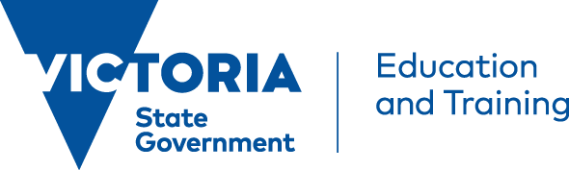 | 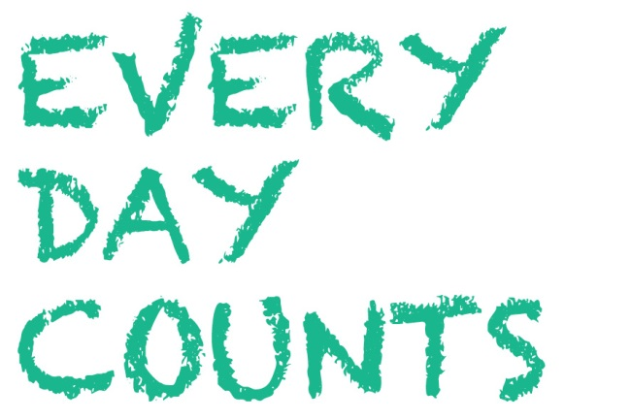 How to enrol your child in school or register for home schooling

Enrolling in school
You can enrol your child in a Victorian government school at any time during the year. This is particularly helpful if you are moving to a new area, or from interstate or overseas.
- To find a government school in your local area, see: http://www.education.vic.gov.au/findaservice/Home.aspx
- To find a Catholic school in your local area, see: http://www.ceomelb.catholic.edu.au/our-schools/school-finder/
- To find an independent school in your local area, see: http://services.is.vic.edu.au/ebiz/customerservice/schoollocator.aspx
- Alternatively, you could call your local council for a list of schools in your area.
- For assistance in choosing a primary school, see: http://www.education.vic.gov.au/school/parents/primary/Pages/choosing.aspx
- For assistance in choosing a secondary school, see: http://www.education.vic.gov.au/school/parents/secondary/Pages/choosing.aspx

Enrolling in Primary School
Your child must be at school (or registered for home schooling) in the year that they turn six years of age - this is the compulsory school starting age.

How to enrol
To enrol your child in a Victorian government school you will need to fill out an enrolment form at that school and provide the school with important information about your child, including:
- evidence of your child’s date of birth
- your contact details, including phone number and address, and those of any other parent, guardian and/or carer
- names and contact details of emergency contacts
- doctor’s and dentist’s names and phone numbers
- Immunisation Status Certificate
- health and welfare information
- information about the language/s your child speaks and hears at home.
Enrolment forms are available at each school. If you need an interpreter to help fill out the enrolment form, the school staff can help organise this for you.
For further information, see: http://www.education.vic.gov.au/school/parents/primary/Pages/enrol.aspx

Enrolling in Secondary School
- Most children attend the government secondary school closest to their home. Families may, however, choose to send their child to a different secondary school, if there are places available, because the school has a specific focus, such as music, science, art or sport.
- Residential boundaries may affect whether your child can attend a particular secondary school.
- It can be good to visit different schools, attend information sessions and find a school that meets your child’s needs and aspirations.
- When a student transfers from one school to another, the school you are leaving will provide the principal of the new school with a transfer note. This note includes information about the student such as name, address, emergency contact details, any medical conditions the student may have, as well as their academic records.

How to enrol
Enrolling your child in a Victorian government secondary school is a straightforward process. You will need to fill out an enrolment form for that school. You will be asked for information including:
- evidence of your child’s date of birth
- your contact details, including phone number and address, and those of any other parent, guardian and/or carer
- names and contact details of emergency contacts
- health and welfare information
- information about the language/s your child speaks and hears at home.
For further information, see: http://www.education.vic.gov.au/school/parents/secondary/Pages/enrol.aspx

Registering for home schooling
- In Victoria, home schooling your child during their compulsory school years is a recognised alternative to attending government or registered non-government schools.
- When you decide to educate your child from a home base, you assume overall responsibility for the planning, implementation and assessment of your child’s education.
- If you are a parent living in Victoria, and want to Home School your child, you must register your child with the Victorian Registration and Qualifications Authority (VRQA). For further information, including application forms and supporting materials, see: http://www.vrqa.vic.gov.au/registration/Pages/homeschooldefault.aspx
- Students registered for home schooling are eligible to partially enrol at their local government school for specific activities agreed on by the school and the student’s family.

