**SUPPORTED PLAYGROUPS**

POLICY AND FUNDING GUIDELINES

September 2017

**CONTENTS**

INTRODUCTION 3

Purpose Of The Guidelines 3

Strategic context 3

EVIDENCE BASE FOR SUPPORTED PLAYGROUPS 3

SERVICE SPECIFICATIONS 7

Outcomes 7

Funding 7

Target Group 7

In-Home Support 7

Group size 8

Delivery and location of Supported Playgroups 8

Qualified and skilled facilitators 8

Evidence-based service delivery 9

Enrolment 9

Parent questionnaire 9

Transition planning 9

PERFORMANCE AND ACCOUNTABILITY FRAMEWORK 11

SUPPORT FOR SERVICE PROVIDERS 13

APPENDICES 14

Appendix 1 Eligibility Criteria for enrolment in a Supported Playgroup funded by the department 14

Appendix 2A Qualifications and competencies for Supported Playgroup facilitators 15

Appendix 2B Sample position description 16

Appendix 3 Forms…………………………………………………………………………………………………………..…17

Appendix 4 Supported Playgroups information collection and storage Protocol 28

INTRODUCTION

PURPOSE OF THE GUIDELINES

The Supported Playgroup Policy and Funding Guidelines support the delivery and administration of Supported Playgroups funded by the Victorian Department of Education and Training (the Department). They outline the Department’s expectations of service providers funded to deliver Supported Playgroups. The Guidelines should be read in conjunction with the Department’s service agreement, which outlines mutual responsibilities and requirements. The Department reserves the right to amend these Guidelines with reasonable notice of any changes.

These Guidelines provide:

* service specifications and outcomes to be achieved
* a performance and accountability framework
* other information relevant to the delivery of Supported Playgroups.

strategic context

**Victoria the Education State and the Early Childhood Reform Plan**

The Victorian Government is committed to supporting all parents with the knowledge and skills to help their children thrive, from birth onwards.

In 2014, the Andrews Government committed to making Victoria the Education State. Victoria aims to be a global centre of excellence in learning and development and to ensure all Victorians, regardless of their starting point or postcode, have the skills, knowledge and attributes they need to shape their future in a changing world.

In the Education State, Victorians value education, for themselves and those around them, at all stages of life and recognise that some stages of learning have a more significant impact on life outcomes. This starts with a focus on the early years to ensure all children get the best start in life. It includes access to safe, quality early childhood services and support to learn, play and grow. A key focus of reform is creating a more flexible and integrated service system to ensure children and families experiencing vulnerability and disadvantage are supported to succeed.

The Early Childhood Reform Plan sets out a transformative program of reform to help every Victorian child and family access high quality, equitable and inclusive services. The Victorian Government is committed to providing more support for parents, particularly those experiencing vulnerability and disadvantage. One of the key reform directions of the Education State Early Childhood Reform is to provide more support for parents, particularly those experiencing vulnerability and disadvantage. The 2017–18 State Budget committed significant additional funding to provide more support for parenting; this includes funds to expand Supported Playgroups so they would be available in every local government area.

Supported Playgroups also help meet all four of the challenges Victoria faces in becoming a world leader in early childhood learning and development: earlier engagement in learning, better educational quality, more support for parents, and support for vulnerable and disadvantaged children and families.

EVIDENCE BASE FOR SUPPORTED PLAYGROUPS

The importance of providing high quality care and stimulation to children from birth is well recognised. Research shows that during early childhood, the foundations of social, emotional, mental and physical health and wellbeing are established with executive functioning and self-regulation largely developed before the age of five.

For the majority of children, a loving home environment in the care of parents who are attuned to their needs and provide support, stimulation and encouragement sets them on a good developmental pathway. However, many children living in families experiencing disadvantage do not have home environments that provide opportunities that promote learning and development. These children are also less likely to participate in early childhood education and care services.

There is a growing body of evidence that participation in a Supported Playgroup run by a skilled and qualified worker and with evidence based practice embedded, has a positive impact on children’s learning, social, and emotional development. The findings of the Early Home Learning Study (2009-2012), and the *smalltalk* program developed as part of this study, demonstrated that it was possible to enhance the role of parents as first teachers and improve the quality and frequency of the parent-child interactions that are known to improve childrens’ learning outcomes.

Supported Playgroups also provide opportunities for parents to learn about local services, to meet with other parents for support and friendship and to build social support networks in the communities in which they live.

***smalltalk***

Supported Playgroups funded by the Department are required to deliver *smalltalk* to all participating families. Supported Playgroup facilitators are responsible for the delivery of *smalltalk* in Supported Playgroups and through In-Home Support for eligible families (see Target Group).

*Smalltalk* is a set of evidence-based strategies that introduce parents to a small number of parenting essentials that lead to optimal child outcomes. *smalltalk* strategies help parents become aware of the importance of their interactions with their child and increase the number and type of situations in which they engage in quality interactions. Quality parent-child interactions are:

* encouraging parents to interact with their children in a ***warm and gentle manner***
* ***tuning in*** to their child by giving them their full attention frequently and promptly
* ***attending*** to whatever their child shows an interest in
* ***listening and talking*** to their child more frequently
* using ***teachable moments*** when they arise
* ***shared reading***.

*smalltalk* also aims to encourage parents to provide opportunities that stimulate their child’s learning at home by:

* creating routines
* reading to children from birth
* supporting children’s play

Another important element of *smalltalk* is that parents are encouraged to look after their own health and wellbeing by developing positive social support networks and seeking professional help if stressed and not coping.

**Service delivery context**

Supported Playgroups are located within a system of services that support the learning and development of children from birth to the commencement of formal schooling. This section provides a brief overview of overarching Frameworks, key services and their role.

**Victorian Government - Department of Education and Training**

The Victorian Government plays a significant role in coordinating and supporting early years services, monitoring performance and ensuring the accountability of service providers that are in receipt of government funding. The Department’s Central Office oversees the design of the Supported Playgroup program and monitors the performance and impact of the program on a statewide basis. The Department Central Office works in partnership with the Department Regional Offices who provide advice and guidance on the requirements of the program to service providers.

Department Regional Offices are the first point of contact for service providers funded to deliver Supported Playgroups. Regional Offices provide advice regarding service delivery. This includes advising where Supported Playgroups should be located in a local government area. The inclusion of Regional Office staff can be helpful in the selection of appropriate staff.

Regional Offices monitor service delivery quarterly against the performance targets and quality measures specified in these Guidelines. They are also responsible for variations and annual reviews of service agreements including financial acquittals at the end of each financial year.

**Local Government**

Local government makes a significant contribution to early years services and infrastructure. This includes the joint role played by local councils and the Department of Education and Training in funding the Maternal and Child Health (MCH) Service. Municipal Early Years Plans (MEYPs) are also developed by all local councils and provide a framework for the delivery of services for children and families within a geographical area. Many local governments also support their local community playgroups in a variety of ways, including the provision of information, resources and access to facilities.

A significant number of councils also operate central enrolment for four-year-old kindergarten and twenty-eight local councils operate central enrolment for three years old kindergarten. Local councils operate central enrolment as a way of ensuring consistent, easier and fairer access for families to kindergarten and to assist in their early years and infrastructure planning.

The Municipal Association of Victoria (MAV) representing local government, the Department of Education and Training and the Department of Health and Human Services have entered into a Compact, ‘Supporting Children and Families in the Early Years’. The objective of the Compact is strengthened collaboration in the planning, development and provision of early years services to provide more consistent and well connected service delivery across the state.

**Community playgroups**

Community playgroups are regular gatherings of parents and caregivers with their under-school age children. Parents manage and lead community playgroups and organise play and social activities for the playgroup. Community playgroups provide opportunities for children to engage in play activities with their parents and other children. They also provide opportunities for parents to meet other parents to form friendships and for mutual support and advice. Parents also learn from other parents about services in their local area.

Playgroup Victoria promotes and encourages the formation and development of playgroups throughout Victoria, including providing training and resources to playgroups. For more information, see: [www.playgroup.org.au](http://www.playgroup.org.au)

**Early years services**

Early years services for children and families include programs supporting children’s health, development and learning, including early childhood education and care services, kindergarten and the Maternal and Child Health Service.

The MCH Service is provided through a partnership between the Victorian Government and local government. It is a free service available to all families with young children. The MCH Service offers support, education and advice in more than 640,000 consultations with families every year.

Children go to Kindergarten in the year before they start primary school. The Victorian Government contributes funding to support children to attend a kindergarten program delivered by a qualified early childhood teacher. A Kindergarten Fee Subsidy enables eligible children to attend a funded kindergarten program for 15 hours free of charge, eligibility criteria is available in the Kindergarten Funding Guide: <http://www.education.vic.gov.au/childhood/providers/funding/Pages/kinderfundingcriteria.asp>

Early Start Kindergarten is a Victorian Government-funded grant that provides free access to kindergarten for three year old children who are Aboriginal and/or Torres Strait Islander or known to Child Protection or who have been referred by Child Protection to Child FIRST. The Department’s staff in regional offices can assist families with any queries about kindergarten programs including Early Start Kindergarten.

There are also a range of more intensive early years services including the Enhanced MCH Service, Early Parenting Centres, Early Childhood Intervention Services and Kindergarten Inclusion Support. The In-Home Support and Home-Based Learning Initiative for Aboriginal families also operates in a number of locations across Victoria and works closely with the Koorie Maternity Service.

**Victorian Early Years Learning and Development Framework**

The Victorian Early Years Learning and Development Framework (VEYLDF) is an evidence-based practice framework for all professionals working with children from birth to eight years to advance their children’s learning and development. The VEYLDF also promotes a common language to support communication about children’s learning and development across the relevant sectors and with families.

The VEYLDF has five learning and development outcomes for children. These are:

* *Children have a strong sense of identity*
* *Children are connected and contribute to the world*
* *Children have a strong sense of wellbeing*
* *Children are confident and involved learners*
* *Children are effective communicators.*

The VEYLDF has eight practice principles. These are:

* *Reflective Practice*
* *Partnerships with families*
* *High expectations for every child*
* *Respectful relationships and responsive engagement*
* *Equity and diversity*
* *Assessment for learning and development*
* *Integrated teaching and learning approaches*
* *Partnerships with professionals*

Resources have been developed to support implementation of the VEYLDF in early childhood settings. These resources are available on the Department’s website. <http://www.education.vic.gov.au/childhood/providers/edcare/Pages/profresource.aspx>

**Parenting support**

Parenting support for families with children aged from birth to 18 years seek to improve parents’ competence and confidence. Parenting support is provided by a range of services including those outlined below:

**Parentline** is a statewide telephone counselling service providing information, advice, referral and counselling for parents and carers of children from birth to 18 years.

**Regional Parenting Services** operate across the state and provide parenting information, education, and individual and group based parenting support to families experiencing parenting challenges. They also provide advice to other professionals who work with families.

**Early Parenting Centres** provide services and support to assist parents experiencing acute early parenting difficulties to care for their children by increasing parents’ knowledge, skills and confidence through the provision of consultation, counselling, skill development and education services.

**Strengthening Parents Support Program** assists parents who have a child with a disability or developmental delay to connect with other families and their local community.

SERVICE SPECIFICATIONS

OUTCOMES

Supported Playgroups funded by the Department aim to achieve the following outcomes:

* **disadvantaged children** have improved learning, development and wellbeing outcomes through improved parent-child interaction in the early home learning environment
* **parents** develop their parenting skills and confidence to support their children’s learning and development
* **families** are supported to transition into other community supports such as community playgroups or to more intensive early childhood or specialist services.

FUNDING

The funding model for Supported Playgroups is based on service providers delivering a professional model of Supported Playgroups in accordance with these Guidelines.

Service providers are required to employ qualified and skilled Supported Playgroup facilitators. The role of the facilitator is to deliver Supported Playgroups and In-Home Support (see In-Home Support) using the evidence based *smalltalk*. **Eighty per cent (80%) of the funding for Supported Playgroups is for the salary and salary-related costs (Long Service Leave/WorkCover/Sick Leave) of employing a qualified facilitator.** The balance of the funding (20%) is for administration and operation of the program.

Continuation of funding is based on service providers meeting the performance targets specified in these Guidelines. The performance of all service providers funded by the Department through service agreements is reviewed quarterly and at the end of the financial year. At the end of each financial year, a full acquittal of funding is required.

As is the case for all service providers receiving funding through service agreements, if targets are not met, the Department and the service provider will work together to identify the causes and implement remedial action. Failure to meet targets, despite remedial efforts, may lead to a reduction or cessation of funding in accordance with the terms of the service agreement.

If there is any unexpended funding at the end of financial year, it must be returned to the Department within 90 days of the new financial year or as otherwise agreed.

TARGET GROUP

Supported Playgroups are a targeted service. They are funded by the Department for families experiencing disadvantage to improve the learning, development, and wellbeing outcomes of children from birth until they start primary school. Improvements in child outcomes are the result of improvements in the quality of parent-child interactions and the home learning environment that occur as a result of parents participating in a Supported Playgroup.

To be enrolled in a Supported Playgroup, families must meet at least one of the following eligibility criteria

* a family member in the household holds a Health Care Card or equivalent (see appendix 1 for full list)
* families in which a family member identifies as Aboriginal and/or Torres Strait Islander
* families looking after children in kinship care arrangements (out of home care)
* families referred from Child FIRST/Child Protection.
* families referred from or participating in Enhanced Maternal and Child Health Services

The Department has also agreed that on case-by-case basis and in consultation with the Department, flexible application of the eligibility criteria can apply in *small rural communities,* provided that, access is *prioritised for families who meet the eligibility criteria* and there are *limited alternate services* available.

In-Home Support

Some parents are also eligible for In-Home Support. In-Home Support is provided by a qualified facilitator who visits a family in their own home fortnightly during school terms for approximately one and a half (1.5) hours each fortnight. During these home-based sessions, parents have the opportunity to practice the *smalltalk* strategies supported by a qualified facilitator. Parents participating in In-Home Support may also be attending a Supported Playgroup. In-Home Support may be used to engage eligible families who are initially reluctant to attend a Supported Playgroup.

The target group for In-Home Support is families who are eligible to attend Supported Playgroups (see above) who also have at least one of the following characteristics:

* parent aged 25 years or less
* mother has not completed high school
* single parent family
* ten or less children’s books in the home.

Group size

Supported Playgroups operate on the basis that up to ten families are enrolled in each Supported Playgroup each term.

**Families may be re-enrolled in a Supported Playgroup for a number of terms if the facilitator assesses this would be beneficial for the family.**

Enrolling more than ten families in a Supported Playgroup is likely to have a negative impact on the quality and intensity of the support that families receive and the outcomes that can be achieved for each family. It could also significantly increase the time that would need to be allocated to following up families who cease attending a Supported Playgroup, which is also a requirement of the program.

If the demand for Supported Playgroups exceeds available places, consideration may need to be given to operating a waiting list and/or referring families to other supports in the interim such as a community playgroup or family support services.

The requirement to develop Family Transition Plans will increase the likelihood that families connect and participate in other relevant services in a timelier manner, thereby increasing the number of families who can access Supported Playgroups over a year.

Delivery and location of Supported Playgroups

Supported Playgroups are facilitated by a single facilitator and run weekly during school terms for approximately two hours each week.

Planning the location of Supported Playgroups should occur in collaboration with the Department’s regional offices. Supported Playgroups must be located in areas with high numbers of families experiencing disadvantage and be easily accessible to them.

Service providers may need to consider arranging transport for some families to Supported Playgroups.

Consideration should also be given to locating Supported Playgroups in primary schools where this increases families’ access and supports the transition of children to school. The Department’s regional offices will facilitate these arrangements.

Service providers are required to record details of all Supported Playgroups and facilitators at the beginning of each term on the electronic information management system.

Qualified and skilled facilitators

Supported Playgroup facilitators must hold relevant qualifications and have the skills to:

* establish professional relationships and networks with referral organisations
* actively outreach to families to engage them in Supported Playgroups and In-home Support
* plan, deliver and evaluate Supported Playgroup sessions including implementing evidence based parenting strategies (*smalltalk*) and providing learning opportunities that are consistent with the VEYLDF
* deliver In-Home Support to eligible families
* follow up families who stop attending Supported Playgroups to address any barriers to participation
* develop transition plans with families to refer and connect them to services and community supports such as community playgroups.

The required qualifications and competencies for facilitators and a sample Position Description are at Appendix 2A/B.

Completion of training in *smalltalk* is required for all facilitators. Facilitators are also required to participate in post-training practice coaching run by the Parenting Research Centre (PRC) and a Supported Playgroup Community of Practice convened by Play Group Victoria (PGV).

It is also a requirement of funding that facilitators are provided with regular professional supervision from a suitably qualified and experienced supervisor. This is to ensure appropriate accountability and to provide professional support and professional development to the facilitator.

Establishing referral processes and enrolling families in Supported Playgroup is part of the professional practice role of the facilitator and not an administrative or coordination function. Active involvement by the facilitator in all aspects of families’ participation in Supported Playgroups, including assisting them to complete enrolment forms and supporting their attendance, increases families’ engagement with the facilitator and increases the likelihood that families will attend regularly and actively participate.

Evidence-based service delivery

Supported Playgroups are required to deliver *smalltalk*, which is an evidence-based program focused on improving the quality of everyday interactions between parents and children to promote children’s learning and improve the quality of the early home learning environment.

As described above, service delivery is also based on the Practice Principles and Learning Outcomes of the VEYLDF, including the importance of supporting children’s and families’ transitions into early childhood settings and school.

Enrolment

Service providers funded to deliver Supported Playgroups must establish clear referral pathways for families to Supported Playgroups. Establishing a referral pathway from the MCH and/or Enhanced MCH Service to Supported Playgroups is critical to identifying families in the target group.

A Family Record (Appendix 3) must be completed at a family’s initial enrolment and when families are re-enrolled in a Supported Playgroup each term. The purpose of the Family Record is to collect information about the family to support their participation in the Supported Playgroup and for service accountability and performance monitoring.

The Family Record also records whether families have had a Family Transition Plan developed, the status of each child at the beginning and end of each term in relation to their MCH Key Ages and Stages Consultations and whether (if eligible) they are enrolled in kindergarten or Early Start Kindergarten.

Facilitators use their professional judgment to determine how long a family should continue to attend a Supported Playgroup after their first term (refer to section on Transition Planning below). If facilitators consider that a family would benefit from continuing to attend a Supported Playgroup, they may re-enroll the family in each subsequent term.

Parent questionnaire

The Parent Questionnaire includes empirically validated questions and is used to assess the impact that participation in a Supported Playgroup and/or in In-Home Support has on parents’ skills and confidence. One aspect of the facilitator’s role is to assist parents to complete the Parent Questionnaire when they enroll and when they cease attending a Supported Playgroup. For families who attend a Supported Playgroup for more than one term, the parent completes the questionnaire at the end of the last term they attend.

Transition planning

A Family Transition Plan (Appendix 3) is required to be developed in consultation with each family enrolled in a Supported Playgroup. The purpose of the Family Transition Plan is to ensure that families are supported to access services that will assist them both during and at the end of their participation in a Supported Playgroup and/or In-home Support, including the MCH Service and kindergarten.

The Family Transition Plan is a ‘living document’ developed and refined with the active involvement and agreement of the family throughout their participation in the Supported Playgroup. The Family Transition Plan is finalised when a family ceases attending a Supported Playgroup and/or In-home Support.

For example, in discussion with a family soon after they commence attending a Supported Playgroup it is identified that a child’s development would be enhanced by attending an early childhood education and care service. The facilitator would assist the family to identify a suitable service and support the family to enroll the child. Another example would be identifying a suitable community playgroup for a family to join after they have completed a term of Supported Playgroup. The facilitator would make contact with Playgroup Victoria to identify a suitable playgroup that meets the needs of the family in the longer term. The facilitator would support the family to make contact with the community playgroup to organise their attendance.

Families may also be referred by the facilitator to other relevant services anytime during their participation in a Supported Playgroup. Examples of possible referrals include:

* placing a child on a central enrolment list to attend kindergarten the following year
* referring a child to the Early Start Kindergarten program
* referring a family to parenting support, relationship counselling, alcohol and drug services or a specialist children’s service.

PERFORMANCE AND ACCOUNTABILITY FRAMEWORK

Service providers that receive funding from the Department to deliver Supported Playgroups and/ or In-Home Support are required to:

* deliver Supported Playgroups and IHS in accordance with the service specifications in these Guidelines
* meet the performance targets specified in these Guidelines
* provide the information/data specified in the Guidelines to the Department.

**Performance targets**

The following performance targets apply to each full-time equivalent (FTE) Supported Playgroup facilitator employed by a service provider to deliver Supported Playgroups.

**Quantitative targets**

|  |  |  |
| --- | --- | --- |
| **Performance Indicator** | **Target for each FTE** | **Source of information** |
| Number of Supported Playgroups in operation at any point in time | 5 Supported Playgroups each term per FTE | Electronic information management system |
| Number of Supported Playgroups each calendar year | 20 Supported Playgroups each calendar year per FTE | Electronic information management system |
| Number of families enrolled in Supported Playgroups each calendar year[1] | 160 families enrolled each calendar year per FTE[2] | Electronic information management system |
| Number of families receiving In-Home Support at any point in time | [3]6 families each term per FTE | Electronic information management system |
| Number of families receiving In-Home Support each calendar year | 24 families each calendar year per FTE | Electronic information management system |

**Quality Measures**

|  |  |  |
| --- | --- | --- |
| **Measure** | **Target** | **Source of information** |
| Per cent of families with Family Transition Plans at the end of each term | 85% | Electronic information management system |
| Per cent of children eligible for kindergarten enrolled in kindergarten at the end of each term | 100% | Electronic information management system |
| Per cent of families up to date with MCH Key Ages and Stages consultations at the end of each term | 100% | Electronic information management system |
| Per cent of children eligible for Early Start Kindergarten (ESK) enrolled in ESK at the end of each term | 100% | Electronic information management system |
| Per cent of parents who improve on all scores on the Parent Questionnaire at the end of each term | 80% | Electronic information management system |
| Per cent of families satisfied with the service at the end of each term | 85% | Service providers to use their own process |

**DATA COLLECTION AND REPORTING**

Service providers are responsible for collecting information about the operation of Supported Playgroups. Some of this information is retained by the service provider and some is entered onto the electronic information management system. The collection of information has a number of purposes. Firstly, the collection of information assists facilitators provide a service to families. Secondly, aggregating de-identified data at the service provider level enables service provider managers and the Department to monitor performance against quantitative targets and quality measures. Finally, de-identified data aggregated at the statewide level, enables statewide performance to be monitored and the impact and effectiveness of the program to be further examined.

Information was previously collected and stored on paper forms. Some of the information may still be required to be collected on paper forms in the first instance and then entered into the electronic information management system. Some of the information will not be entered into the electronic information system, as the purpose of the information is to assist in service delivery. This includes Referral Forms and the Family Transition Plan. The protocol for collecting and storing information is detailed in Appendix 4.

The Department will provide data to service providers on the overall statewide performance and impact of Supported Playgroups.

At the end of each financial year, the Department’s Regional Office will discuss with each service provider their expenditure on Supported Playgroups for the financial year. The Department will recoup any accumulated underspend as part of the acquittal process.

SUPPORT FOR SERVICE PROVIDERS

In addition to the support provided by the Department’s regional staff, the Department has contracted Playgroup Victoria and the Parenting Research Centre to support service providers in their delivery of Supported Playgroups.

**Playgroup Victoria**

Playgroup Victoria convenes an annual playgroup conference. Playgroup Victoria will also convene Supported Playgroup Communities of Practice for Supported Playgroup facilitators.

Communities of Practice (COP) are a professional development and professional support opportunity for facilitators of Supported Playgroups. Communities of Practice will be delivered by experienced staff and will be structured to enable facilitators to share practice challenges, successes and case studies with their colleagues in a professionally supportive environment. Themes including implications for practice identified at each Community of Practice will be recorded and which distributed to the facilitators who attended and their managers.

Communities of Practice will support facilitators to build their skills and confidence and share their skills and knowledge with others. They will also provide the opportunity for facilitators to develop professional networks for support and learning and the time and space to reflect on their practice.

Allocating specific time for attendance at Communities of Practice also acknowledges the professional status of Supported Playgroup facilitators and recognition of their contribution.

Playgroup Victoria, with the support of the Parenting Research Centre, will deliver Communities of Practice for Supported Playgroup facilitators.

**Parenting Research Centre**

The Parenting Research Centre (PRC) undertakes research, evaluation, training and the development of parenting information and resources. The PRC also manages the Raising Children Network: [www.raisingchildren.net.au](http://www.raisingchildren.net.au)

The PRC provide training to Supported Playgroup facilitators in the delivery of *smalltalk* and provide implementation support to facilitators, including practice coaching to maintain program fidelity.

As a condition of funding, facilitators are required to participate in implementation support, which includes:

* training
* practice coaching
* participation in Supported Playgroups Communities of Practice.

**Training**

Training in evidence-based strategies (*smalltalk*) is provided to all facilitators to ensure they have the knowledge and skills to implement evidence based strategies in Supported Playgroups and In-home Support. The training includes both online and face-to-face training.

**Practice coaching includes**:

* a planning meeting with the Regional Departmental representative, the service provider manager and the PRC Practice Coach to agree to the timing and approach ,
* Supported Playgroup and In-Home Support observation visit(s) as required
* regular phone contact with every facilitator.

Facilitators also have access to an online community of practice through the *smalltalk* website: [www.smalltalk.net.au](http://www.smalltalk.net.au)

APPENDICES

Appendix 1 Eligibility CRITERIA for enrolment in a Supported Playgroup funded by the department

A family member in the household holds one of the following:

* a Commonwealth Health Care Card
* a Commonwealth Pensioner Concession Card
* a Department of Veterans’ Affairs Gold Card or White Card
* Refugee visa (subclass 200)
* In-country Special Humanitarian visa (subclass 201)
* Global Special Humanitarian visa (subclass 202)
* Temporary Humanitarian Concern visa (subclass 786)
* Protection visa (subclass 866)
* Emergency Rescue visa (subclass 203)
* Woman at risk visa (subclass 204)
* Bridging visas A-E.

In addition, the following families are also eligible:

* families in which a family member identifies as Aboriginal and/or Torres Strait Islander;
* families who are looking after children in kinship care arrangements (out of home care);
* families referred from Child FIRST or Child Protection
* families referred from or receiving Enhanced Maternal and Child Health Services.

**Target group for In-Home Support**

The target group for In-Home Support is families who are eligible to attend Supported Playgroups (see above) and have at least one of the following characteristics:

* parent aged 25 years or less
* mother has not completed high school
* single parent family
* ten or less books in the home.

The Department has also agreed that on case-by-case basis and in consultation with the Department, flexible application of the eligibility criteria can apply in *small rural communities,* provided that, access is *prioritised for families who meet the eligibility criteria* and there are *limited alternate services* available.

Appendix 2A Qualifications and competencies for Supported Playgroup facilitators

**Qualifications**

The Guidelines require that all Supported Playgroup facilitators hold an appropriate qualification for the role.

The following qualifications, listed by field of study, are appropriate qualifications at a minimum Diploma level:

**Competencies**

Supported Playgroup facilitators are required to have the following knowledge and skills.

**Knowledge** – demonstrated knowledge and/or understanding of:

* early childhood development and family support service systems
* early childhood learning and development stages
* Victorian Early Years Learning and Development Framework including the Practice Principles and Learning Outcomes
* causes of economic and sociocultural disadvantage and its impact on families and children
* delivery of group-based and individual programs.

**Skills** – ability to:

* develop relationships with key local stakeholders and referral sources to develop referral pathways for families in the target group
* develop and implement strategies to engage families and support their attendance at Supported Playgroups
* communicate respectfully and effectively with families
* model and support quality parent child/interactions
* provide developmentally appropriate play experiences that promote learning
* effectively facilitate a Supported Playgroup
* effectively provide In-home Support
* respond in a timely and appropriate way to group dynamics and individual issues
* implement effective active listening skills and effective interpersonal communication skills
* implement motivational interviewing skills
* undertake transition planning with families to link them into relevant early years services community playgroups and other community services such as libraries.

**Other requirements**

Other required skills are the ability to:

* maintain accurate records and information regarding Supported Playgroups as required by the employing organisation and funding body
* participate in professional development and take a proactive approach to continually improving skills and abilities
* possess a current Working with Children Check.

Appendix 2B Sample position description

**POSITION TITLE: Supported Playgroup facilitator**

**POSITION SUMMARY:**

The Victorian Government is providing funding through the Department of Education and Training to provide Supported Playgroups for families experiencing disadvantage.

Supported Playgroups provide opportunities for eligible families to develop parenting skills and confidence to support their children’s development. Supported Playgroups are for families with children aged birth up until they start primary school. In-Home Support is provided to families who meet additional criteria.

The responsibilities of this role include running Supported Playgroups (incorporating the *smalltalk* program) and providing In-Home Support.

Supported Playgroup facilitators are required to have completed, or be working towards completing, tertiary qualifications in early education and care services, social work or equivalent at Diploma level or above. Supported Playgroup facilitators are required to have the following:

**Knowledge** – demonstrated knowledge and/or understanding of:

* early childhood and family support service systems
* early childhood learning and development stages
* Victorian Early Years Learning and Development Framework including the Practice Principles and Learning Outcomes
* causes of economic and sociocultural disadvantage and its impact on families and children
* delivery of group processes.

**Skills** – ability to:

* develop relationships with key local stakeholders and referral sources to develop referral pathways for disadvantaged families
* develop and implement strategies to support regular attendance at Supported Playgroups
* communicate respectfully and effectively with families using language that families understand
* model and support developmentally appropriate play experiences and parent/child interactions at Supported Playgroups and during In-Home Support sessions
* effectively facilitate playgroups
* respond in a timely and appropriate way to group dynamics and individual issues
* implement effective active listening skills and effective interpersonal communication skills
* implement motivational interviewing skills
* support and advocate positive parenting and behavior and guidance strategies
* undertake transition planning with families to link them into relevant early years services, community playgroups and other community services such as libraries.

**Appendix 3 Forms**

Please contact the relevant Early Childhood Performance and Planning Adviser in your region for electronic copies of the data collection forms.​

**SUPPORTED PLAYGROUP FACILITATORS AND SUMMARY OF SUPPORTED PLAYGROUPS**

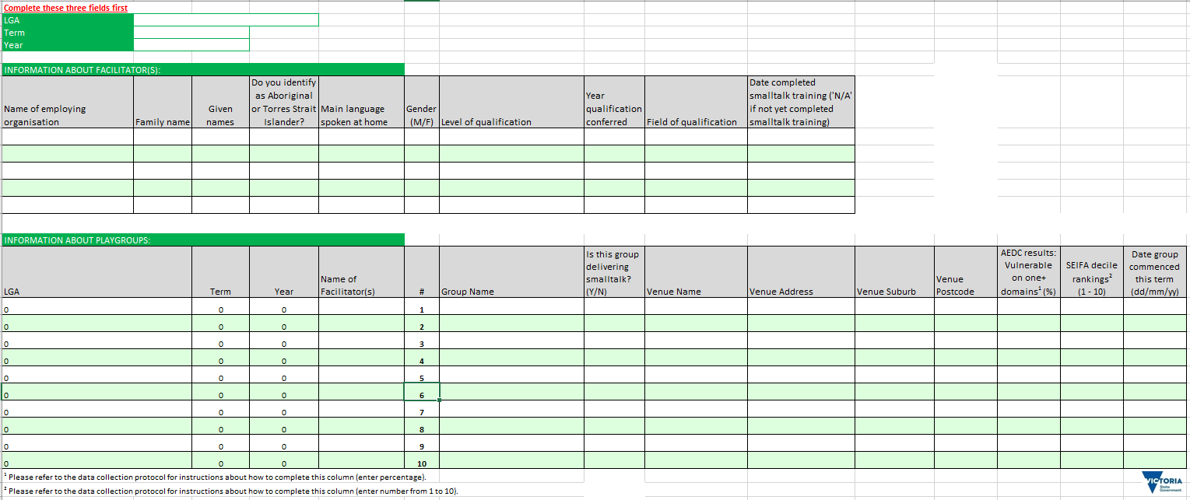

**REFERRAL FORM – IN (OPTIONAL)**

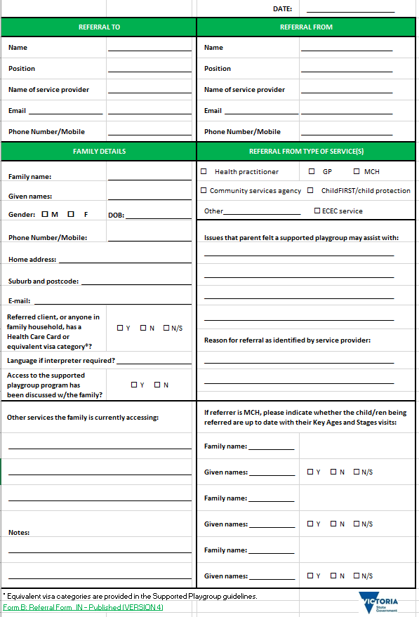

**FAMILY RECORD (COMPLETED UPON ENROLMENT)**

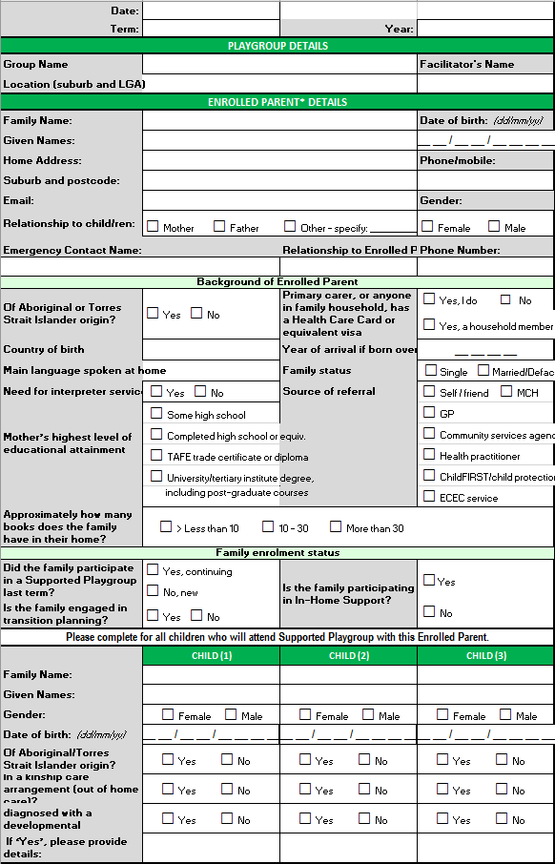

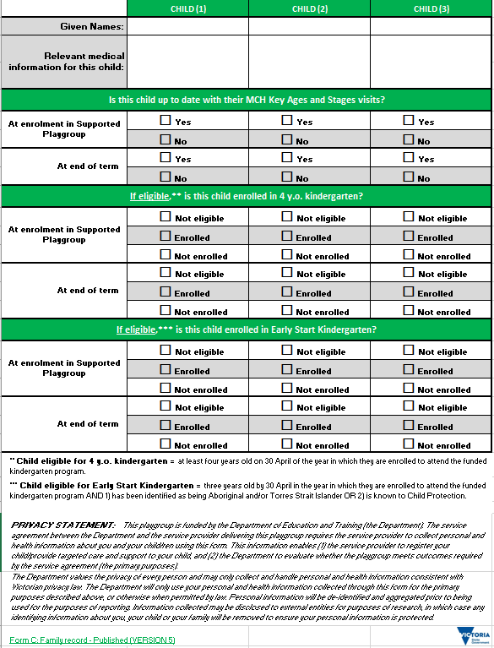

**ATTENDANCE RECORD AND *SMALLTALK* TOPIC TRACKER**

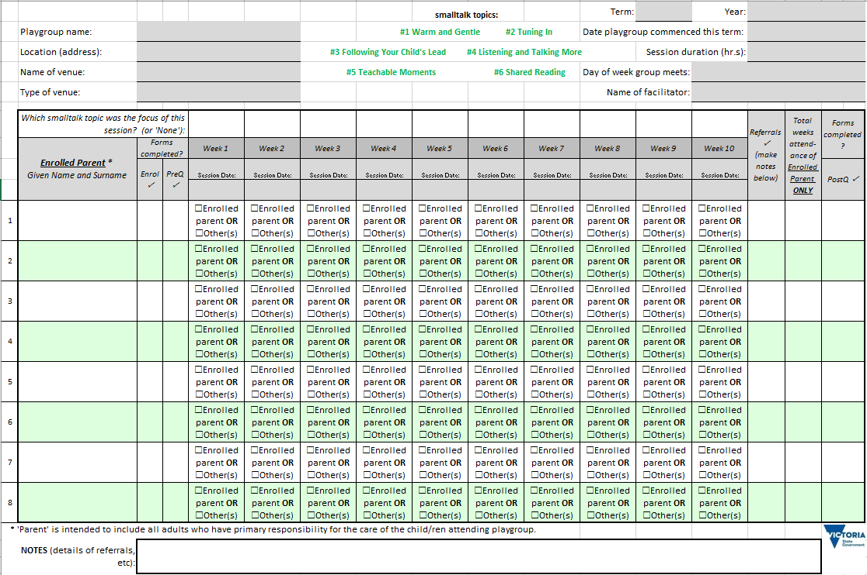

**FAMILY TRANSITION PLAN (DEVELOPED THROUGHOUT THE TERM AND FINALISED AT THE CONCLUSION OF FAMILY’S ATTENDANCE)**

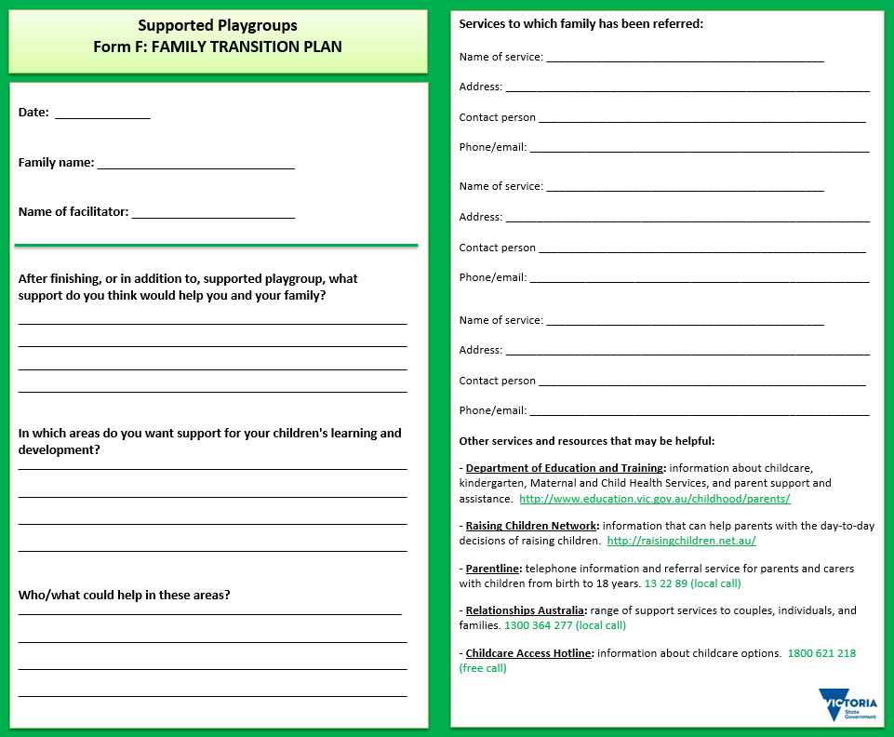

**REFERRAL FORM – OUT (AS NEEDED)**

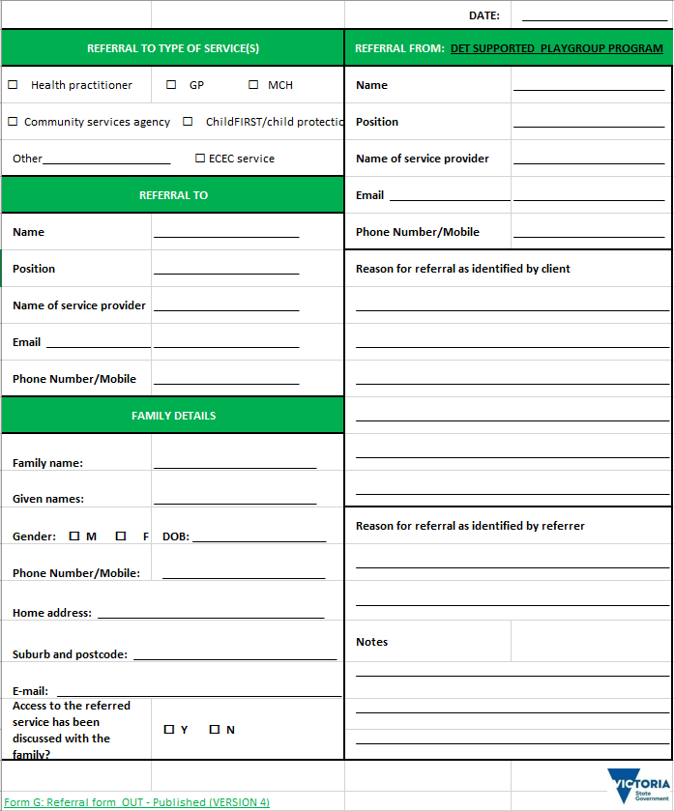

**PARENT QUESTIONNAIRE (PRE) AND PARENT QUESTIONNAIRE (POST) (FIRST WEEK OF TERM AND LAST WEEK OF FAMILY’S PARTICIPATION IN SUPPORTED PLAYGROUP)**

**PRE**

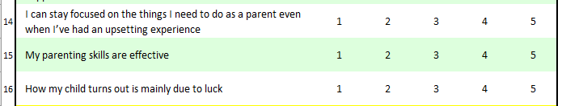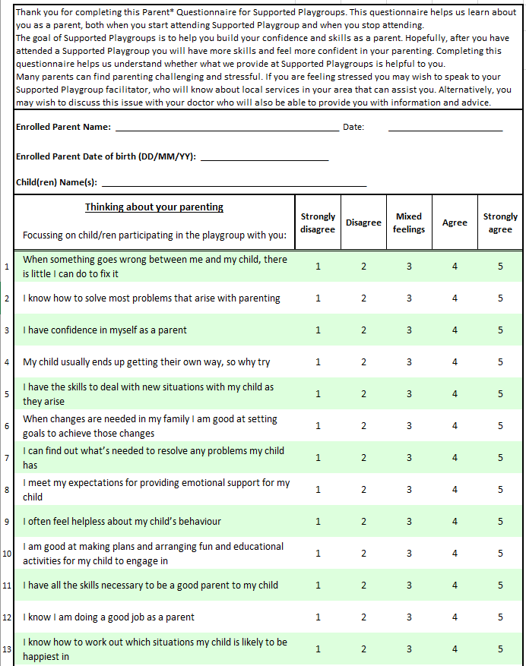

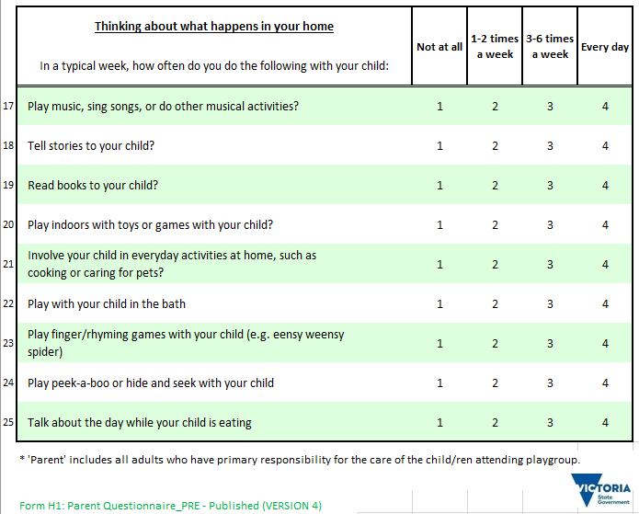

**POST**

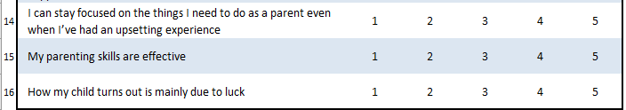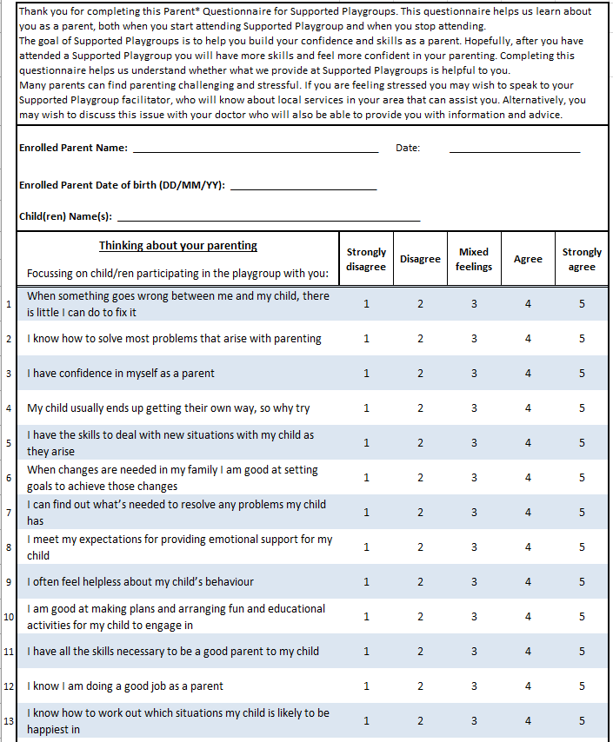

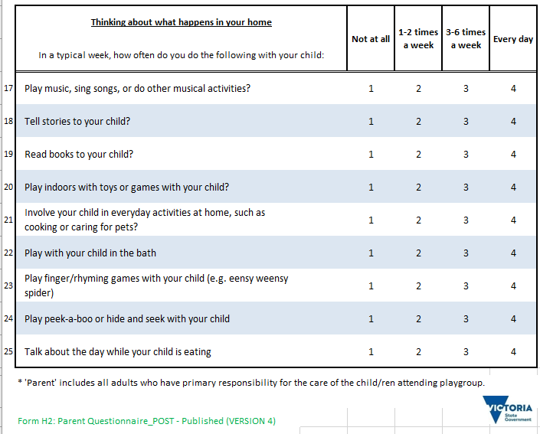

Appendix 4 Supported Playgroups information collection and storage PROTOCOL

This protocol specifies the information collected the purpose of the information and how the information is stored for Supported Playgroups.

Supported Playgroup facilitators and summary of Supported Playgroups

***Information collected***

Completed by the Supported Playgroup facilitator, the name and qualifications of the Supported Playgroup facilitator(s) and details of Supported Playgroups delivered each term (both new and continuing) including Australian Early Development Census (AEDC) and Socio-Economic Indexes for Areas (SEIFA) of suburbs where Supported Playgroups are located (see blue box below).

***Purpose of information***

Performance monitoring.

***Storage of information***

Entered onto the electronic information management system at the beginning of each term.

|  |  |  |  |  |  |  |  |  |  |  |  |  |  |  |  |  |  |  |  |  |  |  |  |  |
| --- | --- | --- | --- | --- | --- | --- | --- | --- | --- | --- | --- | --- | --- | --- | --- | --- | --- | --- | --- | --- | --- | --- | --- | --- |
| The details for each playgroup should include AEDC results (% children vulnerable on one or more domains) and the SEIFA decile ranking for the suburb in which the playgroup is located.   |  |  | | --- | --- | | % of children developmentally vulnerable on 1 or more AEDC domains (2015) | Level of vulnerability | | 26.1 – 68.5% | Very high | | 19.6 – 26.0% | High | | 15.4 – 19.5% | State average | | 11.0 – 15.3% | Low | | <= 10.9% | Very low |   This information is used to assess whether Supported Playgroups are appropriately located in areas of disadvantage.  The details for each playgroup should include AEDC results (% children vulnerable on one or more domains) and the SEIFA decile ranking for the suburb in which the playgroup is located. This information is used to assess whether Supported Playgroups are appropriately located in areas of disadvantage.  AEDC results can be accessed from a suburb’s Community Profile, which is available on the Australian Early Development Census website via this link: [AEDC Community Profiles](http://www.aedc.gov.au/data). Choose the percentage result displayed in the ‘Vuln 1’ column (developmentally vulnerable on one or more AEDC domains) of the corresponding table.  Degrees of vulnerability in a particular domain are grouped as follows:   |  |  | | --- | --- | | SEIFA decile (2011) | Level of disadvantage | | 1 and 2 | Very high | | 3 and 4 | High | | 5 and 6 | Average | | 7 and 8 | Low | | 9 and 10 | Very low |   SEIFA decile rankings can be accessed from the ABS website via this link: [SEIFA by Suburb](http://www.abs.gov.au/ausstats/abs@.nsf/DetailsPage/2033.0.55.0012011?OpenDocument). Select ‘State Suburb Indexes, SEIFA 2011’ from the list of Data Cubes. This opens an Excel spreadsheet – choose the third tab:  cid:image005.jpg@01D04C58.E1844740  In the spreadsheet, look to the left-hand side and find the group of columns labelled ‘Ranking Within State or Territory.’ The ‘Decile’ column contains rankings of disadvantage by suburb, which are defined as follows: |

Referral form – IN (optional)

***Information collected***

Completed by the professional referrer (E.g. MCH nurse) and includes details of family being referred and reasons for referral.

***Purpose***

To support service delivery to families

***Storage of Information***

Completed forms stored in accordance with the service providers client records policy.

Family record (completed upon enrolment)

***Information Collected***

Completed by the Supported Playgroup facilitator with all families at the start of each term – new and continuing - and includes details of the families enrolled in Supported Playgroups including parents and children.

***Purpose:***

Service delivery and performance monitoring

***Storage of Information***

Entered onto the electronic information management system at the beginning of each term Completed forms stored in accordance with the service provider’s client records policy and used to assist service delivery to family.

Attendance Record and *smalltalk* Topic Tracker

***Information Collected***

Completed by the Supported the Playgroup facilitator. Records attendance at Supported Playgroups for each Enrolled Parent and the smalltalk topics delivered each week at the Supported Playgroup.

***Purpose*** To support service delivery and monitoring program fidelity

***Storage of Information***

Completed forms retained in accordance with the service provider’s client records policy.

Family transition plan (developed throughout the term and finalised at the conclusion of family’s attendance)

***Information Collected***

Completed by Supported Playgroup facilitator with the family and records the services and supports a family has decided to attend during or after attending a Supported Playgroup.

***Purpose***

To support service delivery.

***Storage of Information***

Original Transition Plan provided to family and copy retained in accordance with the service provider’s client records policy.

Referral form – OUT (as needed)

***Information Collected***

Completed by Supported Playgroup facilitator to provide relevant details regarding the family to another service that a family has decided to attend.

***Purpose***

To support service delivery.

***Storage of Information***

Original Referral Form forwarded to other service provider, copies provided to family and retained in accordance with the service provider’s client records policy.

Parent questionnaire (PRE) and Parent questionnaire (POST) (First week of term AND last week of family’s participation in Supported Playgroup)

***Information Collected***

Completed by the enrolled parent, these two questionnaires are used to record information about the impact of attending a Supported Playgroup on parents’ skills and confidence

The Parent Questionnaires are completed by enrolled parents attending Supported Playgroups:

* upon enrolment Form H1: PRE is completed
* at the end of the term in which they transition out of the Supported Playgroup (Form H2: POST).

Time should be set aside for parents to complete these questionnaires, i.e. ten minutes at the first session and ten minutes at the last session.

It is important to ensure that the enrolled parent – not other parents/carers who occasionally attend with or in place of the enrolled parent – completes both the pre- and post-questionnaire.

These two questionnaires are used to record information about the impact of attending a Supported Playgroup on parents’ skills and confidence

***Purpose***

Monitoring the impact and effectiveness of the service

***Storage of Information***

Data from completed questionnaires entered onto the electronic information management system.

Completed forms retained in accordance with the service provider’s client records policy.

|  |  |  |
| --- | --- | --- |
| **Time frame** | **Process** | **√** |
| Week 1 of term | *Details of facilitators and* *summary of Supported Playgroups entered onto electronic management information system* |  |
| By end of Week 2 | *Family record* and *Parent* Q*uestionnaire (PRE)* for each enrolled parent. |  |
| For each session | *Supported Playgroup attendance record and topic tracker* |  |
| Last session | Complete– *Parent* *questionnaire (POST)* for each Enrolled Parent who is transitioning out of the playgroup. |  |
| At the end of each term | **Ensure all required information is entered onto the** electronic management information system |  |
| **All other information to be stored** in accordance with the service provider’s client records policy. |  |

1. Families who attend more than one term are re-enrolled and counted each term they attend
2. Based on a minimum of 8 and up to 10 families. Refer ‘Size of Group’ page 8
3.