Best Start – improving local support for families
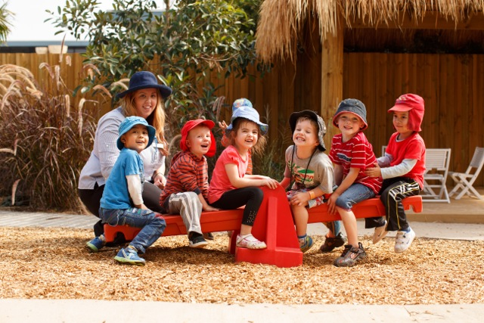

What is best start?
The first years of life are crucial to lifelong learning, wellbeing and success. The Andrews Labor Government is making Victoria the Education State and this begins with giving every child a great start in life by strengthening early childhood services for children and families.
Best Start is a prevention and early intervention program that aims to improve the health, development, learning and wellbeing of all Victorian children from conception through to transition to school (up to eight years old).
There is consensus that a loving, healthy and intellectually stimulating early childhood is critical to a person’s wellbeing and success throughout their life. Children who have a strong start in life are more likely to do well academically and socially as they grow older. Conversely, young children who miss out on positive experiences with parents, caregivers and educators are much more likely to have to struggle to catch up.
Best Start is characterised by an approach that supports parents and caregivers to create a positive environment for children by encouraging communities to work with their local early years services and schools.

Communities and service providers collaborate to address issues as they are experienced at a neighbourhood or regional level.
This localised, targeted way of finding solutions to problems faced by families has been shown to be extremely effective. Efforts are focused on boosting children’s participation in the programs we know have the best results for setting them up for success, such as kindergarten and maternal and child health (MCH) services. The program also puts in place prevention strategies, such as providing referral pathways when targeted supports are required.
Victoria has a strong early childhood system with high participation rates in MCH services and kindergarten – however some children are missing out. Typically, these are children who are experiencing vulnerability and have the most to gain from engaging in high-quality services.
The Best Start program operates in 30 locations across Victoria. There are 24 mainstream sites and six Aboriginal Best Start sites in rural and metropolitan locations.
It is based on formal partnerships of local agencies and service providers to improve the outcomes for children.

ABORIGINAL best start
The Aboriginal Best Start projects have been established to ensure that local Aboriginal communities and organisations are given every possible opportunity to support positive outcomes for their children and families.
The Aboriginal Best Start sites are operated by Aboriginal organisations in Horsham; La Trobe and Baw Baw; Wathaurong-Geelong; Echuca; and Dandenong-Casey. The East Gippsland Aboriginal Best Start site is operated by East Gippsland Shire.
WHY IS Best Start CHANGING?
In 2015, the Department of Education and Training conducted a comprehensive review of Best Start with the aim of updating the project in light of the latest research and policy developments.
The review identified a number of priorities to ensure that Best Start remains an effective program for supporting families, including the need for:
- clearer, more measurable and more evidence-based strategies and actions
- a strengthened focus on boosting the participation of all Aboriginal children and children experiencing vulnerability in key universal and targeted services, in particular in kindergarten, maternal and child health services and supported playgroups; and
- improved monitoring, data collection and reporting.
The review has led to the development of a set of new Best Start guidelines.

WHAT HAS CHANGED?
The new guidelines set out four new priorities. These replace the 15 indicators in the previous guidelines.
The new outcomes have a sharper focus than the previous 15 indicators, and emphasise a child’s holistic growth, including their learning, health and development. There is also a greater focus on ways to improve and tailor the service for families and children experiencing significant challenges.

Best Start Outcomes
Primary | Children engage and participate in early childhood education (kindergarten and supported playgroups).
 | Children and families actively engage with MCH services, attending key ages and stages visits.
Optional | Children acquire literacy and numeracy skills through active participation in their education.
 | Early childhood services provide an engaging and high-quality environment for children and families experiencing vulnerability.
The new approach is also centered on monitoring and reporting. An evaluation of the Best Start program highlighted the need for clearer, more measurable and more evidence-based strategies and actions.
The new approach provides Best Start partnerships with evidence-based strategies and actions to deliver measurable benefits for young children.
Best Start Partnerships will now use rapid action-reflection ‘Plan, Do, Study, Act’ cycles. The cycle tests an idea by temporarily trialing a change and assessing its immediate impact.
How will the new approach be implemented?
The approach will commence from 1 July 2016. Training and support to Best Start sites has already commenced and will continue throughout 2016 and into 2017.
Improved data collection and reporting will assist local communities, service providers and Government to track and regularly monitor the progress towards the outcomes.
What support will be provided?
The Murdoch Childrens Research Institute’s Centre for Community Child Health will deliver training and support to Best Start Facilitators to assist all Best Start Partnerships implement the new approach. This will include a focus on building local capacity to understand and apply data from a range to sources to plan and implement effective strategies to improve children’s learning and development outcomes.

