STATE SCHOOLS’ RELIEF
GLASSES FOR KIDS PROGRAM

COVID-19 HYGIENE PROTOCOLS

V9 – Friday 15 October 2021

State Schools’ Relief (SSR), in conjunction with our Program Partners (Optometrists), has developed hygiene protocols, in addition to the Government’s public health advice, to ensure the safe resumption of school visits for the Glasses for Kids (GFK) program in Term 4, 2021 throughout metropolitan Melbourne and regional Victoria.

Vaccinations

SSR and GFK staff along with all program partners comply with the mandatory vaccination requirements.

SSR keeps a vaccine register with certificates sighted and held.

Face masks in schools

Please see the Department of Health and Human Services (DHHS) website for the latest face mask requirements, as advice may change at short notice.

GFK staff and program partners strictly adhere to the requirement to wear a fitted face mask indoors and outdoors.

GFK staff and program partners ensure that Grade 3 students are wearing a mask whilst attending screening and testing.

Glasses for Kids staff and optometrist (program staff) COVID-19 hygiene protocols

- GFK program staff do not attend a school if they are unwell.
- GFK program staff maintain physical distancing (1.5m) with the exception of the examination and fitting and follow health and safety advice as per Health and safety advice for all Victorian schools
- GFK program staff practice good hand hygiene during and between consultations.
- Students should also practice hand hygiene prior to, and after, each consultation.
- GFK program staff always wear face masks pursuant to VCHO directions; and
- Any optical equipment is cleaned and disinfected between use.

In addition to health advice, Glasses for Kids program staff:

- Have completed the Australian Department of Health Online Training Module for COVID-19 Infection prevention prior to commencing work on the GFK program.
- Follow the Victorian Department of Health’s safety advice on environmental and disinfection protocols and observe any other advice for screening students and appropriate personal protective equipment, including face coverings.
- Maintain a daily log of student interactions for future contact tracing if required.
- Request that schools ensure that students will not attend vision screening sessions if they are experiencing any upper respiratory symptoms (cough, sore throat, fever), or have travelled in the last 14 days, or have been in contact with any confirmed cases.

Optometrists:

- Ensure the layout of the screening room adheres to physical distancing guidelines.
(i.e. screening and/or testing equipment, chairs and computers/devices adhere to the 1.5 metre distancing guidelines).
- Clean and disinfect frequently touched equipment and surfaces between each individual screening and testing of students (see equipment cleaning).

Equipment Cleaning

Optometrists clean and disinfect frequently touched surfaces between each screening and testing of student care with an appropriate cleaning agent (alcohol 70%w/w or bleach 3% w/w solution).

This includes but is not limited to:

  - Trial frame
  - Autorefractor
  - Colour vision book
  - Stereopsis book and glasses
  - Shape matching card and pointers

Examination Room Layout

Changes have been made to the layout to reflect physical distancing guidelines, including:

- Designated entrance and exit lanes into room (if possible).
- Maximum 8 students in the examination waiting area at once.
- Allow 1.5m between students waiting for examination (if possible).
- Place a taped line on the ground 1.5m in front of the chairs in the waiting area.
- Students will be asked to not cross the tape (line) until they are instructed to.
- Ensure 1m spacing between students and equipment table to minimise the risk of contact.
- Room layouts will vary slightly depending on the availability of each school.
- See over page for example examination room layout, courtesy of Daniel Gerasimou Optometry.

Example Examination Room Layout

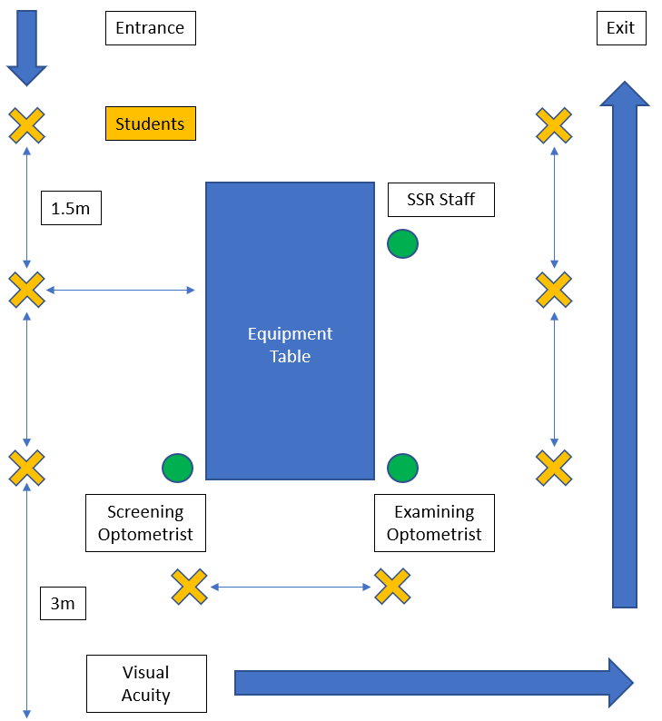

Should you have any questions regarding this information, please do not hesitate to contact me.

Lisa MacKinven
Program Manager, Glasses for Kids
P: 03 8769 8459 M: 0457 364 450 E: lisa.mac@ssr.net.au

